12/14/2013 - Joshua Anderson

Title: Inception & Web app requirements

Summary:
This document will go over all the functional requirements the application needs to have in this phase.

Description of application
This application needs to record individual internships for UNH Manchester COMP students.

There are 3 (three) primary entities that create the end result of a new “Internship Position”.

1. Student
2. Company
3. Supervisor

Each entity has their own properties, and constraints

Student
- studentId
- first_name
- last_name
- email
- graduation_year
- advisor

Company
- companyId
- name
- website
- city
- state

Supervisor
- first_name
- last_name
- email
- phone
- companyId

Student and Company entities are top level
Supervisor only can exist when a company is attached

Class Sequence UML Diagram
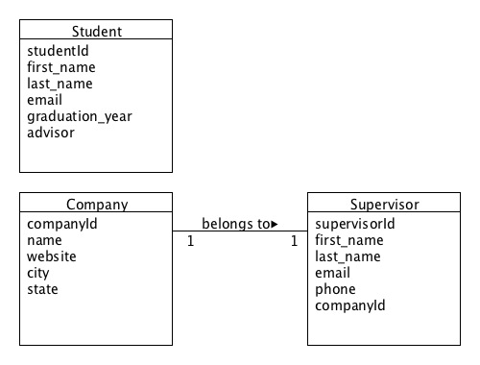

A Position entity is what these 3 entities will end up creating

Position
- positionId
- position_title
- term
- year
- is_paid
- notes (nvarchar max)
- est_hours_per_week
- studentId
- companyId
- supervisorId

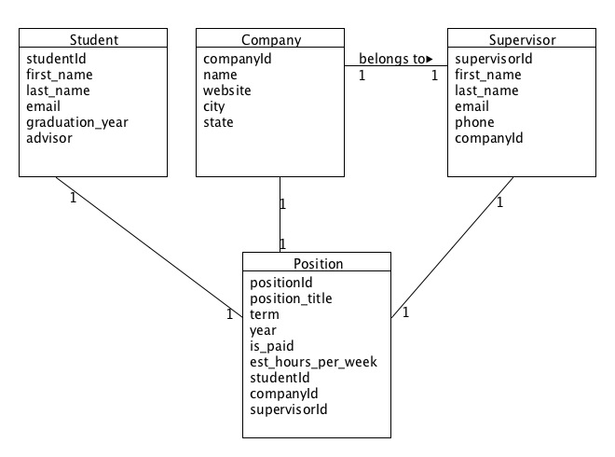

II. What are the functional requirements

UNH employee must be able to:
1. Homepage structure
This page should be very simple with the main functions of the site present:
- Create new Position
- Search existing Position
- Student tab
- search students
- email
- first + last name
- create new student form
- Company tab
- search companies
- company name
- create new company form
- Supervisor tab
- search supervisors
- email
- first + last name

2a. Create a new Internship Position
there should be a form that has 4 sections to it that flows nicely - finish one section before next one shows up
section 1: Student Information
section 2: Company Information
section 3: Supervisor Information
section 4: Position Information

Upon saving the full form, we will be creating new records of a student, company, supervisor and position. The position record will contain the 3 foreign keys of the 3 primary entities noted.

2b. Be able to search for student, company, and supervisor during creating a new position
UNH employee, when creating a new position, should be able to search for companies and supervisors already in the database before filling out a new one.

