**Development of a Computerized Order Management System for Edzel Samantha Department Store at Ilang-Ilang Street, Payatas A**

Perez, Vander

Solayao,Emanuel

Tomes, Ruzzel

Villanueva, Mark Joshua

Ms. Eleonor T. Rodriguez, MIT

*Professor*

**TABLE OF CONTENTS**

## **CHAPTER 1 - INTRODUCTION………………………………………….………………….**1

* 1. **Background of the Study………………………………..…..…………………**1
  2. **Statement of the Problem………………………………………………………2**

**- General Problem:**  
**- Specific Problems:**

### **1.3 Objectives of the Study ……………………………………………………………….. 3**

**- General Objective:**  
**- Specific Objectives:**

### **1.4 Significance of the Study ..……………………….……………………………………. 4**

### **1.5 Scope and Delimitation ………………………………………………………………… 4**

### **1.6 Definition of Terms …………………………………….…………………………………5**

## **CHAPTER 2 – REVIEW OF RELATED LITERATURE AND SYSTEMS ……………….. 6**

### **2.1 Review of Related Literature ………….……………………………………………….. 6**

### **2.2 Review of Related Systems ……………………...……………………………….……. 7**

### **2.3 Synthesis …………………………..……………………………………………………… 9**

## **CHAPTER 3 – METHODOLOGY / SYSTEM DESIGN ……………………….…………. 10**

### **3.1 Research Design ……………………………………...…………………….………….. 11**

### **3.2 Conceptual Framework ……………………………………………………………….. 12**

### **3.3 System Architecture …….……………………….……………………………………. 13**

### **3.4 Data Flow Diagram (DFD) …………….………………………………………………. 14**

### **3.5 Entity Relationship Diagram (ERD) …………………………………………………. 16**

### **3.6 Tools and Technologies Used ………………………………………………………. 18**

### **3.7 System Modules and Functions ……………………..……………………………… 19**

## 

## **CHAPTER 4 – SYSTEM IMPLEMENTATION AND TESTING ………………….……… 21**

### **4.1 System Interface …………………………………………………………...…………… 21**

### **4.2 Description of Each Module ………………………………………………………….. 23**

### **4.3 Testing Procedures …………………………………………………………………….. 25**

### **4.4 Test Results and Discussion ……………..………………………………………….. 26**

### **4.5 User Evaluation …………………………………………………………………………. 27**

## **CHAPTER 5 – SUMMARY, CONCLUSIONS, AND RECOMMENDATIONS ………… 28**

### **5.1 Summary of Findings ……………………………………………………….………… 28**

### **5.2 Conclusion ………………………………….….……………………………………….. 29**

### **5.3 Recommendations ……………………….……………………………………………. 30**

**APPENDICES (placed at the last page of the documentation)**

**Gantt Chart**

**CSE311 – CS Elective 1**

**Computer Science Final Mini Project – System Defense Criteria**

|  |  |  |
| --- | --- | --- |
| **CRITERIA** | **POINTS** | **REMARKS** |
| 1. **Technical Content (40%)**  * System Design & Architecture (15%) – clear structure, correct use of technologies, proper documentation (ERD, DFD, UML, etc.) * Implementation & Functionality (15%) – working prototype/system, meets stated objectives, minimal errors. * Innovation & Problem-Solving (10%) – originality, creativity, and real-world application of the system. |  |  |
| **2. Presentation & Defense (30%)**   * Clarity of Presentation (10%) – organized flow, concise explanation of concepts, effective use of slides/demos. * Defense & Q&A (15%) – ability to justify design choices, handle panel questions confidently. * Teamwork & Participation (5%) – equal participation of members during defense. |  |  |
| **3. Documentation (20%)**   * Completeness (10%) – includes title page, abstract, objectives, methodology, results, references, appendices. * Formatting & Organization (5%) – proper formatting, grammar, spelling, and professional layout. * Citation & References (5%) – correct use of references/sources. |  |  |
| **4. Professionalism & Formal Attire (10%)**   * Formal Attire (5%) – neat, professional dress code (barong/polo/slacks for men; blouse/blazer/skirt or slacks for women). * Professional Demeanor (5%) – punctuality, respectful manner, confident posture and speech. |  |  |
| **Total: (100%)** |  |  |

**Individual Grade: Signatures with Date:**

**Leader: Perez,Vander**. ______________ __________________

**Members: Solayao,Emanuel** ______________ __________________

**Tomes,Ruzzel**. ______________ __________________

**Villanueva,Mark Joshua** ______________ __________________

**Comments and Suggestions:** ________________________________________________________________________________________________________________________________

**CHAPTER 1 – INTRODUCTION**

**INTRODUCTION**

The**Departmental Roles and Functions in a Computerized Order Management System** is a browser-based designed to help small to mid-sized department stores improve their sales and transaction processes and many stores today still rely on manual methods that often lead to errors, delays, and confusion in managing sales records. (**Departmental Roles and Functions in a Computerized Order Management System)** aims to solve these problems by providing a digital system that makes daily operations faster, more accurate, and more organized.Receipts, the system ensures smoother workflow and more reliable store management.

The system focuses on simplicity, efficiency, and accessibility. Since **Departmental Roles and Functions in a Computerized Order Management System** is browser-based, it can be accessed through any computer connected to the internet without the need for complicated installation. Authorized cashiers can log in securely to process transactions, manage orders, and print receipts instantly. This improves the overall checkout experience for customers while reducing the workload for employees. The system also minimizes human errors that often occur in manual processes, making transactions more accurate and secure.

Overall, the **Departmental Roles and Functions in a Computerized Order Management System** serves as a modern solution to traditional sales management challenges. It helps department stores operate more efficiently by integrating sales, inventory, and reporting functions into one system. Through **Departmental Roles and Functions in a Computerized Order Management System**, store owners can monitor business performance in real-time, improve customer satisfaction, and maintain accurate financial records. Ultimately, the system promotes digital transformation and supports the growth of small to mid-sized department stores in a competitive retail environment.

**1.1 Background of the Study**

Department stores are key retail establishments offering a wide variety of consumer goods. Historically, their operations were managed through manual, paper-based processes, which were slow, prone to errors, and inefficient. This often resulted in inventory variation, delayed transactions, and financial inaccuracies, hindering both operational growth and customer satisfaction.

The shift to computerized systems has revolutionized this landscape. These integrated platforms, like the **Departmental Roles and Functions in a Computerized Order Management System**, centralize core operations such as sales, inventory, and billing. By automating these processes, stores can track stock in real-time, speed up checkouts, and ensure data accuracy, leading to a significantly improved customer experience.

This transition to technology is now essential for competitiveness. Modern systems provide valuable data insights that guide strategic decision-making. Therefore, implementing an efficient and automated order management system is crucial for any department store aiming to achieve operational excellence and sustainable growth in the digital age.

**1.2 Statement of the Problem**

The current manual process at our department store creates significant challenges, resulting in **slow transactions**, frequent **pricing errors**, and a consistently **poor customer experience**. Without an automated system, cashiers must manually enter each item, which not only slows down the checkout line but also increases the likelihood of human error. This lack of an instant **product preview** means customers can’t verify their items before payment, and the absence of a real-time digital receipt adds to the frustration. The overall result’s a complicated, inefficient, and often inaccurate process that reduce customer satisfaction and negatively impacts our store's reputation.This outdated system highlights an urgent need for a technological upgrade to streamline operations and improve service.

**1.3 Objective of the Study**

**General Objective:**

The main goal of the Departmental Roles and Functions in a Computerized Order Management System is to streamline and automate the process of managing customer orders, inventory, and sales transactions to improve efficiency, accuracy, and customer satisfaction within the store’s operations.

**Specific Objectives:**

**1.**To design a user-friendly system that enables efficient processing and tracking of customer orders.

**2.**To automate inventory updates to ensure accurate and real-time stock management.

**3.**To generate detailed sales and inventory reports for effective business monitoring and decision-making.

**4.**To enhance overall customer satisfaction by reducing errors and improving order accuracy and speed.

**1.4 Significance of the Study**

**1. For the Department Store:**

The study will help the store identify and address operational inefficiencies caused by manual processes. By implementing a computerized order and inventory system, the store can improve accuracy, speed, and profitability. It will also serve as a blueprint for adopting new technologies, allowing the business to stay competitive and organized.

**2. For the Employees:**

Employees will benefit from reduced workload and fewer repetitive tasks. Automated systems for inventory tracking, order processing, and record-keeping will minimize human error and save time. This will allow employees to focus more on customer service and other value-adding tasks, improving their productivity and job satisfaction.

1. **For the Customers:**

Customers will enjoy faster and more reliable transactions, accurate product availability information, and possibly reward or loyalty programs made possible by the computerized system. These improvements will enhance the overall shopping experience and increase customer satisfaction.

**1.5 Scopes and Delimitations**

The scope of this study is to examine the operations of a single department store that does not use a computer system. The research will focus on inventory management, sales tracking, and customer transactions over a one-year period. We will use a combination of observations, employee interviews, and record analysis to gather data./This study is delimited, or limited, in a few key ways. We will not recommend a specific new system, nor will we provide a full financial audit. The findings apply only to this one department store and cannot be generalized to other businesses.The research will also not look at the long-term effects of implementing a new system.

**1.6 Defination of terms**

**1. Departmental Roles and Functions in a Computerized Order Management System** – A computerized system designed to make ordering, sales, and inventory management faster and more organized in a department store.

**2. Inventory Management** – The process of tracking and updating store stocks to ensure accurate and real-time information.

**3. Automation** – The use of technology to perform tasks automatically, reducing manual work and human error.

**4. Point of Sale**  – The system used by cashiers to record sales transactions and process customer payments.

**5. Customer Satisfaction** – The level of happiness and fulfillment customers feel toward the store’s service speed and accuracy.automating tasks such as recording sales, updating inventory, and get

**CHAPTER 2 - REVIEW OF RELATED LITERATURE AND SYSTEMS**

**2.1 Review of related of literature**

Studies show that using **automated systems** in stores improves efficiency and reduces human error. A **computerized order** helps process transactions faster and ensures accurate data, unlike manual methods that often cause delays and mistakes

### **2.2 Review of Related Systems**

### Existing systems like **POS (P**oint of Sales)**** help manage sales and stocks, but some are complex or lack integration. The **DRFCOMS**combines these functions in one user-friendly platform for smoother and faster operations.

### **2.3 Synthesis**

### Overall, related studies and systems prove that automation increases speed, accuracy, and customer satisfaction. These findings guided the development of **DRFCOMS**, making it efficient and suitable for modern department stores.

**CHAPTER 3 - METHODOLOGY / SYSTEM DESIGN**

**3.1 Research Design**

This research will use a Descriptive Research Design to study the current transaction

interaction and flow of data between the three main parts: the Customer, the **Departmental Roles and Functions in a Computerized Order Management System**

This design will work as a Case Study of a specific order and payment system. Data will be gathered through:

1.Document Analysis: Reviewing existing materials like flowcharts and system manuals to understand the planned process.

2.Observation: Directly watching real transactions between the customer, cashier, and the **DRFCOMS**to see if the actual practice matches the planned model.

This design is a good fit to clearly show the step-by-step flow of a complete transaction, from selecting an item to getting a receipt.

**3.2 Conceptual Framework**

The figure above illustrates the process flow of the **Departmental Roles and Functions in a Computerized Order Management System**.The system connects three main components the **Customer**, the **DRFCOMS**, and the **Cashier** to ensure a smooth and efficient transaction process.

1. **Customer → (Pick Item)**  
   The process begins when the customer selects the items they wish to purchase. The selected items are recorded in the **DRFCOMS** for monitoring and processing.
2. **DRFCOMS → Cashier (Payment)** Once the items are confirmed, the **DRFCOMS** sends the order details to the cashier for payment processing. The cashier verifies the total cost and payment method through the system

**3. Cashier → (Checking)**  
The cashier checks and validates the payment transaction. After confirmation, the **DRFCOMS** updates the record to reflect that the payment has been completed.

**4. Customer → (Print Receipt):**  
After the transaction is finalized, the **DRFCOMS**generates and prints an official receipt for the customer, completing the transaction process.

**3.4 Data Flow Diagram:**

This DFD it shows how it work’s

This diagram illustrates the process of a customer making a purchase within a system, which appears to be a Department Store Ordering System (DSOS). It shows the flow of information and interactions between three main entities: the Customer, the DSOS, and the Cashier.

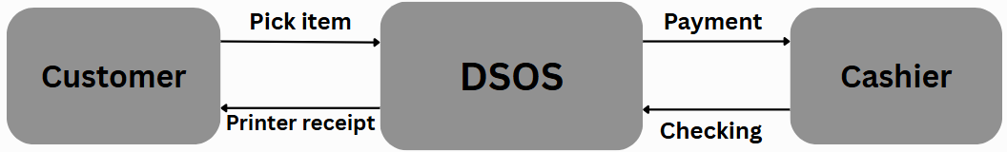

**3.5 Entity Relationship Diagram**

The Entity Relationship Diagram shows how data entities are related in the database.

**Main Entities and Relationships**

**Customer** – can place many Orders

**Order** – contains multiple Order

**Product** – appears in many Order

**Employee** – processes Orders

**Admin** – manages Products, Employees, and Reports

**3.6 Tools and Technologies Used**

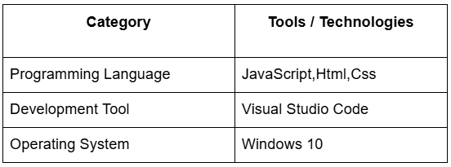

**3.7 System Modules and Functions**

**Login and Authentication Module**

Ensures secure access for admin and employees.

**Order Management Module**

Records and tracks customer orders, including item quantity and total amount.

**Inventory Management Module**

Updates stock levels automatically after each sale or restock.

**Payment and Sales Module**

Handles billing, records payments, and generates receipts.

**Report Generation Module**

Provides sales, inventory, and order summary reports.

**User Management Module**

Allows the admin to manage employee accounts and access privileges.

**CHAPTER 4 – SYSTEM IMPLEMENTATION AND TESTING**

**4.1 System Interface**

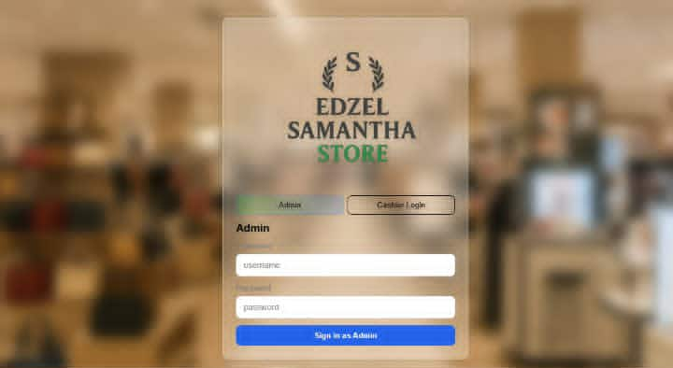

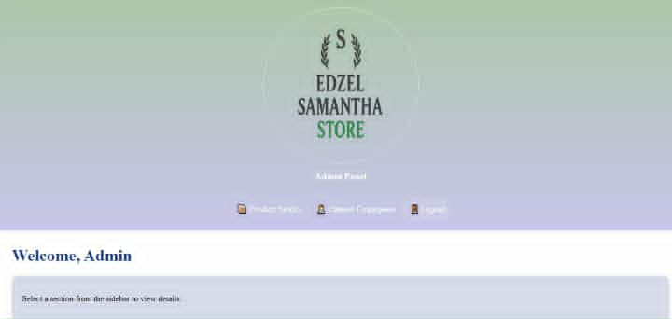

**4.2 Description of Each Module**

1. **Login/Authentication Module**

Allows Admin and Cashier to log in securely using their credentials.

Directs users to their respective dashboards after verification.

1. **User Management Module**

Enables the Admin to add, edit, or remove users and assign roles.

Controls access permissions to other system modules.

1. **Product/Inventory Management Module**

Used to add, update, and track product details and stock levels.

Automatically updates inventory after each sale or purchase.

1. **Sales (Point-of-Sale) Module**

Main interface for cashiers to record transactions and print receipts.

Calculates total amount, tax, and discount, and updates stock levels after each sale.

.**4.3 Testing Procedures**

1. **Unit Testing** – Each module (Login, Sales, Inventory, Reports) was tested individually to verify that all basic functions, such as login validation and sales computation, worked correctly.
2. **Integration Testing** – Modules were tested together to confirm smooth data flow between them. For example, sales transactions were checked to ensure inventory and reports updated automatically.
3. **System Testing** – The entire system was tested using real operational scenarios to ensure all processes worked together properly for both Admin and Cashier roles.
4. **User Acceptance Testing (UAT)** – Actual users tested the system to evaluate its usability and performance. Feedback lead to minor improvements in the interface and workflow.
5. **Error Handling Testing** – Invalid inputs and connection issues were simulated to ensure the system displayed proper error messages and handled problems effectively.

**4.4 Test Results and Discussion**

**Test Results:**

The **Login Module** correctly validated user credentials and restricted unauthorized access.

The **Inventory and Sales Modules** accurately updated stock levels and calculated totals after each transaction..

**Issues Encountered:**

Minor issues such as slow report loading, small rounding errors in totals, and layout misalignment were found.

These were fixed through system optimization, formula corrections, and interface adjustments.

**CHAPTER 5 – SUMMARY, CONCLUSIONS, AND RECOMMENDATIONS**

**5.1 Summary of Findings**

**Summary of Findings and Overall Results**

**Functionality:** All modules—Login, Inventory, Sales/POS, Purchase, Reports, and User Management—worked correctly, with accurate data flow between them.

**Usability:** The system was user-friendly and for both Admins and Cashiers, allowing efficient task performance.

**Performance:** Stable and fast, handling multiple transactions with real-time inventory and sales updates.

**Overall Outcome:** The system successfully streamlined store operations, improved accuracy, reduced errors, and met project objectives as a reliable, efficient, and user-friendly platform.

**5.2 Conclusion**

Here’s a clear **conclusion** for the *Edzel Department Store System*, addressing its objectives:

**Conclusion**

The system proved to be **user-friendly, reliable, and stable**, allowing Admins and Cashiers to perform daily tasks such as sales transactions, inventory tracking, and report generation with minimal errors. User evaluations confirmed its effectiveness and satisfaction in usability and performance. Minor recommendations, such as adding search filters and alerts, were noted for future enhancements.

**5.3 Recommendations**

Add **advanced search and filter options** for faster access to products, sales, and reports.

Implement **alerts and notifications** for low stock or pending orders.

Develop a **mobile-friendly version or POS app** for flexibility.

Provide **customizable report formats** for better data analysis.

Include **automated data backup and recovery** for security.

Enhance **user interface responsiveness** and add help guides.

Integrate **digital payment options** for modernized transactions.

Optimize **system performance** for faster loading of reports and large datasets.