MODULE 2: SYSTEMATIC DYNAMIC PROBLEMS WITH RATE PROPORTIONAL TO AMOUNT
WEEK 2
Learning Outcomes:
After completing this course, you are expected to demonstrate the following:
- Discuss the system dynamic tools, unconstrained growth and decay and Drug Dosage

- Engage
Quotation Station


Figure 2.0: A quote by Alfonso John Romero an American director, designer, programmer, and developer in the video game industry. He is best known as a co-founder of id Software and designer for many of their games, including Wolfenstein 3D, Dangerous Dave, Hexen, Doom, Doom II and Quake.

- Explore

Video Title: Introduction to System Dynamics
YouTube Link:https://youtu.be/IenySRdkRu8
Module Video Filename:WEEK2_Introduction to System Dynamics

- Explain
System dynamics is a highly abstract method of modeling. It ignores the fine details of a system, such as the individual properties of people, products, or events, and produces a general representation of a complex system. These abstract simulation models may be used for long-term, strategic modeling and simulation.

- Elaborate

System Dynamics Tools

Dynamic Systems, which change with time, are usually very complex, having many components, with the involved relationships. Two examples are systems involving competition among difference species for limited resources and the kinetics of enzymatic reactions. With a system dynamics tool, we can model complex systems using diagrams and equations. Thus, such a tool helps us perform Step 2 of the modeling process formulate a model by helping us document our simplifying assumptions, variables, and units; establish relationships among variables and sub-models and record equations and functions. Then, a system dynamics tool can help us solve the model Step 3 of the modeling process by performing simulations using the model and generating tables and graphs of the results. We use this output to perform Step 4 and the modeling process verify and interpret the model’s solution. Often such examination leads us to change a model. With its graphical view and built-in functions, a system dynamics tool facilitates cycling back to an earlier step of the modeling process to simplify or refine a model. Once we have verified and validated a model, the tool’s diagrams and equations from the design and the results from the simulation should be part of our report, which we do in Step 5 of the modeling process. The tool can even help us as we maintain the model (Step 6) by making corrections, improvements, or enhancements.

Unconstrained Growth and Decay
Many situations exist where the rate at which an amount is changing is proportional to the amount present. Such might be the case for a population of people, deer, or bacteria, for example. When money is compounded continuously, the rate of change of the amount of radioactivity decays at a rate proportional to the amount present. Similarly, the concentration of a chemical pollutant decays at a rate proportional to the concentration of pollutant present.

Rate of Change
We deal with rate of change every time we drive a car. Suppose our position (y) is a function (s)of time y = s(1). Suppose also that we start driving on a straight road at time t = 0 hours (h) at position marker s(0) = 10 miles (mi; about 16.1 km), and a time t = 2 h we are at position s(2) = 116 mi ( about 186.7 km). Our average velocity, or average rate of change of position with respect of time, is the change in position (∆s) over the change in time (∆t) and incorporates average speed as well as direction by its sign:
Average velocity = $\frac{Δ_{S}}{Δ_{t}}=\frac{\frac{116}{}m\dot{ⅈ}-10m_{i}}{2h_{-0}h}=\frac{106m_{i}}{2h}={53}^{m_{i}}∕h$
Or about 96.6 km/h

Definition
Suppose s(t) is the position of an object at time t, where a ≤ t ≤ b. Then the change in time, ∆t, is ∆t = b – a; and the change in position, ∆s, is ∆s = s(b) – s(a). Moreover, the average velocity, or the average rate of change of s with respect to t, of the object from time a = b – ∆t to time b is
Average velocity = $\frac{change in position}{change in time}=\frac{Δs}{Δt}$
= $\frac{s\left(b\right)-s(a)}{b-a}=\frac{s \left(b\right)-s( b- Δt}{Δt}$
We probably are not driving at a constant rate of 53 mi/h (85.3 km/h), but sometimes we are moving faster and other times, slower. To obtain a more accurate measure of our velocity at time t = 1 h, we
can use a smaller interval. For instance, at time t = 1 h, our position might be at marker s (1) = 51.2 mi, while a short time before at t = 0.98 h, our position was s(0.98) = 50.0 mi. As the following calculation shows, over this interval of 0.02 h (1.2 min), our average velocity is faster, 60 mi/h.

Differential Equation
Continuing with the population example, suppose we have a population in which no individuals arrive or depart; the only change in the population comes from births and deaths. No constraints, such as competition for food or a predator, exist on growth of the population. When no limiting factor exists, we have the Malthusian model for unconstrained population growth, where the rate of change of the population is directly proportional (∝) to the number of individuals in the population. If P represents the population and t represents time, then we have the following proportion:
$\frac{dP}{dt}$∞ P
For a positive growth rate, the larger the population, the greater the change in the population. With the same positive growth rate in two cities, say New York City and Spartanburg, S.C., the population of the larger New York City increases more in magnitude in a year than that of Spartanburg. In a later section of this module, “Unconstrained Decay,” we consider a situation in which the rate is negative. We write the preceding proportion in equation form as follows:
$\frac{dP}{dt}$∞ rP
The constant r is the growth rate, or instantaneous growth rate, or continuous growth rate, while dP/dt is the rate of change of the population.

Definitions
A differential equation is an equation that contains one or more derivatives. An initial condition is the value of the dependent variable when the independent variable is zero. A solution to a differential equation is a function that satisfies the equation and initial condition(s).

Difference Equation
Each diagram in Figure 2.1, developed with a choice of modeling tools and with the generic format employed by the text, depicts the situation with population indicating P, growth_rate representing r, and growth meaning dP/dt. A stock (box variable, or reservoir), such as population, accumulates with time. By contrast, a converter (variable-auxiliary/constant, or formula), such as growth-rate, does not accumulate but stores an equation or a constant. The growth is the additional number of organisms that join the population. Thus, a flow (rate), such as growth, is an activity that changes the magnitude of a stock and represents a derivative. Because both population and growth rate are necessary to determine the growth, we have arrows (connectors, or arcs) from these quantities to the flow indicator. For a simulation with a system dynamics tool or a program we write, we consider time advancing in small, incremental steps. For time, t, and length of a time step, ∆t, the previous time is t – ∆t. Thus, if t is 7.75 s and ∆t is 0.25 s, the previous time is 7.50 s. A system dynamics tool might call the change in time dt, DT, or something else instead of ∆t. As some tools do to avoid confusion, we replace each blank in a diagram component name with an underscore when using the name in equations and discussions. For example, we employ growth rate in the diagrams of Figure 2.2.1 and the corresponding growth_rate in the following discussion. Regardless of the notation, with initial population = 100, growth_rate = 0.1, and growth = growth_rate * population, as in Figure 2.2.1, a system dynamics tool generates an equation similar to the following, where population(t) is the population at time t and population(t – ∆t) is the population at time t – ∆t:
population(t) = population (t – ∆t) + (growth) * ∆t
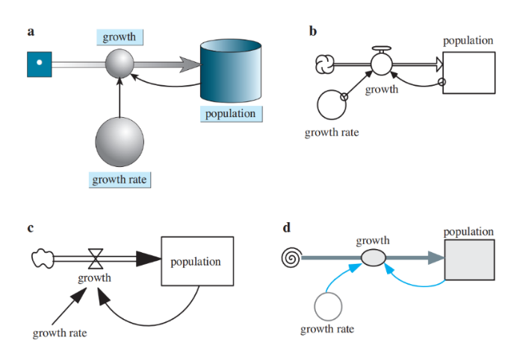

Figure 2.1 Diagrams of population models where growth rate is proportional to population: (a) Berkeley Madonna® (b) STELLA® (c) Vensim PLE® (d) Text’s format

This equation, called a finite difference equation, indicates that the population at one time step is the population at the previous time step plus the change in population over that time interval:
(new population) = (old population) + (change in population)
Or population(t) = population (t – ∆t) + ∆population

where ∆population is a notation for the change in population. We approximate the change in the population over one-time step, ∆population or (growth) * ∆t, as the finite difference of the populations at one time step and at the previous time step, population(t) – population (t – ∆t). Thus, solving for growth, we have an approximation of the derivative dP/dt as follows:
growth =$\frac{∆ population}{∆t}$ = $\frac{population \left(t\right)-population (t- ∆t)}{∆t}$
Computer programs and system dynamics tools employ such finite difference equations to solve differential equations.
Definition
A finite difference equation is of the following form:
(new value) = (old value) + (change in value)
Such an equation is a discrete approximation to a differential equation.

Simulation Program
In developing a simulation program, we use statements similar to the preceding finite difference equations. We initialize constants, such as growthRate, population, ∆t, and the length of time the simulation is to run (simulationLength), and we update the population repeatedly in a loop. The calculation for the total number of iterations (numIterations) of this loop is simulationLength/∆t. For example, if the simulation length is 10 h and ∆t is 0.25 h, then the number of loop iterations is numIterations = 10/0.25 = 40. We have a loop index (i) go from 1 through numIterations. Inside the loop, we calculate time t as the product of i and ∆t. For example, if ∆t is 0.25 h, during the first iteration, the index i becomes 1 and the time is 1 * ∆t = 0.25 h. On loop iteration i = 8, the time gets the value 8 * ∆t = 8 * 0.25 h = 4.00 h. Algorithm 1 contains pseudocode, or a structured English outline of the design, for generating and displaying the time, growth, and population at each time step. In algorithm, a left-facing arrow (←) indicates assignment of the value of the expression on the right to the variable on the left. For example, numIterations ←simulationLength/∆t represents an assignment statement in which numIterations gets the value of simulationLength/∆t.

Algorithm 1 Algorithm for simulation of unconstrained growth
initialize simulationLength
initialize population
initialize growthRate
initialize length of time step ∆t
numIterations ← simulationLength/∆t
for i going from 1 through numIterations do the following:
growth ← growthRate * population
population ← population + growth * ∆t t ← i * ∆t
display t, growth, and population

If we do not need to display growth (derivative) at each step and the length of a step(∆t) is constant throughout the simulation, we can calculate the constant growth rate per step (growthRatePerStep) before the loop, as follows:growthRatePerStep ← growthRate * ∆t
Within the loop, we do not compute growth but estimate population as follows:population ← population + growthRatePerStep * population Thus, within the loop, we have two assignments instead of three and two multiplications instead of three, saving time in a lengthy simulation. The revised algorithm appears as Algorithm 2.

Algorithm 2 Alternative algorithm to Algorithm 1 for simulation of unconstrained growth that does not display growth
initialize simulationLength
initialize population
initialize growthRate
initialize ∆t
growthRatePerStep ← growthRate * ∆t
numIterations ← simulationLength/∆t
for i going from 1 through numIterations do the following:
population ← population + growthRatePerStep * population
t ← i * ∆t
display t and population

Analytical Solution: Introduction
We can solve the preceding model analytically for unconstrained growth, which is the differential equation $\frac{dP}{dt}$= 0 1.0P with initial condition P0 = 100, as follows:
The next three sections develop the analytical solution. The first section starts the explanation using indefinite integrals, while the second section begins the discussion sing derivatives without using integrals. Thus, you may select the section that matches your calculus background. The third section completes the development of the analytical solution for both tracks. Those without calculus background may go immediately to the section “Completion of the Analytical Solution.”
When it is possible to solve a problem analytically, we should usually do so. We have employed simulation of unconstrained growth with a system dynamic tool as n introduction to fundamental concepts and as a building block to more complex problems for which no analytical solutions exist.

Analytical Solution: Explanation with definite Integrals (Optional)
We can solve the different equation $\frac{dP}{dt}$= 0.10 P with initial condition $P_{0}$ = 100, as follows:

P = 100 e0.10t

The next three sections develop the analytical solution. The first section starts the explanation using indefinite integrals, while the second section begins the discussion using derivatives without using integrals. Thus, you may select the section that matches your calculus background. The third section completes the development of the analytical solution for both tracks. Those without calculus background may go immediately to the section “Completion of the Analytical Solution. When it is possible to solve a problem analytically, we should usually do so. We have employed simulation of unconstrained growth with a system dynamic tool as an introduction to fundamental concepts and as a building block to more complex problems for which no analytical solutions exist.

We can solve the differential equation $\frac{dP}{dt}$ = 0 1.0P using a technique called separation of variables. First, we move all terms involving P to one side of the equation and all those involving t to the other. Leaving 0.10 on the right, we have the following:
$\frac{1}{P}$ – dp = ∫ 0.10 dt
|P| = 0.10t + C for an arbitrary constant C
We solve for |P| by taking the exponential function of both sides and using the fact that the exponential and natural logarithmic functions are inverses of each other.
e$\ln\left|p\right|=ⅇ^{0.10t+C}$
$$\left|p\right|= ⅇ^{0.10t+C}ⅇ^{c}=A ⅇ^{0.10t}$$
where A = eC. Solving for P, we have
P = (±A)$A ⅇ^{0.10t}$
Or P =K$ⅇ^{0.10t}$
where k = (±A) is a constant.

Analytical Solution: Explanation with Derivatives (Optional)
We can solve the differential equation$\frac{dP}{dt}$= 0 1. 0 for P analytically by finding a function whose derivative is 0.10 times the function itself. The only functions that are their own derivative are exponential functions of the following form:
f(t) = ket, where k is a constant
For example, the derivative of 5et is 5et. To obtain a factor of 0.10 through use of the chain rule, we have the general solution:
P = ke0.10t
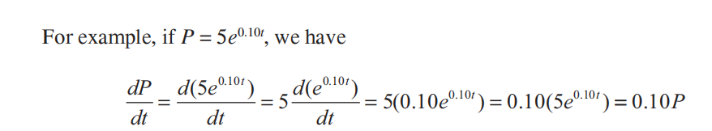
System Dynamics Problems with Rate Proportional to Amount

Completion of the Analytical Solution
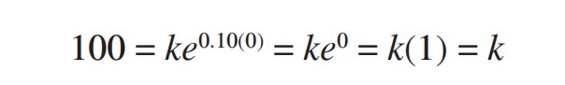
Thus, the general solution $\frac{dP}{dt}$ = 0.10P = ${Kⅇ}^{0.10t}$ for a constant k. Using the initial condition that, $p_{0}$= 100, we can determine a particular value of k and, thus, a particular solution of the form P =K$ⅇ^{0.10t}$. Substituting 0 for t and 100 for P, we have the following:

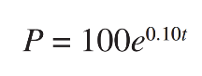
The constant is the initial population. For this example,
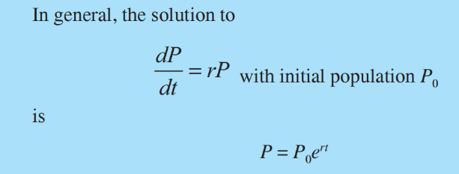

Figure 2.2 displays the dramatic increase in the bacterial population as time advances.
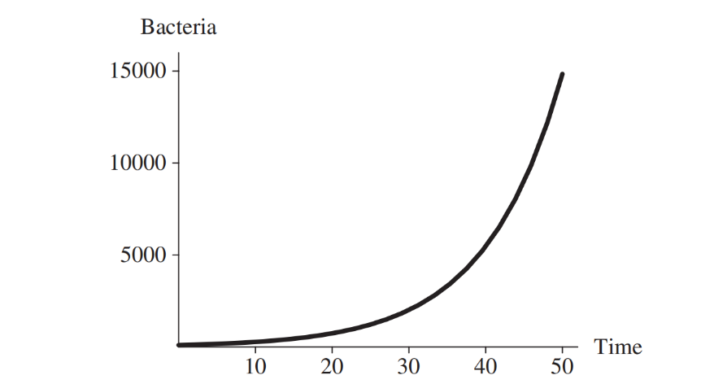

Figure 2.2 Bacterial population with a continuous growth rate of 10% per hour and an initial population of 100 bacteria

Unconstrained Decay
The rate of change of the mass of a radioactive substance if a proportional to the mass of the substance, and the constant of proportionality is negative. Thus, the mass of decays with time. For example, the constant of proportionality for radioactive carbon is -14 is approximately – 0.000120968. The continuous decay rate Is about 0.0120968% per year, and the differential equation is as follows, where Q is the quantity (mass) of carbon -14:
$\frac{dQ}{dt}$ = 0.000120968Q
As indicated in the section “Completion of the Analytical Solution”, the analytical solution to this equation is
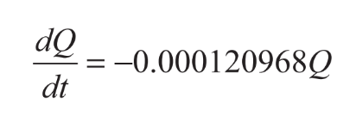

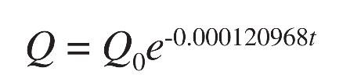
After 10,000 year, only about 29.8% of the original quantity of carbon -14 remains, as the following shows:
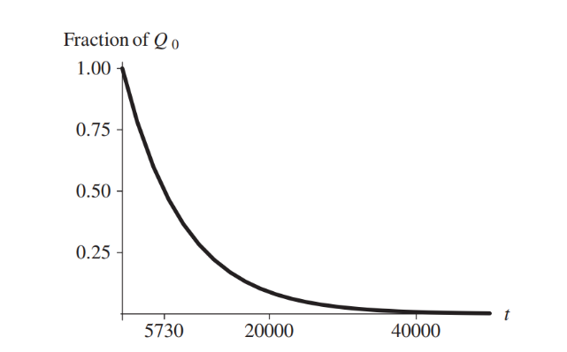

Figure 2.3 Exponential decay of radioactive carbon -14 as a fraction of the initial quantity$Q_{0}$, with time (t) in years
Figure 2.3 displays the decay of carbon -14 with time. Carbon dating uses the amount of carbon -14 in an object to estimate the age of an object. All living organism dies. For example, we can compare the proportion of carbon -14 in living bone to that in bone of a mummy and estimate the age of the mummy using the model.

LABORATORY ACTIVITY 2.0
HOW TO INSTALL PYTHON WITH IDE
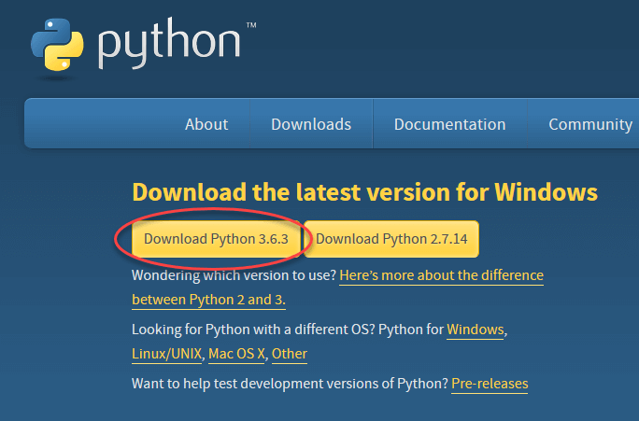
Step 1 To download and install Python, visit the official website of Python Httpss://www.python.org/downloads/ and choose your version or the latest version

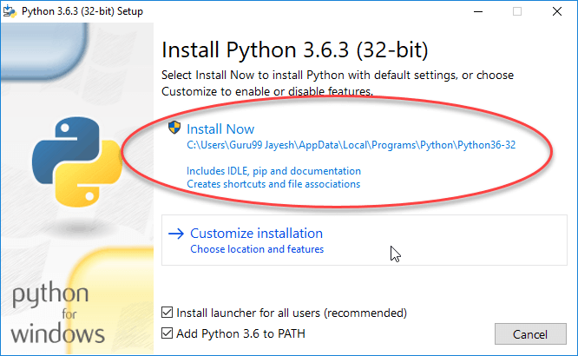
Step 2 Once the download is completed, run the .exe file to install the Python. Now click on Install Now.

Step 3 When it finishes, you can see a screen that says the Setup was successful. Now click on “Close”.
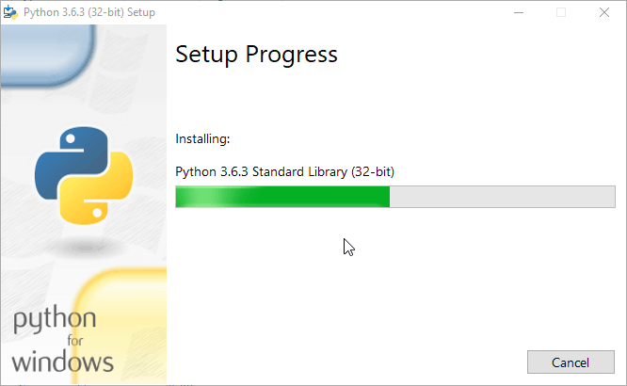

Step 4 When It finish, you can see a screen that says the Setup was successful. Now click on “Close”.
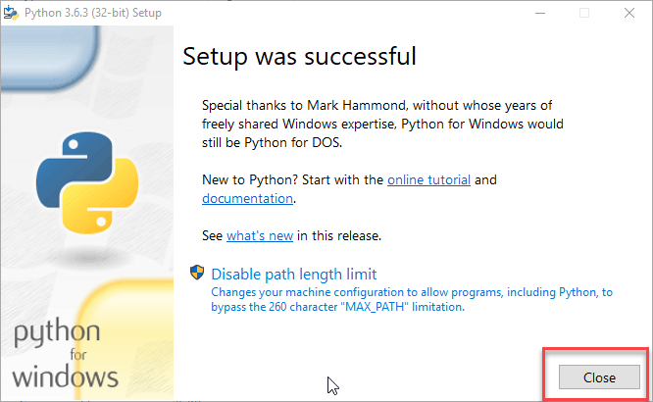

LABORATORY ACTIVITY 2.1
HOW TO INSTALL PYCHARM
Step 1 To download PyCharm visit the website https://www.jebtrains.com/pycharm/download and click the “DOWNLOAD” link under the Community Section.
Step 2 Once the download is complete, run the exe for install PyCharm. The setup wizard should have started. Click “Next”.
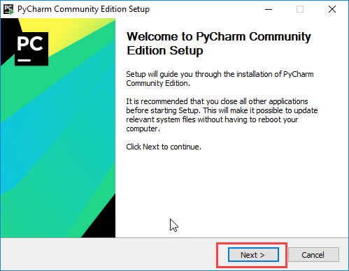

Step 3 On the next screen, Change the installation path if required. Click “Next”

Step 4 On the next scree, you can create a desktop shortcut if you want and click on “Next”
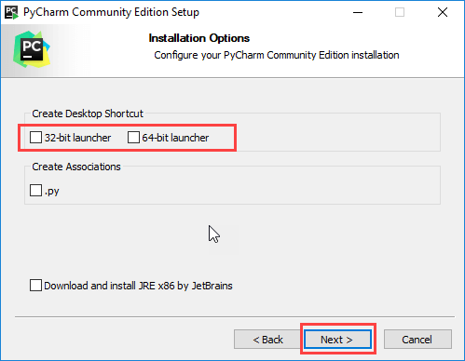

Step 5 Choose the start menu folder. Keep Selected JetBrains and click on “Install”.
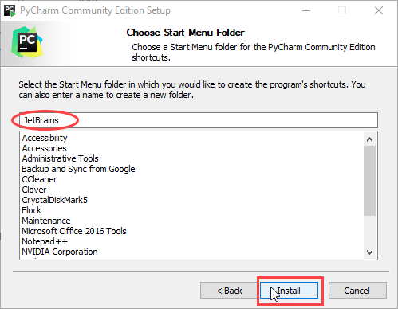

Step 6 Wait for the installation to finish.
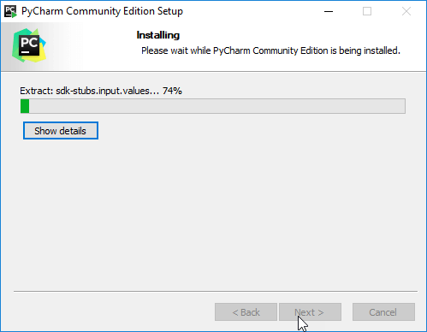

Step 7 Once installation is finished, you should receive a message screen that PyCharm is installed. If you want to go ahead and run it, click the “Run PyCharm Community Edition” box first and click “Finish”
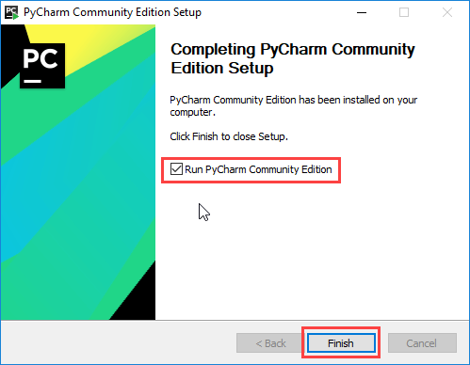

CREATING FIRST PROGRAM
Step 1 Open PyCharm Editor. You can see the introductory screen for PyCharm. To create a new project, click on “Create New Project”.


Step 2 You will need to select a location.
- You can select the location where you want the project to be created. If you don’t want to change location than keep it as it is but at least change the name from “untitled” to something more meaningful, like “FirstProject”.
- PyCharm should have found the Python interpreter you installed earlier.
- Next Click the “Create” Button
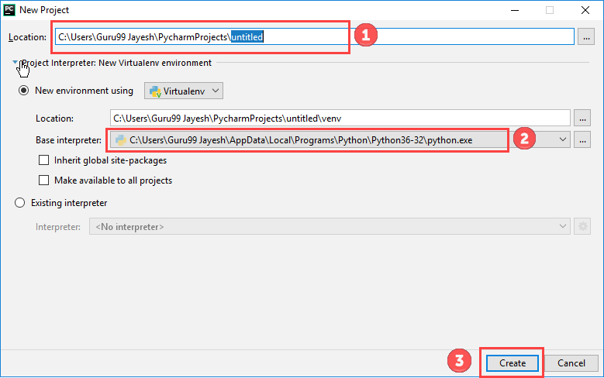

Step 3 Now Go up to the “File” menu and select “New”. Next, select “Python File”.
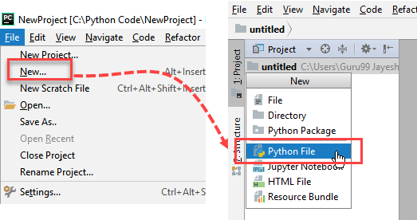

Step 4 A new pop up will appear. Now type the name of the file you want (Here we give “HelloWorld”) and hit “OK”.
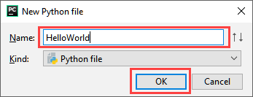

Step 5 Now type a simple program - print (‘Hello World!’).
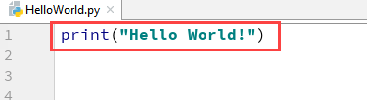

Step 6 Now Go up to the “Run” menu and select “Run” to run your program.
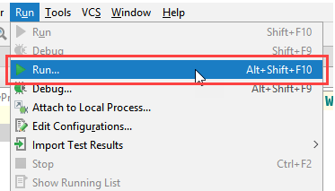

Step 7 You can see the output of your program at the bottom of the screen.
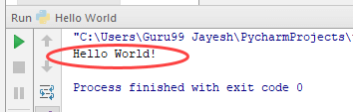

Step 8 Don't worry if you don't have Pycharm Editor installed, you can still run the code from the command prompt. Enter the correct path of a file in command prompt to run the program.
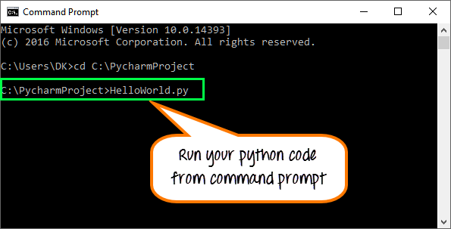

The output of the code would be

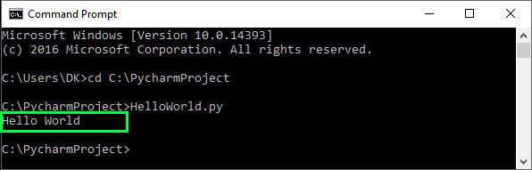

- Evaluate
ASSESSMENT:
Instructions: Write your answer on the Answer Sheet (AS) provided in this module.
- Identification (2 Points each)
- It is a highly abstract method of modeling. It ignores the fine details of a system, such as individual properties of people, products, or events, and produces a general representation of a complex system.
- It indicates that the population at one time step is the population at the previous time step plus the change in population over that time.
- The rate of change of the mass of radioactive substance if a proportional to the mass of the substance, and the constant of proportionality is negative.
- Write the sample formula of Finite Difference Equation
- Write the formula Difference Equation

References:

- Introduction to computational science http://www.gbv.de/dms/tib-ub-hannover/752347535.pdf

Facilitated By:
Name | :
MS Teams Account (email) | :
Smart Phone Number | :

