MODULE 3: FORCE AND MOTION
WEEK 3
Learning Outcomes:
After completing this course, you are expected to demonstrate the following:
- Discuss the Modelling falling, skydiving and bungee jumping

- Engage

Quotation Station
Figure 3.0: A quote by Grace Brewster Murray Hopper was an American computer scientist and United States Navy rear admiral. One of the first programmers of the Harvard Mark I computer, she was a pioneer of computer programming who invented one of the first linkers.

- Explore

Video title: Inertia | Forces and Motion | Physics | FuseSchool
YouTube Link: https://youtu.be/qBjmO8w-QqU
Module Video Filename: WEEK3_ nertia | Forces and Motion | Physics | FuseSchool

- Explain
When we think of When we think of a pendulum, many of us think about clocks, grandfather clocks, mantel clocks, kitchen clocks, and the like. We may even become nostalgic for the sound of such a clock in our grandparents or parents’ home. Such clocks had them a pendulum, about clocks. Considering the early date, his first clock was incredibly accurate, losing less than a minute each day (Jespersen and Fitz – Randolph 1999)
Galileo is usually credited with the invention of pendulum, studying its motion during the sixteenth century. Although a popular myth is that he studied gravity by dropping objects from the top of the Learning Tower of Pisa, Galileo actually used the motion of a pendulum (Boyd 2002)

- Elaborate

FORCE AND MOTION
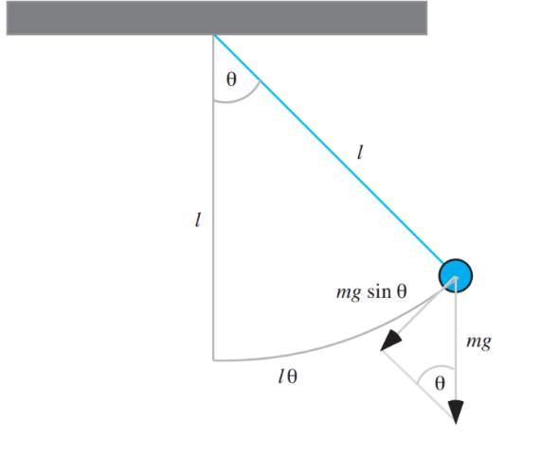

Figure 3.1 A simple pendulum

SIMPLE PENDULUM
start our model of a pendulum’s motion by considering a simple pendulum, which incorporates the following simplifying assumptions: All the mass for the bob is concentrated at a point; the stiff string has no mass; and friction does not exist. Figure 3.1 depicts such a simple pendulum with bob of mass m and string of length. l being at an angle θ (in radians, rad) off the vertical (Elmer 2011; Weissteins 2003). We consider the angle to be positive when to the right of the vertical and negative when to the left. As noted in the diagram, the weight of the bob is mg, where g = 9.8 m/s2 is 0the acceleration due to gravity with down being the positive direction. The only force pulling the bob along an arc in this simple pendulum is the tangential component of the weight, whose magnitude is mg sinθ. Because the component points to the left when θ > 0 and points to the right when θ < 0, the force acting on the bob is –mg sinθ. According to a geometric formula, the arc length from the bob to the vertical is the product of the string length and the angle in radians, lθ. Thus, acceleration along the bob’s path, the angular acceleration, is the second derivative of this arc length, or angular acceleration = d2(lθ)/dt2. Because length is constant for a given pendulum, by calculus, d2(lθ)/dt2 = ld2(θ)/dt2. By Newton’s second law of motion, the force is equal the mass times the acceleration. Thus, the force pulling the bob along the arc is as follows:
force = (mass)(angular acceleration) = mld2(θ)/dt2
Equating this expression to the negative of the earlier component of weight along the arc, –mg sinθ, we have the following:
mld2(θ)/dt2 = –mg sinθ
Canceling m and dividing by l, we have the following formula for angular acceleration: angular acceleration = d2(θ)/dt2 = –g(sinθ)/l Initial conditions include specifying that at time t = 0, θ = π/4.
and the initial angular velocity is d(θ)/dt = 0. Because we cancel m, we see that the mass of the bob is irrelevant for the angular acceleration. According to the formula, for a given acceleration due to gravity at a particular location, the angular acceleration of a simple pendulum depends only on the length of the string and the angle off the vertical.
angle change = angular velocity
angle (0) = init_angle
angular_acceleration = –g * sin(angle) / length
angular_velocity (0) = 0
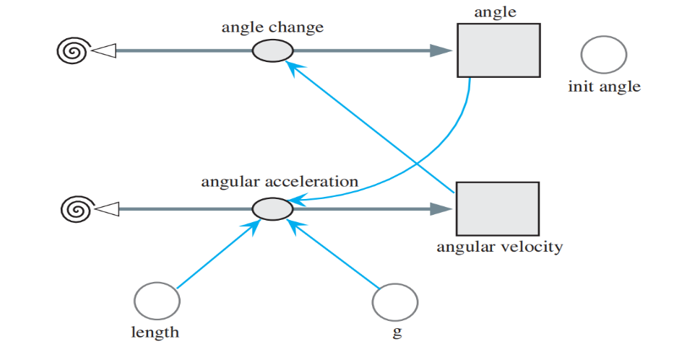

Figure 3.2 A Model diagram for a simple pendulum
For a string length of 1 m and initial angle of π/4, Figure 3.3. presents a plot of the angle θ, angular velocity, and angular acceleration versus time. With only the force involving weight, the pendulum moves back and forth forever.
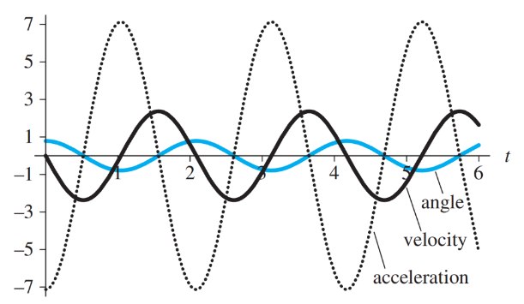

Figure 3.3 Plot of angle (rad), angular velocity (rad/s), and angular acceleration (rad/s2) versus time (s)

LINEAR DAMPING
In a real pendulum, the motion is damped by friction. A simple model of such effect is Stokes’ friction (F = kv). Thus, we assume that the damping force is proportional to the angular velocity, d(θ)/dt. In this case of linear damping, the model for the forces is as follows, where k is a positive constant:
ml d2(θ)/dt2 = –mg sinθ – kd(θ)/dt
The initial conditions continue to be θ = θ0 and d(θ)/dt = 0 when t = 0. Projects explore various models of a pendulum’s motion that incorporate friction (Danby 1997).

PENDULUM CLOCK
As the exercises and projects explore, the angle θ of a pendulum does not affect its period, or the length of time to complete a full cycle. Thus, we can use the device in construction of a clock. We consider the construction of a 60-second clock with only one hand, as in Figure 3.3.4. Falling toward the ground, a weight attached to a rope wound around a drum provides potential energy to run the clock. The drum also has an attached clock hand so that the hand moves as the drum does. The weight is prevented from falling to the floor immediately by the action of the pendulum and a toothed wheel, or escapement gear. The shaft of the pendulum bob attaches rigidly to a shaft with an anchor that has an associated lever arm. As the pendulum swings in one direction, this attachment moves the anchor, and a tooth of the gear escapes the grasp of a right or left stop on the anchor, lowering the weight and producing a “tick” sound. Swinging in the opposite direction, the advancing gear hits the other stop with a “tock” sound. Besides regulating the lowering weight, the gear imparts enough of the falling weight’s potential energy through the rigid shaft attachment to the pendulum for the latter to overcome friction that dampens its motion. Thus, the pendulum continues swinging for an extended period. Although we do not picture it here, through the interaction of gears, the mechanism also controls the hour and minute hands of the clock. A project models a pendulum clock with a second hand (Brain 2002).
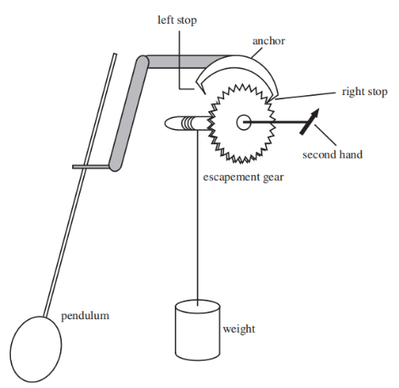

Figure 3.4 Pendulum clock with only a second hand
UP, UP AND A WAY – ROCKET MOTION
Of course Peter had been trifling with them, for no one
can fly unless the fairy dust has been blown on him.”
—J. M. Barrie, The Adventures of Peter Pan
Human beings have long looked to the sky with a yearning to fly and have long experimented with various methods and contrivances to accomplish this goal. Around AD 1500, a mandarin named Wan-Hu attempted to fly to the moon in a wicker chair to which were attached 47 “rockets”—47 bamboo tubes filled with black powder (Dvir 2003; Lethbridge 2000). Unfortunately, the innovator was unable to conduct other experiments with the potential of rockets to propel human beings into the sky. The successful launching of human beings into space would have to wait several centuries. Now, the launching of rockets with or without human beings is quite an ordinary event. The space above earth is littered with various types of satellites placed into orbit by rockets. The Chinese generated a form of black powder, or “gun powder,” during the first century AD from charcoal, saltpeter, and sulfur (Lethbridge 2000). Initially, they used this powder for fireworks; but sometime around the year AD 1000, they adapted this powder for use in fire arrows. These fire arrows were made by attaching powder filled bamboo tubes to arrows and launching them with a bow. By 1232, they had modified these arrows by fixing tubes, open at one end and capped at the other end, to long sticks. They lit the powder, and the first true rockets were launched toward their Mongol attackers. The tips of these rockets were coated with either flammable materials or poison.

PHYSICS BACKGROUND
Before embarking on our development of a model of rocket motion, we need to consider some of the physics fundamentals. We have already worked extensively with Newton’s second law, F = ma, where F is a force acting on an object of mass m and imparting an acceleration. In that same section, we discussed drag on an object. With rockets, we consider another mechanical force, thrust. A rocket’s engine generates thrust through the acceleration of a mass of gas through the bottom, propelling the rocket in the opposite direction. Thus, the forces obey Newton’s third law of motion: “for every action, there is an equal and opposite reaction.” The concept for a rocket is the same as that of a filled and released balloon, where expelled gas under pressure causes the balloon to fly around the room.
Definition
Thrust is a mechanical force caused by the acceleration of a mass of fluid and in the opposite direction to flow.
Suppose c is the velocity of the gas relative to the rocket and v is the velocity of the rocket, so that c + v is the velocity of the gas in space. If m is the mass and up is positive, then the thrust of the engine (T) is as follows:
$$T=c\frac{ⅆm}{ⅆt}$$
Over a period of time ∆t, we have the following discrete version:
$$T=c\frac{Δm}{Δt}$$
Or T ∆t = c ∆m

SYSTEM DYNAMIC MODEL
The model of the motion of a ball tossed into the air Figure 3.1 of Module 3.1 , “Modeling Falling and Skydiving”, serves as basis for the rocket – motion model.
For the extension, we make several assumptions:
- The only forces acting on the rocket are gravitation and thrust derived from burning fuel.
- Acceleration due to gravity is constant.
- The earth is flat.
- The rocket Is vertical.
- The rocket has only one stage.
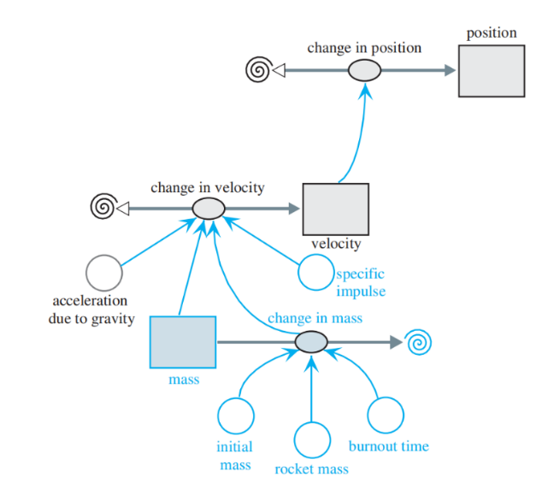

Figure 3.5 Model Diagram of a Rocket’s Motion
Extending the first model in “Modeling Falling and Skydiving,” in which we assume no friction, thrust from burning fuel also impacts the motion of a rocket. The change_in_velocity, or acceleration, now involves acceleration due to this t thrust as well as acceleration due to gravity. The extended model has an additional stock (box variable), mass, that contains the total mass of the fuel and rocket, which has mass rocket_mass. This stock has an initial value of initial_mass. We assume that wile fuel I present, the flow out, change_in_mass, is constant and consists of the mass of the initial unburned fuel divided by the time for it to burn (burnout_time). After burnout, change_in_mass becomes zero.
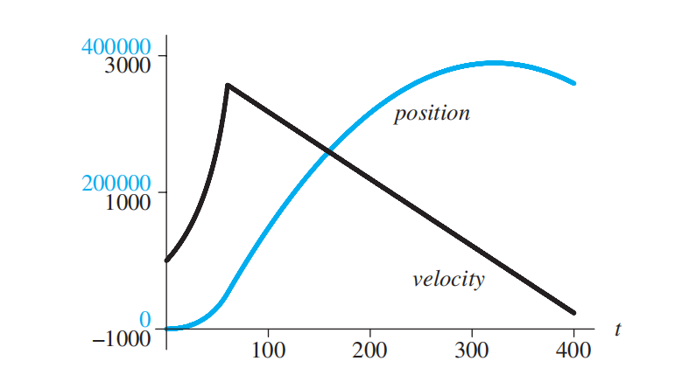

Figure 3.6 Graph of position (m) and velocity (m/s) versus time for rocket
Full completely burns. With a velocity of about 2567 m/s = 2.567 km/s at that instant, the rocket continues to rise to a height of about 388,500 = 388.5 km before starting its decent. Various projects complete and expand upon the model in Figure 3.5

- Evaluate
ASSESSMENT:
Instructions: Write your answer on the Answer Sheet (AS) provided in this module.
- Identification (2 points each)

- All the mass for the bob is concentrated at a point; the stiff string has no mass; and friction does not exist.
- The motion is damped by friction.
- What is Force?
- What is Motion?
- What serves as basis for the rocket - motion model?

Review Questions (5 Points each)
- What is Modeling Falling?
- What is Modeling Skydiving?
- What is the difference of Modeling Falling and Modeling Skydiving ?

LABORATORY ACTIVITY 3.1
Instructions: You may write your answer on the Answer Sheet (AS) provided in this module.
I. Create the given activity. (50 points each)

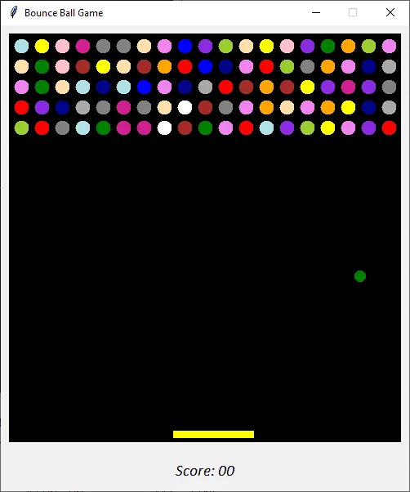
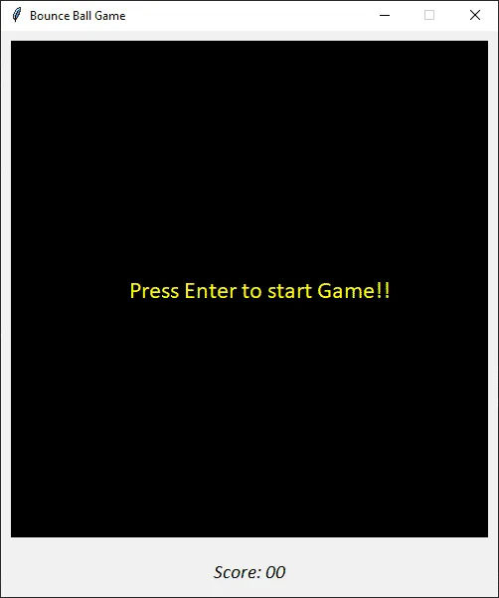
- Make a Bouncing Ball Game (please see sample picture below)

References:

- Introduction to computational science
http://www.gbv.de/dms/tib-ub-hannover/752347535.pdf

Facilitated By:
Name | :
MS Teams Account (email) | :
Smart Phone Number | :

