MODULE 4: SYSTEM DYNAMIC PROBLEMS WITH RATE PROPORTIONAL TO AMOUNT
WEEK 4
Learning Outcomes:
After completing this course, you are expected to demonstrate the following:
- Discuss Competition
- Explain Predator – Prey models
- Clarify Modelling the Spread of SARS and Persistent Malaria

- Engage

Quotation Station

Figure 4.0: A quote by William Henry Gates III is an American business magnate, software developer, and philanthropist. He is best known as the co – founder of Microsoft Corporation.

- Explore

Video Title: Python Tutorial : Introduction to Linear Modeling in Python
YouTube Link: https://youtu.be/QrCMbYmdMrc
Module Video Filename: WEEK4_ Python Tutorial : Introduction to Linear Modeling in Python

- Explain

Any system or process can be described by some mathematical equations. Their nature may be arbitrary. Does security service of a stadium want to know fan traffic in the case of fire? Does an engineer construct a thermal generating unit for your house? Usually, using a small set of general rules and laws of nature, one can predict everything at least for the nearest future.

- Elaborate

COMPETITION
Community Relations
In any population of organisms, the individuals are interacting with each other and with their environment. Populations, which are made up of only one species, are also interacting with other species in a particular area in what we term a community. These interactions influence the composition and dynamic of the community through time. Some of these interactions are robust, while others are not so robust or are even every weak. The magnitude of these interactions depends on the extent of their niche overlap. The magnitude of these interactions depends on the extent of their niche overlap. An ecological niche can be defined as the complete role that a species plays in an ecosystem. The more overlap two species have, the stronger the interaction will be. Two of these interactions between species are competition and predator-prey relationships.

INTRODUCTION TO COMPETITION
Everyone is familiar with competition. We compete for attention in families, for grades in school, for jobs and promotions, for parking spaces, and on and on. Competition is integral to most economic activity. Through competition in human societies, wages and prices are set; quantities and types of products manufactured are selected; businesses succeed or fail; and resources are distributed. Economic and social competition may occur even in non-capitalist systems.
More broadly, competition is a basic characteristic of all communities, human and nonhuman. It may occur within a population of the same species (intraspecific), like the human species, or it may occur between populations of different species (interspecific). Competitive interactions affect species distribution, community organization, and species evolution.
Simply speaking, competition is the struggle between individuals of a population or between species for the same limiting resource. If one individual (species) reduces the availability of the resource to the other, we term that type of competition exploitative, or resource depletion. This interaction is indirect and may involve removal of the resource or denial of living space. If there is direct interaction between individuals (species), where one interferes with or denies access to a resource, we term that competition interference. In this form, there may be physical contests for territory or resource. Interference may also, as in some plants, involve the production of toxic chemicals.

MODELING COMPETITION
Sometimes two species are not eating each other but are competing for the same limited food source. For example, whitetip sharks (WTS) and blacktip sharks (BTS) in an area might feed on the same kinds of fish in a year when the fish supply is low. We anticipate that a large increase in one species, such as BTS, might have a detrimental effect on the ability of the other species, such as WTS, to obtain an adequate amount of food and, therefore, to thrive. Also, we expect that superior hunting skills of one species would diminish the food supply for the other species. As one species grows, the other shrinks, and vice versa.
In an unconstrained growth model (see Module 2.2, “Unconstrained Growth”), which ignores competition and limiting factors, we consider a population’s (P) births to be proportional to the number of individuals in the population (r1P) and its deaths to follow a similar proportionality (r2P). Thus, in this model, the rate of change of the population is dP/dt = r1P – r2P = (r1 – r2)P, so that the solution is an exponential function, P = P0e(r1 – r2)t.
However, with competition, a competing species has a negative impact on the rate of change of a population. In this situation, we can model the number of deaths of each species as being proportional to its population size and the population size of the other species. Thus, for B being the population of BTS and W the population of WTS, the number of deaths of each species is proportional to the product BW. Moreover, the constant of proportionality associated with this proportionality for one species reflects competitive skills of the other species. (Projects explore various types of competition.) Consequently, we have the following equations for the change in the number of deaths of each species:
∆ (deaths of WTS) = wBW, where wis a WTS death proportionality constant
∆ (deaths of BTS) = bWB = bBW, where b is a BTS death proportionality constant
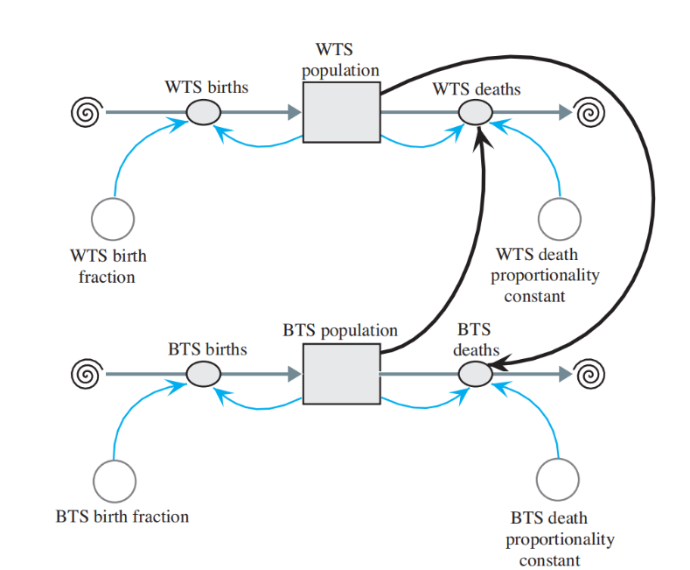
SYSTEM DYNAMICS MODELS WITH INTERACTIONS

Figure 4.1 Model Diagram of Competition of Specifies

Equation Set 4.1
Some equations to accompany Figure 4.1 with basic unit of time being 1 month
BTS_population(0) = 15
BTS_birth_fraction = 1
BTS_births = BTS_birth_fraction * BTS_population
BTS_death_proportionality_constant = 0.20
BTS_deaths = (BTS_death_proportionality_constant * WTS_population) *
BTS_population
WTS_population(0) = 20
WTS_birth_fraction = 1
WTS_births = WTS_population * WTS_birth_fraction
WTS_death_proportionality_constant = 0.27
WTS_deaths = (WTS_death_proportionality_constant * BTS_population) *
WTS_population

Figure 4.1 illustrates the interaction with the number of each species of shark affecting the deaths of the other species. With the basic unit of time being a month, Equation Set 4.1.1 gives some of the equations and constants, which in this case models births as being unconstrained. The set of numbers serve as an example and, although realistic, do not represent any actual population. Typically, a computational scientist uses actual field data to establish reasonable parameters for a model.

Quick Review Question 1
This question reflects on Step 2 of the modeling process—formulating a model—for developing a model for competition. As before, let W be the number of WTS and B
the number of BTS. We simplify this model by assuming unconstrained births. After completing this question and before continuing in the text, we suggest that you develop a model for competition.
a. Give an equation for WTS births.
b. Give an equation for WTS deaths.
Quick Review Question 2
If all other parameters are equal and the WTS death proportionality constant (w) is larger than the BTS death proportionality constant (b), which population should be larger after a few time steps?

A. WTS
B. BTS
C. Impossible to determine
Note that in this hypothetical example, the death proportionality constants (0.2 and 0.27) are much smaller than the birth fractions (1 and 1). The former constants are multiplied by product of the two populations, BW, potentially a very large number, while the later are multiplied by their respective populations, B or W. For birth fractions of 1, each type of shark gives birth to approximately one pup each month. With BTS_population(0) being 15 and WTS_population(0) being 20, initial predictions are for about 15 BTS and 20 WTS to be born in the first month. Should a death proportionality constant for BTS or WTS also be 1, the rate of change of deaths for
that type of shark would initially be 1 × 15 × 20 = 300 sharks/month; and the population would quickly become extinct. Thus, we have the following rule of thumb.

RULE OF THUMB
A constant of proportionality for a product of populations, such as BW, is frequently at least an order of magnitude (decimal point moved one place to the left) less than a constant of proportionality for one population, such as B or W.

With populations inhibited only by the competition for food, we might have a situation like the one illustrated in Figure 4.1. and Table 4.1. In this case, the WTS initially outnumber the BTS. However, the WTS death proportionality constant (w = 0.27) is larger than the BTS death proportionality constant (b = 0.20). Early in the simulation, the population of both species decreases. Eventually, the WTS die out and the BTS thrive. The projects and exercises explore situations that have different initial populations and constants of proportionality and, consequently, different results.
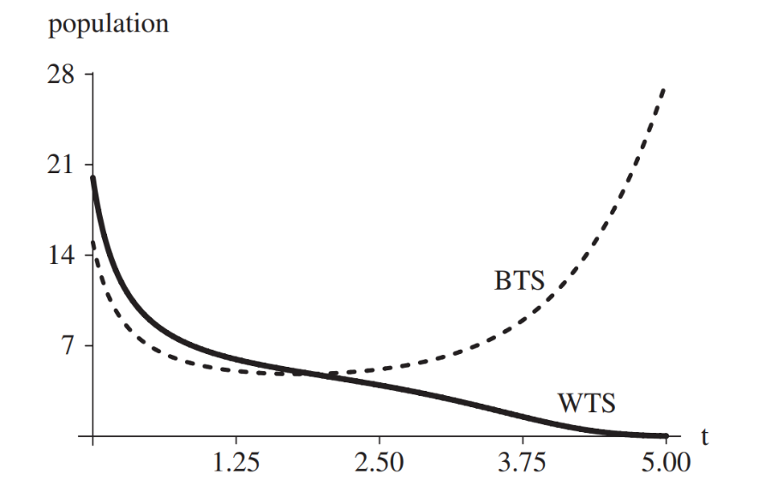

Figure 4.2 Graph of results of simulation from Figure 4.1, where the WTS death proportionality constant (w) is 0.27, the BTS death proportionality constant (b) is 0.20, and time (t) is in months.

Table of Results of Simulation from Figure 4.1 and Figure 4.2 where w = 0.27 b = 0.20
Time (months) WTS BTS
- 20.00 15.00
1 6.57 5.37
2 4.69 4.84
3 3.08 6.00
4 0.99 10.83
5 0.02 27.43

PREDATOR – PREY MODEL
One of the interspecific interactions common to biological communities is the predator – prey relationship. When one species is (predator) consumes another species (prey) while the latter is still living, the action is predation. Predation might involve the consumption of a young squirrel by a hawk, but examples also include tomato hornworms consuming tomato plant leaves and a tapeworm feeding off its mammalian host. Predator – prey interactions are important influences on population levels and ecosystem energy flow.
One of the most interesting characteristics of this type of relationship is that both predators and prey develop fascinating adaptations, which normally come about over long periods of time. Predator adaptations usually involve better prey detection and capture, whereas prey adaptations normally involve improved abilities to escape and avoid detection.
So, let’s consider a 3/4-in. frog, commonly called a poison dart frog. We might expect that such a small animal would, to avoid predation, come out only at night or adopt some camouflaged coloration. However, this brazen creature forages for small invertebrates during the day (prey may also be predators) and is brilliantly colored (bright red, yellow, etc.). How might it manage then to avoid predation? The answer lies in the skin of the frog, which contains toxic, alkaloid chemicals that cause paralysis and/or death in the predator. Over time, predators associate the coloration with the toxic nature of the prey and, hence, avoid that prey. So, the bright coloration is termed warning, or aposematic, coloration.

LOTKA – VOLTERRA MODEL
In the 1920s, mathematicians Vito Volterra and Alfred Lotka independently proposed a model for populations of a predator species and its prey, such as hawk and squirrel populations in a certain area. For simplicity, we assume that a hawk hunts only squirrels and that no other animal eats squirrels. If the hawk’s only food source is squirrel and the number of squirrels diminishes significantly, then scarcity of food will result in starvation for some of the hawks. With reduced numbers of hawks, the squirrel population should increase.

Quick Review Question 3
This question reflects on the predator-prey situation before we begin the discussion.
- Do predator-prey interactions have a direct impact on the births or deaths of
the prey?
- Based on other interaction model of COMPETITION; we can model the prey deaths as being directly proportional to what?
- If we consider prey births as being unconstrained, we can model prey births as being directly proportional to what?
- Are predator-prey interactions advantageous or disadvantageous for predators?
- Based on other interaction models in COMPETITION, we can model predator births as being directly proportional to what?
- If we consider predator deaths as being unconstrained, we can model the predator deaths as being directly proportional to what?

Let S be the number of squirrels in the area and h be the number of hawks. If no hawks are present, the change in s from time t – ∆t to time t is as in the unconstrained model (see Module 2, “Unconstrained Growth and Decay”):
∆s = s(t) – s(t - ∆t)
= (squirrel growth at time t – ∆t) * ∆t
= ks * s(t – ∆t) * ∆t for constant ks
for constants ks and khs. We can interpret the term khs * h(t – ∆t) * s(t – ∆t) in a couple of ways. First, h(t – ∆t) * s(t – ∆t) is the maximum number of distinct interactions of hawks with squirrels. For example, for h(t – ∆t) = 3 hawks and s(t – ∆t) = 2 squirrels, (3)(2) = 6 possible pairings exist. The decrease in the number of squirrels is proportional to this product, where the constant of proportionality, khs, is related to the hunting ability of the hawks and the survival ability of the squirrels. A second interpretation of khs * h(t – ∆t) * s(t – ∆t) = (khs * h(t – ∆t)) * s(t – ∆t) is that the size of the squirrel population decreases in proportion to the size of the hawk population.
While the squirrel population decreases with more contacts between the predator and prey, the hawk population increases. Moreover, the death rate of hawks is proportional to the number of hawks. Thus, the change in the hawk population from time t – ∆t to time t is as follows:
∆h = h(t) – h(t – ∆t)
= (hawk growth at time t – ∆t) * ∆t = (ksh * s(t – ∆t) * h(t – ∆t) – kh * h(t – ∆t)) * ∆t

for constants ksh and kh. Although the deaths of the squirrels and the births of the hawks are both proportional to the product of the number of possible interactions of the two populations, their constants of proportionality, khs and ksh, respectively, are probably different. For instance, 2% of the possible interactions might result in the death of a squirrel, while only 1% of the possible interactions might contribute to the birth of a hawk.
We can express the predator-prey model, known as the Lotka-Volterra model, as the following pair of difference equations for the change in prey (here, change in the squirrel population, ∆s) and change in predator (here, change in the hawk population, ∆h) from time t – ∆t to time t:
∆s = (ks * s(t – ∆t) – khs * h(t – ∆t) * s(t – ∆t)) * ∆t
∆h = (ksh * s(t – ∆t) * h(t – ∆t) – kh * h(t – ∆t)) * ∆t

or as the following pair of differential equations:
$$\frac{ⅆs}{ⅆt}=k_{s}s-k_{hs} hs$$
$\frac{ⅆh}{ⅆt}=k_{sh}sh-k_{h} h$
Figure 4.2 contains a diagram for the predator – prey model with the prey population affecting the number of predator births and the predator population influencing the number of prey deaths.

Quick Review Question 4
Consider the following Lotka – Volterra difference equations:
∆x = (2 * x(t – ∆t) – 0.02 * y(t – ∆t) * x(t – ∆t)) * ∆t with x(0) = 100
∆y = (0.01 * x(t – ∆t) * y(t – ∆t) – 1.06 * y(t – ∆t) ) * ∆t with y(0) = 15
- Which equation (∆x, ∆y, both, or neither) models the change in predator population?
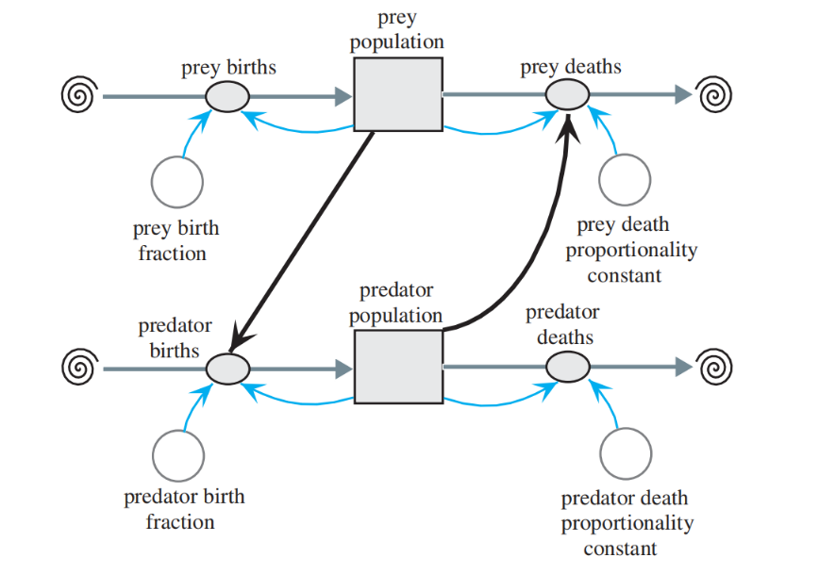

Figure 4.3 Predator – prey diagram
For each of the following questions, indicate the appropriate answer from the following choices:
A. 2 B. 0.02 C. –0.02 D. 0.01
E. 1.06 F. –1.06 G. 100 H. 15

- Which number represents the predator birth fraction?
- Which number represents the prey birth fraction?
- Which number represents the predator death proportionality constant?
- Which number represents the prey death proportionality constant?
- What is the initial number of predators?
- What is the initial number of prey?

Particular Situations
Historical Note
During the Cultural Revolution in China (1958–1960), Chairman Mao Zedong decreed that all sparrows be killed because they ate too much of the crops and they seemed to be only for pleasure anyway. With reduction in its main predator, the insect population increased dramatically. The insects destroyed much more of the crops than the birds ever did. Consequently, the Chinese reversed the decision that caused the imbalance (PBS 2002).

Returning to the example of the hawks and squirrels, some of the model’s equations and constants appear in Equation Set 4.2.1. In that example, prey_birth_fraction (ks) = 2, prey_death_proportionality_constant (khs) = 0.01, predator_birth_fraction (ksh) = 0.01, predator_death_proportionality_constant (kh) = 1.06, the initial prey_population (s0) = 100, and the initial predator_population (h0) = 15. As suggested in the “Rule of Thumb” in Module 4.1, “Competition,” the proportionality constants (0.01 and 0.01) for products, which involve interactions, are at least an order of magnitude less than the proportionality constants (2 and 1.06) for single populations.

Equation Set 4.2
Some of the equations and constants for model in Figure 4.2
predator_population(0) = 15
predator_birth_fraction = 0.01
predator_births = (predator_birth_fraction * prey_population) * predator_population
predator_death_proportionality_constant = 1.06
predator_deaths = predator_death_proportionality_constant * predator_population
prey_population(0) = 100
prey_birth_fraction = 2
prey_births = prey_birth_fraction * prey_population
prey_death_proportionality_constant = 0.02
prey_deaths = (prey_death_proportionality_constant * predator_population) *
prey_population

Table 4.2. and Figure 4.2.2 show the varying prey and predator populations as time advances through 12 months. Shortly after the squirrel, or prey, population.

Table 4.2

Table of Prey and Predator over 12 – month period
Months Prey Population Predator Population
0.000 100.0 15.00
1.000 449.58 62.00
2.000 30.43 280.24
3.000 5.63 108.55
4.000 10.54 40.32
5.000 45.61 17.59
6.000 244.25 19.97
7.000 215.76 298.60
8.000 7.91 173.18
9.000 6.52 63.69
10.000 21.30 24.81
11.000 109.68 14.61
Final 470.44 74.28

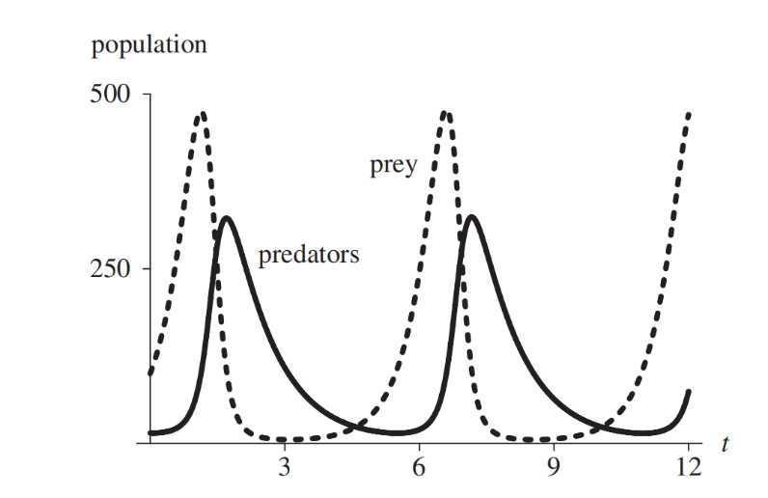

Figure 4.4 Graph of Populations versus time in months
Increases, the hawk, or predator, population does likewise. As the predators kill off their food supply, the number of predators decreases. Then, the cyclic process starts over.

Quick Review Question 5
To the nearest whole number, what is the period (in months) of the cyclic functions for populations in Figure 4.4?

Figure 4.5 shows the graph of a solution to the differential equations with the prey population along the horizontal axis and the predator population along the vertical axis and the predator population along the vertical axis. With the initial predator population being 15 and prey population being 100, the plot starts at the bottom toward the left and proceeds counterclockwise as time progresses. Initially, with few predators endangering them,
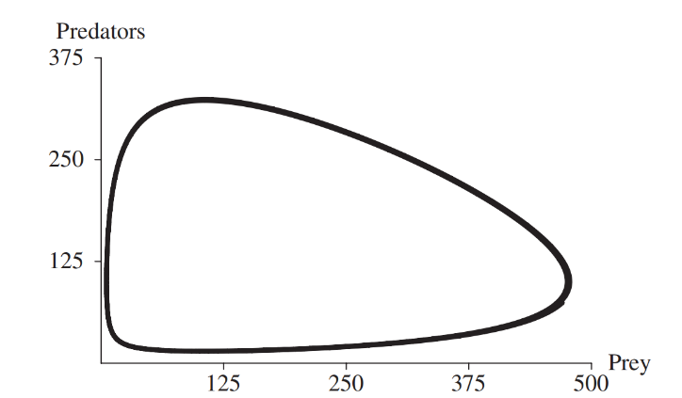

Figure 4.5 Graph of Predator Population versus Prey Population
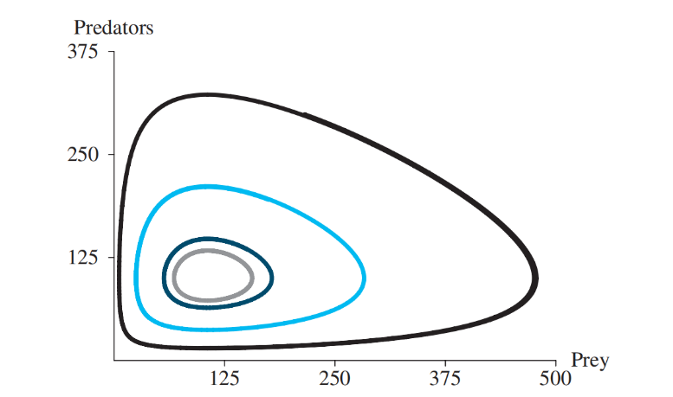

Figure 4.6 Several solutions to the predator – prey model using different initial conditions and the coloration shown

Predator Prey Color of Graph
15 100 black
75 125 gray
135 150 dark color
195 175 light color

Prey population reaches a maximum of about 475 when the predator population is about 100. Then, with the graph developing to the left and up, we see that the prey population starts decreasing as the predator population continues to increase with the abundant supply of its food, the prey. At the graph’s high point, about (107, 322), with approximately 107 prey, the predator population achieves a maximum of 322 individuals. That same number of predators, about 107, occurs toward the bottom of the graph when the prey only number about 15. After a maximum, the number of predators falls off rapidly because of the limited food supply, and the number of prey decreases as well. Eventually, on the bottom part of the graph, with the diminished number of predators, the prey is able to stage a comeback, and the cyclical process begins again. Figure 4.5 illustrates several such solutions employing different initial conditions.

MODELING THE SPREAD OF SARS – CONTAINING EMERGING DISEASE

Imagine being a college student in New York City and being told not to leave the city. That is what happened in 2003 in Beijing, when thousands of people were ordered to stay home and college students were told to stay in Beijing. Quarantine procedures were instituted for those who were thought to have had “intimate contact” with others who showed signs of a new rapidly spreading respiratory disease. More than 40 had died in the capital, and thousands of people in China were displaying symptoms of this pneumonia. Imagine the feelings of fear and panic that Beijing residents must have had—people in masks, disinfecting their homes, and hoarding of food and other necessities. This new disease was called SARS, severe acute respiratory syndrome, with the first case occurring on November 16, 2002, in southern China. Chinese health officials reported the outbreak to the World Health Organization (WHO) on February 11, 2003. By April 2, the total reported cases of SARS were 2000; and by July, the count was over 8400 with more than 800 dead. In response to the initial report, WHO coordinated the investigation into the cause and implemented procedures to control the spread of this disease. The control measures were extremely effective, and the last new case was reported on June 12, 2003 (WHO). By the third week in March several laboratories worldwide had identified the probable causative agent—SARS-CoV, the SARS coronavirus. Coronaviruses represent a large group of +-stranded RNA-containing viruses associated with various respiratory and gastrointestinal illnesses. Although the human diseases associated with these viruses have been mild previously, this coronavirus is quite different. Like many respiratory pathogens, SARS is spread by close personal contact and perhaps by airborne transmission. The Centers for Disease Control and Prevention (CDC) in the United States uses clinical epidemiological and laboratory criteria to diagnose SARS. Severe cases exhibit a fever higher than 38 o C and one or more respiratory symptoms—difficulty breathing, cough, or shortness of breath. Additionally, the person must show radiographic evidence (lung infiltrates) of pneumonia, or respiratory distress syndrome (RDS). RDS is an inflammatory disease of the lung, characterized by a sudden onset of edema and respiratory failure. A few others qualified if they exhibited an unexplained respiratory illness that resulted in death and an autopsy confirmed RDS with no identifiable cause. Epidemiological evidence might include close contact with a known SARS patient or travel to a region with documented transmission within 10 days of onset of symptoms. Today, laboratory tests confirm SARS if they reveal one of the following (CDC):
- Antibody to SARS virus in specimens obtained during acute illness or more than 28 days after onset of illness.
- SARS viral RNA detected by RT-PCR.
- SARS virus
On July 5, 2003, the World Health Organization declared that SARS had been contained. The outbreak resulted in 812 deaths, but the toll might have been much higher if WHO and other health agencies had not acted so quickly and effectively (WHO). Besides the direct effect on the victims and their families, SARS became a major drag on the economies of China, Taiwan, and Canada. Hong Kong’s unemployment rate climbed to an unprecedented 8.3%, and travel warnings for Toronto cost Canada an estimated $30 million per day. One can only imagine the impact of this disease being spread into Africa, where there are poor healthcare systems and
the astronomical HIV infection rates generate immunologically compromised populations. SARS is an interesting disease for modeling, particularly because there is so much epidemiological information. We still have much to learn about SARS, and we still have no available, effective treatment.

SIR MODEL
Before developing a model for the spread of SARS, we consider the simpler situation of a disease in a closed environment in which there are no births, deaths, immigration, or emigration. A 1978 British Medical Journal article reported on such a situation—influenza at a boys’ boarding school. On January 22, only one boy had the flu, which none of the other boys had ever had. By the end of the epidemic on February 4, 512 of the 763 boys in the school had contracted the disease (Murray 1989; NCSLIP).
To model this spread of influenza, we employ the SIR Model, which W. O. Kermack and A. G. McKendrick developed in 1927 (Kermack and McKendrick 1927). Many systems models of the spread of disease, including the SARS model later in this module, are extensions of the SIR Model. The name derives from the following three populations considered:

Susceptibles (S) have no immunity from the disease.
Infecteds (I) have the disease and can spread it to others.
Recovereds (R) have recovered from the disease and are immune to further infection.

The model gives the differential equation for the rate of change for each of these populations. We assume that after a certain amount of time, an individual with the flu recovers. Thus, the rate of change of the number of recovereds is proportional to the number of infecteds.
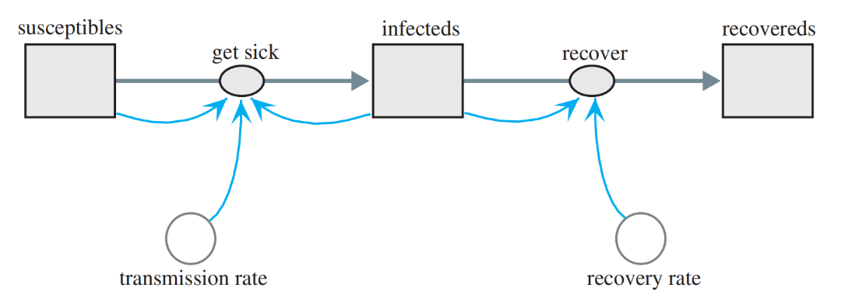
Equation Set 4.3

Figure 4.7 Diagram for SIR Model

get_sick = transmission_constant * susceptibles * infecteds
infecteds(0) = 1
recovery_rate = 0.5
recover = recovery_rate * infecteds
recovereds(0) = 0

The graphs of the three populations that result from running the simulation are in Figure 4.8. The number of susceptibles decreases slowly at first before experiencing a rapid decline and subsequent leveling. In contrast, the number of recovereds, which is initially 0, has a graph that appears similar to the logistic curve. When the number of susceptibles decreases sharply, the infecteds increase to their maximum. Afterwards, as the number of infecteds decreases, the number of recovereds rises. Although not mimicking the final numbers exactly, this model does capture the trend of the data along with the epidemic increase and decrease and the progress
towards a steady state.
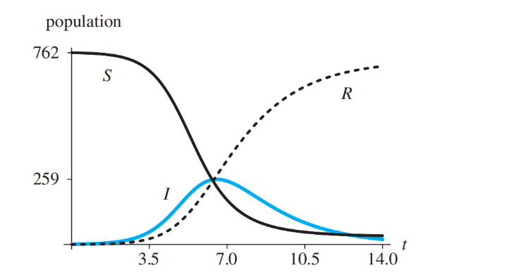

Figure 4.8 Graphs of susceptibles (S), infecteds (I), and recovereds (R) versus time (t) in days

SARS MODEL
Marc Lipsitch in collaboration with others developed a model for the spread of severe acute respiratory syndrome (SARS) and used the model to make predictions on the impact of public health efforts to reduce disease transmission (Lipsitch et al. 2003). Such efforts included quarantine of exposed individuals to separate them from the susceptible population, perhaps by confinement to their homes, and isolation of those who had SARS to remove them to strictly supervised hospital areas with no contacts other than by healthcare personnel. The Lipsitch model is an extension of the SEIR model, which is a refinement of the SIR model. Besides the populations considered by SIR, the SEIR Model (susceptible-exposeds-infecteds-recovereds) has an intermediate exposed (E) population of individuals who have the disease but are not yet infectious. The Lipsitch model modifies SEIR to allow for quarantine, isolation, and death. The modelers make the following simplifying assumptions:
1. There are no births.
2. The only deaths are because of SARS.
3. The number of contacts of an infected individual with a susceptible person is constant and does not depend on the population density.
4. For susceptible individuals with exposure to the disease, the quarantine proportion (q) is the same for non-infected as for infected people.
5. Quarantine and isolation are completely effective. Someone in quarantine or isolation cannot spread disease or, in the case of a susceptible, cannot catch the disease.

MODELING A PERSITENT PLAGUE: MALARIA
How important to civilization can a mosquito-borne protozoan be? Unfortunately, e cannot ask the ancient Romans, but we do have some recent evidence that implicates this tiny parasite in the fall of one of the mightiest empires of all time. Excavations in a cemetery near Lugano, Italy, have uncovered at least one infant from AD 450 that yielded the DNA of Plasmodium falciparum—the deadliest of all the human malarias. Nearby, 50 other infants, who also showed fingerprints of this parasite, were buried in a relatively short period of time. The death of many infants would be expected during a malaria epidemic, partially because falciparum induces high rates of miscarriages and infant death. The mosquitoes that transmit malaria flourish in marshy areas found in the Tiber River valley; and if malaria swept through Rome, the disease may indeed have contributed to its downfall. Even if Roman troops were not directly affected by disease, disruptions to the production and supply of food and war materials could have drastically impaired the military’s ability to protect Rome. Interestingly, around the time the infant lived, Attila’s Huns were pillaging in the north of Italy en route to Rome. Although legend credits Pope Leo the Great with persuading Attila to withdraw, it is more likely that the presence of malaria in the city was even more convincing (Carroll 2001).Malaria is a very old disease (probably prehistoric), originating in Africa, spreading as humankind migrated to other lands. The disease gets its name from an Italian word for “bad air” (RPH).

Evaluate
ASSESSMENT:
Instructions: Write your answer on the Answer Sheet (AS) provided in this module.
- Identification (2 Points each)

  - S for SIR stands for?
  - I for SIR stands for?
  - R for SIR stands for?
  - When one species is predator consumes another species prey while the latter is still living, the action is called?
  - Populations, which are made up of only one species, are also interacting with other species in a particular area in what we term?

LABORATORY ACTIVITY 4.1
Instructions: You may write your answer on the Answer Sheet (AS) provided in this module.
- Write a program to check if a given positive integer is a power of two.

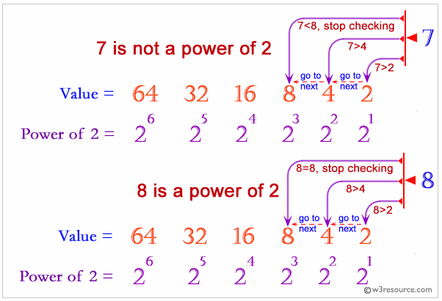


- Write a program to check if a number is a perfect square


3. Write a program to find a missing number from a list.

References

- Introduction to computational science http://www.gbv.de/dms/tib-ub-hannover/752347535.pdf

Facilitated By:
Name | :
MS Teams Account (email) | :
Smart Phone Number | :

