MODULE 5: COMPUTATIONAL ERROR
WEEK 5
Learning Outcomes:
After completing this course, you are expected to demonstrate the following:
- Discuss the Computational Tools
- Explain Error


- Engage
Figure 5.0: A quote by William Henry Gates III is an American business magnate, software developer, and philanthropist. He is best known as the co – founder of Microsoft Corporation.

- Explore

Video title: Python Tutorial Introduction to model validation
YouTube Link: https://youtu.be/MpxK4Ozv2Ds
Module Video Filename: WEEK5_ Python Tutorial Introduction to model validation

- Explain

Various computer software tools are useful for graphing, numeric computation, and symbolic manipulation.
Errors can occur in the solution of a computational science problem at any stage, from the earlier steps of data collection and simplifying assumptions to the later time of computer implementation. The modeler must be aware of possible errors to minimize their occurrence and to avoid drawing incorrect conclusions from flawed solutions. In this module, we discuss various concepts surrounding and the sources of errors.

- Elaborate

DATA ERRORS
Unfortunately, the sources for errors in the data upon which we base and verify our models can be numerous. For example, a sensor measuring barometric pressure might malfunction, giving incorrect values or values that are valid in one range but not in another. Moreover, the accuracy of the sensor might not be sufficient. In addition to equipment error, someone can fail to calibrate an instrument properly, misread measurements, or record results incorrectly.

Modeling Errors
Humans can also make errors in formulation of a model. Perhaps the modeler makes simplifying assumptions or determines incorrect equations that cause the model’s results to deviate drastically from reality. He or she may not even be aware of crucial factors. For example, Lord Kelvin (William Thomson, Baron Kelvin of Largs), the accomplished nineteenth-century scientist who proposed the absolute temperature scale that bears his name, developed, in the mid to late part of that century, a mathematical model to calculate the age of the earth. Kelvin based his model on the assumption that the earth was cooling from a molten mass, with the sun being its only source of energy. Using only conduction, he calculated the time it would have taken for the earth, as it cooled, to reach the surface temperature at the time, and from that he made his estimates. It was difficult to determine the temperature of the earth’s innermost region; but assuming that the earth was solid, he calculated that the temperature could not be high enough to melt the rock. His model estimated the age of the earth to be between 20 and 400 million years old (although later in life he reduced the upper value to 40 million years). His computed range is drastically different from its currently accepted age, which is about 4.5 billion years.

Implementation Errors
In a computer program implementing a model, computational scientists can make logical errors that produce disastrous results. For example, in 1999, NASA’s Mars Climate Orbiter spacecraft was lost because the builder of the spacecraft, Lockheed Martin Corp., programmed the system to use English units, such as pounds and feet, and NASA’s Jet Propulsion scientists employed metric units, such as newtons and meters.

Precision
Other errors we consider in this module also involve computer calculations. In this section, we
discuss some basic terms involved with such computations; and in the next section, we define two metrics of error. Then, we return to a discussion of other errors encountered in modeling and simulation. Many computer languages allow floating-point numbers to be printed in exponential form as a decimal fraction times a power of 10. For instance, output of 9.843600e02 means 9.843600 × 102 = 984.36 = 0.98436 × 103. Usually, floating point numbers, or numbers with a decimal expansion, are stored in the computer in three parts: 0 or 1 representing the sign + or –, respectively; a significand, fractional part, or mantissa, such as 98436; and an exponent, such as 3. Every day, we use the decimal, or base 10, number system with digits, 0, 1, 2, . . ., 9, A computer usually employs the binary, or base 2, number system with only 2 binary digits, or bits, 0 and 1, but the concepts are the same regardless of base.

Definition
A floating-point number is expressed with a decimal expansion. Exponential notation represents a floating-point number as a decimal fraction times a power of 10. With a being a decimal fraction and n n integer, the exponential notation aen represents a × 10n. The integer formed by dropping the decimal point from as the significand, fractional part, or mantissa, and n is the exponent.

A normalized number in exponential notation has the decimal point immediately preceding the first nonzero digit, as in 0.98436 × 103. This notation is similar to scientific notation, which places the decimal point immediately after the first nonzero digit, such as 9.8436 × 102. When a number is expressed in normalized exponential notation, as with 0.98436 × 103, all the digits of the significand, such as 98436, are what we call significant digits. For integers written without a decimal, all the digits except leading and trailing zeros are significant digits; for other numbers, all digits are significant except leading zeros. For example, there are 4 significant digits in 003,704,000 = 0.3704 × 107: 3, 7, 0, and 4. The most significant digit is the leftmost one, 3. The most significant digit of 0.09200 = 0.9200 × 10–1 is 9 because the leading zero is not significant. All other digits after the decimal point (9, 2, 0, 0), however, are significant in this number.

Definitions
A normalized number in exponential notation has the decimal point immediately preceding the first nonzero digit. The significant digits of a floating-point number are all the digits except the
leading zeros. The significant digits of an integer are all the digits except the leading and trailing zeros.

Precision is the number of significant digits. Thus, 003,704,000 and 0.09200 each have a precision of 4. Magnitude is an indication of the relative size of a number and is 10 to the power when the number is expressed in normalized exponential notation. Therefore, 0.3704 × 107 has a magnitude of 107. In C and C++, the precision of a floating-point number of type float, which we call a single-precision number, is about 6 or 7 decimal digits, whereas the magnitude ranges from about 10–38 to 1038. Taking up twice as much computer storage space as a float variable, a variable of type double, which stores a double-precision number, has 14 or 15 significant digits and magnitude from about 10–308 to 10308.

Definitions
The precision of a number is the number of significant digits. Magnitude is 10 to the power when the number is expressed in normalized exponential notation.

Absolute and Relative Errors
To understand the size of a problem, it is helpful to have ways of measuring error. The absolute error is the absolute value of the difference between the exact answer and the computed answer. The relative error is this difference divided by the absolute value of the exact answer, provided the exact answer is not zero. We often express relative error as a percentage. For example, we can write a relative error if 0.03 as 3%.
Definitions
If the correct is the correct answer and result is the result obtained, then
Absolute error = | correct – result |
Relative error = (absolute error) = |correct – result|
|correct| |correct|

= (absolute error) |correct – result|
|correct| $x100\%$ = |correct|
Provided correct ≠ 0.

Round-off Error

Instead of truncating a number to fit in storage, a computer might round. To round the significand of 0.81168 × 104 to a precision of 3, we consider the fourth significant digit, 6. If that digit is less than 5, we round down; but if the digit is greater than or equal to 5, we round up. Thus, 0.81168 × 104 and 0.81158 × 104 round up to 0.812 × 104, while 0.81138 × 104 rounds down to 0.811 × 104.

Definitions
To round a normalized number to precision k, consider the (k + 1)th significant digit, d. If d is less than 5, round down the normalized number by truncating the significand to k significant digits. If d is greater than or equal to 5, round up the normalized number by truncating the significand to k significant digits and then adding 1 to the kth significant digit of the significand, carrying as necessary to digits on the left.

Overflow and Underflow
The problems of overflow and underflow can also ensue from finite storage and binary representation of numbers in a computer. Suppose we are working with a very small computer that uses 16 bits to store an integer. If we ask the computer to perform the sum 20480 + 16384, the result, surprisingly, will be a negative number, –28672. The problem arises when the leftmost bit, the sign bit, gets a carry from the addition on the right, converting the result to a negative number. There simply are not enough bits to express the answer, so the final answer has the wrong sign. Overflow also occurs when we add two negative numbers and get a positive result.

Definitions
Overflow is an error condition that occurs when there are not enough bits to express a value in a computer.

An overflow error caused the European Space Agency’s Ariane 5 rocket to explode in 1996. Less than 37 seconds into the launch, the guidance system’s computer attempted to convert the rocket’s sideway velocity from a 64-bit floating-point number to a 16-bit integer. However, because the number was too large, overflow resulted; the guidance system attempted a severe correction for a wrong turn that had not occurred; and very quickly the rocket had to self-destruct. The overflow of a few bits caused the loss of a rocket that took 10 years and $7 billion to develop (Gleick 1996)
Problems can also arise when the result of a computation is too small for a computer to represent, in a situation called underflow. For example, suppose the smallest floating-point number a computer can express has magnitude 10–39. If the correct value for an arithmetic expression, such as 10–48. , is smaller than the smallest positive floating-point value a computer can represent, then underflow occurs, and the computer evaluates the expression as zero.
Definitions
Underflow is an error condition that occurs when the results of a computation is too small for a computer to represent.

Arithmetic Errors
Errors can arise in addition. Consider (0.684 x ${10}^{3}$) + (0.95 x ${10}^{-2}$). Unlike in multiplication, the decimal points must be aligned for addition, so we have the following:
0.684 x ${10}^{3}$ = 684.0000
0.95 x ${10}^{-2}$ = + 0.0095
684.0095
If our computer allows for only 3 significant digits, the normalized result is 0.684 x ${10}^{3}$, and the effect of the 0.95 x ${10}^{-2}$is the lost.

Error Propagation
Looping enables the computer to execute a segment of code several times. Such a segment that is expected repeatedly is called a loop. Performing floating-point operations within loops can compound round-off error.

Definition
A loop is a segment of code that is executed repeatedly.

An accumulation error in a loop had disastrous consequences during the First Gulf War in Dharan, Saudi Arabia, when and American Patriot missile battery failed to intercept a Scud missile. The Scud hit an American army barracks, killed 28 soldiers, and injured more than 100 other. The Patriot’s internal computer clock measured time in tenths of a second and multiplied the number of ticks by 1/10 to obtain the actual time in seconds. For example, 15 ticks indicated an elapsed time of (15 ticks) (0.1 s/tick) = 1.5 s. The missile’s computer used 24 bits to store numbers. However, because 1/10 an infinite expansion in binary representation (similar to the expansion 1/3 has in decimal representation), the system could not hold all the number’s bits. Each 1/10 increment produced an error of about 0.000000095 s. At the time o the disaster, the Patriot Missile had been operating for 100 h, causing an error of about (100 h) (60 min/h) (60 s/min) (10 ticks/s) (0.000000095 s/tick) = 0/34 s. During that third of a second, a Scud flew about 1676m, so that the intercepting Patriot Missile missed its target (Arnold 2000).
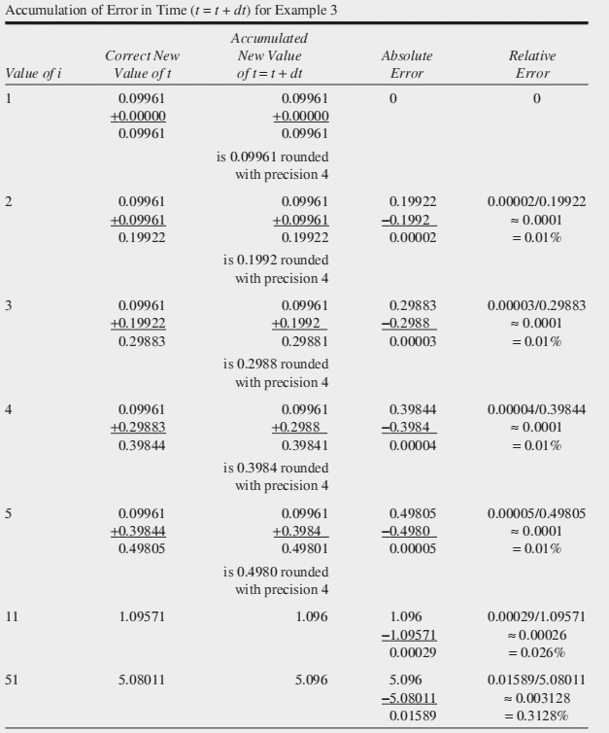
able 5.1
To avoid the cumulative error of this loop, we should compute t as the index, i, times dt = 0.09961, as follows with *indicating multiplication:
t=i * dt
We still have round-off error, but its effect is minimized because there is no accumulation. For example, in the evaluation with i = 51 of (51) (0.09961) = 5.08011, the computer stores 4 significant digits, 5.080. The absolute error is 5.08011 – 5.080 = 0.00011 = 0.011%, while the relative error is 0.00011/5.08011 = 0.000022 = 0.0022%. In the iteration i = 51, the relative error using an accumulated t = t + dt = t + 0.09961 is about 140 times greater than the corresponding relative error using t = i * dt = (i)(0.09961). In some simulations, it is not possible to avoid such repeated additions; but where possible, we should.

Rule of Thumb
Which assignment statement is better (if there is a difference) in a loop with index k whose initial value as 1? Assume that sum is initialized to 0 before the loop.

Violation of Numeric Properties
The section “Arithmetic Errors” hints at a problem that can lead to errors—numeric properties do not necessarily hold in computer arithmetic. Expressions that are numerically equivalent might not evaluate to equal values on the computer. Mathematically, (x/y)z = (xz)/y, but for x = 2.41, y = 9.75, and z = 1.54 on a 3-significant-digit machine with rounding, we showed (x/y)z = 0.380, while (xz)/y = 0.381. Specifically, the following are some of the properties that can be violated using computer arithmetic:
Associative Properties: (a + b) + c = a + (b + c) and (ab)c = a(bc)
These properties indicate that grouping of numbers in addition or multiplication does not matter. However, a computer can yield different results, for example, if a and b are small numbers and c is very large.
Distributive Property: a(b + c) = ab + ac
This property involves the distribution of multiplication over addition. Under certain circumstances, this property may not hold in a computer, such as in the case where a and b are very small in comparison to c.

Comparison of Floating-Point Numbers
Conversion back and forth between the decimal system that people usually employ and the binary system of computers can result in the loss of information. For example, with a subscript indicating the base, the decimal number 0.610 is equivalent to the binary number 0.1001 2, where the line over 1001 indicates that this pattern continues forever. However, a computer cannot store an infinite expansion. If the particular computer truncates to 20 bits to store the significand, the stored value would be 0.100110011001100110012, which is equivalent to 0.5999994277954101562510. Thus, if we want to print this value, the computer might display 0.599999 instead of the expected 0.600000.
This conversion between bases, a finite amount of computer storage, and error propagation are the reasons we should not test if floating-point numbers are exactly equal in a computer. Thus, in a spreadsheet, we should not test if the floating-point contents of cells B2 and B3 are equal as follows:
= If (B2 = B3, . . .) # Do NOT test floating-point numbers this way
Similarly, in a programming language, we should not test if floating-point variables x and z are
identical, as in the following C/C++/Java statement, which employs two adjacent equal signs, ==, to check for equality:
if (x == z) . . . // Do NOT test floating-point numbers this way

Truncation Error
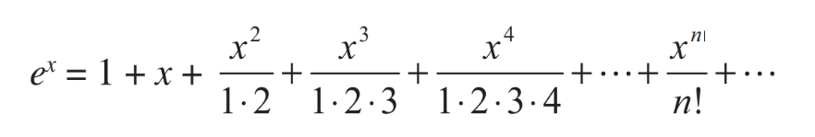
Just as a computer cannot exactly store numbers with infinite precision, a computer cannot perform an infinite number of calculations. Let us consider a result of calculus that says ex has the following infinite series expansion:

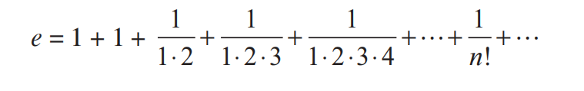
Therefore, e1 = e, which is Euler’s number, 2.718281828459045 . . ., is exactly equal to the following infinite series, with 1 replacing x in the last equation:

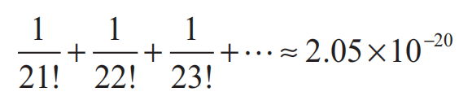
This finite sum does not include terms from 1/(21!) on and results in the following truncation error:

Definition
A truncation error is an error that occurs when a truncated, or finite, sum is used as an approximation for the sum of an infinite series.

Figure 5.1 displays graphs of $ⅇ^{x}$ (in color) and the following approximating partial-sum functions (in black):
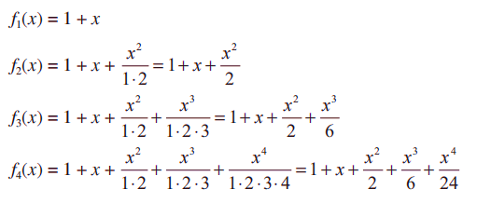
$f_{n}\left(x\right)=1+x+\frac{x^{2}}{1.2}+\frac{x^{3}}{1.2⋅3}+\frac{x^{4}}{1.2⋅3⋅y}+…+\frac{x^{n}}{n!}$ For n=1 through n=4 :

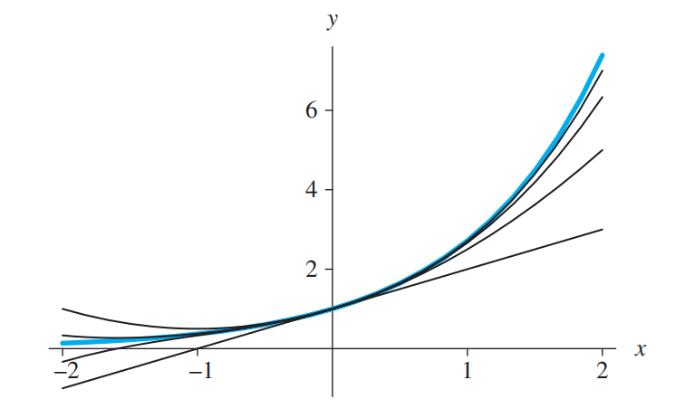
As n becomes larger, the graphs of the partial-sum functions fn(x) approach, or converge to, the graph of f(x) = ex.

Figure 5.1 Graphs of ex (in color) and four finite series approximations

Evaluate
Instructions: Write your answer on the Answer Sheet (AS) provided in this module.
- Identification (2 Points each)
- This error produces disastrous results.
- This allow many computers to print in an exponential form as a decimal fraction times a power of 10.
- This error value the difference between the exact answer and the computed answer.
- This error divided the difference by the absolute value of the exact answer, provided the exact answer is not zero.
- This error truncating a number to fit in storage.

II. Review Question (10 points each)
- Explain what Violation of Numeric Properties is?
- Explain what is difference of Associative Properties and Distributive Properties?

LABORATORY ACTIVITY 5.0

- Show the result of the given codes below.
def binary_search(item_list,item):
first = 0
last = len(item_list)-1
found = False
while( first<=last and not found):
mid = (first + last)//2
if item_list[mid] == item :
found = True
else:
if item < item_list[mid]:
last = mid - 1
else:
first = mid + 1
return found

print(binary_search([1,2,3,5,8], 6))
print(binary_search([1,2,3,5,8], 5))
- Show the result of the given codes below.
def binary_search(item_list,item):
first = 0
last = len(item_list)-1
found = False
while( first<=last and not found):
mid = (first + last)//2
if item_list[mid] == item :
found = True
else:
if item < item_list[mid]:
last = mid - 1
else:
first = mid + 1
return found

print(binary_search([1,2,3,5,8], 6))
print(binary_search([1,2,3,5,8], 5))
References:

- Introduction to computational science http://www.gbv.de/dms/tib-ub-hannover/752347535.pdf

Facilitated By:
Name | :
MS Teams Account (email) | :
Smart Phone Number | :

