Packet tracer lab setup

Either download the following pre-created packet tracer lab or create a packet tracer lab as described below.

[Download link of the pre-created practice lab](https://www.computernetworkingnotes.org/download/cisco/ccna-study-guide/pklab/csg71-01-configure-dhcp-server-for-multiple-vlans-without-configuration.pkt)

Add a switch, a router, and six PCs to the workspace. Connect PCs to the switch and the switch to the router. The following image shows this lab.

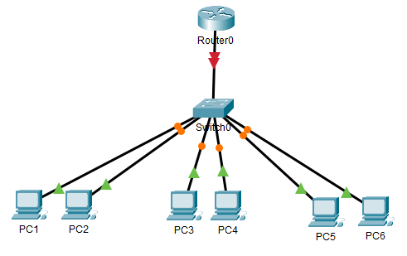

Configure this lab to meet the following objectives.

* Create three VLANs and add 2 PCs to each VLAN.
* Configure the DHCP server on the switch and create three DHCP pools.
* Assign a DHCP pool to each VLAN.
* Configure all PCs as DHCP clients.
* Verify that all PCs receive their IP configuration from the DHCP server.
* Test connectivity between all PCs.

Creating and assigning VLANs

To create a VLAN, run the following command in global configuration mode.

Switch(config)#vlan [VLAN number or name]

To assign a VLAN to an interface, use the following command.

Switch(config-if)#switchport access vlan [VLAN number or name]

Create 3 VLANs: VLAN 10, VLAN 20, and VLAN 30 by running the following commands.

Switch>enable

Switch#configure terminal

Switch(config)#vlan 10

Switch(config-vlan)#exit

Switch(config)#vlan 20

Switch(config-vlan)#exit

Switch(config)#vlan 30

Switch(config-vlan)#exit

Switch(config)#

The following image shows how to execute the above commands on the packet tracer.

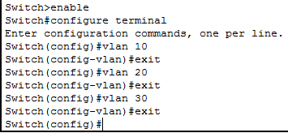

Assign **VLAN 10** to *Fa0/1* and *Fa0/2*, **VLAN 20** to *Fa0/3* and *Fa0/4*, and **VLAN 30** to *Fa0/5* and *Fa0/6*.

Switch(config)#interface FastEthernet 0/1

Switch(config-if)#switchport access vlan 10

Switch(config-if)#exit

Switch(config)#interface FastEthernet 0/2

Switch(config-if)#switchport access vlan 10

Switch(config-if)#exit

Switch(config)#interface FastEthernet 0/3

Switch(config-if)#switchport access vlan 20

Switch(config-if)#exit

Switch(config)#interface FastEthernet 0/4

Switch(config-if)#switchport access vlan 20

Switch(config-if)#exit

Switch(config)#interface FastEthernet 0/5

Switch(config-if)#switchport access vlan 30

Switch(config-if)#exit

Switch(config)#interface FastEthernet 0/6

Switch(config-if)#switchport access vlan 30

Switch(config-if)#exit

Switch(config)#

The following image shows the above configuration on the packet tracer.

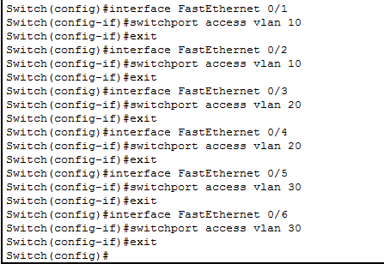

Configuring trunk port

By default, all switch ports operate in access mode. In access mode, a switch port allows traffic of a single VLAN only. To allow traffic from multiple VLANs, we have to configure the port as the **trunk port**.

In our example, only the port that connects the switch and the router carries the traffic of multiple VLANs. To configure this port as a **trunk port**, use the **'switchport mode trunk'** command in interface configuration mode.

Switch(config)#interface GigabitEthernet 0/1

Switch(config-if)#switchport mode trunk

Switch(config-if)#exit

Switch(config)#

The following image show this configuration on the packet tracer.

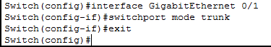

Configuring DHCP server and creating DHCP pools

By default, DHCP service is enabled on all supporting Cisco switches. To use this service, we have to create and configure a DHCP pool on the switch.

The following table lists the steps that are required to create and configure a DHCP pool.

|  |  |
| --- | --- |
| **Configuration step** | **Description (*required command*)** |
| Define reserved IP addresses | Use the **'ip dhcp excluded-address'** command to define the range of reserved IP addresses. |
| Create the DHCP pool | To create a DHCP pool and enter DHCP pool configuration mode, use the **'ip dhcp pool [*pool name*]'** command. |
| Define IP range for lease | use the **'network [*network ID*] [*subnet mask*]'** command to define the range of IP addresses. DHCP uses this range to provide IP configuration to clients. |
| Set default gateway IP | To set the default gateway IP address, use the **'default-router [*IP address of the default gateway*]'** command. |
| Set DNS server IP | To set the DNS server IP address, use the **'dns-server [*IP address of the DNS server*]'** command. |

Create three DHCP pools by using the above configuration steps.

Switch(config)#ip dhcp excluded-address 10.0.0.1 10.0.0.10

Switch(config)#ip dhcp excluded-address 20.0.0.1 20.0.0.10

Switch(config)#ip dhcp excluded-address 30.0.0.1 30.0.0.10

Switch(config)#ip dhcp pool vPool10

Switch(dhcp-config)#network 10.0.0.0 255.0.0.0

Switch(dhcp-config)#default-router 10.0.0.1

Switch(dhcp-config)#dns-server 4.4.4.4

Switch(dhcp-config)#exit

Switch(config)#ip dhcp pool vPool20

Switch(dhcp-config)#network 20.0.0.0 255.0.0.0

Switch(dhcp-config)# default-router 20.0.0.1

Switch(dhcp-config)# dns-server 8.8.8.8

Switch(dhcp-config)#exit

Switch(config)#ip dhcp pool vPool30

Switch(dhcp-config)#network 30.0.0.0 255.0.0.0

Switch(dhcp-config)#default-router 30.0.0.1

Switch(dhcp-config)#dns-server 30.0.0.2

Switch(dhcp-config)#exit

Switch(config)#

The following image shows the above configuration on the packet tracer.

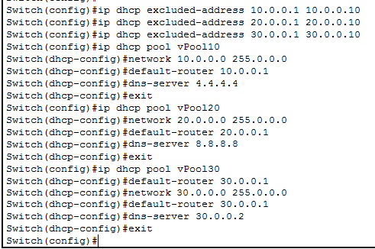

Assigning IP addresses to VLANs

DHCP uses the IP address of a VLAN to determine the pool from which it should provide an IP configuration. To assign an IP address to the VLAN, use the following commands.

Switch(config)#interface vlan [vlan name or number]

Switch(config-if)#ip address [ip address] [subnet mask]

Assign an IP address to each VLAN from the reserved IP address of the corresponding DHCP pool.

Switch(config)#interface vlan 10

Switch(config-if)#ip address 10.0.0.5 255.0.0.0

Switch(config-if)#exit

Switch(config)#interface vlan 20

Switch(config-if)#ip address 20.0.0.5 255.0.0.0

Switch(config-if)#exit

Switch(config)#interface vlan 30

Switch(config-if)#ip address 30.0.0.5 255.0.0.0

Switch(config-if)#exit

Switch(config)#

The following image shows the above configuration on the packet tracer.

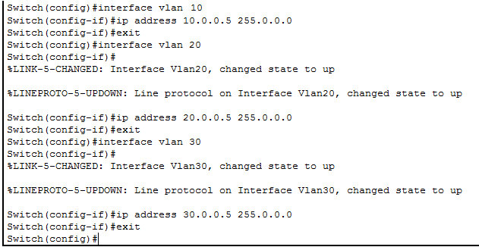

Configuring the router's interface

By default, different VLANs cannot communicate with each other. To allow communication between different VLANs, we have to connect them through a router. We don't need a dedicated router interface for each VLAN. Routers support interface virtualization. We can use a single router interface to allow communication between multiple VLANs.

To virtualize the Fa0/0 interface and to configure it to allow communication between different VLANs, use the following configuration on the router.

Router>enable

Router#configure terminal

Enter configuration commands, one per line. End with CNTL/Z.

Router(config)#interface FastEthernet 0/0

Router(config-if)#no ip address

Router(config-if)#no shutdown

Router(config-if)#exit

Router(config)#interface FastEthernet 0/0.10

Router(config-subif)#encapsulation dot1Q 10

Router(config-subif)#ip address 10.0.0.1 255.0.0.0

Router(config-subif)#exit

Router(config)#interface FastEthernet 0/0.20

Router(config-subif)#encapsulation dot1Q 20

Router(config-subif)#ip address 20.0.0.1 255.0.0.0

Router(config-subif)#exit

Router(config)#interface FastEthernet 0/0.30

Router(config-subif)#encapsulation dot1Q 30

Router(config-subif)#ip address 30.0.0.1 255.0.0.0

Router(config-subif)#exit

Router(config)#

The following image shows the above configuration on the packet tracer.

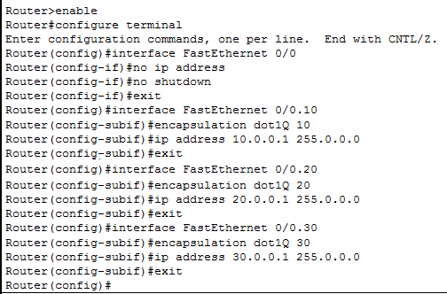

*To learn how different VLANs communicate through the router in detail, you can check the following tutorial. It explains how to configure and use VLANs in detail.*  
[VLAN Configuration Commands Step by Step Explained](https://www.computernetworkingnotes.com/ccna-study-guide/vlan-configuration-commands-step-by-step-explained.html)

Configuring and verifying DHCP clients

To configure a host as the DHCP client, click the host and click the **Desktop** menu option and click the **IP configuration** option and choose the **DHCP** option. If the DHCP server is properly configured, the DHCP client will receive the IP configuration in a few seconds.

The following image shows this procedure step by step.

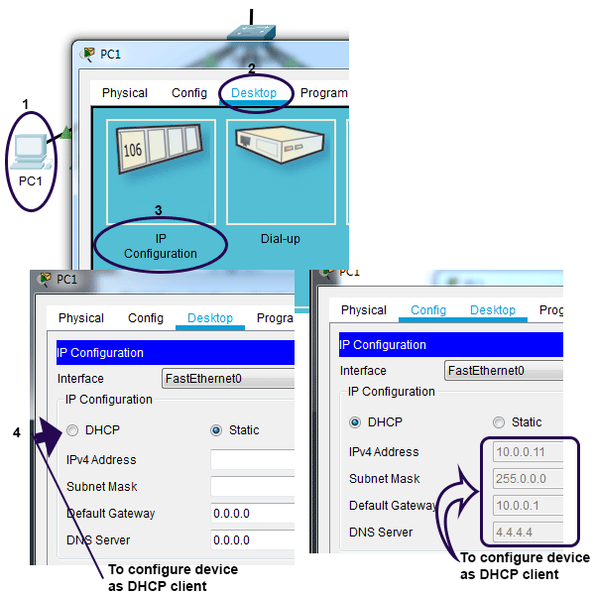

If you prefer, you can use the **ping** command to test and verify connectivity between two hosts of different VLANs.

The following image shows how to use this command to test connectivity between PC1 and PC6. Since PC1 and PC6 belong to VLAN 10 and VLAN 30, respectively, a successful **ping** response verifies that both VLANs have proper connectivity.

