How To Configure DNS Server On A Cisco Router

The DNS protocol is used to resolve FQDN (Fully Qualified Domain Names) to IP addresses around the world. This allows us to successfully find and connect to Internet websites and services no matter where they are. Its usefulness, however, doesn't stop there: local company and private networks also rely on DNS to operate efficiently and correctly.
In many cases, where a local DNS server is not available, we are forced to either use our ISP's DNS servers or some public DNS server, however, this can sometimes prove troublesome. Today, small low-end routers have the ability to integrate DNS functionality, making life easier, but so do Cisco routers - they simply have to be setup and you're done.
This article will show you how to configure your Cisco router to provide DNS services to your network, and make all clients use it as a DNS server. Our easy to follow step-by-step process ensures you'll understand the process and have it running within minutes.
Example Scenario
Consider the following network diagram. This is our example network, we'd like to enable the DNS Service so our workstations can properly resolve Internet domains but also local network names.
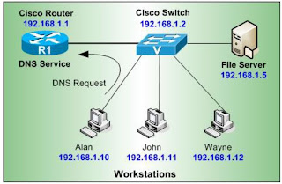
First step is to enable the DNS service on the router.
Next, we need to configure the router with a public name-server, this will force the router to perform recursive DNS lookups, in other words, for every request it receives from our
workstations the router will try to find the answer by asking as many DNS servers it needs, and finally return with an answer.
The Cisco IOS will allow you to enter up to 6 different name servers (essentially DNS servers). Usually you would use your ISP's DNS server to ensure you have quick responses, then place a few free public DNS servers such as the ones above. This will ensure that you'll get a DNS response from either your ISP or public DNS servers.
Next step is to configure your DNS server with the host names of your local network, this way when Alan's PC trys to ping or connect to Wayne, the router will successfully resolve its netbios name to the appropriate IP address.

If you now try to ping 'wayne' directly from your router's CLI prompt, you should receive an answer:
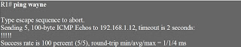
At this point, you can configure your workstations to use your router's IP address as the primary DNS server.
