How to create web server on packet tracer
1.In this lesson we will learn about how to create first web page on cisco packet tracer that can be apply on real time web server.
2. First let me clarify with you why do we create web page? What does it mean? What is for?
3. When we search anything on Google, Bing, Mozila, safari or any web browser. Its result comes on web page that appears on screen.
4. So we are taking few PCs and one web server and one switch for connecting all devices. Make sure all devices should be connected by straight through cable because for connecting different devices, straight through cable is required. Assign IPs to each end device (server and PCs) of single network (192.168.1.0) with subnet mask 255.255.255.0 It can different as per your choice.
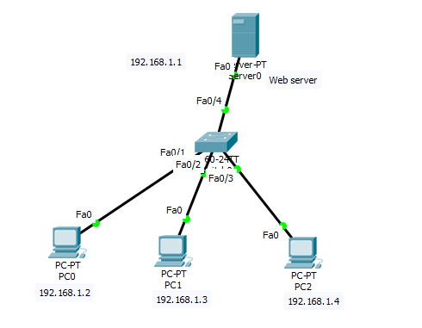

5. In next step we go on server >services>Http>select both services as on mode.
6. Now we can search webpage from any connected PC. This will so you only existing HTTP file when you put Server IP. Go to any PC>Desktop>Web Browser>put server IP(192.168.1.1)> click Enter. It will so you below result.
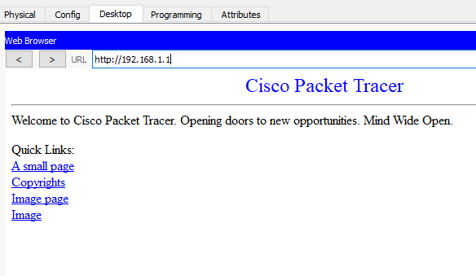
7. If you want to create your own webpage then it is very simple. Just follow path
Go to on server>services>HTTP>new file>just write you html code whatsoever you want as I coded here.
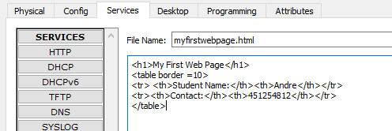
Then click on save button.
8. you may not find you file when search from PC. For it select path Go to server>Services>HTTP>index.html>edit>write it as below.
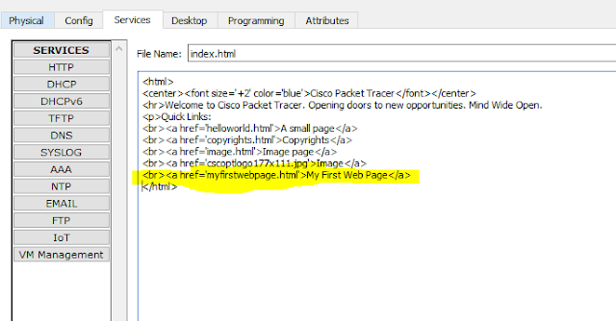

8. We can find now our created web page.
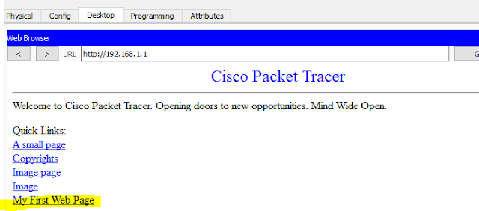
Just click on your page (My First Web Page)
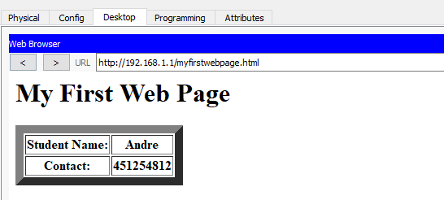
Kindly comment on comment box for any concern. Or drop a mail to dharmnedra857295@gmail.com

Email ThisBlogThis!Share to TwitterShare to FacebookShare to Pinterest

