**MERU UNIVERSITY OF SCIENCE AND TECHNOLOGY**

**SCHOOL OF ENGINEERING AND ARCHITECTURE**

**DEPARTMENT OF ELECTRICAL AND ELECTRONICS ENGINEERING**

**BACHELOR OF TECHNOLOGY IN ELECTRICAL AND ELECTRONICS ENGINEERING**

**LAB REPORT**

**EET 3351: COMMUNICATION SYSTEMS**

*GROUP MEMBERS:*

*1. JOSHUA MUTHENYA WAMBUA EG209/109705/22*

*2. AKALA DALVAN EG209/109726/22*

Instructor: Eng. Job Kerosi.

Date: 13-04-2025

**OBJECTIVES**

1. To understand the theoretical foundations of Analog Communications as well as of Double-Side-Band Amplitude Modulation and Demodulation (DSB-AM).
2. To design the Simulink model of the DSB-AM to analyze each signal in time and frequency domains using time scope and spectrum analyzer.
3. To examine the effects of the Additive Gaussian Channel (AWGN) in the Simulink Model of DSB-AM.

BACKGROUND THEORY

Amplitude Modulation (AM) is a method of transmitting signals, such as audio or other data, using variations in the amplitude of a carrier wave. In Double Sideband Amplitude Modulation (DSB-AM), the carrier signal is modulated with the message signal in a way that produces both upper and lower sidebands, carrying the same information. This form of modulation is widely used due to its simplicity in implementation and compatibility with existing radio frequency systems.

The demodulation process aims to recover the original message signal from the modulated carrier. This is typically done using synchronous detection techniques, where a locally generated carrier signal is used to extract the original message signal. The process involves multiplying the received signal with the local oscillator followed by low-pass filtering to isolate the baseband signal. Understanding and simulating this process helps in evaluating signal recovery and system performance under various parameters, including noise and filtering effects.

EQUIPMENT /SOFTWARES USED

1. Computer
2. Matlab_Simulink

PROCEDURE

The circuits were built in Simulink as per instructed by the task’s guidelines.

RESULTS

The screeshots below shows the results from the Simulink simulations of both tasks.

The circuit of the first task in the Simulink is as shown below.

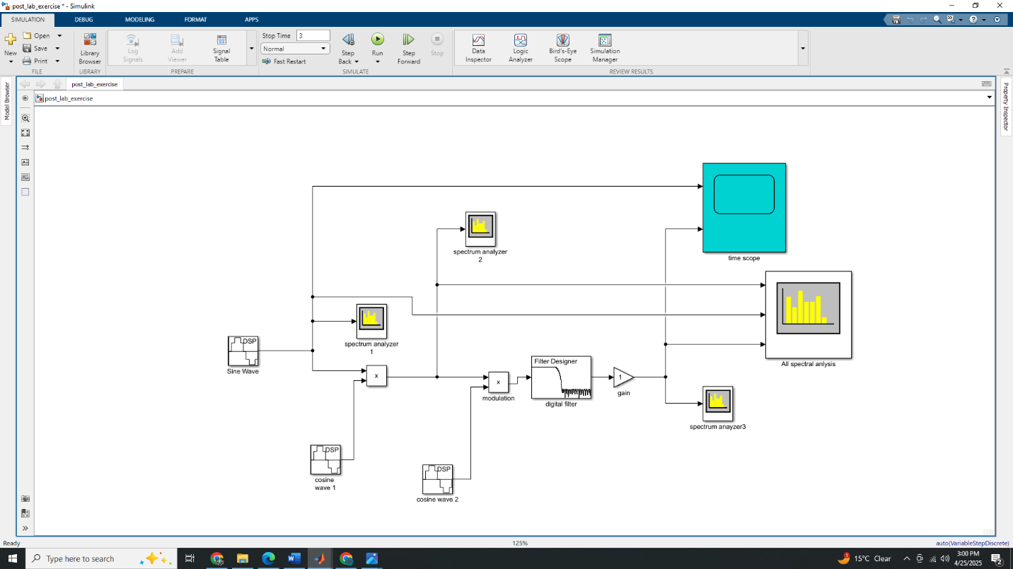

The screenshot below shows the message and demodulated signal (labelled)

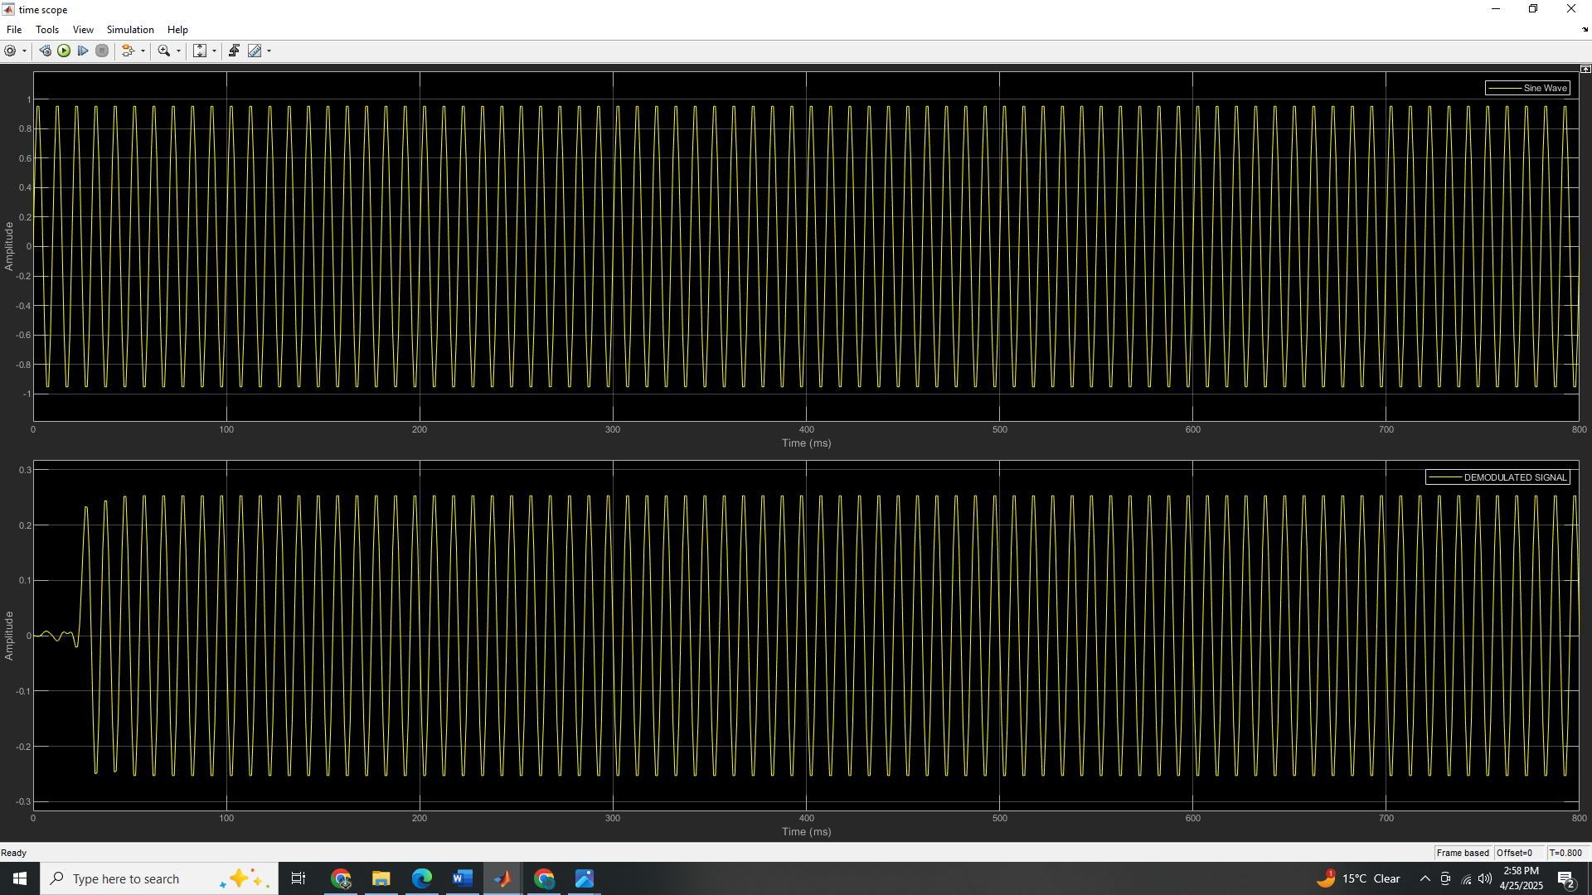

The screenshot below shows the spectral (frequency domain) of the message signal.

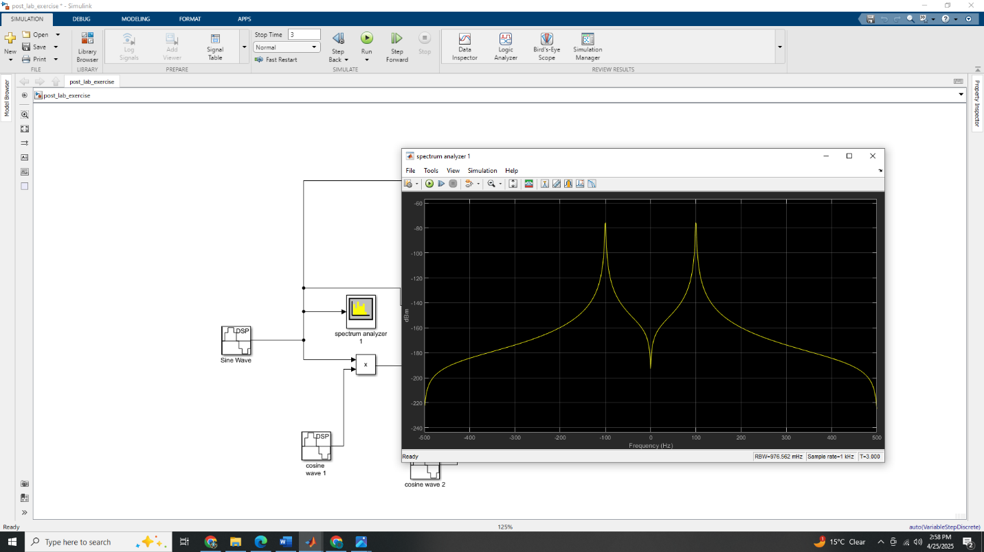

The screenshot below shows the spectral (frequency domain) of the carrier signal.

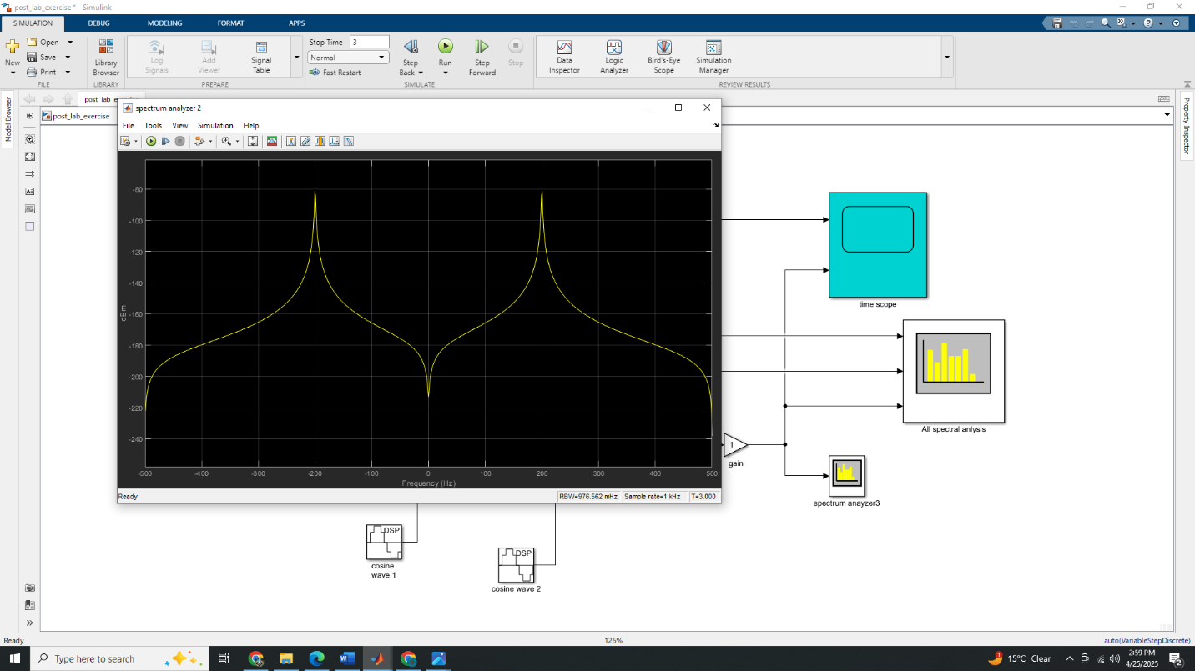

The screenshot below shows the spectral (frequency domain) of the demodulated signal signal.

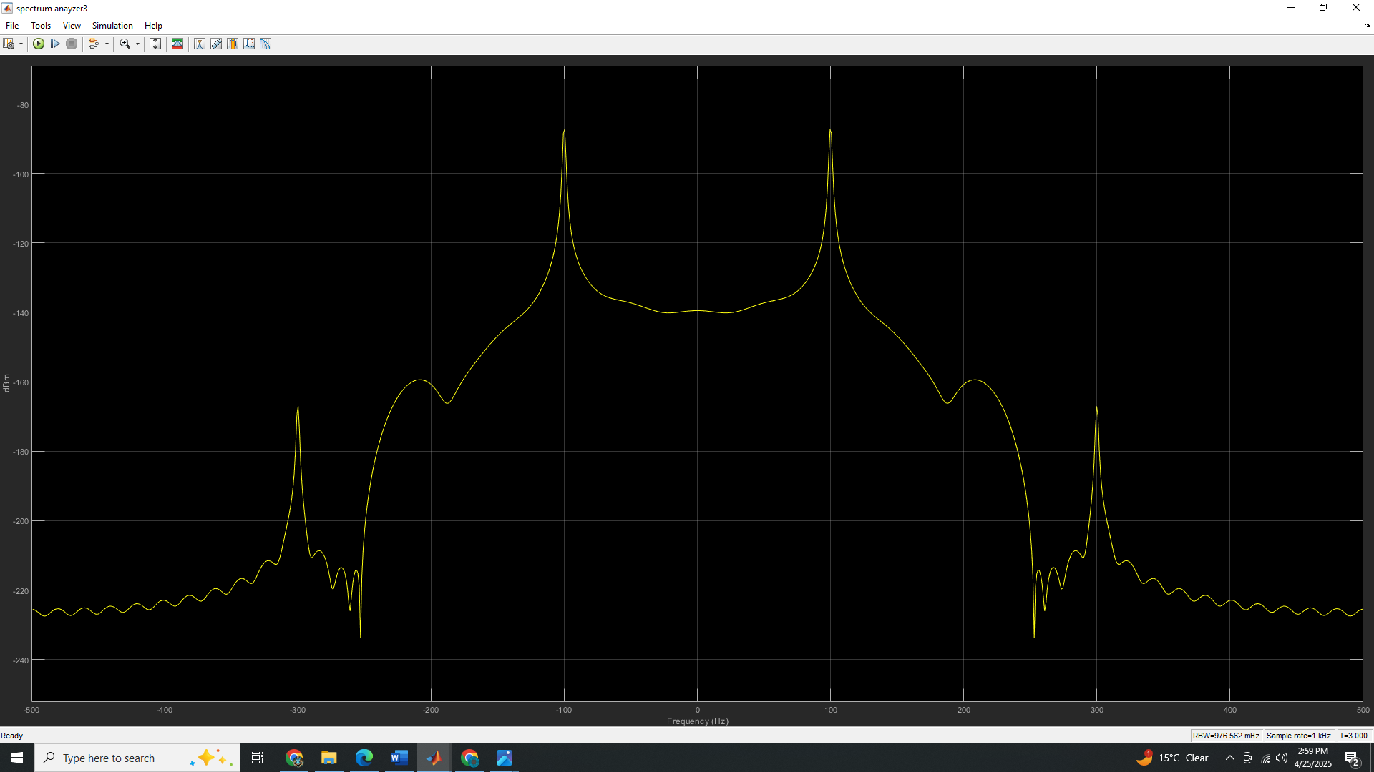

All frequency spectra shown on the same analyzer.

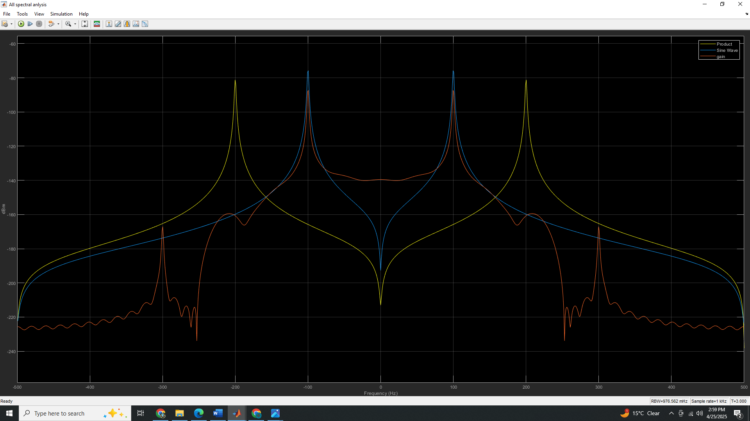

The circuit for the second task in Simulink is as shown below

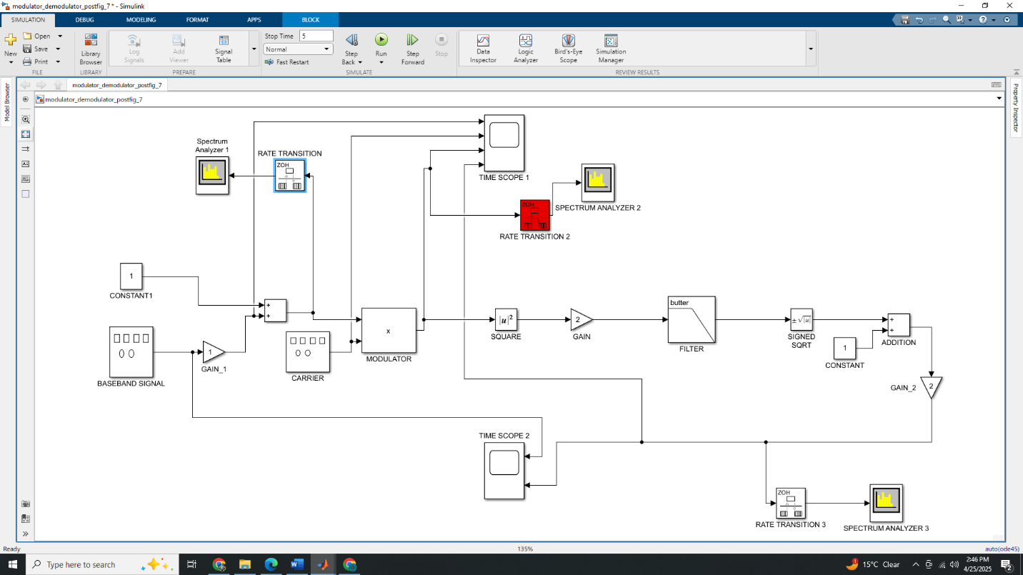

The screenshot below shows the message signal, carrier signal, modulated and demodulated signal (labelled)

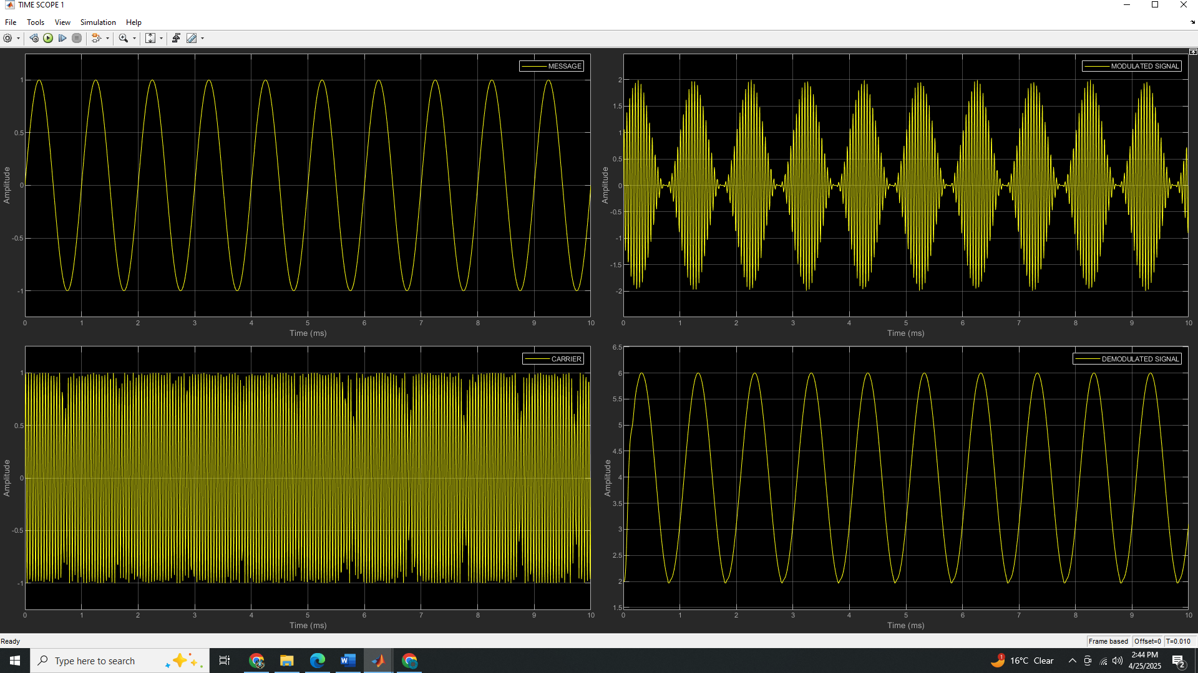

The screenshot below shows the message and demodulated signal (labelled)

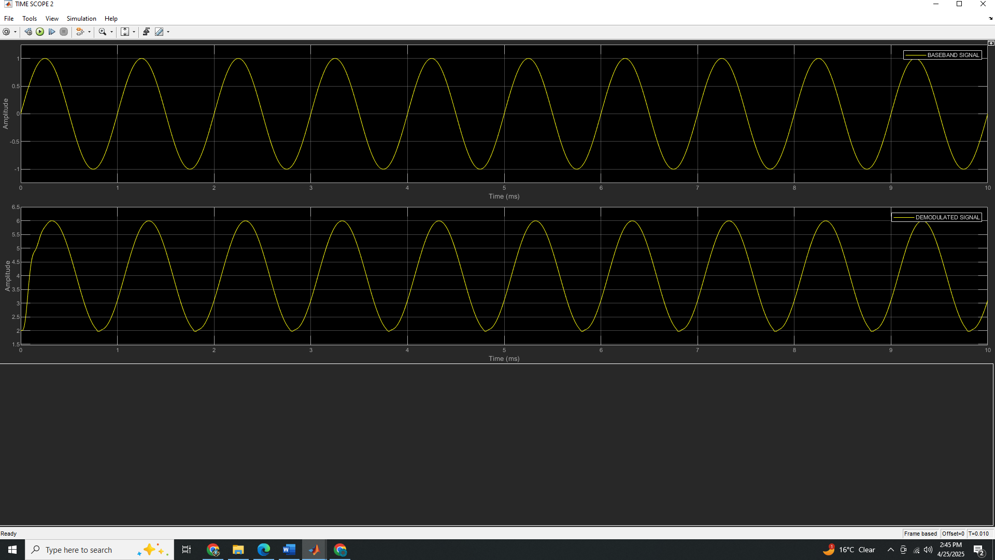

Spectrum for message signal.

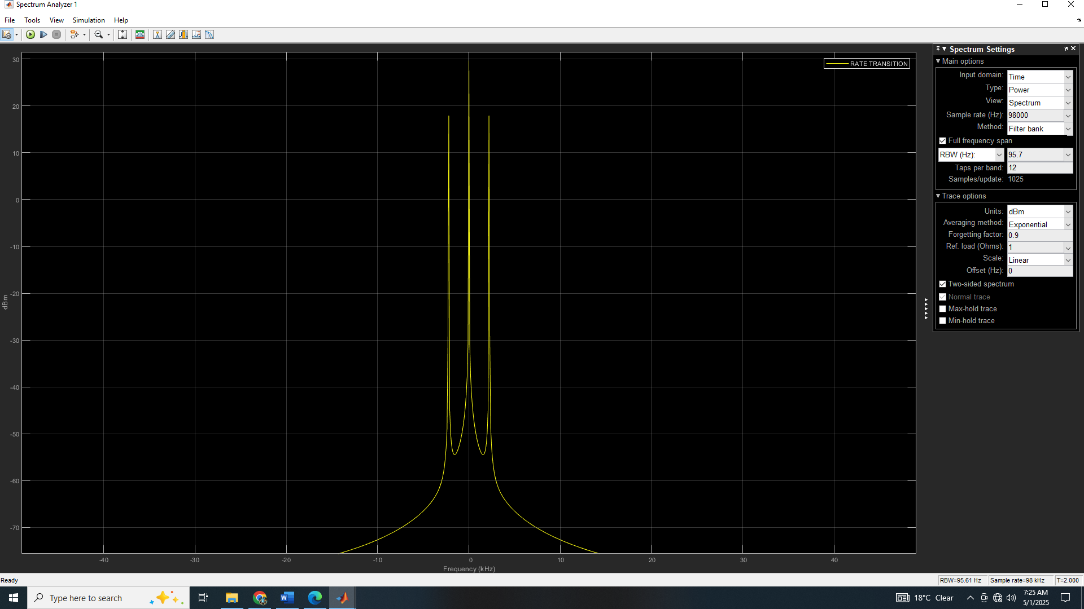

Spectrum for modulated signal

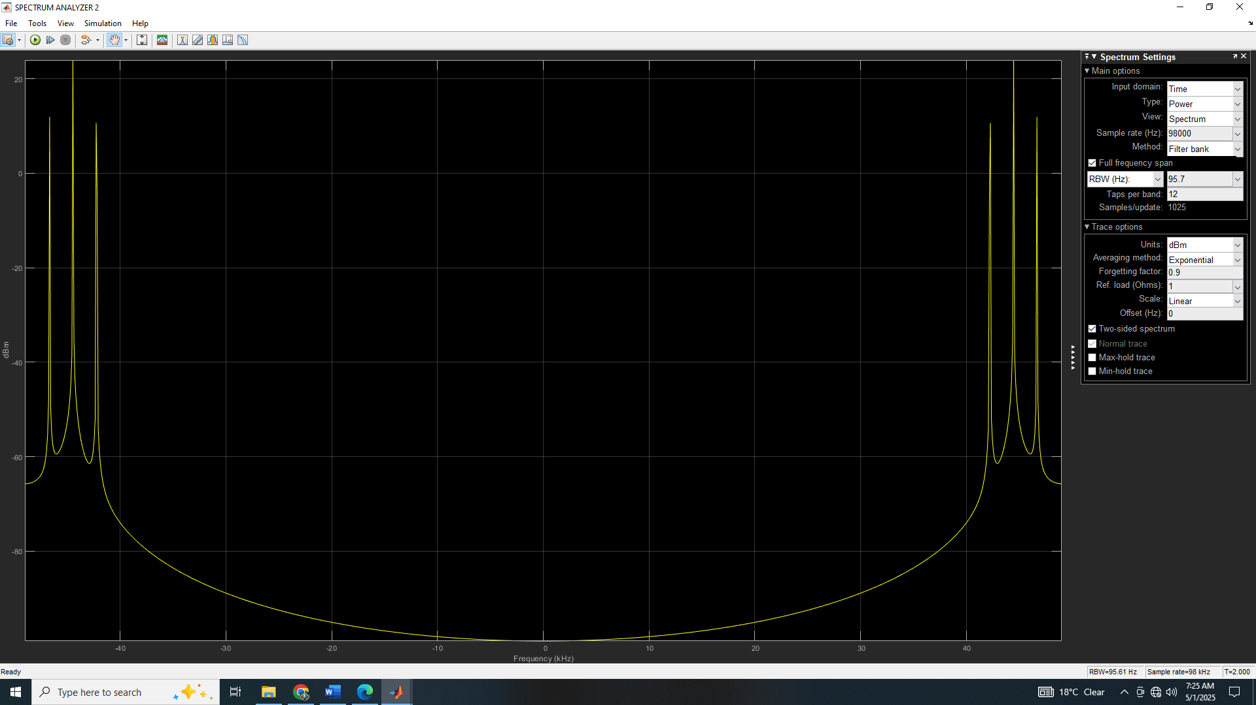

Spectrum for the demodulated signal.

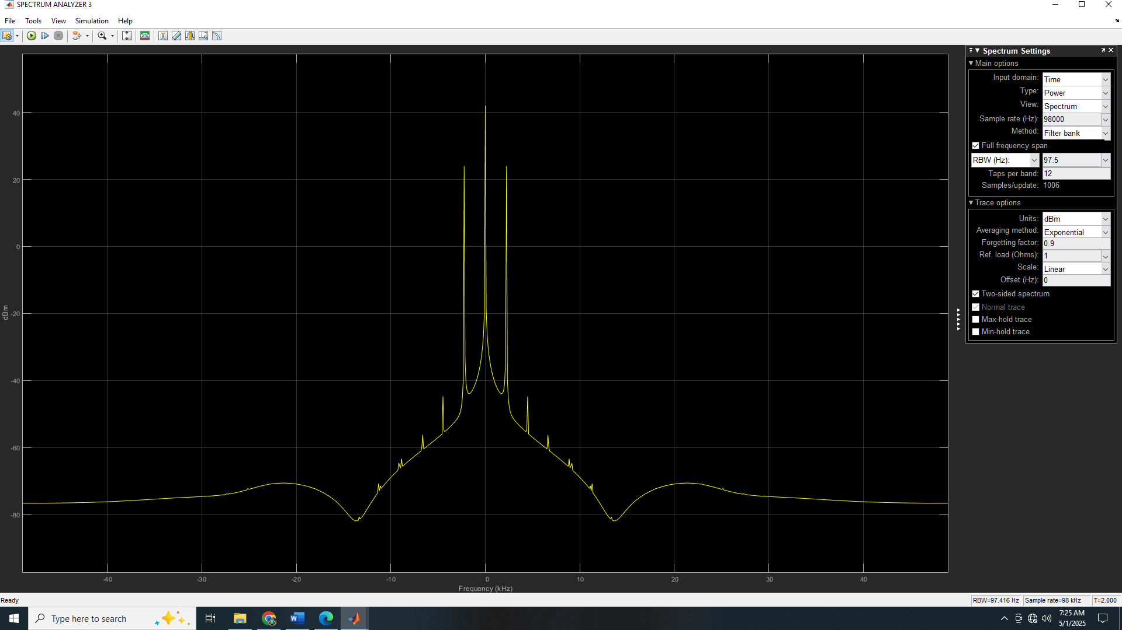

The explanation below is for the function of each block put in simple terms

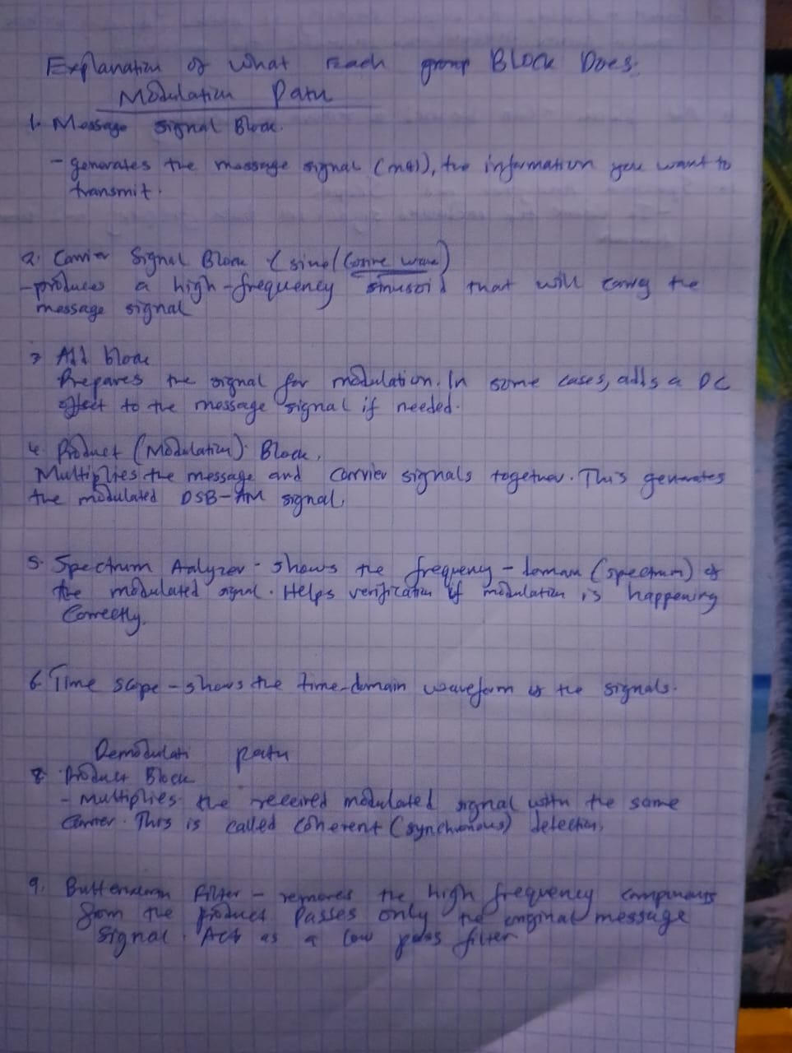

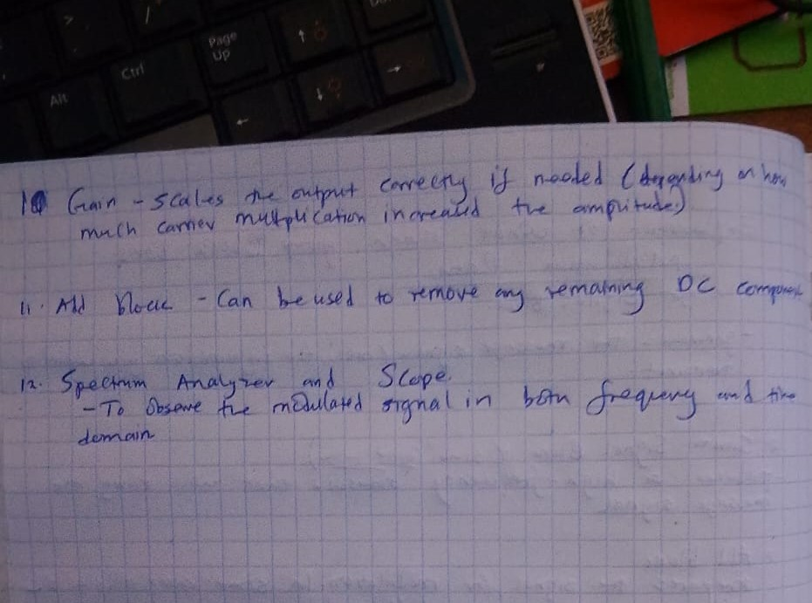

OBSERVATIONS

* It was observed that to modulate a signal you just need to multiply it with a high frequency sinusoid (THE CARRIR SIGNAL).
* It was observed that the a filter is really essential in the reconstruction of the baseband signal.

DISCUSSION

CONCLUSIONS

REFERENCES

1. Lab reference (manual) provided.