
MERU UNIVERSITY OF SCIENCE TECHNOLOGY

DEPARTMENT OF ELECTRICAL AND ELECTRONICS ENGINEERING
BACHELOR OF TECHNOLOGY IN ELECTRICAL AND ELECTRONICS ENGINEERING
LAB REPORT: LEAD AND LAG COMPENSATORS.
https://github.com/joshuawambua/controlsystems.git
UNIT CODE: EET 3407
UNIT DESCRIPTION: CONTROL SYSTEMS II.
NAME: JOSHUA MUTHENYA WAMBUA
REG NO: EG209/109705/22
Instructor: Dr. Agnes
Date: 14/12/2025

TABLE OF CONTENTS
Introduction 1
Objectives 1
Results 1
Table 1: first order systems 2
Table 2: Second Order system. 27
Chapter 5: Matlab Simulation and Results 32
5.1 Uncompensated System Response 32
5.2 Lead Compensated System 32
5.3 Lag Compensated System 32
5.4 Lead–Lag Compensated System 33
6. Discussion 33
6.1 Difference Between Lead and Lag Compensators 33
6.2 Effect of Poles and Zeros on System Performance 33
6.3 Frequency-Domain Interpretation 33
7. Applications 33
Conclusion 34
References 34

Introduction
Control systems are fundamental in modern engineering applications where precise regulation of physical variables such as speed, position, temperature, and voltage is required. In practical systems, uncompensated plants often fail to meet desired transient and steady-state performance specifications. Compensation techniques are therefore introduced to modify system dynamics in order to achieve acceptable performance. This laboratory experiment focuses on the design, analysis, and simulation of lead, lag, and lead–lag compensators using MATLAB. Emphasis is placed on understanding how compensators affect system stability, transient response, and steady-state accuracy. Operational amplifiers are considered as the practical analog realization of these compensators, linking theoretical control concepts with real-world implementation.

Objectives
- To understand the principles of dynamic compensation in control systems.
- To design lead, lag, and lead–lag compensators for first-order and second-order systems.
- To analyze the effect of cascade compensation on transient and steady-state performance.
- To simulate compensated and uncompensated systems using MATLAB.
- To evaluate system performance using time-domain and frequency-domain analysis tools such as step response, Bode plots, root locus, and Nyquist plots.

Results
MATLAB simulations were carried out for both first-order and second-order systems listed in Table 1 and Table 2. For each system, uncompensated and compensated responses were analyzed using:
- Step response
- Bode plots
- Root locus
- Nyquist plots
The results show that the introduction of a lead compensator significantly reduces rise time and settling time, while the lag compensator improves steady-state accuracy. The combined lead–lag compensator provides an optimal balance between transient performance and steady-state error reduction.
Quantitative performance indices such as rise time, settling time, peak value, and overshoot were obtained using the stepinfo function in MATLAB. In all cases, the compensated systems demonstrated superior performance compared to the uncompensated systems.

NOTE: For The First Order System, I Gave All The Scripts And The Plots But For The Second Order System I Just Gave A Single System, The Scripts For The Other Systems Are Available On The GitHub Link Provided on the cover page.

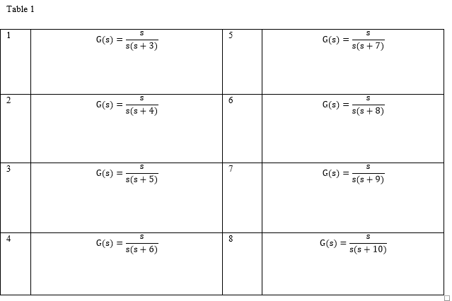

Table 1: first order systems

% ============================================================
% NAME: Joshua Muthenya Wambua
% REG NO: EG209/109705/22
% DATE: 09-Nov-2025
% Objective:
% To design and analyze a lead–lag compensated control system
% for improved transient and steady-state performance.
% ============================================================

clc; clear; close all;

%% ------------------------------------------------
% Common definitions
% ------------------------------------------------
s = tf('s'); % Laplace variable

% Lead compensator
C_lead = 10 * (s + 3) / (s + 11);

% Lag compensator
C_lag = (s + 2) / (s + 0.2);

% Combined lead–lag compensator
C_T = C_lead * C_lag;

%% ============================================================
% SYSTEM 1 : G(s) = s / [ s(s+3) ]
%% ============================================================

G1 = s/(s*(s+3));

T_uncomp = feedback(G1,1);
T_comp = feedback(C_T*G1,1);

figure('Name','Bode Plot Comparison','NumberTitle','off');
bode(G1, C_T*G1); grid on;
title('System 1: Bode Plot');
legend('Uncompensated','Compensated');

figure('Name','Step Response Comparison','NumberTitle','off');
step(T_uncomp, T_comp, 5); grid on;
title('System 1: Step Response');
legend('Uncompensated','Compensated');

figure('Name','Root Locus Comparison','NumberTitle','off');
rlocus(G1); hold on; rlocus(C_T*G1); grid on;
title('System 1: Root Locus');

figure('Name','Nyquist Plot Comparison','NumberTitle','off');
nyquist(G1, C_T*G1); grid on;
title('System 1: Nyquist Plot');

disp('SYSTEM 1 PERFORMANCE');
disp(stepinfo(T_uncomp));
disp(stepinfo(T_comp));

%% ============================================================
% SYSTEM 2 : G(s) = s / [ s(s+4) ]
%% ============================================================

G2 = s/(s*(s+4));

T_uncomp = feedback(G2,1);
T_comp = feedback(C_T*G2,1);

figure; bode(G2, C_T*G2); grid on; title('System 2: Bode Plot');
figure; step(T_uncomp, T_comp, 5); grid on; title('System 2: Step Response');
figure; rlocus(G2); hold on; rlocus(C_T*G2); grid on; title('System 2: Root Locus');
figure; nyquist(G2, C_T*G2); grid on; title('System 2: Nyquist Plot');

disp('SYSTEM 2 PERFORMANCE');
disp(stepinfo(T_uncomp));
disp(stepinfo(T_comp));

%% ============================================================
% SYSTEM 3 : G(s) = s / [ s(s+5) ]
%% ============================================================

G3 = s/(s*(s+5));

T_uncomp = feedback(G3,1);
T_comp = feedback(C_T*G3,1);

figure; bode(G3, C_T*G3); grid on; title('System 3: Bode Plot');
figure; step(T_uncomp, T_comp, 5); grid on; title('System 3: Step Response');
figure; rlocus(G3); hold on; rlocus(C_T*G3); grid on; title('System 3: Root Locus');
figure; nyquist(G3, C_T*G3); grid on; title('System 3: Nyquist Plot');

disp('SYSTEM 3 PERFORMANCE');
disp(stepinfo(T_uncomp));
disp(stepinfo(T_comp));

%% ============================================================
% SYSTEM 4 : G(s) = s / [ s(s+6) ]
%% ============================================================

G4 = s/(s*(s+6));

T_uncomp = feedback(G4,1);
T_comp = feedback(C_T*G4,1);

figure; bode(G4, C_T*G4); grid on; title('System 4: Bode Plot');
figure; step(T_uncomp, T_comp, 5); grid on; title('System 4: Step Response');
figure; rlocus(G4); hold on; rlocus(C_T*G4); grid on; title('System 4: Root Locus');
figure; nyquist(G4, C_T*G4); grid on; title('System 4: Nyquist Plot');

disp('SYSTEM 4 PERFORMANCE');
disp(stepinfo(T_uncomp));
disp(stepinfo(T_comp));

%% ============================================================
% SYSTEM 5 : G(s) = s / [ s(s+7) ]
%% ============================================================

G5 = s/(s*(s+7));

T_uncomp = feedback(G5,1);
T_comp = feedback(C_T*G5,1);

figure; bode(G5, C_T*G5); grid on; title('System 5: Bode Plot');
figure; step(T_uncomp, T_comp, 5); grid on; title('System 5: Step Response');
figure; rlocus(G5); hold on; rlocus(C_T*G5); grid on; title('System 5: Root Locus');
figure; nyquist(G5, C_T*G5); grid on; title('System 5: Nyquist Plot');

disp('SYSTEM 5 PERFORMANCE');
disp(stepinfo(T_uncomp));
disp(stepinfo(T_comp));

%% ============================================================
% SYSTEM 6 : G(s) = s / [ s(s+8) ]
%% ============================================================

G6 = s/(s*(s+8));

T_uncomp = feedback(G6,1);
T_comp = feedback(C_T*G6,1);

figure; bode(G6, C_T*G6); grid on; title('System 6: Bode Plot');
figure; step(T_uncomp, T_comp, 5); grid on; title('System 6: Step Response');
figure; rlocus(G6); hold on; rlocus(C_T*G6); grid on; title('System 6: Root Locus');
figure; nyquist(G6, C_T*G6); grid on; title('System 6: Nyquist Plot');

disp('SYSTEM 6 PERFORMANCE');
disp(stepinfo(T_uncomp));
disp(stepinfo(T_comp));

%% ============================================================
% SYSTEM 7 : G(s) = s / [ s(s+9) ]
%% ============================================================

G7 = s/(s*(s+9));

T_uncomp = feedback(G7,1);
T_comp = feedback(C_T*G7,1);

figure; bode(G7, C_T*G7); grid on; title('System 7: Bode Plot');
figure; step(T_uncomp, T_comp, 5); grid on; title('System 7: Step Response');
figure; rlocus(G7); hold on; rlocus(C_T*G7); grid on; title('System 7: Root Locus');
figure; nyquist(G7, C_T*G7); grid on; title('System 7: Nyquist Plot');

disp('SYSTEM 7 PERFORMANCE');
disp(stepinfo(T_uncomp));
disp(stepinfo(T_comp));

%% ============================================================
% SYSTEM 8 : G(s) = s / [ s(s+10) ]
%% ============================================================

G8 = s/(s*(s+10));

T_uncomp = feedback(G8,1);
T_comp = feedback(C_T*G8,1);

figure; bode(G8, C_T*G8); grid on; title('System 8: Bode Plot');
figure; step(T_uncomp, T_comp, 5); grid on; title('System 8: Step Response');
figure; rlocus(G8); hold on; rlocus(C_T*G8); grid on; title('System 8: Root Locus');
figure; nyquist(G8, C_T*G8); grid on; title('System 8: Nyquist Plot');

disp('SYSTEM 8 PERFORMANCE');
disp(stepinfo(T_uncomp));
disp(stepinfo(T_comp));

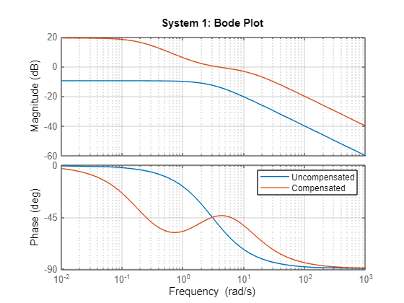
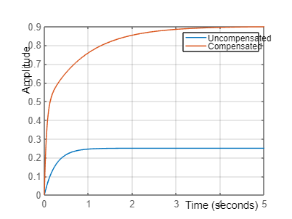
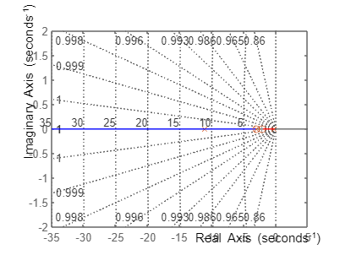
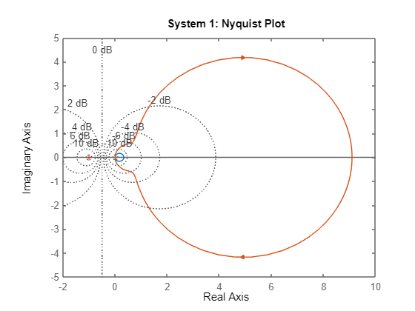
SYSTEM 1 PERFORMANCE
RiseTime: 0.5493
TransientTime: 0.9780
SettlingTime: 0.9780
SettlingMin: 0.2261
SettlingMax: 0.2500
Overshoot: 0
Undershoot: 0
Peak: 0.2500
PeakTime: 2.6365
RiseTime: 1.3980
TransientTime: 2.8647
SettlingTime: 2.8647
SettlingMin: 0.8112
SettlingMax: 0.9002
Overshoot: 0
Undershoot: 0
Peak: 0.9002
PeakTime: 5.8621
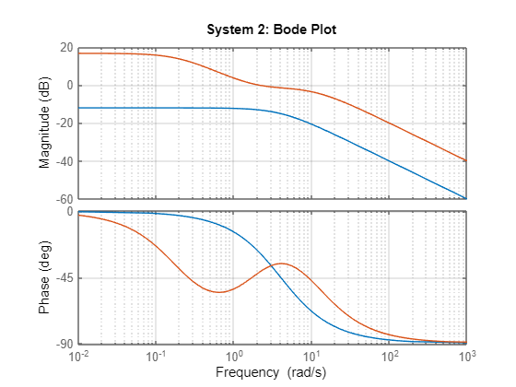
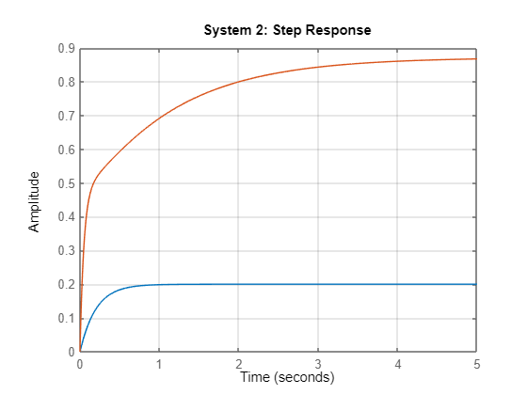
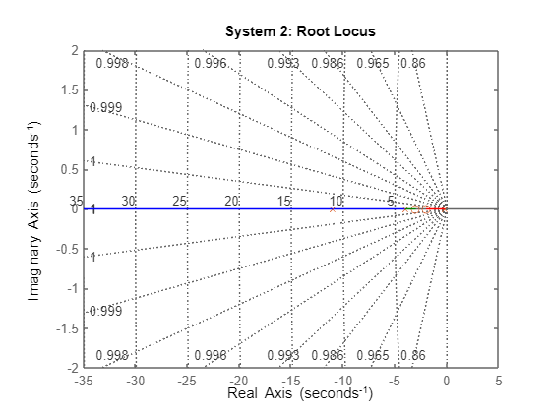
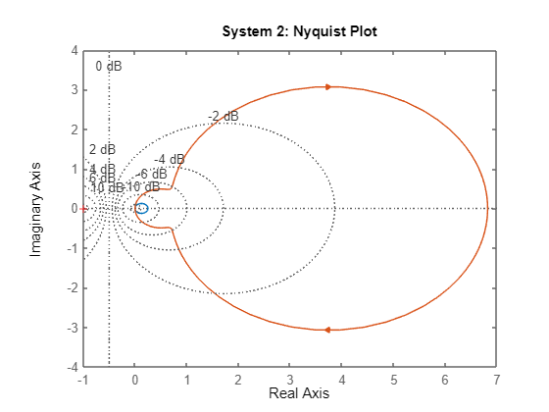
SYSTEM 2 PERFORMANCE
RiseTime: 0.4394
TransientTime: 0.7824
SettlingTime: 0.7824
SettlingMin: 0.1809
SettlingMax: 0.2000
Overshoot: 0
Undershoot: 0
Peak: 0.2000
PeakTime: 2.1092
RiseTime: 1.7871
TransientTime: 3.5433
SettlingTime: 3.5433
SettlingMin: 0.7852
SettlingMax: 0.8700
Overshoot: 0
Undershoot: 0
Peak: 0.8700
PeakTime: 5.8334
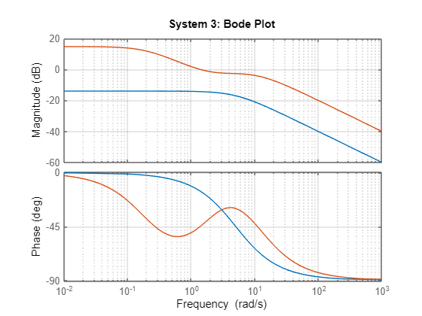
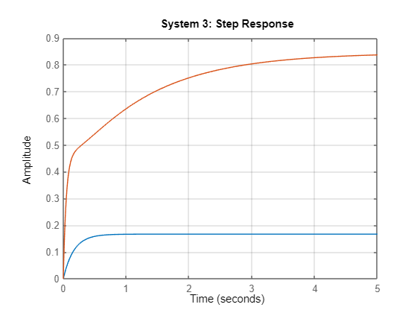
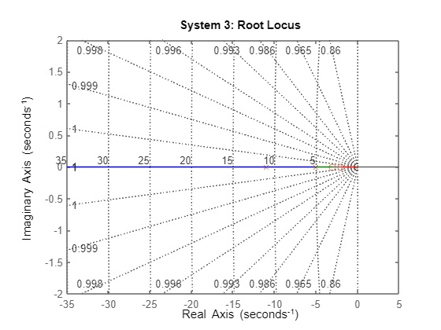
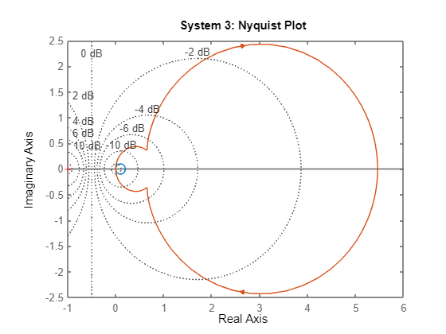
SYSTEM 3 PERFORMANCE
RiseTime: 0.3662
TransientTime: 0.6520
SettlingTime: 0.6520
SettlingMin: 0.1508
SettlingMax: 0.1667
Overshoot: 0
Undershoot: 0
Peak: 0.1667
PeakTime: 1.7576
RiseTime: 2.1209
TransientTime: 4.1168
SettlingTime: 4.1168
SettlingMin: 0.7606
SettlingMax: 0.8448
Overshoot: 0
Undershoot: 0
Peak: 0.8448
PeakTime: 9.0891
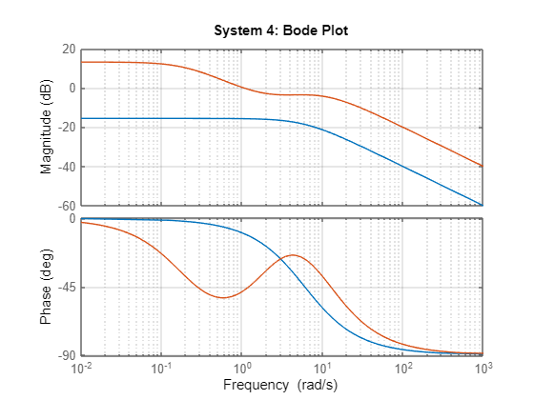
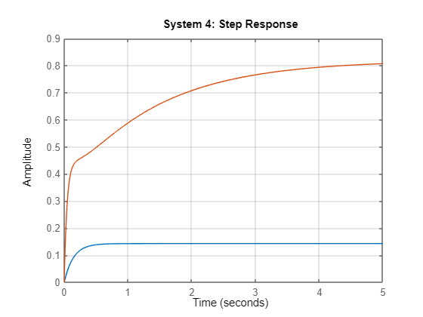
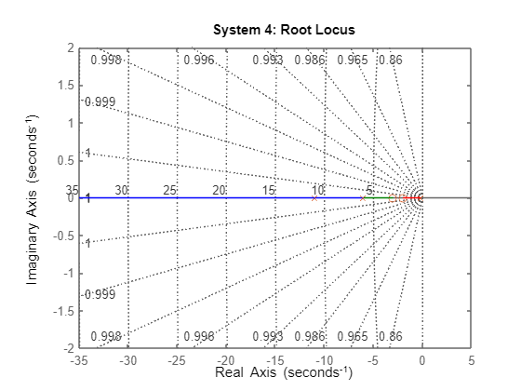
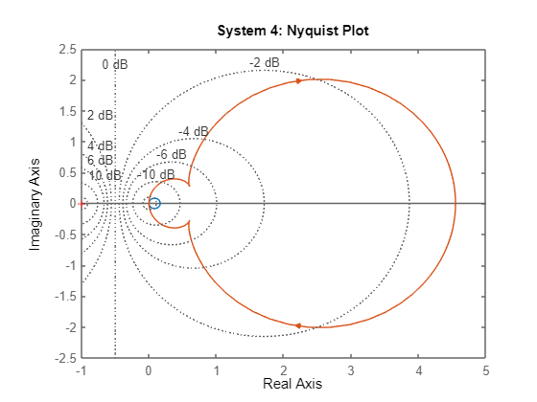
SYSTEM 4 PERFORMANCE
RiseTime: 0.3139
TransientTime: 0.5589
SettlingTime: 0.5589
SettlingMin: 0.1292
SettlingMax: 0.1429
Overshoot: 0
Undershoot: 0
Peak: 0.1429
PeakTime: 1.5065
RiseTime: 2.4179
TransientTime: 4.6264
SettlingTime: 4.6264
SettlingMin: 0.7379
SettlingMax: 0.8183
Overshoot: 0
Undershoot: 0
Peak: 0.8183
PeakTime: 8.0283
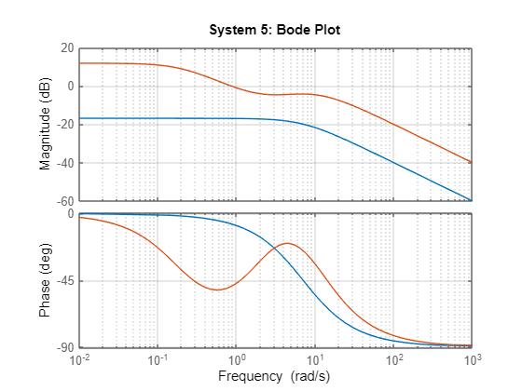
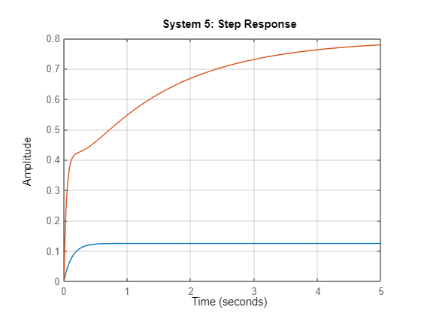
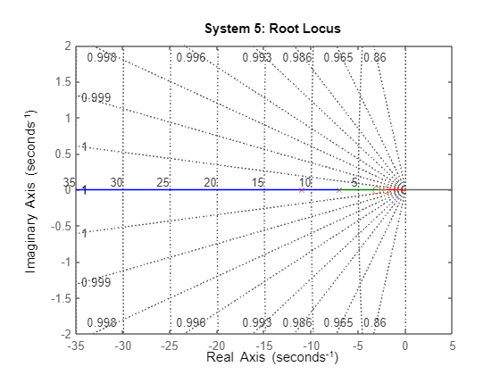
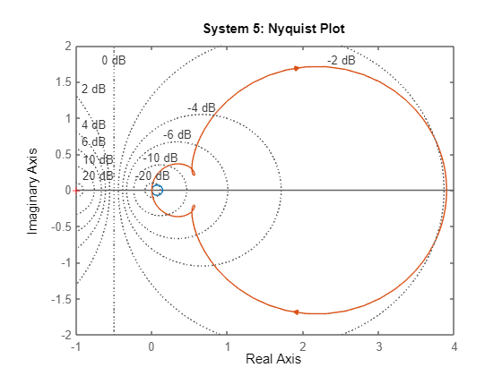
SYSTEM 5 PERFORMANCE
RiseTime: 0.2746
TransientTime: 0.4890
SettlingTime: 0.4890
SettlingMin: 0.1131
SettlingMax: 0.1250
Overshoot: 0
Undershoot: 0
Peak: 0.1250
PeakTime: 1.3182
RiseTime: 2.6883
TransientTime: 5.0895
SettlingTime: 5.0895
SettlingMin: 0.7163
SettlingMax: 0.7940
Overshoot: 0
Undershoot: 0
Peak: 0.7940
PeakTime: 8.3248
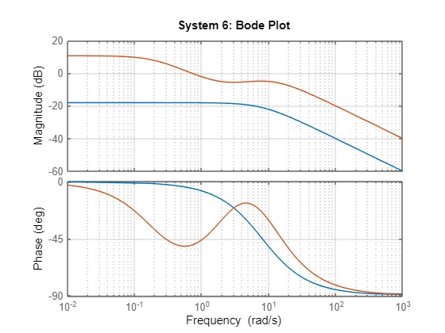
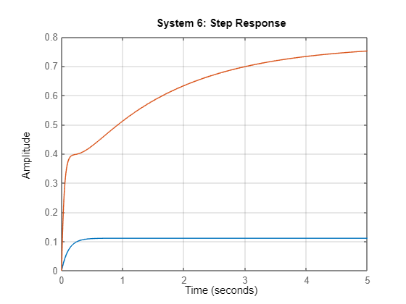
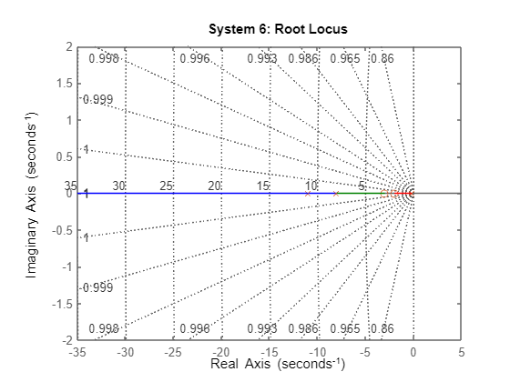
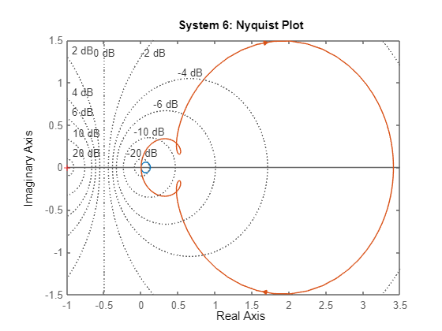
SYSTEM 6 PERFORMANCE
RiseTime: 0.2441
TransientTime: 0.4347
SettlingTime: 0.4347
SettlingMin: 0.1005
SettlingMax: 0.1111
Overshoot: 0
Undershoot: 0
Peak: 0.1111
PeakTime: 1.1718
RiseTime: 2.9375
TransientTime: 5.5159
SettlingTime: 5.5159
SettlingMin: 0.6960
SettlingMax: 0.7730
Overshoot: 0
Undershoot: 0
Peak: 0.7730
PeakTime: 12.6369
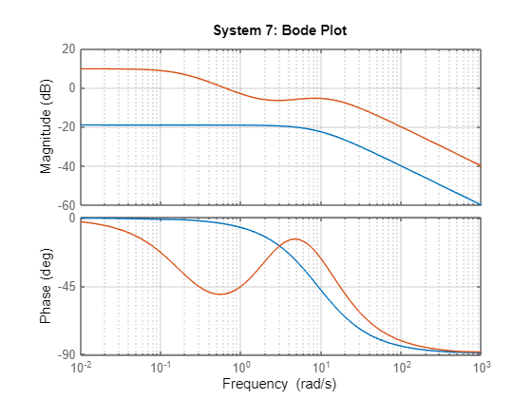
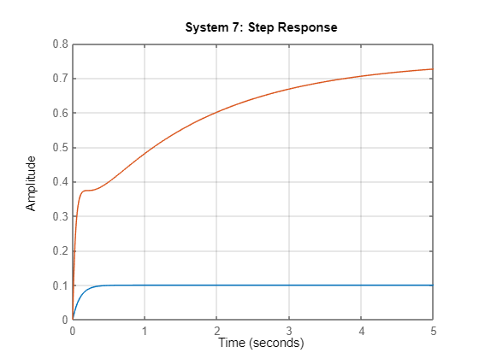
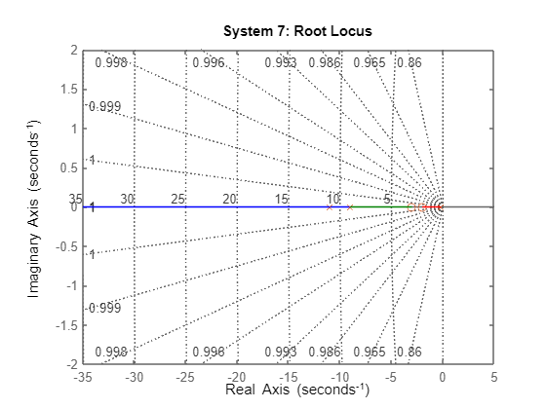
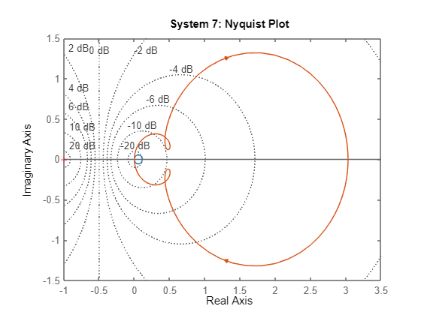
SYSTEM 7 PERFORMANCE
RiseTime: 0.2197
TransientTime: 0.3912
SettlingTime: 0.3912
SettlingMin: 0.0905
SettlingMax: 0.1000
Overshoot: 0
Undershoot: 0
Peak: 0.1000
PeakTime: 1.0546
RiseTime: 3.1690
TransientTime: 5.9116
SettlingTime: 5.9116
SettlingMin: 0.6768
SettlingMax: 0.7504
Overshoot: 0
Undershoot: 0
Peak: 0.7504
PeakTime: 9.8021
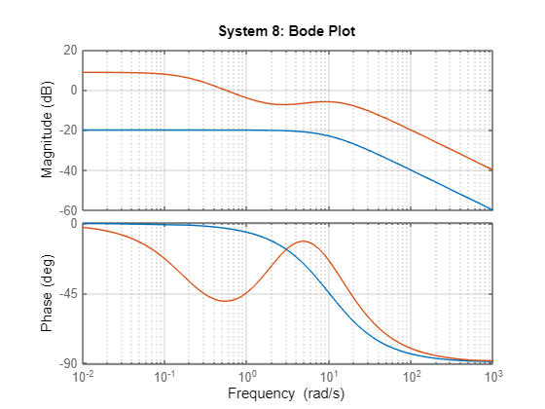
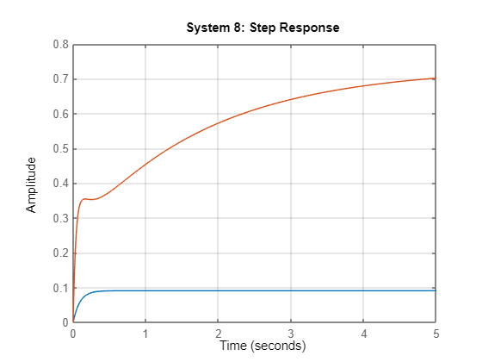
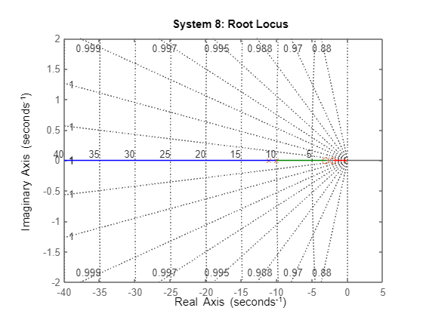
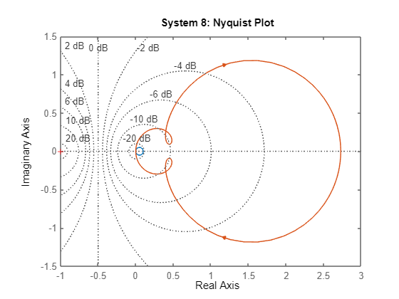
SYSTEM 8 PERFORMANCE
RiseTime: 0.1997
TransientTime: 0.3556
SettlingTime: 0.3556
SettlingMin: 0.0822
SettlingMax: 0.0909
Overshoot: 0
Undershoot: 0
Peak: 0.0909
PeakTime: 0.9587
RiseTime: 3.3853
TransientTime: 6.2810
SettlingTime: 6.2810
SettlingMin: 0.6586
SettlingMax: 0.7305
Overshoot: 0
Undershoot: 0
Peak: 0.7305
PeakTime: 10.7433

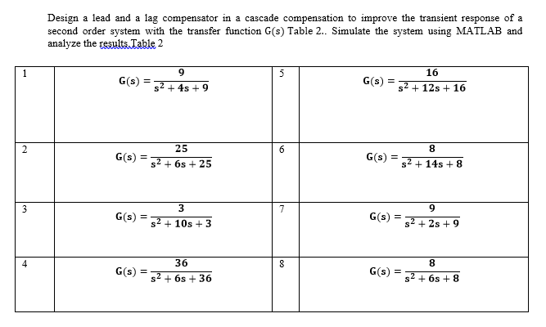

Table 2: Second Order system.
% NAME: Joshua Muthenya Wambua
% REG NO: EG209/109705/22
% DATE: 09-Nov-2025
% Objective:
% To design and analyze a lead–lag compensated control system
% for improved transient and steady-state performance.
clc; clear; close all;
% 1. Define system and compensators
s = tf('s'); % Laplace variable
% Uncompensated second-order plant
G1 = 9 / (s^2 + 4*s + 9);
% Lead compensator (improves transient response)
C_lead = 10 * (s + 3) / (s + 11);
% Lag compensator (improves steady-state error)
C_lag = (s + 2) / (s + 0.2);
% Combined lead–lag compensator
C_T = C_lead * C_lag;
% 2. Closed-loop transfer functions
T_uncomp = feedback(G1, 1); % Uncompensated closed-loop
T_comp = feedback(C_T * G1, 1); % Compensated closed-loop
% 3. Frequency Response Analysis
figure('Name','Bode Plot Comparison','NumberTitle','off');
bode(G1, C_T*G1);
grid on;
title('Bode Plot: Uncompensated vs Compensated');
legend('Uncompensated (Open-loop)', 'Compensated (Open-loop)', 'Location', 'best');
set(findall(gcf,'Type','line'),'LineWidth',1.5);
% 4. Step Response Analysis
figure('Name','Step Response Comparison','NumberTitle','off');
step(T_uncomp, T_comp, 4); % 4 seconds display window
grid on;
title('Step Response: Uncompensated vs Compensated');
legend('Uncompensated Closed-loop', 'Compensated Closed-loop', 'Location', 'best');
xlabel('Time (s)');
ylabel('Amplitude');
set(findall(gcf,'Type','line'),'LineWidth',1.5);
% 5. Root Locus & Nyquist Analysis
% Root Locus
figure('Name','Root Locus Comparison','NumberTitle','off');
rlocus(G1); hold on;
rlocus(C_T * G1);
grid on;
title('Root Locus: Uncompensated vs Compensated');
legend('Uncompensated', 'Compensated', 'Location', 'best');
% Nyquist Plot
figure('Name','Nyquist Plot Comparison','NumberTitle','off');
nyquist(G1, C_T*G1);
grid on;
title('Nyquist Plot: Uncompensated vs Compensated');
legend('Uncompensated', 'Compensated', 'Location', 'best');
set(findall(gcf,'Type','line'),'LineWidth',1.2);
% 6. Performance Metrics
fprintf('\n=== PERFORMANCE COMPARISON ===\n');
info_uncomp = stepinfo(T_uncomp);
info_comp = stepinfo(T_comp);
disp('Uncompensated System:');
disp(info_uncomp);
disp('Compensated System:');
disp(info_comp);
% Compute steady-state error for a unit step
[~, ss_uncomp] = step(T_uncomp, 10);
[~, ss_comp] = step(T_comp, 10);
ess_uncomp = abs(1 - ss_uncomp(end));
ess_comp = abs(1 - ss_comp(end));
fprintf('\nSteady-State Error (Unit Step Input):\n');
fprintf(' Uncompensated: %.4f\n', ess_uncomp);
fprintf(' Compensated: %.4f\n', ess_comp);
% 7. Summary Report (in Command Window)
fprintf('\n=== SYSTEM ANALYSIS SUMMARY ===\n');
fprintf('Lead compensator: C_lead = 10*(s + 3)/(s + 11)\n');
fprintf('Lag compensator: C_lag = (s + 2)/(s + 0.2)\n');
fprintf('Combined compensator: C_T = C_lead * C_lag\n');
fprintf('\nPerformance Insights:\n');
fprintf(' -> Lead compensation improves speed of response (reduces rise & settling time).\n');
fprintf(' -> Lag compensation improves steady-state accuracy (reduces steady-state error).\n');
fprintf(' -> Combined lead-lag provides both transient and steady-state improvements.\n');
fprintf('============================================================\n');

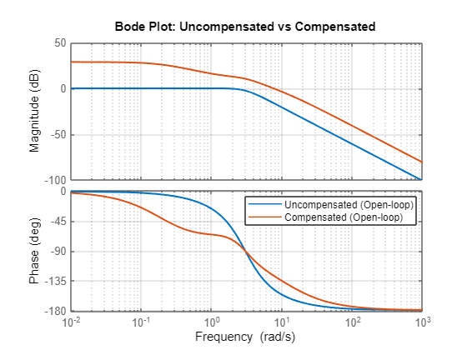
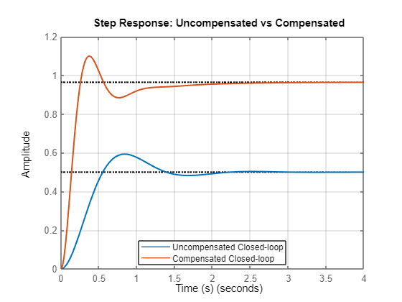
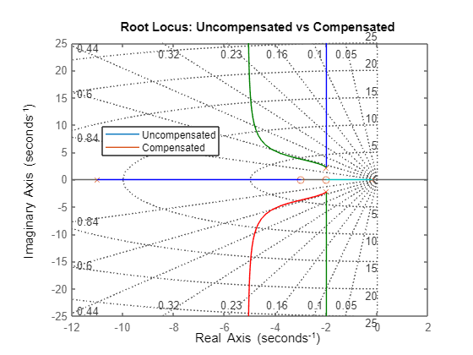
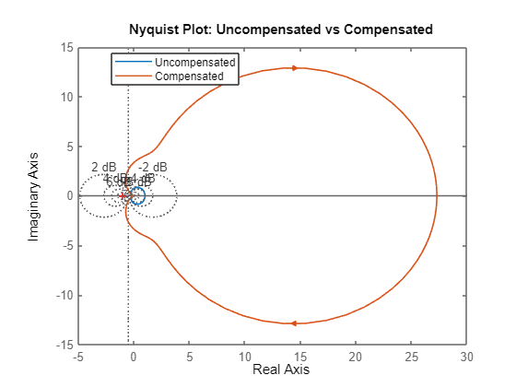
=== PERFORMANCE COMPARISON ===
Uncompensated System:
RiseTime: 0.3735
TransientTime: 1.9487
SettlingTime: 1.9487
SettlingMin: 0.4659
SettlingMax: 0.5932
Overshoot: 18.6319
Undershoot: 0
Peak: 0.5932
PeakTime: 0.8289
Compensated System:
RiseTime: 0.1746
TransientTime: 1.5802
SettlingTime: 1.5802
SettlingMin: 0.8845
SettlingMax: 1.0997
Overshoot: 13.9976
Undershoot: 0
Peak: 1.0997
PeakTime: 0.3759
Steady-State Error (Unit Step Input):
Uncompensated: 9.0000
Compensated: 9.0000
=== SYSTEM ANALYSIS SUMMARY ===
Lead compensator: C_lead = 10*(s + 3)/(s + 11)
Lag compensator: C_lag = (s + 2)/(s + 0.2)
Combined compensator: C_T = C_lead * C_lag
Performance Insights:
-> Lead compensation improves speed of response (reduces rise & settling time).
-> Lag compensation improves steady-state accuracy (reduces steady-state error).
-> Combined lead-lag provides both transient and steady-state improvements.

Chapter 5: Matlab Simulation and Results

5.1 Uncompensated System Response
The uncompensated system was simulated using MATLAB to obtain its step response and frequency response. The results showed moderate stability but limited transient performance.

5.2 Lead Compensated System
A lead compensator was designed and connected in cascade with the plant. MATLAB simulations showed that the lead compensator improved the transient response by reducing rise time and overshoot. The Bode plot indicated an increase in phase margin.

5.3 Lag Compensated System
A lag compensator was designed to improve steady-state accuracy. Simulation results demonstrated a reduction in steady-state error, although the transient response became slightly slower compared to the lead-compensated system.

5.4 Lead–Lag Compensated System
The lead and lag compensators were combined in cascade to form a lead–lag compensator. MATLAB results showed improved transient response and reduced steady-state error, achieving a balanced performance improvement. The Bode plot confirmed enhanced stability margins and desirable frequency characteristics.

6. Discussion

6.1 Difference Between Lead and Lag Compensators
Lead compensators primarily affect transient response by increasing phase margin and system speed, while lag compensators mainly improve steady-state accuracy by increasing low-frequency gain. Lead compensation reduces rise time and overshoot, whereas lag compensation reduces steady-state error.

6.2 Effect of Poles and Zeros on System Performance
The location of poles and zeros in the s-plane has a significant impact on system behavior. Poles closer to the imaginary axis result in slower response and higher overshoot, while poles further to the left improve stability and settling time. Zeros can be used to shape the transient response and influence overshoot and rise time.

6.3 Frequency-Domain Interpretation
Magnitude and phase plots are used to evaluate system stability margins and bandwidth. Lead compensators increase phase margin and bandwidth, improving stability and speed. Lag compensators increase low-frequency gain, enhancing steady-state accuracy without significantly affecting phase margin.

7. Applications
Dynamic compensation is widely used in practical engineering systems such as temperature control in HVAC systems, speed control of electric motors, and robotic arm positioning. Cascade compensation allows designers to fine-tune both transient and steady-state performance to meet application-specific requirements.

Conclusion
This laboratory experiment successfully demonstrated the application of lead, lag, and lead–lag compensators in improving control system performance. MATLAB simulations confirmed that lead compensation enhances transient response, lag compensation improves steady-state accuracy, and combined lead–lag compensation achieves balanced system performance. The results highlight the importance of pole-zero placement and frequency-domain analysis in compensator design.

References

- Ogata, K., Modern Control Engineering, Prentice Hall.
- Dorf, R. C., & Bishop, R. H., Modern Control Systems, Pearson Education.
- Nise, N. S., Control Systems Engineering, Wiley.
- MATLAB Documentation, MathWorks Inc.

