MERU UNIVERSITY OF SCIENCE TECHNOLOGY


DEPARTMENT OF ELECTRICAL AND ELECTRONICS ENGINEERING
BACHELOR OF TECHNOLOGY IN ELECTRICAL AND ELECTRONICS ENGINEERING
LAB 1 REPORT: DC MOTOR SPEED CONTROL SIMULINK MODELING
https://github.com/joshuawambua/controlsystems.git
UNIT CODE: EET 3407
UNIT DESCRIPTION: CONTROL SYSTEMS II.
NAME: JOSHUA MUTHENYA WAMBUA
REG NO: EG209/109705/22
Instructor: Dr. Agnes
Date: 14/12/2025

TABLE OF CONTENTS

Introduction 1
Objectives 1
Materials and Software Used 1
Results 2
Fig 1. DC motor speed model using integrators, gain blocks, and summing junctions 4
Fig 2. Abstracted motor Model. 5
Fig 3. Closed-loop DC motor speed control with lead compensator 5
Fig 4. Output of lead compensator 6
Fig 5. Closed-loop DC motor speed control with lag compensator 6
Fig 6. Output of the lag compensator 7
Fig 7. Lead and lag compensated dc model 8
Fig 8. Dc model output after compensation 8
Fig 9. Comparison of lead and lag compensated responses using a Scope 9
Fig 10: output of linearization 9
Fig 11. Simscape -based DC motor model with sensors and controlled voltage source 10
Fig 12 : Simscape complete design 10
Discussion & assignment 10
Conclusion 13
References 14

Introduction
DC motors are among the most widely used actuators in control systems due to their simple structure, ease of control, and well-understood dynamics. By varying the armature voltage, precise control of speed and position can be achieved, making DC motors suitable for industrial drives, robotics, and automation applications. In this laboratory experiment, a DC motor speed control system was modeled and analyzed using MATLAB/Simulink. The system was developed from first principles by combining the electrical dynamics of the armature circuit and the mechanical dynamics of the rotor. Both classical Simulink block-based modeling and physical-domain modeling using Simscape were employed. Furthermore, lead and lag compensators were designed and implemented to study their effects on transient and steady-state performance, as well as on control effort requirements.

Objectives
- To derive the transfer function of a DC motor speed control system from fundamental electrical and mechanical equations.
- To develop a block diagram model of the DC motor speed control system using Simulink.
- To implement a physically accurate DC motor model using the Simscape library.
- To integrate the motor speed signal to obtain the angular position of the motor shaft.
- To design and analyze lead and lag compensators and evaluate their impact on system performance.

Materials and Software Used
The following materials and software tools were used in this experiment:
- MATLAB R2021b
- Simulink
- Simscape
- Control System Toolbox
- Simulink Control Design Toolbox
- Personal computer
DC Motor Parameters used in the simulations:
- Moment of inertia, J = 0.01 kg.m²
- Viscous friction coefficient, b = 0.1 N.m.s/rad
- Motor torque constant, K_{t} = 0.01 N.m/A
- Back emf constant, K_{e} = 0.01 V/(rad/s)
- Armature resistance, R = 1 Ω
- Armature inductance, L = 0.5 H

Results
The scripts and the Simulink models are available on the GitHub repository provided on the cover page.

The DC motor models were successfully implemented using both classical Simulink blocks and the Simscape physical modeling environment. Screenshots of the following models are provided in this section:
The code for the DC motor parameters

%% DC Motor Physical Parameters

J = 0.01; % Moment of inertia (kg.m^2)
b = 0.1; % Viscous friction constant (N.m.s)
Ke = 0.01; % Back EMF constant (V/rad/s)
Kt = 0.01; % Torque constant (N.m/A)
R = 1; % Armature resistance (Ohm)
L = 0.5; % Armature inductance (H)

%% Transfer Function of DC Motor (Speed Control)
% Output: Angular speed (rad/s)
% Input : Armature voltage (V)

s = tf('s');

Motor_TF = Kt / ( (J*s + b)*(L*s + R) + Ke*Kt );

%% Display Transfer Function
disp('DC Motor Transfer Function (Speed / Voltage):')
Motor_TF

%% Step Response
figure;
step(Motor_TF)
grid on
title('Step Response of DC Motor Speed')
xlabel('Time (seconds)')
ylabel('Angular Speed (rad/s)')

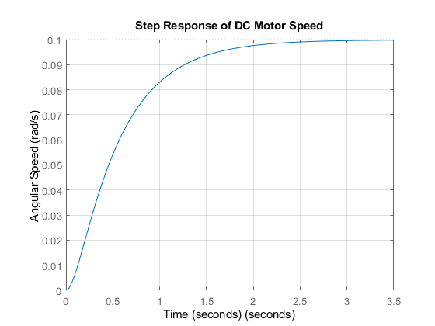
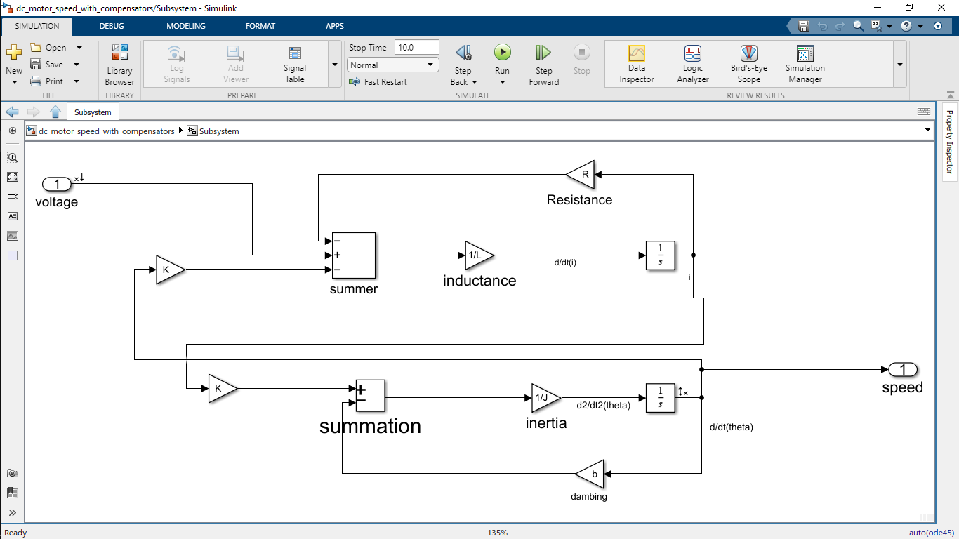

Fig 1. DC motor speed model using integrators, gain blocks, and summing junctions

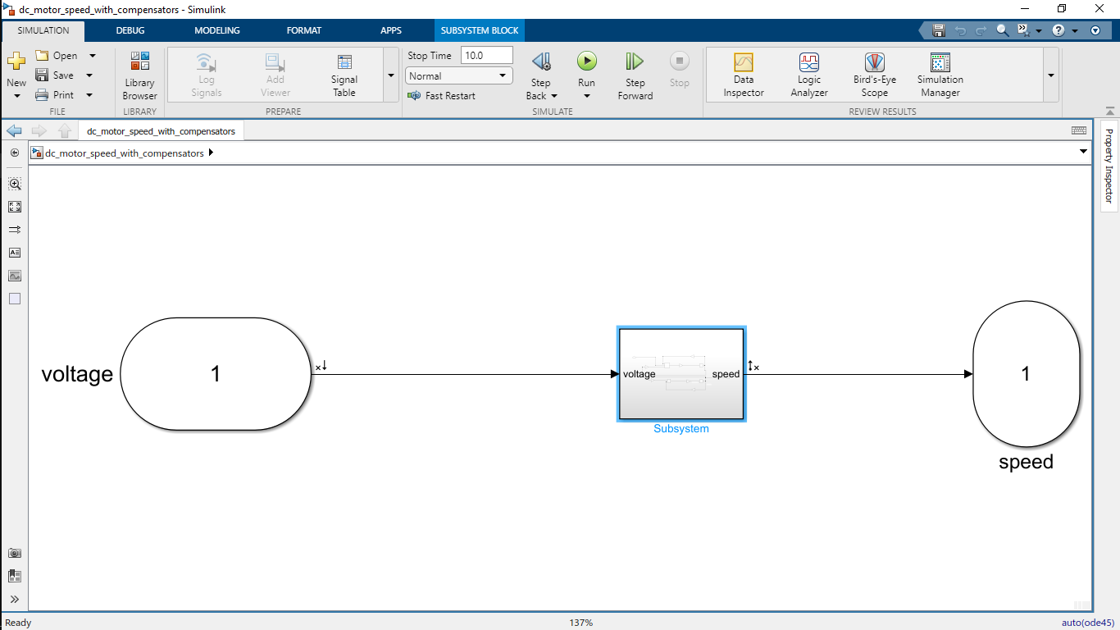

Fig 2. Abstracted motor Model.

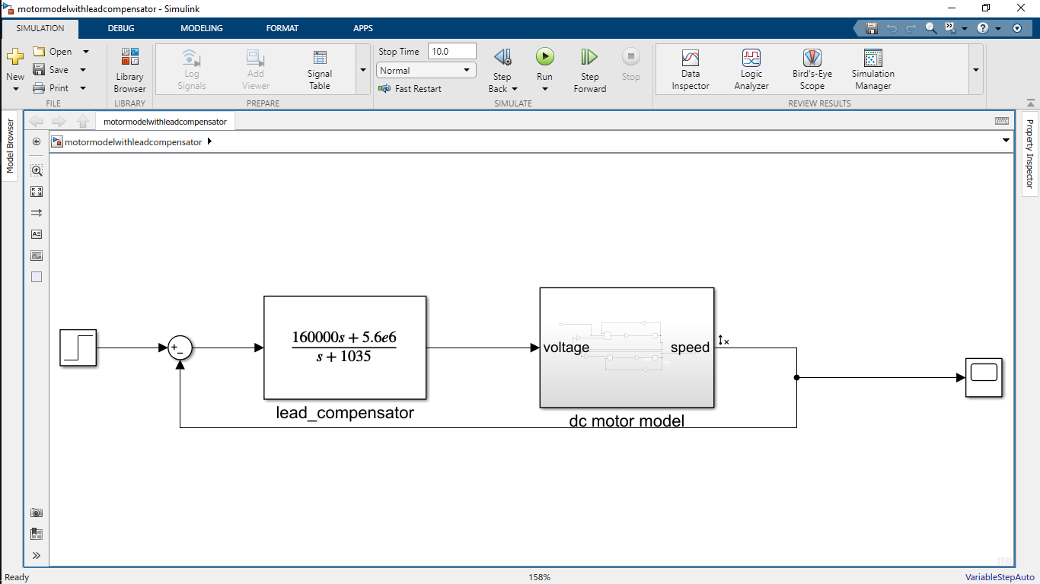

Fig 3. Closed-loop DC motor speed control with lead compensator
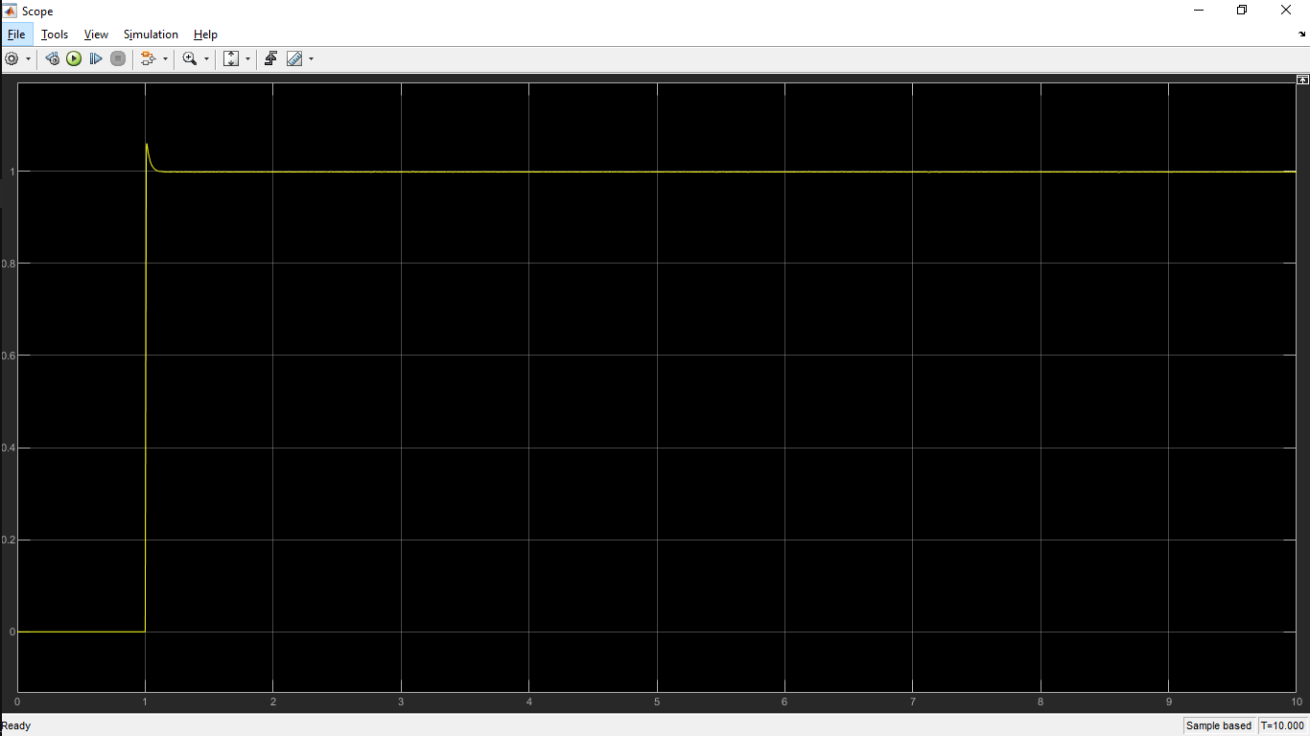

Fig 4. Output of lead compensator
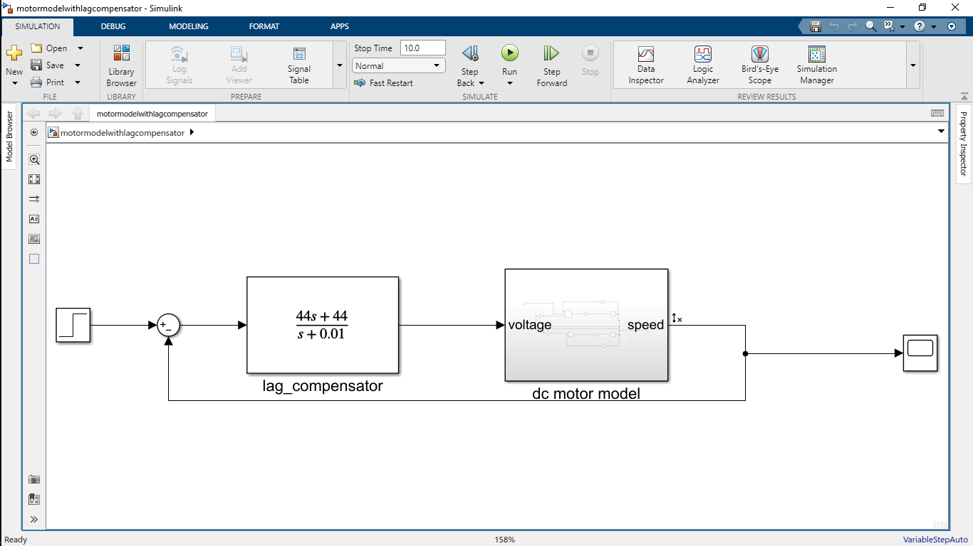

Fig 5. Closed-loop DC motor speed control with lag compensator

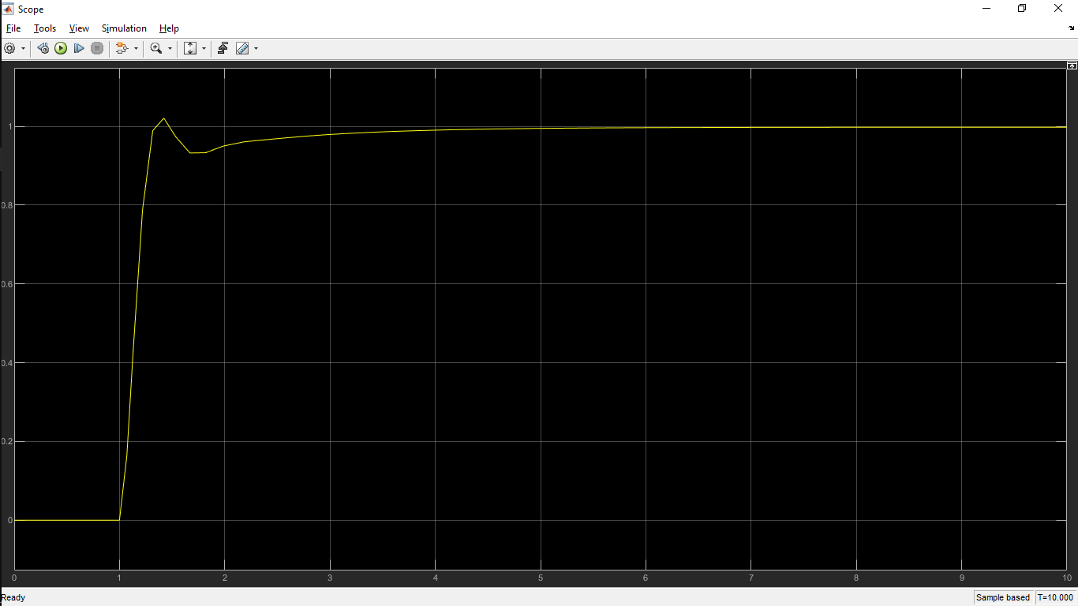

Fig 6. Output of the lag compensator
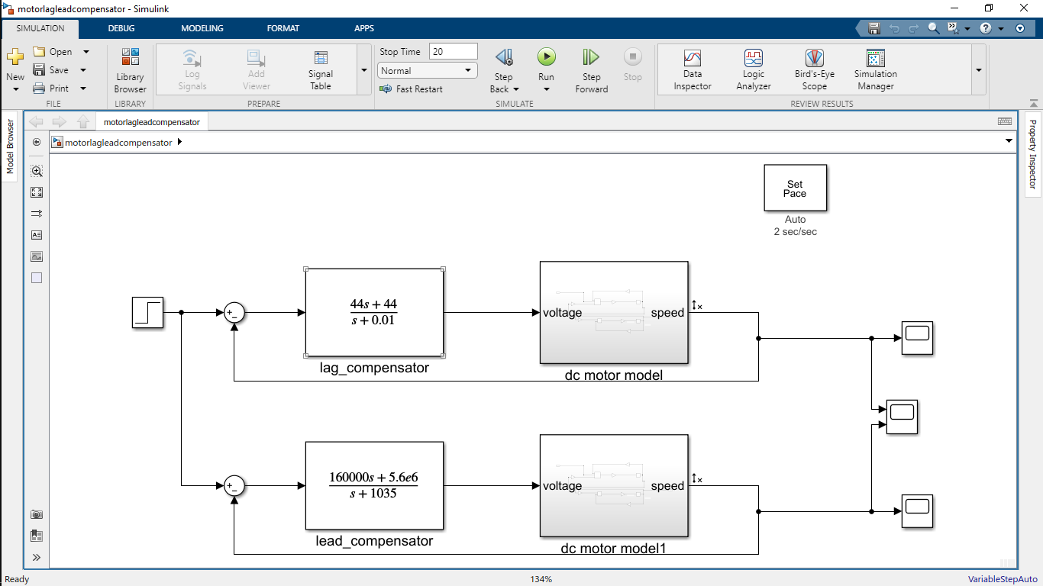

Fig 7. Lead and lag compensated dc model
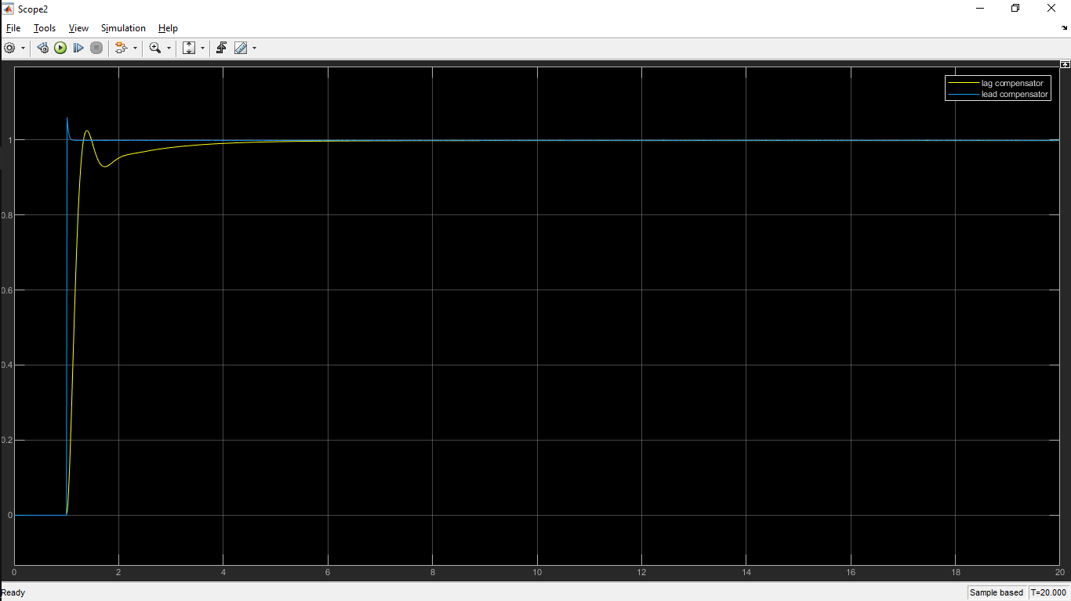

Fig 8. Dc model output after compensation
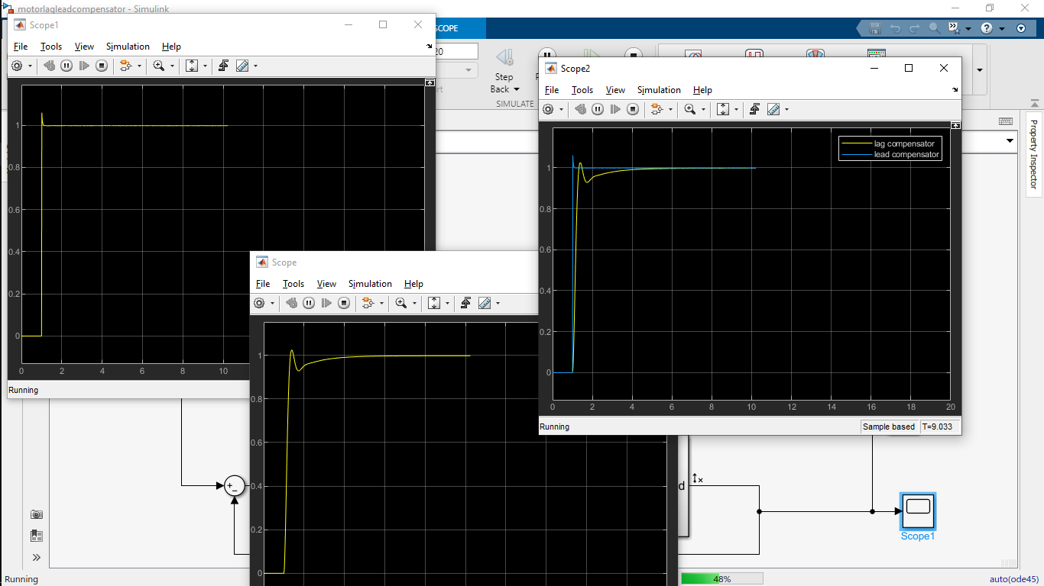

Fig 9. Comparison of lead and lag compensated responses using a Scope
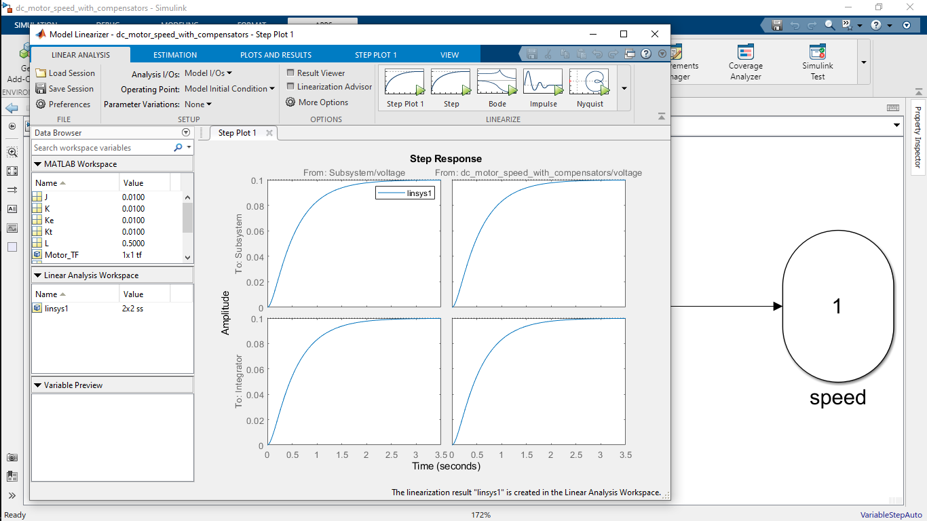

Fig 10: output of linearization
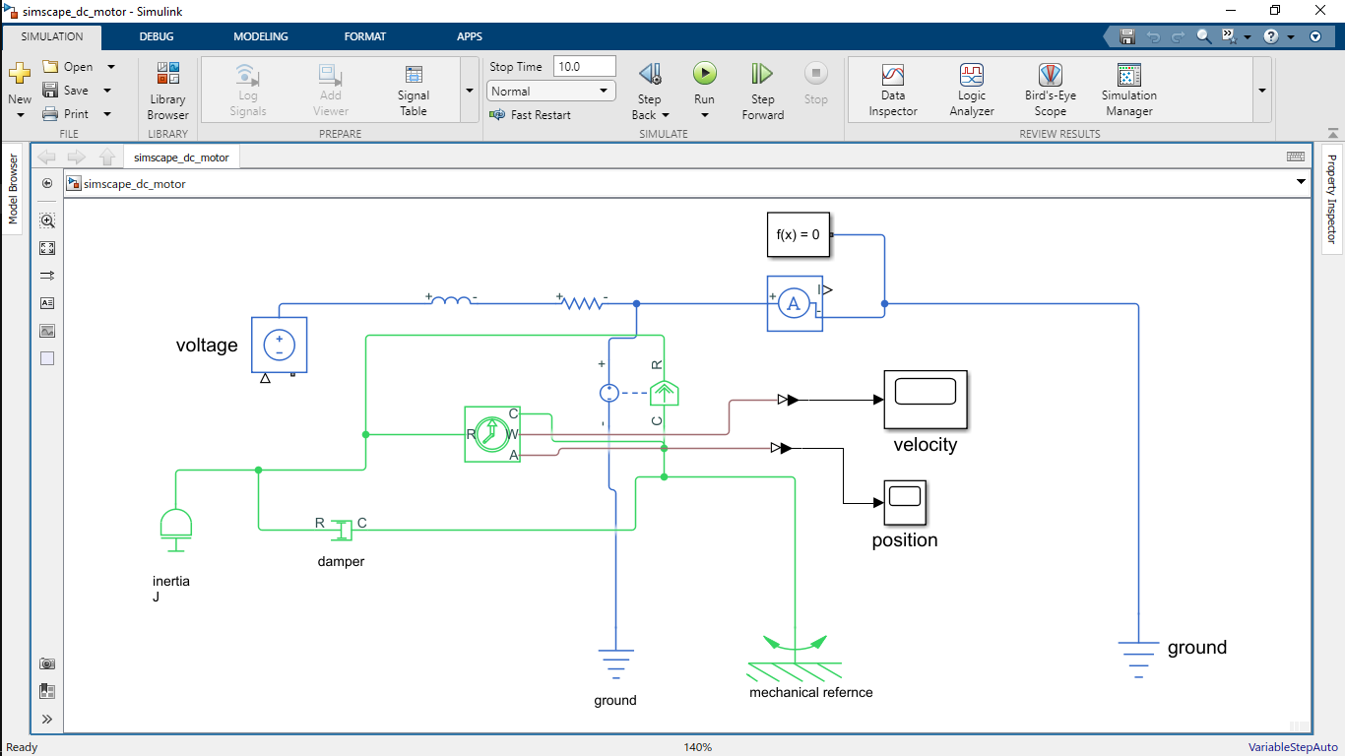

Fig 11. Simscape -based DC motor model with sensors and controlled voltage source
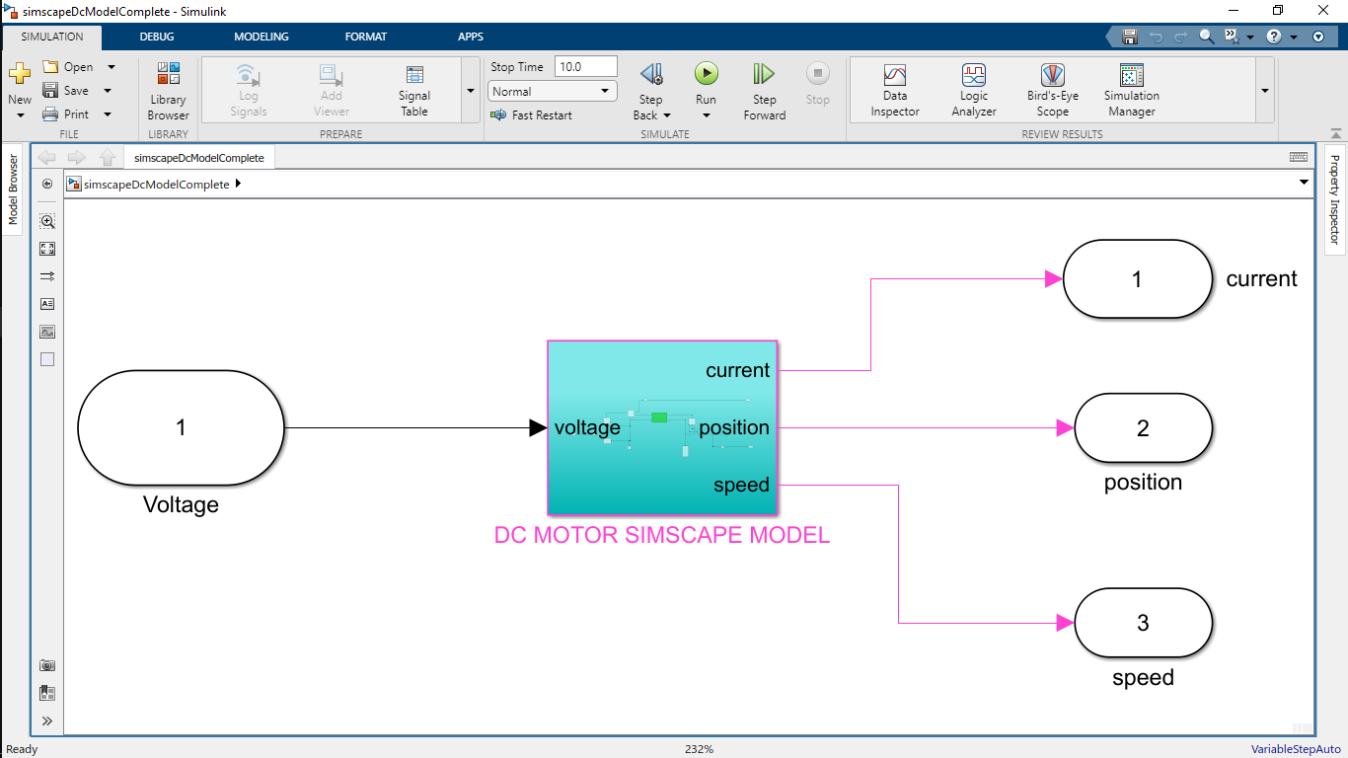

Fig 12 : Simscape complete design
Simulation results demonstrated stable closed-loop operation for both compensators. The lead compensator produced a faster response with reduced settling time, while the lag compensator achieved steady-state accuracy with significantly lower control effort.

Discussion & assignment
i. Derive the Transfer Function of the DC Motor Speed Control System. Starting from the fundamental electrical and mechanical equations of a series excited DC motor, derive the transfer function relating armature voltage to angular speed.
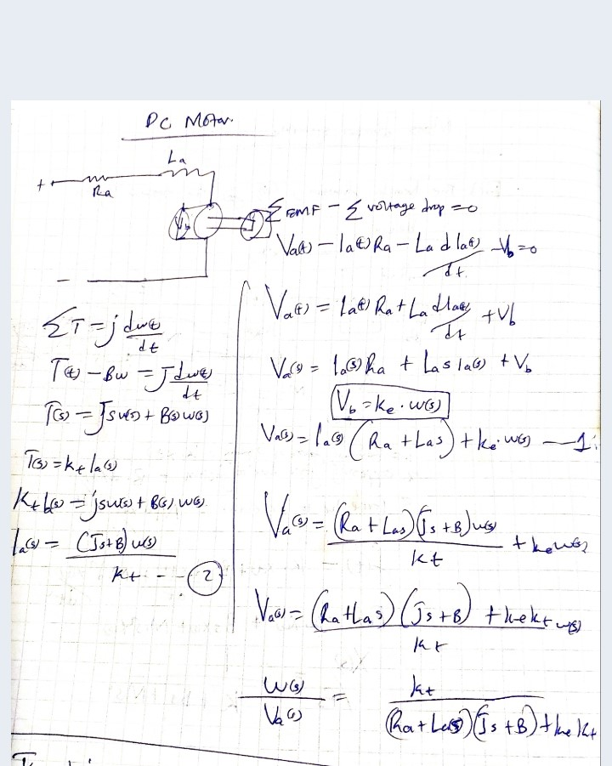
ii. Model the DC Motor Speed Control System.
Done in the results section

i) Develop the block diagram model of the DC speed control system.
The block diagram model was developed by representing the electrical and mechanical equations using integrator blocks, gain blocks, and summing junctions. The armature current and angular speed were obtained by integrating their respective derivatives. Feedback paths were used to model back emf and viscous friction effects. This approach provides a clear and transparent representation of the motor dynamics.
ii) Implement the Simscape model of the same system in MATLAB/Simulink.
The Simscape model was implemented using physical components such as resistors, inductors, inertia, rotational damper, and a rotational electromechanical converter. Sensor blocks were added to measure current, speed, and position. A controlled voltage source provided excitation to the motor. The Simscape model closely matched the behavior of the classical Simulink model, validating the equivalence of both approaches when identical parameters are used.

iii. Integrate Speed to Obtain Position. Using the derived transfer function, integrate the speed signal to obtain the angular position of the motor shaft.
Angular position is obtained by integrating angular speed with respect to time. In the Laplace domain, this corresponds to dividing the speed transfer function by s:
θ(s)/V_a(s) = (1/s) · [K / ((Js + b)(Ls + R) + K²)]
In Simulink, this was implemented by adding an integrator block at the output of the speed signal. The resulting position response exhibited smooth and physically realistic behavior, confirming the correctness of the integration process.

iv. Design and Analyze Compensators. Introduce lead and lag compensators to the DC motor speed control system. Analyze and compare their effects on the transient response (rise time, settling time, overshoot) and steady-state response (error, stability). Comment on how each compensator improves system performance.
A lag compensator was designed and connected in series with the DC motor to improve steady-state accuracy. The lag compensator significantly reduced steady-state error while maintaining system stability. However, the response was relatively slow, with a longer settling time and moderate rise time.
A lead compensator was then introduced to improve transient performance. The lead-compensated system exhibited a much faster rise time and reduced settling time compared to the lag-compensated system. However, this improvement came at the cost of increased control effort. Simulation results showed that the control voltage required by the lead compensator was extremely high, exceeding practical limits of real DC motors.
Overall, the lag compensator is preferred in practical applications where actuator limitations and power efficiency are critical, while the lead compensator is useful when fast response is the primary requirement and high control effort can be tolerated.

The classical Simulink model and the Simscape physical model produced equivalent dynamic responses when identical parameters were used, confirming that the mathematical model accurately represents the DC motor’s physical behavior. The modeling approach assumes linear viscous friction, constant magnetic field strength, and negligible nonlinear effects. While these assumptions simplify analysis and controller design, real DC motors may exhibit nonlinear friction, magnetic saturation, and parameter variations, which can affect accuracy under practical operating conditions.
The lead and lag compensators highlighted the trade-off between performance and practicality. The lead compensator significantly improved rise time and settling time but required excessively high control effort, making it impractical for real motor drives. In contrast, the lag compensator achieved good steady-state accuracy with much lower control effort, making it more suitable for real-world implementation where actuator limits, power consumption, and component ratings must be considered.

Conclusion
In this laboratory experiment, a DC motor speed control system was successfully modeled, simulated, and analyzed using MATLAB/Simulink and Simscape. The transfer function was derived from first principles and validated through simulation. Both lead and lag compensators were implemented and compared in terms of transient response, steady-state accuracy, and control effort. The results demonstrated the inherent trade-off between speed of response and control effort in feedback control systems. While lead compensation improves transient performance, lag compensation offers a more practical solution due to reduced energy requirements. The experiment reinforced fundamental concepts of system modeling, control design, and performance analysis.

References
- Ogata, K., Modern Control Engineering, 5th Edition, Prentice Hall.
- Dorf, R. C., and Bishop, R. H., Modern Control Systems, Pearson Education.
- MathWorks, DC Motor Modeling and Control, MATLAB & Simulink Documentation.
- MathWorks, Simscape User’s Guide, The MathWorks Inc.

