
MERU UNIVERSITY OF SCIENCE AND TECHNOLOGY
DEPARTMENT OF ELECTRICAL AND ELECTRONICS ENGINEERING
BACHELOR OF TECHNOLOGY IN ELECTRICTRAL AND ELECTRONIS ENGINEERING
TITLE: LAB REPORT
UNIT CODE: 3404
Description: Digital Circuit Design
https://github.com/joshuawambua/digitalCircuitDesign.git
Group members
- Joshua Wambua EG209/109705/22
- Nason Alfred EG209/111030/22
- Abuto Tonny Hillary -EG209/106792/21.
- Collins Kimanthi -EG209/109696/22.
- Wilkister Kwamboka -EG209/109739/22
INSTRUCTOR: DR. JOSEPH MUGURO
DATE:05/12/2025

Table of contents
1. Introduction 1
2. Objectives 1
3. Software and Components Used 1
3.1 Software Used 1
3.2 Components Used 1
3.3 Hardware used; 2
4. Procedure 2
5. Results 3
5.1 Circuit Implementation 3
Figure 1. The general circuit. 3
Figure 2. The general circuit with the logic analyzer. 4
5.2 Truth Table Simulation Results 4
Figure 3. The addition circuit. (S0,S1=0,0). 5
Figure 4. The substraction circuit. (S0,S1=1,0). 6
Figure 5. The ORING circuit. (S0,S1=1,1). 6
Figure 6. The ANDING circuit. (S0,S1=0,1). 7
5.3 Timing Waveform Analysis 7
Figure 7. The arithmetic circuit logic analyzer. (S0,S1=0,0). 8
Figure 8. The arithmetic circuit logic analyzer. (S0,S1=1,1). 8
5.4: The ALU IC Implementation (SN74LS181N). 9
Figure 9: An ALU performing normal addition on a breadboard at a HOMELAB 9
6. Discussion 9
(i) Arithmetic Operation 9
(ii) Logic Operation 10
(iii) Operation Selection 10
(iv) Timing Behavior 10
7. Conclusion 10
8. References 10
9. Appendices 11
Appendix 1: Pin configuration of the ALU IC used. 11
Appendix 2: Complete Circuit On Multism 12
Appendix 3: GitHub repository for more resources of the report. 12

1. Introduction
An Arithmetic Logic Unit (ALU) is a fundamental building block of digital systems and microprocessors. It is responsible for performing arithmetic operations such as addition and subtraction, as well as logical operations such as AND and OR. Understanding the internal construction and operation of an ALU provides insight into how processors execute instructions at the hardware level. In this experiment, a 4-bit ALU was designed and simulated using Multisim. The ALU was constructed using basic digital components including full adders, logic gates, and multiplexers. Different operations were selected using control signals, and the corresponding outputs were observed through simulation. Timing behavior and propagation delays were also analyzed using a logic analyzer. Finally, a hardware implementation was done using an ALU IC SN74LS181N.

2. Objectives
The objectives of this experiment were to:
- Design and construct a 4-bit Arithmetic Logic Unit using Multisim.
- Implement arithmetic operations (addition and subtraction) using full adders.
- Implement logical operations (AND and OR) using basic logic gates.
- Use multiplexers to select the desired ALU operation based on control inputs.
- Simulate various input combinations and observe output behavior.
- Analyze timing waveforms and observe propagation delays, especially ripple-carry delay.
- Record and interpret simulation results in the form of truth tables and waveforms.
- To build the circuit on a bread board and perform simple addition.

3. Software and Components Used

3.1 Software Used
- Multisim – for schematic design, simulation, and waveform analysis.

3.2 Components Used
- Full Adders (×2)
- XOR Gates
- AND Gates
- OR Gates
- 4-to-1 Multiplexers (one per output bit)
- Toggle switches and Interactive_Digital_Constant (for inputs A, B, and select lines S1, S0)
- Logic Probes (for output display)
- Logic Analyzer
- Power supply (Vcc) and Ground

3.3 Hardware used;
- ALU IC 74LS181N
- JUMBERS
- LEDS
- BREADBOARD
- POWER SUPPLY UNIT

4. Procedure
- Multisim was launched and a new schematic file was created.
- Four full adders were connected in cascade to form a 4-bit ripple-carry adder.
- For subtraction, each bit of input B was inverted using NOT gates, and a logic ‘1’ was applied to the initial carry-in to generate the 2’s complement of B.
- AND and OR gates were connected to form the logic unit for bitwise operations.
- A 4-to-1 multiplexer was used for each output bit to select between:
- Addition result
- Subtraction result
- AND result
- OR result
- The multiplexer select lines were connected to control inputs S1 and S0.
- Toggle switches were connected to inputs A3–A0 and B3–B0.
- LEDs or logic probes were connected to outputs F3–F0 and Cout.
- A logic analyzer was connected to selected inputs and outputs to observe timing waveforms.
- Multiple test cases were simulated, and outputs were recorded.
- Finally, the circuit of the ALU IC addition was done on a breadboard and basic addition done.

5. Results

5.1 Circuit Implementation
The complete 4-bit ALU circuit was successfully constructed in Multisim using basic digital components.
S1 S0 | Operation | Description
00 | A + B | 4-bit addition (ripple-carry adder)
01 | A – B | 4-bit subtraction (A + 2’s complement of B)
10 | A AND B | Bitwise AND
11 | A OR B | Bitwise OR
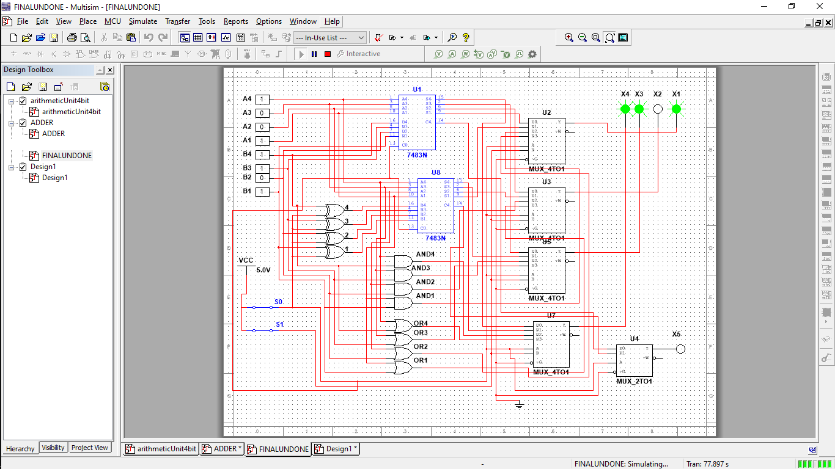

Figure 1. The general circuit.

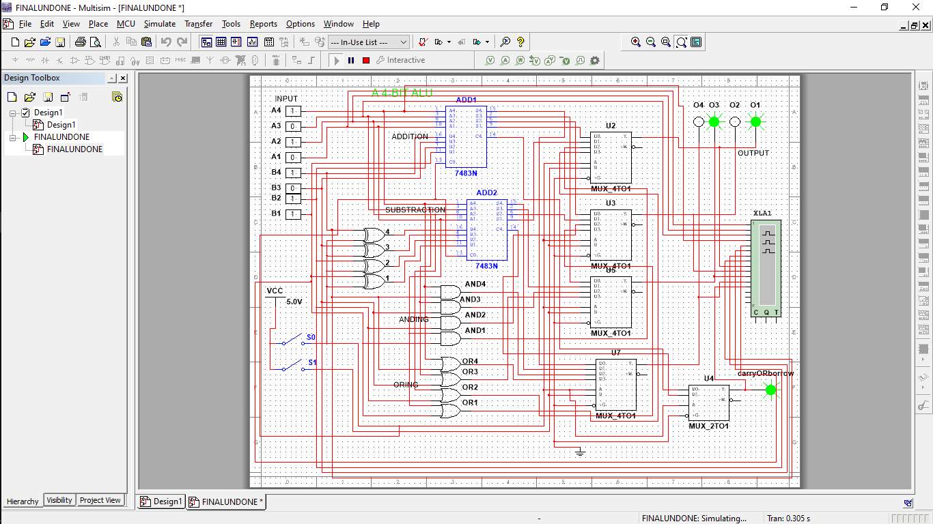

Figure 2. The general circuit with the logic analyzer.

5.2 Truth Table Simulation Results
The ALU was tested using various combinations of A, B, and select inputs. The outputs observed on the LEDs and logic probes matched the expected results for each operation.
- ADDITION TRUTH TABLE
A3 | A2 | A1 | A0 | B3 | B2 | B1 | B0 | O3 | O2 | O1 | O0 | C_out
0 | 1 | 0 | 0 | 1 | 0 | 0 | 0 | 1 | 1 | 0 | 0 | 0
1 | 0 | 0 | 0 | 1 | 1 | 0 | 0 | 0 | 1 | 0 | 0 | 1
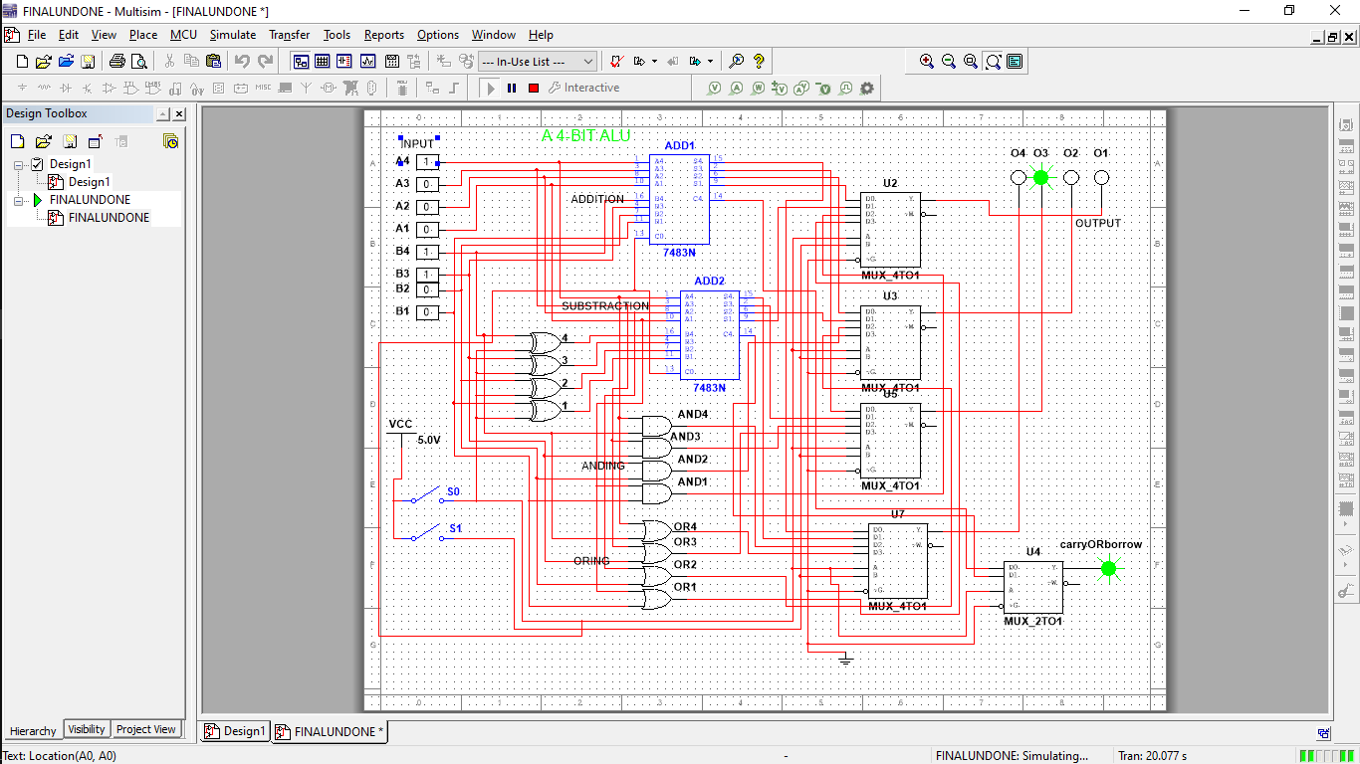

Figure 3. The addition circuit. (S0,S1=0,0).
- SUBSTRACTION (2’S COMPLEMENT) TRUTH TABLE

A3 | A2 | A1 | A0 | B3 | B2 | B1 | B0 | O3 | O2 | O1 | O0 | BORROW
0 | 1 | 0 | 1 | 0 | 0 | 0 | 0 | 0 | 1 | 0 | 1 | 1
1 | 1 | 0 | 0 | 1 | 1 | 1 | 0 | 1 | 1 | 1 | 0 | 0
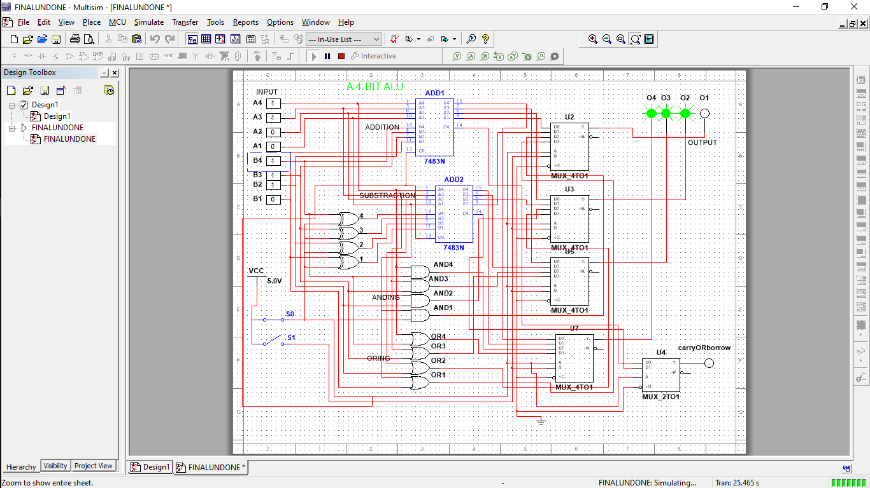

Figure 4. The substraction circuit. (S0,S1=1,0).
- ORING TRUTH TABLE
A3 | A2 | A1 | A0 | B3 | B2 | B1 | B0 | O3 | O2 | O1 | O0
0 | 1 | 0 | 0 | 1 | 0 | 0 | 0 | 1 | 1 | 0 | 0
1 | 0 | 1 | 1 | 1 | 1 | 0 | 0 | 1 | 1 | 1 | 1
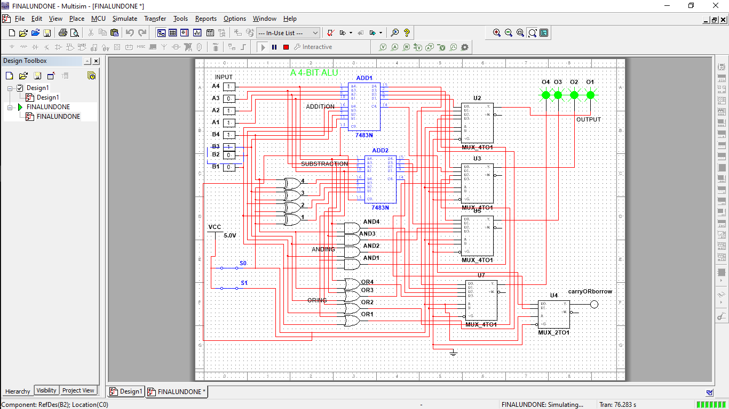

Figure 5. The ORING circuit. (S0,S1=1,1).
- ANDING TRUTH TABLE
A3 | A2 | A1 | A0 | B3 | B2 | B1 | B0 | O3 | O2 | O1 | O0
0 | 1 | 1 | 0 | 0 | 1 | 1 | 1 | 0 | 1 | 1 | 0
1 | 1 | 1 | 1 | 1 | 1 | 1 | 1 | 1 | 1 | 1 | 1
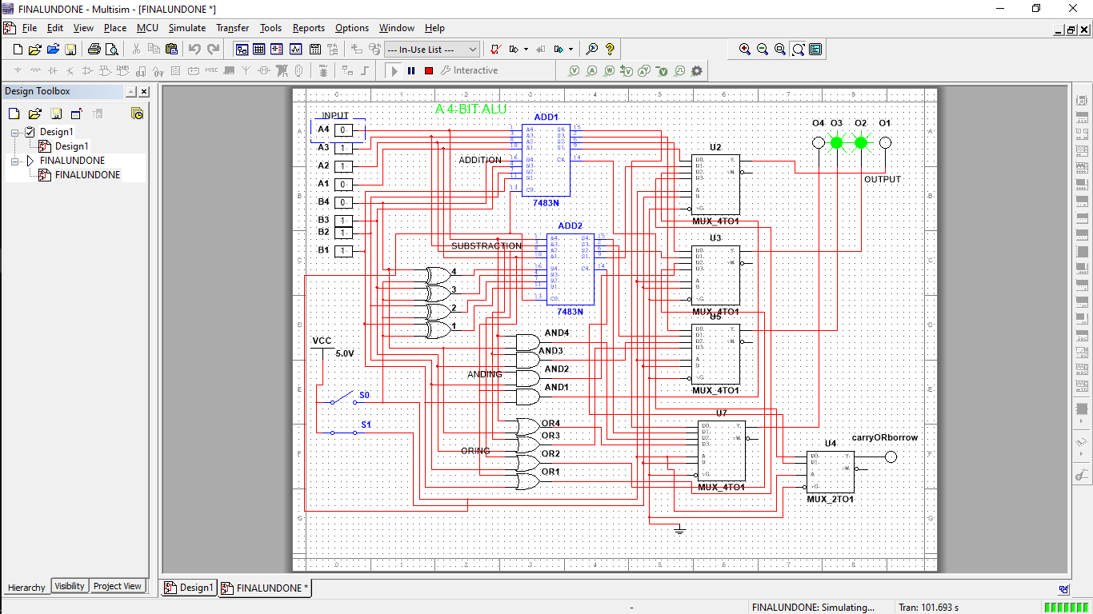

Figure 6. The ANDING circuit. (S0,S1=0,1).

5.3 Timing Waveform Analysis
Timing waveforms were captured using the logic analyzer. During addition and subtraction operations, a noticeable ripple-carry delay was observed as the carry propagated through successive full adders. Logic operations showed minimal delay compared to arithmetic operations.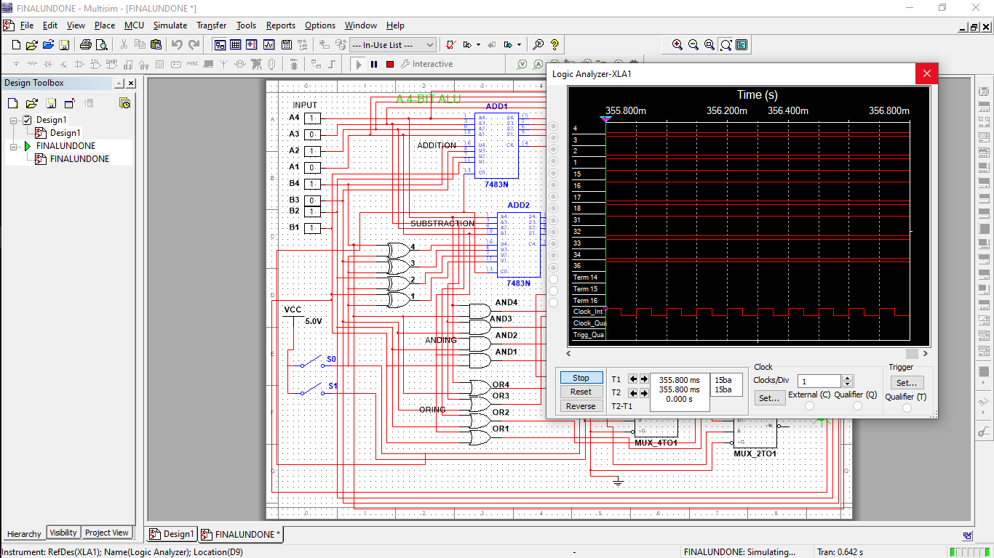

Figure 7. The arithmetic circuit logic analyzer. (S0,S1=0,0).
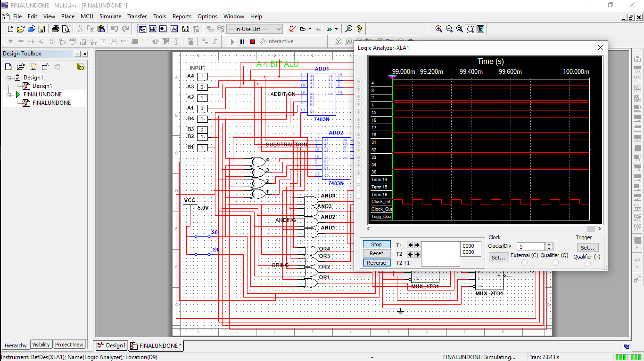

Figure 8. The arithmetic circuit logic analyzer. (S0,S1=1,1).

5.4: The ALU IC Implementation (SN74LS181N).
The basic addition was done as shown in the figure below.
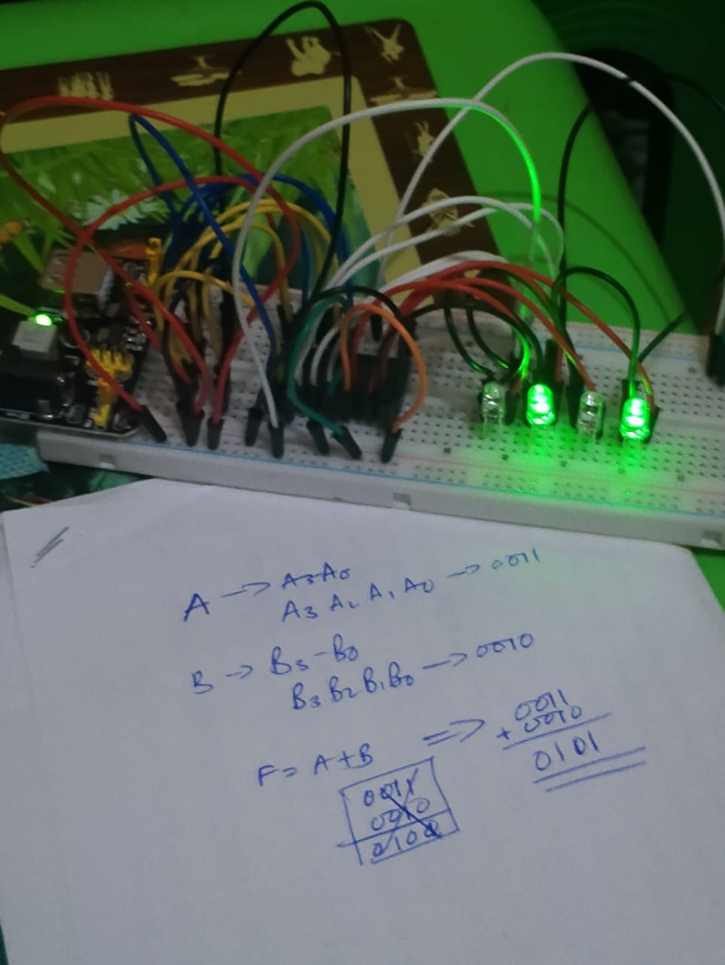

Figure 9: An ALU performing normal addition on a breadboard at a HOMELAB

6. Discussion

(i) Arithmetic Operation
The ALU performs addition by using a single 4-bit adder, which internally handles the carry propagation across all four bits. For subtraction, the 2’s complement of input B is generated by inverting B and applying a logic ‘1’ to the carry-in of the 4-bit adder. This allows subtraction (A − B) to be performed using the same adder hardware, ensuring efficient utilization of the arithmetic unit.

(ii) Logic Operation
Logical AND and OR operations are implemented using dedicated logic gates for each corresponding bit of inputs A and B. Each bit is processed independently, producing bitwise logical results without carry interaction. Because these operations do not involve arithmetic carry propagation, the outputs respond faster compared to arithmetic operations.

(iii) Operation Selection
The outputs from the arithmetic and logic units are connected to 4-to-1 multiplexers. The select inputs S1 and S0 control the multiplexers to determine which operation result (addition, subtraction, AND, or OR) is routed to the final output lines F3–F0. This approach allows seamless switching between operations using control signals.

(iv) Timing Behavior
During addition and subtraction, a ripple-carry delay is observed due to internal carry propagation within the 4-bit adder. Logic operations exhibit near-instantaneous output changes since no carry chain is involved. Minor propagation delays are also visible due to gate and multiplexer delays, as observed in the timing waveform.

7. Conclusion
In this experiment, a functional 4-bit Arithmetic Logic Unit was successfully designed and simulated using Multisim. The ALU correctly performed addition, subtraction, AND, and OR operations based on control inputs. Simulation results matched expected theoretical values, and timing analysis revealed propagation delays inherent in ripple-carry adders. The hardware implementation of the same was done using IC SN74LS181N. This experiment enhanced understanding of digital arithmetic, logic design, and ALU operation in modern computing systems.

8. References
- M. Morris Mano and Michael D. Ciletti, Digital Design: With an Introduction to the Verilog HDL, Pearson Education.
- Thomas L. Floyd, Digital Fundamentals, Pearson Education.
- Multisim User Manual, National Instruments.
- Lecture Notes – Digital Logic Design, Department of Electrical and Electronics Engineering.

9. Appendices

Appendix 1: Pin configuration of the ALU IC used.
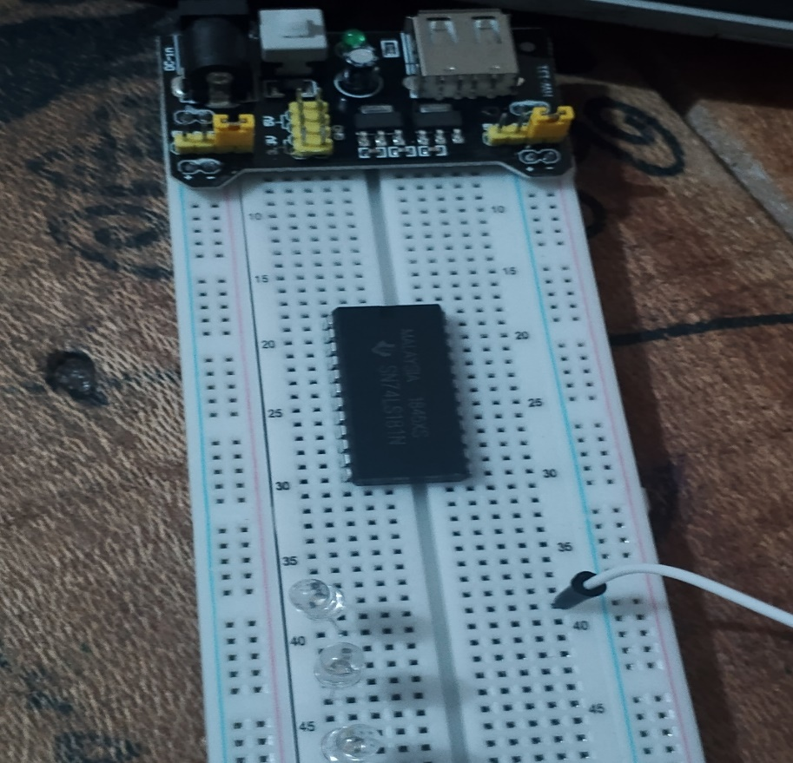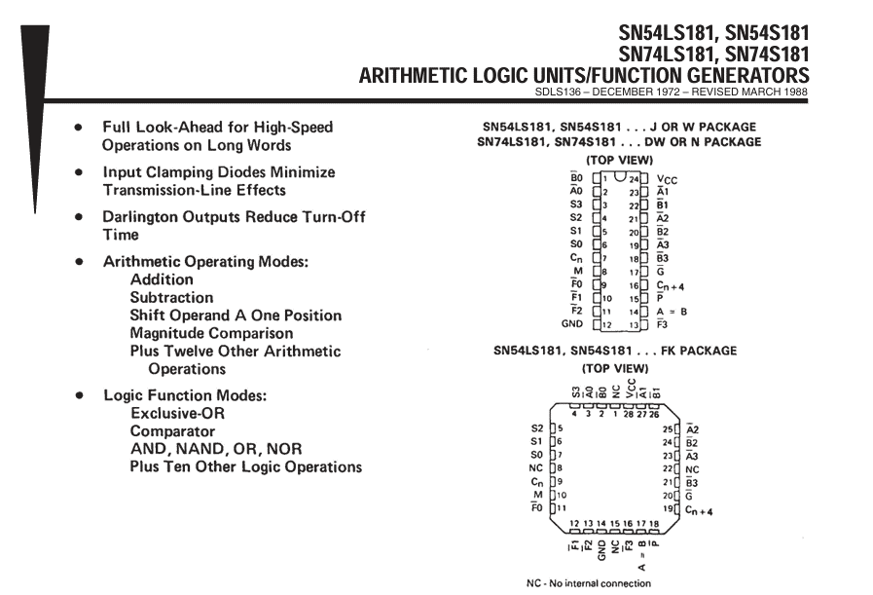

Appendix 2: Complete Circuit On Multism
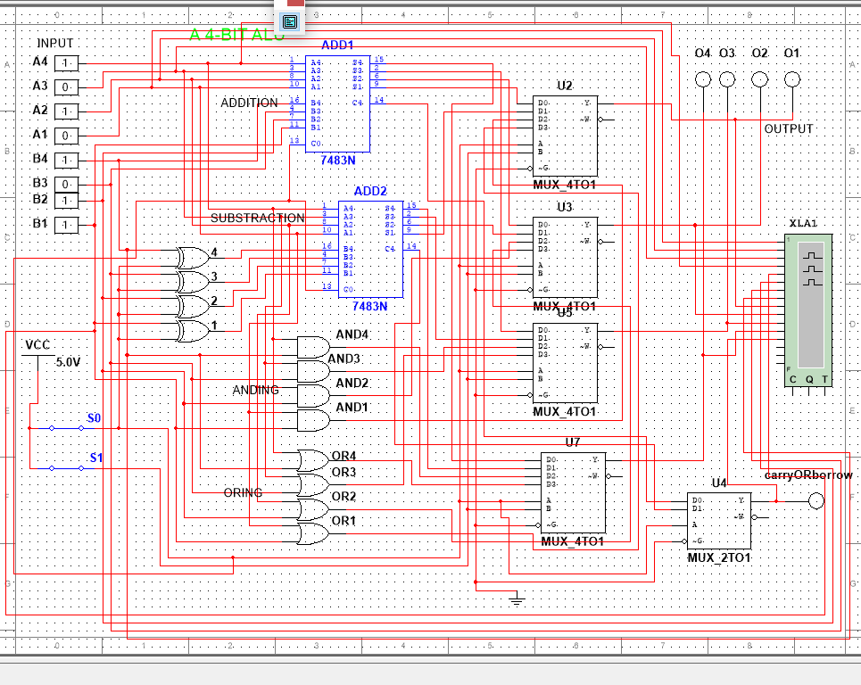

Appendix 3: GitHub repository for more resources of the report.

https://github.com/joshuawambua/digitalCircuitDesign.git

