
School of Engineering and Architecture
Department of Electrical and Electronics Engineering

IOT-BASED AIR QUALITY MONITORING SYSTEM

Joshua Muthenya Wambua
EG209/109705/22
A proposal submitted in partial fulfillment of the requirements for the award of the Degree of Bachelor of Technology in Electrical and Electronics Engineering in the Department of Electrical and Electronics Engineering at Meru University of Science and Technology.
January, 2026

DECLARATION
I hereby declare that this project proposal is my original work except as cited in the references and has not been presented for the award of a degree in any other University.

Sign: .........................................Date: ...........................................
Joshua Muthenya Wambua
EG209/109705/22

This proposal has been submitted for examination with our approval as the University supervisors:
Sign: ....................................... Date: ……...................................
Supervisor: Mr. Job Kerosi

LIST OF ABBREVIATIONS
ESP32 - Espressif 32-bit Microcontroller
IoT – Internet of Things
DHT11 - Digital Humidity and Temperature Sensor
LPG - Liquefied Petroleum Gas
MQ - Metal Oxide Semiconductor Gas Sensor Series
MQ7 - Carbon Monoxide Gas Sensor
PM - Particulate Matter
PM_{2.5} – Particulate Matter with diameter ≤ 2.5 micrometers
PM₁₀- Particulate Matter with diameter ≤ 10 micrometers
ML - Machine Learning
CO - Carbon Monoxide
RMSE - Root Mean Square Error
MAE - Mean Absolute Error
RF – Random Forest
IS – Isolation Forest
DT – Decision Tree

ABSTRACT
Air quality degradation and hazardous gas emissions pose significant challenges to public health, safety, and environmental sustainability. Urbanization and industrialization have increased the release of pollutants such as carbon oxides, methane, and particulate matter (PM2.5 and PM10), while domestic environments remain at risk from leaks of liquefied petroleum gas (LPG) and other combustible gases. These pollutants are linked to respiratory illnesses, cardiovascular diseases, climate change, and fire hazards. Existing monitoring systems are often centralized, expensive, and inaccessible for real-time decision-making at the household or community level. This project proposes an IoT-based air quality monitoring system capable of real-time data acquisition, cloud-based storage, and predictive analytics. The system integrates low-cost MQ gas sensors, particulate matter sensors, and environmental sensors with an ESP32 microcontroller for data collection and processing. Data is transmitted to Firebase for secure storage, visualization, and alert dissemination through a web application. Predictive models are employed to forecast pollution levels, detect anomalies, and assess potential fire hazards, while an actuation and safety response mechanism ensures timely mitigation. The proposed system provides a scalable, resource-efficient solution for continuous air quality monitoring, early warning, and risk management across urban, domestic, agricultural, and healthcare environments.

TABLE OF CONTENTS
DECLARATION ii
LIST OF ABBREVIATIONS iii
ABSTRACT iv
LIST OF FIGURES vi
CHAPTER 1: INTRODUCTION 1
1.1 BACKGROUND OF STUDY 1
1.2 PROBLEM STATEMENT 2
1.3 OBJECTIVES 3
1.4 JUSTIFICATION 3
1.5 SCOPE 4
CHAPTER 2: LITERATURE REVIEW 5
2.1 Technologies Used in Air Quality Monitoring 5
2.2 Review of Existing Systems 6
2.3 Research Gaps 7
CHAPTER 3: METHODOLOGY 8
3.1 SYSTEM REQUIREMENTS 8
3.2 SYSTEM DEVELOPMENT 10
3.2.1 Circuit Development 10
3.2.2 Database and Web Development 10
3.2.3 Firmware Development 11
3.3 DATA COLLECTION 11
3.4 DATA ANALYSIS METHODS 13
3.4.1 Machine Learning Modeling 13
3.4.2 Model Training and Deployment 14
3.4.3 Model Evaluation 14
3.4.4 SYSTEM FLOWCHART 15
3.5 PROTOTYPE TESTING 17
3.6 ETHICAL AND SAFETY CONSIDERATIONS 17
EXPECTED OUTCOMES 18
REFERENCES 19
PROJECT WORKPLAN 21
PROJECT BUDGET 22

LIST OF FIGURES
Figure 1:Passive Buzzer 9
Figure 2: ESP32 Board 9
Figure 3: DHT11 Sensor 9
Figure 4: LCD Display 9
Figure 5: PM nova Sensor 9
Figure 6: MQ8 Sensor 9
Figure 7:MQ5 Sensor 9
Figure 8: 4_way relay Channel 9
Figure 9: MQ7 Sensor 9
Figure 10: Voltage Regulator 9
Figure 11: Circuit Connection 10
Figure 12: Flow of Data 11
Figure 13: System Block Diagram 12
Figure 14: System Flow Chart 16
Figure 15: Project Gantt chart 21

CHAPTER 1: INTRODUCTION

1.1 BACKGROUND OF STUDY
Air quality degradation has become a pressing environmental and public health concern globally. Rapid urbanization, increased industrial activities, transportation, and population growth have significantly elevated the release of harmful pollutants such as particulate matter (PM_{2.5} and PM₁₀), methane, carbon oxides, and volatile organic and inorganic compounds [1]. These pollutants are directly associated with respiratory illnesses, cardiovascular diseases, allergies, and climate impacts [1]. In addition to outdoor pollution, domestic environments face risks of hazardous gas leaks such as liquefied petroleum gas (LPG) and methane, which can lead to poisoning, fire outbreaks, and explosions [2].
Although government-operated monitoring stations exist in major cities, current air quality monitoring approaches remain centralized, expensive, and inaccessible to individuals at the household level [1]. This creates a gap in real-time localized monitoring that can help mitigate risks [3].
Recent advancements in Internet of Things (IoT), cloud computing, and machine learning present a promising opportunity to develop affordable and scalable monitoring systems [3]. The proposed IoT-Based Air Quality Monitoring System integrates low-cost sensors with cloud-based storage and real-time data visualization to deliver accessible environmental insights [4]; [5]. By leveraging MQ-series gas sensors, particulate matter sensors, temperature and humidity sensors (DHT11), and ESP32 microcontrollers, the system offers continuous surveillance of air pollutants and hazardous gases [4]; [5]. The integration of predictive analytics further enhances the capability to detect anomalies and forecast pollution trends [3]; [6]; [7].
The integration of an actuation and safety response system strengthens hazard mitigation at the household level [2]. Environmental factors such as temperature and humidity also influence sensor readings and system accuracy, making real-time calibration and compensation necessary [8]; [9]. The system, therefore, represents a timely initiative toward improving environmental health, public safety, and awareness by bridging the gap between centralized air quality monitoring and household-level accessibility [5].

1.2 PROBLEM STATEMENT

Air pollution and hazardous gas exposure remain persistent problems in urban and domestic environments due to increasing industrial activity, vehicle emissions, and the widespread use of gas-powered appliances. In many residential areas and small business premises, exposure to pollutants such as carbon monoxide and combustible gases often goes undetected until health symptoms, fires, or explosions occur, significantly increasing the risk of injury, property damage, and loss of life. Existing air quality and gas monitoring systems are largely centralized, expensive, and designed for regulatory or industrial applications rather than individual households or small enterprises. As a result, they are inaccessible to most users and fail to provide continuous, real-time, and location-specific information at the point of exposure, leaving individuals without timely awareness or early warning of deteriorating air quality or gas leakages in their immediate surroundings. The absence of a resource-efficient, real-time, and localized monitoring solution therefore creates a critical safety and public health gap, causing communities to remain reactive rather than preventive in managing air pollution and gas-related hazards. Addressing this gap requires an economical, scalable, and accessible monitoring system capable of detecting air pollutants and hazardous gases in real time, generating timely alerts, and enabling preventive response through automated actuation, which is the aim of the proposed IoT-Based Air Quality Monitoring System.

1.3 OBJECTIVES
Main objective
To design a scalable IoT-Based Air Quality Monitoring System with real-time detection, prediction, alerts, and actuation.
Specific objectives:
- To measure and log air pollutants (PM2.5, PM10, CO, LPG) along with temperature and humidity using low-cost sensors connected to an ESP32 microcontroller.
- To transmit collected data to a cloud platform for real-time visualization, predictive modeling of air quality trends, and threshold-based alert generation through a web interface.
- To implement automated actuation mechanisms that respond to detected hazards or predicted unsafe conditions, such as activating ventilation or triggering safety alerts.

1.4 JUSTIFICATION
Air quality monitoring solutions are predominantly confined to government-operated or industrial-scale installations, which limits accessibility for households and small businesses. Consequently, individuals are frequently exposed to invisible yet hazardous pollutants and gas leaks without timely detection or warning. An economical and scalable IoT-based Air Quality Monitoring System addresses this gap by enabling early detection and automated alerts that enhance public safety. It provides accessible, real-time environmental data that supports informed decision-making at the individual and community levels, thereby reducing exposure-related health risks. By promoting community awareness and integrating IoT infrastructure with machine learning analytics, the system enables continuous monitoring and early detection of air quality issues. It provides a practical, research-based solution for improving environmental health and public safety.

1.5 SCOPE
This project focuses on designing and implementing an IoT-based air quality monitoring system using low-cost gas sensors, particulate matter sensors, environmental sensors, actuators, and ESP32 microcontrollers. The scope includes real-time data collection, wireless transmission to a cloud platform (Firebase), web-based data visualization, safety response, and predictive modeling for anomaly detection and forecasting. The project will cover; hardware integration, firmware development, cloud connectivity, web application interface, alert systems, and evaluation of system performance. This project, however, does not cover nationwide monitoring or industrial certification standards. Instead, the focus remains on household, urban, agricultural, and healthcare environments where feasible and cost-effective deployment is needed.

CHAPTER 2: LITERATURE REVIEW
Air quality monitoring has become increasingly important due to rising pollution levels and associated health risks. Traditional reference-grade monitoring stations provide high measurement accuracy but are expensive and sparsely distributed, limiting their spatial coverage and accessibility. Bagkis et al. [1]; Kumar et al. [2] highlighted the technological evolution of low-cost sensor networks and emphasized the need for scalable, distributed monitoring solutions. Similarly, Garcia et al. [3] noted that centralized systems restrict accessibility and integration with modern digital infrastructures.
Recent research has therefore shifted toward low-cost sensors and IoT-based systems to improve real-time environmental monitoring. Concas et al. [4] surveyed low-cost outdoor air quality monitoring systems, discussing calibration challenges, sensor drift, and cross-sensitivity effects. Their work emphasized proper calibration strategies for reliable deployment at scale.

2.1 Technologies Used in Air Quality Monitoring
Low-cost sensors are increasingly preferred for distributed monitoring due to their affordability and compact size. Concas et al. [4] explained that sensor drift and environmental interference can affect measurement accuracy over time. Environmental conditions further impact sensor performance. Spinelle et al. [14] showed that temperature and humidity variations influence sensor sensitivity and stability, while Casari and Po [8] reported that high humidity inflates particulate matter readings due to hygroscopic growth.
To address these challenges, IoT architectures and machine learning techniques are widely used. Zaid et al. [10] developed an IoT-based low-cost sensor network capable of reliable wireless data transmission, real-time monitoring, and cloud storage. Ramesh et al. [11] reported that integrating sensors with microcontrollers and cloud dashboards enables real-time monitoring and early hazard detection. Garcia et al. [3] also highlighted the use of AI to improve predictive analytics and system automation.

Machine learning has improved sensor reliability and data accuracy. Tastan [6] applied machine learning for sensor calibration and reported improvements in measurement accuracy and stability. Kim and Seung-Hyun [7] reviewed a decade of machine learning methods for correcting sensor drift and noise, including Random Forest, SVM, and deep learning. Idir et al. [12] compared predictive models for urban air quality using mobile and fixed sensors, showing that data fusion enhances spatial resolution and forecasting accuracy.

2.2 Review of Existing Systems
Several studies have demonstrated the practical deployment of low-cost monitoring systems. Gatari et al. [13] conducted one of the earliest studies in Kenya using calibrated particulate matter sensors, validating their accuracy against reference instruments. Njeru et al. [14] deployed a PM2.5 sensor network in Mombasa, Kenya, reporting frequent exceedances of health-based air quality guidelines, indicating high exposure risks.
Community-integrated approaches improve monitoring effectiveness. Manshur et al. [15] implemented citizen-science air quality monitoring in a Kenyan informal settlement, showing both technical feasibility and social value. Bowyer et al. [16] demonstrated that participatory arts-based methods, such as theatre, music, murals, and school outreach, increase awareness and participation in air pollution studies.
Indoor and household-level monitoring systems are increasingly emphasized. Othman et al. [5] reviewed low-cost IoT-based indoor air quality monitoring systems, highlighting low power requirements and suitability for household deployment. Kumar et al. [2] developed a gas leakage detection system with automated alerts, showing the importance of safety response mechanisms in household monitoring.
Ramesh et al. [11] identified safety response mechanisms as a key component of air quality monitoring systems, enabling real-time hazard detection and mitigation.

2.3 Research Gaps
Despite advances in low-cost sensors, IoT platforms, and machine learning, several gaps remain. Household-level access to reliable air quality monitoring is still limited. Many current systems lack real-time alert mechanisms and predictive analytics integration. Community engagement strategies are often underutilized, reducing participation and trust. Finally, sensor performance can be affected by environmental conditions, and more work is needed to maintain accuracy under varying temperature and humidity. These gaps justify the development of an integrated solution combining distributed sensors, IoT communication, cloud-based data management, machine learning analytics, and community engagement to provide accessible and actionable air quality information.

CHAPTER 3: METHODOLOGY

3.1 SYSTEM REQUIREMENTS
- ESP32 microcontroller.
- DHT11 sensor - Temperature and humidity.
- Mq7 sensor - carbon monoxide(CO).
- MQ8 sensor – Hydrogen Gas
- MQ5 sensor - LPG
- Nova PM sensor Particulate matter.
- Breadboard and stripboard.
- 12 V battery and battery charger.
- Powerbank.
- Buzzer.
- Relay.
- Jumper wires.
- Firebase
- Arduino IDE
- Visual studio code
- GitHub
- LCD Display.
- Voltage regulator

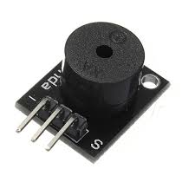  Figure 1:Passive Buzzer | 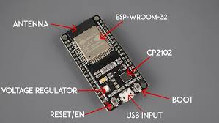  Figure 2: ESP32 Board
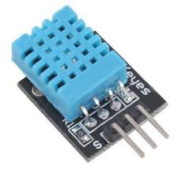  Figure 3: DHT11 Sensor | 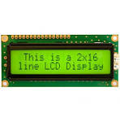  Figure 4: LCD Display
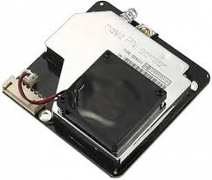  Figure 5: PM nova Sensor | 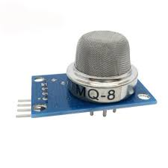  Figure 6: MQ8 Sensor
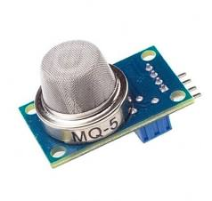  Figure 7:MQ5 Sensor | 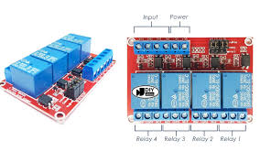  Figure 8: 4_way relay Channel
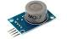  Figure 9: MQ7 Sensor | 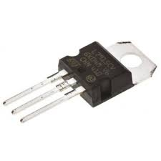  Figure 10: Voltage Regulator

3.2 SYSTEM DEVELOPMENT

3.2.1 Circuit Development
The sensors’ Vcc pin will be connected to the positive terminal (+5V) of the power supply unit (PSU) and the ground pins will be connected to the ground terminal (negative terminal) of the power supply unit. The sensors cannot be supplied by the 5V pin of the ESP32 because the total power consumption of the sensors exceeds what can be supplied by the ESP32’s 5V pin and doing so will overload the onboard voltage regulator that will damage the ESP32 board. This is due to the fact that the MQ series sensors require preheating making them power hungry. The ground pin of the ESP32 and the power supply unit’s ground terminal will be connected together to provide a common ground for the sensors ensuring that the signal values from the sensors are stable.

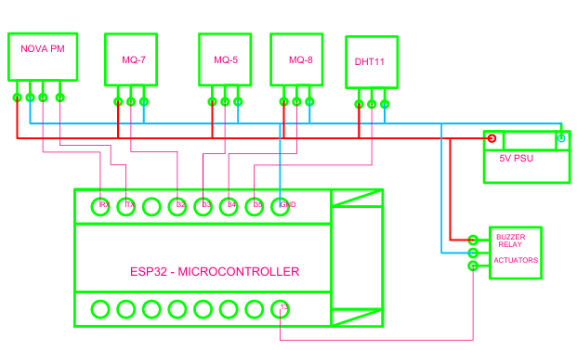
Figure 11: Circuit Connection

3.2.2 Database and Web Development
The real-time database will be developed on firebase studio for storage of the sensor values transmitted from the ESP32 node. The web scripts will be done on visual studio code and configuration keys for the database to enable seamless communication between the database and the web page will be inserted accordingly. The web app will be tested before deploying to the GitHub pages for hosting.

3.2.3 Firmware Development
The program that will enable the ESP32 microcontroller to read values from the sensors, connect to the internet, perform necessary signal processing and package the data for transmission to the firebase database will be developed in Arduino IDE. The configuration keys for the database will be embedded into the program to enable seamless communication between the ESP32 and the firebase real-time database. This program will aid in data collection.

3.3 DATA COLLECTION
DHT11 sensor will be used for temperature and humidity monitoring, PM nova sensor will be used for particulate matter (PM_{2.5} and PM₁₀) monitoring, MQ5 will be used for LPG monitoring, MQ8 will be used for hydrogen monitoring, and MQ7 will be used for foe carbon monoxide (CO) monitoring.
The sensors will take readings of the respective air constituents and transmit the values in terms of a voltage signal to the analog pins of the ESP32 board, the signal will therefore be digitized inside the ESP32 using the analog to digital converters (ADCs) inside the ESP32 board. The values will be quantized within a 12-bit range of 0-4095 depending on the strength of the signal received and transmitted via internet to the firebase real-time database for storage. Through HyperText Transfer Protocol (HTTP), the data will be conveyed to the web application for real-time visualization.
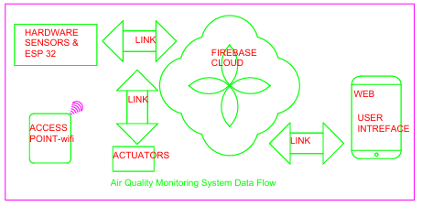
Figure 12: Flow of Data

The data collection exercise will span for a minimum 30 days and all of it will be stored in the firebase database where later it’ll be accessed for analysis. The transfer of the data to the firebase database will occur after every 30 seconds. This is a design property to reduce the number of requests and responses (HTTP protocol) that the ESP32 has to make per unit time during transmission of the data to the cloud based database. This reduces network overhead and improves system stability ensuring the ESP32 doesn’t oveheat and prolongs its life and improves the overall performance of the system.

SYSTEM OPERATION

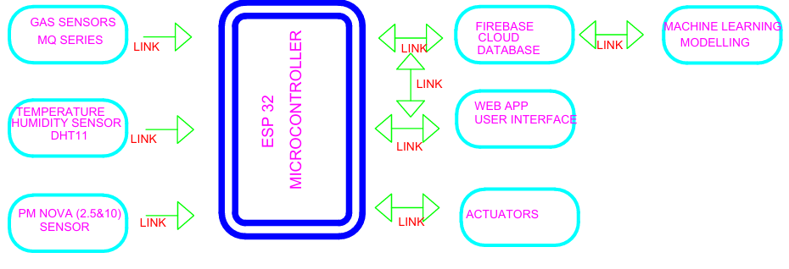
Figure 13: System Block Diagram
Data collected by the sensors will be passed to the ESP32 microcontroller for calibration, packaging and transmission to firebase for the purposes of storage. From firebase the data will be accessed by the web application for real-time visualization. The machine learning unit that is responsible for short term prediction and anomaly detection will access the data from firebase and perform necessary analytics. Depending on the results of the analytics alerts will be disseminated accordingly. The actuators will be activated or deactivated necessarily depending on the output of the analytics.

3.4 DATA ANALYSIS METHODS
Sensor data will be collected and stored in the Firebase database at a fixed interval of 30 seconds for a minimum duration of 30 days. The total number of data points will be estimated using the expression:
(Days × Hours_In_A_day × Minutes_In_Hour × Seconds_In_minute) ÷30
For a 30-day data collection period, this results in approximately 86,400 data points per sensor.
The collected dataset will be preprocessed to remove missing values, handle outliers, and ensure timestamp consistency before further analysis. The cleaned data will be used to train simple machine learning models aimed at short-term prediction and anomaly detection.

3.4.1 Machine Learning Modeling
The following machine learning models will be employed in this project:
I. Decision Tree (DT) - Decision Trees are supervised learning algorithms used for both classification and regression tasks. They operate by recursively splitting the input data based on feature values, forming a tree structure where internal nodes represent decision rules and leaf nodes represent output predictions. Decision Trees are easy to interpret, computationally efficient, and suitable for structured sensor data. However, they are sensitive to small variations in the dataset and are prone to overfitting. To reduce this effect, tree depth and splitting criteria will be controlled during training.
II. Random Forest (RF) - Random Forest is an ensemble learning technique that combines multiple Decision Trees to improve prediction accuracy and robustness. Each tree is trained on a random subset of the dataset, and final predictions are obtained through averaging (for regression) or majority voting (for classification). Random Forest models are less sensitive to noise and provide improved generalization compared to individual Decision Trees. Their main limitation is increased computational cost and reduced interpretability due to the ensemble structure.
III. Isolation Forest (IF)
Isolation Forest is an unsupervised learning algorithm designed for anomaly detection. It works by isolating data points through random partitioning, where anomalies require fewer splits to be isolated compared to normal data points. This model will be used to detect abnormal pollution patterns such as sudden gas concentration spikes that deviate from normal operating conditions.

3.4.2 Models’ Training and Deployment
The collected data will be subdivided in the ratio 80:20 where 80% of the data will be used for the models’ training and the remaining 20% will be used for testing the models. The models’ training will be done locally on the PC and will be run either locally on the PC or remotely on google cloud. The models cannot be run inside the ESP32 board because it’s limited in hardware resources. The predicted values (random Forest, RD) will be displayed on the web dashboard and incase of anomaly detection (Isolation forest, IF) alerts will be triggered on the web dashboard for action.

Model Evaluation
- Mean Absolute Error (MAE) - MAE measures the average magnitude of errors between the predicted values and the actual sensor readings, ignoring the direction of the errors. It is calculated as the arithmetic mean of the absolute differences between predicted and actual values.
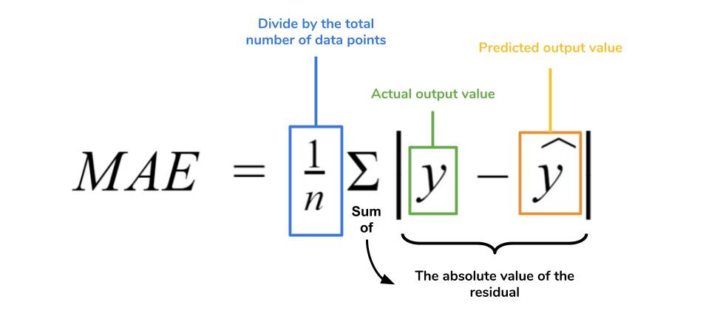
- Root Mean Square Error (RMSE) - RMSE measures the square root of the average squared differences between predicted and actual values:
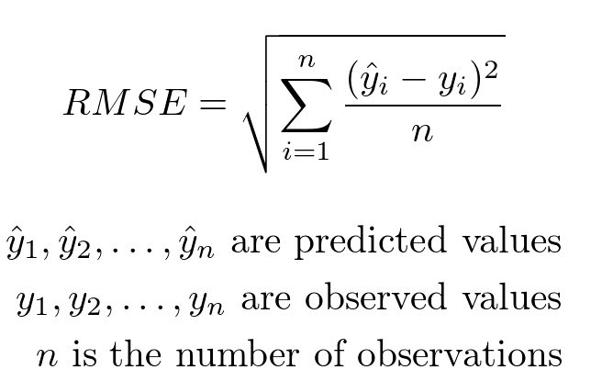

Unlike MAE, RMSE penalizes larger errors more heavily, making it more sensitive to outliers. Together with MAE, RMSE provides a comprehensive view of the model’s prediction accuracy.
- Confusion Matrix
Isolation Forest will be evaluated using a confusion matrix to allow for a detailed assessment of its ability to detect anomalies in air quality. From the confusion matrix, metrics such as accuracy, precision, recall, and F1-score will be derived. This evaluation ensures that the Isolation Forest reliably detects abnormal pollution events, such as sudden spikes in gas concentration, while minimizing false alarms.

SYSTEM FLOWCHART
The flowchart shows flow of the system’s logic. Data is collected by sensors and ESP handles necessary processing for transmission to firebase, from firebase date is visualized on the web app, the machine learning unit (Python server) handles the short term prediction and anomaly detection and from the results alerts are disseminated and necessary actuation mechanisms activated.

Start
Firebase Database

Any Pollutant spike?
DHT11 Sensor
ESP32
Board
Gas Sensors
PM Nova Sensor
Is Actuator needed?
Send Alert
On Web App
NO
YES
NO
Activate
Safety Response System
YES
Air Clean
ML Python Server
Figure 14: System Flow Chart

3.5 PROTOTYPE TESTING
The developed prototype will be tested under both controlled and real-world operating conditions to verify system functionality and performance. Controlled testing will be carried out using simulated pollutant sources to evaluate sensor response, threshold detection, and alert triggering behavior. These tests will be used to confirm correct sensor interfacing, data acquisition, and cloud data transmission. Real-world testing will be conducted in a domestic environment to assess system reliability under normal environmental variations such as temperature changes, ventilation differences, and background pollution levels. Key performance parameters to be evaluated will include sensor responsiveness, alert latency, cloud data update consistency, and web dashboard functionality. The results of these tests will be used to validate that the system meets its intended functional and operational requirements.

3.6 ETHICAL AND SAFETY CONSIDERATIONS
- Gas sources used during controlled testing are handled in well-ventilated environments to minimize the risk of accidental exposure.
- Testing procedures are designed to ensure that no individuals are exposed to hazardous gas concentrations at any stage of system evaluation.
- The system collects only environmental sensor data for research and performance evaluation purposes. No personal or sensitive user data is recorded, and access to stored data is restricted to authorized users.

EXPECTED OUTCOMES
Real-Time Monitoring of Air Pollutants - The system will continuously monitor carbon monoxide, combustible gases (LPG and hydrogen), and particulate matter using MQ-series gas sensors and particulate sensors interfaced with the ESP32 microcontroller. Sensor data will be sampled locally and transmitted to the cloud database every thirty seconds, enabling near real-time observation of pollutant concentration variations in the monitored environment through a web-based dashboard.
Anomaly Detection, Short-Term Prediction, and Automated Alerts - Collected sensor data will be analyzed to identify abnormal patterns such as sudden gas concentration spikes or values exceeding predefined safety thresholds. Machine learning models including Decision Tree (DT), Random Forest (RF), and Isolation Forest (IF) will be applied to historical cloud data to perform short-term prediction of pollutant levels. When abnormal conditions or threshold exceedances are detected, the system will automatically trigger alerts through the cloud platform and display notifications on the web application interface, enabling early detection of potential gas leaks or unsafe air quality events.
Enhanced Environmental Awareness - By providing continuous air quality data, historical trends, and alert notifications, the system will improve user awareness of indoor or localized outdoor environmental conditions. Users will observe how pollutant levels change over time and relate these variations to activities such as cooking, fuel usage, or ventilation, supporting informed decision-making and safer environmental practices based on measured data.

REFERENCES

[1] | E. Bagkis , . A. Hassani, P. Schneider, P. DeSouza, S. Shetty, T. Kassandros and J. Khan, "Evolving trends in application of low-cost air quality sensor networks: challenges and future directions:challenges and future directions," npj Climate and Atmospheric Science, vol. 8, no. 1, p. 335, 2025.
[2] | . R. Kumar, R. Khan , R. Singh, A. Singh, R. Vijay and D. Ather, "Development and Evaluation of an IoT-Based Gas Leakage Detection System Using Arduino Uno. In International Conference on Cyber Intelligence and Information Retrieval," Singapore: Springer Nature Singapore, pp. 307-319, 2023.
[3] | A. Garcia, Y. Saez, I. Harris, X. Huang and E. Collado, "Advancements in air quality monitoring: a systematic review of IoT-based air quality monitoring and AI technologies," Artificial Intelligence Review, vol. 58, no. 9, p. 275, 2025.
[4] | F. Concas, J. Mineraud, E. Lagerspetz, S. Varjonen, X. Liu, S. Tarkoma and K. Puolamäki, "Low-cost outdoor air quality monitoring and sensor calibration: A survey and critical analysis.," ACM Transactions on Sensor Networks (TOSN), vol. 17, no. 2, pp. 1-44, 2021.
[5] | H. Othman, R. Azari and T. Guimarães , "Low-Cost IoT-based Indoor Air Quality Monitoring.," Technology| Architecture+ Design, vol. 8, no. 2, pp. 250-270, 2024.
[6] | M. Tastan, " Machine Learning–Based Calibration and Performance Evaluation of Low-Cost Internet of Things Air Quality Sensors.," Sensors, vol. 25, no. 10, p. 3183, 2025.
[7] | K. Yong-Hyuk and M. Seung-Hyun, "Machine Learning-Based Quality Control for Low-Cost Air Quality Monitoring: A Comprehensive Review of the Past Decade," Atmosphere, vol. 16, no. 10, p. 1136, 2025.
[8] | M. Casari and . L. Po, "Mitigating the Impact of Humidity on Low-Cost PM Sensors," In CEUR WORKSHOP PROCEEDINGS, vol. Vol. 3489, pp. 599-604, 2023.
[9] | . L. Spinelle, . M. Gerboles, . M. G. Villani, . M. Aleixandre and . F. Bonavitacola, " Calibration of a cluster of low-cost sensors for the measurement of air pollution in ambient air," In SENSORS, 2014 IEEE, pp. 21-24, 2014.
[10] | M. Zaid, P. Nawale, V. Kumar, V. Malyan and M. Sahu, "Investigating IoT-Based Low-cost Sensor Network for Real-Time Hyper-Local Air Quality Monitoring and Exposure Assessment.," Atmospheric Pollution Research, p. 102749, 2025.
[11] | R. Ramesh, . H. Vallabhu, A. Unni and . S. Nalinakshan, "IoT-Enabled Air Quality Monitoring: Advancements, Applications, and Challenges.," In 2024 9th International Conference on Communication and Electronics Systems (ICCES), pp. 561-567, 2024.
[12] | Y. M. Idir, O. Orfila, P. Chatellier, V. Judalet and V. Guaffre, "Idir, Y.M., Orfila, O., Chatellier, P., Judalet, V. and Guaffre, V., 2025. Mapping urban air quality using mobile and fixed low cost sensors: a model comparison.," arXiv preprint arXiv, vol. 2511.22550., 2025.
[13] | M. J. Gatari, F. D. Pope, D. Ng'ang'a , A. Poynter and R. Blake, "Airborne particulate matter monitoring in Kenya using calibrated low-cost sensors.," Atmospheric Chemistry and Physics, vol. 18, no. 20, pp. 15403-15418., 2018.
[14] | M. N. Njeru, E. Mwangi, M. J. Gatari, M. I. Kaniu, J. Kanyeria, G. Raheja and D. M. Westervelt, "First results from a calibrated network of low‐cost PM2. 5 monitors in Mombasa, Kenya show exceedance of healthy guidelines," GeoHealth, vol. 8, no. 9, p. e2024GH001049, 2024.
[15] | T. Manshur, C. Luiu, W. R. Avis, V. Bukachi, F. D. Pope, J. Mulligan and M. Gatari, "A citizen science approach for air quality monitoring in a Kenyan informal development.," City and Environment Interactions, vol. 19, p. 100105, 2023.
[16] | B. C., N. L. , M. H. , . D. G. and H. M. , "Community sensitisation using participatory arts-based methods for the research study 'Tupumue: Non-communicable lung disease in Kenya: from burden and early life determinants to participatory inter-disciplinary solutions'," in The Global Health Network Conference 2022: Enabling healthcare in every healthcare setting, University of Cape Town, South Africa, 24–25 Nov. 2022, Cape Town, South Africa, 2023,June.

PROJECT WORKPLAN
The project will span for 8 months.
Project Gantt Chart.

ACTIVITY | SEP | OCT | NOV | DEC | JAN | FEB | MAR | APR
Project topic choice
Introduction and background study on the topic
Literature review and proposal writing
Proposal presentation and submission
Component procurement and prototype building
Web, database, and firmware development.
Prototype deployment, data collection, processing, analysis and machine learning modelling
Project presentation and submission

Figure 15: Project Gantt chart

PROJECT BUDGET

Serial No | Component | DESCRIPTION | Unit cost | Quantity | Total
1 | ESP 32 | DOIT ESP32 DEVKIT V1 | 1500 | 1 | 1500
2 | MQ-SERIES | MQ-135 / MQ-7 gas sensors (analog modules) | 400 | 4 | 1600
3 | NOVA PM | SDS011 PM2.5/PM10 particulate sensor (UART) | 2300 | 1 | 2300
4 | BATTERY | 12 V Li-ion / lead-acid battery, 2–5 Ah typical | 1800 | 1 | 1800
5 | BATTERY CHARGER | charger module | 1200 | 1 | 1200
6 | PSU | AMS1117-3.3 voltage regulator (3.3 V output). | 400 | 1 | 400
7 | JUMPERS | 20 cm male-to-male jumper wires. (common prototyping set) | 250 | 2 | 500
8 | STRIP BOARD | Standard perfboard, proto assembly | 100 | 2 | 200
9 | BREAD BOARD | Standard 830-tie point breadboard. | 200 | 1 | 200
10 | ENCLOSURE | wooden box | 1000 | 1 | 1000
11 | INTERNET | Wi-Fi data connection plan (monthly) | 1000 | 2 | 2000
12 | DHT11 | Temp/humidity sensor module (5 V) | 500 | 1 | 500
13 | ACCESS POINT | Wi-Fi router | 2500 | 1 | 2500
14 | POWERBANK | 10 000 mAh USB power bank | 1200 | 1 | 1200
15 | Miscellaneous | Screws, headers, mounts. | 400 | 1 | 400
16 | LEDS | 5 mm LEDs (e.g., red, green, blue). | 10 | 10 | 100
17 | BUZZER | 5 V active piezo buzzer. | 2 | 20 | 40
18 | PUSH BUTTON | Standard tactile push button/switch | 1 | 20 | 20
19 | RESISTORS | Assorted: 10 kΩ, 4.7 kΩ, 1 kΩ, 220 Ω | 10 | 20 | 200
20 | CAPACITORS | Decoupling and bulk: 100 µF, 10 µF, 0.1 µF | 20 | 10 | 200
 |  |  |  | TOTAL | 17860

Chapter 4: Results.

