
School of Engineering and Architecture
Department of Electrical and Electronics Engineering

IOT-BASED AIR QUALITY MONITORING SYSTEM

Joshua Muthenya Wambua
EG209/109705/22
Tabitha Naisiai
EG209/109725/22
A project submitted in partial fulfillment of the requirements for the award of the Degree of Bachelor of Technology in Electrical and Electronics Engineering in the Department of Electrical and Electronics Engineering at Meru University of Science and Technology.
April, 2026

DECLARATION
We hereby declare that this project proposal is our original work except as cited in the references and has not been presented for the award of a degree in any other University.

Sign: .........................................Date: ...........................................
Joshua Muthenya Wambua
EG209/109705/22
Sign: .........................................Date: ...........................................
Tabitha Naisiai
EG209/109725/22

This report has been submitted for examination with our approval as the University supervisors:
Sign: ....................................... Date: ……...................................
Supervisor: Mr. Job Kerosi

Sign: ....................................... Date: ……...................................
Supervisor: Madam Fiona Atieno

LIST OF ABBREVIATIONS
ESP32 - Espressif 32-bit Microcontroller
IoT – Internet of Things
DHT11 - Digital Humidity and Temperature Sensor
LPG - Liquefied Petroleum Gas
MQ - Metal Oxide Semiconductor Gas Sensor Series
MQ7 - Carbon Monoxide Gas Sensor
PM - Particulate Matter
PM_{2.5} – Particulate Matter with diameter ≤ 2.5 micrometers
PM₁₀- Particulate Matter with diameter ≤ 10 micrometers
ML - Machine Learning
CO - Carbon Monoxide
RMSE - Root Mean Square Error
MAE - Mean Absolute Error
RF – Random Forest
IS – Isolation Forest
DT – Decision Tree

ABSTRACT
Air quality degradation and hazardous gas emissions present significant challenges to public health, safety, and environmental sustainability. Rapid urbanization and industrial activities have increased the concentration of pollutants such as carbon monoxide, methane, and particulate matter (PM2.5 and PM10), while indoor environments remain vulnerable to leaks of liquefied petroleum gas (LPG) and other combustible gases. Existing monitoring systems are largely centralized, costly, and inaccessible for real-time, localized decision-making. This project developed an Internet of Things (IoT)-based air quality monitoring system for real-time detection, analysis, and response to environmental hazards. The system integrates low-cost MQ-series gas sensors, a particulate matter sensor, and a DHT11 temperature and humidity sensor with an ESP32 microcontroller for data acquisition and processing. Data was transmitted to a Firebase cloud platform for storage, visualization, and remote monitoring via a web-based dashboard.
Machine learning models, including Decision Tree, Random Forest, and Isolation Forest, were implemented for prediction and anomaly detection. The Random Forest model achieved improved performance, outperforming the Decision Tree model. The Isolation Forest model effectively identified abnormal pollution spikes, particularly in gas sensor readings, enabling timely hazard detection. The system successfully demonstrated reliable real-time monitoring, predictive capability, and automated alert generation, providing a scalable and cost-effective solution for continuous air quality monitoring and early risk mitigation.

TABLE OF CONTENTS
DECLARATION ii
LIST OF ABBREVIATIONS iii
ABSTRACT iv
LIST OF FIGURES vii
LIST OF TABLES viii
CHAPTER 1: INTRODUCTION 1
1.1 BACKGROUND OF STUDY 1
1.2 PROBLEM STATEMENT 2
1.3 OBJECTIVES 3
1.4 JUSTIFICATION 3
1.5 SCOPE 4
CHAPTER 2: LITERATURE REVIEW 5
2.1 Technologies Used in Air Quality Monitoring 5
2.2 Review of Existing Systems 6
2.3 Research Gaps 7
CHAPTER 3: METHODOLOGY 8
3.1 SYSTEM REQUIREMENTS 8
3.2 SYSTEM DEVELOPMENT 10
3.2.1 Circuit Development 10
3.2.2 Database and Web Development 11
3.2.3 Firmware Development 11
3.3 DATA COLLECTION 12
3.3.1 SYSTEM OPERATION 13
3.4 DATA ANALYSIS METHODS 14
3.4.1 Machine Learning Modeling 14
3.4.2 Models’ Training and Deployment 15
3.4.3 Model Evaluation 15
3.4.4 SYSTEM FLOWCHART 16
3.5 PROTOTYPE TESTING 18
CHAPTER 4: RESULTS 19
4.1 PROTOTYPE, DATABASE, WEBSITE 19
4.2 MACHINE LEARNING MODELS 23
4.3 MODEL PERFORMANCE AND COMPARISON 31
CONCLUSION 32
RECOMMENDATIONS 33
REFERENCES 34

LIST OF FIGURES
Figure 1:Passive Buzzer 9
Figure 2: ESP32 Board 9
Figure 3: DHT11 Sensor 9
Figure 4: LCD Display 9
Figure 5: PM nova Sensor 9
Figure 6: MQ8 Sensor 9
Figure 7:MQ2 Sensor 9
Figure 8: 4_way relay Channel 9
Figure 9: MQ7 Sensor 9
Figure 10: Voltage Regulator 9
Figure 11: Circuit Connection 10
Figure 12: Flow of Data 12
Figure 13: System Block Diagram 13
Figure 14: System Flow Chart 17
Figure 15: LPG and CO testing. 18
Figure 16: prototype, web, and DB. 21
Figure 17: DT actual vs predicteg 23
Figure 18:DT time series 24
Figure 19: DT performance 25
Figure 20: RF actual vs predicted 26
Figure 21:RF time series 27
Figure 22: RF performance. 28
Figure 23: IS anomaly distribution 29
Figure 24:IS anomaly score 30

LIST OF TABLES
Table 1: sample of data collected. 22
Table 2: model performance comparison 31

CHAPTER 1: INTRODUCTION

1.1 BACKGROUND OF STUDY
Air quality degradation is a major environmental and public health concern worldwide. Rapid urbanization, industrial activities, transportation growth, and population increase have significantly elevated the emission of harmful pollutants such as particulate matter (PM2.5 and PM10), carbon oxides, methane, and volatile organic compounds [1]. These pollutants are associated with respiratory diseases, cardiovascular conditions, and adverse climate effects [1]. In addition to outdoor pollution, indoor environments are also exposed to risks from hazardous gas leaks such as liquefied petroleum gas (LPG) and methane, which may result in poisoning, fire outbreaks, and explosions [2].
Despite the existence of government-operated air quality monitoring stations in major urban areas, monitoring systems remain largely centralized, expensive, and inaccessible at the household level [1]. Consequently, individuals lack real-time, localized information about air quality conditions in their immediate environment, limiting their ability to respond to potential hazards [3].
Advancements in Internet of Things (IoT), cloud computing, and machine learning have enabled the development of low-cost, scalable, and distributed monitoring systems [3]. In this project, an IoT-based air quality monitoring system was developed to address these limitations. The system integrated low-cost gas sensors (MQ-series), particulate matter sensors, and environmental sensors (DHT11) with an ESP32 microcontroller to enable continuous monitoring of air pollutants and hazardous gases [4]; [5].
The system incorporated cloud-based storage and web-based visualization for real-time access to environmental data. In addition, machine learning techniques were implemented to support short-term prediction and anomaly detection, enhancing the system’s ability to identify abnormal pollution levels [3]; [6]; [7]. A safety response mechanism was also integrated to enable automated alerts and actuation in the presence of hazardous conditions, thereby improving risk mitigation at the household level [2].
Environmental factors such as temperature and humidity were observed to influence sensor performance and measurement accuracy, necessitating calibration and compensation techniques [8]; [9]. Therefore, the developed system provides a practical and scalable solution for improving environmental monitoring, enhancing public safety, and bridging the gap between centralized monitoring systems and household-level accessibility [5].

1.2 PROBLEM STATEMENT
Air pollution and hazardous gas exposure remain significant challenges in both urban and domestic environments due to increasing industrial activity, vehicle emissions, and the widespread use of gas-powered appliances. In many residential and small business settings, exposure to pollutants such as carbon monoxide and combustible gases often goes undetected until adverse health effects, fires, or explosions occur, leading to increased risks of injury, property damage, and loss of life. Existing air quality and gas monitoring systems are largely centralized, expensive, and primarily designed for industrial or regulatory applications. As a result, they are inaccessible to most households and small enterprises and do not provide continuous, real-time, and location-specific monitoring at the point of exposure. This lack of accessible monitoring limits early detection and timely response to hazardous conditions. The absence of a cost-effective, real-time, and localized monitoring solution therefore creates a critical gap in environmental safety and public health, leaving communities reactive rather than proactive in managing air pollution and gas-related risks. Addressing this challenge requires the development of an affordable and scalable system capable of continuous monitoring, early hazard detection, real-time alert generation, and automated safety response.

1.3 OBJECTIVES
Main Objective
To design and implement a scalable IoT-based air quality monitoring system capable of real-time detection, prediction, alert generation, and actuation.
Specific Objectives
- To measure and log air pollutants (PM2.5, PM10, H, CO, and LPG) along with temperature and humidity using low-cost sensors interfaced with an ESP32 microcontroller.
- To transmit the collected data to a cloud platform for real-time visualization, predictive modeling of air quality trends, and threshold-based alert generation through a web-based interface.
- To implement automated actuation mechanisms that respond to detected hazards or predicted unsafe conditions, such as activating ventilation systems or triggering safety alerts.

1.4 JUSTIFICATION
Air quality monitoring solutions are predominantly confined to government-operated or industrial-scale installations, limiting accessibility for households and small businesses. As a result, individuals are often exposed to hazardous pollutants and gas leaks without timely detection or warning. A resource-efficient and scalable IoT-based air quality monitoring system addresses this gap by enabling real-time monitoring, early detection of hazardous conditions, and automated alert mechanisms that enhance public safety. The system provides accessible environmental data that supports informed decision-making at both individual and community levels, thereby reducing exposure-related health risks. The integration of machine learning techniques enables predictive analysis and anomaly detection, improving the system’s capability beyond conventional monitoring approaches. This project therefore presents a practical, research-based solution for enhancing environmental monitoring, public awareness, and safety.

1.5 SCOPE
This project focuses on the design and implementation of an IoT-based air quality monitoring system using low-cost gas sensors, particulate matter sensors, environmental sensors, actuators, and an ESP32 microcontroller. The system performs real-time data acquisition, wireless transmission to a cloud platform (Firebase Realtime Database), web-based data visualization, safety response, and predictive modeling for anomaly detection and short-term forecasting. The scope of the project includes hardware integration, firmware development, cloud connectivity, web application development, alert system implementation, and evaluation of system performance under real-world conditions. However, the project does not cover large-scale industrial deployment, regulatory certification standards, or nationwide monitoring systems. The focus is limited to household, urban, agricultural, and small-scale environments where cost-effective and scalable monitoring solutions are required.

CHAPTER 2: LITERATURE REVIEW
Air quality monitoring has become increasingly important due to rising pollution levels and associated health risks. Traditional reference-grade monitoring stations provide high measurement accuracy but are expensive and sparsely distributed, limiting their spatial coverage and accessibility. Bagkis et al. [1]; Kumar et al. [2] highlighted the technological evolution of low-cost sensor networks and emphasized the need for scalable, distributed monitoring solutions. Similarly, Garcia et al. [3] noted that centralized systems restrict accessibility and integration with modern digital infrastructures.
Recent research has therefore shifted toward low-cost sensors and IoT-based systems to improve real-time environmental monitoring. Concas et al. [4] surveyed low-cost outdoor air quality monitoring systems, discussing calibration challenges, sensor drift, and cross-sensitivity effects. Their work emphasized proper calibration strategies for reliable deployment at scale.

2.1 Technologies Used in Air Quality Monitoring
Low-cost sensors are increasingly preferred for distributed monitoring due to their affordability and compact size. Concas et al. [4] explained that sensor drift and environmental interference can affect measurement accuracy over time. Environmental conditions further impact sensor performance. Spinelle et al. [14] showed that temperature and humidity variations influence sensor sensitivity and stability, while Casari and Po [5] reported that high humidity inflates particulate matter readings due to hygroscopic growth.
To address these challenges, IoT architectures and machine learning techniques are widely used. Zaid et al. [6] developed an IoT-based low-cost sensor network capable of reliable wireless data transmission, real-time monitoring, and cloud storage. Ramesh et al. [7] reported that integrating sensors with microcontrollers and cloud dashboards enables real-time monitoring and early hazard detection. Garcia et al. [3] also highlighted the use of AI to improve predictive analytics and system automation.

Machine learning has improved sensor reliability and data accuracy. Tastan [8] applied machine learning for sensor calibration and reported improvements in measurement accuracy and stability. Kim and Seung-Hyun [9] reviewed a decade of machine learning methods for correcting sensor drift and noise, including Random Forest, SVM, and deep learning. Idir et al. [10] compared predictive models for urban air quality using mobile and fixed sensors, showing that data fusion enhances spatial resolution and forecasting accuracy.

2.2 Review of Existing Systems
Several studies have demonstrated the practical deployment of low-cost monitoring systems. Gatari et al. [11] conducted one of the earliest studies in Kenya using calibrated particulate matter sensors, validating their accuracy against reference instruments. Njeru et al. [12] deployed a PM2.5 sensor network in Mombasa, Kenya, reporting frequent exceedances of health-based air quality guidelines, indicating high exposure risks.
Community-integrated approaches improve monitoring effectiveness. Manshur et al. [13] implemented citizen-science air quality monitoring in a Kenyan informal settlement, showing both technical feasibility and social value. Bowyer et al. [14] demonstrated that participatory arts-based methods, such as theatre, music, murals, and school outreach, increase awareness and participation in air pollution studies.
Indoor and household-level monitoring systems are increasingly emphasized. Othman et al. [15] reviewed low-cost IoT-based indoor air quality monitoring systems, highlighting low power requirements and suitability for household deployment. Kumar et al. [2] developed a gas leakage detection system with automated alerts, showing the importance of safety response mechanisms in household monitoring.
Ramesh et al. [7] identified safety response mechanisms as a key component of air quality monitoring systems, enabling real-time hazard detection and mitigation.

2.3 Research Gaps
Despite advances in low-cost sensors, IoT platforms, and machine learning, several gaps remain. Household-level access to reliable air quality monitoring is still limited. Many current systems lack real-time alert mechanisms and predictive analytics integration. Community engagement strategies are often underutilized, reducing participation and trust. Finally, sensor performance can be affected by environmental conditions, and more work is needed to maintain accuracy under varying temperature and humidity. These gaps justify the development of an integrated solution combining distributed sensors, IoT communication, cloud-based data management, machine learning analytics, and community engagement to provide accessible and actionable air quality information.

CHAPTER 3: METHODOLOGY

3.1 SYSTEM REQUIREMENTS
- ESP32 microcontroller.
- DHT11 sensor - Temperature and humidity.
- Mq7 sensor - carbon monoxide(CO).
- MQ8 sensor – Hydrogen Gas
- MQ2 sensor - LPG
- Nova PM sensor Particulate matter.
- Breadboard and stripboard.
- 12 V battery and battery charger.
- Powerbank.
- Buzzer.
- Relay.
- Jumper wires.
- Firebase
- Arduino IDE
- Visual studio code
- GitHub
- LCD Display.
- Voltage regulator

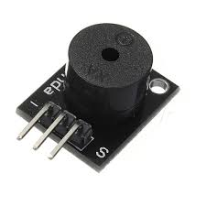  Figure 1:Passive Buzzer | 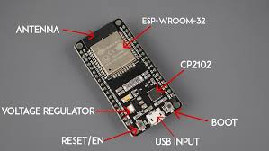  Figure 2: ESP32 Board
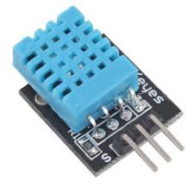  Figure 3: DHT11 Sensor | 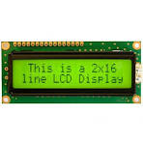  Figure 4: LCD Display
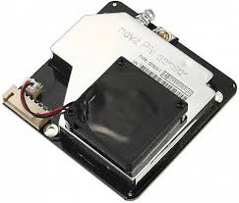  Figure 5: PM nova Sensor | 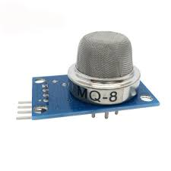  Figure 6: MQ8 Sensor
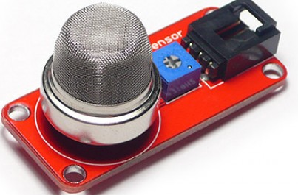  Figure 7:MQ2 Sensor | 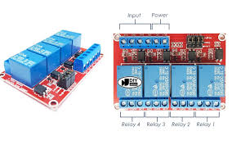  Figure 8: 4_way relay Channel
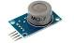  Figure 9: MQ7 Sensor | 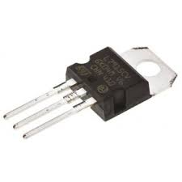  Figure 10: Voltage Regulator

3.2 SYSTEM DEVELOPMENT

3.2.1 Circuit Development
The sensors’ Vcc pins were connected to the +5V output of the power supply unit (PSU), while their ground pins were connected to the PSU ground terminal. The sensors were not powered directly from the ESP32 5V pin because their combined current requirements exceeded the supply capacity of the ESP32 onboard voltage regulator. Supplying the sensors from the ESP32 could therefore have resulted in overheating or permanent damage to the board. To ensure stable and accurate signal acquisition, the ground of the ESP32 was connected to the PSU ground, establishing a common reference point for all components. This common grounding minimized noise and ensured reliable sensor readings.

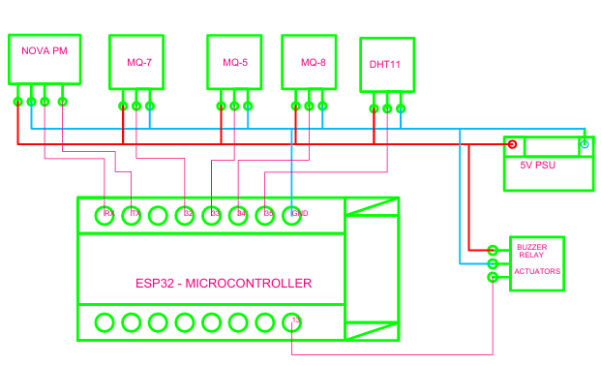
Figure 11: Circuit Connection

3.2.2 Database and Web Development
The system database was implemented using Firebase Realtime Database to store sensor values transmitted from the ESP32 node. The web interface was developed using Visual Studio Code, where client-side scripts were written to retrieve, process, and visualize the stored sensor data. Firebase configuration keys and authentication parameters were integrated into the web application to enable secure and reliable communication between the database and the frontend interface. The system was tested to verify data retrieval accuracy and real-time update consistency prior to deployment. After successful validation, the web application was hosted using GitHub Pages to provide remote accessibility and continuous monitoring of environmental parameters. The deployed web dashboard is accessible at: https://joshuawambua.github.io/ecosphere1/ . The source code for the system is available at: https://github.com/joshuawambua/project_IOT.git

3.2.3 Firmware Development
The firmware for the ESP32 microcontroller was developed using the Arduino Integrated Development Environment (IDE). The program was responsible for reading sensor values, establishing Wi-Fi connectivity, performing basic signal conditioning, and packaging the data for transmission to the Firebase Realtime Database. Firebase authentication credentials and database configuration parameters were embedded within the firmware to enable direct communication between the ESP32 and the cloud database. The microcontroller periodically collected sensor data, converted analog signals to digital values using its internal analog-to-digital converter (ADC), and transmitted the processed data via HTTP protocol. This firmware enabled continuous data acquisition and real-time synchronization between the physical sensor nodes and the cloud-based monitoring system. The source code for the firmware is available in the project repository at: https://github.com/joshuawambua/project_IOT.git

3.3 DATA COLLECTION
The DHT11 sensor was used for temperature and humidity monitoring, the Nova PM sensor was used for particulate matter (PM2.5 and PM10) detection, the MQ2 sensor was used for LPG monitoring, the MQ8 sensor for hydrogen gas detection, and the MQ7 sensor for carbon monoxide (CO) monitoring. The sensors measured their respective air quality parameters and produced analog voltage signals, which were fed into the analog input pins of the ESP32 microcontroller. The signals were then digitized using the ESP32’s internal analog-to-digital converters (ADCs). The digital values were quantized within a 12-bit resolution range of 0 to 4095, depending on the input signal strength. The processed data was transmitted over the internet to the Firebase Realtime Database for storage. Using the Hypertext Transfer Protocol (HTTP), the stored data was subsequently accessed by the web application for real-time visualization.
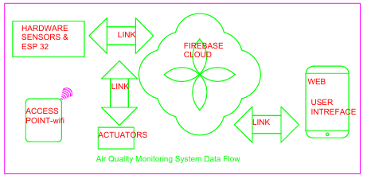
Figure 12: Flow of Data

The data collection process spanned 27 days, during which all sensor readings were continuously stored in the Firebase database and later retrieved for analysis. Data transmission to the cloud was performed at 30-second intervals. This reduced the frequency of HTTP requests between the ESP32 and the server, thereby minimizing network overhead and improving system stability and reliability.

3.3.1 SYSTEM OPERATION

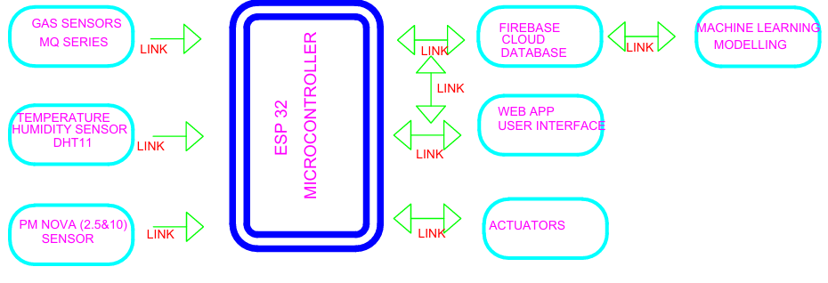
Figure 13: System Block Diagram
Data collected by the sensors is passed to the ESP32 microcontroller for calibration, packaging, and transmission to Firebase for storage. From Firebase, the data is accessed by the web application for real-time visualization. The machine learning unit, which is responsible for short-term prediction and anomaly detection, accesses the data from Firebase and performs the necessary analytics. Depending on the results of the analytics, alerts are disseminated accordingly. The actuator is activated or deactivated depending on the output of the analytics.

3.4 DATA ANALYSIS METHODS
Sensor data was collected and stored in the Firebase Realtime Database at a fixed interval of 30 seconds over a duration of 27 days. The theoretical number of data points was estimated using the expression:
(Days × Hours in a Day × Minutes in an Hour × Seconds in a Minute) ÷ 30
For a 27-day collection period, this corresponds to approximately 66,919 data points per sensor. However, minor data losses were observed during system operation due to occasional network interruptions and temporary system downtimes. These interruptions led to missing entries in the dataset, which is common in real-world IoT deployments. The collected dataset was therefore preprocessed to remove missing values, handle outliers, and ensure timestamp consistency before further analysis. The cleaned dataset was then used to train machine learning models for short-term prediction and anomaly detection.

3.4.1 Machine Learning Modeling
The following machine learning models were employed in this project:
- Decision Tree (DT)
Decision Trees are supervised learning algorithms used for both classification and regression tasks. They operate by recursively splitting input data based on feature values, forming a tree structure in which internal nodes represent decision rules and leaf nodes represent output predictions. Decision Trees are easy to interpret, computationally efficient, and suitable for structured sensor data. However, they are sensitive to small variations in the dataset and are prone to overfitting. To reduce this effect, tree depth and splitting criteria were controlled during training.

- Random Forest (RF)
Random Forest is an ensemble learning technique that combines multiple Decision Trees to improve prediction accuracy and robustness. Each tree was trained on a random subset of the dataset, and final predictions were obtained through averaging in the case of regression. Random Forest models are less sensitive to noise and provide improved generalization compared to individual Decision Trees. However, they have higher computational cost and reduced interpretability due to their ensemble structure.
- Isolation Forest (IF)
Isolation Forest is an unsupervised learning algorithm used for anomaly detection. It isolates data points through random partitioning, where anomalies require fewer splits to be isolated compared to normal observations. This model was used to detect abnormal pollution patterns such as sudden gas concentration spikes that deviated from normal operating conditions.

3.4.2 Models’ Training and Deployment
The collected dataset was split into an 80:20 ratio, where 80% of the data was used for training the machine learning models and the remaining 20% was used for testing. Model training was performed locally on a personal computer. Predicted values from the Random Forest model were displayed on the web dashboard, while anomaly detection results from the Isolation Forest model triggered alerts on the dashboard when abnormal conditions were detected.

Model Evaluation
- Mean Absolute Error (MAE) - MAE measured the average magnitude of errors between the predicted values and the actual sensor readings, ignoring the direction of the errors. It was calculated as the arithmetic mean of the absolute differences between predicted and actual values.
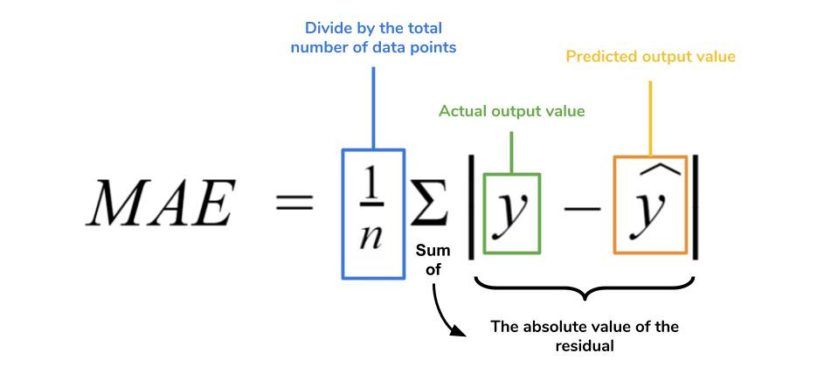
- Root Mean Square Error (RMSE) - RMSE measured the square root of the average squared differences between predicted and actual values:
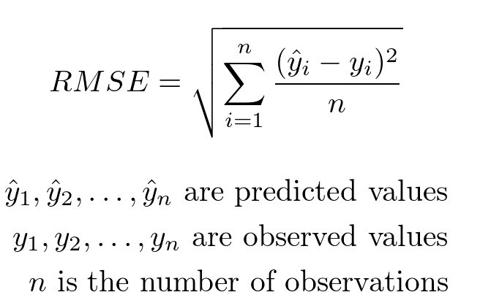

Unlike MAE, RMSE penalized larger errors more heavily, making it more sensitive to outliers. Together with MAE, RMSE provided a comprehensive view of the model’s prediction accuracy.
- Coefficient of Determination (R² Score) - R² measures how well the model explains the variability of the target data. It indicates the proportion of variance in the dependent variable that is predictable from the independent variables. An R² value closer to 1 indicates a better fit, meaning the model explains most of the variability in the data, while a value closer to 0 indicates poor predictive performance.


SYSTEM FLOWCHART
The flowchart shows flow of the system’s logic. Data is collected by sensors and ESP handles necessary processing for transmission to firebase, from firebase date is visualized on the web app, the machine learning unit (Python server) handles the short term prediction and anomaly detection and from the results alerts are disseminated and necessary actuation mechanisms activated.

Start
Firebase Database

Any Pollutant spike?
DHT11 Sensor
ESP32
Board
Gas Sensors
PM Nova Sensor
Is Actuator needed?
Send Alert
On Web App
NO
YES
NO
Activate
Safety Response System
YES
Air Clean
ML Python Server
Figure 14: System Flow Chart

3.5 PROTOTYPE TESTING
The images below show testing for LPG and CO. The paper provides smoke that has some CO and the lighter contains a combustible gas.
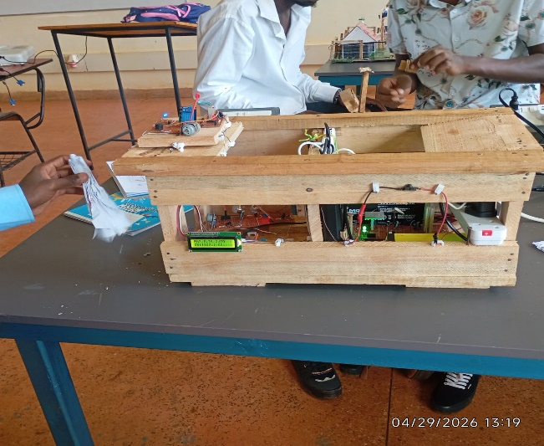  1: CO testing | 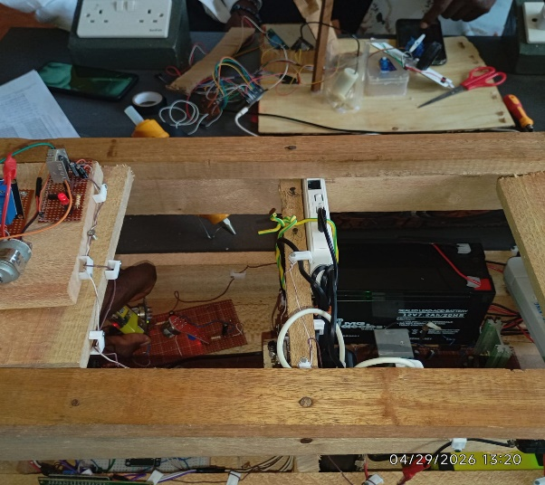  2: LPG(combustible gas testing)
Figure 15: LPG and CO testing.

CHAPTER 4: RESULTS

4.1 PROTOTYPE, DATABASE, WEBSITE
The figures below show what was achieved and they also demonstrate how the system worked visually. The first figure shows the prototype developed with a paper being burnt on the sensor subsystem side. The paper produces smoke which is sensed by MQ7 sensor, the value sensed is passed to ESP32 which transmits it to Firebase Real Time Database (Figure 2) from where the dashboard (figure 3) obtains the data and displays it. The smoke from the paper is a form of air quality degradation so the actuation subsystem is activated as a safety response (figure 4)
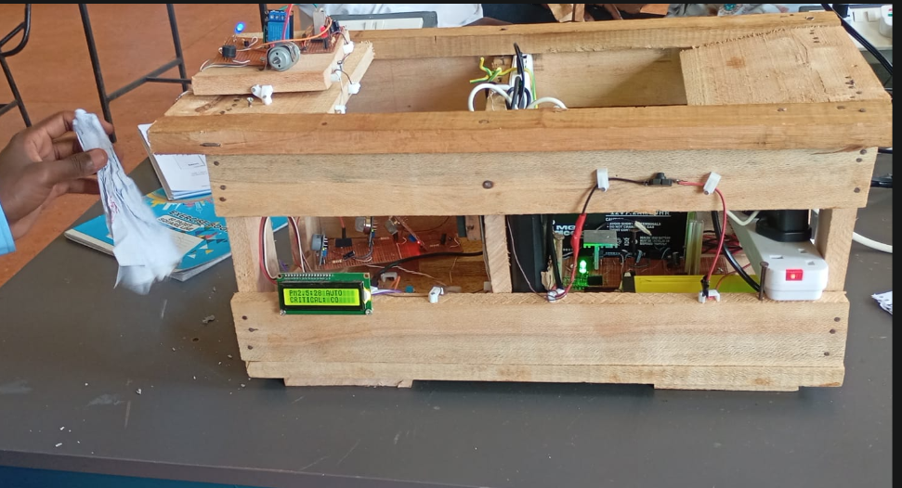
prototype
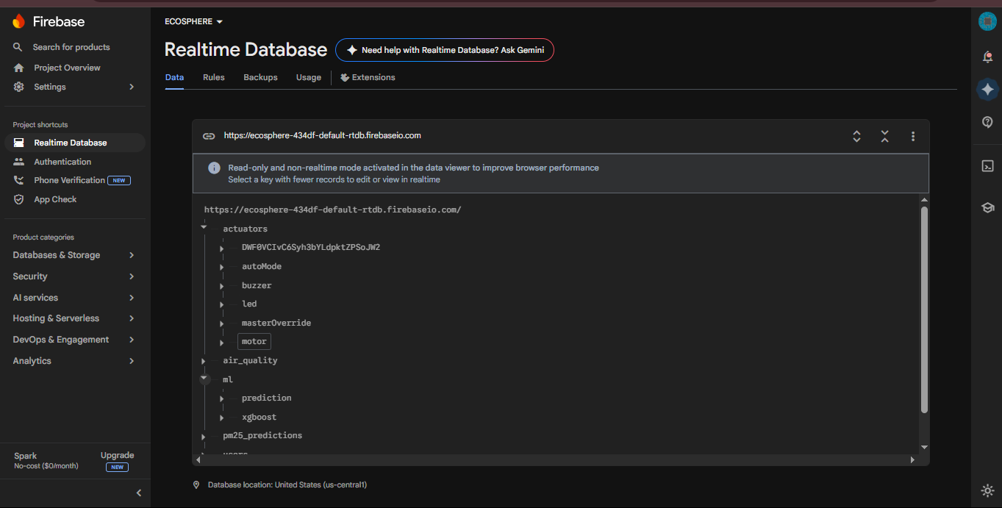
database
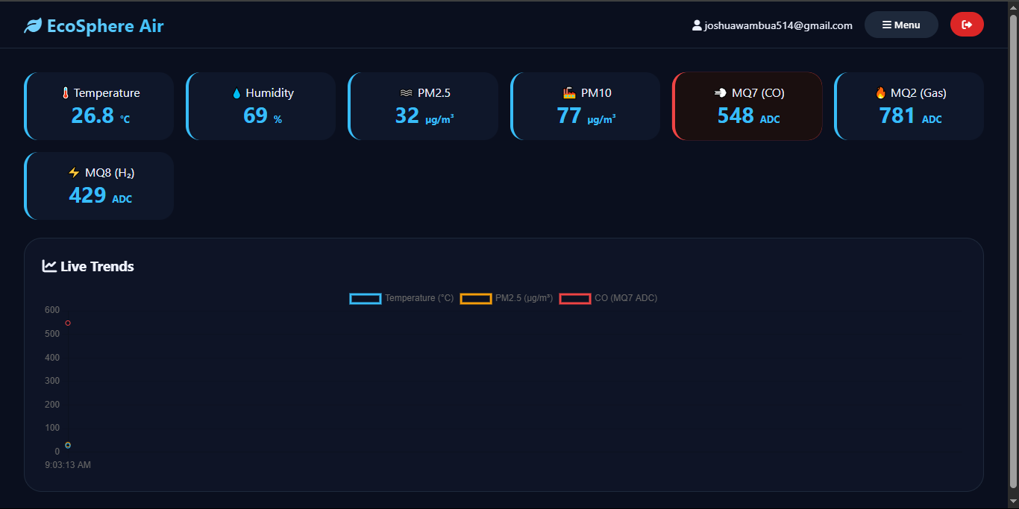
dashboard
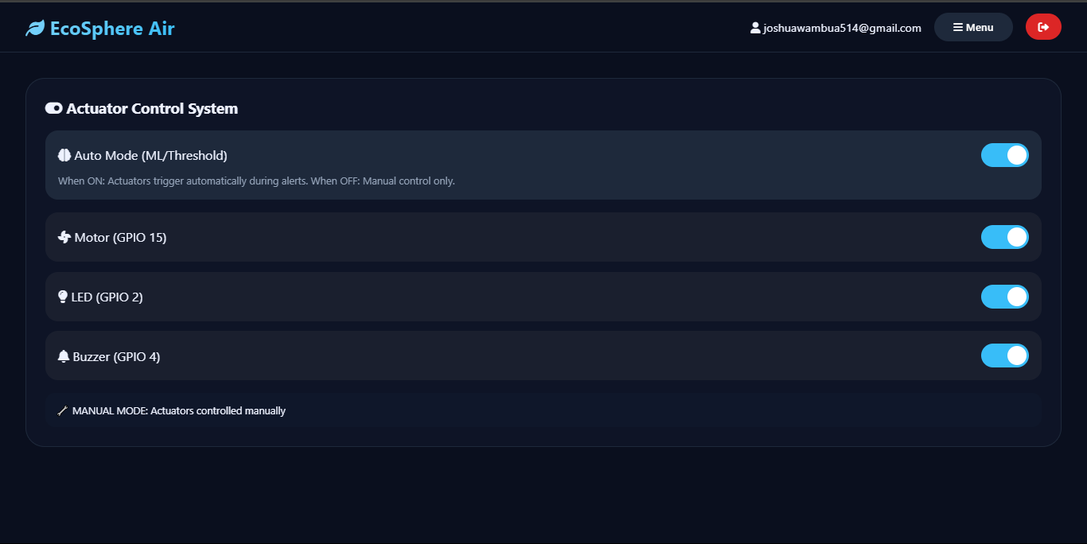
Dashboard-actuators page
Figure 16: prototype, web, and DB.

The table below shows part of data collected, a total of 66919 30-sec separated data was collected. the complete data can be accessed on the project repository: https://github.com/joshuawambua/project_IOT.git

id | reading_time | year | month | day | hour | minute | second | temperature | humidity | pm25 | pm10 | mq2 | mq7 | mq8
83 | 3/9/2026 0:42 | 2026 | 3 | 9 | 0 | 42 | 5 | 24.1 | 72.1 | 136 | 144 | 452 | 600 | 319
84 | 3/9/2026 0:42 | 2026 | 3 | 9 | 0 | 42 | 35 | 24.1 | 72.2 | 134 | 143 | 456 | 596 | 284
85 | 3/9/2026 0:43 | 2026 | 3 | 9 | 0 | 43 | 6 | 24.1 | 72.1 | 138 | 147 | 454 | 592 | 292
86 | 3/9/2026 0:43 | 2026 | 3 | 9 | 0 | 43 | 36 | 24.1 | 72.2 | 139 | 148 | 459 | 593 | 280
87 | 3/9/2026 0:44 | 2026 | 3 | 9 | 0 | 44 | 6 | 24.1 | 72.3 | 139 | 147 | 457 | 602 | 315
88 | 3/9/2026 0:44 | 2026 | 3 | 9 | 0 | 44 | 37 | 24.1 | 72.2 | 138 | 147 | 457 | 660 | 321
89 | 3/9/2026 0:45 | 2026 | 3 | 9 | 0 | 45 | 7 | 24.1 | 72.5 | 140 | 150 | 458 | 598 | 319
90 | 3/9/2026 0:45 | 2026 | 3 | 9 | 0 | 45 | 37 | 24.1 | 72.3 | 139 | 147 | 458 | 539 | 285
91 | 3/9/2026 0:46 | 2026 | 3 | 9 | 0 | 46 | 7 | 24.1 | 72.3 | 140 | 149 | 455 | 589 | 314
92 | 3/9/2026 0:46 | 2026 | 3 | 9 | 0 | 46 | 37 | 24.1 | 72.2 | 138 | 146 | 467 | 597 | 287
93 | 3/9/2026 0:47 | 2026 | 3 | 9 | 0 | 47 | 7 | 24.1 | 72.3 | 133 | 141 | 409 | 594 | 318
94 | 3/9/2026 0:47 | 2026 | 3 | 9 | 0 | 47 | 37 | 24.1 | 72.3 | 138 | 149 | 407 | 535 | 321
95 | 3/9/2026 0:48 | 2026 | 3 | 9 | 0 | 48 | 7 | 24.1 | 72.5 | 138 | 147 | 420 | 599 | 318
96 | 3/9/2026 0:48 | 2026 | 3 | 9 | 0 | 48 | 37 | 24 | 72.4 | 138 | 147 | 453 | 600 | 318
97 | 3/9/2026 0:49 | 2026 | 3 | 9 | 0 | 49 | 8 | 24.1 | 72.3 | 136 | 145 | 455 | 597 | 320
98 | 3/9/2026 0:49 | 2026 | 3 | 9 | 0 | 49 | 38 | 24.1 | 72.2 | 140 | 150 | 453 | 584 | 317
99 | 3/9/2026 0:50 | 2026 | 3 | 9 | 0 | 50 | 8 | 24.1 | 72.1 | 136 | 144 | 454 | 577 | 294
100 | 3/9/2026 0:50 | 2026 | 3 | 9 | 0 | 50 | 38 | 24 | 72.3 | 133 | 142 | 451 | 533 | 320
Table 1: sample of data collected.

4.2 MACHINE LEARNING MODELS
Data collected (66919) was split into 80:20 ratio, where 80%(53535) of the data was used to train the models and the 20%(13383) was used for testing. The source codes together with the models can be accessed from the project repository: https://github.com/joshuawambua/project_IOT.git

The plots show below in each model are the outputs of testing of the models. The plots are provided in the repository too. The plots form the basis for the model performance and comparison.
- Decision Tree (DT)

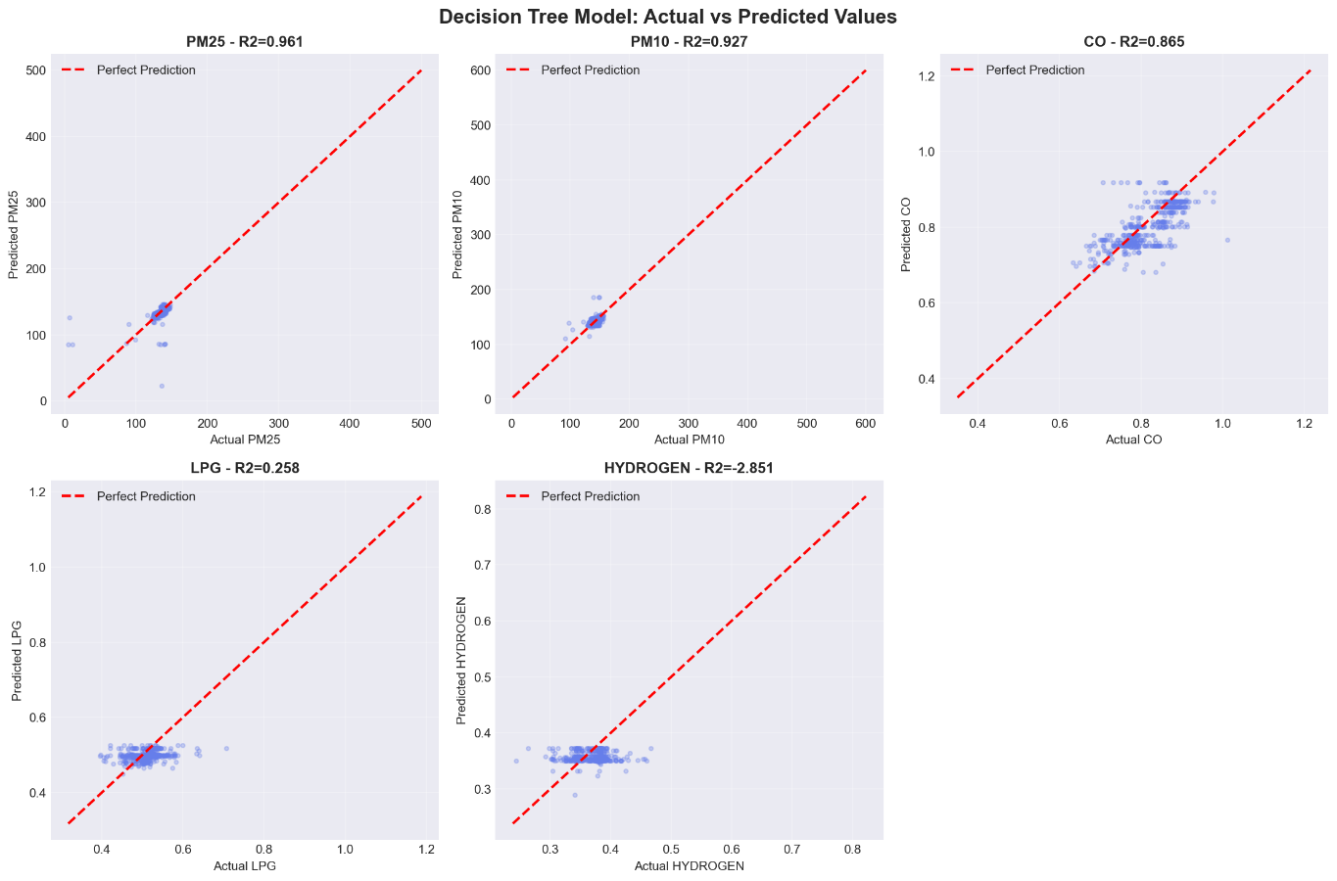
Figure 17: DT actual vs predicted
The plot shows the comparison between actual and predicted values generated by the Decision Tree model. The model captures general trends in the data, but noticeable deviations occur due to its sensitivity to noise and tendency to over fit.
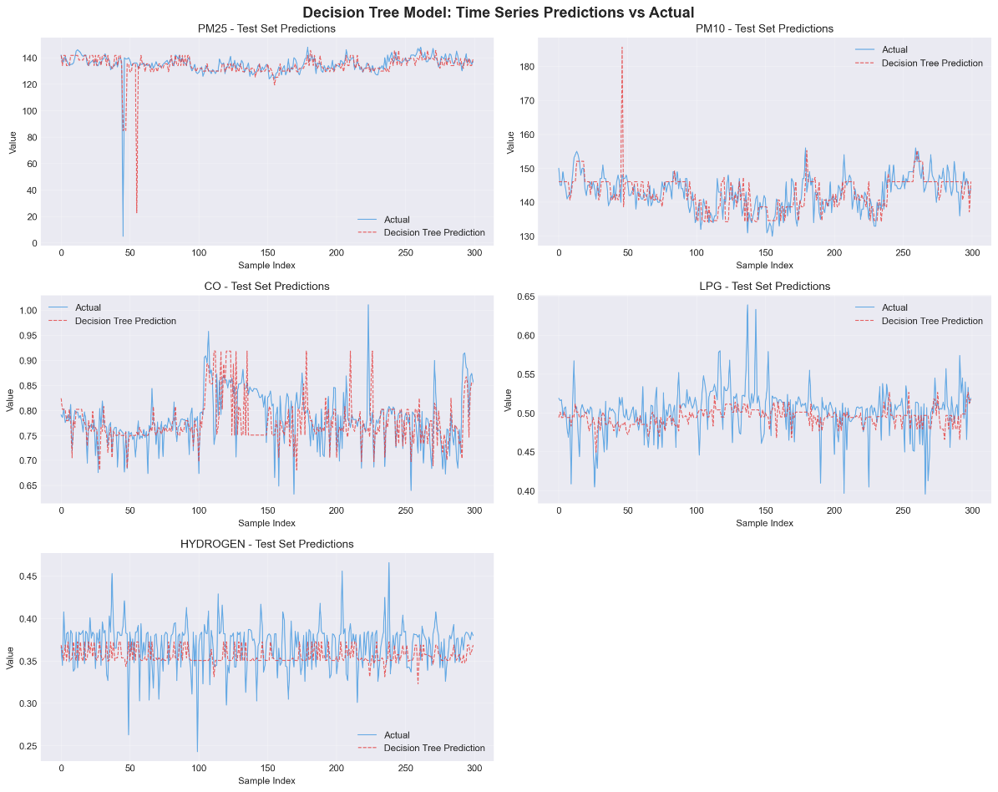
Figure 18:DT time series
The time series plot shows how the Decision Tree model tracks variations in sensor readings over time. While overall trends are captured, fluctuations in prediction accuracy are observed during sudden environmental changes.

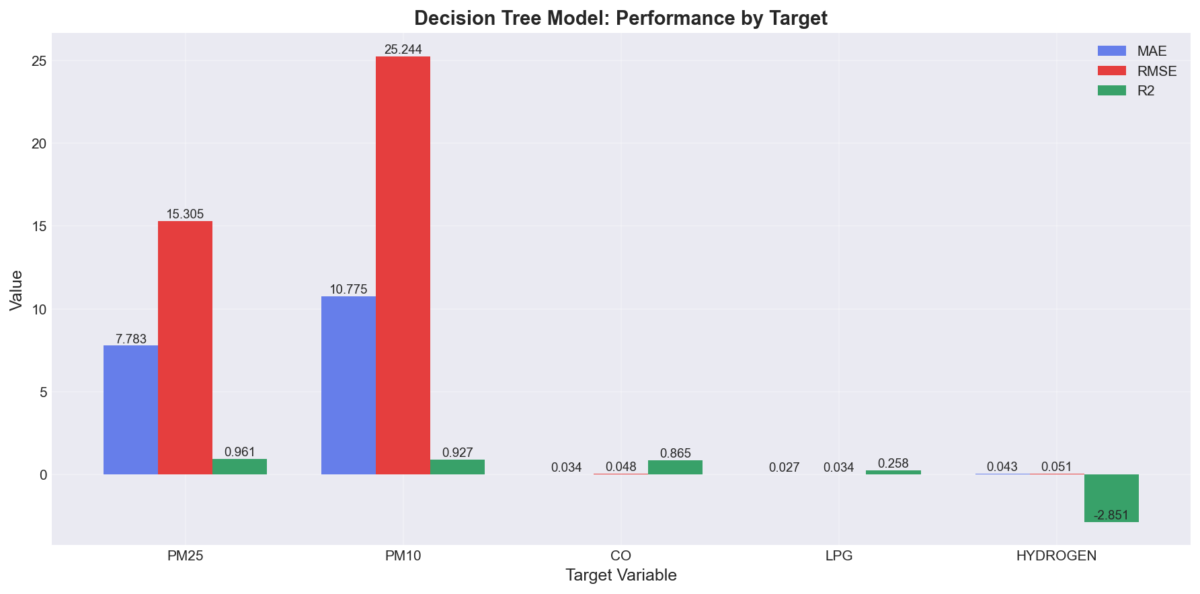
Figure 19: DT performance
The evaluation metrics indicate moderate performance of the Decision Tree model across all parameters. Higher error values and lower R² in some cases show limited predictive accuracy for complex environmental variables.

- Random Forest (RF)

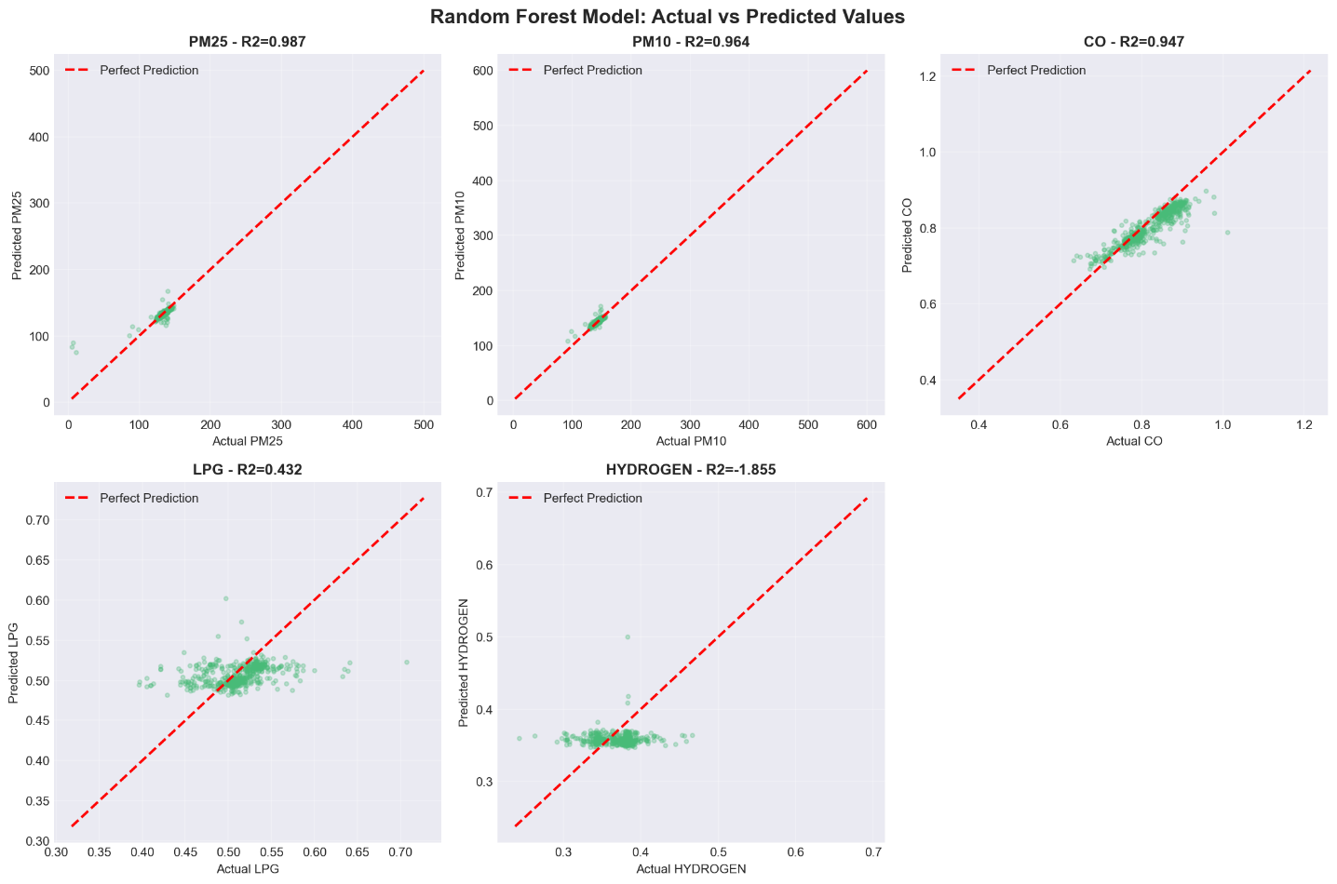
Figure 20: RF actual vs predicted
The plot illustrates a strong alignment between predicted and actual values from the Random Forest model. The reduced deviation indicates improved accuracy and better generalization compared to the Decision Tree model.

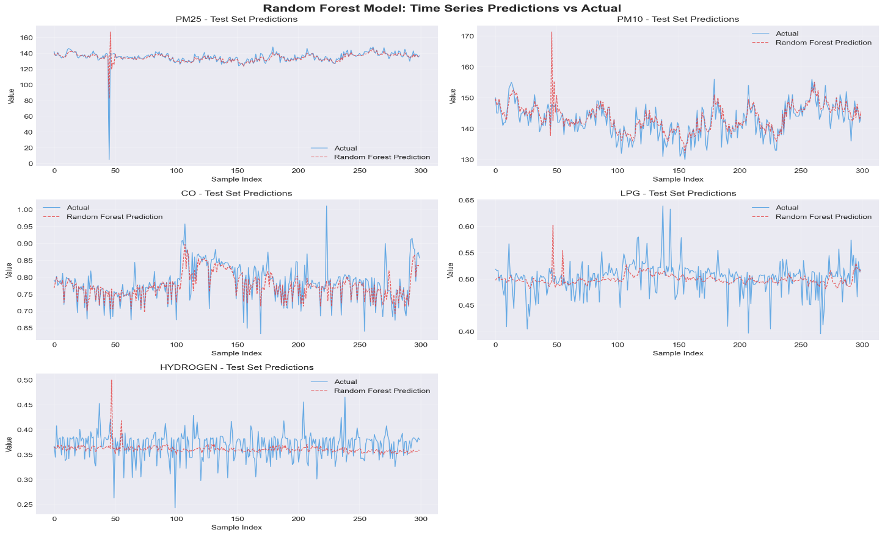
Figure 21:RF time series
The Random Forest model closely follows the actual time series patterns of the sensor data. Its ensemble structure provides smoother and more stable predictions over time.
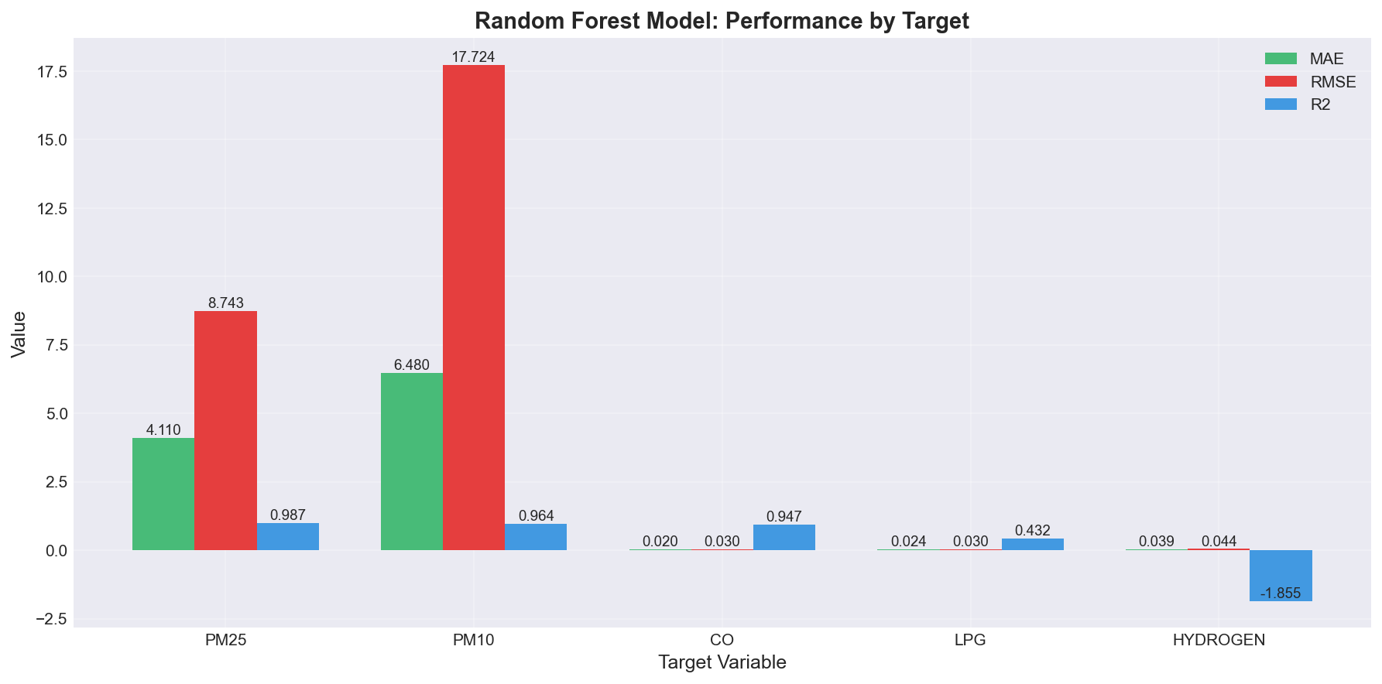
Figure 22: RF performance.
The Random Forest model shows improved performance with lower MAE and RMSE values and higher R² scores. This confirms better prediction accuracy and stronger generalization compared to the Decision Tree model.

- Isolation Forest (IF)

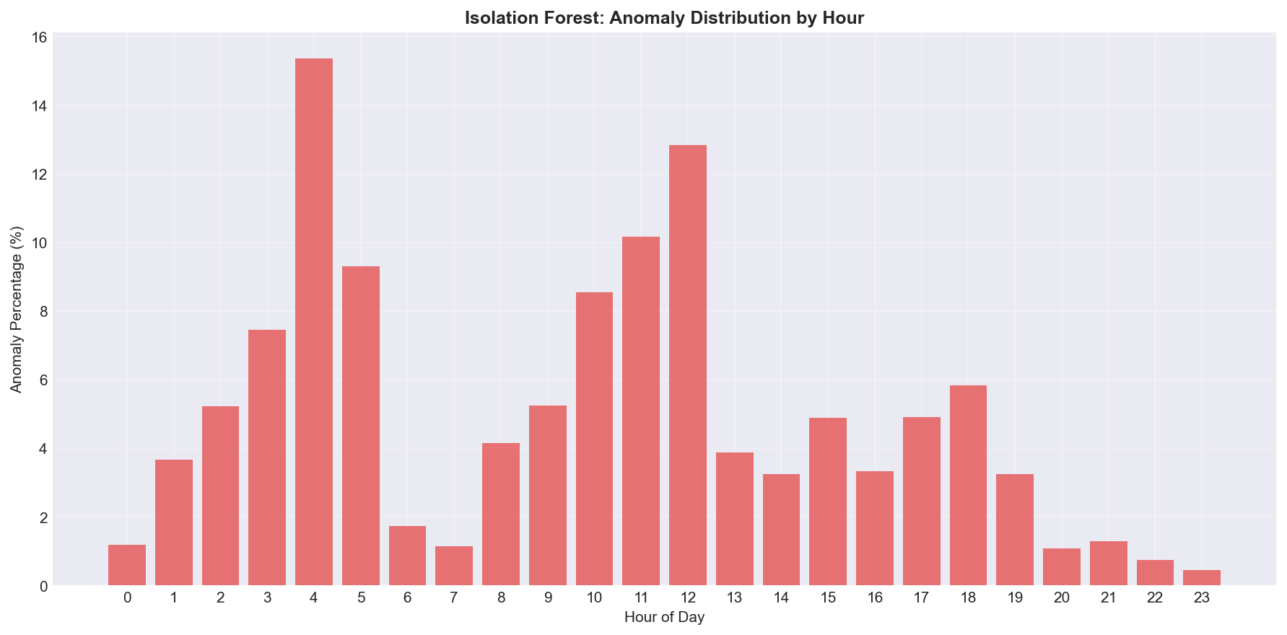
Figure 23: IS anomaly distribution
The Isolation Forest plot shows the distribution of detected anomalies across different hours of the day. The results indicate that anomalies are not uniformly distributed, with certain time periods showing higher abnormal activity due to variations in environmental conditions.
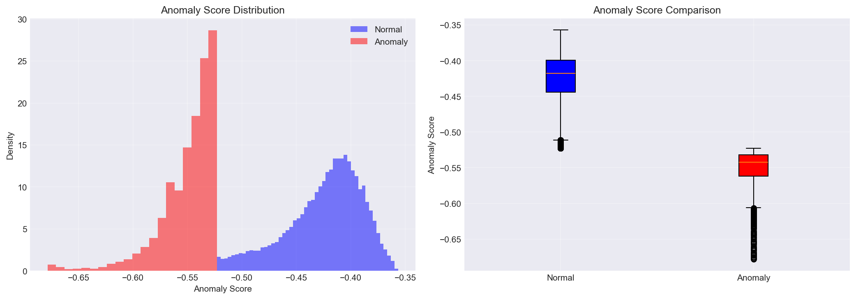
Figure 24:IS anomaly score
The anomaly score distribution shows how the Isolation Forest model assigns anomaly scores across the dataset. The plot displays the spread of anomaly scores for all data points. The anomaly score plot illustrates individual sensor readings ranked according to their computed anomaly scores, showing how each data point is evaluated by the model.

4.3 MODEL PERFORMANCE AND COMPARISON
The performance of the Decision Tree and Random Forest models was evaluated using MAE, RMSE, and R² metrics across multiple environmental parameters, including PM2.5, PM10, CO, LPG, and hydrogen gas. The results are summarized in Table 2 below.

Decision tree |  |  |  |  |  | Random forest
Metric | Pm2.5 | Pm10 | CO | LPG | hydrogen | Pm2.5 | Pm10 | CO | LPG | hydrogen
MAE | 7.78 | 10.78 | 6.03 | 0.03 | 0.04 | 4.11 | 6.48 | 0.02 | 0.02 | 0.04
RMAE | 15.3 | 25.74 | 0.05 | 0.03 | 0.05 | 8.74 | 17.72 | 0.04 | 0.03 | 0.04
R² | 0.96 | 0.93 | 0.85 | 0.23 | -2.851 | 0.99 | 0.96 | 0.95 | 0.435 | -1.855

Table 2: model performance comparison

The Decision Tree model achieved moderate performance across most parameters, with lower errors observed for CO, LPG, and hydrogen compared to particulate matter readings. However, the R² values indicate reduced predictive reliability for LPG and negative performance for hydrogen, suggesting poor generalization in highly non-linear or noisy features. The Random Forest model demonstrated significantly improved performance across all parameters. It recorded lower MAE and RMSE values compared to the Decision Tree, indicating reduced prediction error. Additionally, higher R² values (closer to 1) for PM2.5, PM10, and CO show strong predictive capability and better model generalization. The Random Forest model outperformed the Decision Tree model across all evaluation metrics. This is attributed to its ensemble learning approach, which reduces overfitting and improves robustness to noise in sensor data. The Decision Tree model, while simpler and interpretable, showed limitations in handling complex environmental patterns.

CONCLUSION
This study successfully achieved its main objective of designing and implementing a scalable IoT-based air quality monitoring system capable of real-time environmental sensing, cloud-based data visualization, predictive analysis, anomaly detection, alert generation, and safety actuation. The system effectively integrated an ESP32 microcontroller with low-cost sensors (MQ-series gas sensors, particulate matter sensor, and DHT11), Firebase cloud infrastructure, a web-based dashboard, and machine learning algorithms to form a functional and cost-efficient monitoring platform.
The system successfully measured and recorded key environmental parameters including PM2.5, PM10, carbon monoxide (CO), LPG, hydrogen gas, temperature, and humidity. Data was reliably transmitted to Firebase in real time and visualized through a web dashboard, enabling continuous environmental monitoring and remote accessibility. The integration of machine learning models further enhanced system functionality, where Decision Tree and Random Forest models were used for short-term prediction, while Isolation Forest effectively detected abnormal environmental conditions. Performance evaluation showed that the Random Forest model consistently outperformed the Decision Tree model across most parameters, achieving lower prediction errors and higher R² values, particularly for PM2.5, PM10, and CO. However, weaker performance was observed in highly noisy or weakly correlated parameters such as hydrogen gas, where negative R² values indicated poor predictive fit. This highlights the influence of sensor noise and environmental variability on model accuracy.
The system also demonstrated effective anomaly detection capability through Isolation Forest, successfully identifying abnormal pollution spikes and unusual environmental behavior patterns. These results confirm that combining IoT sensing with machine learning techniques improves both monitoring accuracy and system intelligence. The developed system provides a practical and low-cost solution for real-time air quality monitoring, environmental awareness, and early hazard detection in domestic and small-scale environments. The project successfully met its intended objectives and demonstrated the feasibility of integrating IoT and machine learning for environmental monitoring applications.

RECOMMENDATIONS
  - Future improvements should include proper calibration of the gas and particulate matter sensors to enhance measurement accuracy and reduce errors caused by environmental conditions and sensor drift.
  - The system should incorporate a local data buffering mechanism on the ESP32 to prevent data loss during temporary network interruptions and improve overall data reliability.
  - Advanced machine learning models such as time-series forecasting techniques could be explored in future work to improve long-term air quality prediction performance.
  - The system can be scaled to a multi-node IoT network to enable wider environmental coverage and improve spatial resolution of air quality monitoring data.

REFERENCES

[1] | E. Bagkis , . A. Hassani, P. Schneider, P. DeSouza, S. Shetty, T. Kassandros and J. Khan, "Evolving trends in application of low-cost air quality sensor networks: challenges and future directions:challenges and future directions," npj Climate and Atmospheric Science, vol. 8, no. 1, p. 335, 2025.
[2] | . R. Kumar, R. Khan , R. Singh, A. Singh, R. Vijay and D. Ather, "Development and Evaluation of an IoT-Based Gas Leakage Detection System Using Arduino Uno. In International Conference on Cyber Intelligence and Information Retrieval," Singapore: Springer Nature Singapore, pp. 307-319, 2023.
[3] | A. Garcia, Y. Saez, I. Harris, X. Huang and E. Collado, "Advancements in air quality monitoring: a systematic review of IoT-based air quality monitoring and AI technologies," Artificial Intelligence Review, vol. 58, no. 9, p. 275, 2025.
[4] | F. Concas, J. Mineraud, E. Lagerspetz, S. Varjonen, X. Liu, S. Tarkoma and K. Puolamäki, "Low-cost outdoor air quality monitoring and sensor calibration: A survey and critical analysis.," ACM Transactions on Sensor Networks (TOSN), vol. 17, no. 2, pp. 1-44, 2021.
[5] | M. Casari and . L. Po, "Mitigating the Impact of Humidity on Low-Cost PM Sensors," In CEUR WORKSHOP PROCEEDINGS, vol. Vol. 3489, pp. 599-604, 2023.
[6] | M. Zaid, P. Nawale, V. Kumar, V. Malyan and M. Sahu, "Investigating IoT-Based Low-cost Sensor Network for Real-Time Hyper-Local Air Quality Monitoring and Exposure Assessment.," Atmospheric Pollution Research, p. 102749, 2025.
[7] | R. Ramesh, . H. Vallabhu, A. Unni and . S. Nalinakshan, "IoT-Enabled Air Quality Monitoring: Advancements, Applications, and Challenges.," In 2024 9th International Conference on Communication and Electronics Systems (ICCES), pp. 561-567, 2024.
[8] | M. Tastan, " Machine Learning–Based Calibration and Performance Evaluation of Low-Cost Internet of Things Air Quality Sensors.," Sensors, vol. 25, no. 10, p. 3183, 2025.
[9] | K. Yong-Hyuk and M. Seung-Hyun, "Machine Learning-Based Quality Control for Low-Cost Air Quality Monitoring: A Comprehensive Review of the Past Decade," Atmosphere, vol. 16, no. 10, p. 1136, 2025.
[10] | Y. M. Idir, O. Orfila, P. Chatellier, V. Judalet and V. Guaffre, "Idir, Y.M., Orfila, O., Chatellier, P., Judalet, V. and Guaffre, V., 2025. Mapping urban air quality using mobile and fixed low cost sensors: a model comparison.," arXiv preprint arXiv, vol. 2511.22550., 2025.
[11] | M. J. Gatari, F. D. Pope, D. Ng'ang'a , A. Poynter and R. Blake, "Airborne particulate matter monitoring in Kenya using calibrated low-cost sensors.," Atmospheric Chemistry and Physics, vol. 18, no. 20, pp. 15403-15418., 2018.
[12] | M. N. Njeru, E. Mwangi, M. J. Gatari, M. I. Kaniu, J. Kanyeria, G. Raheja and D. M. Westervelt, "First results from a calibrated network of low‐cost PM2. 5 monitors in Mombasa, Kenya show exceedance of healthy guidelines," GeoHealth, vol. 8, no. 9, p. e2024GH001049, 2024.
[13] | T. Manshur, C. Luiu, W. R. Avis, V. Bukachi, F. D. Pope, J. Mulligan and M. Gatari, "A citizen science approach for air quality monitoring in a Kenyan informal development.," City and Environment Interactions, vol. 19, p. 100105, 2023.
[14] | B. C., N. L. , M. H. , . D. G. and H. M. , "Community sensitisation using participatory arts-based methods for the research study 'Tupumue: Non-communicable lung disease in Kenya: from burden and early life determinants to participatory inter-disciplinary solutions'," in The Global Health Network Conference 2022: Enabling healthcare in every healthcare setting, University of Cape Town, South Africa, 24–25 Nov. 2022, Cape Town, South Africa, 2023,June.
[15] | H. Othman, R. Azari and T. Guimarães , "Low-Cost IoT-based Indoor Air Quality Monitoring.," Technology| Architecture+ Design, vol. 8, no. 2, pp. 250-270, 2024.
[16] | . L. Spinelle, . M. Gerboles, . M. G. Villani, . M. Aleixandre and . F. Bonavitacola, " Calibration of a cluster of low-cost sensors for the measurement of air pollution in ambient air," In SENSORS, 2014 IEEE, pp. 21-24, 2014.

