**JobSatisfaction2.jmp**

An employee in a human resources department wants to improve job satisfaction. The example uses the Structural Equation Models platform to analyze responses to a survey of 200 individuals regarding aspects of their job satisfaction. The survey contains responses to 11 questions related to their job satisfaction. You seek to build a structural regression model that relates the answers to the survey questions to the latent variables of leadership characteristics, role conflict, and overall job satisfaction.

More information: <https://www.jmp.com/support/help/en/16.0/index.shtml#page/jmp/example-of-a-structural-equation-model.shtml>

**Thomsen2.sav**

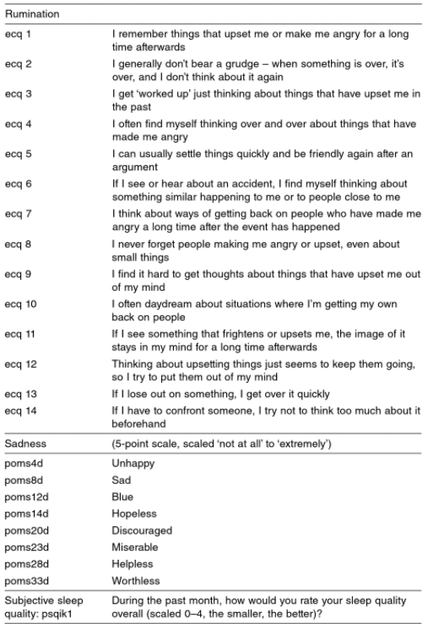An investigator sought to understand the relationship between–Rumination (negative recurrent thoughts)–Sleep Quality–Immune Parameters–Healthcare Utilization in the elderly (>=65 population). Rumination was measured using the rehearsal sub-scale from the Emotional Control Questionnaire version 2 (Roger & Narajian, 1989), sadness by the depression—dejection sub-scale from the short version of the Profile of Moods Scale (McNair, LOIT, & Dopplemann, 1981; Shacham, 1983) and sleep quality by the one item on subjective sleep quality from the Pittsburgh Sleep Quality index (Buysse, Reynolds. Monk, Berman. & Kupfer, 1989). The items used are below and, in the table,

aside.

Immune Parameters:

* Lymphocy: Number of Lymphocytes
* Leukocyt: Number of Leukocytes

Healthcare Utilization:

* # Telephone Consultation/5
* # Personal Consultation /5

**OnlineConsumerData2.jmp**

The data in the jmp file are simulated (made up) data based on this article: <https://www.researchgate.net/publication/338541227_Impact_of_Social_Media_Security_Risks_and_Reputation_of_E-Retailer_on_Consumer_Buying_Intentions_through_Trust_in_Online_Buying_A_Structural_Equation_Modeling_Approach>. You can download the full paper [here](https://www.researchgate.net/publication/338541227_Impact_of_Social_Media_Security_Risks_and_Reputation_of_E-Retailer_on_Consumer_Buying_Intentions_through_Trust_in_Online_Buying_A_Structural_Equation_Modeling_Approach).