Module 4.2 Assignment
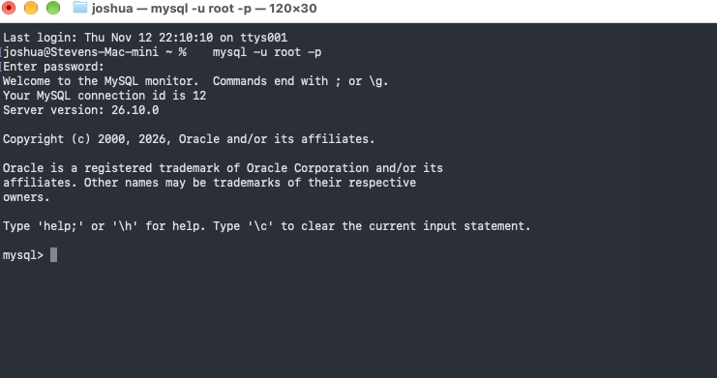
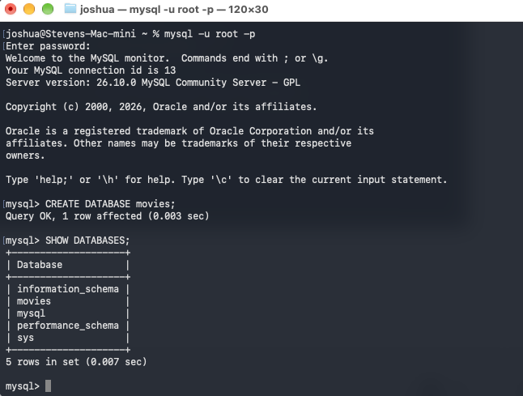
1. CONCAT (string function)
- This can be used to combine columns or text into one value, such as joining a first and last name into a full name for a report.
- Alias: full_name
sql
SELECT CONCAT('Joshua', ' ', 'Xiong') AS full_name;

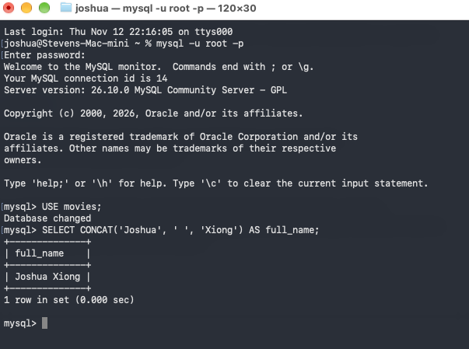
2. ROUND (numeric function)
- This can be used to limit a decimal to a set number of places, such as showing a price, average rating, or total with two decimals.
- Alias: rounded_price
sql
SELECT ROUND(1234.5678, 2) AS rounded_price;

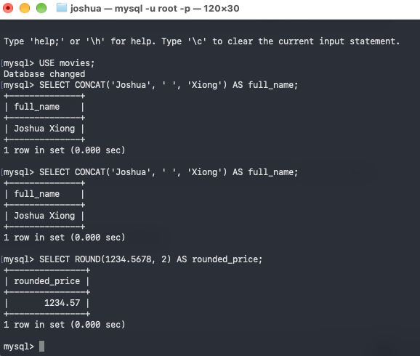
3. DATEDIFF (date function)
This can be used to count the days between two dates, such as days until a due date or days since a movie’s release.
- Alias: days_until_christmas
sql
SELECT DATEDIFF('2026-12-25', CURDATE()) AS days_until_christmas;



