## Problem

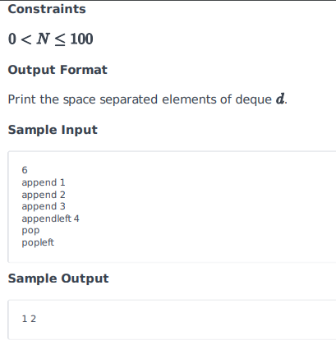

## Solution

# Enter your code here. Read input from STDIN. Print output to STDOUT

from collections import deque

d = deque()

m = int(input())

for  i in range(m):

    oper = input().split()

    if oper[0] == "append":

        d.append(int(oper[1]))

    elif oper[0] == "appendleft":

        d.appendleft(int(oper[1]))

    elif oper[0] == "count":

        d.count(int(oper[1]))

    elif oper[0] == "remove":

        d.remove(int(oper[1]))

    elif oper[0] == "reverse":

        d.reverse(int(oper[1]))

    elif oper[0] == "rotate":

        d.rotate(int(oper[1]))

    elif oper[0] == "extend":

        d.extend(int(oper[1]))

    elif oper[0] == "extendleft":

        d.extendleft(int(oper[1]))

    elif oper[0] == "count":

        d.count(int(oper[1]))

    elif oper[0] == "pop":

        d.pop()

    elif oper[0] == "popleft":

        d.popleft()

final_string = ""

for j in d:

    final_string += str(j) + " "

print(final_string)