# Problem

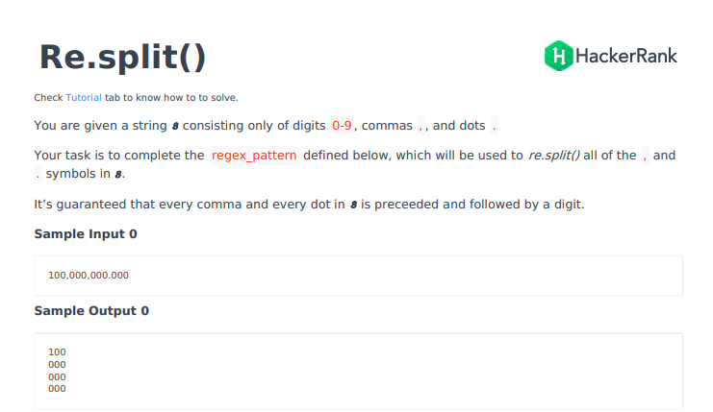

# Josh Solution

regex_pattern = r"" # Do not delete 'r'.

i = input()

#print(i)

import re

l = list(re.split(r'\s+|[,;.-]\s*', i))

#print(l)

for x in l:

    print(x)

import re

print("\n".join(re.split(regex_pattern, input())))

# Josh solution 2

regex_pattern = r"\s+|[,;.-]\s*"    # Do not delete 'r'.

import re

print("\n".join(re.split(regex_pattern, input())))

import re

print("\n".join(re.split(regex_pattern, input())))