## Problem

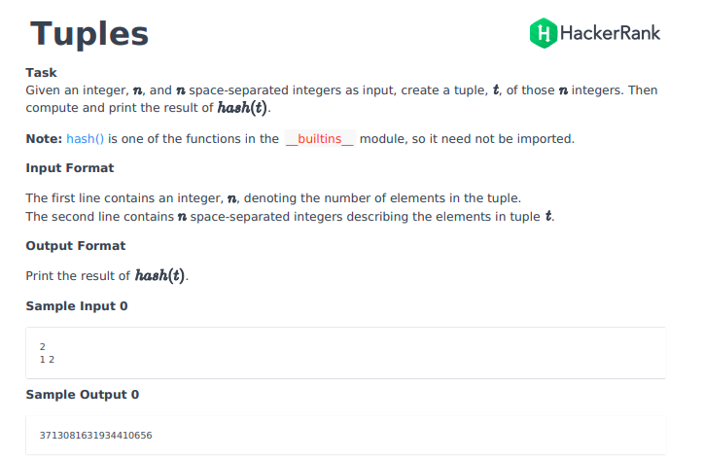

## Solution

if __name__ == '__main__':

    n = int(raw_input())

    integer_list = map(int, raw_input().split())

a=tuple(integer_list)

print hash(a)

## Python3

if __name__ == '__main__':

n = int(input())

integer_list = map(int, input().split())

tup = ()

for x in integer_list:

tup+=(x,)

print(hash(tup))