# Problem



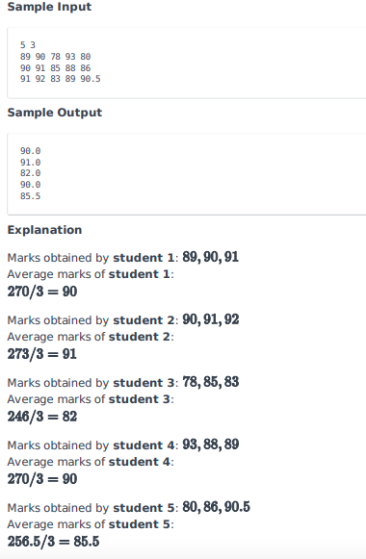

# Josh answer with Lists

n, x = map(int, input().split())

sheet = []

for _ in range(x):

     i = list(input().split())

     sheet.append(i)

#zip(*sheet)

for y in range(0,5):

    student_score_sum = 0

    for z in sheet:

        student_score_sum += float(z[y])

    student_average = student_score_sum / x

    print(student_average)

# Other answers

n, x = map(int, input().split())

sheet = []

for _ in range(x):

sheet.append( map(float, input().split()) )

for i in zip(*sheet):

print( sum(i)/len(i) )