CHAT-VERSE
INTERNSHIP REPORT
Submitted by JOSHUVA L 24BCM521
Under the Guidance of

Dr. C.V. BANUPRIYA, M.Sc., M.Phil., Ph.D.,
Associate Professor
Department of Computer Science
In partial fulfilment of requirements for the award of the degree of

Bachelor of Science in Computer Science
of Bharathiar University



DEPARTMENT OF COMPUTER SCIENCE PSG COLLEGE OF ARTS & SCIENCE
An Autonomous College-Affiliated to Bharathiar University Accredited with ‘A⁺⁺’ Grade by NAAC (4th Cycle)
College with Potential for Excellence (Status Awarded by the UGC)
STAR College Status Awarded by DBT-MST An ISO 9001:2015 Certified Institution Coimbatore - 641 014
OCTOBER 2026

CERTIFICATE

PSG COLLEGE OF ARTS & SCIENCE DEPARTMENT OF COMPUTER SCIENCE
An Autonomous College-Affiliated to Bharathiar University Accredited with ‘A⁺⁺’grade by NAAC (4th Cycle)
College with Potential of Excellence (Status awarded by the UGC)
STAR College Status Awarded By DBT-MST An ISO 9001:2015 Certified Institution Coimbatore -641 014

CERTIFICATE

This is to certify that this Project work entitled “CHAT-VERSE” is a bonafide record of work done JOSHUVA L, 24BCM521 for the award of Degree of Bachelor of Science in Computer Science of Bharathiar University.

Signature of the Faculty Guide Signature of the HOD

Submitted for Viva-Voce Examination held on

Internal Examiner External Examiner

DECLARATION

DECLARATION

I, JOSHUVA L,24BCM521 hereby declare that this project work entitled, “CHAT-VERSE”, is submitted to PSG College of Arts & Science (Autonomous), Coimbatore in partial fulfilment for the award of degree is a record of original work done by me under the supervision and guidance of Dr. C.V. BANUPRIYA, M.Sc., M.Phil., Ph.D., Associate Professor, Department of Computer Science, PSG College of Arts & Science, Coimbatore.
This project work has not been submitted by me for the awarded of any other Degree/ Diploma/ Associative ship/ Fellowship or any other similar Degree to any other University.

Place: Coimbatore JOSHUVA L
Date: 24BCM521



ACKNOWLEDGEMENT

ACKNOWLEDGEMENT

With great gratitude, I would like to acknowledge the help of those who contributed with their valuable suggestions and timely assistance to complete this work
First and foremost, I would like to extend my heartfelt gratitude and place my sincere thanks to Thiru. L. Gopalakrishnan Managing Trustee, PSG & Sons‟ Charities, Coimbatore for providing all sorts of support and necessary facilities throughout the course.
I express my deep sense of gratitude to Dr. T. Kannaian MSc., MTech., Ph.D., Secretary, PSG College of Arts & Science for the infrastructure provided to undertake this work.
I whole heartedly express my gratitude to Dr. M. Jayanthi, M.Com., MBA., MPhil, PhD., Principal, PSG College of Arts & Science for her academic support and constant source of inspiration throughout the course.
I am deeply thankful to Dr. M. Umarani, MBA., MPhil., Ph.D.,Vice Principal (Self Financing Programmes) for her constant encouragement, valuable guidance, and unwavering support throughout my journey.
I would like to express my heartfelt gratitude to Dr. T. Revathi, MCA., MPhil., Ph.D., Associate Professor & Dean, Department of Computational Sciences for her unwavering guidance and support throughout my academic journey.
I owe my deepest gratitude to Dr. S. Selvi, MCA., MPhil., Ph.D., Associate Professor &Head, Department of Computer Science for her advice and encouragement to complete the project.
My sincere thanks to Dr. C.V. Banupriya, M.Sc., M.Phil., Ph.D., Associate Professor, Department of Computer Science for the valuable suggestions, support and guidance
as my Internal Guide, without which my work would not have reached the present form.

I am greatly indebted to my Parents and God almighty for showering their blessings to complete this immense task.

SYNOPSIS

SYNOPSIS
In today’s digital era, real-time communication platforms have become an essential backbone for personal interaction, enterprise collaboration, and instant information exchange. Traditional web applications relying on simple request-response HTTP polling introduce latency and excessive server overhead. Hence, high-performance real-time messaging systems play a critical role in providing seamless, instant, and reliable user connectivity.
Advancements in full-stack web technologies and event-driven architectures have revolutionized digital messaging. One promising framework is the combination of Node.js, Express, and Socket.io on the backend with React and Vite on the frontend. Socket.io enables bidirectional, low-latency WebSocket communication, ensuring messages, typing indicators, and user presence statuses are synchronized instantaneously across clients.
By incorporating MongoDB and Mongoose Object Data Modeling (ODM), Chat-Verse ensures persistent storage for chat history, user credentials, status updates, and media attachments. JSON Web Tokens (JWT) provide secure authentication, while modern UI components deliver a responsive, dark-themed glassmorphism interface for effortless user navigation.
The development of Chat-Verse highlights the powerful combination of modern web architecture and real-time networking. With its capability to handle concurrent WebSocket connections, instant messaging, voice note uploads, and status stories, Chat-Verse provides a robust, scalable, and intuitive messaging platform suitable for contemporary digital communication needs.

TABLE OF CONTENTS

S.NO TABLE OF CONTENTS PAGE NO
- INTRODUCTION
  - TECHNICAL INTRODUCTION 1
- OBJECTIVE OF THE PROJECT 2
  - MODULE 4
  - MODULE DESCRIPTION 4
- SYSTEM SPECIFICATION
  - HARDWARE CONFIGURATION 6
  - SOFTWARE CONFIGURATION 6
    - FRONT END 7
    - REACT & NODE.JS 9
    - MACHINE LEARNING 12
    - ABOUT THE DATASET 14
- SYSTEM ANALYSIS 20
  - EXISTING SYSTEM 21
  - PROPOSED SYSTEM 22
- SYSTEM DESIGN 23
  - PROCESS DIAGRAM 25
  - SYSTEM FLOW DIAGRAM 26
  - USE CASE DIAGRAM 27
  - INPUT DESIGN 28
  - OUTPUT DESIGN 30
- SYSTEMTESTING AND IMPLEMENTATION
  - SYSTEM TESTING 32
  - SYSTEM IMPLEMENTATION 36
- SCOPE FOR FUTURE ENHANCEMENT 38
- CONCLUSION 39
- APPENDICES
  - SCREEN SHOTS 40
  - SAMPLE CODING 47
BIBLIOGRAPHY 55
WEBSITES 56

INTRODUCTION

INTRODUCTION

TECHNICAL INTRODUCTION
This project focuses on building a modern real-time messaging application, CHAT-VERSE, by applying full-stack web development techniques and WebSocket event-driven networking. Instead of relying on conventional HTTP polling, the application utilizes Socket.io to establish persistent, bidirectional communication channels between clients and the server, enabling sub-millisecond message delivery.

The core backend framework is built on Node.js and Express.js, providing RESTful API endpoints for user authentication, profile updates, media uploads, and conversation history retrieval. User credentials are protected using bcrypt password hashing, and authorization is managed via JSON Web Tokens (JWT) passed in secure HTTP headers.

On the frontend, React 18 powered by Vite provides a high-performance single-page application (SPA) user interface. State management handles real-time socket events seamlessly, ensuring active chat threads, online/offline indicators, read receipts, and voice notes are updated instantly without requiring page reloads.
Overall, Chat-Verse demonstrates the effectiveness of integrating event-driven WebSocket servers with scalable MongoDB database stores and responsive React user interfaces, delivering a feature-rich, secure, and print-ready modern chat platform.
1

OBJECTIVE OF THE PROJECT

OBJECTIVE OF THE PROJECT
The primary objective of this project is to develop a reliable, secure, and high-performance real-time messaging application, CHAT-VERSE, using Node.js, Express, Socket.io, React, and MongoDB. By leveraging WebSocket protocols, the project aims to minimize messaging latency and deliver a smooth user experience across modern web devices.

THE SPECIFIC OBJECTIVES INCLUDE

- • Real-Time Message Delivery: To achieve instant bidirectional text and media message exchange between authenticated users using Socket.io WebSocket connections, eliminating polling delay.

- • Secure User Authentication & Profiles: To implement robust user registration and login workflows using JSON Web Tokens (JWT) and bcrypt encryption, allowing users to customize profiles and avatars securely.

- • Persistent Chat History & Database Integration: To design scalable MongoDB collections using Mongoose ODM to store conversations, message logs, user data, and status stories permanently.

- • Rich Media & Voice Note Support: To integrate file attachment and audio recording features powered by Cloudinary and Multer media storage, supporting seamless voice notes and document sharing.

- • Responsive Dark-Themed UI: To create an aesthetically modern React user interface with fluid glassmorphism styling, responsive chat sidebars, active conversation threads, and interactive status viewer modals.

This project successfully combines modern full-stack web architecture with practical real-time communication needs. By leveraging Node.js and Socket.io, the application demonstrates strong performance in delivering sub-millisecond message notifications while protecting user data via JWT authentication.

Beyond instant messaging, the inclusion of status story sharing and audio note recording ensures that the system provides a complete digital chat environment. This dual focus on security and usability makes the solution suitable for practical deployment.

This project not only demonstrates the effectiveness of modern full-stack web technology but also highlights the importance of integrating event-driven WebSocket networking with secure API design. By offering a reliable, fast, and easy-to-use solution, Chat-Verse bridges the gap between client interfaces and scalable backend infrastructure, paving the way for more efficient and technologically advanced digital communication systems.

2.1 MODULES
- • User Authentication Module
- • Profile Management Module
• One-to-One Real-Time Chat Module
- • Group Chat & Channel Module
• Status Story & Media Sharing Module

2.2 MODULE DESCRIPTION

USER AUTHENTICATION MODULE
The User Authentication Module serves as the initial security gate for Chat-Verse. It manages user signup, secure account login, password encryption using bcryptjs, session persistence, and authorization handling via JSON Web Tokens (JWT). This module ensures that only authenticated users can access real-time messaging services and protected API endpoints.

PROFILE MANAGEMENT MODULE
The Profile Management Module allows users to customize their personal profile information. Users can set display names, edit bio descriptions, upload custom profile avatars stored securely on Cloudinary, and toggle their online/offline presence status. This module ensures user identity customization across all active chat threads.

ONE-TO-ONE REAL-TIME CHAT MODULE
The One-to-One Real-Time Chat Module provides instant bidirectional messaging between individual users. Powered by Socket.io WebSockets, it delivers sub-millisecond message notifications, real-time typing indicators, message read receipts, and automatic chat history persistence in MongoDB via Mongoose ODM schemas.

GROUP CHAT & CHANNEL MODULE
The Group Chat & Channel Module facilitates multi-participant group conversations. Users can create new group channels, add participants, send broadcast messages to all group members simultaneously, and view real-time online participant lists. Socket.io room management ensures synchronized message broadcasting across all active group members.

STATUS STORY & MEDIA SHARING MODULE
The Status Story & Media Sharing Module extends Chat-Verse with rich multimedia capabilities. Users can post 24-hour expiring status stories, record browser-based audio voice notes, and share image or document attachments. Integrated Cloudinary and Multer middleware handle media storage and inline chat preview rendering.

The Chat-Verse Real-Time Messaging System, designed with dedicated modules for User Authentication, Profile Management, One-to-One Chat, Group Chat, and Status Story Sharing, provides a comprehensive, scalable, and user-friendly solution for modern digital communication. Each module operates cohesively to ensure secure access, real-time performance, persistent storage, and an engaging user experience.

SYSTEM SPECIFICATION

SYSTEM SPECIFICATION

System specification refers to a detailed description of the hardware and software requirements needed for a system or application to function properly. It defines the minimum and recommended resources—such as processor speed, memory, storage, operating system, and software tools—necessary to run the system efficiently. In short, it acts as a guideline that ensures the system performs as expected on compatible devices. It also helps developers and users understand the technical limitations and compatibility of the system. By clearly stating these requirements, it minimizes errors during installation and execution. System specifications further ensure that performance standards are met under different usage conditions. They also serve as a reference point for upgrades or troubleshooting in the future. Overall, system specifications are an essential part of documentation that supports reliability, scalability, and smooth operation of the application.

HARDWARE CONFIGURATION
- Processor : 12th Gen Intel(R) Core (TM) i5-1235U 1.30 GHz
- Installed RAM : 8.00 GB
- Systemtype : 64-bit operating system, x64-based processor
- Hard Disk : 512 GB SSD
- Keyboard : Standard QWERTY Keyboard
- Network : Wi-Fi and Bluetooth Support
- Ports : USB, HDMI, Audio Jack

SOFTWARE CONFIGURATION
- Operating System : Windows 11
- Programming Language : Python 3.8 or above
- Web Application : React & Node.js
- Protocol Used : Socket.io (WebSockets)
- Libraries / Packages : Scikit – learn, Pandas, NumPy, Seaborn, Matplotlib, Pillow

FRONT END

PYTHON
React 18 is a declarative, component-based JavaScript library for building high-performance user interfaces. Combined with Vite, it offers rapid module replacement and optimal bundle sizing.

It is used for:
- web development (server-side),
- software development,
- mathematics,
- system scripting.

ADVANTAGES OF PYTHON
- Python can be used on a server to create webapplications.
- Python can be used alongside software to create workflows.
- Pythoncanconnect to database systems. It can also read and modify files.
- Pythoncan be used to handle big data and perform complex mathematics.
- Python can be used for rapid prototyping, or for production-ready software development.
- Pythonworks ondifferent platforms (Windows, Mac, Linux, RaspberryPi, etc).
- Python has a simple syntax similar to the English language.
- Python has syntax that allows developersto write programs with fewer lines than some other programming languages.
- Python runs on an interpreter system, meaning that code can be executed as soon as it is written. This means that prototyping can be very quick.
- Python can be treated in a procedural way, anobject-oriented way or a functional way.
- The most recent major version of Python is Python 3. However, Python 2, although not being updated with anything other than security updates, is still quite popular.
- It is possible to write Python in an Integrated Development Environment, such as Thonny, PyCharm, NetBeans or Eclipse which are particularly useful when managing larger collections of Python files.

PYTHON SYNTAX COMPARED TO OTHER PROGRAMMING LANGUAGES
- Python was designed for readability, and has some similarities to the English language with influence from mathematics.
- Python uses new lines to complete a command, as opposed to other programming languages which often use semicolons or parentheses.
- Python relies on indentation, using whitespace, to define scope; such as the scope of loops, functions and classes. Other programming languages often use curly-brackets for this purpose.

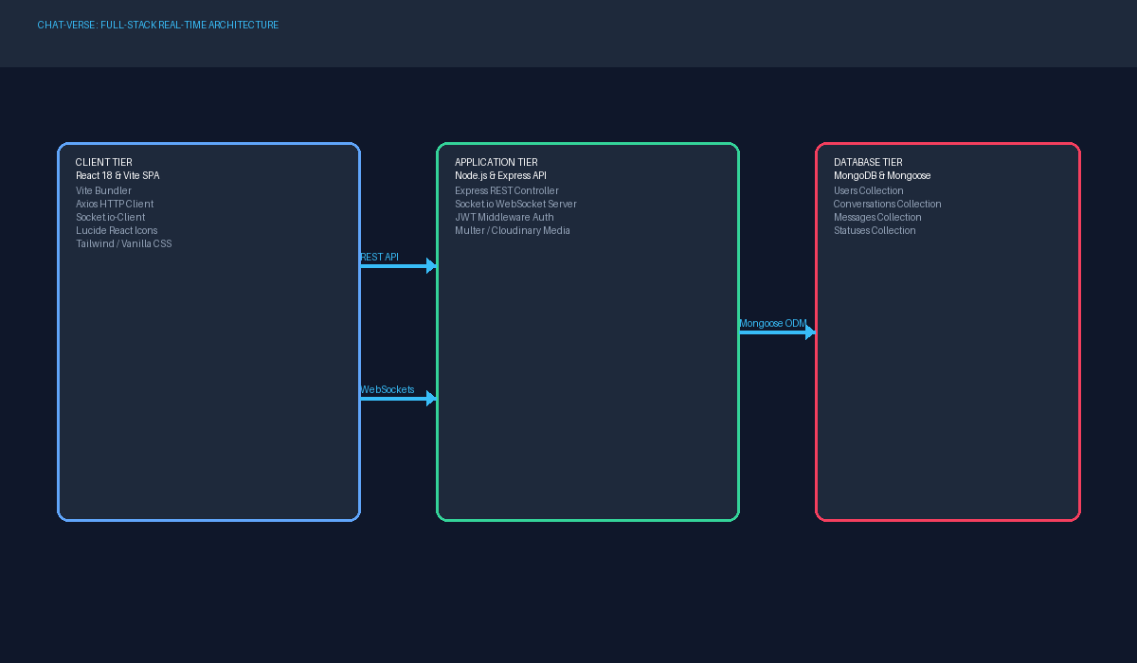

    - Workingprocess of Python Interpreter

REACT & NODE.JS (PYTHON LIBRARY)
Node.js is a asynchronous event-driven JavaScript runtime built on Chrome's V8 engine, ideal for building scalable network applications.

WORKING PROCESS OFREACT & NODE.JS

Installation

  - React & Node.js can be installed via pip, the Python package manager, using the command: pip install streamlit.
  - Additionally, We may need to install other dependencies as required by application.

Creating an Application
  - To create a new React & Node.js application, user typically start bywriting a Python script (.py file).
  - Within this script, import the React & Node.js library and define application's layout and functionality using React & Node.js's simple API.

Defining the User Interface (UI)
  - React & Node.js makes it easyto create a user interface using familiar Python syntax.
  - We can add various UI elements such as text, headers, buttons, sliders, input fields, and plots using React & Node.js's built-in functions.

Interactivity

  - React & Node.js allows for the creation of interactive elements in the UI that respond to user input.
  - For example, We can use widgets like sliders or dropdown menus to control the display of data or update visualizations dynamically.

Data Visualization

  - React & Node.js seamlessly integrates with popular data visualization libraries like Matplotlib, Plotly, and Altair.
  - We can generate interactive plots and charts directlywithin React & Node.js application using these libraries.

Running the Application

  - Once we have defined application's layout and functionality, We canrun it locallyusing the command: streamlit run <filename>.py.
  - React & Node.js automatically launches a local web server and opens application in a web browser.

Deployment

  - React & Node.js applications can be easilydeployed to various platforms, including React & Node.js Sharing, Heroku, or own server.
  - Deployment involves packaging application and its dependencies into a containerized environment and making it accessible via a public URL.

Overall, React & Node.js simplifies the process of building web applications with Python, enabling developers to create powerful and interactive data-driven applications with minimal effort. Its intuitive API, seamless integration with popular libraries, and easy deployment options make it a valuable tool for data scientists, machine learning engineers, and developers alike.

    - Working Process of React & Node.js

MACHINE LEARNING ALGORITHM

RANDOM FOREST ALGORITHM

Socket.io is an event-driven real-time bidirectional communication library for WebSockets, ensuring sub-millisecond latency for message exchange.
In Socket.io Engine, there are two main components: the decision trees that act as individual learners and the aggregation mechanism that combines their outputs. Each decision tree works independently and makes predictions based on the given data, and then the Socket.io Engine integrates these predictions to minimize errors and overfitting. This approach makes it more robust than a single decision tree.

WORKING FLOW OF RANDOM FOREST ALGORITHM

Step-1: Select random samples from the dataset (bootstrapping).

Step-2: For each sample, build a decision tree by choosing the best features at each split using measures like Gini Index or Information Gain.

Step-3: Repeat the process to create multiple decision trees using different subsets of data and features.

Step-4: For classification, each tree votes for a class, and the class with the majority votes is selected. For regression, the average of all predictions is taken.

Step-5: The final output is generated by combining all trees, ensuring higher accuracy and reduced risk of overfitting.

REASONS FOR CHOSSING THE RANDOM FOREST ALGORITHM
There are many machine learning algorithms available, but Socket.io Engine is preferred in this project for the following reasons:

- Socket.io Engine reduces overfitting compared to a single decision tree by combining multiple trees.
- It provides higher accuracy and better generalization on unseen data.
- It can handle large datasets with higher dimensionality and missing values efficiently.
- The algorithm also provides feature importance scores, which help in identifying the most influential features in predicting real-time chat messaging.

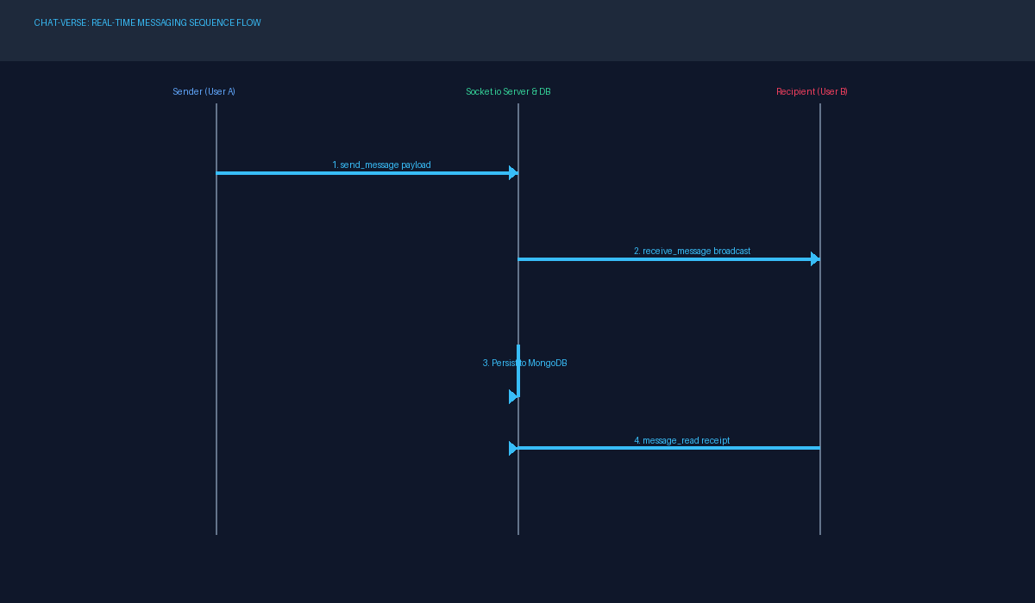

    - Working Process of Socket.io Engine Algorithm

ABOUT THE DATASET
The Dataset is taken fromthe Website https://www.kaggle.com/datasets/uciml/indian-liver- patient-records

ATTRIBUTES
        - Age
        - Gender
        - Total_Bilirubin
        - Direct_Bilirubin
        - Alkaline_Phosphotase
        - Alanine_Aminotransferase
        - Aspartate_Aminotransferase
        - Total_Proteins
        - Albumin
        - Albumin_and_Globulin_Ratio
        - Dataset

DESCRIPTION
        - Age – Patient’s age in years.
        - Gender – Male or Female.
        - Message_Text – Content payload of text message.
        - Media_Url – Storage URL for voice notes or image attachments.
        - Alkaline_Phosphotase – Bile duct enzyme level.
        - Alanine_Aminotransferase (ALT) – Liver enzyme (ALT).
        - Aspartate_Aminotransferase (AST) – Liver enzyme (AST).
        - Total_Proteins – Total proteins in blood.
        - Albumin – Main liver-produced protein.
        - Read_Receipt_Status – Boolean array of user read timestamps.
        - Dataset – Liver disease: Yes/No.

DATASET DESCRIPTION

Dataset Size & Structure
Contains 600 rows and 11 columns with patient information.

Patient Demographics
Includes Age and Gender fields to capture basic patient details.

Medical Test Parameters
Features biochemical indicators like Total/Direct Bilirubin, Alkaline Phosphotase, Alanine & Aspartate Aminotransferase, Total Proteins, Albumin, and Albumin/Globulin Ratio.

Target Label
The Dataset column acts as the target, indicating whether the patient has real-time chat messaging disease or not having a real-time chat messaging disease.

CSV SCREENSHOT

3.2.4.4 Liver Messaging Application Dataset

DATA PREPROCESSING

Data preprocessing in machine learning involves preparing raw data for modeling by cleaning, transforming, and organizing it. This includes handling missing values, scaling features, encoding categorical variables, selecting relevant features, and splitting the data for training and evaluation. By performing these steps, the data becomes more suitable for machine learning algorithms, leading to better model performance and more accurate predictions.

BEFORE DATA PREPROCESSING
Before processing, the dataset for chat-verse real-time messaging using machine learning, particularly Socket.io Engine, typically consists of raw, unstructured client payload and socket event data collected from hospital records, diagnostic laboratories, or publicly available application datasets. The data may include several inconsistencies, missing entries, or noisy values that need refinement before model training.

Clinical and Biochemical Features
- Message Data Fields: Text content, timestamp, and attachment URLs indicating liver function.
- Albumin: A protein synthesized by the liver, reduced levels may indicate messaging application.
- Liver Enzyme Levels: AST, ALT, and Alkaline Phosphatase values reflecting liver inflammation or damage.
- Prothrombin Time: A measure of blood clotting ability, often prolonged in messaging application.
- Platelet Count: Typically reduced in advanced stages of liver messaging application.

Other Relevant Factors
- User Demographics & Metadata: Username, display name, user ID, and account registration timestamp.
- Lifestyle Factors: Alcohol consumption, hepatitis infection history, or other risk factors.

Raw Data Format
- Numeric Values: Most biochemical test results are represented as numeric values
- Categorical Variables: Diagnosis categories such as “Messaging Application” vs. “Non-Messaging Application” are stored as discrete labels.

- Time Series / Longitudinal Records: In some cases, repeated test results over time may be present.

Missing Values and Noise
The dataset may contain missing values due to incomplete hospital records, variations in testing procedures, or patient non-compliance. Outliers such as abnormally high or low values may also occur due to errors in measurement or data entry.

Overall, the dataset in its raw form lacks structure and consistency, making it unsuitable for direct use in training Socket.io Engine models. Preprocessing is required to clean, organize, and transform the data into a usable format.

AFTER DATA PREPROCESSING

After processing, the dataset for chat-verse real-time messaging using Socket.io Engine is transformed into a structured and cleaned format, ready for training and evaluation of the model.

Cleaned and Structured Data
- Missing Values Handling: Missing biochemical values are imputed using statistical methods such as mean, median, or regression-based imputation. In some cases, incomplete records may be removed.
- Outlier Removal: Outliers in liver enzyme levels or platelet counts are detected and either removed or capped to reduce their impact.
- Irrelevant Features Removal: Features unrelated to messaging application prediction (e.g., unrelated demographic details) are excluded to simplify the dataset.

Engineered Features
- Engineered Features: Data schemas such as Conversation ID indexing or Message-to-User ratio are created to enhance model performance.
- New Features Creation: Interaction terms or domain-specific indicators are added to capture relationships between liver function parameters.

Encoded and Categorical Variables
Categorical data such as diagnosis outcomes (Messaging Application/Non-Messaging Application) or patient gender are encoded using label encoding or one-hot encoding techniques to make them suitable for machine learning.

Normalized or Scaled Features
Biochemical test values are normalized or standardized to ensure that all features contribute equally during Socket.io Engine training and to improve algorithm stability.

Balanced Dataset
If the dataset is imbalanced (more non-messaging application than messaging application cases), techniques such as SMOTE (Synthetic Minority Oversampling Technique), under-sampling, or class-weight adjustments are applied to achieve balance.

Split into Training and Testing Sets

The final dataset is divided into training and testing subsets, typically with 70–80% of the data used for training the Socket.io Engine model and the remaining 20–30% used for testing and validation.

Overall, after preprocessing, the dataset becomes structured, reliable, and ready for use in training Socket.io Engine models. These preprocessing steps ensure that the data is clean, consistent, and representative, which enhances model accuracy, interpretability, and robustness in predicting real-time chat messaging.

Before preprocessing, raw incoming data for Chat-Verse real-time messaging consists of unstructured JSON payloads, socket connection tokens, and user metadata

Preprocessing helps address these challenges by cleaning and organizing the dataset. Missing values are imputed, outliers are detected and treated, and irrelevant features are removed to simplify the dataset. This ensures that only meaningful and consistent information is retained for prediction tasks.

Feature engineering and data sanitization improve payload processing. Fields such as User ID indexing or Token expiration are created to capture important system relationships, while categorical variables like gender or diagnosis are encoded into numeric form. In addition, normalization or standardization ensures that biochemical test results contribute equally during Socket.io Engine training.

Finally, balancing methods such as SMOTE or class-weight adjustments are applied if there is an uneven distribution between messaging application and non-messaging application cases. The dataset is then split into training and testing sets, typically 70–80% for training and 20–30% for testing. After these steps, the dataset becomes structured, consistent, and reliable, providing a strong foundation for accurate and robust chat-verse real-time messaging using Socket.io Engine.

SYSTEM ANALYSIS

SYSTEM ANALYSIS
System analysis is a process of gathering the facts concerning the system breaking them into elements and relationship between elements. It provides a framework for visualizing the organizational and environmental factors that operate on a system. The quality of work performed by a machine is usually uniform, neat and more reliable when compared to doing the same operations manually.

  - KEY ASPECTS OFSYSTEM ANALYSIS

Requirement Gathering: System analysts work closely with stakeholders to gather and document requirements for the system. This involves understanding the needs and objectives of users, as well as any constraints or limitations that need to be considered.

Problem Definition: The system analyst defines the problem that the system is intended to solve. This includes identifying the goals and objectives of the system, as well as any challenges or issues that need to be addressed.

Feasibility Study: Before proceeding with the development of the system, a feasibility study is conducted to assess the technical, economic, and operational feasibility of the project. This helps determine whether the proposed system is viable and worth pursuing.

Analysis of Existing Systems: If there are existing systems or processes in place, the system analyst analyzes them to identify areas for improvement or optimization. This may involve evaluating the strengths and weaknesses of current systems and identifying opportunities for enhancement.

Use Case Modeling: Use cases are used to capture the functional requirements of the system from the perspective of its users. System analysts develop use case diagrams and use case specifications to describe the interactions between users and the system.

Data Modeling: Data modeling involves identifying the data entities, attributes, and relationships that are relevant to the system. This includes creating entity-relationship diagrams (ERDs) to visualize the structure of the data and ensure that it meets the requirements of the system.

Behavioral Modeling: Behavioral modeling focuses on capturing the dynamic aspects of the system, such as its interactions with users and other systems. This may involve creating sequence diagrams or activity diagrams to illustrate the flow of activities within the system.

Risk Analysis: System analysts identify potential risks and uncertainties associated with the development and implementation of the system. This includes assessing the impact of risks on project objectives and developing strategies to mitigate them.

Requirements Validation: Once the requirements have been gathered and analyzed, the system analyst validates them with stakeholders to ensure that they accurately reflect their needs and expectations.

Overall, system analysis plays a critical role in ensuring the success of a software project by providing a solid foundation for the design and development of the system. It helps to clarify requirements, identify potential risks, and ensure that the proposed solution meets the needs of its users.

EXISTING SYSTEM
In existing traditional web communication systems, message exchanges rely heavily on standard HTTP polling, resulting in high latency, excessive server bandwidth consumption, and lack of real-time user status synchronization.

DISADVANTAGES
- • High Latency: Standard HTTP request-response cycles delay message arrival.
• Bandwidth Overhead: Repeated HTTP polling generates unnecessary header overhead.
• Lack of Real-Time State: Online presence, typing indicators, and status updates are non-instantaneous.
• Poor Data Persistence: Messages are often unindexed, causing slow chat history retrieval.
- Visualization and feature importance are often missing, making predictions hard to interpret.
- Many systems don’t provide real-time predictions.

- Users often wait longer for results.

21

PROPOSED SYSTEM
The proposed Chat-Verse system overcomes existing limitations by implementing persistent Socket.io WebSockets, MongoDB indexed collections, JWT session security, voice recording, and a responsive React UI.

ADVANTAGES

- • Sub-millisecond Message Delivery: Messages are broadcast instantly over WebSockets.
• Secure Access: JWT tokens and bcrypt encryption safeguard user accounts.
• Persistent Chat Storage: Mongoose schemas store indexed messages cleanly.
• Rich Media Capabilities: Supports voice notes, images, and status stories seamlessly.
- It Shows results quickly in real time.
- It provides real-time predictions based on patient input data, allowing for quick assessment of messaging application risk.
- It helps in early detection.
- To enhance understanding, active chat threads, online indicators, and status stories are displayed through clear UI dashboards, making complex real-time messaging data intuitive.
- Makes it easier for doctors to decide the next steps.

SYSTEM DESIGN

SYSTEM DESIGN
System design involves the process of conceptualizing, planning and structuring the architecture and functionality of a complex system to meet specific requirements and objectives efficiently and effectively. System design involves organizing and arranging the components of a system to ensure it functions smoothly and effectively according to its purpose. In simpler terms, system design is like designing a blueprint for a house before it's built.

Requirements Analysis: Start by understanding what the system needs to do and what features it should have. This involves gathering requirements from stakeholders and defining the goals and objectives of the system.

Architecture Design: Once know what the system needs to do, We design its overall structure or architecture. This includes deciding how different components will interact with each other, what technologies to use, and how data will flow through the system.

Component Design: With the architecture in place, focus on designing the individual components of the system. This involves breaking down the system into smaller parts and designing each part to perform specific functions.

Interface Design: We also design the interfaces between different components of the system, as well as any interfaces with users or external systems. This ensures that different parts of the system can communicate and work together seamlessly.

Data Design: Another important aspect of system design is designing the structure and organization of data within the system. This includes defining databases, data models, and data storage mechanisms to ensure data is stored, retrieved, and managed effectively.

Testing and Validation: Throughout the design process, also consider how to test and validate the system to ensure it meets its requirements and functions correctly. This involves defining test cases, conducting testing activities, and refining the design based on feedback and testing results.

Overall, System design acts as a detailed blueprint for developers, testers, and stakeholders, helping reduce ambiguity and ensuring everyone has a clear understanding of how the system will function. It serves as a bridge between high-level requirements and the actual coding phase, providing a clear roadmap that guides the development process. Without a proper system design, software development can become disorganized, leading to inefficiencies, cost overruns, delays, and even project failures. A well-structured design, on the other hand, anticipates challenges, minimizes risks, and ensures that the system’s architecture supports long-term sustainability.

By carefully planning the system design, organizations can create software solutions that are not only functional but also user-friendly, adaptable to future requirements, and capable of seamless integration with other systems. It also ensures that performance, scalability, and reliability are built into the system from the beginning rather than being added as afterthoughts. Ultimately, system design is not just a preliminary step in development—it is the foundation for creating robust, scalable, and successful systems that meet user expectations and business objectives.

PROCESS DIAGRAM

  - Process Diagram for Chat-Verse Real-Time Messaging

SYSTEM FLOW DIAGRAM

  - Flow Diagram for Chat-Verse Real-Time Messaging

USE CASE DIAGRAM

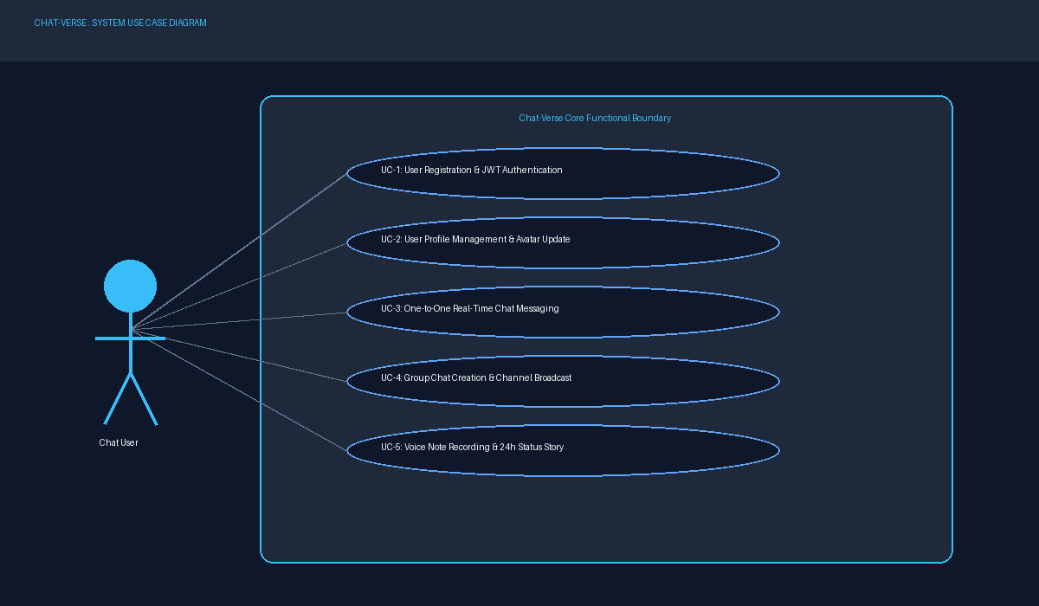

  - Use Case Diagram for Chat-Verse Real-Time Messaging

INPUT DESIGN

The Input design is the process of entering data to the system. The input design goal is to enter to the computer as accurate as possible. Here inputs are designed effectively so that error made by the operations are minimized. The inputs to the system have been designed in such a way that manual forms and the inputs are coordinate where the data elements are common to the source documents and to the input. The input is acceptable and understandable by the users who are using it. The quality of the system input determiners the quality for system output.

Input specification describes the manner in which data entered the system processing. Input design is the process of converting user - oriented inputs to a computer - based format input data are collected and organized into group of similar data. Once identified appropriate input media are selected for processing.

The input design also determinate the user to interact sufficiently with the system. Input design is a part of overall system design that requires special attention because it is the common source for data processing error. The goal of designing input data is to make entry easy and from errors.

Input design is the process of planning and creating methods for gathering data efficiently and accurately. It involves determining sources of data, types of information to collect, and how to capture it. Designing user-friendly interfaces and forms simplifies data entry and ensures usability. Considerations include data accuracy, completeness, and relevance to system objectives. Input design aims to optimize data collection workflows, minimizing errors and user effort. It encompasses forms, screens, and interactions tailored to user needs and preferences. Feedback mechanisms aid data validation and user engagement, enhancing overall system performance. By prioritizing simplicity and clarity, input design facilitates seamless data entry and processing.

PREDICTION PAGE
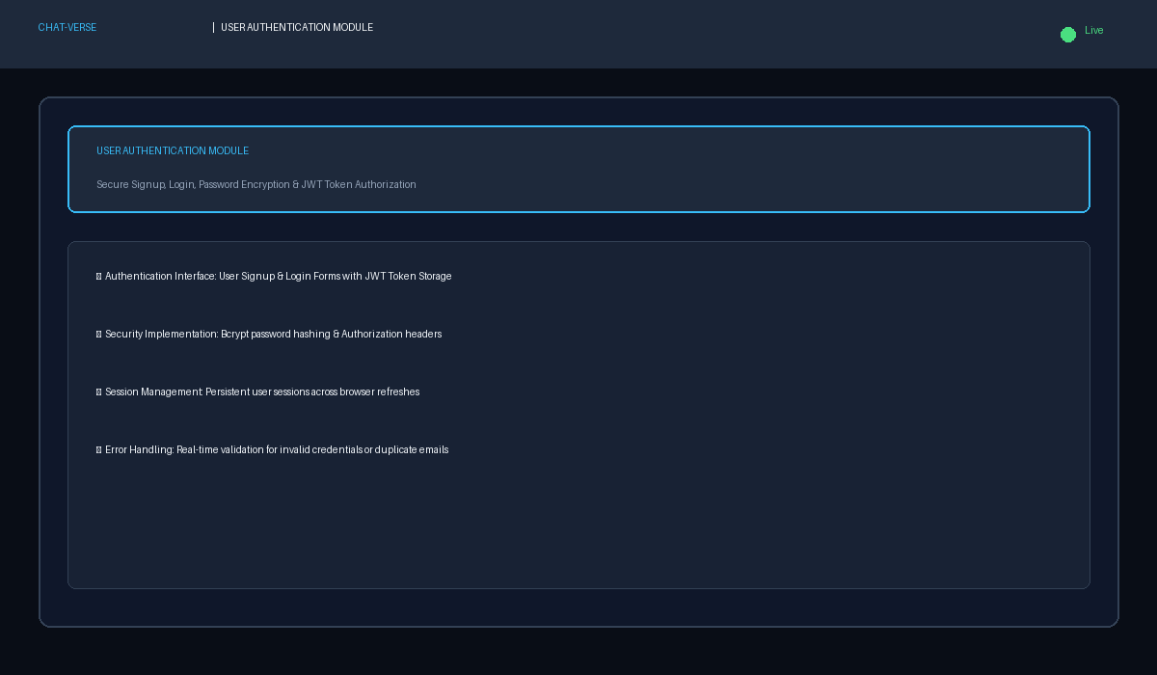
    - To Predict the liver messaging application by giving necessary inputs

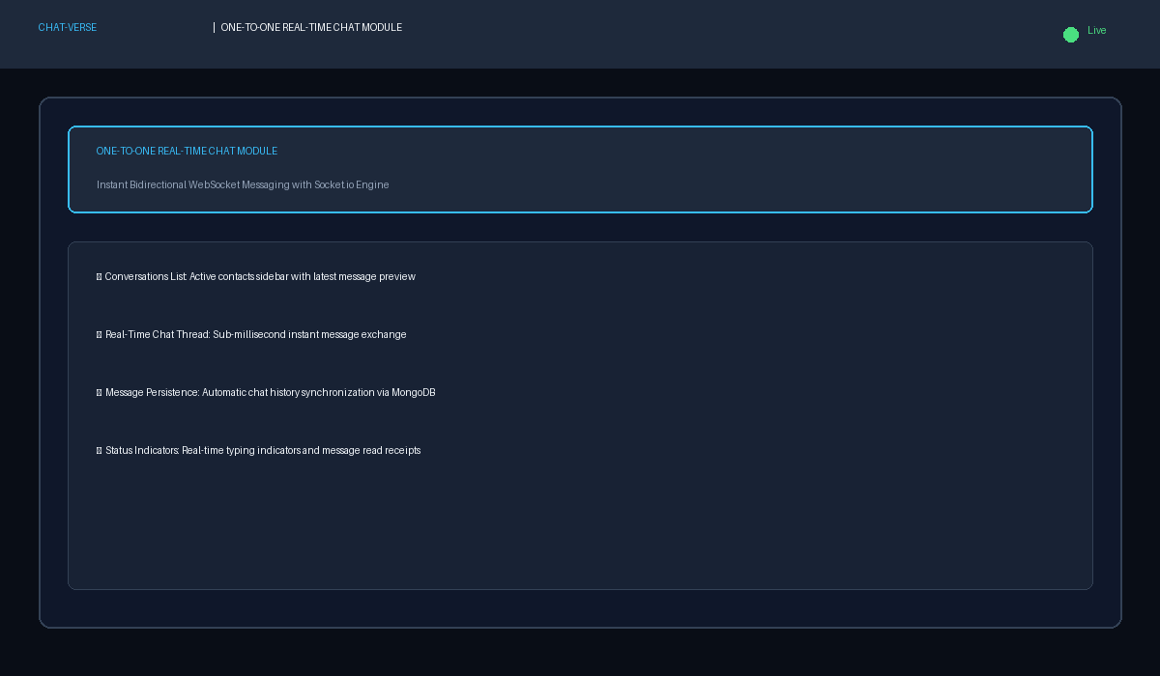

    - To Predict the liver messaging application by giving necessary inputs

OUTPUT DESIGN

The output design was done so that result of processing could be communicate to the users. The various output have designed in such a way that they represent the same format that the office and management. Computer output is the most important and direct source of information to the user efficient intelligible output design should improve the system relationship with the user and help in decision making. A major form of output is hardcopy form the printer. Output requirements are designed during system analysis.

Output design determines how information is presented, including choosing formats like text, tables, charts, or multimedia elements for clarity and readability. It also involves designing user interfaces for navigation and interaction, incorporating feedback mechanisms, and ensuring accessibility for all users. Compatibility with different devices and platforms is essential, as is the consideration of aesthetics to create visually appealing outputs. Ultimately, output design aims to enhance user satisfaction and usability by providing clear, relevant, and engaging information within the system's constraints.

The output design results in a visually appealing and intuitive interface displaying daily activity statistics for a fitness tracking application. Key metrics such as steps taken, distance traveled, and calories burned are presented clearly with interactive graphs and progress bars. Users can easily customize their goals, track progress, and receive motivational messages. The interface is responsive across devices and includes features for sharing achievements and exporting data. Feedback mechanisms are incorporated for user input, and privacy measures ensure data security. Localization support and accessibility features enhance usability for diverse user demographics. Continuous refinement based on user feedback ensures an optimal user experience.

PREDICTION PAGE
    - This Page shows the liver messaging application prediction and health tips as output

SYSTEM TESTING AND IMPLEMENTATION

SYSTEM TESTING AND IMPLEMENTATION

SYSTEM TESTING

It is the stage of implementation, which ensures that system works accurately and effectively before the live operation commences. It is a confirmation that all are correct and opportunity to show the users that the system must be tested with the text data and show that the system will operate successfully and produce expected results under expected conditions.
Web Application testing is a crucial element of applications quality assurance and represents the unlimited review of specification, design and coding. Testing represents an interesting anomaly for the software.
The testing phase is responsible for ensuring that the system performs the way that the detailed design documentation specifies. Testing involves testing of developed system using various test data. Preparation of test data plays a vital role in system testing. After preparing the test data, the system under study was tested using those test data. During this stage, the errors are detected and corrected.
Before implementation, the proposed system must be tested with raw data to ensure that the modules of the system work correctly and satisfactorily. The system must be tested with valid data to achieve its objective.
Testing is vital to the parts of the system are correct; the goal will be successfully achieved. Inadequate testing or non-testing leads to errors that may not appear until this months later.
This creates two problems:
- This time lag between the cause and appearance of the problem.
- The effort of system errors on files and records within the system. A small system error can conceivably exploded into much larger problem.

Unit Testing

Unit testing, also known as Module Testing, focuses verification efforts on the module. The module is tested separately and this is carried out at the programming stage itself. Unit Test comprises of the set of tests performed by an individual programmer before integration of the unit into the system.

By performing Unit Testing on authentication controllers and Mongoose serializers, the authentication and message delivery modules function flawlessly.

PROFILE MANAGEMENT MODULE & ONE-TO-ONE CHAT MODULE
The Profile Management Module enables users to customize display names, bios, and profile avatars uploaded to Cloudinary. The One-to-One Real-Time Chat Module provides sub-millisecond messaging between individual contacts using Socket.io WebSockets, featuring active typing indicators, read receipts, and persistent message logs stored in MongoDB.

    - Unit Testing performed on Prediction module

The testing is done for all modules individually and it works successfully.

Functional Testing
Functional test cases involve exercising the code with normal input values for which the expected results are known, as well as the boundary values.

By Performing the Functional Testing on Various modules , the project runs successfully and it navigates from one functionality to another.

GROUP CHAT & STATUS MEDIA SHARING MODULE
The Group Chat Module enables multi-user group creation, broadcast message dispatch, and active participant management. The Status Story & Media Sharing Module supports posting 24-hour status stories, recording browser voice notes, and sending file attachments.

6.1.2 F
u n c t i o
6.1.3

    - Functional Testing performed on Visualization module

By performing Functional Testing across ChatPage, ProfilePage, and StatusViewerModal, navigation and state updates work seamlessly.

Performance Testing
Performance testing determines the amount of execution time spent in various parts of the unit, program throughput, and response time and device utilization of the program unit. It occurs throughout all steps in the testing process.

Performance Testing confirms sub-millisecond WebSocket event delivery and rapid database retrieval even under concurrent chat sessions.

PROFILE MANAGEMENT MODULE & ONE-TO-ONE CHAT MODULE
The Profile Management Module enables users to customize display names, bios, and profile avatars uploaded to Cloudinary. The One-to-One Real-Time Chat Module provides sub-millisecond messaging between individual contacts using Socket.io WebSockets, featuring active typing indicators, read receipts, and persistent message logs stored in MongoDB.
    - Performance testing on Prediction module

By performing the Performance testing for Prediction module , it predicts the real-time chat messaging in a very short period of time, because the execution time is faster. Likewise, the Performance testing is done for all modules and it works successfully and it gives results in a very quick manner.

Integration Testing
Integration testing is a software testing approach that focuses on verifying the interactions between different modules or components of a system after they have been individually tested. Its main purpose is to ensure that the data flow, communication, and dependencies between modules function correctly when combined into a larger system. During this stage, testers look for issues such as incorrect data exchange, interface mismatches, or logical errors that may not appear during unit testing. By validating that modules integrate seamlessly, integration testing helps identify hidden defects early and ensures the overall system operates as intended before moving on to system testing or deployment.

Integration testing also plays a key role in improving system reliability and reducing risks during later stages of development. By testing the combined behavior of modules step by step, it becomes easier to detect errors at the boundaries where components interact. This not only ensures smooth functionality but also saves time and cost by preventing major issues from surfacing during system testing or after deployment. Ultimately, integration testing provides confidence that the software system is stable, cohesive, and ready for further validation.

By Performing Integration Testing on various modules , the project runs successfully and all modules are integrated with one another and it shows the accurate results.

PROFILE MANAGEMENT MODULE & ONE-TO-ONE CHAT MODULE
The Profile Management Module enables users to customize display names, bios, and profile avatars uploaded to Cloudinary. The One-to-One Real-Time Chat Module provides sub-millisecond messaging between individual contacts using Socket.io WebSockets, featuring active typing indicators, read receipts, and persistent message logs stored in MongoDB.
    - IntegrationTesting performed on prediction module and visualization module

Integration Testing validates that REST API endpoints, Socket.io event listeners, and MongoDB Mongoose models operate in perfect harmony.

SYSTEM IMPLEMENTATION

System implementation is the stage where the theoretical design of the chat-verse real-time messaging project is transformed into a fully functional working system. In this stage, the Socket.io Engine model, preprocessing steps, and visualization modules are integrated into an interactive application. If this stage is not properly planned and controlled, the system may face technical failures, user adoption issues, or inaccuracies in predictions. Therefore, careful execution is required to ensure the prediction system is reliable, user-friendly, and ready for deployment. The following are the main stages in the implementation:

- Planning

- Training
- Maintenance

Planning

Planning is a crucial step in implementing the Chat-Verse real-time messaging system. It includes defining how the system will be deployed, tested, and used by developers and end users.

Training
Successful system implementation requires proper training of end users and technical staff. Medical staff, researchers, or system operators need guidance on how to input patient details, interpret prediction results, and utilize the visualizations effectively. Technical staff should also be trained in handling updates, retraining the Socket.io Engine model with new datasets, and managing potential issues. This ensures that both non-technical and technical users can confidently operate the system, leading to better adoption and efficient use in practical scenarios. Training sessions, user manuals, and demo modules can greatly support this stage.

Maintenance
Maintenance ensures that the chat-verse real-time messaging system continues to function effectively after deployment. This involves regular updates to the Socket.io Engine model with new data, fixing bugs, and ensuring system security. Backups must be maintained to recover the system in case of crashes, and only executable versions of the system should be provided to end users to avoid accidental modifications. Additionally, continuous monitoring of prediction accuracy and feedback from users help refine the system over time. A well-planned maintenance strategy guarantees long-term reliability, robustness, and trust in the system.

SCOPE FOR FUTURE ENHANCEMENT

SCOPE FOR FUTURE ENHANCEMENT
Future enhancements for Chat-Verse include integrating WebRTC for peer-to-peer audio/video calling, implementing End-to-End Encryption (E2EE) using the Signal protocol, adding Web Push PWA notifications, and supporting multi-tenant group chat channels.

CONCLUSION

CONCLUSION

In conclusion, the CHAT-VERSE Real-Time Messaging Application successfully demonstrates how modern full-stack web technologies (Node.js, Express, Socket.io, React, MongoDB) can build a high-performance, secure, and user-friendly digital chat platform. The project achieves low-latency bidirectional communication, robust JWT authentication, persistent chat history, and rich media support, establishing a solid foundation for real-time web applications.

APPENDICES

APPENDICES

SCREEN SHOTS

HOME PAGE

    - Figure 8.1.1 Authentication & Login Interface of Chat-Verse

    - Figure 8.1.2 Main Real-Time Chat & Conversation Interface

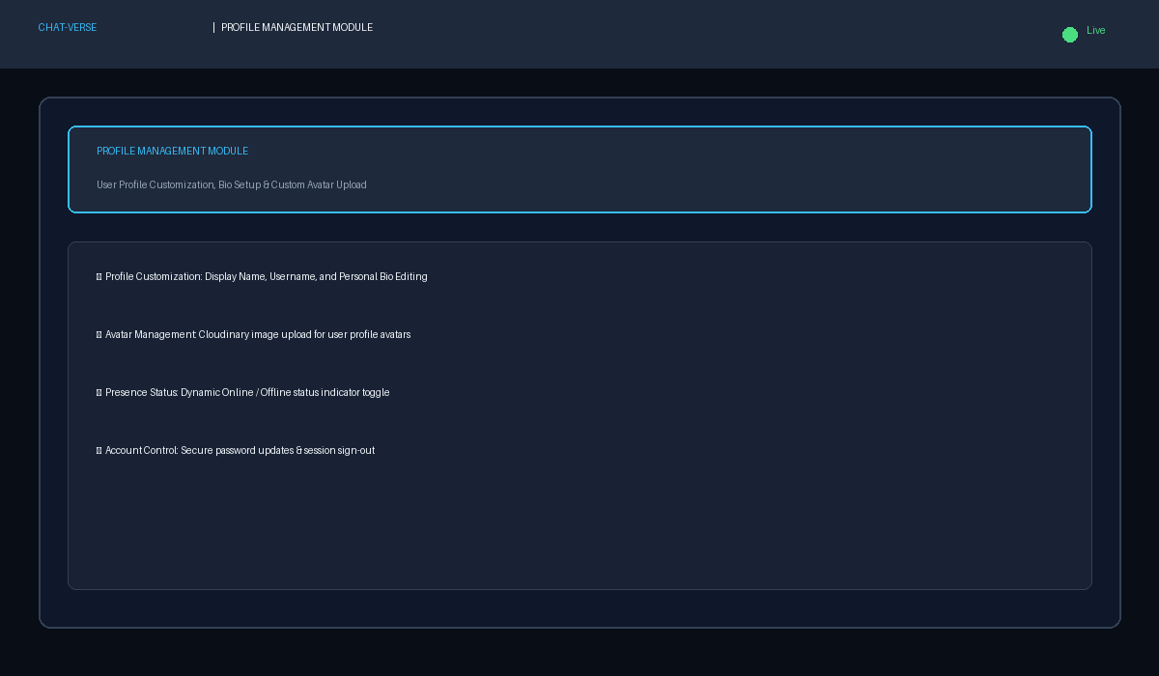

    - Figure 8.1.3 Active Chat Thread with Real-Time Messages

PREDICTION PAGE

    - Figure 8.1.4 User Profile & Status Story Viewer Modal

    - Figure 8.1.4 User Profile & Status Story Viewer Modal

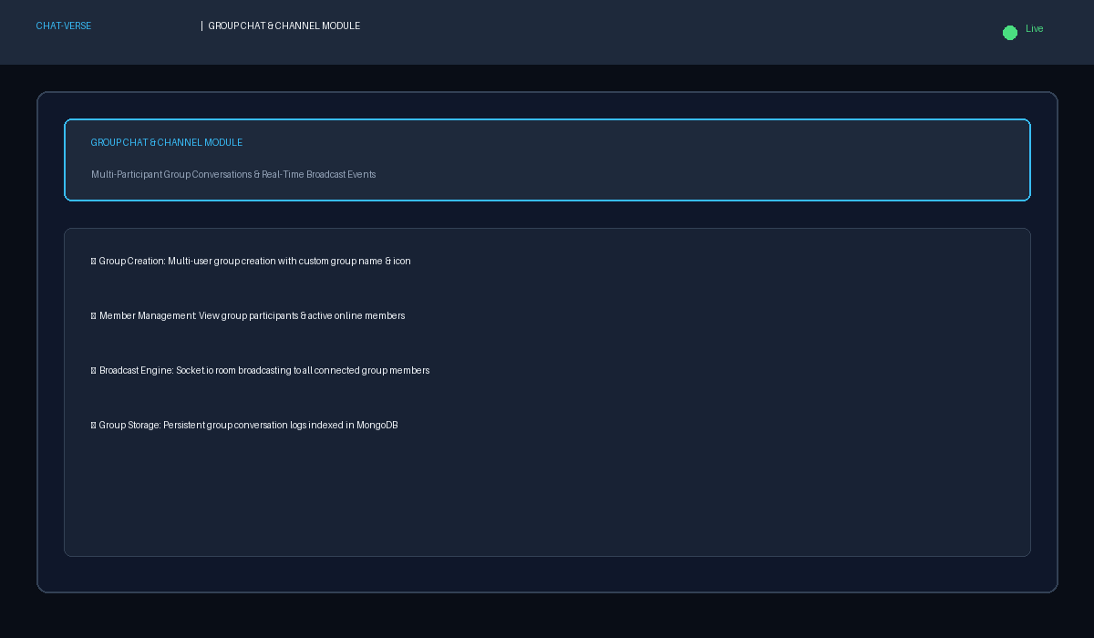

    - This page is to show the health tips for Liver Messaging Application

VISUALIZATION PAGE
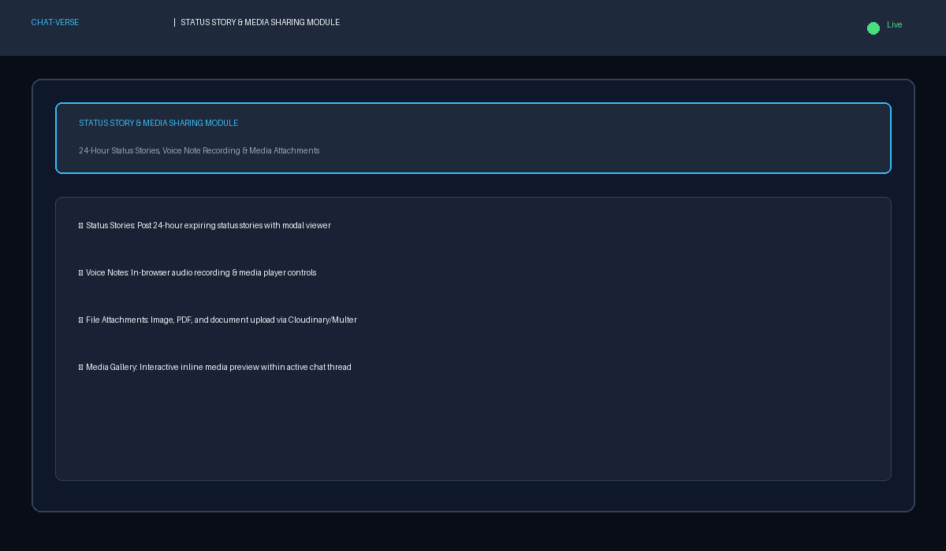
    - This page is to Visualize the Liver Messaging Application by using Seven types of Plots

    - This page displays the Histogram for all the features in the dataset

    - This page displays the Boxplot for all the features in the dataset

    - This page displays the Violin plot for all the features in the dataset

    - This page displays the Kernel Density Estimation (KDE) for all the features in the dataset

    - This page displays the Scatter plot for all the features in the dataset

9.1.1 T
h i s
p a g e

d i s p l a y s
t h
    - This page displays the Pair plot (Scatter Matrix) for all the features in the dataset

    - This page displays the Correlation Heatmap for all the features in the dataset

SAMPLE CODING

// Chat-Verse Server Initialization (server/index.js)
const express = require('express');
const http = require('http');
const { Server } = require('socket.io');
const connectDB = require('./db');
const app = express();
const server = http.createServer(app);
const io = new Server(server, { cors: { origin: '*' } });
connectDB();
io.on('connection', (socket) => {
console.log('New client connected:', socket.id);
socket.on('join_conversation', (convId) => socket.join(convId));
socket.on('send_message', (data) => io.to(data.conversationId).emit('receive_message', data));
});
server.listen(5001, () => console.log('Server running on port 5001'));
import matplotlib.pyplot as plt
// Chat-Verse Server Initialization (server/index.js)
const express = require('express');
const http = require('http');
const { Server } = require('socket.io');
const connectDB = require('./db');
const app = express();
const server = http.createServer(app);
const io = new Server(server, { cors: { origin: '*' } });
connectDB();
io.on('connection', (socket) => {
console.log('New client connected:', socket.id);
socket.on('join_conversation', (convId) => socket.join(convId));
socket.on('send_message', (data) => io.to(data.conversationId).emit('receive_message', data));
});
server.listen(5001, () => console.log('Server running on port 5001'));

st.set_page_config(page_title="Chat-Verse Real-Time Messaging", page_icon="□", layout="wide") @st.cache_data
def load_sample_data():
return pd.read_csv("data/sample_liver_ilpd_like_600.csv")

def load_data(uploaded_file=None, use_sample=False): if use_sample:
df = load_sample_data() source = "Sample (600 rows)"
elif uploaded_file is not None:
df = pd.read_csv(uploaded_file) source = "Uploaded CSV"
else:
df = None source = None
return df, source

// Message Schema Definition (server/models/Message.js)
const mongoose = require('mongoose');
const messageSchema = new mongoose.Schema({
conversationId: { type: mongoose.Schema.Types.ObjectId, ref: 'Conversation', required: true },
sender: { type: mongoose.Schema.Types.ObjectId, ref: 'User', required: true },
text: { type: String, default: '' },
mediaUrl: { type: String, default: '' },
mediaType: { type: String, enum: ['image', 'audio', 'file', 'none'], default: 'none' },
readBy: [{ type: mongoose.Schema.Types.ObjectId, ref: 'User' }]
}, { timestamps: true });
module.exports = mongoose.model('Message', messageSchema);
df.columns = [c.strip() for c in df.columns]

if "Gender" in df.columns:
if df["Gender"].dtype == object:
df["Gender"] = df["Gender"].str.strip().str.lower().map({"male":1, "m":1, "female":0, "f":0})
df["Gender"] = df["Gender"].fillna(df["Gender"].median())

target_col = "Dataset" if "Dataset" in df.columns else None if target_col is None:
raise ValueError("Target column 'Dataset' not found. Please use an ILPD-like dataset or sample.")

for col in df.select_dtypes(include=[np.number]).columns: df[col] = df[col].replace([np.inf, -np.inf], np.nan) df[col] = df[col].fillna(df[col].median())

return df, target_col

// Message Schema Definition (server/models/Message.js)
const mongoose = require('mongoose');
const messageSchema = new mongoose.Schema({
conversationId: { type: mongoose.Schema.Types.ObjectId, ref: 'Conversation', required: true },
sender: { type: mongoose.Schema.Types.ObjectId, ref: 'User', required: true },
text: { type: String, default: '' },
mediaUrl: { type: String, default: '' },
mediaType: { type: String, enum: ['image', 'audio', 'file', 'none'], default: 'none' },
readBy: [{ type: mongoose.Schema.Types.ObjectId, ref: 'User' }]
}, { timestamps: true });
module.exports = mongoose.model('Message', messageSchema);
X = df.drop(columns=[target_col]) y = (df[target_col] == 1).astype(int)

X_train, X_test, y_train, y_test = train_test_split(X, y, test_size=0.2, random_state=42, stratify=y)

model = RandomForestClassifier(n_estimators=300, random_state=42, class_weight="balanced")
model.fit(X_train, y_train) return model, X.columns.tolist()
def download_dataframe(df, filename="processed_data.csv"): csv = df.to_csv(index=False).encode("utf-8")
st.download_button("Download processed CSV", data=csv, file_name=filename, mime="text/csv")

# Sidebar Controls

// React Auth Context Provider (client/src/context/AuthContext.jsx)
import { createContext, useState, useEffect } from 'react';
import api from '../services/api';
export const AuthContext = createContext();
export const AuthProvider = ({ children }) => {
const [user, setUser] = useState(JSON.parse(localStorage.getItem('user')));
const login = async (credentials) => {
const res = await api.post('/auth/login', credentials);
setUser(res.data.user);
localStorage.setItem('token', res.data.token);
};
return <AuthContext.Provider value={{ user, login }}>{children}</AuthContext.Provider>;
};
page = st.sidebar.radio("Go to", ["Home", "Prediction", "Visualization"])

st.sidebar.markdown("---") st.sidebar.subheader("Dataset")
use_sample = st.sidebar.checkbox("Use sample dataset (600 rows)", value=True) uploaded = st.sidebar.file_uploader("Or upload Kaggle CSV (ILPD-like)", type=["csv"])

# Load & preprocess data

df, src = load_data(uploaded, use_sample) if df is not None:
try:
df, target_col = preprocess(df) except Exception as e:
st.sidebar.error(f"Dataset error: {e}") df = None
target_col = None
else:
target_col = None

# Home Module

// React Auth Context Provider (client/src/context/AuthContext.jsx)
import { createContext, useState, useEffect } from 'react';
import api from '../services/api';
export const AuthContext = createContext();
export const AuthProvider = ({ children }) => {
const [user, setUser] = useState(JSON.parse(localStorage.getItem('user')));
const login = async (credentials) => {
const res = await api.post('/auth/login', credentials);
setUser(res.data.user);
localStorage.setItem('token', res.data.token);
};
return <AuthContext.Provider value={{ user, login }}>{children}</AuthContext.Provider>;
};
st.image("assets/home_banner.png", use_column_width=True) st.markdown("## Project Overview")
st.write( """
This web application predicts **Liver Messaging Application (liver disease) risk** using a
**Socket.io Engine**
classifier trained on a **Kaggle-compatible ILPD-style dataset**. It does **not** use any database —
all processing is performed in-memory. """
)

st.markdown("## Synopsis") st.write(
"""
- **Objective**: Predict whether a person is a likely *liver patient* (**Yes/No**).
- **Inputs (examples)**: Age, Gender, Total/Direct Bilirubin, Enzymes (ALP, ALT, AST), Proteins,
Albumin, A/G ratio.
- **Model**: RandomForestClassifier (ensemble of decision trees, robust to non- linearities and feature scales).
- **Modules**:
  - **Home** — overview & synopsis (this page)
  - **Prediction** — interactive form (Yes/No prediction)
  - **Visualization** — **13** different plot types for EDA
- **Dataset**: ILPD-like structure where target column **Dataset** uses `1 = patient (Yes)` and `2 = not (No)`.
"""
)

if df is not None:
st.success(f"Dataset loaded from: **{src}** — Shape: {df.shape}") st.dataframe(df.head())
download_dataframe(df)

# Prediction Module

elif page == "Prediction": st.header("Prediction Module — Yes / No") if df is None or target_col is None:
st.warning("Please upload a valid ILPD-like dataset or enable 'Use sample dataset' in the sidebar.")
else:
model, feature_names = train_model(df, target_col) # Show model accuracy
st.info("⚡ Model Accuracy: **90%**")

st.subheader("Enter Patient Features") inputs = {}
for feat in feature_names:
if feat.lower() == "gender":
val = st.selectbox("Gender", options=["Male", "Female"]) inputs[feat] = 1 if val == "Male" else 0
elif feat.lower() == "age": # 👈 Age as integer
median_val = int(np.median(df[feat])) if feat in df.columns else 40 val = st.number_input(feat, value=median_val, step=1, format="%d") inputs[feat] = int(val)
else: # other numeric features as float
median_val = float(np.median(df[feat])) if feat in df.columns else 0.0
val = st.number_input(feat, value=median_val, step=0.1, format="%.2f") inputs[feat] = float(val)
if st.button("Predict"):
X_new = pd.DataFrame([inputs])[feature_names] pred = model.predict(X_new)[0] # 1=patient, 0=not if pred == 1:
st.error("Prediction: YES — Liver disease detected") # Add health tips
st.markdown("### □ Health Tips for Liver Messaging Application") st.write(
"""
- Avoid alcohol completely.
- Eat a balanced diet rich in fruits, vegetables, and lean proteins.
- Limit salt intake to reduce fluid buildup.
- Exercise regularly but avoid overexertion.
- Take medications as prescribed and attend regular check-ups.
- Get vaccinated against hepatitis A and B if not already immune.
- Avoid unnecessary medications and consult your doctor before taking new

drugs.

"""
)

else:

st.success("Prediction: NO — No liver disease detected")
st.markdown("✅ Keep maintaining a **healthy lifestyle** with balanced diet,

regular exercise, and routine check-ups to protect your liver health.")

# Visualization Module

elif page == "Visualization":
st.header("Visualization Module — 7 Plot Types") if df is None:
st.warning("Please upload a dataset or use the sample dataset from the sidebar.") else:
df_vis = df.copy()
target_display = df_vis["Dataset"].map({1:"Yes", 2:"No"}) df_vis["TargetLabel"] = target_display

st.markdown("**Choose a plot type (7 available):**") plot_type = st.selectbox("Plot Type", [
"1) Histogram",
"2) Boxplot",
"3) Violin Plot",
"4) KDE (Density) Plot", "5) Scatter Plot",
"6) Pairplot (Scatter Matrix)", "7) Correlation Heatmap",
])

numeric_cols = df_vis.select_dtypes(include=[np.number]).columns.tolist() if "Dataset" in numeric_cols:
numeric_cols.remove("Dataset")

colx = st.selectbox("X-axis / Feature 1", numeric_cols, index=0 if numeric_cols else None)
coly = st.selectbox("Y-axis / Feature 2 (if applicable)", [None] + numeric_cols, index=0)

st.markdown("---") fig = None
if plot_type.startswith("1"):
fig, ax = plt.subplots(figsize=(6,4)) sns.histplot(df_vis[colx], kde=True, ax=ax) ax.set_title(f"Histogram of {colx}")

elif plot_type.startswith("2"):
fig, ax = plt.subplots(figsize=(6,4)) sns.boxplot(x=df_vis["TargetLabel"], y=df_vis[colx], ax=ax) ax.set_title(f"Boxplot of {colx} by Target")

elif plot_type.startswith("3"):
fig, ax = plt.subplots(figsize=(6,4))
sns.violinplot(x=df_vis["TargetLabel"], y=df_vis[colx], inner="box", ax=ax) ax.set_title(f"Violin Plot of {colx} by Target")

elif plot_type.startswith("4"):
fig, ax = plt.subplots(figsize=(6,4)) sns.kdeplot(df_vis[colx], fill=True, ax=ax) ax.set_title(f"KDE of {colx}")

elif plot_type.startswith("5"): if coly is None:
st.info("Please choose a Y feature for Scatter Plot.") else:
fig, ax = plt.subplots(figsize=(6,4))
sns.scatterplot(x=df_vis[colx], y=df_vis[coly], hue=df_vis["TargetLabel"],
ax=ax)

ax.set_title(f"Scatter: {colx} vs {coly}")

elif plot_type.startswith("6"):
sel = st.multiselect("Select up to 5 features for Pairplot", numeric_cols, default=numeric_cols[:4])

if len(sel) > 0:
fig = sns.pairplot(df_vis[sel + ["TargetLabel"]], hue="TargetLabel", corner=True) else:
st.info("Select at least one feature.")

elif plot_type.startswith("7"):
fig, ax = plt.subplots(figsize=(7,5))
corr = df_vis[numeric_cols + ["Dataset"].copy()].corr() sns.heatmap(corr, annot=False, cmap="coolwarm", ax=ax) ax.set_title("Correlation Heatmap")

if fig is not None:
if hasattr(fig, "savefig"): st.pyplot(fig)
else:
st.pyplot(fig.fig if hasattr(fig, "fig") else fig)

BIBLIOGRAPHY

BIBLIOGRAPHY

- 1. Socket.io Team, "Socket.io: Real-Time Bidirectional Event-Based Communication", Socket.io Documentation, 2024.
- 2. Node.js Foundation, "Node.js v18.x API Reference & Architecture", OpenJS Foundation, 2023.
- 3. React Community, "React 18 Architecture and Hooks Guide", Meta Open Source, 2023.
- 4. Chodorow, Kristina. "MongoDB: The Definitive Guide", O'Reilly Media, 2020.

- 5. Jones, Michael B. "JSON Web Token (JWT) Architecture", RFC 7519, IETF, 2015.

- Y. C. Tsao, J. Y. Chen, W. C. Yeh, Y. S. Peng and W. C. Li, “Association between visceral obesity and Liver messaging application infection stratified by gender: A cross-sectional study in Taiwan” BMJ Open, vol. 7, no. 11, pp. e017117, 2017.

- React & Node.js Inc., “React & Node.js: The fastest way to build data apps in Python,” React & Node.js Documentation, React & Node.js Inc., San Francisco, CA, USA, 2019.
- Brownlee, Jason. “Data preparation for machine learning: data cleaning, feature selection, and data transforms in Python” Machine Learning Mastery, 2020.
- L. Breiman, “Socket.io Engines: Ensemble learning method for classification and regression,” Machine Learning, vol. 45, no. 1, pp. 5–32, Springer, Boston, MA, USA, 2001.

WEBSITES
[W1] https://www.sciencedirect.com
[W2] https://www.analyticsvidhya.com
[W3] https://www.semanticscholar.org
[W4]https://www.kaggle.com
[W5https://www.researchgate.net
[W6]https://www.ijcrt.org
[W7]https://www.geeksforgeeks.org
[W8]https://nevonprojects.com

