Performance Test Execution Closure Report
30 September 2026
Version 0.1

Approvals
Role and Approval Detail | Name & Email of the approver | Title
Version History
List all revisions to the original artifact, starting with publication of the artifact with the author listed.
Version No. | Revision Date | Revised By | Change Description
0.0 | 0-March-2026 | Performance Team | Initial Draft
Contributors
The following listed individuals provided content to this document.
Name | Role
Karthikeyan Rajendran | Performance Test Lead
Reviewers
The listed individuals had the opportunity to review this document and provide input prior to submission.
Name | Work effort role
Udayakumar Diravidamani | Senior Project Manager

Table of Contents
1. Executive Summary 4
2. Key Objectives 4
3. Test Environment 4
4. Test Scope, Metrics & KPIs 5
5. Workload Matrix 5
6. Test Results and Analysis – STATUS – green 5
6.1 S1 – Standard Load: 5
6.2 S2 – Heavy Load: 6
7. Findings 7
8. Server Metrics 7
9. Conclusion 8

1. Executive Summary
The performance testing for IST Switch - Ecom Non-Tokenized transactions is conducted to evaluate its capacity to handle concurrent transactions (based on expected workload), while ensuring compliance with established Service Level Agreements (SLAs).
For this round of performance testing, UAE Acquirer & UAE Issuer (non-tokenized) is identified and tested across two distinct load scenarios:
- Standard Load - Specific SLA metrics for the number of transactions and response time.
- Heavy Load - Specific SLA metrics to evaluate performance under peak usage conditions.
The testing results aimed to validate the application's ability to maintain performance within the defined SLA targets for both scenarios.

2. Key Objectives
The primary objectives of this performance test were:
- To evaluate the application’s stability and responsiveness for different load levels.
- To verify that each transaction can meet its SLA requirements in each load scenario.
- To identify and analyse any bottlenecks that could impact performance under increasing load levels and provide recommendations.
- Identify key performance indicators (KPIs), such as response time, throughput, CPU usage, memory usage, and errors.

3. Test Environment
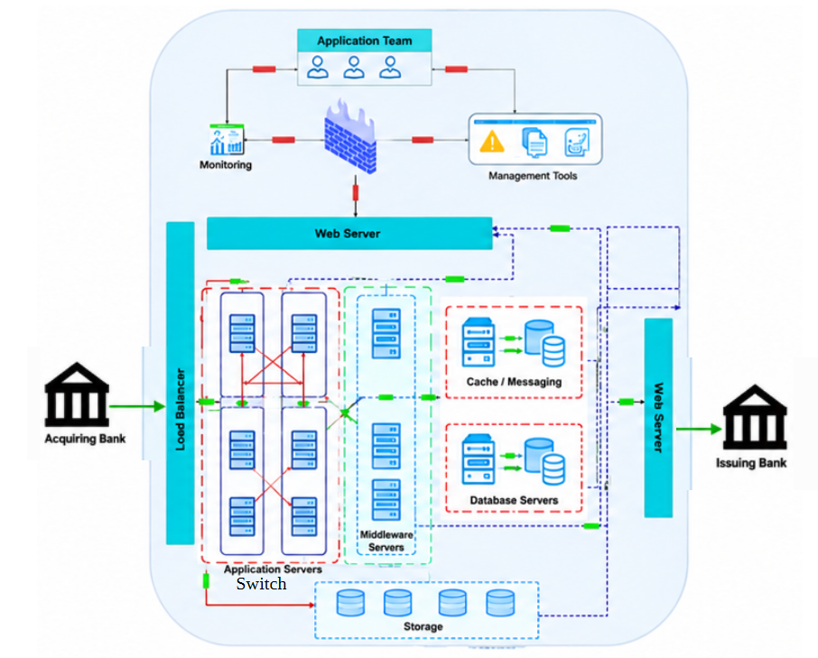

Nodes | IP
Switch Nodes | 10.XXX.XXX.XX
Switch Nodes | 10.XXX.XXX.XX
Load Balancer | 10.XXX.XXX.XX
Load Balancer | 10.XXX.XXX.XX

4. Test Scope, Metrics & KPIs
Load testing scenarios simulated actual user behaviour for the three critical transactions, under each of the Standard and heavy loads.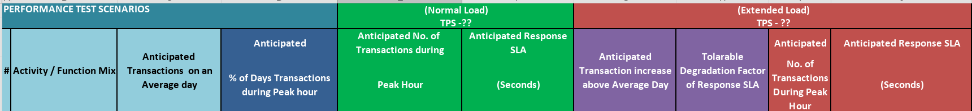

5. Workload Matrix
The workload matrix outlines the user load distribution across test scenarios and timeframes.
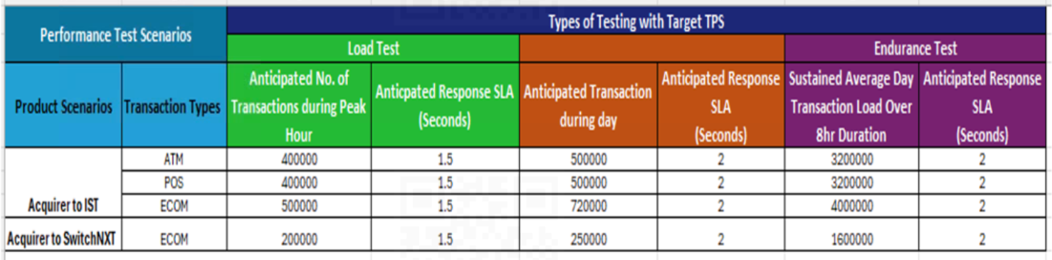

6. Test Results and Analysis – STATUS – green
As planned the performance test execution was carried out in 2 rounds with for standard and heavy load.

6.1 S1 – Standard Load:
S1 (4/9/25 12.18PM-2.28PM)
Application | Transactions | Threads | Total Transactions
ECom | UAE Acquirer & UAE Issuer (non-tokenized) | 20 | 157485
Total |  | 20 | 157485

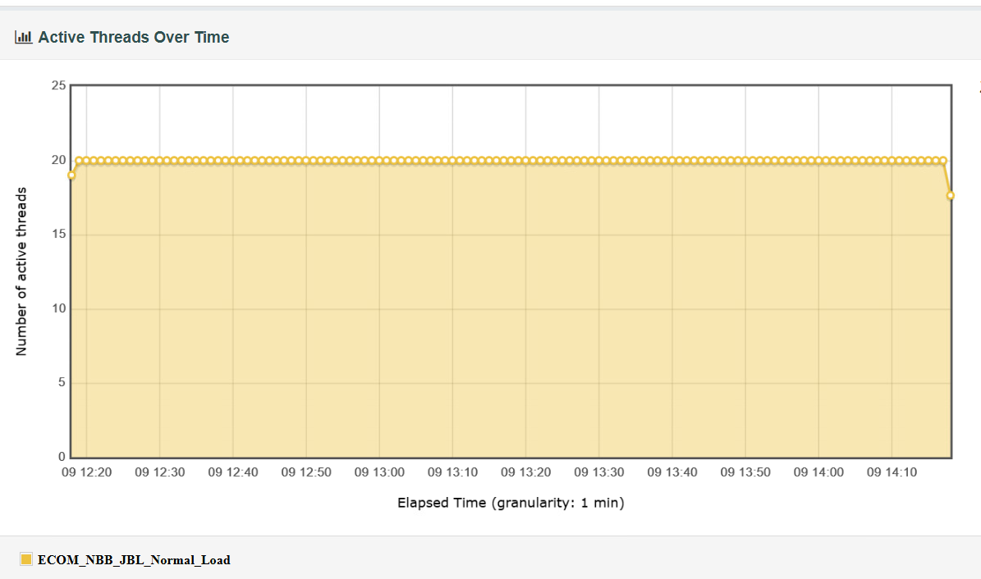
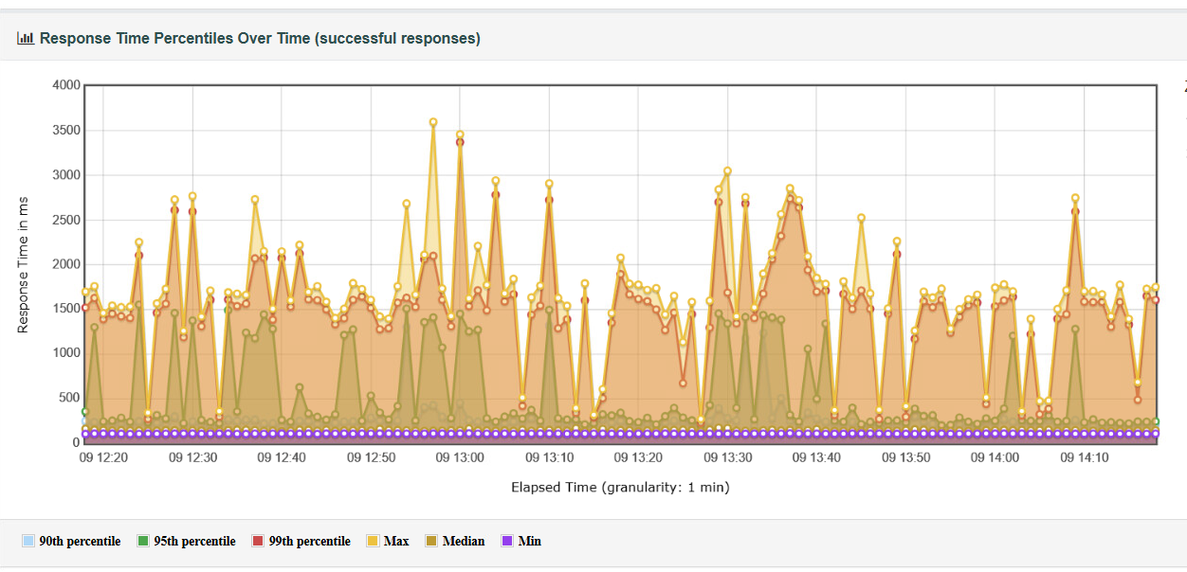
Observations:
- All transactions, except for a negligible percentage of error transactions, were completed within the accepted response time SLA of 1.5 seconds.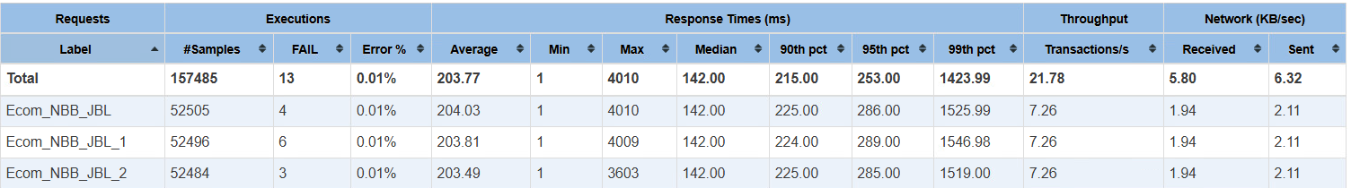

6.2 S2 – Heavy Load:

S2 (04/08/25 - 4.09 PM - 6.10 PM)
Application | Transactions | Threads | Total Transactions
Ecom | UAE Acquirer & UAE Issuer (non-tokenized) | 50 | 291652
Total |  | 50 | 291652

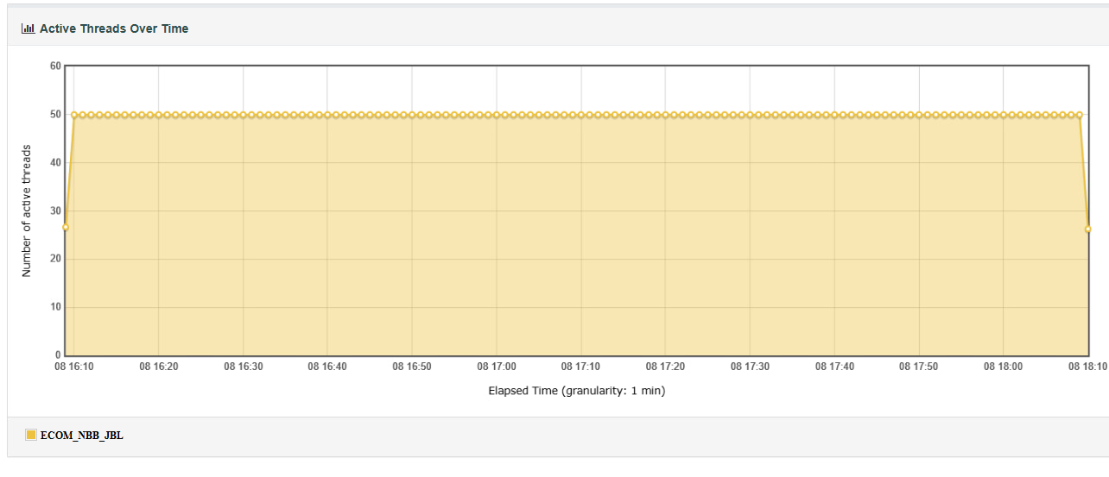

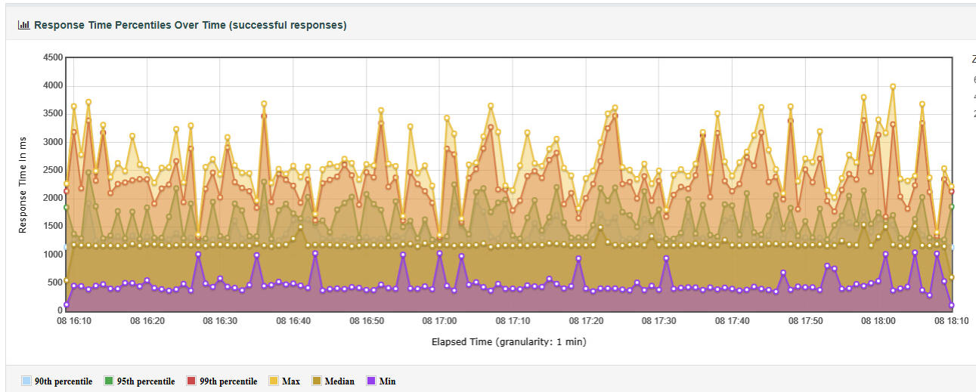
Observations:
- Response time SLA (2 seconds) breach was observed only for the minimal amount of error transactions.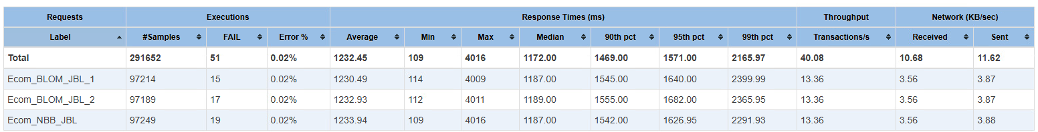

7. Findings
- Transaction Response Times: Even though some transactions exceeded their SLA-defined response times under both standard and peak load conditions, the percentage of such instances was minimal compared to the overall load. The vast majority of transactions were processed within the expected response times, indicating that the system performed efficiently under varying load conditions.
- Transaction Failures: Minimal transaction failures were observed during performance testing.

8. Server Metrics
To be included once received

9. Conclusion
The IST switch (Ecom-Non Tokenized) testing showed that the system supported the expected load without any server capacity issues. However, certain transactions exceeded their SLA-defined response times, with only a minimal error percentage observed, indicating that the server performed well under the load.

