Project Plan

Slide show
Version 0.4

IS217 – Advanced Web Development

Table of Contents
1. Introduction 3
2. Project Organization 3
2.1 Development Model 3
2.2 Project Team 3
2.3 Step Process 3
3. Requirements 4
4. Project Structure 4
4.1 Wire Frame 4
4.2 Vision Product 5

Revision History

Version 0.4
- Introduction
- Added new steps:
  - Learn Node.js
  - Learn MongoDB
  - Connect Slideshow to MongoDB
- Software Requirements
  - JavaScript
    - Node.js
    - MongoDB
- Wireframe Diagram (v0.3)

1. Introduction
The purpose of this project is to demonstrate the capability to create a JavaScript application. The goal of the project is to create slide show that will perform the following:
- Gather images from Flickr.
- Load images into a slide show.
- Store on a server using Document Database model (v0.40
- Be mobile swipe compatible.

2. Project Organization

2.1 Development Model

The project will be approached by the waterfall model.

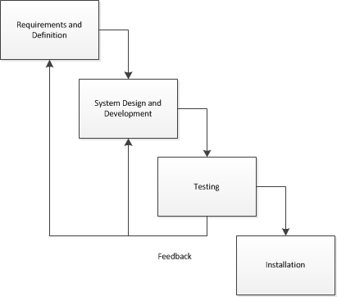

2.2 Project Team

Project Team
Joshua John Villahermosa
Tim Valishin

2.3 Step by Step Process

Learn Backbone JS

Create Backbone Factory slide show

Create Singleton Flickr REST API

Integrate Factory and Singleton
- Learn Node.js
- Learn MongoDB
- Connect Slideshow MongoDB

Convert Mobile

3. Software Requirements

The project will use:
- HTML
- JavaScript
  - Backbone.js
  - JQuery
  - JSON
  - Node.js
  - MongoDB
- Possibly PHP
- CSS

4. Project Structure

4.1 Wire frame (v0.3)
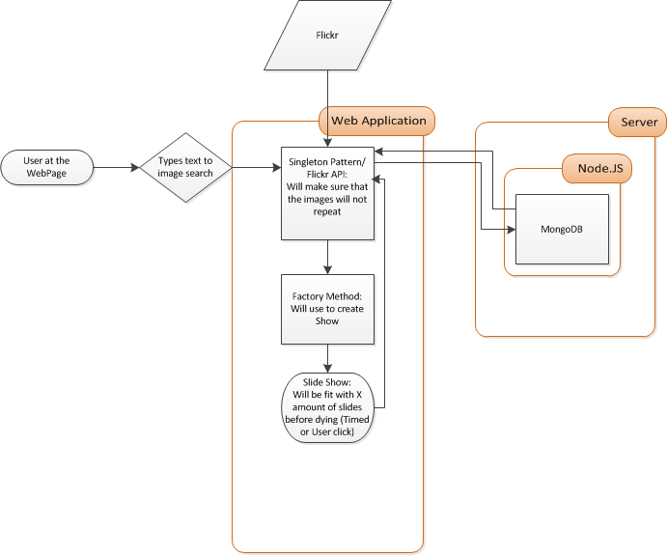

Note: The Flickr process is still unknown to us at this point. We will do some research on how the Flickr API will be used. So far the API will use JSON.

4.2 Vision Product (v0.2)
