Where do we store code ?

<https://github.com/joshwhit99/health/tree/master>

IDE – netbean

To download netBeans go t to URL <https://netbeans.org/downloads/>

Project Structure:

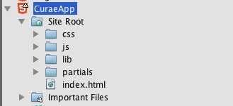

controllers bind data and views

all controllers to be added to contollers.js

var patientControllers = angular.module('patientControllers', []);

var patientControllers = angular.module('patientControllers', []);

patientControllers.controller('ListController', ['$scope', '$http', function($scope, $http) {

$http.get('js/data.json').success(function(data) {

$scope.patients = data;

$scope.patientOrder = 'name';

});

}]);

patientControllers.controller('DetailsController', ['$scope', '$http','$routeParams', function($scope, $http, $routeParams) {

$http.get('js/data.json').success(function(data) {

ListController controls data in partials folder list.html

DetailsController controls data in partials folder details.html

The list may expand to the need of application