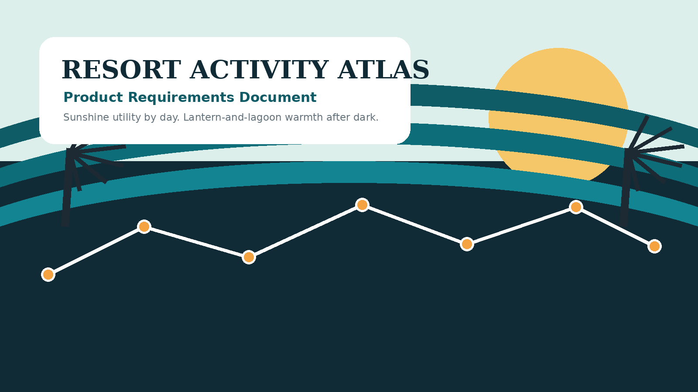

FULL PRODUCT REQUIREMENTS DOCUMENT
  - Front-facing product, responsive UX, design system, growth, advertising, and technical implementation
Version | 1.0
Prepared for | Josh
Date | June 20, 2026
Status | Build-ready product direction

Working-title notice
“Resort Activity Atlas” is a strategic working title, not a cleared trademark. Final naming, domain, logo, and prominent fan-oriented references require trademark review before launch.

0. Document guide
  - What this PRD decides and how to use it
This document combines a non-technical product brief with a build-ready technical specification. It intentionally excludes the ingestion and normalization pipeline for resort activity data, but defines the front-end contract that pipeline must satisfy.
Audience | Use this document for
Founder / business owner | Product positioning, scope, monetization rules, launch sequencing, and success metrics.
Product and UX | Information architecture, journeys, responsive behavior, page requirements, accessibility, and acceptance criteria.
Brand / creative | Visual system, imagery, tone, daypart concept, original Easter eggs, and IP guardrails.
Engineering | Architecture, API contract, state model, performance budgets, security, analytics, SEO, and testing.
Advertising / partnerships | Inventory, relevance rules, creative standards, direct-sold sponsorships, and reporting.
Legal counsel | Brand name, nominative references, photography, disclaimers, ad disclosures, privacy, and Easter-egg review.

Decision summary
Build this
A fast responsive web application and installable PWA that lets travelers answer “What can we do now, tonight, during our stay, for free, and near our resort?” in seconds. The interface is a premium data-first atlas, warmed with vintage Florida resort cues by day and lantern-and-lagoon atmosphere after dark. Advertising is contextual, scarce, clearly labeled, and designed as a useful planning service.

Research-backed operating assumptions
- Travel users expect the primary planning tool to be immediately visible, want robust task-specific filters, and need detailed experience information; missing those elements can drive abandonment. [R1]
- Disney theme-park fandom is strongly connected to family introduction, positive memory, and continuing loyalty, so the product should evoke anticipation and shared memories without copying protected brand expression. [R2]
- Visual quality affects site evaluation partly through usability and pleasure; the interface must be beautiful because it is usable, not beautiful instead of usable. [R3]
- WCAG 2.2 AA, measurable Core Web Vitals, explicit ad disclosure, and non-disruptive advertising are launch requirements rather than later enhancements. [R4-R8]

Table of contents
1. Product vision and strategy
2. Users, jobs, and journeys
3. Brand and design direction
4. Information architecture and navigation
5. Page-by-page product requirements
6. Responsive and adaptive behavior
7. Accessibility and inclusive planning
8. Advertising and monetization
9. Marketing and growth
10. Easter eggs and fan delight
11. Technical architecture
12. Front-end data contract
13. Performance, SEO, privacy, and security
14. Analytics and experimentation
15. QA, launch plan, and acceptance criteria
16. Risks and legal guardrails
17. Appendices and references

1. Product vision and strategy
  - The independent planning layer for resort activities

Vision
Become the most trusted and delightful independent place to discover, compare, and organize resort activities around Walt Disney World in Orlando—without making visitors decode multiple flyers, pages, or resort-specific schedules.

Product promise
One clear promise
Open the site, state what matters, and get a trustworthy answer in under 20 seconds.

Problem statement
- Activity information is fragmented by resort, document, day, and activity type.
- Travelers often decide in real time, on a phone, while tired, outdoors, or managing children.
- A long undifferentiated list does not answer practical questions such as “Is it free?”, “Can my preschooler do it?”, “Will rain cancel it?”, or “How far is it from us?”
- Unofficial sites frequently optimize for articles and ad impressions rather than the planning task itself.
- Fans want warmth, nostalgia, discovery, and detail, but an unofficial site must remain clearly independent and visually original.

Value proposition
For | The product delivers
In-stay guests | A one-tap answer to what is happening now, next, and tonight.
Pre-trip planners | A date-range view of free, paid, age-appropriate, indoor, and evening activities.
Resort hoppers | A map-aware view of activities worth traveling for, with practical context.
Budget-conscious families | Fast identification of free options and total estimated activity spend.
Fans and repeat visitors | A polished discovery experience with subtle original details that reward repeat use.
Advertisers | High-intent placements aligned with a real planning need, not generic page traffic.

North-star metric
Weekly successful planning sessions: unique sessions in which a user applies a meaningful context (date, resort, time, budget, age, or activity type) and then opens, saves, shares, exports, or navigates to at least one activity.

Primary goals
Goal | Launch target / definition
Fast relevance | Median time from landing to first activity detail opened: under 45 seconds; target under 20 seconds for “Now” and “Tonight” shortcuts.
Search success | At least 75% of search sessions produce an activity detail open, save, share, or source click.
Trust | Every activity displays source freshness and uncertainty state; stale or incomplete data is never silently presented as current.
Retention | Users can save a stay context and return directly to a personalized “Today” view.
Revenue without resentment | Ad complaint / hide rate below 0.5%; sponsor modules do not degrade Core Web Vitals or organic ranking.
Cross-device quality | All P0 journeys pass on small phones, large phones, tablets, laptops, wide desktop, keyboard-only, and screen reader.

Non-goals at launch
- Official affiliation, official-looking branding, or a replacement for official Disney apps and policies.
- Park attraction wait times, ticket sales, room booking, dining reservations, or transportation operations.
- A general Disney news site or broad fan forum.
- A native iOS or Android app; the responsive PWA is the launch product.
- User-uploaded character photography or unmoderated resort imagery.
- A high-density programmatic ad site, autoplay video network, or anti-ad-block arms race.
- The underlying PDF ingestion and data normalization pipeline, except for the interface contract described in Section 12.

Product principles
Principle | Meaning in the interface
Utility before theater | The search task appears before large imagery, promotions, articles, or ads.
Show the decision data | Time, resort, location, price, restrictions, weather sensitivity, and freshness appear before descriptive copy.
Progressive disclosure | Common decisions take one tap; advanced filters remain available without crowding the first screen.
Warm, not derivative | Use Florida resort atmosphere, original illustration, and hospitality—not Disney visual grammar.
Honest uncertainty | “Price not published” and “schedule may have changed” are acceptable product states.
Ads serve the trip | A sponsor must solve a likely planning need at that exact moment.
URL equals state | Searches and filters are linkable, shareable, indexable where appropriate, and restorable.
Respect the tired traveler | Large targets, short labels, stable layouts, offline saved plans, and minimal cognitive load.

2. Users, jobs, and journeys
  - Designing around real decisions, not generic demographics

Primary user segments
Segment | Situation | Core job | Critical features
The In-Stay Decider | On property now; phone in hand; needs an answer within minutes. | “What can we do in the next two hours without another complicated plan?” | Now, near me, free, duration, indoor/outdoor, navigation, save.
The Pre-Trip Planner | Planning days or weeks ahead; often desktop or tablet; compares options for a family. | “What will be available during our stay, and what should I leave room for?” | Stay dates, calendar, age filters, saved plan, share, print/export.
The Budget Optimizer | Wants high-value resort time without adding expensive tickets or fees. | “Show me the best free activities and clearly identify every cost.” | Free toggle, price range, total planned spend, no hidden assumptions.
The Resort Hopper | Repeat visitor or enthusiast willing to travel for a distinctive activity. | “What is worth leaving my resort for, and how hard is the trip?” | Map, area, travel context, “worth the trip,” time buffers.
The Accessibility / Sensory Planner | Needs predictable information about physical, sensory, and environmental demands. | “Can this work for our party without unpleasant surprises?” | Indoor/outdoor, seating, noise/energy, duration, accessibility notes, uncertainty labels.
The Fan Researcher | Enjoys browsing the resorts and discovering small details even before a trip. | “Help me find things I would not have known to look for.” | Collections, guides, original photography, seasonal discovery, Easter eggs.

Jobs to be done
Trigger | Job statement | Desired outcome
We have unexpected free time | When our schedule opens up, help me find a nearby activity that fits the time, weather, budget, and children with me. | A confident choice in a few taps.
We are planning our stay | When I know our dates and resort, help me see the full activity landscape without checking each resort separately. | A simple shortlist and flexible plan.
The weather changed | When rain or heat disrupts the day, help me find realistic indoor or weather-resilient alternatives. | A ready Plan B.
We want a low-cost evening | When we are done with the parks, help me find free evening experiences that do not require a major commitment. | A memorable, low-stress ending.
We found something interesting | When I find an activity, help me understand exactly where, when, who can attend, what it costs, and whether the information is fresh. | No surprise at arrival.
Our group is coordinating | When several people are planning, help us share one understandable itinerary without requiring everyone to create an account. | A shared link or export.

Priority user journeys
Journey | Flow | Success condition
J1: Find something now | Landing > one-tap “Now” > location prompt / selected resort > filtered results > activity detail > directions or save. | Under 20 seconds to first relevant result.
J2: Plan tonight | Landing > “Tonight” > party preferences > agenda view > compare options > save two alternatives. | User sees both primary plan and weather backup.
J3: Browse a stay | Set dates and resort > calendar > filter free / ages > open details > build day plan > share. | A linkable, cross-device itinerary.
J4: Resort-first discovery | Resorts > resort page > Today / All / Map tabs > activity detail. | User never needs to know the official flyer structure.
J5: Rain plan | Weather-aware prompt or explicit filter > indoor / sheltered results > list sorted by travel effort and start time. | Alternative does not require re-entering the whole search.
J6: Sponsor utility | Relevant planning context > labeled sponsor module > external partner page. | Commercial content is clearly understood and genuinely useful.

User anxieties the design must remove
- “Is this actually happening today?”
- “Is it free, or are they going to charge us when we arrive?”
- “Is it only for guests of that resort?”
- “Will my child be too young, bored, overwhelmed, or unable to participate?”
- “How far is this, and will we miss it by the time we get there?”
- “Is this an ad pretending to be an activity?”
- “Is this site official?”

3. Brand and design direction
  - Resort atlas structure, postcard warmth, after-dark atmosphere

Creative concept: Sunshine to Starlight
The foundation is the Resort Activity Atlas: precise, modern, map-aware, and data-first. Daytime surfaces borrow warmth from a Florida resort almanac—cream paper, sea-glass water, citrus accents, palms, luggage tags, field notes, and postcard framing. Evening collections shift toward deep lagoon tones, lantern amber, firelight, reflections, and quiet editorial photography. The daypart shift is atmospheric only; navigation, information hierarchy, contrast, and behavior remain consistent.

Brand personality
We are | We are not
Knowledgeable trip companion | Official representative or insider with implied authorization
Sunny, calm, observant, practical | Childish, sugary, breathless, or filled with “magic” clichés
Detailed enough for enthusiasts | Dense, fussy, or full of fan jargon
Nostalgic in materials and mood | Retro cosplay or imitation of Disney eras
Playful in small moments | Animated everywhere or gamified at the expense of planning
Commercially transparent | A content farm with disguised affiliate links

Voice and copy system
Context | Preferred copy | Avoid
Primary CTA | Find activities | Discover the magic
Time shortcut | Happening now / Tonight | Enchant me / Make memories
Save action | Save to my day | Add to My Experience
Map action | See location / Plan the trip | Navigate the kingdom
Uncertainty | Time not yet confirmed | Probably at 7-ish
Restriction | Guests of this resort only | Exclusive magic for hotel guests
Sponsor label | Sponsored planning partner | “Recommended for you” without disclosure
Independence | Independent planning guide; not affiliated with or endorsed by Disney. | “Unofficial Disney site” as the primary brand identity

Color system
Token | Hex | Primary use
Lagoon | #0F5C67 | Primary actions, links, selected states
Midnight | #112B36 | Headers, night mode, high-contrast text
Sea Glass | #DCEFEB | Soft selected states and informational surfaces
Sand | #F7F1E4 | Warm background and editorial sections
Citrus | #F4A340 | Secondary accent, highlights, sponsor border
Coral | #E8755A | Save / favorite accent and warm emphasis
Lantern | #F6C768 | After-dark highlights; never body text on light backgrounds
Plum | #5D486B | Editorial accents and low-frequency category color
Ink | #1D2A33 | Primary text
Mist | #EEF4F3 | Neutral panels and filter surfaces

Color is semantic before decorative. Free/paid, restriction, weather, and availability states must never rely on color alone. The palette should be validated against WCAG 2.2 contrast requirements in every component state. [R4]

Typography
Role | Recommendation | Rules
Display / editorial headings | Newsreader, Fraunces, or another licensed high-quality serif. | Use for section titles and mood, not dense metadata. Maximum two display weights.
Interface / body | Inter, Atkinson Hyperlegible, or another highly legible sans serif. | Body 16px minimum on mobile; tabular numerals for time and price.
Data / code | A restrained monospace only for source IDs, build notes, or admin-facing diagnostics. | Never use as a decorative “futuristic” Disney-adjacent cue.

Layout and components
- Base spacing unit: 4px; common component rhythm: 8, 12, 16, 24, 32, 48, and 64px.
- Card radius: 16-20px; sheet / modal radius: 24px; buttons: 12-16px. Avoid circular clusters that resemble mouse-ear geometry.
- Shadows are soft and rare. Borders and background contrast carry most structure.
- Images use consistent 4:3 and 16:9 crops. Activity cards may collapse to no-image compact mode for maximum scannability.
- Use container queries where practical so components adapt to available space, not only viewport width.

Iconography
Commission or build a small original line-icon set with rounded joins and consistent optical weight: sun, moon, lantern, campfire, paintbrush, game pieces, movie screen, water ripple, walking path, bicycle, leaf, umbrella, clock, wallet, ticket, accessibility, quiet, energetic, indoor, outdoor, and location. Do not use castles, crowns, wands, character silhouettes, mouse-ear arrangements, official transportation icons, or resort logos.

Imagery brief
Use | Examples | Guardrails
Environmental establishing images | Lagoons, boardwalks, paths, gardens, pool reflections, covered patios, waterfront dusk. | Original or fully licensed; no official logos as focal points; avoid compositions that imply Disney supplied the image.
Activity detail images | Hands making crafts, game materials, bicycles, campfire equipment, outdoor movie setup, trivia pencils. | Show the activity rather than protected characters or copyrighted film imagery.
Human moments | Families walking from behind, adults planning together, children participating with releases. | Model releases; inclusive representation; no identifiable minors without appropriate rights.
Illustration fallback | Original category scenes, Florida flora/fauna, route maps, luggage tags, lanterns. | No derivative character art, attraction facades, official map layouts, or “hidden character” concepts.
Editorial night imagery | String lights, firelight, water reflections, silhouettes, twilight skies. | Protect legibility; never place important text directly over a busy image without a solid overlay.

Motion
- Default motion duration: 120-220ms for interface transitions; 300-450ms for optional atmospheric transitions.
- Use opacity and transform rather than layout movement whenever possible.
- No autoplay sound, forced animation, parallax scroll-jacking, or looping attention-grabbers.
- Honor prefers-reduced-motion; all decorative motion disappears without reducing information or status feedback.
- Reserve the richest motion for completion moments: saving a plan, resolving a conflict, or revealing an optional Easter egg.

Visual wireframe: homepage
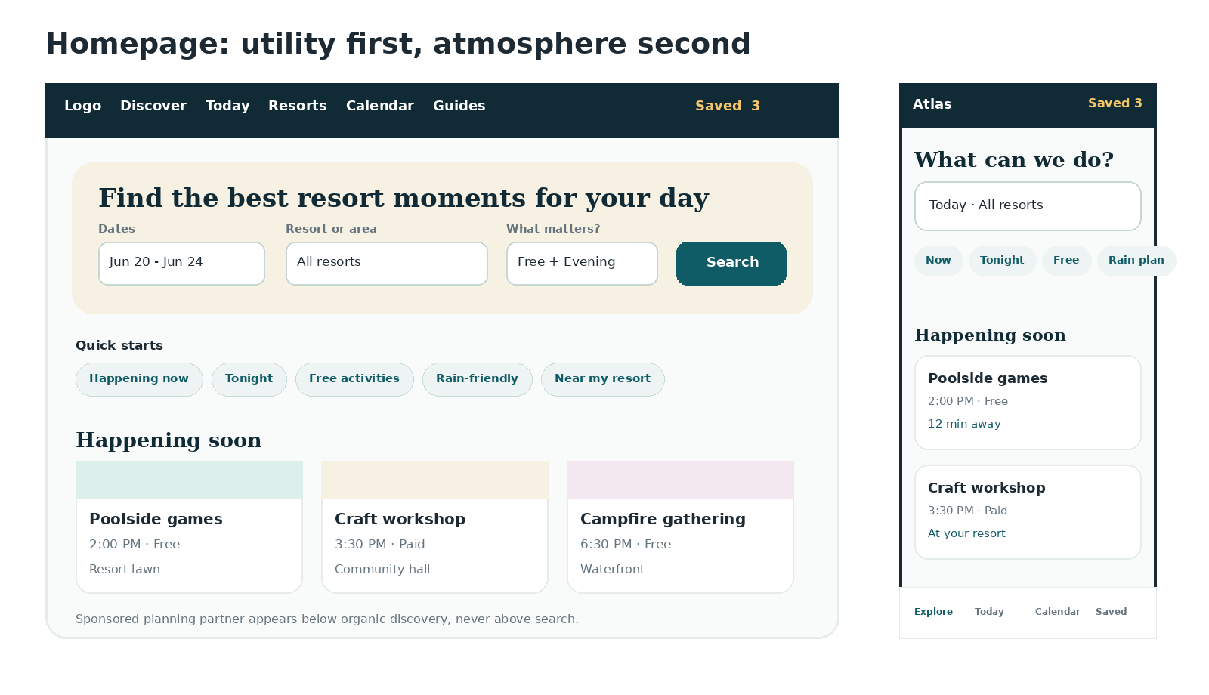
Conceptual wireframe only. Final high-fidelity design should be validated in usability testing at phone, tablet, and desktop widths.

4. Information architecture and navigation
  - Every route starts with the user’s decision

Top-level information architecture
Area | Purpose | Primary routes
Explore | Global discovery, filters, list/agenda/map views. | /activities, /activities/today, /activities/tonight
Today | Personalized current-day view based on stay context and saved items. | /today
Resorts | Browse by resort or resort area. | /resorts, /resorts/{slug}
Calendar | View a day, week, or stay range; add activities to a plan. | /calendar, /calendar/{date}
Saved plan | Timeline, conflicts, travel buffers, sharing, export, offline access. | /plan/{share-id} or /my-plan
Guides | Original editorial collections with live activity modules. | /guides/{slug}
Search | Global text search and command surface. | /search?q=
Trust / legal | About, sourcing methodology, corrections, advertising policy, privacy, terms, non-affiliation. | /about, /methodology, /advertising, /privacy

Navigation by viewport
Viewport | Primary navigation | Secondary navigation
Small / large phone | Bottom navigation: Explore, Today, Calendar, Saved, More. | Search in page header; filters in bottom sheet; trip context opens as a compact sheet.
Tablet portrait | Bottom navigation or compact side rail depending on content width. | Two-column result layouts where useful; full-screen filter sheet remains available.
Tablet landscape / laptop | Top header plus optional left filter rail. | Saved plan and trip context visible in header.
Desktop / wide desktop | Top header: Discover, Today, Resorts, Calendar, Guides; global search; Saved. | Sticky filter rail and optional map panel; never exceed comfortable reading width.

Decision shortcuts
The homepage and persistent Explore surfaces expose a small set of high-intent shortcuts. They are not decorative category links; each applies a meaningful preconfigured query and shows the active filters immediately.
Shortcut | Default query behavior
Happening now | Start within the next 90 minutes; selected resort or nearby area first; exclude already-ended activities.
Tonight | Local time from 4:00 PM onward; sort by start time and travel effort.
Free activities | Price state = free; unknown price excluded unless user explicitly includes it.
Rain-friendly | Indoor or explicitly covered; weather-dependent outdoor options excluded.
Near my resort | Selected home resort first, then same area, then all resorts with travel context.
Good for little ones | Age fit based on sourced or editorially labeled guidance; never infer a hard age restriction without evidence.
Low-key evening | Low / moderate energy, shorter duration, seating likely, no reservation required where known.

URL and state rules
- Search state is encoded in readable query parameters: date, time window, resort, area, cost, age, indoor/outdoor, duration, restriction, reservation, category, sort, and view.
- Filters survive refresh, back/forward navigation, sharing, and cross-device open.
- Anonymous saved plan state lives locally and may be promoted to a shareable server-side plan on demand.
- Indexable landing pages use clean canonical URLs; arbitrary low-value filter combinations are canonicalized or noindexed to avoid thin search pages.
- The selected Orlando timezone and date are always explicit in API calls and rendered output.

5. Page-by-page product requirements
  - Front-facing behavior and acceptance criteria

5.1 Homepage
Purpose: get a first-time or returning visitor into a relevant activity set immediately while establishing the independent brand and the emotional “sunshine to starlight” promise.

Required modules
- Compact global header with logo, primary navigation, search, saved count, and trip context.
- Primary search composer above the fold: date or stay range, resort/area, and one optional “what matters?” control.
- Quick-start chips: Now, Tonight, Free, Rain-friendly, Near my resort.
- Happening soon module using the visitor’s explicit or remembered context.
- Tonight module with agenda cards and a Plan B alternative.
- Free favorites and “worth a short trip” collections.
- One editorial collection or guide, selected by season or time of day.
- Newsletter / trip reminder capture after meaningful content—not as an entry popup.
- Footer with sourcing methodology, independent status, corrections, advertising policy, privacy, and contact.

Homepage rules
- No advertisement appears above the primary search or before the first meaningful organic collection.
- The hero may include one atmospheric image or illustration, but the search remains visually dominant and fully readable without the image.
- Returning users see their stay context and a direct “Continue planning” path; they can clear or change it in one tap.
- Geolocation is never requested on page load. Ask only after a user chooses “Near me” and explain why.
- Content is useful without account creation, cookies beyond essential storage, or consent to targeted advertising.

Homepage acceptance criteria
- At 360x640, the headline, date/resort context, and at least three quick-start options are visible before substantial scrolling.
- At desktop, the primary search is the largest interactive element above the fold.
- Keyboard users can complete the search in a logical order and see a persistent focus indicator.
- The page remains stable as images and sponsor modules load; reserved dimensions prevent layout shifts.

5.2 Explore / search results
Purpose: let users rapidly narrow a potentially large activity set while preserving context, comparability, and back-navigation.

Filter taxonomy
Filter group | Values / behavior
Date / stay range | Today, tomorrow, date, custom range
Time | Now, morning, afternoon, evening, custom time window
Resort | Single, multiple, resort area, “my resort”
Cost | Free, paid, unknown price, price range
Activity type | Crafts, games, movies, campfire, fitness, nature, music, tours, seasonal, other
Age / party fit | Preschool, school-age, teen, adult, all ages; sourced or editorial confidence
Environment | Indoor, covered, outdoor, poolside, waterfront
Energy / sensory | Quiet, moderate, energetic; noise/seating when known
Duration | Under 30 min, 30-60 min, 60-120 min, open-ended
Reservation | Required, recommended, walk-up, unknown
Eligibility | Open to visitors, resort guests only, restriction unknown
Weather | Weather-resilient, weather-dependent, status unknown
Accessibility | Verified attributes only; no assumptions
Freshness | Verified today, this week, older / caution

Filter interaction
- Mobile: full-height bottom sheet with sticky result count and Apply button; selected chips remain visible after closing.
- Tablet / desktop: left rail with collapsible groups and an always-visible “Clear all.”
- Every filter change updates the URL and result count. Apply immediately on desktop; batch changes on mobile to prevent jank.
- Disabled choices show zero results and explain why rather than disappearing unexpectedly.
- Applied filters use plain-language summaries such as “Tonight · Free · 2 resorts · All ages.”

Result card anatomy
Priority | Information
1 | Activity title and current status.
2 | Start/end time and date; local timezone implied but available.
3 | Resort and exact meeting location.
4 | Free / paid / price not published.
5 | Guest restriction and reservation requirement.
6 | Indoor/outdoor, weather dependence, and duration.
7 | Age / energy / accessibility notes when supported.
8 | Travel context: at your resort, estimated walk/transfer category, or “worth a trip.”
9 | Freshness: source published and last checked.
10 | Save action and optional thumbnail.

Ranking and sorting
Default “Recommended” ranking is transparent and deterministic enough to explain. Hard filters are applied first. Remaining activities are scored by time fit, selected resort proximity, stated preferences, eligibility certainty, data freshness, and diversity. Commercial relationships never influence organic ranking.
Sort | Definition
Recommended | Best fit for active context; show “Why this is a match” on request.
Soonest | Start time ascending; exclude ended events.
Nearest / easiest trip | Selected resort / area first, then travel effort.
Lowest cost | Free first, then known price ascending, then unknown.
Recently verified | Freshness descending; useful for schedule-sensitive users.

Views
- List: default and most accessible; supports compact or image-rich density.
- Agenda: grouped by time with a continuous day timeline.
- Map: secondary on mobile; optional split view on wide screens. Never the only way to access results.
- Calendar: available for date ranges and saved planning, not the default for “Now.”

No-results recovery
- Explain which filter combination produced zero results.
- Offer one-tap relaxations: include nearby resorts, include unknown price, widen time by 60 minutes, include weather-dependent, or clear age preference.
- Show no sponsored result in place of missing organic content.
- Provide a direct “Report missing activity / correction” link.

Visual wireframe: discovery results
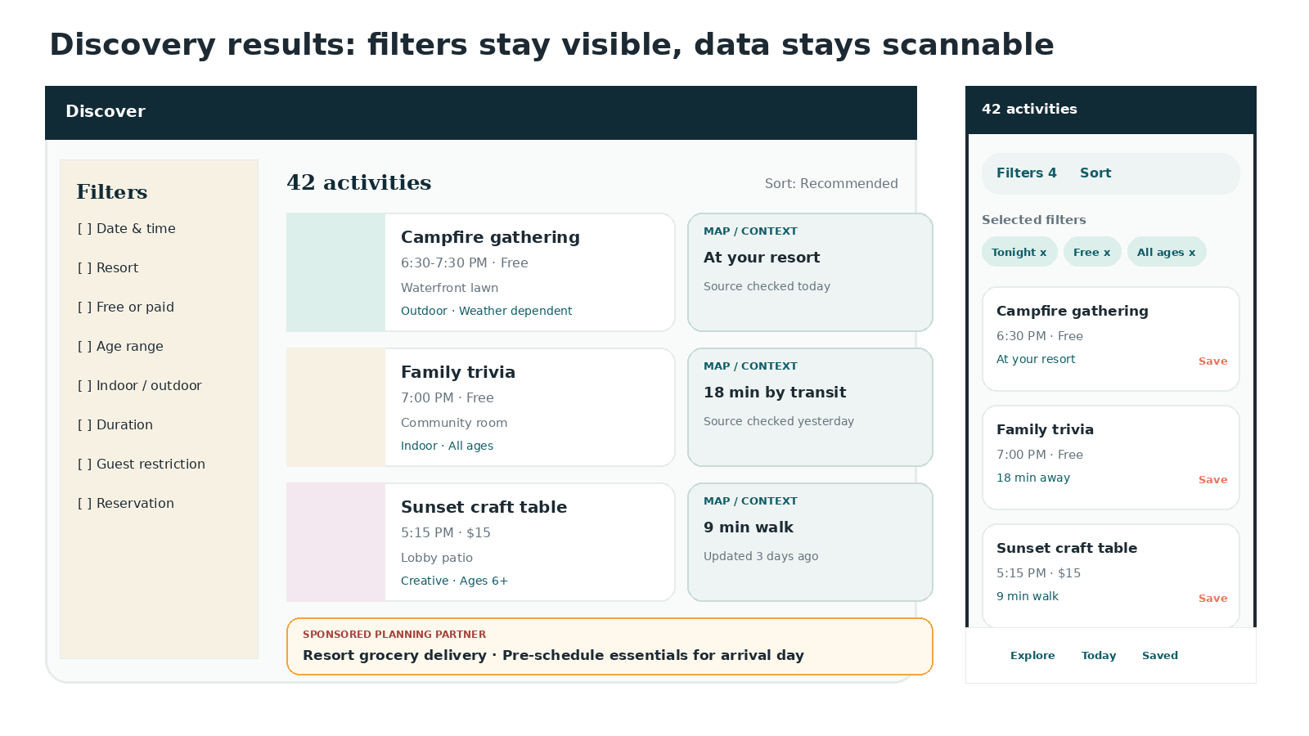

5.3 Activity detail
Purpose: answer every practical question before the traveler commits time or travel effort.
Section | Requirements
Above the fold | Title; date/time; resort; exact location; cost; status; restriction; reservation; Save and Share. Do not lead with a long image gallery.
At a glance | Duration, indoor/outdoor, weather dependency, age fit, energy/noise, seating, accessibility notes, and confidence labels.
Description | Original neutral summary written for planning; no copied promotional language.
Schedule | Specific date occurrence plus recurring pattern where relevant. Clearly distinguish recurring template from confirmed occurrence.
Location | Original schematic map or licensed basemap; meeting point text; practical arrival note; external official source link.
Plan around it | Suggested before/after activities, meal timing prompts, travel buffer, and one weather alternative.
Freshness and source | Source type, source publication date, last checked timestamp, confidence, and “Schedules can change” notice.
Related activities | Same resort, same category, same time window, or better fit for selected party.
Advertising | Maximum one contextual planning-partner module, below primary facts and separated from related activities.

Detail-page wow factors
- “Can we make it?” computes a plain-language trip feasibility estimate using current context and a configurable arrival buffer.
- “Add a backup” suggests a nearby or indoor alternative that does not conflict with the primary selection.
- “Pocket guide” collapses the page to the essential facts for use while walking.
- A time-aware visual header transitions from daylight to lantern tones without changing content placement.

5.4 Resort detail
Module | Behavior
Resort header | Original / licensed image, resort name in plain text, area, independent status link, and saved home-resort action.
At-a-glance metrics | Activities today, free today, evening options, indoor options, most recently verified.
Tabs | Today, All activities, Calendar, Map, Practical notes.
Today timeline | Grouped by morning, afternoon, golden hour, and after dark.
Planning shortcuts | Only free; good for little ones; rainy day; low-key evening; no reservation.
Practical notes | Original editorial content about general layout and planning—not copied resort marketing.
Sponsor | One resort-relevant partner module after organic activity sections.

5.5 Today and Tonight hubs
- Today is personalized by selected stay context, but always offers “All resorts.”
- The first module is a live-feeling agenda: happening now, starting soon, later today, and saved items.
- Tonight begins at a configurable local threshold (default 4:00 PM) and emphasizes campfires, movies, trivia, music, crafts, walks, and low-cost options.
- A compact “day pulse” visualization shows where activity volume rises and falls without replacing the accessible list.
- Weather-sensitive activities show a visible Plan B affordance before a cancellation is known.

5.6 Calendar and saved plan
Capability | Requirements
Date strip | Swipeable on mobile, keyboard-accessible, and anchored to selected stay dates.
Calendar views | Day and agenda on phone; day/week on tablet and desktop. Month view is not needed at launch.
Save | One tap from any result or detail page; optimistic UI with confirmation.
Conflict detection | Warn about time overlap and travel buffer; never block saving.
Reordering | Drag where appropriate plus accessible Move Up / Move Down controls.
Sharing | View-only tokenized link without mandatory account; owner can regenerate or revoke.
Export | ICS calendar export and print / PDF-friendly itinerary.
Offline | Saved plan, essential activity facts, and last-synced timestamp available offline in the PWA.
Account | Optional email magic link or passkey sync after MVP; anonymous planning remains first-class.

5.7 Guides and collections
Guides create organic acquisition and emotional storytelling, but each must remain useful and original. Dynamic activity modules keep editorial pages connected to the current database without turning every filter combination into a thin SEO page.
- Core launch guides: Best free resort activities; rainy-day resort activities; low-key evenings; activities for preschoolers; resort activities worth traveling for; arrival-day ideas; non-park rest-day plan.
- Every guide has an author / editor, original introduction, criteria, last reviewed date, and linked methodology.
- Embedded activity modules inherit the user’s dates where possible and visibly state when dates are not set.
- Commercial links are individually disclosed; the guide’s conclusions are not pay-to-play.

5.8 Search, error, and offline states
State | Experience
Global search | Autocomplete across activities, resorts, categories, and guides; tolerate spelling variants; show type labels.
404 | Original folded-map illustration and clear routes to Explore, Today, Resorts, and Search.
API unavailable | Show cached content if available, last-synced time, retry, and official source links. Never fabricate a schedule.
Partial data | Render known facts; use “not published” / “not confirmed” labels for missing fields.
Offline | Saved plan and recently viewed details available; searches explain that live results require connection.
Stale data | High-visibility caution on list and detail; lower ranking by default but do not hide unless expired.

6. Responsive and adaptive behavior
  - Designed for the device in hand and the decision at hand

Content breakpoints
Range | Layout intent | Key behavior
0-479px | Small phone, one column | Bottom navigation; full-screen filters; compact cards; sticky Save / primary action where needed.
480-767px | Large phone, one column | Richer card metadata; optional thumbnails; horizontal date strip; two chips per row minimum.
768-1023px | Tablet portrait | Two-column cards where content allows; bottom nav or side rail; filter sheet; larger map modal.
1024-1439px | Laptop / tablet landscape | Sticky left filter rail; center results; optional right map / plan drawer.
1440px+ | Wide desktop | Maximum content width 1520px; generous whitespace; do not stretch card text into long lines.

Component adaptation matrix
Component | Phone | Tablet | Desktop
Header | Compact logo, search icon, context chip | Compact top bar or side rail | Full navigation, global search, saved count
Primary search | Stacked fields / sheet | Two-column composer | Single horizontal composer
Filters | Bottom sheet; batch apply | Sheet or collapsible rail | Sticky rail; immediate apply
Result cards | One column; compact default | One or two columns | List with optional split map; image-rich toggle
Date navigation | Horizontal swipe strip | Strip plus week context | Week / stay range controls
Map | Modal or separate tab | Large modal / half screen | Persistent optional panel
Activity detail | Single column; sticky bottom actions | Single or two-column sections | Main content plus facts / plan rail
Saved plan | Agenda list | Agenda with side facts | Timeline plus map / conflict panel
Ads | In-feed or full-width utility card | In-feed / adjacent only when space allows | In-feed or 300-350px adjacent module

Mobile-specific requirements
- No hover-only information or interactions.
- Primary targets are at least 44x44 CSS pixels; spacing prevents accidental taps even where WCAG minimum exceptions apply.
- The bottom navigation respects device safe areas and never overlaps sponsor modules or important controls.
- Sticky controls occupy no more than roughly 15% of the viewport and collapse while scrolling down when safe.
- Filter sheets preserve scroll position and selected values after close, back, orientation change, and browser restore.
- Maps, galleries, and long explanations are lazy loaded after primary facts.
- The browser back button returns users to the same result position and filter state.

Tablet-specific requirements
- Portrait tablets should not merely show a stretched phone layout; use additional width for side facts, two-column cards, and larger timeline context.
- Landscape tablets may use the desktop filter rail but must retain touch-sized controls.
- Support split-screen widths down to approximately 600 CSS pixels without switching to an unusable desktop grid.

Desktop-specific requirements
- Keep filter, result, and map/plan contexts visible simultaneously only when each remains readable.
- Keyboard shortcuts may be offered and documented, but no critical function depends on them.
- Hover enriches cards with preview details, but focus and click provide identical access.
- Use sticky rails judiciously; focus must never be obscured by sticky headers or ads.

Orientation, zoom, and text scaling
- No orientation lock.
- At 200% browser zoom, content reflows without horizontal scrolling except genuinely two-dimensional maps or tables with accessible alternatives.
- Text size preferences and dynamic type equivalents must not truncate times, prices, or filter labels.
- Landscape phones retain a usable primary path without forcing a desktop layout.

7. Accessibility and inclusive planning
  - WCAG 2.2 AA as the floor, practical dignity as the goal
The product will conform to WCAG 2.2 Level AA and use its newer guidance on focus visibility, dragging alternatives, target size, consistent help, and accessible authentication. W3C recommends the current WCAG version for updated accessibility policies. [R4]

Functional accessibility requirements
Area | Requirement
Keyboard | Every search, filter, calendar, save, share, map alternative, and plan action is operable without a pointer.
Focus | Visible high-contrast focus ring; focus order follows visual order; sticky elements never obscure focused controls.
Screen readers | Semantic headings, landmarks, form labels, status announcements, result counts, and meaningful link text.
Forms | Persistent labels; clear errors; no placeholder-only instructions; errors summarized and linked.
Drag interactions | Every reorder or timeline movement has button-based alternatives, consistent with WCAG 2.2 dragging guidance.
Color / contrast | AA contrast for text and controls; status uses text and icons, never color alone.
Motion | Reduced-motion mode removes nonessential transitions; no flashing or rapid repeated motion.
Maps | Text location, resort, meeting point, and direction link always available outside the map.
Dates / times | Machine-readable dates and clear human labels; no ambiguous numeric date formats.
Authentication | Optional and accessible; no memory puzzle or inaccessible CAPTCHA as the sole method.

Inclusive planning metadata
Accessibility-related activity fields must be verified or clearly labeled as editorial observations. The interface must never infer compliance from a generic category.
- Indoor / outdoor / covered.
- Typical seating availability, when verified.
- Approximate duration and ability to leave early, when known.
- Energy / noise level as a transparent editorial label with methodology.
- Mobility or participation notes only from reliable sources.
- Restroom / food proximity only when verified and useful.
- Weather, heat, and sun exposure warnings.
- “Contact the resort to confirm accommodations” where specifics are unavailable.

Accessibility release gate
- Automated axe / Lighthouse checks produce no serious or critical violations on key templates.
- Manual keyboard test passes for every P0 journey.
- Screen-reader review passes in VoiceOver + Safari and NVDA + Chrome or Firefox.
- 200% zoom and 320 CSS-pixel reflow test passes.
- Reduced-motion, high-contrast / forced-colors, and text-scaling tests pass.
- An accessibility statement and feedback channel are published.

8. Advertising and monetization
  - Planning partners, not interruptions

Monetization strategy
Prioritize direct-sold sponsorships and relevant affiliate relationships using first-party, template-controlled modules. Use programmatic advertising only as a limited fallback and only after it meets the same creative, privacy, disclosure, performance, and density rules. The product should be resilient to ad blockers by being valuable, lightweight, and eligible for acceptable-ad approaches—not by disguising or coercively bypassing user choices.

Ad principles
Principle | Requirement
Relevance | Every placement is selected from the current page context, trip stage, and explicit user choices—not hidden behavioral profiles by default.
Scarcity | Ads are deliberately fewer than industry maximums; empty inventory collapses rather than showing low-quality filler.
Transparency | Every commercial item is individually labeled “Sponsored” or “Advertisement” before interaction. FTC guidance emphasizes that advertising must not imply it is independent content. [R8]
Separation | Sponsored content never appears in organic counts, never changes ranking, and uses distinct border / background treatment.
Performance | Reserved dimensions, static creative by default, lazy loading, no layout shift, and no uncontrolled third-party JavaScript.
Privacy | Contextual by default; respect consent, opt-out, and applicable Global Privacy Control signals. [R13]
Quality | Partner landing pages, claims, mobile experience, and creative are reviewed before approval.

Prohibited experiences
The Coalition for Better Ads identifies popups, autoplay video with sound, prestitials / postitials, large sticky ads, flashing animation, full-screen scrollovers, and high mobile ad density among the least preferred formats. None are permitted. [R6]
- No popups, forced interstitials, page takeovers, countdowns, or exit traps.
- No autoplay audio or video; no sticky pop-out video.
- No ad that blocks filters, activity facts, navigation, or the browser back action.
- No deceptive system notifications, fake messages, fake “download” buttons, or urgency timers.
- No sponsor visually styled as an organic activity card without clear distinction.
- No arbitrary advertiser scripts, fingerprinting, CNAME cloaking, or intentional circumvention of privacy / blocking tools.

Ad density policy
Surface | Policy
Homepage | Zero ads above primary search. First sponsor after at least two substantial organic modules.
Search results | First in-feed sponsor after 6-8 organic results; then no more than one per 10 additional results. Sponsored result excluded from organic count.
Activity detail | Maximum one sponsor below key facts and source information; no sticky ad.
Resort page | Maximum one sponsor after primary activity sections; optional footer partner.
Guide | One sponsor after meaningful editorial introduction, then no more than one per approximately 1,200 words / major section.
Saved plan / calendar | No in-line ads inside the personal itinerary. One optional utility partner after the plan or in a clearly separate rail on desktop.
404 / error / offline | No display ad. A support / sponsor message is allowed only if it does not obscure recovery.

Acceptable Ads requires clear distinction and imposes viewport occupancy limits; this PRD uses stricter defaults, including zero ad occupancy above the primary task. Ad space must be reserved before creative loads to avoid movement. [R7]

Approved formats
Format | Responsive behavior | Best use
Planning Partner card | Full-width in feed; same general rhythm as content but distinct background, border, label, and CTA. | Grocery delivery, stroller / mobility rental, transportation, luggage services.
Compact sponsor note | Text-first, 16:5 to 4:1 flexible ratio, no animation. | Contextual tips beside a guide or detail section.
Desktop adjacent utility | Up to 300-350px wide; disappears or moves below content on smaller screens. | Travel agent, transportation, trip protection, resort-area service.
Newsletter sponsor | One clearly labeled sponsor block within an email edition. | High-relevance direct campaigns.
Sponsored guide | Full editorial package with disclosure at title, introduction, and each commercial CTA. Editorial criteria remain visible. | Deep partner education, used sparingly.

Where flexible display inventory is used, follow current IAB guidance for responsive, cross-screen creative rather than relying only on legacy fixed-pixel units. [R9]

Contextual relevance engine
Signal | Allowed use | Example
Page topic | Select matching sponsor category. | Rain-friendly guide -> poncho / delivery / indoor local service.
Resort area | Select operationally relevant coverage. | Airport transfer provider that serves the selected resort area.
Trip stage | Use route and date context. | Arrival-day page -> grocery, luggage, transportation.
Explicit party choices | Use only values the user chose. | Preschool filter -> stroller rental; accessibility filter -> vetted mobility provider.
Time of day | Use context, not behavioral tracking. | Late evening -> meal delivery or safe transportation.
Saved plan contents | Optional and on-device / first-party only. | Multiple pool activities -> waterproof essentials partner.

Allowed advertiser categories
- Airport and local transportation; stroller, wheelchair, and ECV rental; grocery / essentials delivery; luggage storage or transfer; travel insurance; independent travel advisors; licensed vacation photography; family travel products; nearby dining / delivery; vacation rentals or hotels where contextually appropriate; packing and weather essentials.
- Every category remains subject to legal, platform, safety, and brand review. Age-restricted, gambling, deceptive financial, political, adult, weapons, unverified medical, counterfeit, and low-quality arbitrage advertisers are prohibited.

Ad-block approach
- Do not promise to “defeat” ad blockers. Browser content can be filtered, and attempts to disguise ads damage trust.
- Render direct sponsorship modules through the normal application stack with approved first-party templates; do not inject third-party executable creative.
- Evaluate participation in Acceptable Ads or comparable user-consented programs if the inventory qualifies.
- For blocked ads, preserve layout and show nothing by default. After repeated high-value use, optionally show one polite support message offering allowlisting, membership, or newsletter support.
- Never block activity facts or saved plans because a visitor uses an ad blocker.

Creative approval rubric
Dimension | Pass criteria
Relevance | Clearly related to the current planning task and service area.
Disclosure | “Sponsored” or “Advertisement” visible before headline / CTA; partner named.
Clarity | One promise, one CTA, no disguised UI, no exaggerated urgency.
Performance | Static or lightweight; creative payload target under 100KB; no uncontrolled script.
Landing page | Mobile-friendly, HTTPS, accurate offer, transparent price / terms, reasonable load speed.
IP | No unauthorized Disney character, logo, official map, or implication of official endorsement.
Accessibility | Alt text, readable contrast, keyboard access, non-color-dependent CTA.
Privacy | No tracking beyond approved measurement and consent state.

Visual inventory example
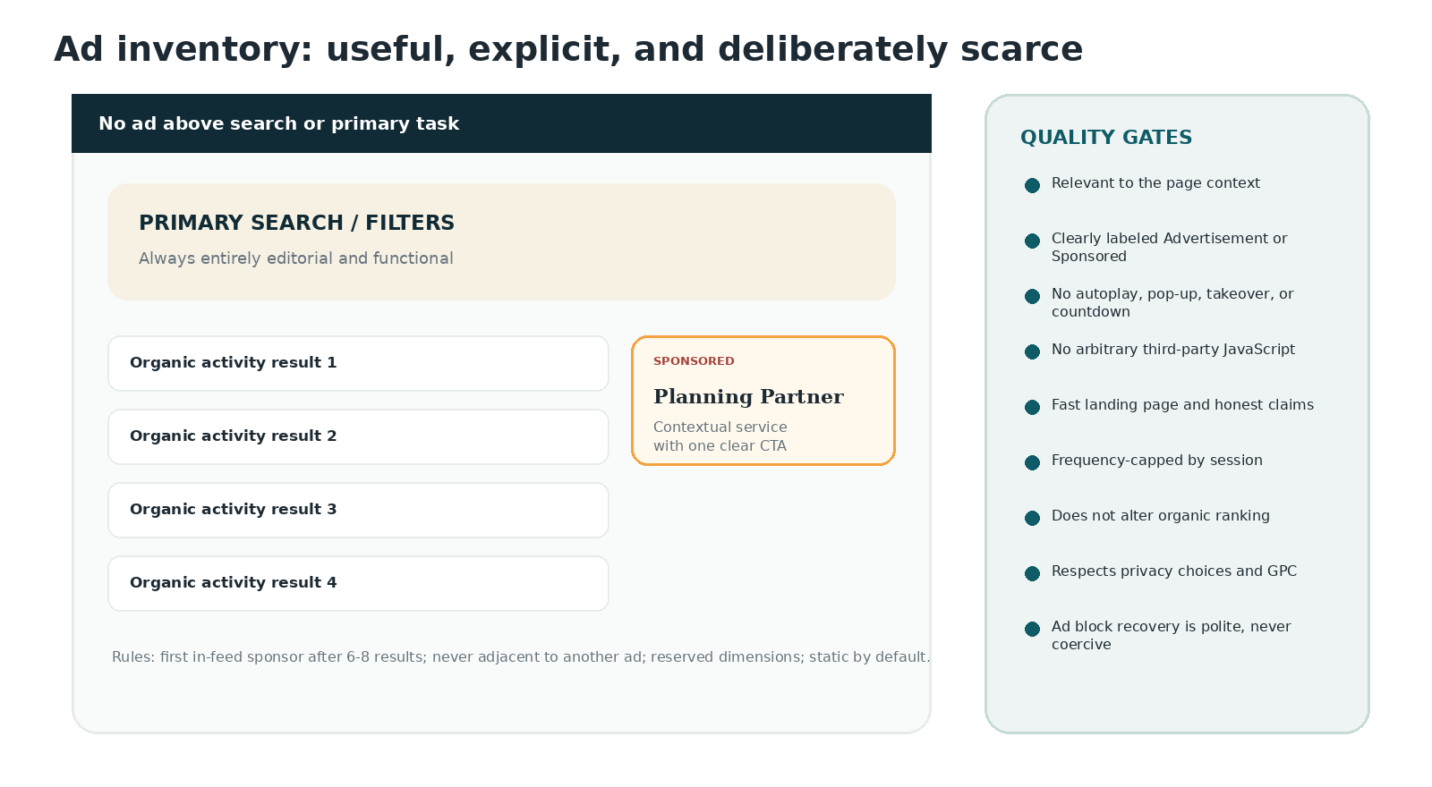

Commercial measurement
Metric | Guardrail / interpretation
Viewable sponsor impressions | Only after module enters viewport; exclude bots and preloaded off-screen slots.
Qualified click-through rate | Report by context and creative; never optimize solely for clickbait.
Partner conversion | Use privacy-safe postback or aggregate reporting where available.
Revenue per 1,000 successful planning sessions | Preferred business metric over raw page RPM.
Ad hide / complaint rate | Product-quality guardrail; investigate any creative above 0.5%.
Performance delta | No material deterioration of LCP, INP, or CLS when ads are enabled.
Organic engagement delta | A/B guardrail for save rate, search success, and return usage.

9. Marketing and growth
  - Earn the planning habit before monetizing the audience

Positioning
Positioning statement
For Walt Disney World resort guests and fans who want to make more of their resort time, Resort Activity Atlas is an independent activity-planning guide that brings resort schedules into one searchable, filterable, trustworthy place. Unlike flyer directories and article-first fan sites, it starts with the traveler’s date, location, budget, party, and time.

Message hierarchy
Level | Message
Primary | Find resort activities for now, tonight, or your whole stay.
Proof | Filter by resort, date, time, free/paid, age, weather, duration, and guest restrictions.
Trust | See when each activity was sourced and last checked.
Delight | Plan from first light to after dark with a beautiful independent resort guide.
Commercial | Useful planning partners, clearly labeled and never allowed to outrank activities.

SEO strategy
- Server-render core content and metadata. Do not require client JavaScript for search engines or users to see essential activity facts.
- Create high-value canonical hubs: activities today, tonight, free activities, rainy-day activities, resort pages, category pages, and original guides.
- Create date-specific pages only when they contain a meaningful, current result set and clear freshness; expire or canonicalize empty / past pages.
- Avoid indexing arbitrary filter combinations. Use canonical tags and noindex rules for thin or duplicate query states.
- Use visible original summaries, methodology, source dates, internal links, and author/editor information.
- Segment XML sitemaps by activities, resorts, guides, and current date pages. Remove expired URLs promptly.
- Use BreadcrumbList and Organization markup. Use Event structured data only where the activity and page satisfy Google’s eligibility and accuracy requirements; structured data must represent visible, current page content and must not imply affiliation. [R10]

Programmatic landing-page quality gate
Requirement | Minimum
Useful inventory | At least 3 current activities or a meaningful no-results planning alternative.
Original context | A unique introduction and explanation of why the page is useful.
Freshness | Visible last-updated time and automated expiry / caution behavior.
Internal navigation | Links to parent resort/category, related dates, and relevant guides.
Index control | Canonical / noindex decision based on inventory and uniqueness.
No ad-first layout | Primary query and organic activity content precede any sponsor.

Content pillars
Pillar | Example content | Business value
Immediate utility | What is happening tonight; rainy-day alternatives; activities before check-in. | High-intent search and repeat usage.
Budget planning | Best free resort activities; zero-cost evening itineraries. | Broad acquisition and relevant partner fit.
Family fit | Preschool, teens, multigenerational, low-energy, sensory-aware. | Strong filter adoption and shareability.
Resort discovery | Complete independent activity guide to each resort. | Long-tail SEO and return visits.
Fan delight | Hidden resort details, atmosphere, seasonal collections, original photography. | Brand affinity without copying protected expression.
Planning education | How to read schedules, guest restrictions, weather notes, and travel buffers. | Trust and lower support burden.

Lifecycle marketing
Moment | Message / feature
First visit | Set your dates and resort; optionally save locally.
After first save | Offer a share link or trip reminder—not immediate account pressure.
7-30 days before stay | “Your resort week” email: new or changed activities, free highlights, and planning gaps.
During stay | Daily morning “Today” link and optional evening reminder, only with explicit permission.
After trip | Ask what was useful, invite corrections / photos only under a rights-cleared program, and offer future-trip watchlist.

Share and referral loops
- Every activity and plan has a clean social preview card with original visual design, date, resort, and key facts.
- Shared plans open in read-only mode without account creation and preserve local timezone context.
- “Tonight at the resorts” can generate a daily share image for social channels and newsletters.
- A copied link includes active filters; recipients land on the same useful state, not the homepage.
- Referral incentives, if added, must not distort editorial ranking or sponsor disclosure.

Trust marketing
- Publish the sourcing and verification methodology.
- Display source and last-checked timestamps on activity pages.
- Offer a visible correction flow with response expectations.
- Publish an advertising policy and partner quality standards.
- State independent / non-affiliated status clearly in About, footer, and relevant legal surfaces without making the disclaimer the brand.

Marketing KPIs
Objective | Primary measures
Acquire qualified users | Non-brand organic sessions, direct return sessions, guide-to-search conversion.
Create habit | Saved stay contexts, 7-day return rate during trip window, Today hub opens.
Drive useful actions | Search success, detail open, save, share, export, source-link click.
Build trust | Correction submissions, stale-data exits, survey trust score, direct traffic growth.
Monetize responsibly | Revenue per successful planning session, partner renewal, ad complaint rate, performance delta.

10. Easter eggs and fan delight
  - Reward recognition without borrowing protected expression
The Easter-egg system should feel like original lore created by this product. Use generic Florida resort culture, travel rituals, theme-park planning habits, original flora/fauna, and public historical facts. No single detail should make a reasonable visitor believe the site is official or licensed. Final implementation should receive trademark and copyright review.

Approved Easter-egg concepts
Concept | Implementation
Sunrise-to-starlight atmosphere | Accent colors gradually shift by Orlando local time; contrast and component positions stay unchanged.
First Light / Golden Hour / After Dark labels | Friendly daypart groupings in timelines, based on ordinary descriptive language.
Orange blossom stamp | Saving a first plan earns a tiny original Florida orange-blossom field-note stamp.
Lantern glow | After dark, original lantern illustrations gain a subtle static glow; reduced-motion mode removes transitions.
Firefly detail | A handful of tiny original firefly dots appear in evening empty space, never as cursor-following particles.
Resort ducks, lizards, frogs, and egrets | Small original fauna appears across illustrations and empty states; repeat visitors can spot them.
Palm pull-to-refresh | A palm frond gently bends during mobile refresh.
Lagoon ripple confirmation | Saving or resolving a conflict creates one quiet ripple, not sparkles.
Campfire ember save | Saving a campfire activity adds a brief ember line that becomes the normal Save state.
Rain-plan umbrella | Selecting Rain-friendly opens the sheet with a tiny umbrella-and-ripple illustration.
Scenic route option | Map users can choose “Simplest trip” or “Scenic route” when route data supports it.
Resort Loop line | The saved-plan timeline uses an original transit-style route line with neutral dots.
Pocket Guide mode | Compact mobile view resembles an original field card / luggage tag, not an official ticket.
Postcard completion | A complete day plan can export as an original Florida postcard layout.
Brass key-tag dividers | Generic vintage hotel key-tag shapes mark sections in editorial pages.
Folded-map 404 | “We took a wrong turn by the lagoon” with an original map fold.
Porch-light status | A small porch light turns on when evening activities are present on a resort page.
Water wake loader | Loading a map uses a short abstract wake line rather than a branded vehicle.
Field-note serials | Optional tiny serial numbers 71, 82, 89, and 98 on collectible original stamps as factual historical nods; legal review required before use.
Hidden compass rose | An original compass rose appears in print mode and the About page.
Trip Desk command | Press “/” on desktop to open global search; label the shortcut visibly in help.
Quiet completion | At itinerary completion, leaves and water lines briefly settle into a stamp—no confetti explosion.
Seasonal flora | Original orange blossoms, magnolia, palms, rain clouds, and migratory birds change by season.
“Worth a short trip” ribbon | A restrained original ribbon marks standout activities chosen by transparent criteria.
Local-time moon | Evening page header uses the correct moon phase only as a decorative original icon, never as operational data.

Explicitly prohibited “fan-service” shortcuts
- No hidden three-circle silhouettes, “Hidden Mickey” language, mouse-ear geometry, castle outlines, character shadows, crowns, wands, pixie dust, or star trails that imitate Disney branding.
- No Disney script-like font, official park / resort color system, official transportation icon, branded map style, ticket design, MagicBand-like interface, or My Disney Experience-like naming.
- No copyrighted attraction audio, film clips, character dialogue, ride quotes, lyrics, or distinctive sound effects.
- No imitation of official badges such as “Disney Resort Guest,” “Cast Member,” PhotoPass, or transportation cards.
- No Easter egg that is also a sponsor placement or manipulates the visitor into a commercial action.

Easter-egg operating rules
- Discoverability is optional; core tasks do not depend on recognition.
- At most one noticeable delight per screen and one hidden detail per major illustration.
- No animation repeats indefinitely.
- Every interactive Easter egg is keyboard accessible and has a reduced-motion state.
- Historical-number nods remain micro-details, not names, logos, navigation, or marketing claims.
- Maintain an internal register with concept, asset owner, legal review, implementation location, and removal switch.

11. Technical architecture
  - A server-rendered, progressively enhanced front end

Recommended stack
Layer | Recommendation | Rationale
Web framework | Next.js with TypeScript, using the current stable release at implementation. | Strong server rendering, routing, metadata, caching, image optimization, and component ecosystem.
UI | React components with design tokens; Tailwind CSS or CSS Modules based on team preference. | Fast consistent implementation; component-level responsive behavior.
Hosting / CDN | Vercel, Cloudflare, or equivalent edge-capable platform. | Global caching, image delivery, preview environments, observability.
Editorial CMS | Structured headless CMS such as Sanity, Contentful, or Strapi. | Guides, image rights metadata, sponsor campaigns, and brand copy independent of activity pipeline.
Search | Adapter over Algolia, Typesense, Meilisearch, or equivalent faceted index. | Typo tolerance, filters, ranking, fast autocomplete, and provider flexibility.
Maps | MapLibre / Mapbox or equivalent with a custom neutral style. | Responsive interactive maps without copying official Disney maps.
Analytics | Privacy-aware first-party event pipeline; RUM for performance. | Business metrics without making third-party trackers a prerequisite.
Feature flags | Server-aware flag service or internal configuration. | Safe rollout of ads, PWA, daypart themes, and experiments.

Architecture principles
- Server render or statically generate indexable, high-traffic pages; hydrate only interactive components that need client state.
- Treat the front end as a Backend-for-Frontend consumer of normalized activity data. Do not expose ingestion-specific schemas directly to UI components.
- Make URL search parameters the source of truth for discovery state.
- Keep maps, analytics, consent, and ads behind lazy boundaries so the activity list works first.
- Use approved component templates for advertising; never run arbitrary advertiser HTML or JavaScript.
- Provide graceful cached and offline behavior when the live activity service is unavailable.

System diagram
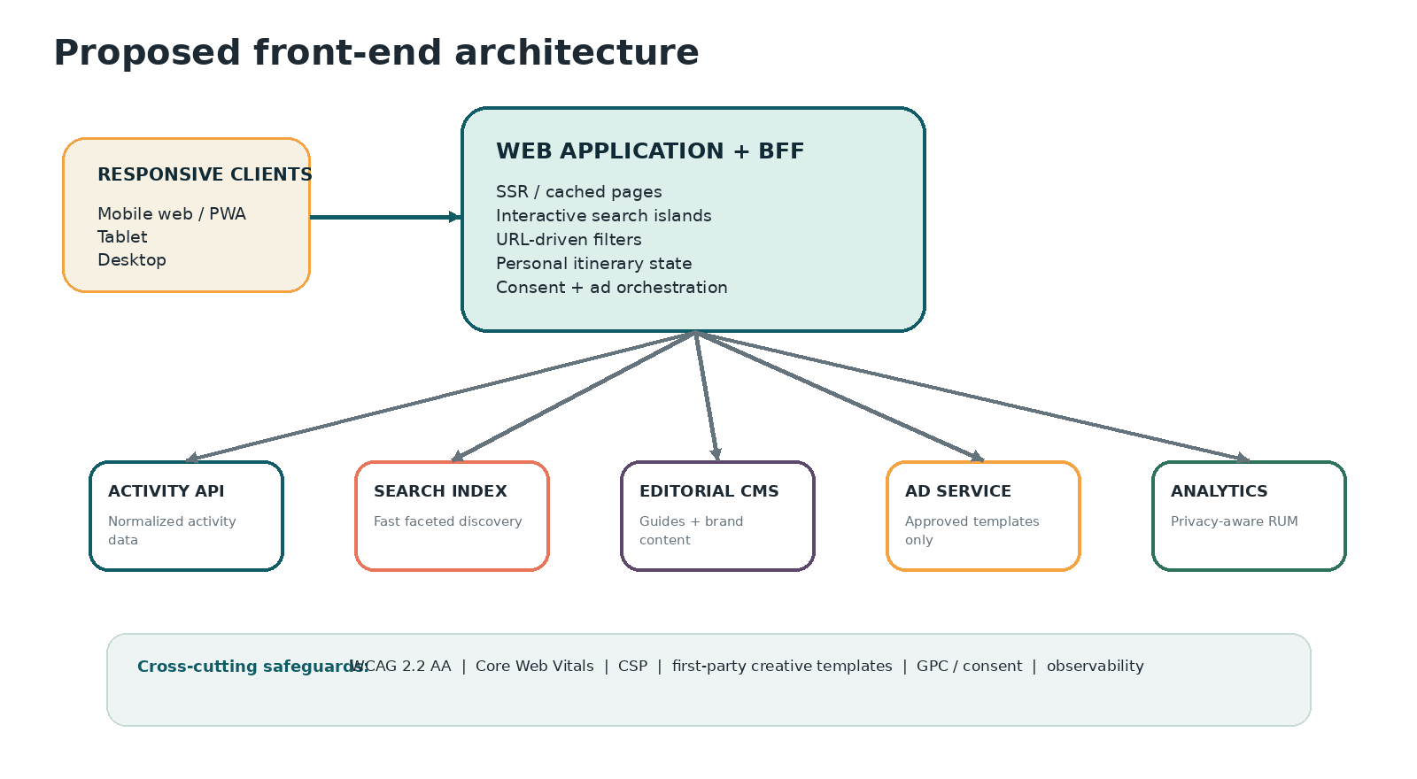

Rendering strategy by route
Route type | Rendering / cache strategy
Homepage | Server-rendered with short revalidation for activity modules; editorial shell cached longer.
Resort pages | Static / incremental generation with on-demand revalidation when schedule data changes.
Activity detail | Static / incremental generation; urgent status updates fetched server-side with bounded cache.
Today / Tonight | Server-rendered per Orlando date and query context; CDN cache by normalized parameter set.
Arbitrary search results | Server-render initial state, then client transitions; do not index thin combinations.
Guides | Static / incremental generation from CMS; embedded activity modules revalidate separately.
Saved plans | Dynamic and private / tokenized; noindex; offline cache for owner device.

Front-end component architecture
Domain | Core components
Shell | AppHeader, MobileBottomNav, TripContext, GlobalSearch, Footer, IndependenceNotice.
Discovery | SearchComposer, QuickStartChips, FilterRail, FilterSheet, AppliedFilterBar, SortMenu, ViewSwitcher, ResultList, ResultCard, NoResultsRecovery.
Activity | ActivityHero, FactGrid, StatusBanner, ScheduleBlock, LocationBlock, FreshnessBlock, PlanAroundIt, SimilarActivities.
Planning | SaveButton, PlanDrawer, DayTimeline, ConflictNotice, TravelBuffer, SharePlan, ExportPlan, OfflineStatus.
Resort | ResortHeader, ResortMetrics, ResortTabs, ResortTimeline, ResortMap, ResortNotes.
Ads | SponsorSlot, SponsorCard, SponsorDisclosure, AdFallback, SupportMessage.
Trust | SourceCitation, ConfidenceBadge, CorrectionForm, MethodologyLink, LegalFooter.
System | ErrorBoundary, Skeleton, Toast, Dialog, Sheet, EmptyState, FeatureFlag, ConsentGate.

State management
- Server state: query/caching library or framework-native data cache with typed fetchers and error boundaries.
- Discovery state: URL parameters, parsed through a single schema and mirrored into controls.
- Anonymous plan: local IndexedDB or local storage with versioned migration; important plan data stored in IndexedDB for offline scale.
- Shared / account plan: server record identified by opaque token or authenticated user; local optimistic cache.
- UI state: component-local or lightweight store for sheets, map selection, and display density only.
- Feature flags and consent state are initialized before optional analytics / ad code executes.

Search architecture
- Index normalized activity occurrences, resorts, guides, and categories separately but search through a unified adapter.
- Support synonyms and misspellings: campfire / bonfire, craft / art, movie / film, resort abbreviations, and common resort name variants.
- Facets match the filter taxonomy; the UI never exposes unsupported filters.
- Index freshness timestamp and confidence so stale items can be demoted or cautioned.
- Search analytics capture no-results queries and refinements for taxonomy improvement.

PWA and offline
- Installable manifest with original icons and theme colors.
- Service worker caches the application shell, saved plan, and recently viewed activity details.
- Offline screen clearly states the last synchronization time and does not imply schedules are current.
- Background sync retries plan edits and analytics only when permitted.
- Push notifications are P2 and opt-in; never required for reminders.

Maps and location
- Use coordinates and textual meeting locations from the normalized data contract.
- Use a custom neutral basemap, original resort-area grouping, and generic pins. Do not trace official Disney maps.
- Travel effort is an estimate with methodology and may be coarse at launch: same resort, same area, transfer required.
- Load the interactive map only after intent; render a static preview or textual alternative first.

12. Front-end data contract
  - What the separate data system must provide
The front end consumes normalized activity occurrences, not raw flyer layouts. An “activity” is the reusable concept; an “occurrence” is a dated or recurring instance. The API may use REST or GraphQL, but the semantic contract below is required.

Required activity occurrence fields
Field | Type | Front-end meaning
id | string | Stable opaque ID.
slug | string | Stable human-readable route key.
title | string | Neutral standardized activity name.
summary | string | Original front-facing description.
resort | object | ID, name, slug, area, geo.
meetingLocation | object | Name, details, optional geo, map confidence.
startDateTime | ISO 8601 | Includes timezone offset.
endDateTime | ISO 8601 / null | Null allowed when not published.
recurrence | object / null | Human label and machine pattern where reliable.
status | enum | scheduled, changed, canceled, completed, unknown.
price | object | state: free, paid, unknown; amount/range/currency when known.
eligibility | object | resortGuestsOnly, visitorAccess, unknown.
reservation | object | required, recommended, walkUp, unknown; official URL / phone if appropriate.
categories | array | Controlled taxonomy.
ageFit | array + confidence | Editorial or sourced labels; not a legal restriction unless explicitly sourced.
environment | array | indoor, covered, outdoor, poolside, waterfront.
weatherDependency | enum | resilient, dependent, unknown.
durationMinutes | number / null | Estimated or published; label source.
sensory | object / null | Energy/noise/seating with source type.
accessibility | array | Verified notes only.
images | array | Licensed asset URL, crop, alt, credit, rights expiry.
source | object | Source type, URL, document date, retrieved date.
verification | object | lastChecked, confidence, reviewer / process, staleAfter.
editorial | object | Why it may fit, planning tips, fact vs opinion labels.
updatedAt | ISO 8601 | Record update timestamp.

Example payload
{
"id": "occ_8f2c...",
"slug": "waterfront-campfire-2026-06-20",
"title": "Waterfront campfire gathering",
"summary": "A casual outdoor campfire activity near the resort waterfront.",
"resort": {"id": "res_123", "name": "Example Resort", "slug": "example-resort", "area": "Lagoon Area"},
"meetingLocation": {"name": "Waterfront lawn", "details": "Near the marina", "lat": 28.000, "lng": -81.000},
"startDateTime": "2026-06-20T18:30:00-04:00",
"endDateTime": "2026-06-20T19:30:00-04:00",
"status": "scheduled",
"price": {"state": "free", "currency": "USD"},
"eligibility": {"resortGuestsOnly": false, "visitorAccess": "allowed"},
"reservation": {"state": "walkUp"},
"categories": ["campfire", "family", "evening"],
"environment": ["outdoor", "waterfront"],
"weatherDependency": "dependent",
"verification": {"lastChecked": "2026-06-20T09:00:00-04:00", "confidence": "high"},
"source": {"type": "official_schedule", "publishedDate": "2026-06-01", "url": "https://..."}
}

Suggested endpoints
Endpoint | Purpose
GET /v1/activities | Faceted occurrence search with date, time, resort, cost, age, category, environment, reservation, restriction, freshness, sort, pagination.
GET /v1/activities/{slug} | Detail view with related occurrences and alternatives.
GET /v1/resorts | Resort directory and counts.
GET /v1/resorts/{slug} | Resort details, current metrics, and activity groups.
GET /v1/calendar | Occurrence groups for a day or stay range.
GET /v1/search/suggest | Fast autocomplete across activities, resorts, and guides.
POST /v1/corrections | Correction / stale report with rate limiting and moderation.
POST /v1/plans / GET /v1/plans/{token} | Shareable itinerary creation and retrieval.

Data presentation rules
- Missing is not false: unknown price, restriction, reservation, or end time must remain explicitly unknown.
- The UI must not infer “free” because no price appears.
- Recurring schedules are not treated as confirmed future occurrences unless the source supports that interpretation.
- Canceled and changed statuses propagate quickly and visibly.
- All times are stored with an offset and interpreted in America/New_York for local display.
- Image records without valid rights metadata are not rendered.

13. Performance, SEO, privacy, and security
  - Non-functional requirements that protect the product promise

Performance budgets
Core Web Vitals launch targets align with Google’s “good” thresholds: LCP at or below 2.5 seconds, INP at or below 200ms, and CLS at or below 0.1 at the 75th percentile. Internal stretch targets should be tighter on high-traffic templates. [R5]
Metric / asset | Launch budget
LCP | <=2.5s p75 field; stretch <=2.0s on homepage and results.
INP | <=200ms p75 field; stretch <=150ms for search and filters.
CLS | <=0.10 p75 field; stretch <=0.05. Ads and images reserve dimensions.
Initial JavaScript | Target <=170KB gzip for homepage / results, excluding optional map loaded after intent.
Critical CSS | Target <=35KB gzip.
Hero image | Responsive AVIF/WebP; generally <=180KB at common mobile width.
Activity card image | Generally <=70KB at rendered size; lazy load below fold.
Sponsor creative | Target <=100KB static; no arbitrary JS.
Fonts | Two families maximum, limited weights, self-hosted where licensing allows; preload only critical files.
API | BFF p95 target <=500ms for cached search; degrade gracefully beyond threshold.

Performance implementation
- Prioritize the LCP resource in HTML; avoid CSS background hero images for primary content.
- Use responsive image srcsets, correct dimensions, and modern formats.
- Lazy load maps, galleries, below-fold images, analytics, and ads.
- Break long client tasks; virtualize only genuinely large lists and preserve accessibility.
- Prefetch likely next routes cautiously based on user intent and data cost.
- Measure field data with real-user monitoring by template, device class, ad state, and consent state.

Technical SEO
Area | Requirement
Metadata | Unique title, description, canonical, Open Graph, and social image per indexable page.
Structured data | JSON-LD recommended; visible and accurate; Organization, BreadcrumbList, Article, and eligible Event only. [R10]
Sitemaps | Separate current activities, resorts, guides, and date hubs; accurate lastmod.
Robots | Allow high-value pages; noindex private plans, arbitrary low-value filters, and internal search pages as appropriate.
Internal links | Resort, category, date, guide, and related-activity links use crawlable anchors.
Expired content | Return useful archived context, redirect, or 410 depending on value; remove stale schedule pages from sitemap.
Pagination | Stable URLs and server-visible links; avoid infinite-scroll-only discovery.

Privacy
- Contextual advertising is the default. Behavioral personalization requires a separate explicit consent and legal review.
- Honor applicable opt-out preference signals such as Global Privacy Control where legally required. California guidance treats GPC as a valid opt-out request for covered businesses. [R13]
- Do not request precise geolocation until the user explicitly invokes location-based functionality.
- Use coarse location or selected resort whenever sufficient.
- Provide equal prominence and effort for accept / reject choices where consent is required; avoid dark patterns.
- Minimize retention of plan and analytics data; document purpose, retention, and deletion mechanisms.
- Do not target ads based on inferred children’s interests. The product is family-oriented, not child-directed by default; legal review determines COPPA obligations.

Security
Control | Requirement
Content Security Policy | Strict allowlist; block inline arbitrary script; separate map / analytics / ad origins.
Sponsored creative | Template-only fields, sanitized text, approved images, signed destination URLs; no raw HTML.
Input handling | Schema validation on query parameters, corrections, plan notes, and CMS content.
External links | noopener / noreferrer where appropriate; rel=sponsored on paid links.
Share tokens | Opaque, high-entropy, revocable; no sequential IDs; private plans noindex.
Authentication | Magic link / passkey with rate limiting, session protection, and accessible recovery.
Dependencies | Automated vulnerability scanning, lockfile integrity, and regular patch cadence.
Headers | HSTS, X-Content-Type-Options, Referrer-Policy, Permissions-Policy, frame protections.
Uploads | No public uploads at launch; future uploads require rights attestation, moderation, malware scan, and metadata stripping.

Ad-tech transparency
If open programmatic inventory is introduced, publish and maintain ads.txt and validate authorized sellers. IAB Tech Lab describes ads.txt as a way for publishers to declare authorized digital sellers and improve supply-chain transparency. [R14]

14. Analytics and experimentation
  - Measure task success, trust, delight, and commercial health

Event taxonomy
Event | Core properties
page_viewed | route, template, referrer class, device class, consent state
trip_context_set | dates, resort/area, party fields selected—not raw sensitive notes
quick_start_selected | now, tonight, free, rain, near_resort
search_submitted | query type, result count, latency
filter_applied | filter name, value class, result count
sort_changed | sort mode
view_changed | list, agenda, map, calendar
result_opened | rank, source surface, organic/sponsored
activity_saved | activity ID, plan date
activity_shared | channel class, activity/plan
plan_conflict_shown | time or travel conflict
plan_exported | ICS, print, share link
source_link_clicked | activity ID, source type
correction_started / submitted | reason class
sponsor_impression | campaign, placement, context class
sponsor_clicked | campaign, placement, destination class
ad_hidden / reported | campaign, reason
offline_viewed | cached template, staleness
web_vital | LCP, INP, CLS, template, ad state

Dashboards
Dashboard | Questions answered
Product health | Are users finding, opening, saving, and sharing relevant activities?
Discovery quality | Which filters drive success? Where do no-results and reformulations occur?
Freshness trust | How often do users encounter stale data, click sources, or submit corrections?
Responsive quality | Do success and performance differ by phone, tablet, desktop, browser, or input method?
Advertising | Which contextual placements create value without reducing organic engagement?
SEO / content | Which landing pages lead to a successful planning session rather than a bounce?
Accessibility | Error reports, keyboard / screen-reader issues, zoom failures, and support requests.

Experiment rules
- Never experiment with hiding source freshness, weakening sponsor disclosure, or making privacy rejection harder.
- Primary experiment metric must reflect task success or durable business value, not raw clicks alone.
- Define guardrails for Core Web Vitals, save rate, complaint rate, and accessibility before launch.
- Use server-side assignment for major layouts to avoid flicker and CLS.
- Document hypothesis, segment, exposure, duration, sample, outcome, and decision.

Initial experiments
Hypothesis | Variants | Primary metric
Users decide faster with task shortcuts above a full form. | Quick-start-first vs full search-first. | Time to first relevant detail open.
Compact cards outperform image-rich cards during in-stay use. | Compact default by time-of-day / device. | Search success and scroll depth.
“Why this matches” improves trust in Recommended sorting. | Explanation affordance on/off. | Recommended-sort retention and saves.
A Plan B prompt increases itinerary confidence. | Backup suggestion on/off. | Second save and plan completion.
Direct sponsor utility cards outperform generic banners. | Planning Partner template vs standard flexible display. | Qualified sponsor click with organic guardrails.

15. QA, launch plan, and acceptance criteria
  - Ship a trusted planning product, not merely a styled database

Release phases
Phase | Deliverables
Phase 0: Validation | Name screening, legal review framework, user interviews, taxonomy test, low-fidelity prototype, advertiser interviews.
Phase 1: Design foundation | Design tokens, component library, responsive prototypes, activity/detail/resort templates, accessibility baseline.
Phase 2: Core discovery MVP | Homepage, Explore, filters, results, activity detail, resort pages, source freshness, analytics, SEO, error states.
Phase 3: Planning layer | Today/Tonight, calendar, anonymous saved plan, share link, ICS export, offline saved plan.
Phase 4: Monetization and growth | Direct sponsor service, approved templates, guides, newsletter, share cards, ad reporting, advertising policy.
Phase 5: Beta and hardening | Usability testing, accessibility audit, field performance, ad-block states, legal/IP sweep, content QA, staged launch.
Phase 6: Differentiation | Weather-aware Plan B, travel estimates, family lens, quiet mode, richer Easter eggs, optional account sync.

MVP / next / later scope
Capability | MVP | Next | Later
Responsive discovery | Yes
Activity and resort detail | Yes
Now / Tonight shortcuts | Yes
Full filter taxonomy | Core fields | Advanced sensory/accessibility | Personalized recommendations
Saved plan | Local + share | Account sync | Collaborative editing
Calendar / ICS | Day + stay range | Conflict refinement | Calendar integrations
Map | Location + basic split view | Travel effort | Routing / live transport integrations
PWA offline | Saved plan | Recent details | Offline search subset
Advertising | Direct sponsor templates | Limited programmatic fallback | Partner self-service portal
Guides / SEO | Launch pillars | Seasonal expansion | Community editorial program
Weather Plan B | Manual filter | Weather-aware prompt | Automatic disruption replan
Easter eggs | Low-risk originals | Historical-number nods after review | Collectible field journal

Device and browser test matrix
Class | Minimum coverage
Small phone | iPhone SE-class width; modern Safari; Android Chrome at 360px.
Large phone | Current iPhone / Pixel class; portrait and landscape.
Tablet | iPad portrait/landscape; Android tablet; split-screen widths.
Laptop | 1366x768 and 1440x900; Chrome, Safari, Firefox, Edge.
Wide desktop | 1920x1080 and high-DPI; verify max-width and map behavior.
Assistive tech | VoiceOver + Safari; NVDA + Chrome/Firefox; keyboard-only; forced colors; reduced motion.
Network | Fast, regular 4G, slow 3G simulation, offline, API timeout.
Ad state | Ads loaded, no inventory, blocked, consent denied, creative error, slow sponsor response.

QA workstreams
Workstream | Required tests
Functional | Filters, dates, timezone, recurring schedules, save/share/export, navigation restore, error recovery.
Content | Missing data, unknown states, source date, canceled/changed activities, image rights, original copy.
Visual | Responsive regression, day/night states, long names, localization-ready expansion, zoom.
Accessibility | Automated plus manual keyboard, screen reader, reduced motion, contrast, reflow.
Performance | Lab and field Core Web Vitals, bundle budgets, image budgets, ad delta.
SEO | SSR output, canonical, noindex, schema validation, sitemap, expired content.
Privacy | Consent states, GPC / opt-out handling, tracker audit, geolocation prompt, deletion path.
Security | CSP, sanitization, share-token enumeration, dependency scan, rate limits.
Advertising | Disclosure, frequency, density, landing page, blocked state, no ranking effect, rel=sponsored.
IP / legal | Name/domain, logo, type, imagery, maps, phrases, Easter eggs, sponsor creative, disclaimer.

Definition of done: launch
- All P0 journeys pass on the device, accessibility, ad, and network matrices.
- WCAG 2.2 AA audit has no unresolved critical or serious issues.
- Core Web Vitals field or controlled beta data meet launch thresholds, with no material ad regression.
- Source freshness, uncertainty, and independent status display correctly on all activity templates.
- No sponsor appears above the primary task, inside a personal plan, or without individual disclosure.
- Legal counsel has reviewed name/domain, brand system, disclaimer, maps, imagery workflow, and Easter-egg register.
- Correction, privacy, accessibility, advertising-policy, and contact channels are live.
- Analytics dashboards, alerting, rollback, feature flags, and incident owner are in place.

Post-launch service levels
Area | Target
Critical front-end incident | Acknowledge within 30 minutes; rollback / mitigate as quickly as practical.
Broken or misleading sponsor creative | Disable immediately through campaign flag.
Reported schedule correction | Triage within one business day; urgent current-day issue prioritized.
Accessibility issue | Triage within two business days; critical blocker expedited.
Performance regression | Alert when p75 threshold or budget regresses by defined margin for 24 hours.

16. Risks and legal guardrails
  - Protecting trust, independence, and long-term viability

Key risks and mitigations
Risk | Failure mode | Mitigation
Brand confusion / trademark | Name, domain, logo, type, visual system, and site presentation could imply affiliation. | Use an original non-Disney brand; clear independent status; avoid protected visual grammar; obtain trademark counsel and clearance. USPTO describes likelihood of confusion as consumers mistakenly believing related goods or services come from the same source. [R11]
Copyright / copied expression | Flyer copy, layout, photography, maps, and artwork may be protected even where underlying facts are not. | Store factual fields, write original descriptions, use original/licensed imagery and maps, and document rights. The U.S. Copyright Office notes facts are not protected, while their expression may be. [R12]
Data freshness | Schedule changes cause disappointed travelers and trust loss. | Visible source/verification, stale rules, status alerts, correction channel, lower ranking for old data, official source link.
Ad trust | Native sponsor modules could be mistaken for activities or degrade the experience. | Individual FTC-compliant disclosure, distinct design, scarcity, no ranking effect, published ad policy. [R8]
Ad-block / revenue | A meaningful share of users may block advertising. | Direct sponsorship, acceptable-ad eligibility, supporter options, no coercive bypass, diversify newsletter and affiliate revenue.
SEO thin content | Automated date/filter pages can create low-value duplication. | Quality gates, canonical/noindex rules, original context, current inventory, segmented sitemaps.
Performance | Maps, ads, images, and filters can overwhelm mobile devices. | Progressive loading, budgets, server rendering, RUM, template-only ads.
Privacy | Ad tech, geolocation, or plan data can exceed user expectations. | Contextual default, data minimization, GPC/consent support, delayed geolocation, transparent retention.
Accessibility metadata accuracy | Overstated accessibility creates harm. | Verified facts only, confidence labels, contact-to-confirm language, inclusive testing.
Sponsor IP misuse | Partners may submit unauthorized Disney imagery or claims. | Creative review, contract warranties, template restrictions, rapid disable switch.

IP-safe brand checklist
- Do not put Disney, Walt Disney World, WDW, character names, park names, or resort names in the product brand or domain without counsel.
- Use those names only as necessary factual references in page content and navigation, with consistent independent presentation.
- Do not use official logos, characters, screenshots, maps, icon sets, attraction silhouettes, branded type, or copied flyer art.
- Do not use “The Most Magical Place on Earth,” “My Disney Experience,” “MagicBand,” “PhotoPass,” “Hidden Mickey,” or other distinctive branded language as product features.
- Do not imply access to Disney systems, exclusive data, partnership, endorsement, or operational authority.
- Place the independence notice in footer, About, methodology, and legal pages; use a concise contextual notice where confusion is plausible.
- Review original photography for property rules, releases, logos in frame, and commercial-use rights.
- Maintain a takedown / correction process and asset-rights register.
Legal note
This PRD is product guidance, not legal advice. Trademark, copyright, right-of-publicity, property photography, advertising, privacy, and data-source questions should be reviewed by qualified counsel before launch.

17. Appendices and references
  - Implementation aids, copy examples, and research sources

Appendix A: sample microcopy
Situation | Recommended copy
Homepage headline | Find the best resort moments for your day.
Homepage subhead | Search activities across the Orlando resorts by date, time, cost, location, and party fit.
No dates set | Set your stay dates to see the most relevant schedule.
Now shortcut | Happening now and starting within 90 minutes.
Unknown price | Price not published.
Resort restriction | Listed for guests of this resort only.
Freshness | Checked today at 9:00 AM.
Stale caution | This schedule is older than usual. Confirm before traveling.
Weather | Outdoor and weather dependent.
Save confirmation | Saved to Saturday.
Conflict | This overlaps another saved activity by 20 minutes.
Travel buffer | Allow extra time to reach this resort.
Sponsor label | Sponsored planning partner
Ad-block support | Ads help fund this guide. We keep them light, relevant, and clearly labeled.
Independent notice | Independent planning guide. Not affiliated with or endorsed by Disney.

Appendix B: core component acceptance checklist
Component | Must pass
Search composer | Labels, keyboard order, error handling, URL update, mobile sheet, restored state.
Filter control | Selected/disabled/zero-result states, clear, screen-reader name, no accidental apply.
Activity card | Long title, missing image, unknown price, canceled state, restricted state, Save, keyboard focus.
Sponsor card | Disclosure, visual distinction, approved CTA, reserved size, rel=sponsored, blocked/no-inventory state.
Calendar | Timezone, DST, overlap, keyboard date movement, mobile swipe alternative, print.
Map | Text alternative, lazy load, focus, pin/list synchronization, attribution.
Freshness block | Source date, last checked, confidence, stale/caution, source link.
Plan share | Opaque token, noindex, revoke, mobile view, inaccessible-content check.

Appendix C: research references
R1. Baymard Institute, “5 UX Best Practices for Travel Accommodation and Tours and Experiences Sites,” July 1, 2025. Source
R2. Havard, Baker, Wann, and Grieve, “Welcome to the magic: Exploring identification, behavior, socialization, and rivalry among fans of Disney’s theme parks,” Transformative Works and Cultures, 2023. Source
R3. Jongmans et al., “Impact of website visual design on user experience and website evaluation,” 2022. Source
R4. W3C, Web Content Accessibility Guidelines (WCAG) 2.2. Source
R5. web.dev, Web Vitals. Source
R6. Coalition for Better Ads, Better Ads Standards. Source
R7. Acceptable Ads Committee, Acceptable Ads Standard. Source
R8. Federal Trade Commission, Native Advertising: A Guide for Businesses. Source
R9. IAB, New Ad Portfolio: Advertising Creative Guidelines, updated February 25, 2025. Source
R10. Google Search Central, Event structured data and general structured data guidelines. Source
R11. U.S. Patent and Trademark Office, Likelihood of Confusion. Source
R12. U.S. Copyright Office, Copyright in General FAQ. Source
R13. California Department of Justice, Global Privacy Control. Source
R14. IAB Tech Lab, ads.txt - Authorized Digital Sellers. Source

Appendix D: final decision checklist
- Choose and clear the final brand name and domain.
- Confirm editorial CMS, search provider, map provider, hosting platform, and analytics approach.
- Define the normalized activity API and freshness service-level agreement.
- Commission original logo, icon set, illustration system, and licensed photography library.
- Prototype Homepage, Explore, Activity Detail, Resort Detail, and Saved Plan in phone/tablet/desktop widths.
- Run five to eight moderated usability sessions spanning in-stay and pre-trip scenarios before high-fidelity lock.
- Recruit two to four initial direct sponsors and test the Planning Partner template before adding programmatic inventory.
- Create the legal/IP register and ad creative approval workflow before public beta.
Product decision
Build the planning habit first. The site wins when a tired traveler can make a confident choice quickly—and later remembers the experience as both useful and delightful.

