TAYLOR’S UNIVERSITY
School of Computing & Information Technology
FINAL EXAMINATION
AI-Based Movie Recommendation System (MRS)

Name: [YOUR NAME]
Student ID: [YOUR STUDENT ID]
Module: [MODULE CODE / NAME]
Score: _____ / 40

SECTION A

(a) UML Class Diagram
The system is modelled with three core classes: Movie, User, and RecommendationEngine. The relationships follow a composition pattern where the RecommendationEngine owns collections of Movie and User objects. A User is associated with Movie through the rating and watch-history mechanism. Figure 1 presents the complete UML class diagram.
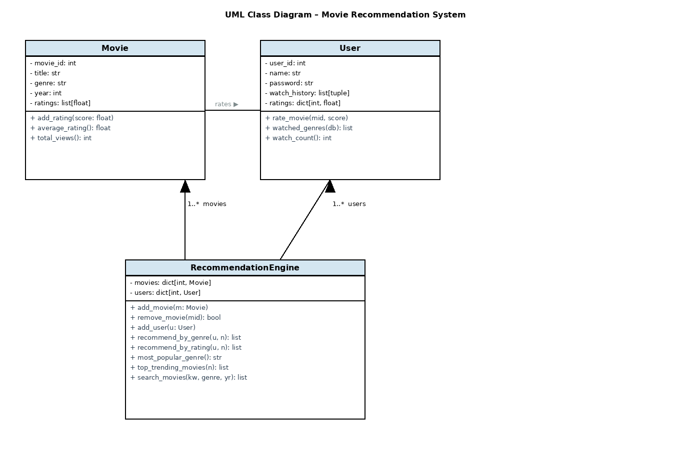
Figure 1: UML Class Diagram for the Movie Recommendation System
Movie class – Stores movie metadata (title, genre, year) and a dynamic list of ratings. The average_rating() method computes the mean in O(n) time, while total_views() returns the count of ratings received.
User class – Holds the user’s profile, a watch history log (stored as a list of tuples containing movie_id and timestamp), and a dictionary mapping movie IDs to the scores the user gave. The rate_movie() method records both the rating and the watch event in a single call.
RecommendationEngine class – Acts as the central controller. It maintains dictionary-based lookup tables for movies and users (O(1) access by ID) and exposes methods for content-based recommendations, rating-based recommendations, analytics, and search.
Relationships: The engine “has-a” collection of movies (1-to-many composition) and a collection of users (1-to-many composition). Users “use” movies through the rating association. This separation of concerns keeps each class focused on a single responsibility.

Object Creation and Interaction Example:
# Creating objects
engine = RecommendationEngine()

m1 = Movie(1, "Inception", "Sci-Fi", 2010)
m2 = Movie(2, "The Dark Knight", "Action", 2008)
engine.add_movie(m1)
engine.add_movie(m2)

u1 = User(1, "Alice", "alice123")
engine.add_user(u1)

# Interaction: user rates a movie
u1.rate_movie(1, 4.5) # Alice rates Inception 4.5
m1.add_rating(4.5) # sync rating to movie object

# Engine generates recommendations for Alice
recs = engine.recommend_by_genre(u1, top_n=5)

(b) Python Program – Viewing History, Ratings & Recommendations
The following code implements the Movie and User classes along with the recommendation logic inside RecommendationEngine. Dictionaries are chosen as the primary data structure because they provide O(1) average-case lookups by ID, which is critical when the system scales to many movies and users. The recommendation methods filter candidates using set operations and sort by average rating in O(n log n) time.
Content-based filtering works by analysing the genres the user has already watched (using collections.Counter), building a set of preferred genres, and then returning unwatched movies in those genres ranked by average rating.
Rating-based filtering simply returns the highest-rated movies the user has not yet seen, regardless of genre. The combined_recommendations() method merges both lists, removes duplicates using a seen-set, and trims to the requested top-N count.
The core class definitions and recommendation methods are shown below:
class Movie:
"""Represents a single movie in the database.

Attributes:
movie_id (int) : unique identifier
title (str) : movie title
genre (str) : genre category
year (int) : release year
ratings (list) : list of float ratings given by users
"""

def __init__(self, movie_id: int, title: str, genre: str, year: int):
self.movie_id = movie_id
self.title = title
self.genre = genre
self.year = year
self.ratings: list[float] = [] # each element is a rating value

def add_rating(self, score: float) -> None:
"""Append a rating (1-5) to this movie's rating list."""
self.ratings.append(score)

def average_rating(self) -> float:
"""Return the mean rating, or 0.0 if no ratings exist."""
if not self.ratings:
return 0.0
return sum(self.ratings) / len(self.ratings)

def total_views(self) -> int:
"""Number of ratings equals number of times the movie was watched/rated."""
return len(self.ratings)

def __repr__(self) -> str:
return f"Movie({self.movie_id}, '{self.title}', {self.genre}, {self.year})"

class User:
"""Represents a registered user of the platform.

Attributes:
user_id (int) : unique identifier
name (str) : display name
password (str) : simple password for login
watch_history (list) : list of (movie_id, timestamp) tuples
ratings (dict) : {movie_id: score} mapping
"""

def __init__(self, user_id: int, name: str, password: str):
self.user_id = user_id
self.name = name
self.password = password
self.watch_history: list[tuple[int, str]] = [] # (movie_id, timestamp)
self.ratings: dict[int, float] = {} # movie_id -> score

def rate_movie(self, movie_id: int, score: float) -> None:

(Full source code is provided in the accompanying app.py file.)

(c) Extended Analytics – Popular Genre, Trending, Watch Counts
The RecommendationEngine class is extended with three analytics methods that satisfy the requirements of identifying the most popular genre, the top 3 trending movies, and the total watch count per user.
most_popular_genre() – Iterates through all movies once, summing the number of ratings (views) per genre using a Counter object. The genre with the highest cumulative view count is returned. Time complexity is O(M) where M is the number of movies.
top_trending_movies(n) – Defines a trending score as total_views × average_rating. This composite metric ensures that a movie must be both popular and well-received to trend. The list is sorted in descending order and the top n entries are returned.
total_watch_count_per_user() – Returns a dictionary mapping each user’s name to the length of their watch_history list. This is an O(U) operation where U is the number of users.
Dynamic update demonstration: When a new rating is submitted, the system calls user.rate_movie() and movie.add_rating() simultaneously. Since the analytics methods recompute from live data on every call (no stale caches), the recommendations, trending list, and genre statistics update immediately. This is demonstrated in the Streamlit interface where rating a movie and refreshing the dashboard shows updated results.
# Example: dynamic update when a new rating is added
user.rate_movie(movie_id=3, score=5.0)
engine.movies[3].add_rating(5.0)

# Analytics recalculate automatically from live data
print(engine.most_popular_genre()) # reflects new rating
print(engine.top_trending_movies(3)) # updated trending list
print(engine.total_watch_count_per_user()) # incremented count

SECTION B – Streamlit Application

(a) Interactive Interface – Search, Rate & Recommend
The Home page of the Streamlit application serves as the primary interaction point. It provides four key functionalities as required:
I. Rate a Movie – Logged-in users can select any movie from a dropdown and submit a rating between 1.0 and 5.0 using a slider. The rating is recorded in both the User object and the Movie object simultaneously, keeping the data consistent.
II. Top-N Recommendations – Available on the Dashboard page, users can adjust a slider to choose how many recommendations they want (3–10). The engine combines content-based and rating-based filtering to generate a personalised list.
III. Search by Multiple Criteria – The Home page offers three search filters: title keyword (partial match, case-insensitive), genre (dropdown), and year (dropdown). These filters are AND-combined, meaning a movie must satisfy all active filters to appear in results.
IV. Display Search Results – Results are shown in a clean Pandas DataFrame table with columns for Title, Genre, Year, Average Rating, and Views. The use_container_width parameter ensures the table scales properly on different screen sizes.
[Insert screenshot of the Home page here]

(b) User Dashboard
The Dashboard page is accessible only to logged-in users and provides a comprehensive overview of their activity and personalised content.
I. Top Recommended Movies – Displayed at the top of the dashboard using the combined_recommendations() method. Recommendations are shown in a table with title, genre, year, and average rating.
II. Trending Movies & Popular Genres – A two-column layout shows the top 5 trending movies (ranked by the views × rating composite score) alongside the most popular genre. A Plotly pie chart visualises the distribution of ratings across genres.
III. Watch History & Rating Logs – A tabular log displays every movie the user has watched, including the movie title, genre, the user’s personal rating, and the timestamp of when they watched it. This is built from the User.watch_history list.
IV. Data Visualisation – A Plotly bar chart shows all movies the user has rated, with the x-axis being movie titles and the y-axis being the rating score (1–5). A colour gradient (Tealgrn) makes it easy to spot the user’s favourites at a glance.
[Insert screenshot of the Dashboard page here]

(c) Admin Console
The Admin Console is protected by a unique login key (admin2025). Only users who enter this key can access administrative features. The console is divided into two tabs:
I. Movie Database Management – Administrators can add new movies (with title, genre, and year fields), edit existing movies by selecting from a dropdown and modifying any field, or remove movies from the database entirely. All changes take effect immediately in the session state.
II. Engagement Analytics – This tab provides three insights: (1) the most-watched movies displayed in both tabular and bar-chart format, (2) the top active users ranked by total watch count, and (3) the current trending movie list. The trending metric is defined as total_views multiplied by average_rating, ensuring that both viewership volume and quality are factored in.
[Insert screenshot of the Admin Console here]

(d) Deployment
The application was deployed as a Streamlit web application using Streamlit Community Cloud. The deployment process involved pushing the project files (app.py and requirements.txt) to a public GitHub repository. Streamlit Community Cloud was then connected to the repository, which automatically detected the app.py entry point and installed the dependencies listed in requirements.txt (streamlit, pandas, plotly). The application was built and hosted on a public URL with no additional server configuration required.

Deployed Application URL: ____________________________
(To be filled in after deployment)

References
Lutz, M. (2013). Learning Python (5th ed.). O’Reilly Media.

McKinney, W. (2022). Python for Data Analysis (3rd ed.). O’Reilly Media.

Plotly Technologies Inc. (2024). Plotly Python graphing library. https://plotly.com/python/

Streamlit Inc. (2024). Streamlit documentation. https://docs.streamlit.io/

Van Rossum, G., & Drake, F. L. (2023). The Python language reference (Release 3.12). Python Software Foundation. https://docs.python.org/3/reference/

