**Problem 1)**

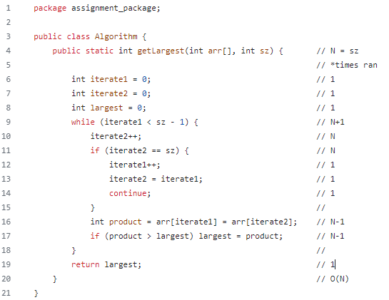

To find the Big O of this function, I took note of how many times each line ran.

The while loop will run n times. And n will be the size of ‘sz’:

2N+(N+1)+2(N-1)+7

5N+6

After removing constants:

5N

This means the complexity of this function is linear:

O(N)

**Problem 2)**

If I were to argue that one *full* use of the scale involves removing the previously weighed bag, then I would put all the bags on the scale one by one without removing any. When the scales tenth place turns to .1, the heavier bag would be the last bag I placed on the scale.

Otherwise, there would be no reliable way to find the heavy bag every time without checking every bag of M&Ms. *O(n)*