**1050 Programming Logic**

Lab W8

Name: Joshua Daum

*Paste your code and screenshots below.*

1. Create a simple while loop that loops from 1-9, incrementing the loop control variable by 2. Add a counter as well. Using comments in your code, identify the following 1) loop control variable, 2) counter, 3) loop terminating condition, and 4) where you modify the loop control variable.

static void Main(string[] args)

{

int control = 1;

int counter = 1;

while (control < 10)

{

Console.WriteLine("control is equal to " + control);

Console.WriteLine("counter is equal to " + counter + "\n");

control += 2;

counter += 1;

}

}

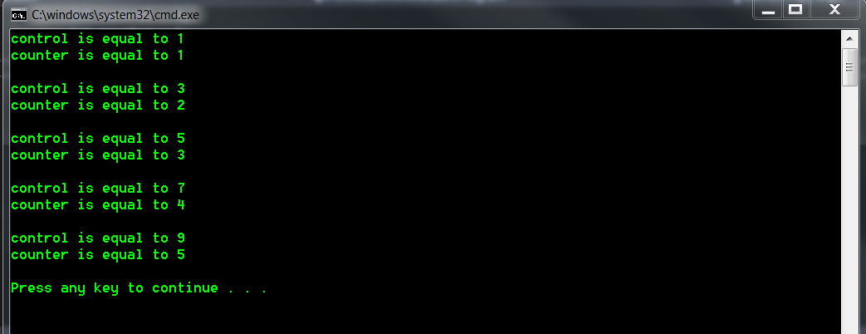

1. Control variable is the integer “control”
2. Counter variable is the integer “counter”
3. Loop terminating condition is “while control < 10”
4. Control variable is modified at the end of the loop, with the statement “control += 2”
5. Create a for loop that loops through values 30-45 using a variable named i as the loop control variable. Increment the loop control variable by 1. Each time through the loop, output whether or not the variable is even or odd

*Hint:* Use and if-else statement and the modulus % operator to determine whether the variable is even or odd. Example: if ((i % 2) == 0) // it’s even

static void Main(string[] args)

{

for (int i = 30; i <= 45; i++)

{

Console.WriteLine(i);

if ((i % 2 ==0))

{

Console.WriteLine("It's even.");

}

}

}

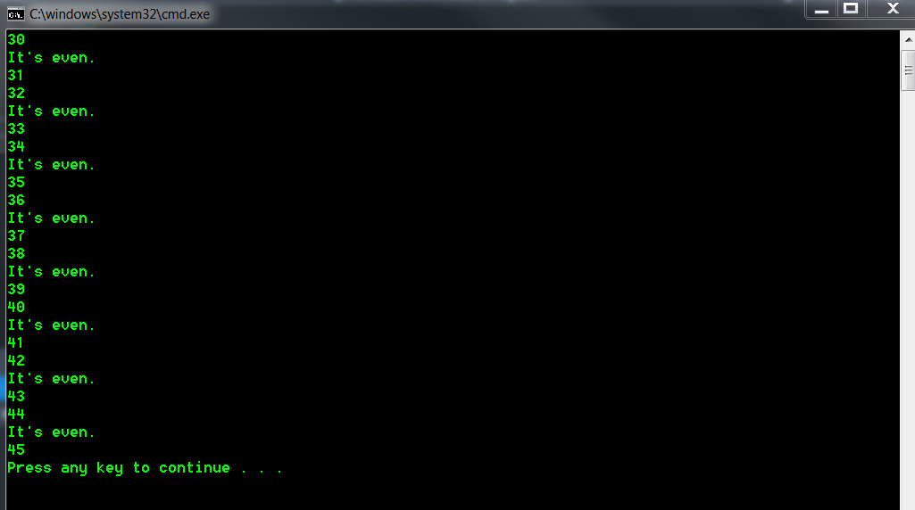

1. Use an if…else-if…else statement to output the following based on an int time entered in military time (ie. 23 == 11:00 p.m., 11 == 11:00 a.m.). You will need to use a ReadLine() and then convert the input to an int value. Based on the input, output the following messages:

**Input Output**

0-11 Good Morning  
12-16 Good Afternoon

> 16 Good Evening

static void Main(string[] args)

{

Console.Write("Enter an integer value for the hour in military time: ");

int milTime = Convert.ToInt16(Console.ReadLine());

if (milTime < 12)

{

Console.WriteLine("Good morning.");

}

else if (milTime < 17) {

Console.WriteLine("Good afternoon.");

}

else if (milTime < 25)

{

Console.WriteLine("Good evening.");

}

else

{

Console.WriteLine("Since you must be on a planet other than earth, " +

"I have no idea what time of day it is where you are." +

"I'll simply wish you a good day.");

}

}

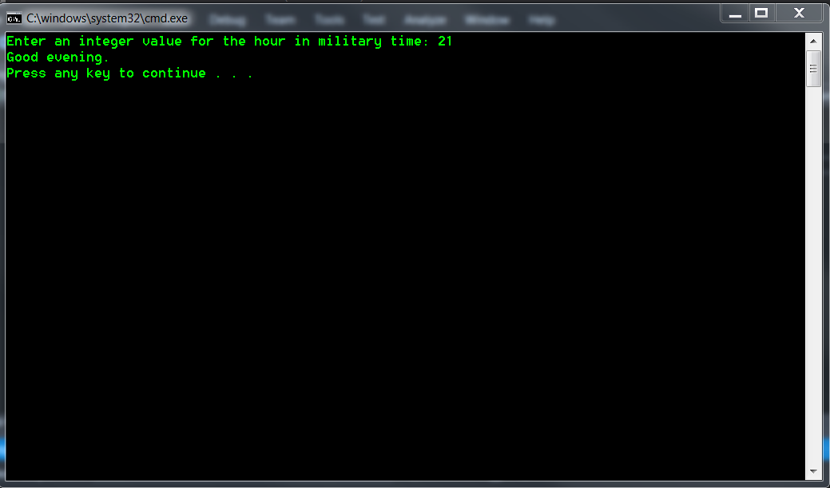

1. The following code is meant to loop and output 10-20, each number on a separate line. What’s wrong? Fix the problem. Explain what was wrong in a comment.

int i = 10;

while (i < 21)

{

Console.WriteLine(i);

}

*Example output:*



*Corrected Code:*

int i = 10;

while (i < 21)

{

Console.WriteLine(i);

//added incrementation for control variable

i++;

}

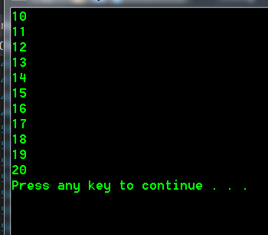

1. The following statement is supposed to output every number from 0-100 separated by a line with asterisks on it. What is wrong with the code? Fix it without changing any of the statements.

for (int i = 0; i < 101; i++)

Console.WriteLine(i);

Console.WriteLine("********");

*Example output:*

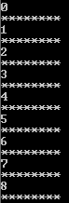

*Corrected Code:*

for (int i = 0; i < 101; i++)

// added braces for looped code

{

Console.WriteLine(i);

Console.WriteLine("********");

}

1. **You only need to create one of the shapes but are welcome to create more than one.** **Use nested for loops** to generate the patterns. All asterisks (*) should be displayed by a single statement of the form Console.Write( '*' ); which causes the asterisks to display side by side. A statement of the form Console.WriteLine(); can be used to move to the next line. A statement of the form Console.Write( ' ' ); can be used to display a space for the last two patterns. There should be no other output statements in the application. [Hint: The last two patterns require that each line begin with an appropriate number of blank spaces.]

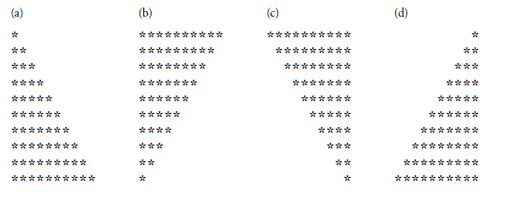

static void Main(string[] args)

{

//shape (a)

for (int rowCount1 = 1; rowCount1 <= 10; rowCount1++)

{

for (int columnCount1 = 1; columnCount1 <= rowCount1; columnCount1++)

{

Console.Write('*');

}

Console.WriteLine();

}

Console.WriteLine();

//shape (b)

for (int rowCount2 = 10; rowCount2 >= 1; rowCount2--)

{

for (int columnCount2 = 1; columnCount2 <= rowCount2; columnCount2++)

{

Console.Write('*');

}

Console.WriteLine();

}

Console.WriteLine();

//shape (c)

int blankies1;

for (int rowCount4 = 10; rowCount4 >= 1; rowCount4--)

{

for (blankies1 = 1; blankies1 <= 10 - rowCount4; blankies1++)

{

Console.Write(' ');

}

for (int columnCount4 = 1; columnCount4 <= rowCount4; columnCount4++)

{

Console.Write('*');

}

Console.WriteLine();

}

Console.WriteLine();

//shape (d)

int blankies2;

for (int rowCount3 = 1; rowCount3 <= 10; rowCount3++)

{

for (blankies2 = 1; blankies2 <= 10 - rowCount3; blankies2++)

{

Console.Write(' ');

}

for (int columnCount3 = 1; columnCount3 <= rowCount3; columnCount3++)

{

Console.Write('*');

}

Console.WriteLine();

}

}

