Joshua Cordero

CMP 464

12/17/21

Professor Zhao

NYPD Arrest Data

To my understanding, many people are visual learners when it comes to intaking information. Therefore, the mission for my project was to take the NYPD Arrest Data dataset and present visual representations in order to show the information to an audience that may not be accustomed to sifting through an entire database. This is, for the most part, what my goal was for the end result of the project. Through a series of graphs and maps, I intended to show what I felt was important information within the database. These were some of my findings:

One finding that I felt was important to present was, how sex influenced the volume of crime. What I mean by this is, I wanted to show the frequency that males committed crimes compared to females. This graph here shows us that within the database, males are listed as the offender almost 5 times as much as women are.

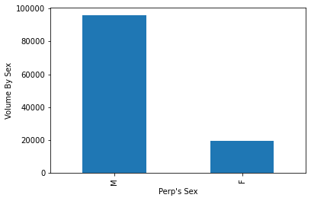

Another bit of useful information was to present the age group and race of these offenders to see what is the likely age group of the people who are committing these crimes. This offers a great deal of awareness. The data shows that an overwhelming majority of the crimes are committed by people within the 25-44 age group. This showed that a majority of the offenders were black and white Hispanic.

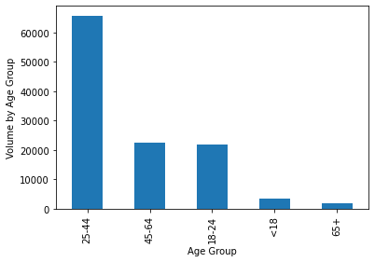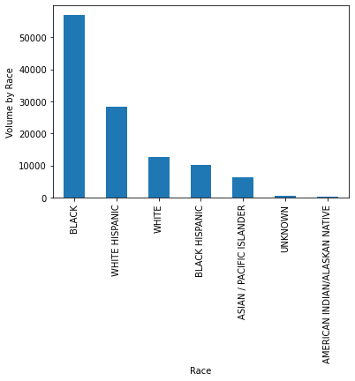

Furthermore, I wanted to present the volume of crime by precinct. I figure that every individual knows their closest precinct number. This will provide a huge level of awareness to those, so they can see how their precinct is doing when it comes to crime volume, which also provides a view on crime within the neighborhood. I also created a graph that shows crime in relation to the borough which shows that Brookyln has the most crime.

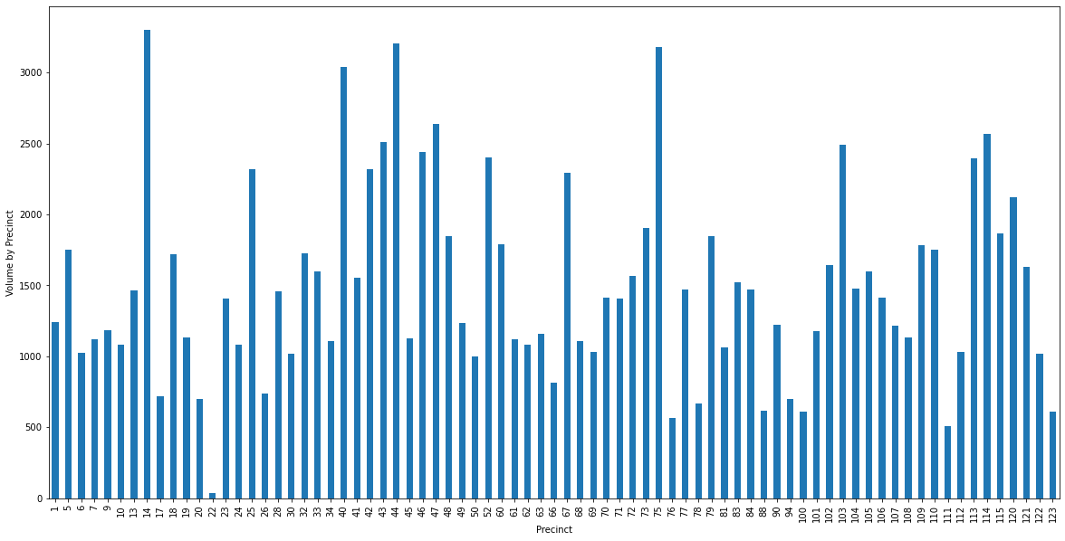

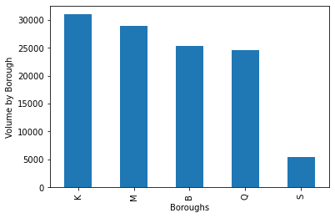

The last two things that I wanted to show were how crimes dispersed over periods of time. My idea was to show how crimes spanned out throughout the year. Unfortunately, we are only provided with three-quarters of the data in this dataset as it is updated quarterly. The graph still gives a very good representation of the crime volumes from January to September. Lastly, I wanted to show a heatmap that would show hot areas for crimes that were mapped using the longitude and latitude given for each of the crimes within the database. Darker areas would mean more crime while lighter areas mean less crime.

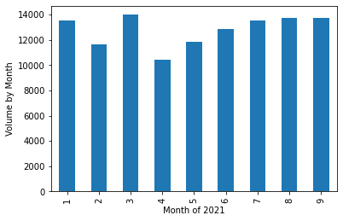

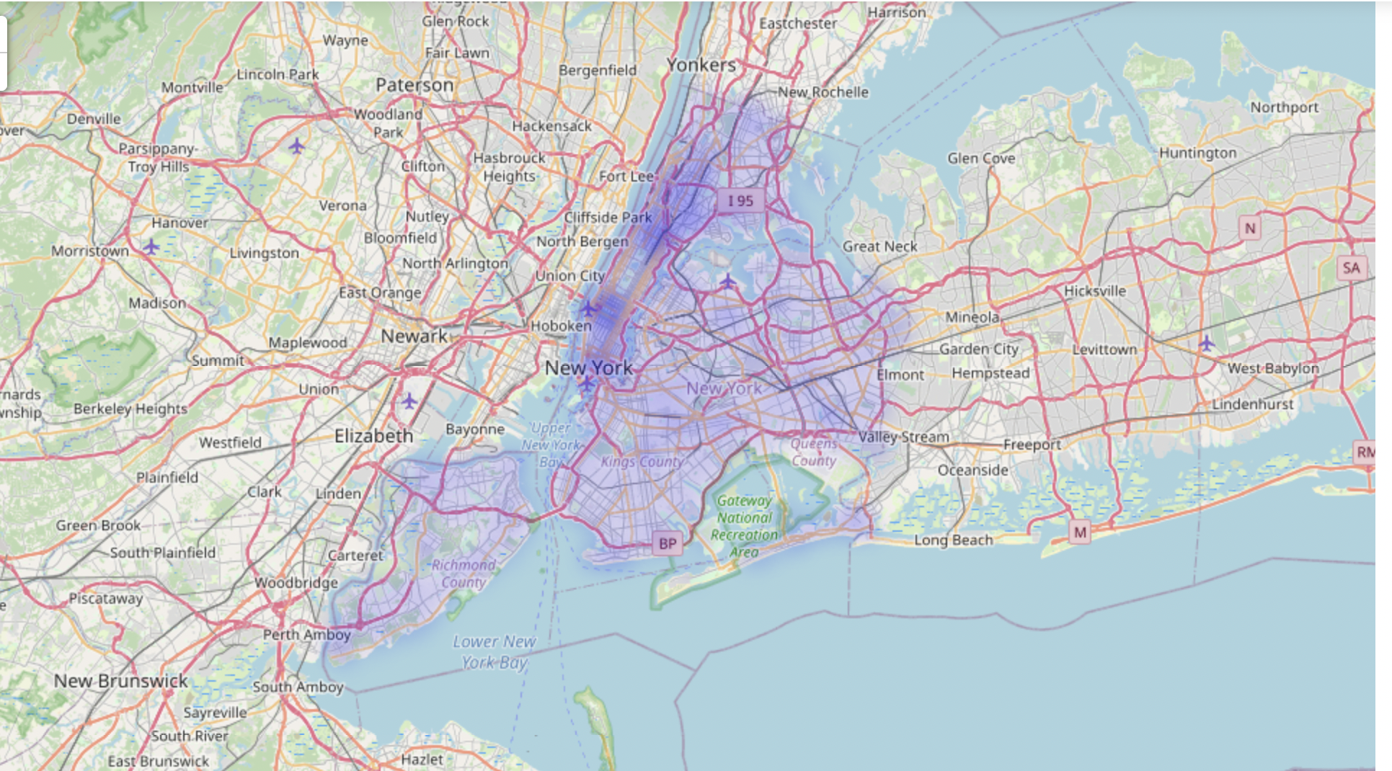

Overall, I feel that the mission of this project, which was creating awareness, was completed. These findings can prove to be important as it allows for people to really see the breakdown of crime happening within New York. Whether it’s how crime rates are broken down by the individuals themselves or looking at how crime volumes look on a map itself, is all very useful.