Deep Learning Predicted Way Guidebook

Before use deep_learning predicted way, you need to build a folder for the software.

**1.Preparation**

The folder should contains with 3 kinds of documents:

**1.id_prop.csv**

**2.atom_init.json(can be common use, just copy one from the example to your folder)**

**3.cif files of the material you want to predict**

Here is an example of the folder:

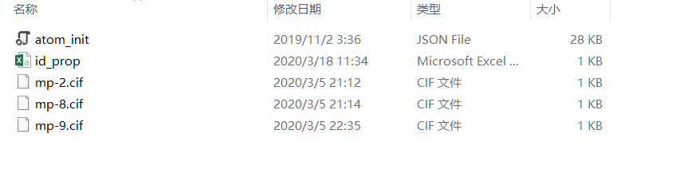

Figure1. An example of the folder’s structure

You can copy the atom_init.json file from example folder, it can be commonly use.

Put the cif files of the material you want to predict in

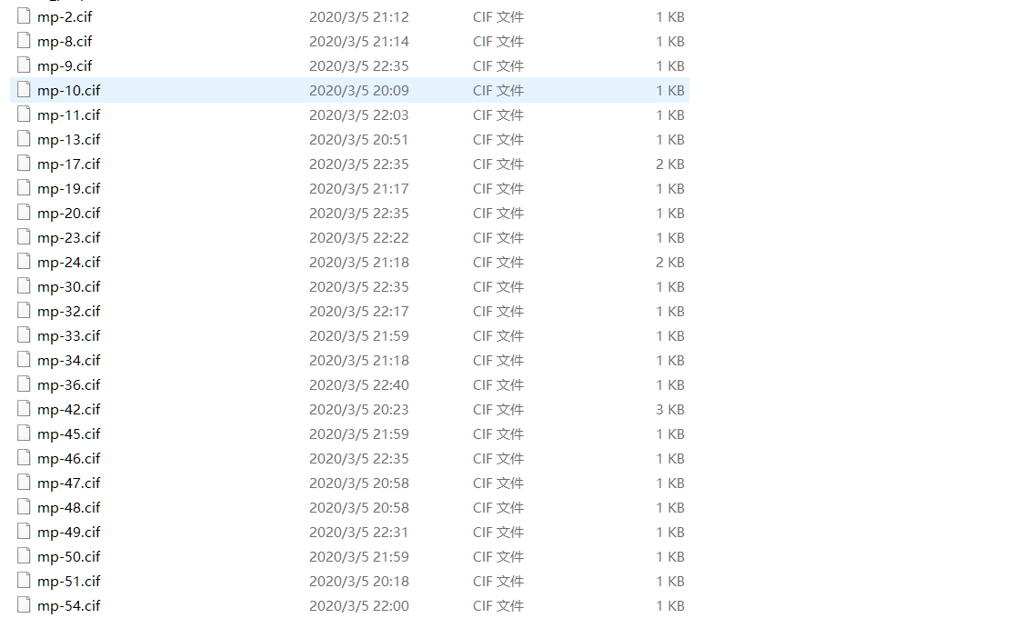

Figure2. The cif files

And here is an example of the id_prop.csv:

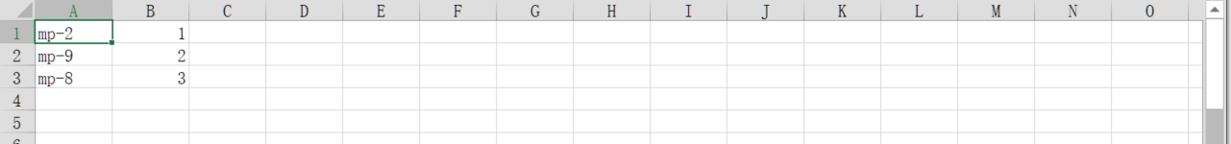

Figure3.How to build up id_prop.csv

The id_prop.csv contains two columns, one is the **cif files name** and another one is the **subsequence of the name**

**Remember the cif files name in id_prop.csv must be correct! Or the result will not be printed!**

Finally, after all these three kinds of documents are put in the folder, now the folder has been formed. Let’s move on to next action.

**2.Prediction**

First, choose the formed folder path  
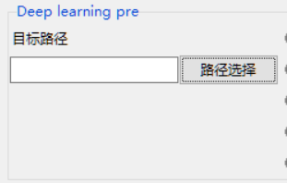

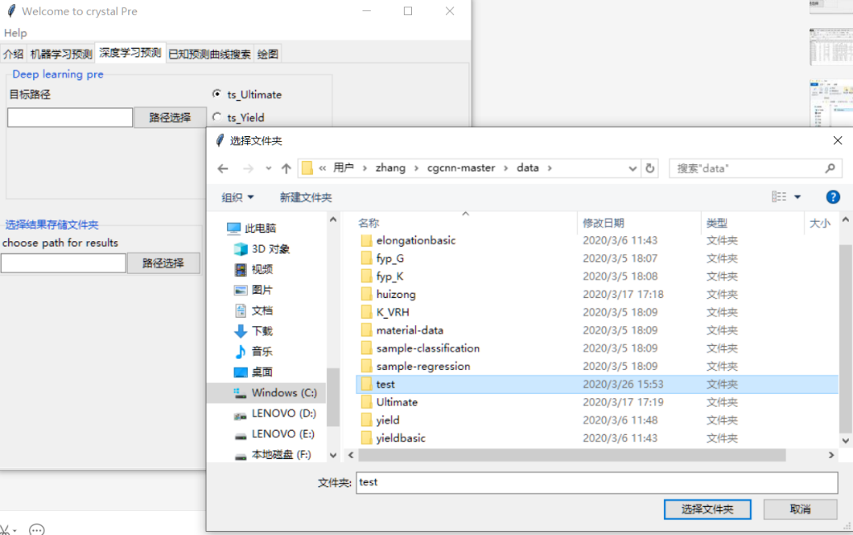

Figure4. Choose the folder path

Second, Choose the property which you want to predict from your material

**The meaning of the properties:**

**ts_Ultimate: Tensile Strength, Ultimate**

**ts_Yield: Tensile Strength, Yield**

**Elongation: Elongation at break**

**K_VRH: Bulk Module**

**G_VRH: Shear Module**

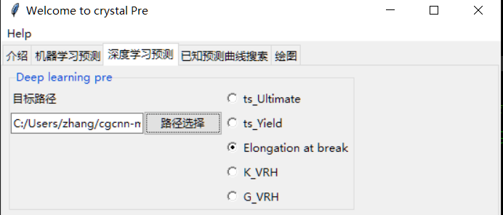

Figure5. Choose the property, here we choose Elongation (%)

Third, please choose the file you want to save the predicted result.

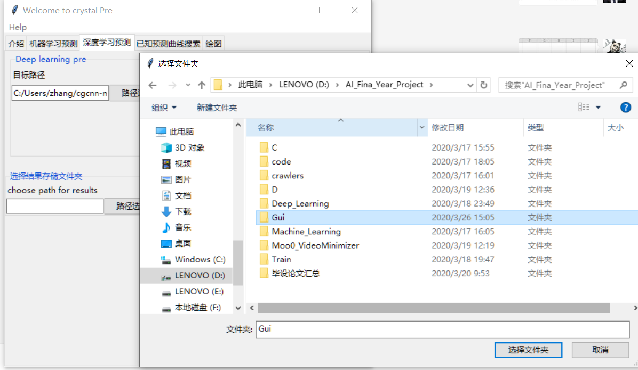

Figure6. Choose the file path for saving your result.

Finally, you can click the prediction button and wait, the result file path will open automatically when the predicted process has done

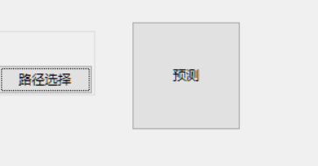

Figure7. Click the button

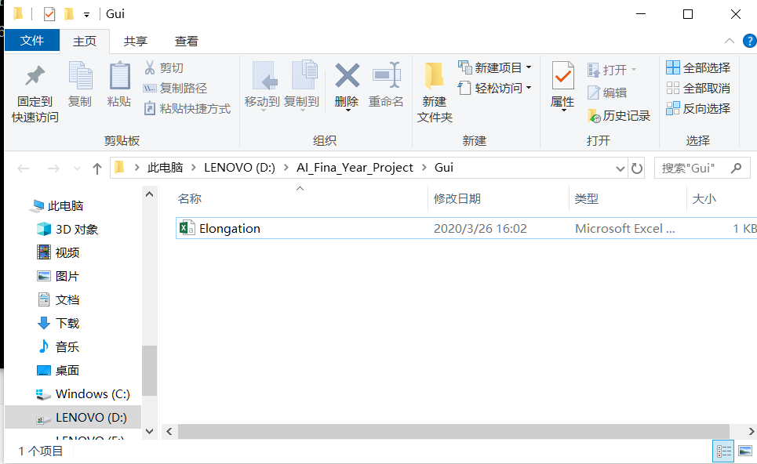

Figure8. The prediction has done, folder will open automatically

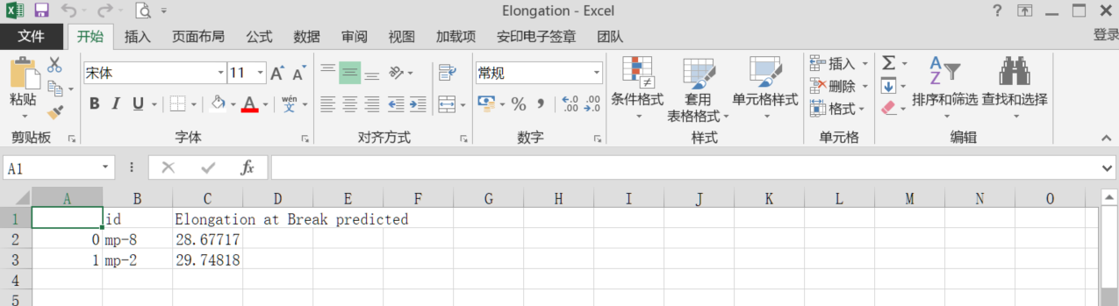

Figure9.The result will store in the .csv file