Machine Learning Predicted Way Guidebook

Before use machine_learning predicted way, you can choose one of these two paths.

1. Predict only one crystal or alloy

If you want to predict only one crystal or alloy the first thing you need to do is to get the composition of the material, and then enter it in this place:

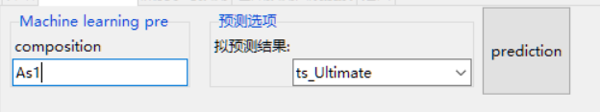

Figure1. Enter the composition of your material

And then choose the property which you want to predict from your material

**The meaning of the properties:**

**ts_Ultimate: Tensile Strength, Ultimate**

**ts_Yield: Tensile Strength, Yield**

**Elongation: Elongation at break**

**K_VRH: Bulk Module**

**G_VRH: Shear Module**

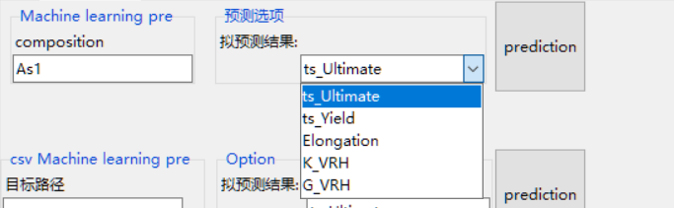

Figure2. Choose the property, here we choose ts_Ultimate(Gpa)

After choosing the property, please choose the file you want to save the predicted result.

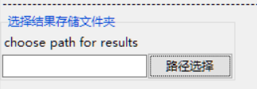

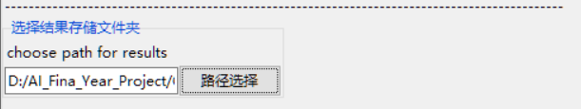

Figure3. Choose the file path for saving your result.

Finally, you can click the prediction button and wait, the result file path will open automatically when the predicted process has done

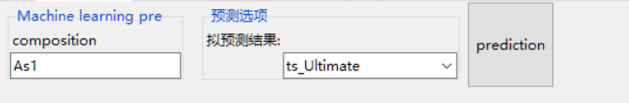

Figure4. Click the button

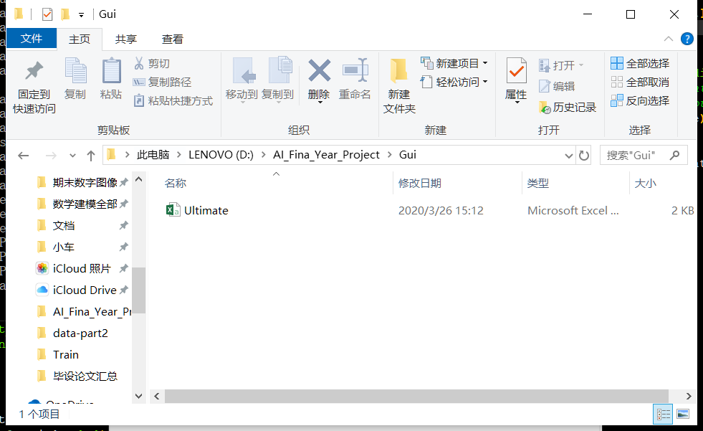

Figure5. The prediction has done, folder will open automatically

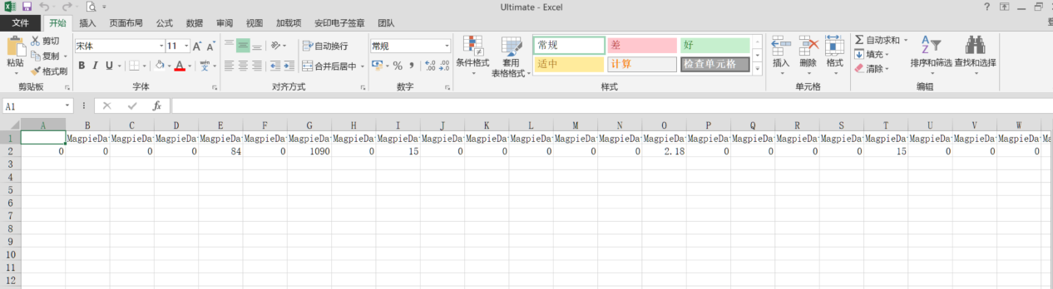

Figure6.The result will store in the .csv file

2. Predict many crystals or alloys

If you want to predict many crystals or alloys, the first one path can be troublesome, so you should build a database for the software to use.

Here is an example of the database, remember only build two columns, one is named id and another one is named composition. The information in id can be everything. Here is two examples, both of the examples can work properly.

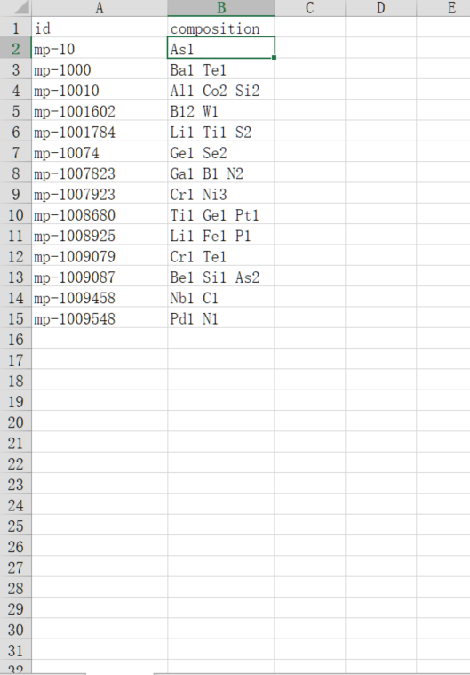

Figure7. e.g The database1

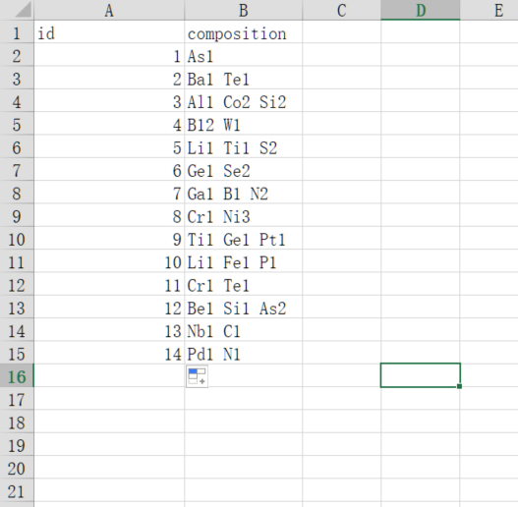

Figure8. e.g The database2

After building up the database, get back to the sofeware to choose where the database is

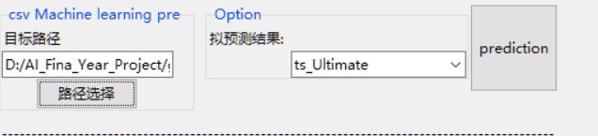

Figure9. Choose where the database is

And then choose the property which you want to predict from your material

**The meaning of the property:**

**ts_Ultimate: Tensile Strength, Ultimate**

**ts_Yield: Tensile Strength, Yield**

**Elongation: Elongation at break**

**K_VRH: Bulk Module**

**G_VRH: Shear Module**

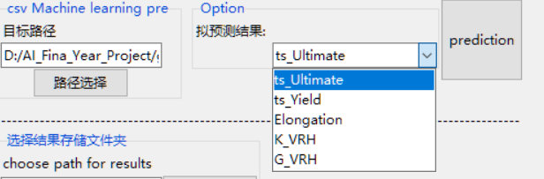

Figure10. Choose the property, here we choose ts_Ultimate

After choosing the property, please choose the file you want to save the predicted result.

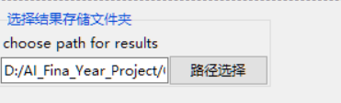

Figure11. Choose the file path for saving your result.

Finally, you can click the prediction button and wait, the result file path will open automatically when the predicted process has done

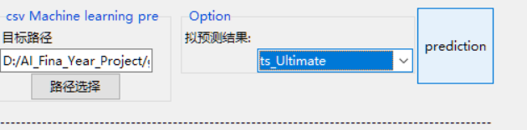

Figure12. Click the button

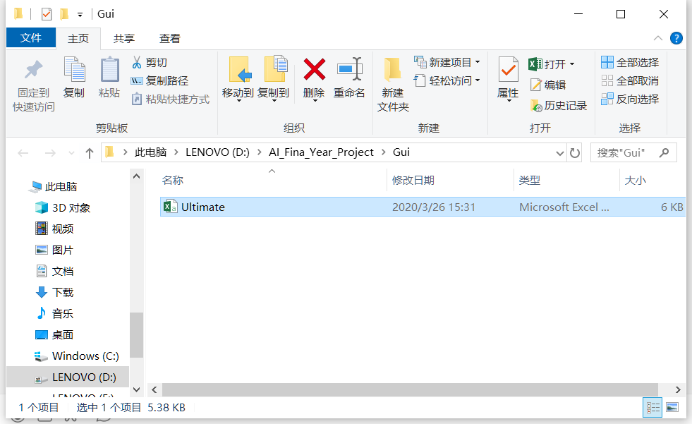

Figure13. The prediction has done, folder will open automatically

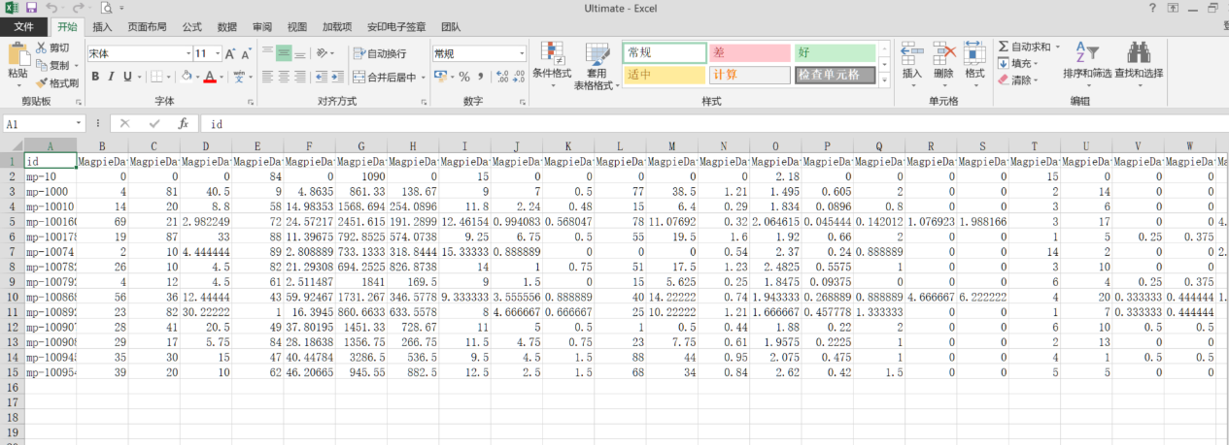

Figure14.The result will store in the .csv file