Plotting Guidebook

Before start plotting the stress-strain curve, please be sure that you have done all the “properties predicted” files from machine_learning way or deep_learning way.

|  |
| --- |
|  |

1. Choose the “properties predicted” files

Please kindly choose these five files path:

Ultimate.csv

Yield.csv

Elongation.csv

K_VRH.csv

G_VRH.csv

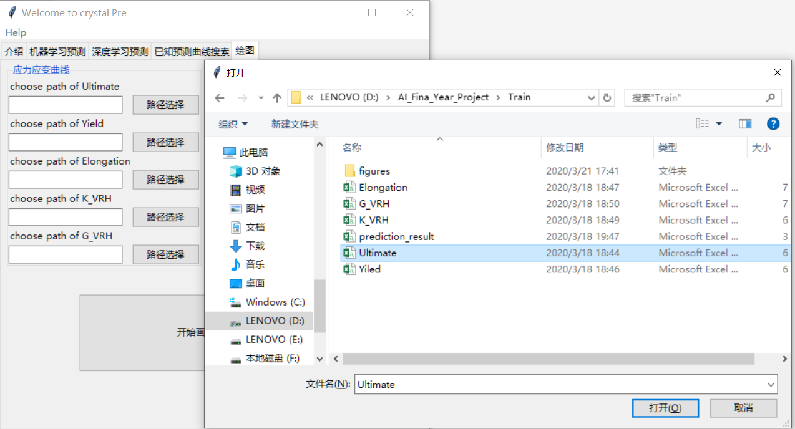

Figure1. choose the file path properly

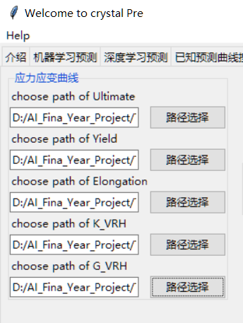

Figure2. choose the file path properly

2. Choose the stored folder

Then please choose the folder for figures and results

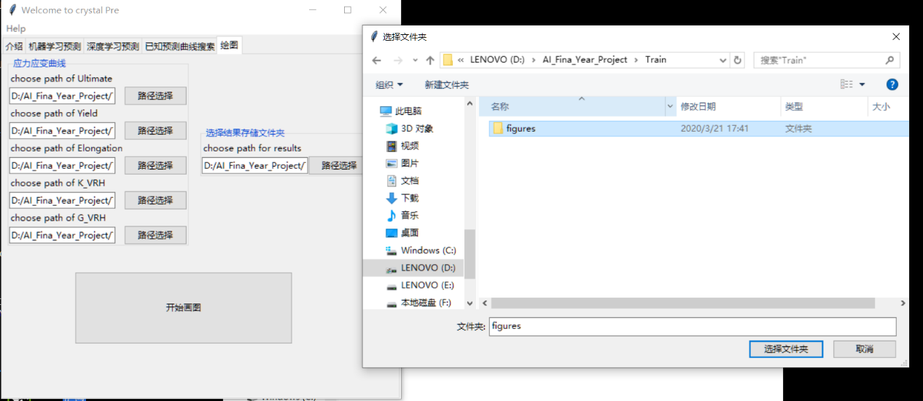

Figure3. choose the folder path for storing

3.Start plotting and analysis the figures and results

Click the button, after plotting, the folder will open automatically

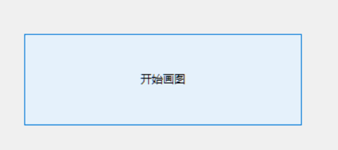

Figure4. Click the button

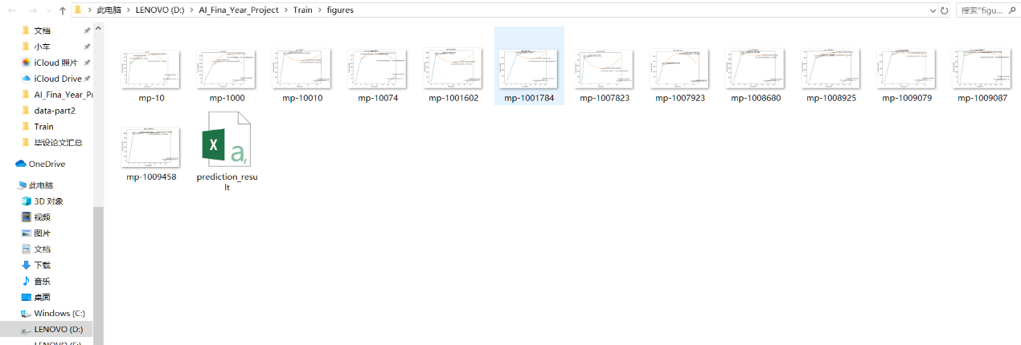

Figure5.Folder will open automatically

Here we have two kinds of documents, plotting figures and prediction_result.csv

From the prediction_result.csv, you can get values for these attributes:

1.Bulk module, which named elasticity K_VRH predicted

2.Shear module, which named elasticity G_CRH predicted

3.Young’s module, which named youngs

4.Poisson rate

5.Stiffness

6.Flexibility

7.Tensile Strength, Ultimate

8.Tensile Strength, Yield

9.Elongation at break

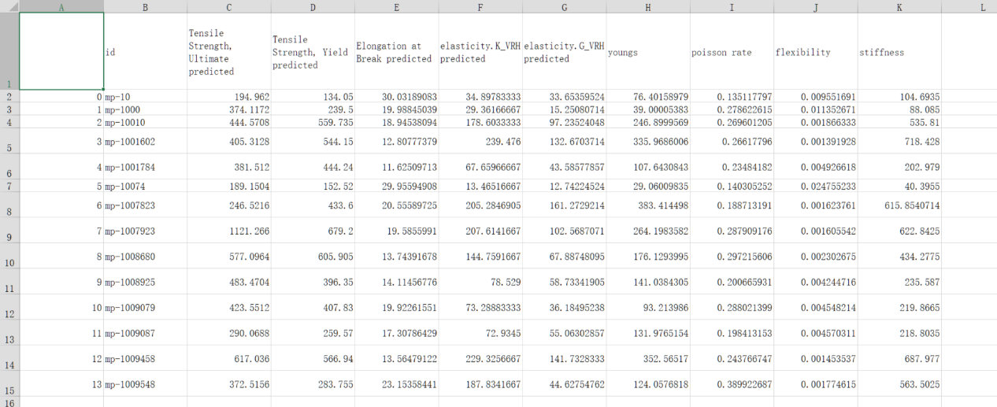

Figure6.An example of prediction_result.csv