Search Guidebook

I have predicted the elastic and plastic values of 8700 crystals from materialsproject

(<https://www.materialsproject.org>) and plotted their stress-strain curves in advance. If you want to predict the material which has occurred in “materialsproject”, you can just search it through the “material-id” instead of predicting it once more.

You can input the material-id here and then click the “search” button

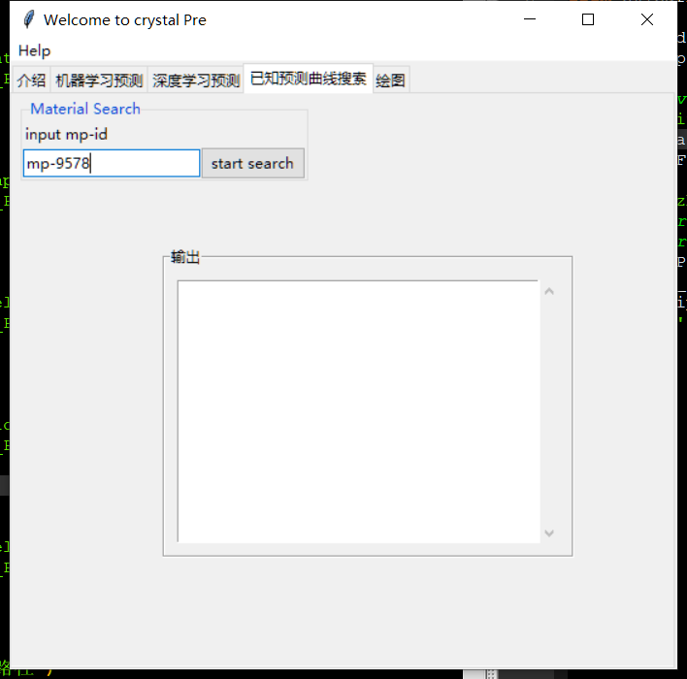

Figure1.input the material-id and search

If the material has been predicted in advance, you can get the stress-strain curve and its elastic and plastic values.

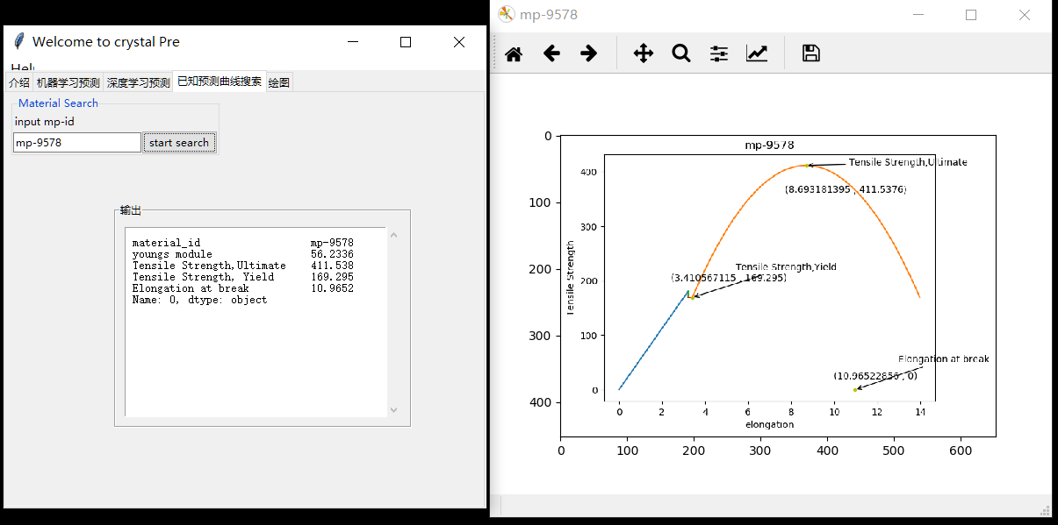

Figure2.if the material exists in the database

If not, there will be “no match” from the scroll text frame.

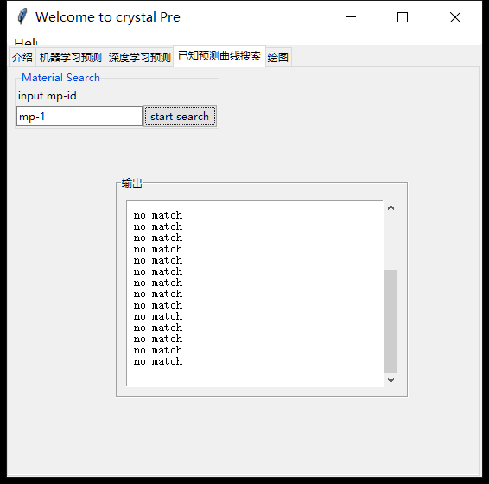

Figure3.if the material does not exist in the database