BAHAFIT
Community Feed — Hosting Cost Impact Analysis
Vercel · Sanity · MongoDB Atlas — prepared July 2026, from current published pricing

The Bottom Line
The community feed itself is cheap to run. Feed pages and API calls are tiny; what costs money is photos and videos. Because media is stored and served through Sanity’s CDN (not Vercel), the feed shifts almost all of its new cost onto Sanity’s bandwidth and storage meters — and both have generous free allowances (100 GB each per month).
Realistic expectation: $20/month (a single Vercel Pro seat) until the feed reaches roughly 1,000–2,000 monthly active users, then costs climb mainly with media viewing. At 10,000 active users, expect roughly $350–400/month across all three services.
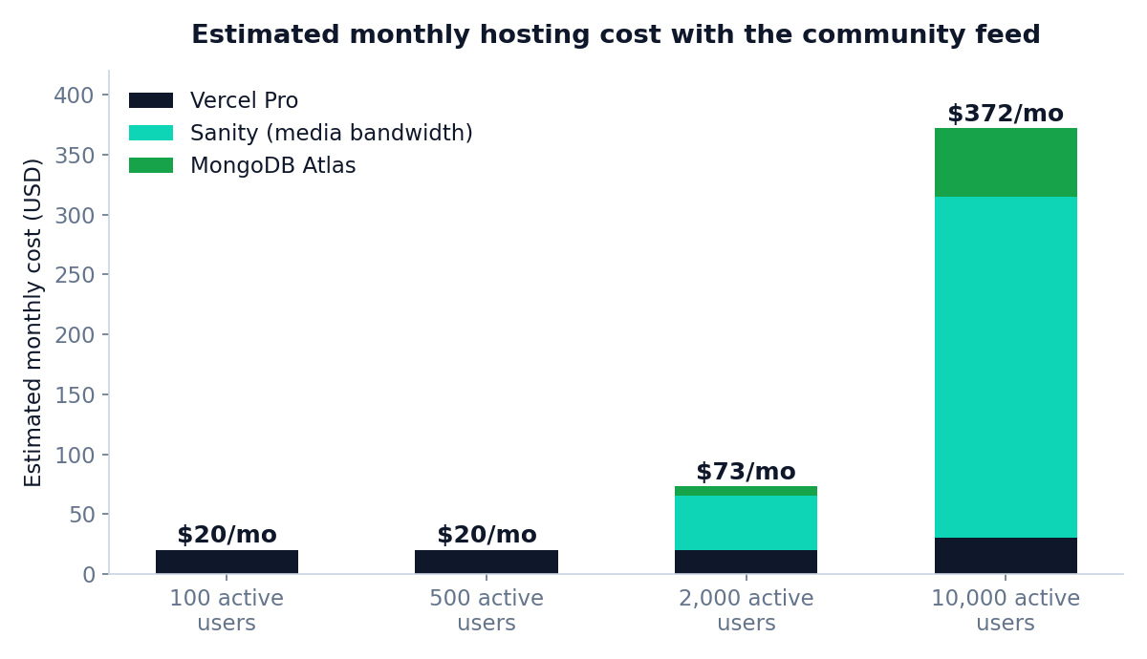
Estimated total monthly cost by community size (assumptions in Section 4).

1. How the Feed Uses Each Service
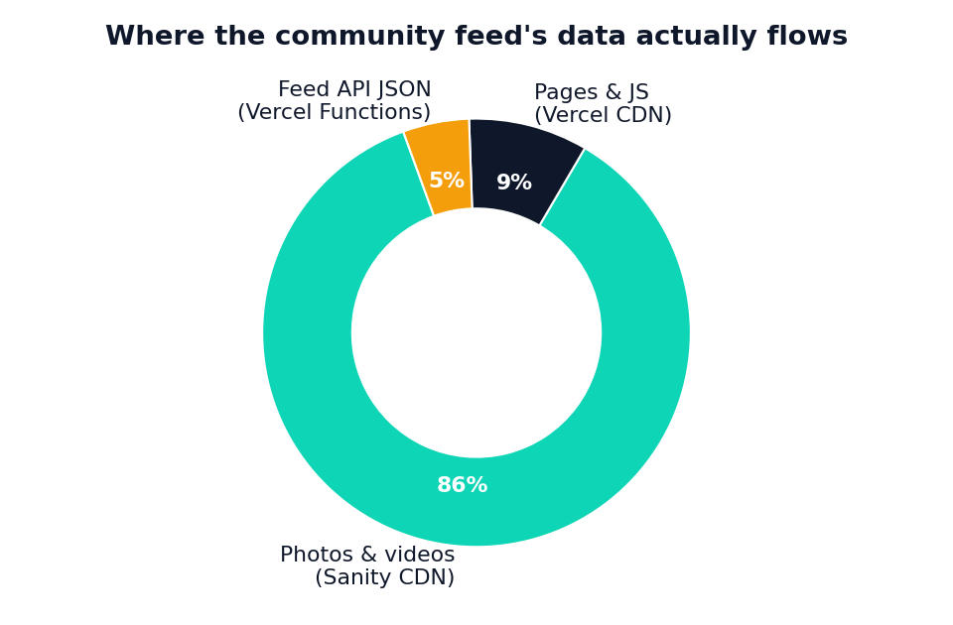
By volume, media dominates — and media is served by Sanity, not Vercel.

Vercel (the website itself)
- Every feed view calls small API functions (activities, stats, follows). These are measured in Active CPU, memory, and invocations — a feed request costs fractions of a cent and the Pro plan’s included usage plus $20 credit absorbs six figures of monthly feed requests.
- Feed JSON is small (~30–50 KB per page load), a rounding error against Pro’s 1 TB of included Fast Data Transfer ($0.15/GB beyond).
- Media uploads pass through a Vercel function on their way to Sanity (that’s why files are capped at 4 MB — Vercel’s ~4.5 MB request body limit), but upload compute time is trivial.
- Note: the free Hobby plan is for non-commercial use. Since Bahafit sells tickets, Vercel Pro at $20/month/seat is the correct baseline regardless of the feed.

Sanity (all photos & videos)
- Storage: every uploaded photo/video lives in Sanity’s asset store — 100 GB included on both Free and Growth plans, then $0.50 per GB/month on Growth.
- Bandwidth: every time media appears in someone’s feed, bytes are served from Sanity’s CDN — 100 GB/month included, then $0.30 per GB on Growth ($15/seat/month).
- The Free plan has no pay-as-you-go: exceed its quotas and you must upgrade to Growth. Treat Growth as inevitable once the feed gets real traction.
- Built-in cost saver (already implemented): feed thumbnails request resized, compressed versions via Sanity’s image pipeline (?w=800&auto=format), cutting image bandwidth by roughly 60–80% versus serving originals.

MongoDB Atlas (feed data)
- Workouts, kudos, comments, and follows are small text records (~1 KB each). The free M0 cluster (512 MB) comfortably holds hundreds of thousands of activities.
- Upgrade drivers are traffic and reliability, not size: budget ~$8–30/month (Flex) around 2,000 active users and ~$60/month (M10) at 10,000.

2. Cost Scenarios
Monthly active users | Vercel | Sanity | MongoDB | Est. total / month
100 | $20 (Pro seat) | $0 (within free tier) | $0 (M0 free) | ~$20
500 | $20 | $0 — ~50 GB bandwidth, still free | $0 | ~$20
2,000 | $20 | ~$45 (Growth $15 + ~100 GB overage) | ~$8 (Flex) | ~$75
10,000 | ~$30 (some usage beyond credit) | ~$285 (Growth + ~900 GB overage) | ~$57 (M10) | ~$370

Per-user economics stay healthy: even at 10,000 active users the infrastructure cost is under $0.04 per user per month — easily covered if even a tiny fraction of that audience buys event tickets (9% + 1% checkout fees).

3. The One Cost That Compounds: Storage
Bandwidth resets every month, but stored media only grows. At 2,000 active users posting ~20 GB of new media per month, the included 100 GB is consumed by around month five:
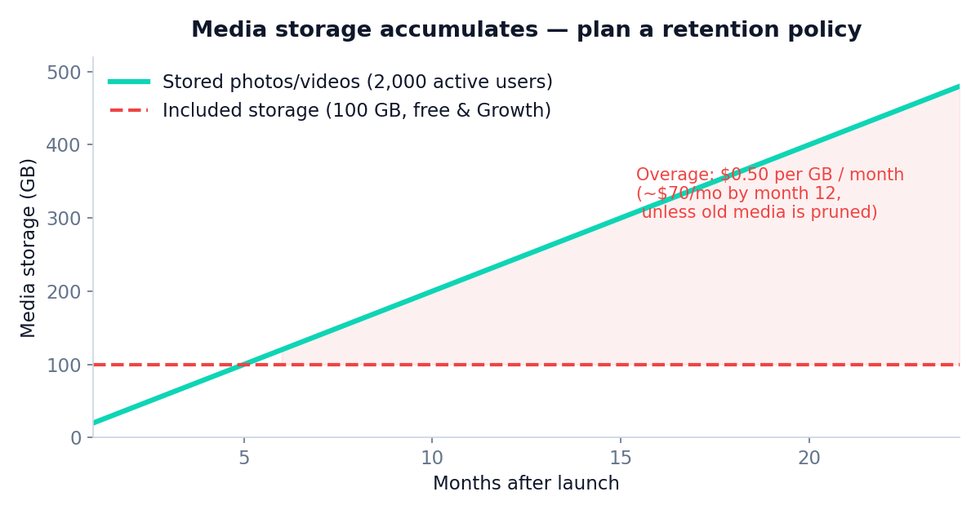
Cumulative media storage vs. the 100 GB included quota.
Recommended mitigations, in order of value:
- Keep the 4 MB per-file cap (already enforced) — it bounds worst-case growth and matches Vercel’s upload limit anyway.
- Add a retention/cleanup job later: delete media assets when an activity is deleted (URLs are stored with assetId, so this is straightforward), and consider pruning media on activities older than 18–24 months.
- If video becomes popular, move video (only) to a dedicated provider with per-minute pricing (e.g., Mux or Cloudflare Stream) — image economics on Sanity remain excellent.

4. Assumptions Behind the Numbers
- An "active user" logs ~8 workouts/month; 40% of workouts include ~1.5 media files averaging 2 MB → ~10 MB uploaded per user/month.
- Each active user browses the feed ~20 times/month, viewing ~12 media thumbnails per session at ~120 KB (optimized) plus occasional short video plays → ~0.1 GB of media bandwidth per user/month.
- Feed API traffic: ~400 function invocations per user/month — far inside Vercel Pro’s included usage at every scenario shown.
- Prices verified July 2026: Vercel Pro $20/seat + $20 usage credit, 1 TB Fast Data Transfer then $0.15/GB. Sanity Free/Growth: 100 GB bandwidth and 100 GB assets included; Growth $15/seat with $0.30/GB bandwidth and $0.50/GB storage overage. MongoDB Atlas M0 free, Flex from ~$8, M10 ~$57.
- Estimates are planning figures, not quotes — real cost tracks how media-heavy user behavior actually is. Watch the Sanity usage dashboard (sanity.io/manage) monthly for the first quarter after launch.

5. Warning Signs to Watch
Metric | Where to check | Action threshold
Sanity bandwidth | sanity.io/manage → Usage | > 80 GB/month → upgrade to Growth before hitting the free cap
Sanity asset storage | sanity.io/manage → Usage | > 80 GB → plan retention policy / video offload
Vercel usage credit | Vercel dashboard → Usage | Credit consumed before month-end → review function hot spots
MongoDB storage/CPU | Atlas dashboard | M0 above 400 MB or throttling → move to Flex

