BAHAFIT
How Everything Works — Owner’s Guide

The Big Picture
Bahafit is one website with two faces: a public fitness community (events, business listings, blog) and a management side (member dashboard and admin dashboard). One Next.js application powers all of it, supported by three outside services: MongoDB Atlas stores people and transactions, Sanity stores polished marketing content and images, and Fygaro handles card payments so no card numbers ever touch the site.

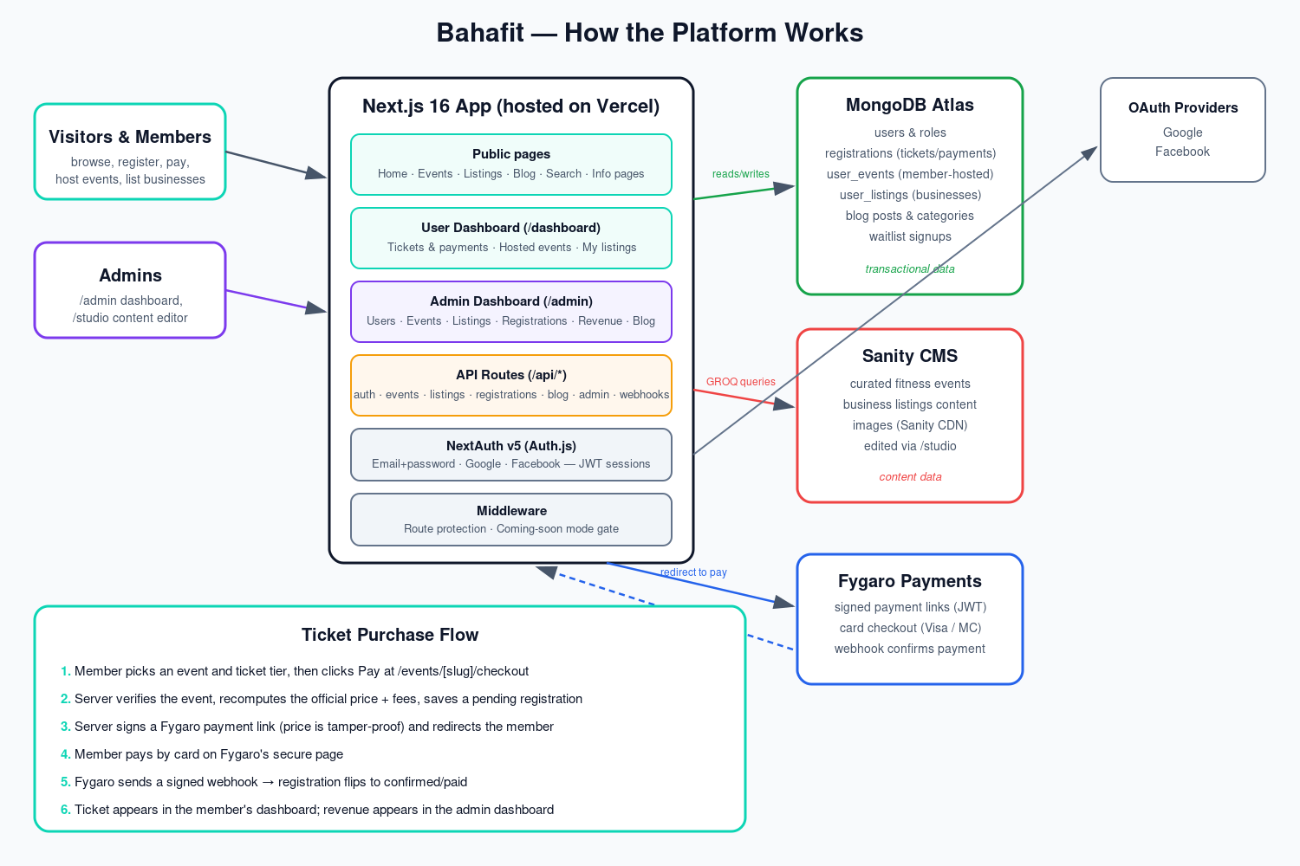
System overview: who talks to what, and how a ticket purchase flows.

Who Uses the Site
- Visitors — browse events, listings, and the blog without an account.
- Members — create a free account (email/password, Google, or Facebook) to buy tickets, host their own events, publish business listings, and write blog posts.
- Admins — everything members can do, plus the /admin dashboard, the /studio content editor, and moderation powers. Admins are promoted by another admin or via the make-admin script.

Where the Data Lives
There are deliberately two homes for data. MongoDB holds everything transactional and member-generated: accounts and roles, ticket registrations with their payment status, events members create, business listings members submit, and blog content. Sanity holds the curated catalogue — the featured events and listings the Bahafit team maintains, with images served from Sanity’s fast global CDN. Public pages read from Sanity first and fall back to member-created MongoDB content, so both kinds of events appear on the site.

How a Ticket Purchase Works
- A member opens an event page and clicks Register / Buy Ticket.
- On the checkout page they pick a ticket tier and agree to the terms. The price shown includes the 9% service charge and 1% facility fee.
- The server looks up the event itself and recalculates the official price — whatever the browser claims is ignored, so prices cannot be manipulated.
- A pending registration is saved, and the member is redirected to Fygaro’s secure card page with a cryptographically signed amount.
- After payment, Fygaro calls the site’s webhook with a signed message; the site verifies the signature and marks the registration confirmed and paid.
- The ticket instantly shows in the member’s dashboard with a receipt link, and the sale appears in admin revenue.
Free events skip steps 4–5 and confirm immediately. Refunds are done in Fygaro; the admin dashboard has a "mark refunded" action to keep records matching.

The Member Dashboard (/dashboard)
Each signed-in member gets a personal dashboard with at-a-glance stats (upcoming events, tickets purchased, total spent, items they run) and three tabs:
- Attending — every ticket, split into upcoming and past, showing payment status, receipts for paid tickets, and self-service cancellation for unpaid registrations.
- Hosting — events the member created, with capacity and registration counts.
- My Listings — the member’s business listings with publish/verification status.

The Admin Dashboard (/admin)
Admins see platform-wide stats — total users, registrations by status, and paid revenue by currency — plus management pages:
- Users — search, activate/deactivate, and change roles.
- Events & Listings — moderate curated (Sanity) content: publish, feature, verify, or remove.
- Registrations — every ticket with filters, revenue summary, event check-in, cancellation, and refund marking.
- Blog — manage posts and choose the featured article.
- Content Studio — the full Sanity editor at /studio for rich content and images.

Launch Switch: Coming-Soon Mode
While COMING_SOON_MODE is set to true, everyone except signed-in admins is redirected to a coming-soon page with a waitlist form. Admins can sign in and preview the entire real site. To launch publicly, change the value to false in Vercel and redeploy — that is the only switch to flip.

If Something Goes Wrong
- Site down or build failing → Vercel dashboard shows deploy logs; roll back to a previous deployment with one click.
- Payments not confirming → check the Fygaro webhook is pointed at /api/webhooks/fygaro and the API secret matches; test with scripts/simulate-fygaro-webhook.js in development.
- Can’t log in as admin → run node scripts/make-admin.js <email>, or reset a password with scripts/reset-password.js.
- Content not appearing → published status matters: Sanity documents must be "published", and member content must not be draft/suspended.

