Kaplan Business School

Industry and Literature Research Review

DATA6000 - Capstone Industry Case Studies
Josiane Januario

Table of Contents
1. Industry context 3
2. Business Problem 3
3. Literature Review 4
4. Data Sources and Analytical Approach 4
5. Business question 7
6. Data Source used 7
7. References 10
8. Appendix 12
1. Used AI to find a social problem in Australia 12
2. Used AI to find the references 17
3. Use of AI to calculate the average energy cost for WA and NT regions 20
4. Development of the dashboard 23

Industry context
The Australian government has been creating renewable energy and in parallel driving to maintain an affordable energy supply. They created a project called Powering Australia, which connects emissions reduction, job creation and lower energy bills, the focus is understand how much energy bills affect household budgets (DCCEEW, 2025).
Energy poverty happens when households cannot pay their energy bills without compromising other basic needs (Smith 2026). Recent ECA analyses (2025) show that a significant proportion of homes are vulnerable or struggling with energy costs, this problem affects different groups and sometimes the data are not real when households reduce consumption to save money.

Business Problem
The main problem is that Australia still lacks a clear national definition or standardized measures to monitor energy poverty across the country (Chandrashekeran et al. 2022). In 2025, the AER concluded that protections were inadequate for consumers with payment difficulties. Without consistent measures to compare states and remote regions makes it more difficult to find vulnerable families, target public support, and distribute resources correctly. Even after the federal government gave a A$300 discount on electricity bills, about one in five households remained vulnerable, and 65% were not enrolled in support programs and 49% did not request assistance (ECA 2025).
The AER (2025) shows that prices paid by consumers vary between regions, and signals that average incomes may not correctly show accessibility problems in areas where income may be lower, that is, the difficulty with energy is not equal in all regions of Australia, reinforcing that there is a need for better targeted support (ACOSS 2025). Different groups that are at greater financial risk need to be considered, for example, the elderly, low-income families, single parents and tenants (Li, Toll & Bentley 2024). Therefore, using only national or state averages may not show more vulnerable communities. An LGA analysis can help identify these issues and show where government can start to act.

Literature Review
According to Li, Toll & Bentley (2024) in a study using 269,500 Australian observations between the years 2005 and 2021, they identified that the greatest risk is when the heat and cold are extreme, which shows that energy poverty does not appear in a single form (Smith 2026). In other studies, the problem is measured by income spent on energy; others note overdue bills, low income, or difficulty keeping the home adequately heated or cooled. However, part of this problem may remain hidden, because some families reduce consumption to avoid bills, they cannot pay (RMIT University 2023).
AER (2025) reported that between March 2024 and March 2025, the average debt of residential customers with overdue energy bills increased from A$1,106 to A$1,415, an increase of 28% and in the same period, fewer customers received help through hardship programs. Regional evidence also shows growing hardship, with the ACT reporting a 78% increase in residents struggling with energy bills since 2021 (ACTCOSS 2025). Finding that the problem is getting worse for some consumers and after a review by the AER department (2025) concluded that current protections for consumers with payment difficulties are not adequate. In other words, offering support is not enough, as it is necessary to better identify who is most at risk and when that risk increases. (Kollmorgen 2026).
The reviewed studies help understand who suffers from energy poverty and which factors increase the risk, but they primarily look at households, consumer behaviour, or broader market outcomes. For example, Prakash et al. (2025) showed in their studies that energy poverty even affects voting intentions, while AER (2025) tracks debt, payment difficulties and public support for the population. From this research, it is noted that there is still room to gather more information in a more detailed analysis by small regions and evaluate how further increases in electricity prices could alter the level of vulnerability of each area.

Data Sources and Analytical Approach
Public datasets were combined at LGA level. Socioeconomic and demographic data were obtained from the Australian Bureau of Statistics, energy costs from official Australian energy sources, and climate data from the Bureau of Meteorology. These datasets allowed socioeconomic vulnerability, geography, climate and energy affordability to be analysed together.
The data was entered into Power BI considering the LGA code as the main key (PK), to understand how much the energy bill represents in the family budget of each LGA, the energy cost was measured as a proportion of family income, called Energy Burden, this approach is used by both ECA (2025) and AER (2025) to assess the financial affordability of energy. The variables considered in the Vulnerability Score were based on studies by Li, Toll and Bentley (2024), which shows that the greatest risk is between vulnerable groups (elderly people, tenants, differences in family structure) and those exposed to extreme temperatures. Based on evidence of electricity price variation and increases (AER 2025), three hypothetical scenarios of +10%, +20% and +30% were created for sensitivity analysis. These percentages were project-defined and do not represent AER forecasts.
To facilitate the interpretation of the results, 3 visualizations were created in Power BI, and some filters were also created to facilitate navigation and to be able to explore the results interactively. The graphs were:
- The first shows on the map the risk of energy poverty among LGAs, identifying where vulnerable regions are concentrated.
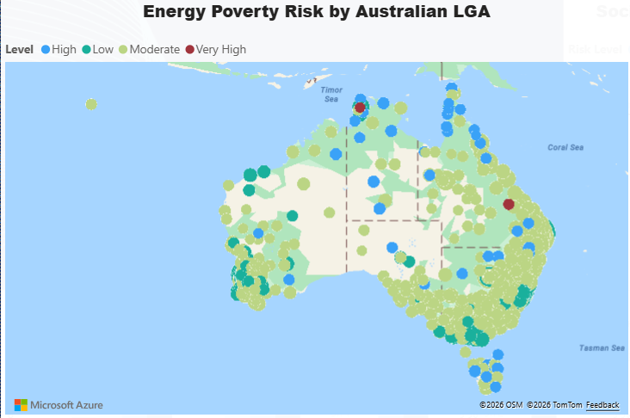

- The second shows the relationship between socioeconomic disadvantage and pressure of energy costs on family income.
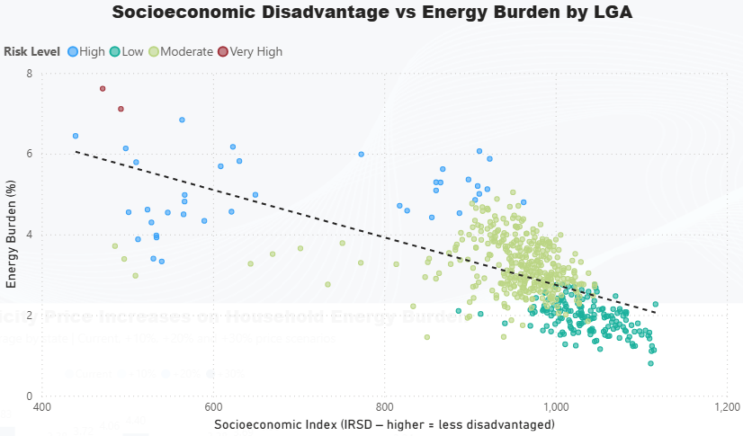

- The third compares current energy burden with scenarios of increases created (10%, 20% and 30%) in electricity prices.
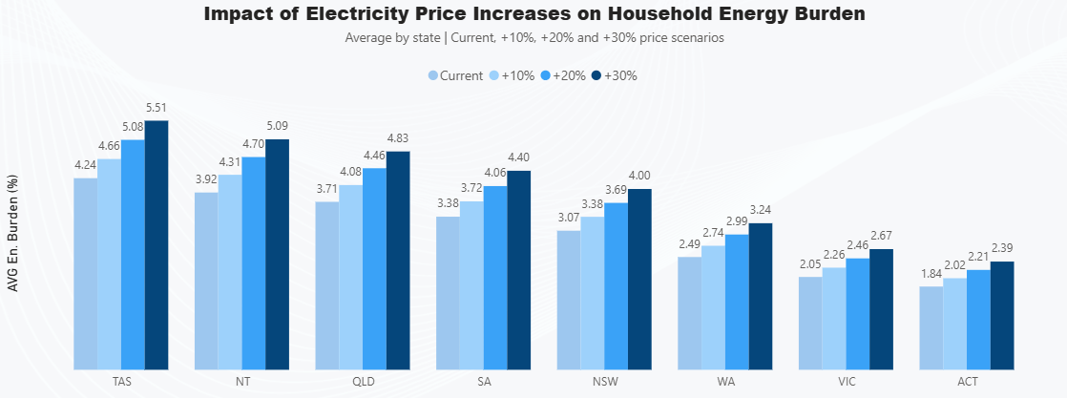
As for the limitations of the data, there were some difficulties, firstly because the data have different periods, for example, the socioeconomic information is from 2021 and the energy data is more recent, the energy costs are estimated values by state or distribution region, and not specific accounts for each LGA, the data related to the climate also uses the nearest available meteorological station in each region. Equal weights were assigned to socioeconomic, demographic, geographic and climatic variables, to ensure transparency and balance in the analysis, since no evidence was found to justify any variable of greater importance, while the weight assigned to Energy Poverty Risk Score was set at 50% for Vulnerability Score (dividing between variables) and 50% for Energy Burden, ensuring that the direct financial pressure of energy has equal relevance to the set of vulnerabilities, however these weights cannot be considered an official classification standard, it was something created just for this project.

Business question
Which Australian LGAs are most at risk of energy poverty, what factors contribute to this risk, and how might price increases affect them?
The analysis seeks to identify regional differences considering socioeconomic, demographic, geographic, climatic factors and the proportion of family income allocated to energy payments. Price increase scenarios are also evaluated (hypotheses).
The results can help identify more vulnerable areas and inform decision-making regarding the distribution of resources and public support.

Data Source used
- https://www.abs.gov.au/statistics/people/people-and-communities/socio-economic-indexes-areas-seifa-australia/latest-release
Index data cubes:
- https://www.abs.gov.au/census/find-census-data/datapacks?release=2021&product=GCP&geography=LGA&header=S
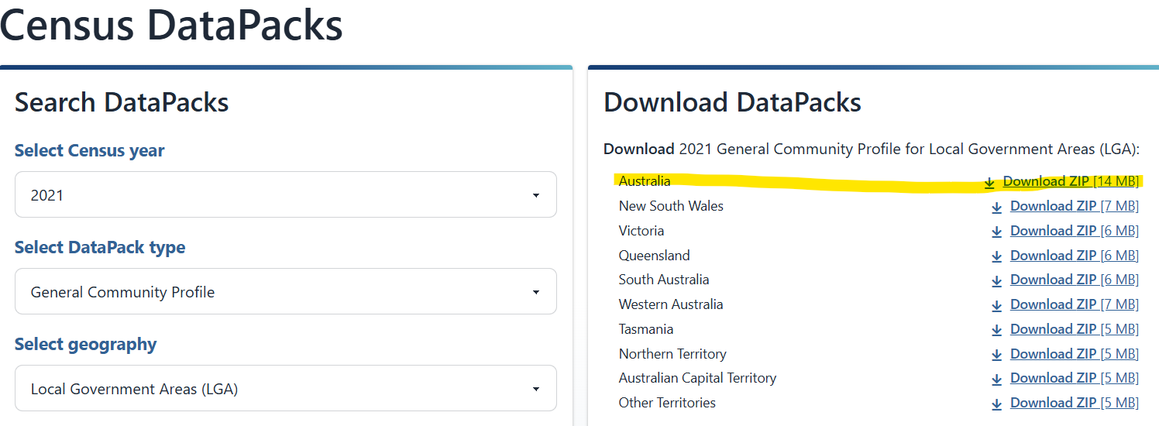
- https://www.abs.gov.au/statistics/standards/australian-statistical-geography-standard-asgs/edition-3-july-2021-june-2026/remoteness-structure/remoteness-areas
- https://www.abs.gov.au/statistics/standards/australian-statistical-geography-standard-asgs/edition-3-july-2021-june-2026/access-and-downloads/allocation-files
- https://reg.bom.gov.au/climate/cdo/about/sitedata.shtml
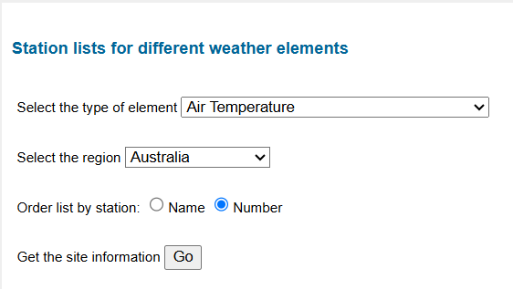
- https://www.aer.gov.au/documents/state-energy-market-2025-data
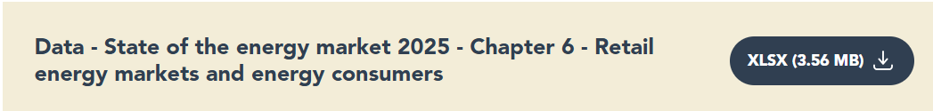

- https://www.synergy.net.au/About-us/News-and-announcements/Annual-reports/Synergy-2025-annual-report
Used to obtain a representative residential electricity cost for Western Australia.
For Western Australia, the annual electricity cost was generated from the short diary described in the report ($5.21 * 365 days a year) resulting in A$1,901.65 per year (Synergy 2025).
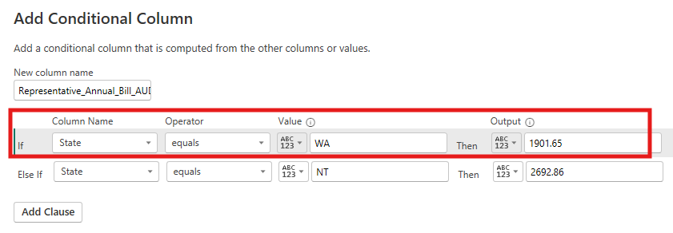
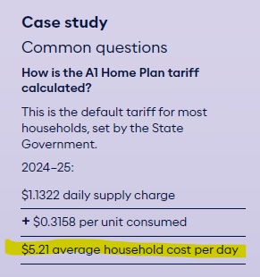
- https://treasury.nt.gov.au/news/2025/electricity-pricing-reforms
- https://parliament.nt.gov.au/business/written-questions/wq/15th-assembly-written-questions/answers/Answer-to-Written-Question-7.pdf
Both above links were used to calculate the average annual cost of the NT region of Australia. The AI was also requested to calculate the values found, appendix 3.
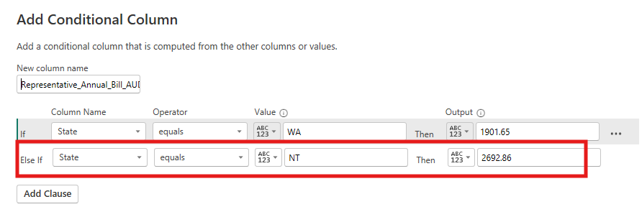
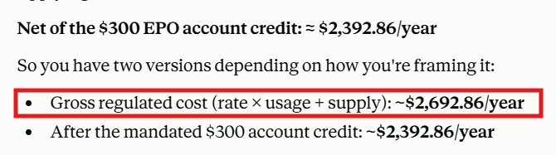

References
- ACT Council of Social Service [ACTCOSS] 2025, ‘Energy hardship is growing in the ACT: urgent action needed’, 3 January 2025, viewed 28 July 2026 <https://actcoss.org.au/news/energy-hardship-is-growing-in-the-act-urgent-action-needed/>.
- Australian Council of Social Service [ACOSS] 2025. ‘Electricity price hike a major blow for people struggling’, 26 May, viewed 24 July 2026 <https://www.acoss.org.au/media-releases/?media_release=electricity-price-hike-a-major-blow-for-people-struggling>.
- Australian Energy Regulator [AER] 2025, ‘State of the Energy Market 2025: Retail energy markets and energy consumers’, Australian Government, viewed 25 July 2026 <https://www.aer.gov.au/system/files/2025-08/State%20of%20the%20energy%20market%202025%20-%20Chapter%206%20-%20Retail%20energy%20markets%20and%20energy%20consumers.pdf>.
- Chandrashekeran, S., Noka, V., Bouzarovski, S. 2022, ‘Energy Poverty: Measurement and Governance in Europe and Lessons for Australia’, The Australian Economic Review, Wiley Online Library, 24 Nov., viewed 25 July 2026 <https://onlinelibrary.wiley.com/doi/full/10.1111/1467-8462.12491>.
- Department of Climate Change, Energy, the Environment and Water [DCCEEW] 2025, ‘Powering Australia, Australian Government’, Australian Government, 03 Oct, viewed 24 July 2026 <https://www.dcceew.gov.au/energy/strategies-and-frameworks/powering-australia>.
- Energy Consumers Australia [ECA] 2025, ‘Consumer Energy Report Card: Understanding and measuring energy hardship in Australia’, Energy Consumers Australia, 28 July, viewed 24 July 2026 <https://energyconsumersaustralia.com.au/our-work/surveys/consumer-energy-report-card-understanding-measuring-energy-hardship-australia>.
- Kollmorgen, A 2026, ‘Should people who can’t pay their bills have their power cut off?’, Choice, viewed 27 July 2026 <https://www.choice.com.au/shopping/shopping-for-services/utilities/articles/should-people-who-cant-pay-their-bills-have-their-power-cut-off>.
- Li, A., Toll, M. & Bentley, R. 2024, ‘The risk of energy hardship increases with extreme heat and cold in Australia’, Communications Earth & Environment, vol. 5, article 595, viewed 25 July 2026 <https://www.nature.com/articles/s43247-024-01729-5>.
- Prakash, K., Churchill, S.A. & Smyth, R. 2025, ‘Perception and reality of energy poverty in Australia: Do they shape voting intentions?’, Australian Economic Review, viewed 28 July 2026 <https://onlinelibrary.wiley.com/doi/full/10.1111/1467-8462.70011>.
- RMIT University 2023, ‘One in four households struggle to pay power bills: five ways to tackle hidden energy poverty’, 2 May, viewed 27 July 2026 <https://www.rmit.edu.au/news/all-news/2023/may/hidden-energy-poverty>.
- Smith, D. 2026, ‘‘What’s more important, the electricity or food?’: extreme heat is driving up power bills in central Australia’, The Guardian, 15 Feb, viewed 21 July 2026 <https://www.theguardian.com/australia-news/2026/feb/15/extreme-heat-driving-up-power-bills-central-australia-prepaid-electricity-northern-territory>.

Appendix

Used AI to find a social problem in Australia
AI used: ClaudeAI
Purpose: Finding a real social problem in Australia that you haven't already accomplished in other work, and that is coherent for a final project. This chat has gotten quite long, I won't post all the screenshots, but I'll leave the link available for consultation.
Link: https://claude.ai/share/35a2fc30-2f5e-401f-a244-0accf48e90dc
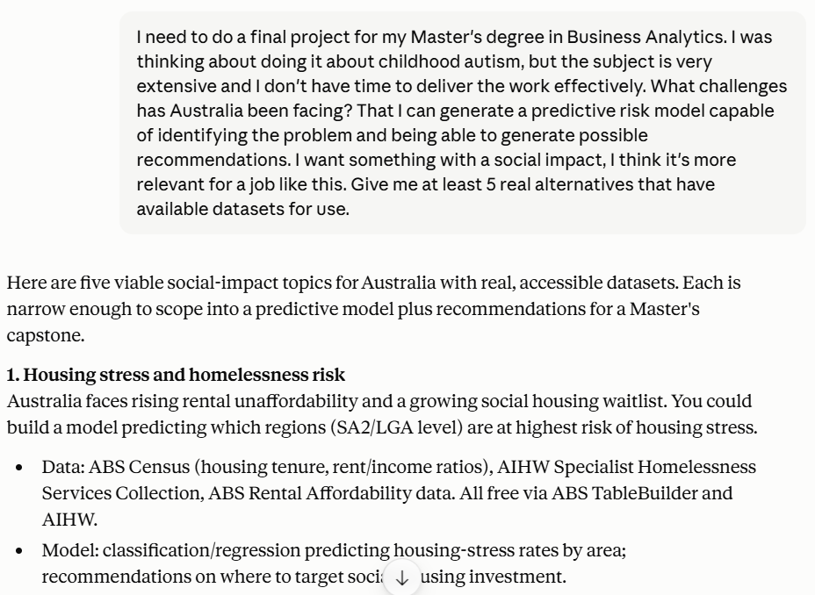
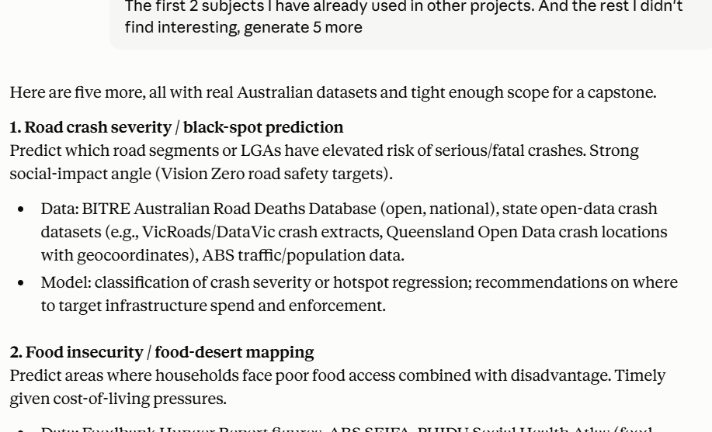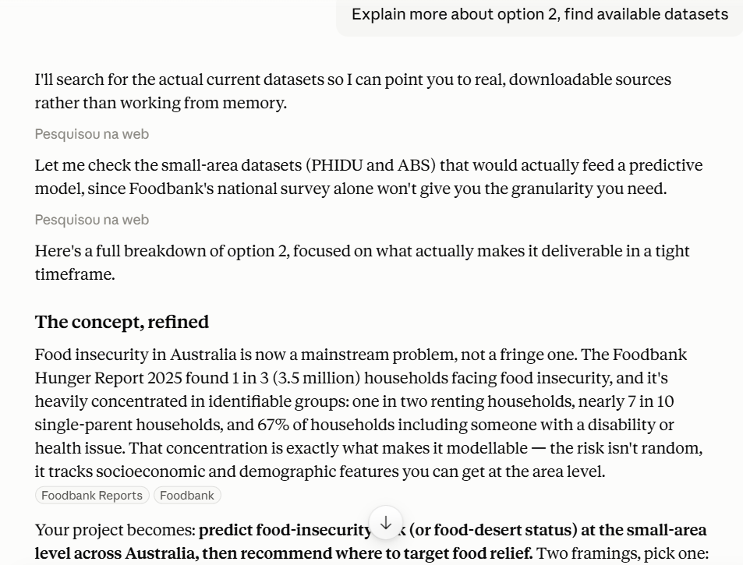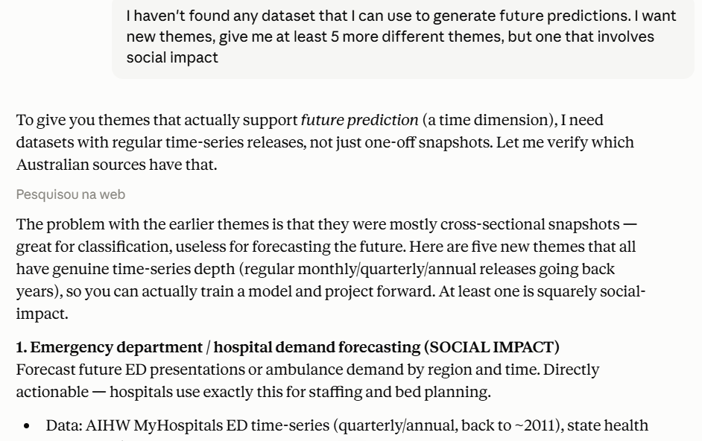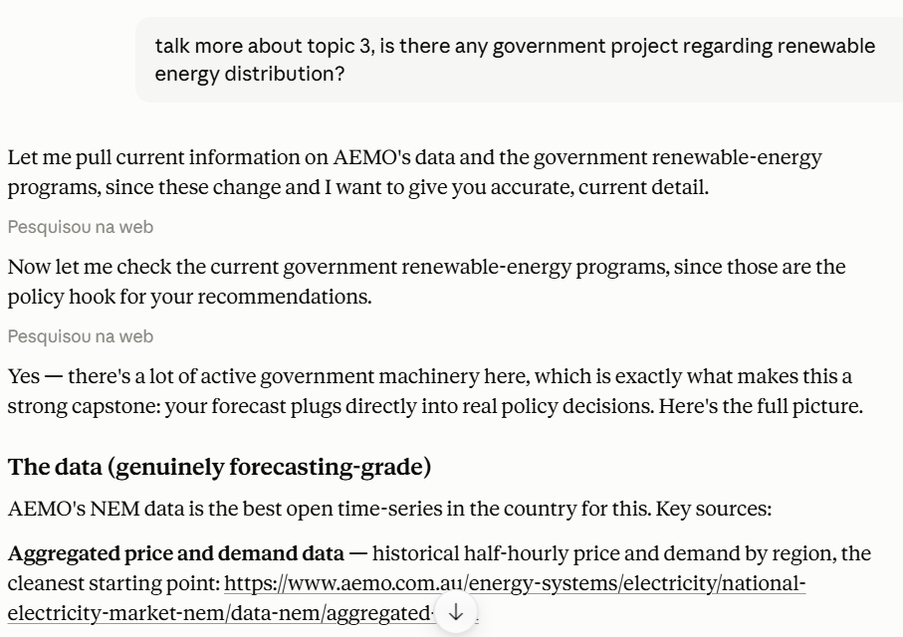
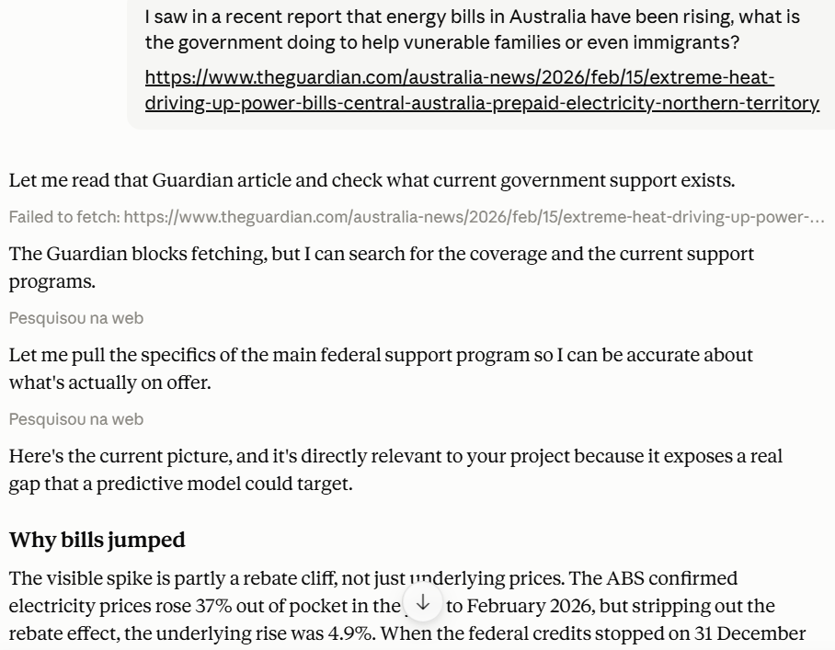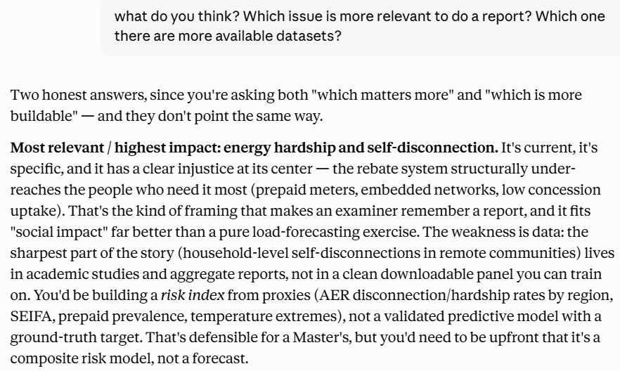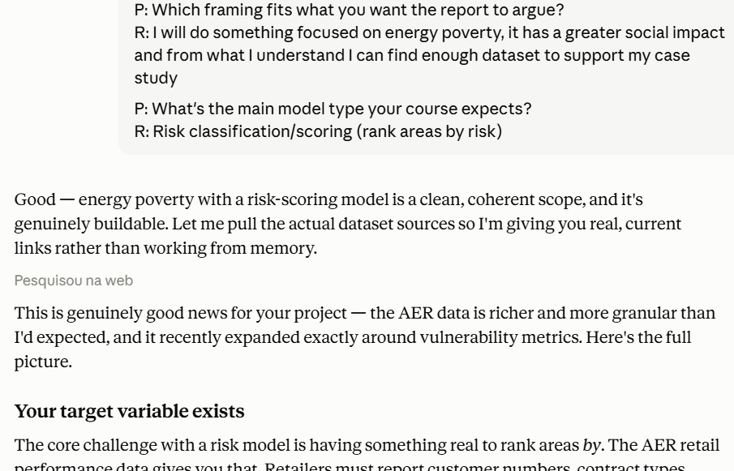
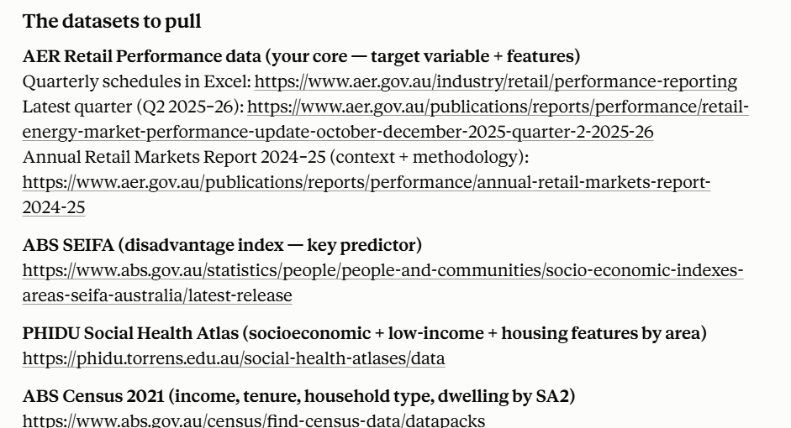

Used AI to find the references
AI used: ClaudeAI
Purpose: Find the maximum reliable references to be used as a basis in the report
Link: https://claude.ai/share/07ba4dc8-e2ca-4cf6-b011-1ff1c1bdc784
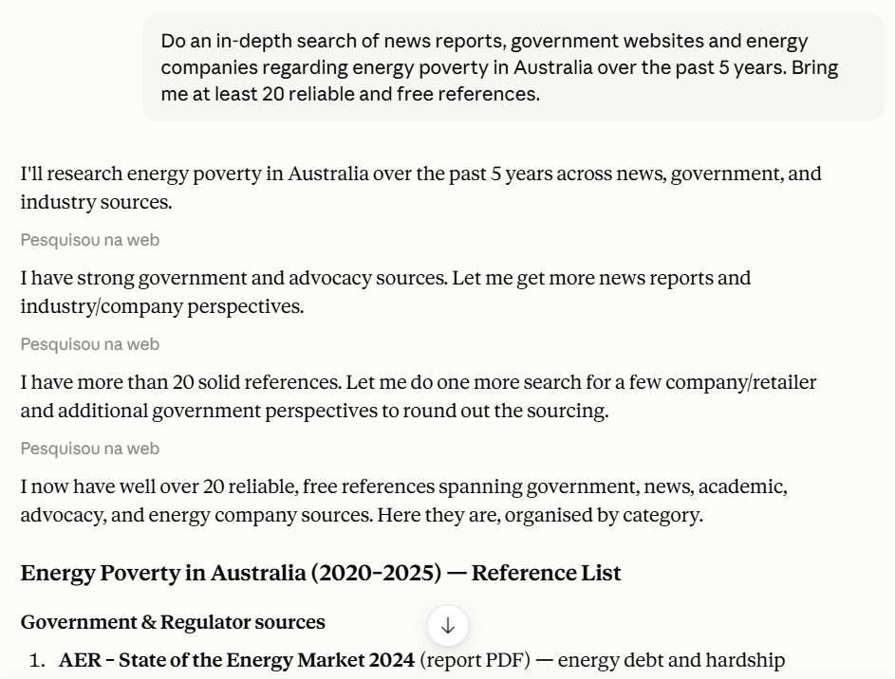
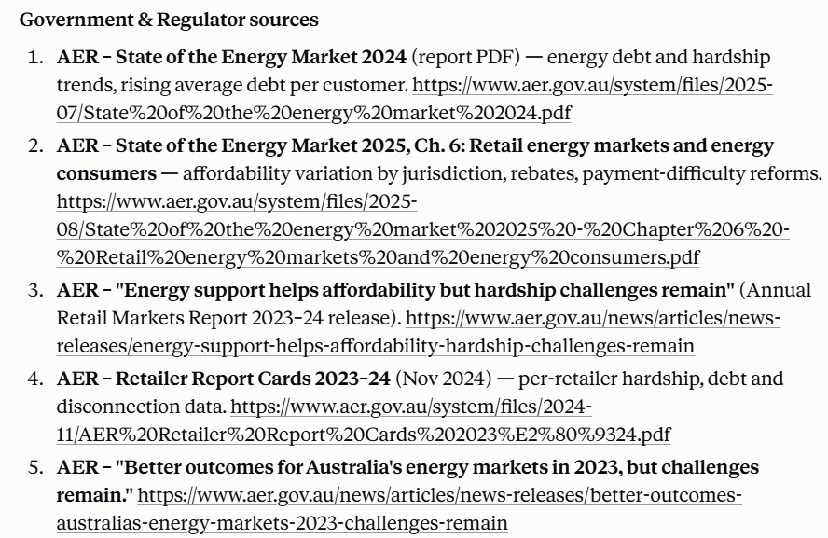
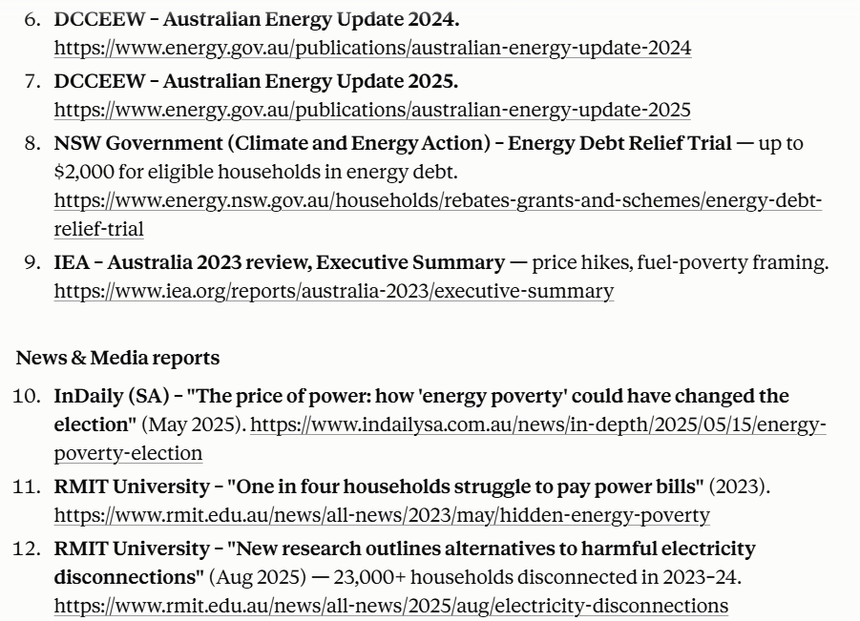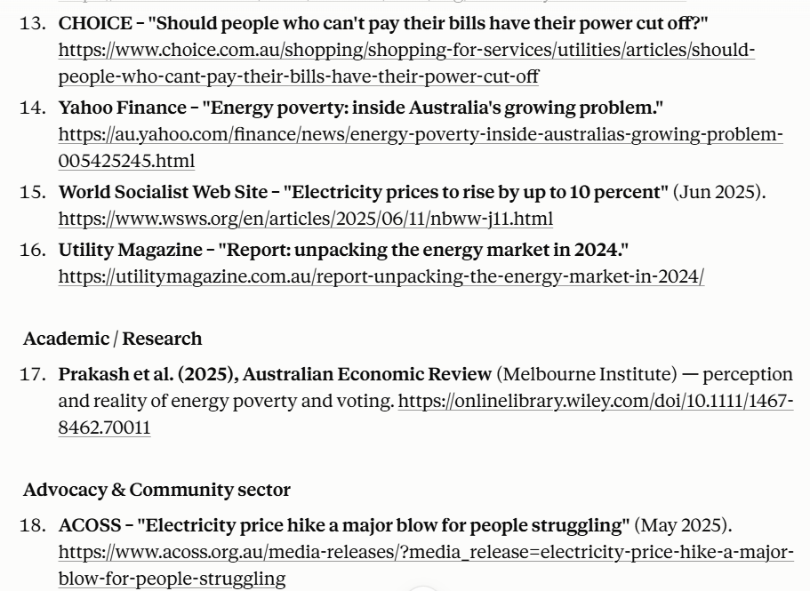
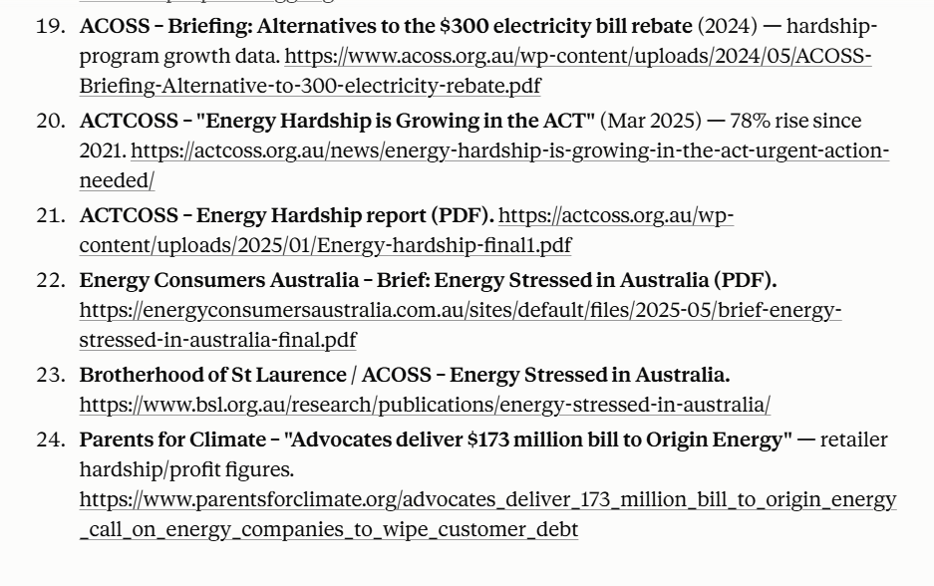
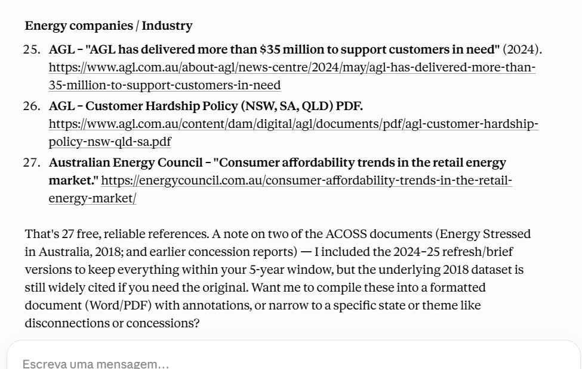

Use of AI to calculate the average energy cost for WA and NT regions
AI used: ClaudeAI
Purpose: Find the average values in the available reports, and then calculate the average values with the data that were found.
Link: https://claude.ai/share/40fd6f9c-ad61-4c8d-84c2-96195a69b03c
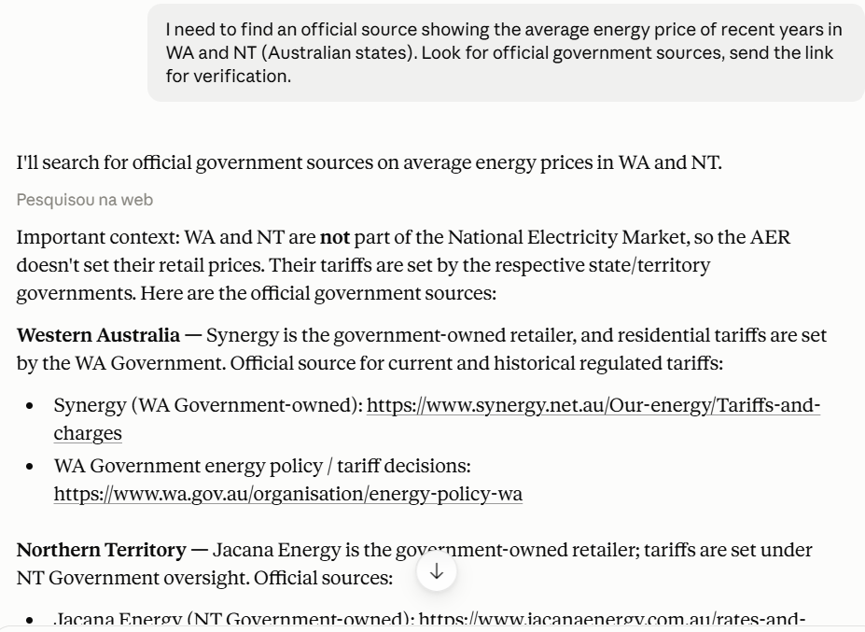
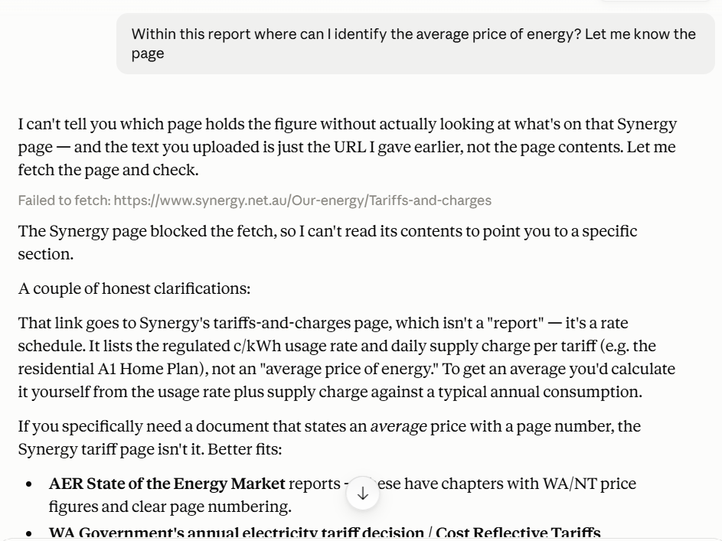
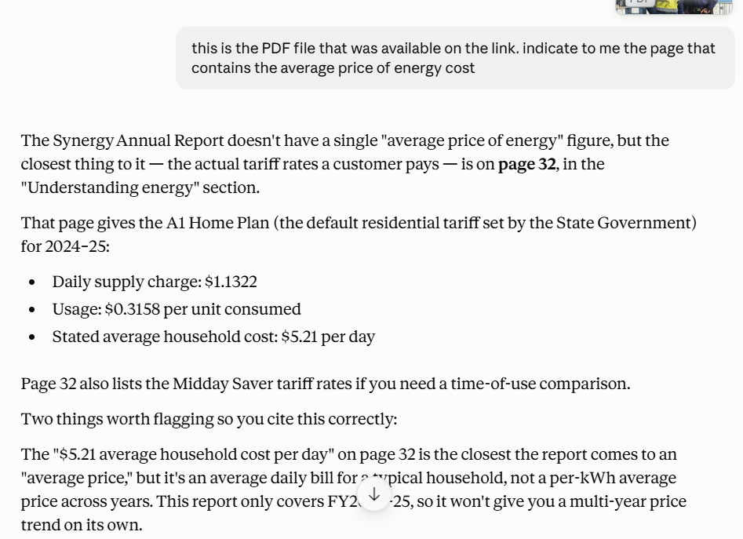
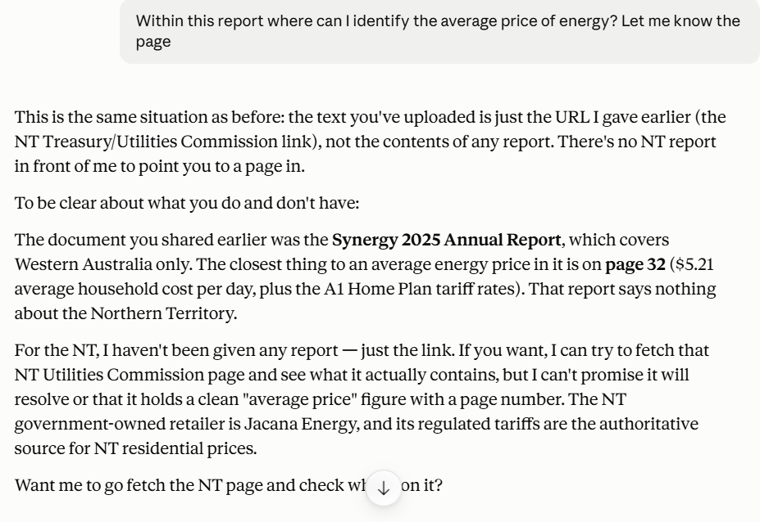
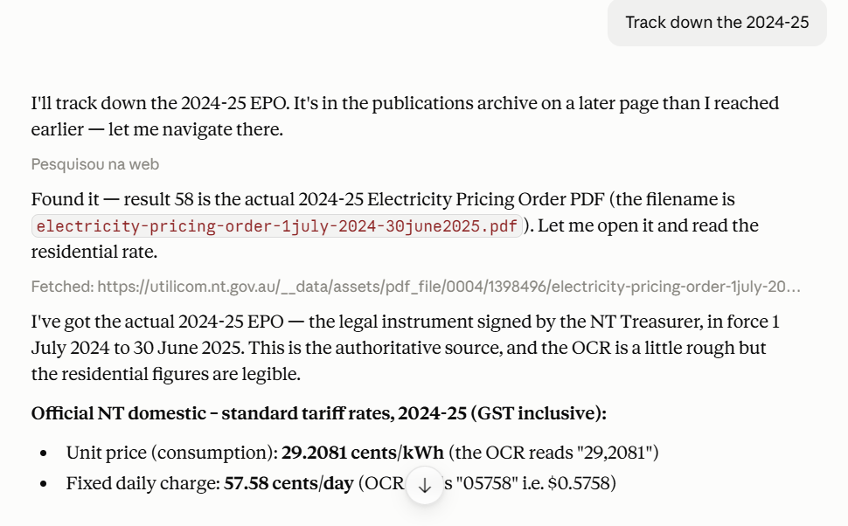
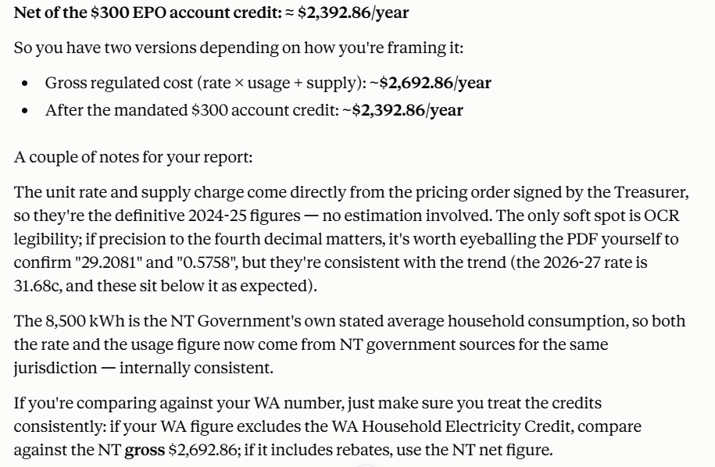

Development of the dashboard
There were many datasets, all of them were loaded into Power BI, including an API related to the weather, which made the model very heavy, some merges were done for a single query, but it remained heavy. The solution was to extract two CSV files (DIM_LGA_Remoteness; DIM_LGA_Risk_Base) from the final result of this single query (DIM_LGA_Risk_Base) and import them into a new model in Power BI, so the model became lighter, I was able to do the calculations, create the columns and create the graphs. However, the attached file in MyKBS is the lightest file; if necessary, I'll show the initial template. Below are some screenshots of the first template.
