Module Five Encryption Activity
Jose Medina
CS 405
Professor Olga Mill
08/02/2026

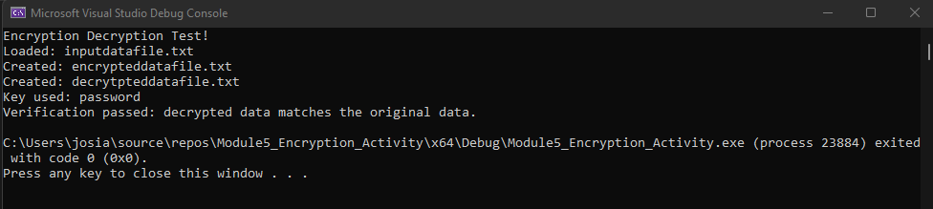
Figure 1: Console output showing that the input file was encrypted, decrypted, and verified successfully.

Process Summary
For this activity, I completed the unfinished parts of the encryption program. The original code already had the basic structure, but it did not encrypt the text, read the input file, or save the encrypted and decrypted results. I added the missing logic and tested each part of the program.
The encryption function uses XOR to process the source text one character at a time. Since the key is shorter than the input file, I used the remainder operator to repeat the key until every character was processed. The same XOR function is used for both encryption and decryption. When the encrypted data is processed again with the same key, it returns to its original form.
I also updated the file-reading function so it opens inputdatafile.txt and loads the complete file into a string. For the saving function, I followed the required file format by placing the student name on the first line, the current date on the second line, the key on the third line, and the data after that. I used binary mode when saving because encrypted information can contain characters that do not display normally in a text editor.
One problem I had to watch for was the length of the encryption key. Using only one part of the key would leave some of the input unchanged. Repeating the key with the remainder operator made sure the entire string was encrypted. I also kept the decrypted filename exactly as it appeared in the starter code, even though the word is misspelled, because the assignment requires the filenames to match the source code.
After making the changes, I rebuilt the project and ran the program. It created both output files and confirmed that the decrypted data matched the original input. This showed that the file loading, XOR encryption, file saving, and decryption were all working correctly.

