FAMILIES ARE PAYING MORE THAN DOUBLE WHAT CHILDCARE SHOULD COST.

CHILDCARE

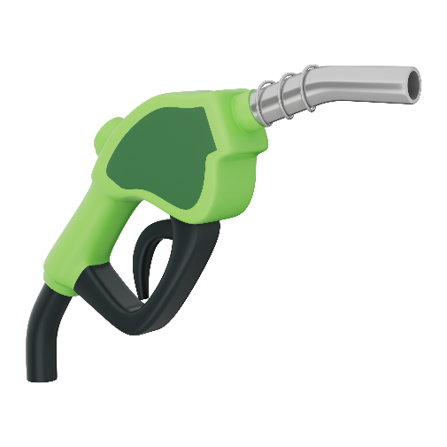

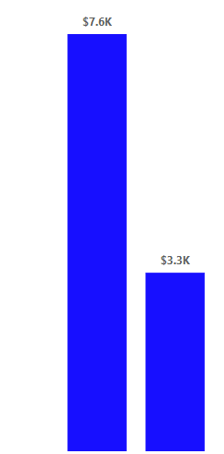

GAS
RENT
What Families Pay a Year
What it Should Cost a Year
CHEESEBURGER

