Docker

# What is Docker?

Docker is a software platform that allows developers to build, test, and deploy applications quickly.

Docker packages software into standardized units called containers that have everything the software needs to run including libraries, system tools, code, and runtime. Using Docker, you can quickly deploy and scale applications into any environment and know your code will run.

# How Docker works

Docker works by providing a standard way to run software code. Docker is an operating system for containers.

Similar to how a virtual machine virtualizes (server hardware, containers virtualize the operating system of a server. Docker is installed on each server and provides simple commands you can use to build, start, or stop containers.

# Why use Docker

Using Docker lets you ship code faster, standardize application operations, seamlessly move code, and save money by improving resource utilization. With Docker, you get a single object that can reliably run anywhere. Docker's simple and straightforward syntax gives you full control. Wide adoption means there's a robust ecosystem of tools and off-the-shelf applications that are ready to use with Docker.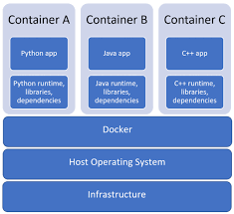

# Docker Compose

is used to run multiple containers as a single service. For example, We’ve build expressJS web app combined with Postgres DB, we also created one .yaml as docker config file which would start both the containers as a service without the need to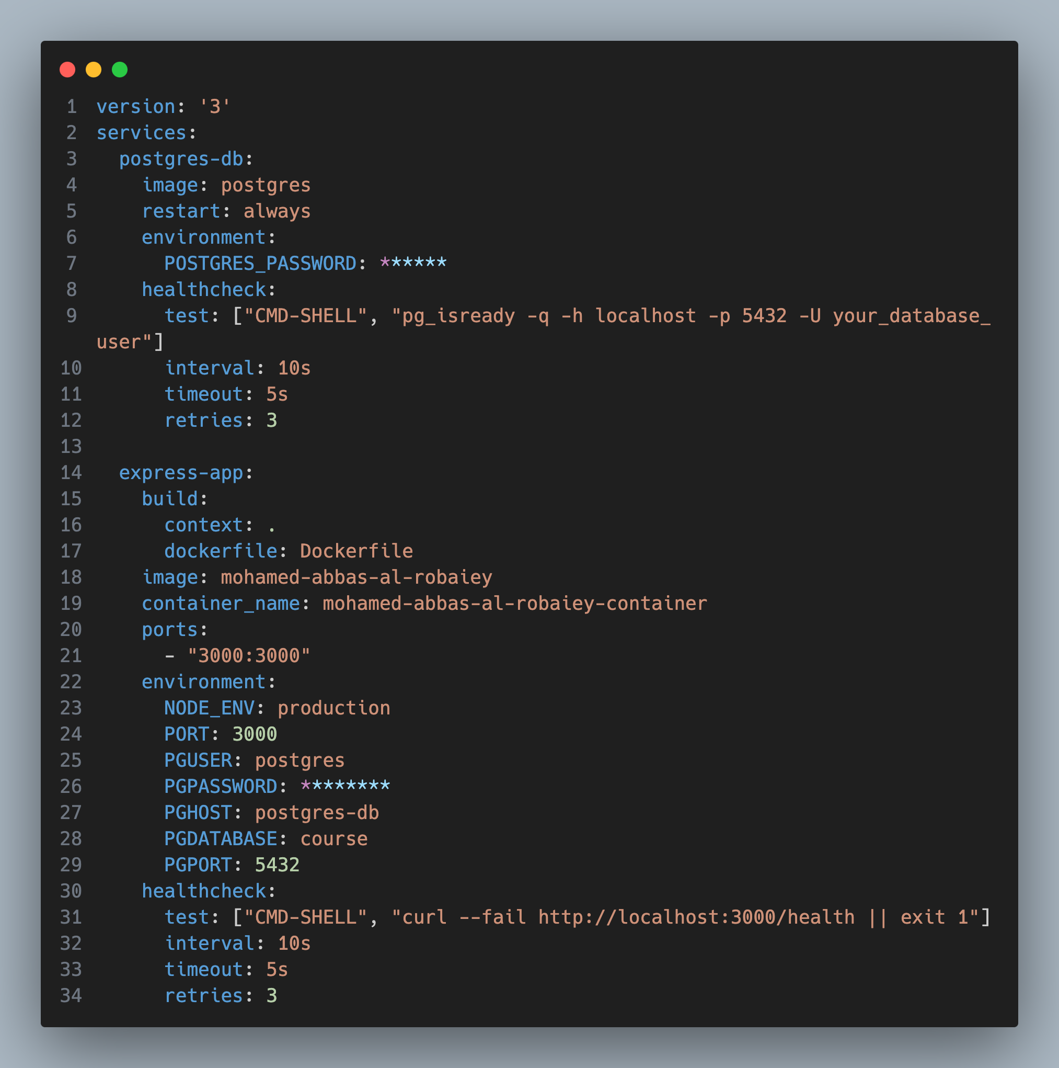 start each one separately.

* + 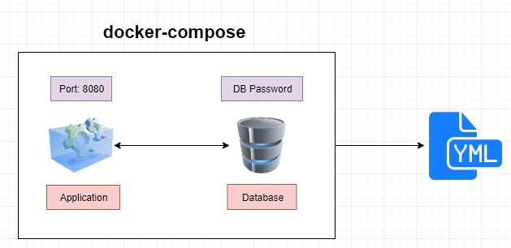

We used docker-composer to build or full stack web app which includes the code base of our web app written in Javascript and expressJS and connected to a Postgres DB as show as bellow docker.composer.YAML file

**We have build sample web app to save users visitors directly to the visitor table in our database**

**Our project structure:**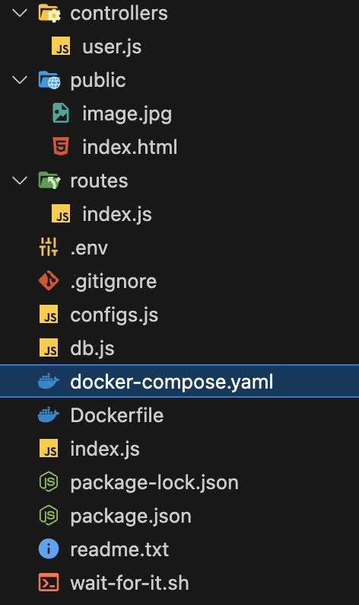

**To run the the web app simply by calling “docker-compose up” in the root folder of the project in our command line**

**Then the docker eco system will download all the dependencies and the necessary libraries as described in our .yaml file from Docker hub and set all the pre-set variables**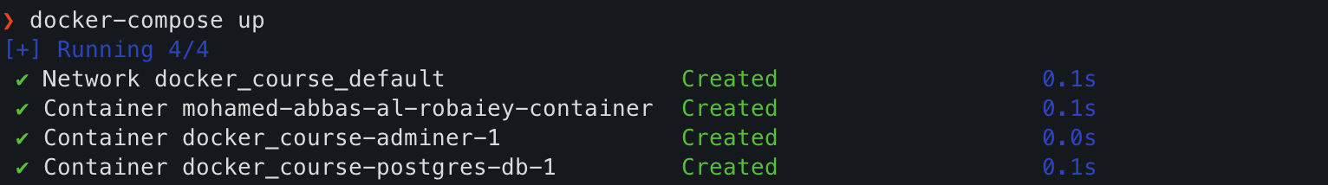

**Now we are ready to lunch our full stack web app by visiting** <http://localhost:3000>