PROJECT DOCUMENTATION
Swift Ship Tracker
Salesforce Developer – NM Eng
TEAM ID: SWTID-2026-2328
Team Members
Role | Name | Reg. No | Email
Team Leader | Josika T | 912623205013 | josikabuvi66@gmail.com
Member | Kaviya N | 912623205015 | kkaviya5244@gmail.com
Member | Kanishka S | 912623205014 | kanishkakani108@gmail.com
Member | Indhumathi S | 912623205011 | indhumati2006@gmail.com
Member | Jenathul Firthosh | 912623205012 | jenathul13@gmail.com

1. Introduction
Swift Ship Tracker is a Salesforce-based shipment and parcel tracking project designed to help manage parcel records and monitor delivery progress in an organized way. The system aims to keep shipment information in one place so that users can create, view, and update parcel details and track the current status of a shipment.
By using Salesforce objects, fields, relationships, tabs, and automation, the project seeks to make shipment handling more consistent and easier to follow. Status information can help users understand whether a parcel is booked, in transit, delivered, or in another configured stage of the delivery process.

2. Project Objective
- Maintain parcel and shipment details in Salesforce records.
- Make parcel information easy to access through a dedicated Salesforce app and tabs.
- Track the shipment lifecycle using a status field and configured picklist values.
- Use Salesforce Flow to automate suitable record updates or notifications where configured.
- Improve visibility of parcel progress and reduce manual tracking effort.

3. Use Case
A user needs to register a parcel and follow its progress from booking through delivery. In Swift Ship Tracker, the parcel details are stored as Salesforce records. The user can open the relevant parcel record to review the available shipment information and its current status. When the shipment progresses, the record can be updated to reflect the appropriate status.
The Salesforce configuration provides a structured way to manage parcel information and status values. Where flows are configured, automation can support repeatable actions such as updating fields or sending notifications.
Note: The exact automation behavior should match the flows implemented in the project org.

4. Requirements

4.1 Salesforce CRM Setup
- Create or configure the Salesforce Developer environment.
- Create custom objects for parcel/shipment information.
- Configure fields and relationships needed to capture parcel details.
- Create custom tabs and a Lightning app.

4.2 Parcel Details and Status Tracking
- Capture relevant parcel details in Salesforce records.
- Configure a Status picklist with the values required by the project.
- Allow users to review a parcel record and its latest recorded status.
- Ensure status values match the team's delivery workflow.

4.3 Salesforce Flow Automation
- Create record-triggered flows for the selected automation requirements.
- Test flow entry conditions and update actions using sample parcel records.
- Activate flows only after confirming the configuration works as expected.

4.4 Testing and Validation
- Verify parcel records can be created and viewed.
- Check that the Status picklist displays intended values.
- Test configured flows with suitable sample records.
- Capture screenshots of the completed configuration and test results.

5. Project Milestones

Milestone 1 | Salesforce Developer Account
Screenshot: Salesforce Developer Org / Setup page.
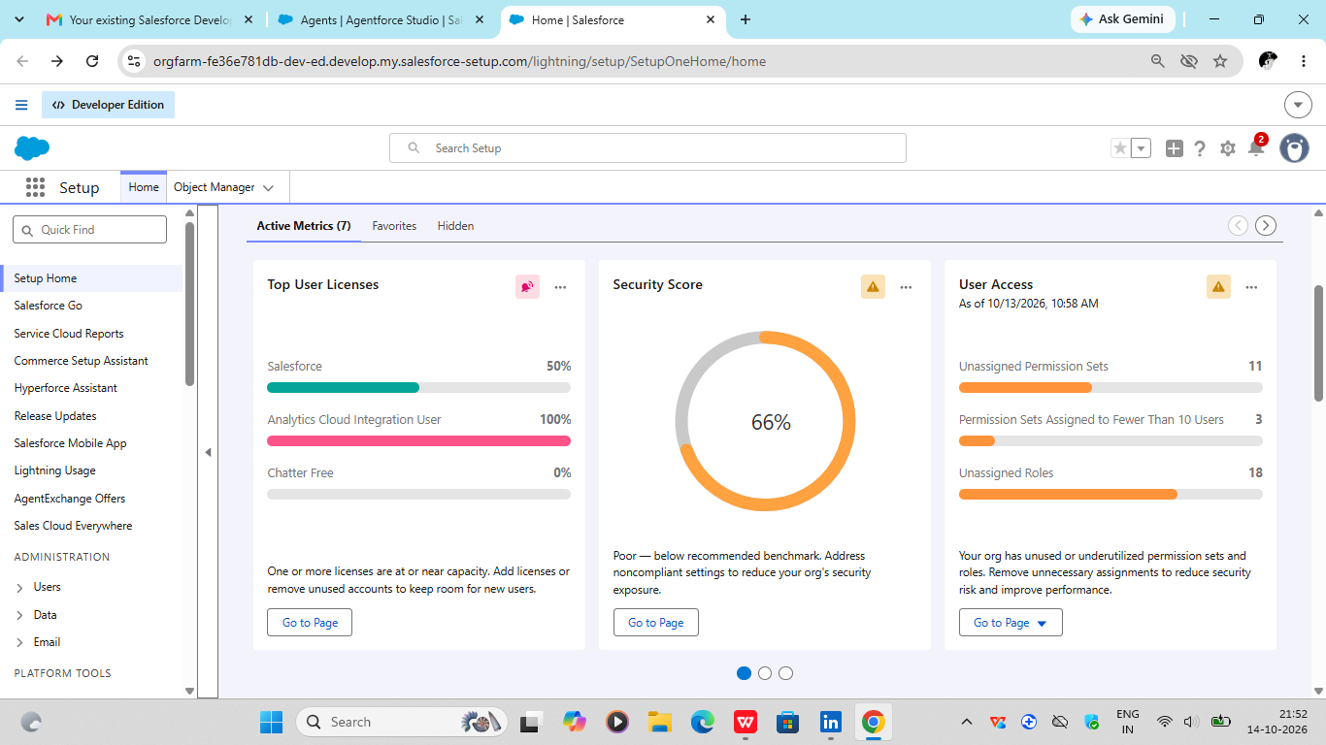

Milestone 2 | Objects and Relationships
Screenshot: Object Manager showing the project objects and relationships.
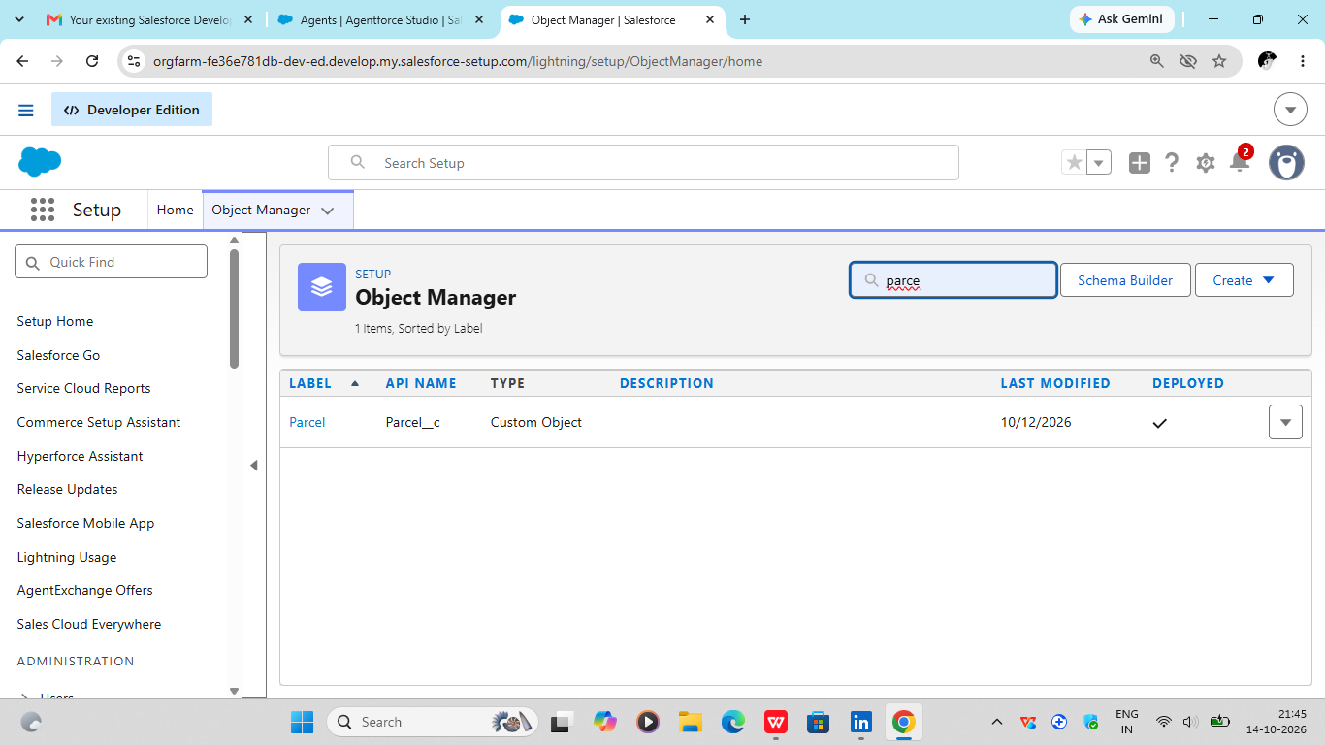

Milestone 3 | Creating Custom Tabs
Screenshot: Custom Tabs configuration for Swift Ship Tracker.
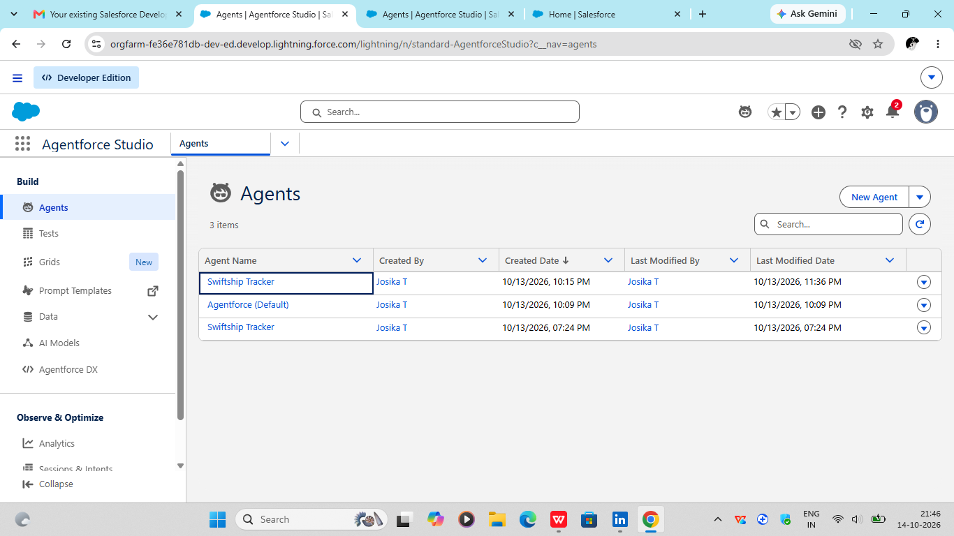

Milestone 4 | Creating a Lightning App
Screenshot: App Manager or the Swift Ship Tracker app in Salesforce.
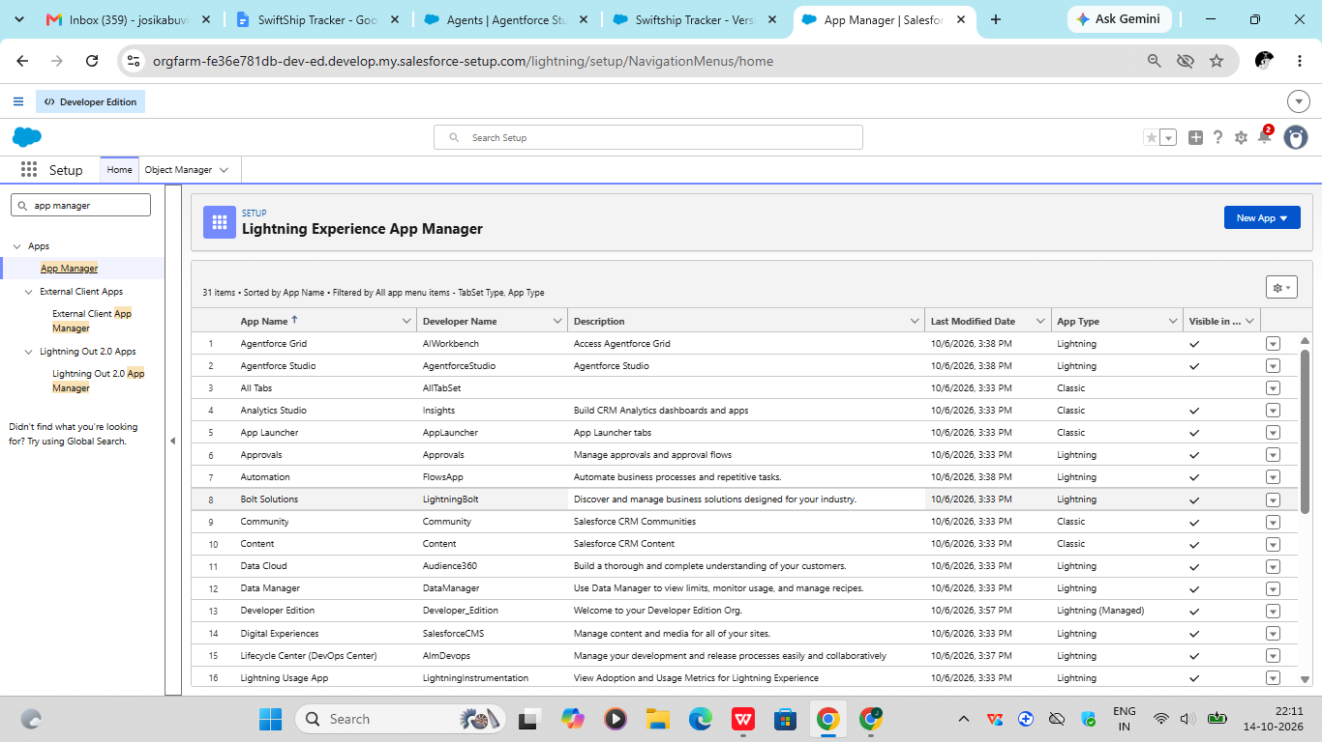

Milestone 5 | Fields and Relationships
Screenshot: Parcel Details fields and related field configuration.
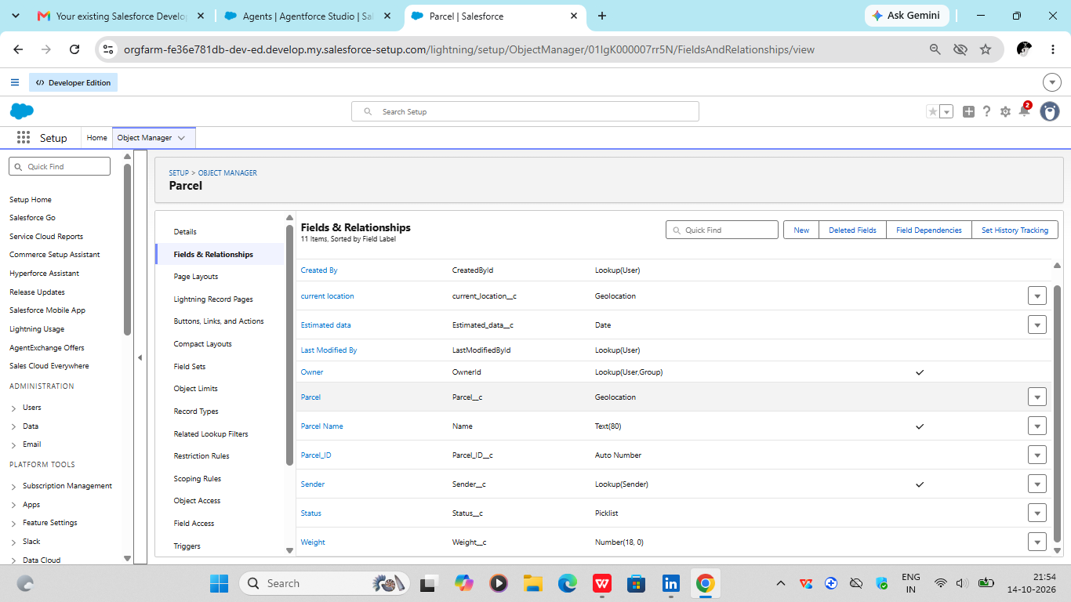

Milestone 6 | Flow Automation
Screenshot: Flow Builder showing the flow(s) configured for parcel tracking.
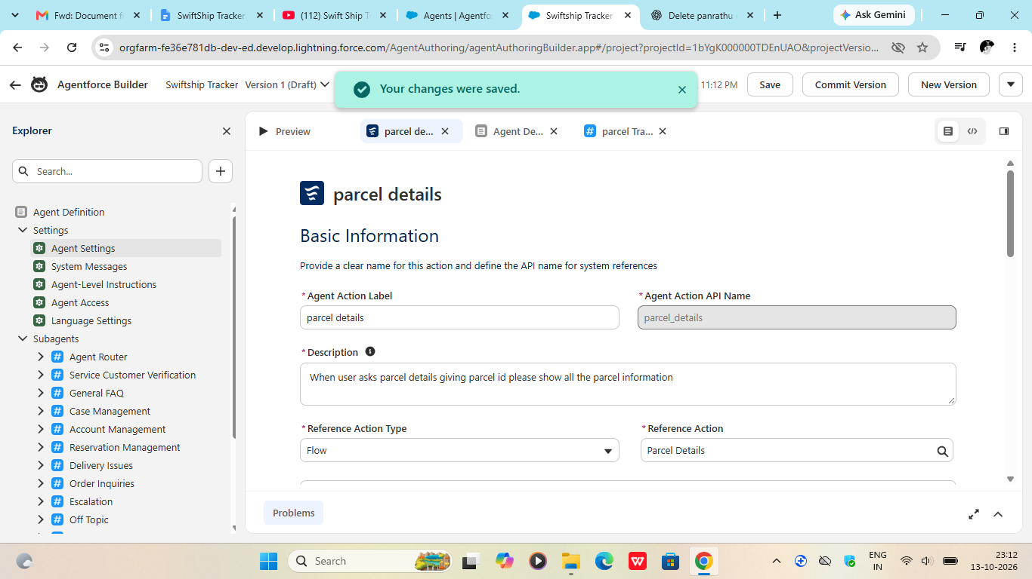
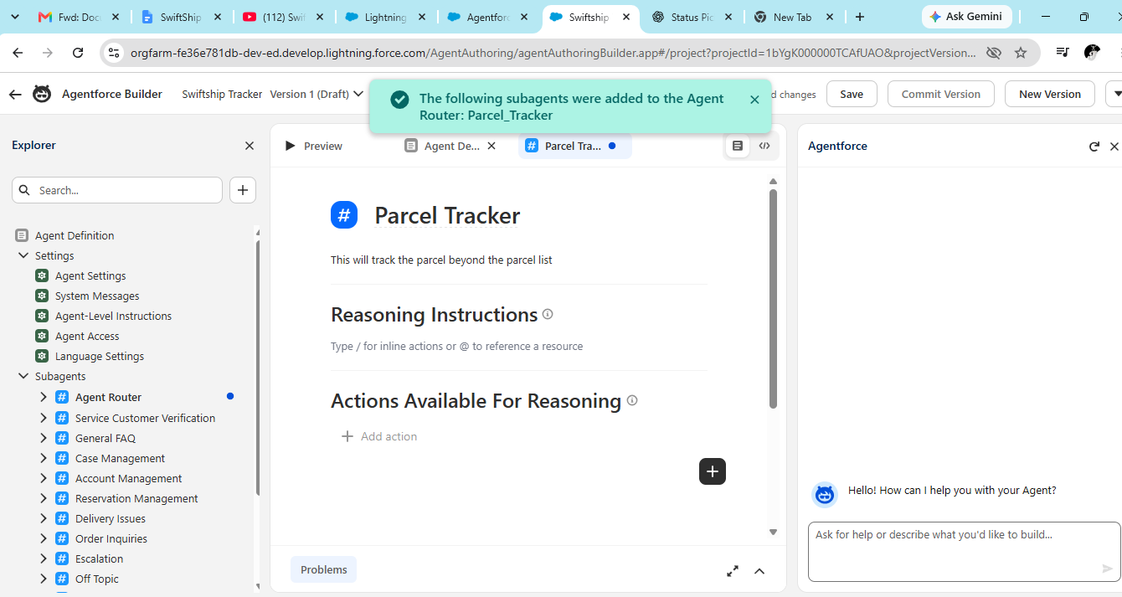
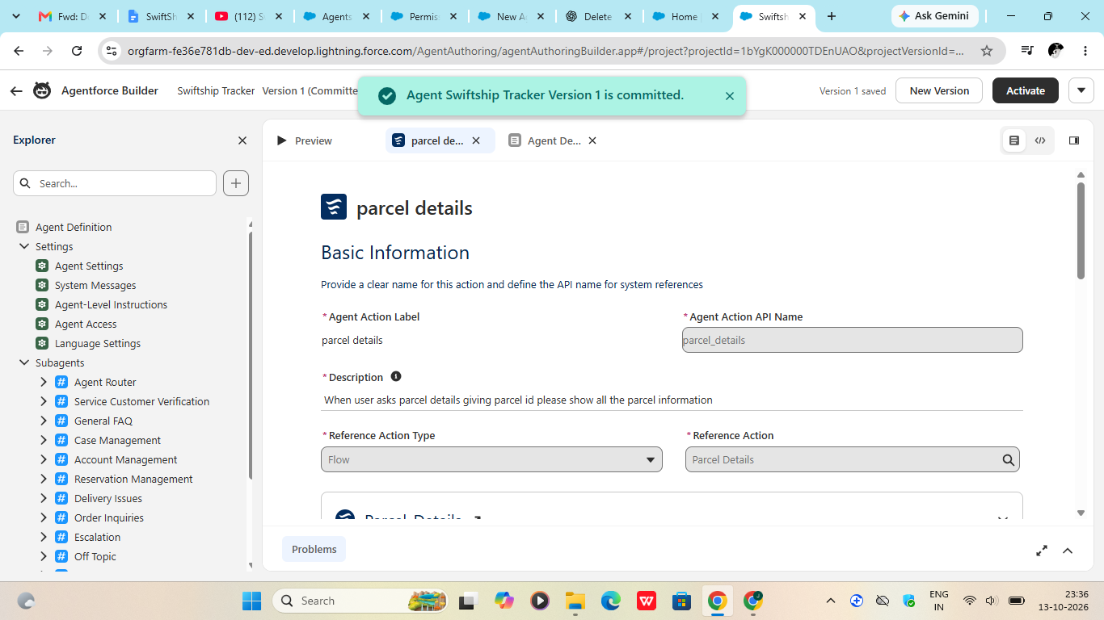

Milestone 7 | Testing and Final Configuration
Screenshot: Parcel record, status picklist, and any relevant test/automation result.
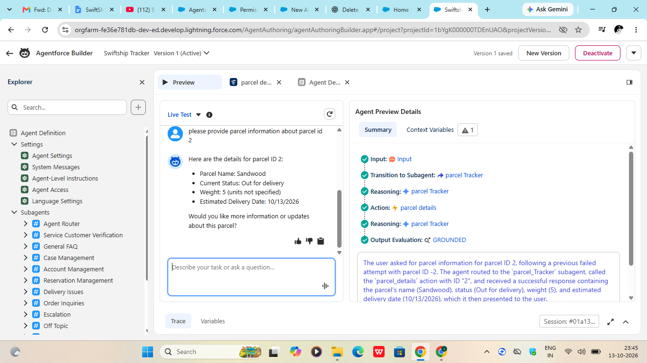

6. Expected Outcome
The expected outcome is a Salesforce-based parcel tracking setup where parcel details are maintained in structured records and shipment progress can be reviewed through status information. Configured automation should support the team's defined workflow and be validated with screenshots and test records.

7. Conclusion
Swift Ship Tracker demonstrates how Salesforce CRM features can be used to organize shipment information and support parcel status tracking. The project brings together custom records, fields, tabs, a Lightning app, and Flow automation as configured by the team. The final documentation should include screenshots that show the actual setup and working results in the Salesforce environment.
Thank You

