Testing pandoc-odt-filters
José de Mattos Neto
07-03-2018

Testing abstract.lua
If this abstract appears as first section in document, with style configured in filter (abstractODTStyle variable), test passes.

Testing odt-captions.lua (2 tests)
If image and table captions below get correct LibreOffice sequence field, 1st and 2nd tests pass.
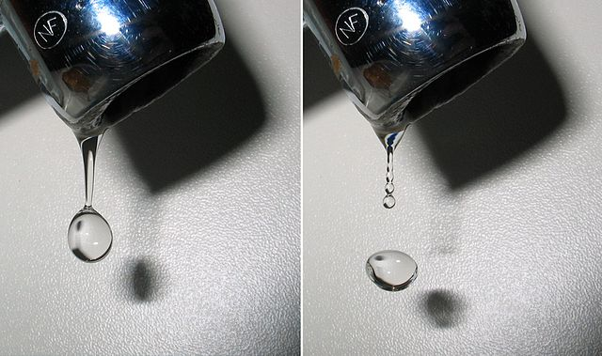
Figure 1: Image by Roger McLassus - Own work, CC BY-SA 3.0, link
Column 1 | Column 2
value 1 | value 2
Table 1: Dummy table

Testing odt-lists.lua (2 tests)
If unordered list gets list style configured in filter (listStyle variable), and items get paragraph style (listParaStyle variable), 1st test passes.
- banana
- apple
- orange
Ordered list style must be of numListStyle variable, and item paragraph style must be of numListParaStyle variable, then 2nd test passes.
- item 1
- item 2
- item 3

Testing odt-anchors.lua (3 tests)
If all following links work, 3 tests pass (note that image and table links point to caption).
Section link, goes to sec. 4 . Image link, goes to fig. 1. Table link, goes to tbl. 1.

Testing odt-custom-styles.lua (3 tests)
If above heading gets style configured in filter (unnumberedStyle variable), 1st test passes.
If following text gets Source_Text character style, 2nd test passes. This phrase should be in Source_Text style, with bold here and italics here.
If following text gets Date paragraph style, 3rd test passes.
Lorem ipsum dolor sit amet, consectetuer adipiscing elit. Maecenas porttitor congue massa.

Testing odt-bib-style.lua
A citation here (Doe 2018). If following bibliography gets style configured in filter (bibliographyStyle variable), test passes.
Doe, Joe. 2018. Dummy Book. Doe city: Joe editions.

