Introduction

To build a machine learning project that suggests recipes from your JSON datasets based on input ingredients, follow these five core steps:

1. Preprocess the JSON Data

Since your data is likely in a raw text format within the JSON files, you must clean it so the model can process it effectively.

- Parsing: Extract just the core "food words" (e.g., turn "2 cups of sliced organic carrots" into "carrots").
- Normalization: Convert all text to lowercase and remove punctuation or common "stop words" like "teaspoon," "cup," or "chopped".
- Helpful Libraries: Use NLTK or spaCy for general text cleaning, or a specific tool like ingredient-parser-nlp which is designed for this exact task.

Firstly, we need to process our dataset: “full_dataset.csv”. This dataset was downloaded from Kaggle and it has about 2 Million different recipes that we will be using in our Project. We need to clean this dataset first. The first 3 lines from our dataset look like follows:

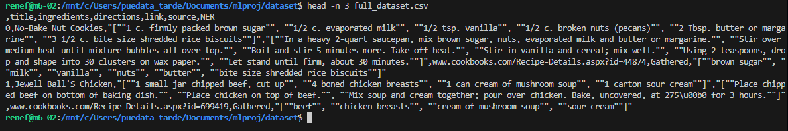

The header from our dataset is as follow:
,title,ingredients,directions,link,source,NER

As we can see that the data is not correctly cleaned. To clean our data, we have a script that cleans a large CSV dataset in chunks so your computer doesn’t run out of memory. The script is as follows:

import pandas as pd
import re
import os

# 1. Configuration
input_file = 'full_dataset.csv'
output_file = 'cleaned_dataset.csv'
chunk_size = 50000 # Adjust this (smaller if you still crash, larger for speed)

# 2. Define cleaning function
def clean_ingredients(text):
text = str(text).lower()
text = re.sub(r'[^a-zA-Z\s,]', '', text)
return text.strip()

# 3. Process in chunks
# Delete output file if it exists to avoid double-appending
if os.path.exists(output_file):
os.remove(output_file)

print("Starting processing...")

# Create an iterator
chunks = pd.read_csv(input_file, chunksize=chunk_size)

for i, chunk in enumerate(chunks):
# Apply cleaning to the current chunk only
# Change 'ingredients' to your actual column name
chunk['cleaned_ingredients'] = chunk['ingredients'].apply(clean_ingredients)

# Append to the new file
# header=True only for the first chunk
chunk.to_csv(output_file, mode='a', index=False, header=(i==0))

print(f"Finished chunk {i+1} ({((i+1)*chunk_size)} rows processed)")

print(f"Success! Cleaned data saved to: {output_file}")

Let’s break it down step by step in simple terms.

- Imports

import pandas as pd
import re
import os

- pandas → for reading and writing CSV files
- re → for text cleaning using regular expressions
- os → for checking/deleting files

- Configuration

input_file = 'full_dataset.csv'
output_file = 'cleaned_dataset.csv'
chunk_size = 50000

- input_file → your original dataset
- output_file → where the cleaned version will be saved
- chunk_size → number of rows processed at a time

Note: Instead of loading the entire CSV into memory, it loads 50,000 rows at a time.

This prevents crashes when working with large files.

- Cleaning Function

def clean_ingredients(text):
text = str(text).lower()
text = re.sub(r'[^a-zA-Z\s,]', '', text)
return text.strip()

This function cleans the text in the ingredients column:

What it does:

- str(text) → Converts everything to a string
- .lower() → Makes all letters lowercase
- re.sub(r'[^a-zA-Z\s,]', '', text) →
Removes everything except:
- Letters (A–Z, a–z)
- Spaces
- Commas
- .strip() → Removes extra spaces at the beginning or end

Example:
"Salt (1 tbsp), Sugar-2!"

Becomes:
"salt tbsp, sugar"

Note: Numbers, brackets, symbols → removed.

- Delete Old Output File

if os.path.exists(output_file):
os.remove(output_file)

If cleaned_dataset.csv already exists, it deletes it.

Note. This prevents accidentally appending new data to old cleaned data.

- Read File in Chunks

chunks = pd.read_csv(input_file, chunksize=chunk_size)

Instead of loading everything at once:

- It creates an iterator
- Each loop processes 50,000 rows

This is memory-efficient.

- Process Each Chunk

for i, chunk in enumerate(chunks):

For every group of 50,000 rows:

A) Clean the "ingredients" column
chunk['cleaned_ingredients'] = chunk['ingredients'].apply (clean_ingredients)

- Takes the ingredients column
- Applies your cleaning function
- Creates a new column called cleaned_ingredients

B) Save the chunk

chunk.to_csv(output_file, mode='a', index=False, header=(i==0))

- mode='a' → append to file
- index=False → don’t write row numbers
- header=(i==0) → write column names only for the first chunk

This way:

- First chunk → writes header
- Other chunks → just adds rows

C) Progress Message

print(f"Finished chunk {i+1} ({((i+1)*chunk_size)} rows processed)")

Shows progress in the terminal.

- Final Message

print(f"Success! Cleaned data saved to: {output_file}")

Confirms completion.

What This Script Does Overall

- Reads a large CSV file in pieces
- Cleans the ingredients column:
- Lowercase
- Removes numbers & special characters
- Creates a new column cleaned_ingredients
- Saves everything into a new cleaned CSV
- Avoids memory crashes

Furthermore, from our input dataset, we still have a problem - The NER column looks like a list, but because it's in a CSV, Python reads it as a string (e.g., '["salt", "pepper"]'). We need to convert that string back into an actual Python list.

To resolve the last problem, we need to an updated step - Fast Processing of the NER column
Since you are using VS Code and a 2GB file, use this updated chunking script. It ignores the messy ingredients and focuses only on the NER column to create your "searchable" index. This is done using the following “dataloadStep2.py” Python script.

import pandas as pd
import ast

input_file = 'full_dataset.csv'
output_file = 'final_recipe_index.csv'
chunk_size = 50000

# This function converts the string "['salt', 'pepper']" into a real list ['salt', 'pepper']
def parse_ner(ner_string):
try:
return " ".join(ast.literal_eval(ner_string))
except:
return ""

# Process chunks
chunks = pd.read_csv(input_file, chunksize=chunk_size)

for i, chunk in enumerate(chunks):
# 1. Clean the NER column: convert string-list to a simple space-separated string
# This makes it ready for the Machine Learning Vectorizer later
chunk['recipe_features'] = chunk['NER'].apply(parse_ner)

# 2. Keep only the columns we need for the suggestion engine to save memory
cols_to_keep = ['title', 'recipe_features', 'ingredients', 'directions', 'link']
simplified_chunk = chunk[cols_to_keep]

# 3. Save
simplified_chunk.to_csv(output_file, mode='a', index=False, header=(i==0))
print(f"Processed {i+1} chunks...")

print("Done! Your optimized dataset is ready in final_recipe_index.csv")

Results

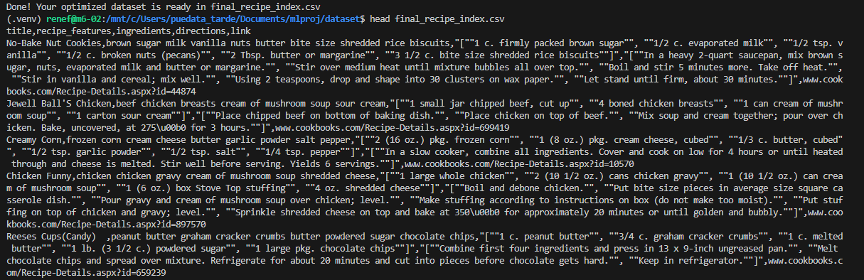

2. Convert Ingredients to Numbers (Vectorization)

Machine learning models require numerical input. We need to turn your list of ingredients into "vectors":

- TF-IDF (Term Frequency-Inverse Document Frequency): This is a great starting point. It gives more weight to unique ingredients (like "saffron") and less weight to common ones (like "salt"), helping the model distinguish between recipes.
- Word2Vec: This creates "word embeddings" where ingredients that often appear together (like "tomato" and "basil") are placed closer together in numerical space.

Since your file is 2GB, we cannot calculate a "Similarity Matrix" for the whole file at once (it would require Terabytes of RAM). Instead, we will:

- Vectorize the dataset once.
- Vectorize the user's input.
- Calculate similarity only for the specific input.

Run the following “dataloadStep2.py” script to test the recommendation engine. I've used TfidfVectorizer because it's great at ignoring common ingredients (like salt) and focusing on unique ones.

import pandas as pd
from sklearn.feature_extraction.text import TfidfVectorizer
from sklearn.metrics.pairwise import cosine_similarity

# 1. Load the cleaned dataset
# If it's still too slow, you can use nrows=100000 to test first
df = pd.read_csv('final_recipe_index.csv')
df['recipe_features'] = df['recipe_features'].fillna('')

print("Vectorizing ingredients... (this may take a minute)")
# 2. Setup TF-IDF
tfidf = TfidfVectorizer(stop_words='english')
tfidf_matrix = tfidf.fit_transform(df['recipe_features'])

def suggest_recipes(user_ingredients, top_n=5):
# 3. Transform user input into the same numerical format
user_vec = tfidf.transform([user_ingredients.lower()])

# 4. Calculate Cosine Similarity between input and all recipes
similarity_scores = cosine_similarity(user_vec, tfidf_matrix).flatten()

# 5. Get indices of the top N highest scores
top_indices = similarity_scores.argsort()[-top_n:][::-1]

return df.iloc[top_indices]

# --- PROBANDOLO AHORA ---
my_fridge = "tomato, potato, onions, rice"
suggestions = suggest_recipes(my_fridge)

print(f"\nTop suggestions for: {my_fridge}")
print(suggestions[['title', 'link']])

One Small Warning - If final_recipe_index.csv is still over 1GB, pd.read_csv might be slow. If you run out of memory here, we should convert the data to a Parquet file or use Scikit-learn's incremental learning.

3. Implement a Similarity Search

Once your recipes are vectorized, you can find the best matches for a user's input:

- Cosine Similarity: This is the most common algorithm for this project. It measures the "angle" between the user's input vector and every recipe vector in your dataset. The smaller the angle, the better the match.
- KNN (K-Nearest Neighbors): You can use the Scikit-learn KNN implementation to quickly find the "K" most similar recipes to the input ingredients.

As we can see there are different library/model to implement the “Similiraty Search” to have a general view, we have created a table to compare all the possible methods.

Summary Table: Which approach should we use?

Dataset Size | Recommended Tool | Complexity
Small (<10k) | cosine_similarity | Very Low
Medium (10k - 500k) | NearestNeighbors | Low
Large (500k+) | FAISS | Medium/High

4. Build a Simple Recommendation Engine

A basic logic flow for your Python script would be:

Input: User provides a list of ingredients.
Process: Clean and vectorized the user's list exactly as you did with your dataset.
Search: Run a similarity calculation (Cosine Similarity) against your entire recipe database.
Output: Return the top 5 or 10 recipes with the highest similarity scores.

5. Enhancement (Optional)

If you want to go further, you can add filters for dietary restrictions (vegan, gluten-free) or cooking time, which are often found in the metadata of recipe JSON files.

Would you like me to provide a Python code example using pandas and scikit-learn to demonstrate how to load your JSON and run a similarity search?

