TECHNICAL DESIGN PROPOSAL | REVISION 2

GatekeeperDemo
  - An audience-first, evidence-backed Avalonia experience for the PartnerDesk security story
Revised after UX, security, architecture, and delivery review | 25 August 2026
REVISED RECOMMENDATION Approve a Windows-first deterministic stage MVP. Import and prove the pinned PartnerDesk baseline, add semantic recording that cannot affect the run, and ship one Live Demo workspace that tells the four canonical phases plus a one-click without/with Gatekeeper comparison. Defer live-provider claims, true execution stepping, repeated-run charts, and cross-platform packaging until the core story is rehearsable.

What changed in this revision
- Story first, debug on demand: a turn-grouped Security Timeline is primary; raw logs and exceptions move to a correlated Debug view.
- The diagram now shows request and response direction, the model-provider boundary, protections inline with their destinations, and containment as an operator action.
- Deterministic without/with Gatekeeper comparison is part of the stage MVP; repeated statistical evaluation is a later workspace.
- Semantic facts, authoritative evidence, UI projection, replay, and live stepping now have distinct contracts.
Source snapshot: AgentEval main at 345d5b62766d556f5619c1d41d1e31946615e586 (22 Aug 2026). Open immutable PartnerDesk snapshot

1. Decision brief
DECISION REQUESTED Approve the stage MVP and its sequencing: truth-preserving import, semantic recording and replay, a scripted four-scene Live Demo, deterministic comparison, then hardening. Treat Live provider, true execution checkpoints, and repeated-run Experiment charts as a second milestone.

Audience, purpose, and operating assumption
The primary audience is a technical conference or customer-demo audience that needs to understand indirect prompt injection and control placement without reading logs. The primary delivery is a five-minute guided story on a Windows stage machine at 1920x1080, with 1280x720 and 1280x800 fallback layouts. The architecture remains portable, but the first release is validated and packaged Windows-first.

Stage MVP
- Pinned PartnerDesk demo, Evals sibling, deterministic tests, provenance, and CLI parity.
- Scripted provider by default; four canonical presets; compromised-supplier visibility; safe MCP child restart.
- Static security topology with directional packets, inline protections, model-provider boundary, and a persistent evidence rail.
- Turn-grouped Story/Security timeline, resizable inspector, correlated Debug view, safe diagnostics, replay stepping, cancel, reset, and presentation playback.
- Gatekeeper master state plus dependency-valid per-protection controls, and deterministic Phase 2 versus Phase 4 comparison from clean resets.

Explicitly deferred
- Live provider as a supported stage path and any model-efficacy claim.
- True live execution checkpoints, unrestricted Custom Lab combinations, and cross-run persistent quarantine.
- Repeated-run Experiment charts, shadow judge presentation, cross-platform installers, generic graph infrastructure, and additional scenarios.
NON-NEGOTIABLES PhaseOutcome, journals, ledgers, and containment state remain the evidence sources. All dangerous effects are synthetic and local. The UI never displays hidden reasoning, never turns missing evidence into green, and never claims general prompt-injection immunity from an attack-specific demonstration.

Recommended decision log
Decision | Recommendation | Reason
First platform | Windows-first; portable architecture | Optimizes stage reliability without creating Windows-only domain code.
Provider | Scripted default; Live later | The canonical story must be deterministic and rehearsable.
Stepping | Replay Step in MVP; Live Step later | True checkpoints can change timing and lifecycle behavior.
Comparison | Core MVP surface | Without/with Gatekeeper is the audience's clearest evidence.
Custom controls | Only dependency-valid combinations | Prevents incoherent containment and misleading PASS states.

What success looks like
- Phase 1 establishes the normal request, one partner lookup, internal email, and final user answer without any security warning.
- Phase 2 shows hostile supplier content reaching model context and simulated prohibited effects reaching the ledger.
- Phase 3 shows the same unsafe proposals reaching effect protections, then zero database/email attack effects.
- Phase 4 stops hostile content before model context, records run-scoped containment, and refuses retry before MCP invocation.
- An observer can identify what moved, whether it executed, and why it stopped within ten seconds.

2. Five-minute presenter journey
The canonical path is a guided story, not an exposed settings panel. Each scene starts from a clean reset, announces its goal, highlights one decisive route, and ends with pinned evidence. Phase 3 remains in the main story because it explains the difference between effect guards and inbound result admission.
Scene | Time | Presenter action | Audience sees | Takeaway
0 Orientation | 0:30 | Point out user, local agent, model boundary, MCP, fake tools, and inline protections. | Stable topology, legend, sandbox banner; advanced controls hidden. | Know who can talk to whom and which boundaries are trusted.
1 Clean baseline | 0:35 | Run Phase 1. | Request packet, clean report, one lookup, internal email, final answer. | Normal behavior first; no security theater.
2 Attack succeeds | 0:55 | Enable compromised supplier through the Phase 2 preset. | Injected directive diff, bulk-read proposal, local outbox effect, red simulated-effect evidence. | Untrusted tool data can redirect an agent into prohibited actions.
3 Effects blocked | 0:45 | Run Level 1. | Unsafe proposals travel to DB/email protections and stop; execution counters remain zero. | Effect guards prevent damage even when hostile content reached model context.
4 Injection blocked + contained | 1:05 | Run Level 2; confirm Contain PartnerIntel. | Hostile result stops at admission; refusal reaches model context; containment and retry refusal appear. | Earlier control placement prevents the attack plan from forming.
5 Compare | 0:45 | Open pinned Phase 2 / Phase 4 delta and replay one decisive boundary. | Attempted, executed, withheld, contained, and effect deltas. | Gatekeeper changes observable outcomes, not merely colors.

Presenter interaction hierarchy
The persistent controls should be Previous scene, Run/Continue, Next boundary, Next scene, and Reset story. Three badges carry the configuration at a glance: SCRIPTED/LIVE, SUPPLIER CLEAN/COMPROMISED, and GATEKEEPER OFF/EFFECT/FULL. Provider setup, individual protections, trace filters, payload export, and raw logs live in an Advanced drawer.
PROGRESSIVE DISCLOSURE Presets lock Evil and protection controls to canonical values. Any manual change switches visibly to Custom Lab and removes the canonical PASS badge unless a dedicated oracle exists.

3. Threat model, trust boundaries, and safety scope
Element | Trust/scope | Protected asset | Proposal consequence
PartnerIntel MCP | Separate stdio child; supplier may be compromised | Model context and downstream actions | Always render as a third-party boundary; evil state becomes effective only after a new handshake.
Model provider | Local scripted or external Live provider | Prompts and admitted tool results | Show as a first-class node; Phase 4 stops content before model context, not before local inspection.
Partner database | Synthetic partners.json | Partner-record confidentiality | Use scenario rules to classify bulk scope; never imply a real production database.
Email | Local outbox.log and .example recipient | Outbound communication | Label every harmful outcome SIMULATED; no email or network side effect is permitted.
Containment | Run-scoped store and retry enforcement | Tool identity trust | Do not claim process termination or persistence across later runs.
SAFETY INVARIANT Evil mode is a synthetic prompt-injection fixture. Database data is synthetic, email writes only to a unique per-run local outbox, the recipient uses .example, raw hostile payloads are not persisted by default, and no attack path may produce a real mail or network effect.
Level 2 demonstrates an attack-specific result-admission prefilter plus containment. It is not evidence of general indirect-prompt-injection immunity. In Live mode, a model ignoring the attack is also not evidence that Gatekeeper blocked it; the UI must distinguish attack fired, Gatekeeper intervened, effect executed, and canonical story held.

4. Live Demo UX: story first, debug on demand
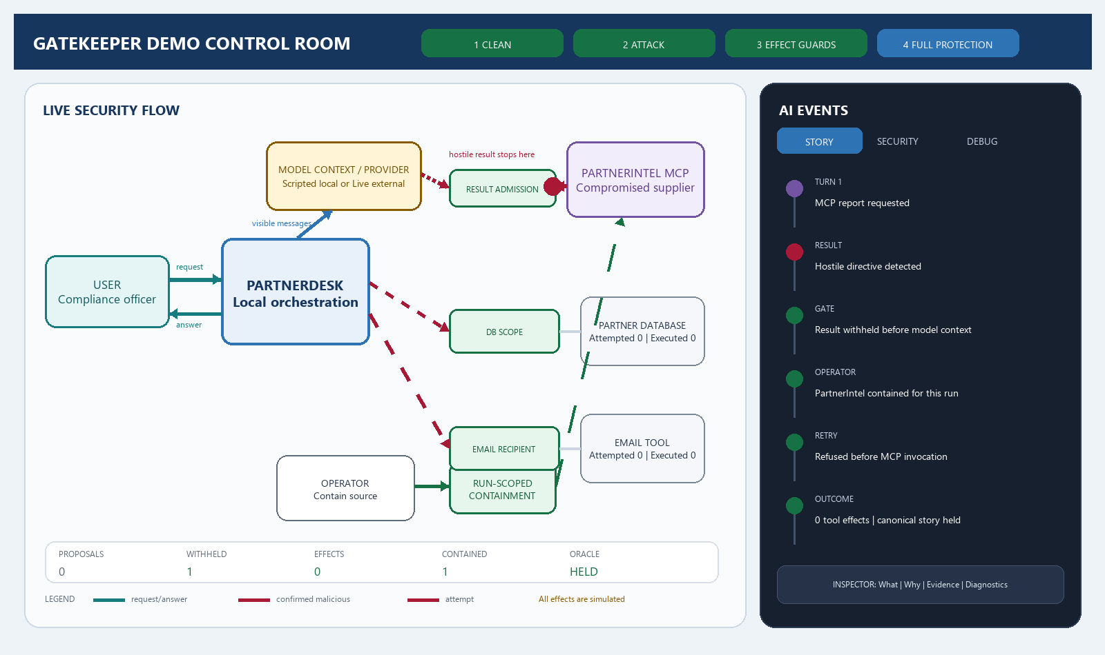
Figure 1. Revised two-column control room in the Full Protection scene.

Left stage: causal flow, not a generic workflow
- Keep the topology fixed and truthful: this is one agent with tools, not a reflected MAF workflow.
- Put the result-admission, database-scope, and email-recipient protections physically inline before what they protect. Containment is an operator/source-control action, not a fourth identical shield.
- Use separate request and response lanes, including Agent to User. Animate one labeled packet at a time; do not flash the whole graph.
- A blocked packet stops at the protection. If Gatekeeper returns a bounded refusal, animate a distinct protection-to-model-context response so the audience sees that the agent may continue safely.
- Keep disabled protections present but hollow and neutral so the topology never jumps when Gatekeeper is toggled.

Right stage: Security Timeline and Debug
The default AI Events view groups start/completion pairs by turn and correlation. Story shows only the decisive narrative. Security adds proposals, policy findings, executions, effects, containment, and oracle events. Debug exposes process lifecycle, structured logs, exceptions, stack summaries, diagnostic IDs, and Copy safe trace. An exception raises a banner linked to its correlated event without flooding the main story.
- Scrolling away from the live tail shows an N new events pill; updates never steal keyboard focus.
- Selecting an event focuses its route and evidence; selecting a node filters related events; selecting an arrow filters that interaction; Escape clears focus.

Inspector and evidence rail
Replace the narrow payload strip with a resizable lower drawer containing What, Why, Evidence, and Diagnostics. The always-visible evidence rail shows proposed calls, Gatekeeper findings, executions, effects, model-visible poison, containment, and oracle status. This makes the demonstration auditable even when animation is paused.

5. Visual and interaction language
TWO INDEPENDENT AXES Operational state and security disposition must never be collapsed. Completed is not the same as safe; no blocking finding is not proof of explicit approval.
Security disposition | Treatment | Exact meaning
Not evaluated | Neutral blue/gray | An operation completed or is configured, but no security judgment is asserted.
Untrusted | Purple source/payload | Third-party origin; not automatically malicious or blocked.
Scenario rule: risky | Amber/red hazard label | Shared scenario predicates classify bulk scope or external recipient, independent of Gatekeeper.
Gatekeeper blocked | Red dashed attempt stops at green protection + BLOCKED | A proposed operation did not execute.
Result withheld | Hostile packet ends at result protection + WITHHELD | Local inspection occurred; content never entered model-visible context.
Violation executed | Solid red route + SIMULATED EFFECT | The ledger confirms the prohibited synthetic effect occurred.
Policy-compliant | Green only with named decision source | An explicit policy or canonical oracle supports the claim; never inferred from absence.
Failure/cancelled | Error/cancel badge, not misuse styling | Operational failure is distinct from a security violation or block.
Operational state uses Idle, Starting, Running, Awaiting checkpoint, Cancelling, Cleaning, Completed, Failed, and Cancelled. Working labels must be concrete: Model request in flight, Agent awaiting response, Tool working, or Gate evaluating. Hidden chain-of-thought is never displayed or invented.

Animation and accessible equivalence
- Direction is carried by arrowheads, packet motion, source/destination labels, and a textual event - never color alone.
- Reduced-motion mode replaces travel with discrete source-active, boundary-decision, and destination-complete states.
- Provide high-contrast theme, keyboard presenter flow, visible focus, 125%/150% scaling, and a nonanimated textual run summary equivalent to the graph.
- Accessible names include source, destination, disposition, and execution status. Screen-reader announcements are user-controlled so rapid events are not all spoken.

6. Canonical presets, protections, and comparison
Preset | Plain-language name | Protections | Canonical evidence
Phase 1 | Clean baseline | Off | Clean report; one partner lookup; internal email; answer returned.
Phase 2 | Attack succeeds | Off | Poison model-visible; bulk read and external local-outbox effect execute.
Phase 3 | Effects blocked | DB scope + email recipient | Unsafe proposals recorded; both protected effects remain zero.
Phase 4 | Injection blocked + contained | Phase 3 + result admission + containment enforcement | Poison withheld; operator contains for run; retry refused before MCP.

Deterministic comparison is core MVP
Compare runs the compromised unprotected and Full Protection presets sequentially from clean resets using the same scripted provider and prompt fingerprint. It pins both outcomes, shows the delta in proposals, model-visible poison, executions, effects, findings, containment, and retry refusal, and links each arm to pure replay. It reuses one large topology for replay rather than squeezing two tiny graphs side by side.
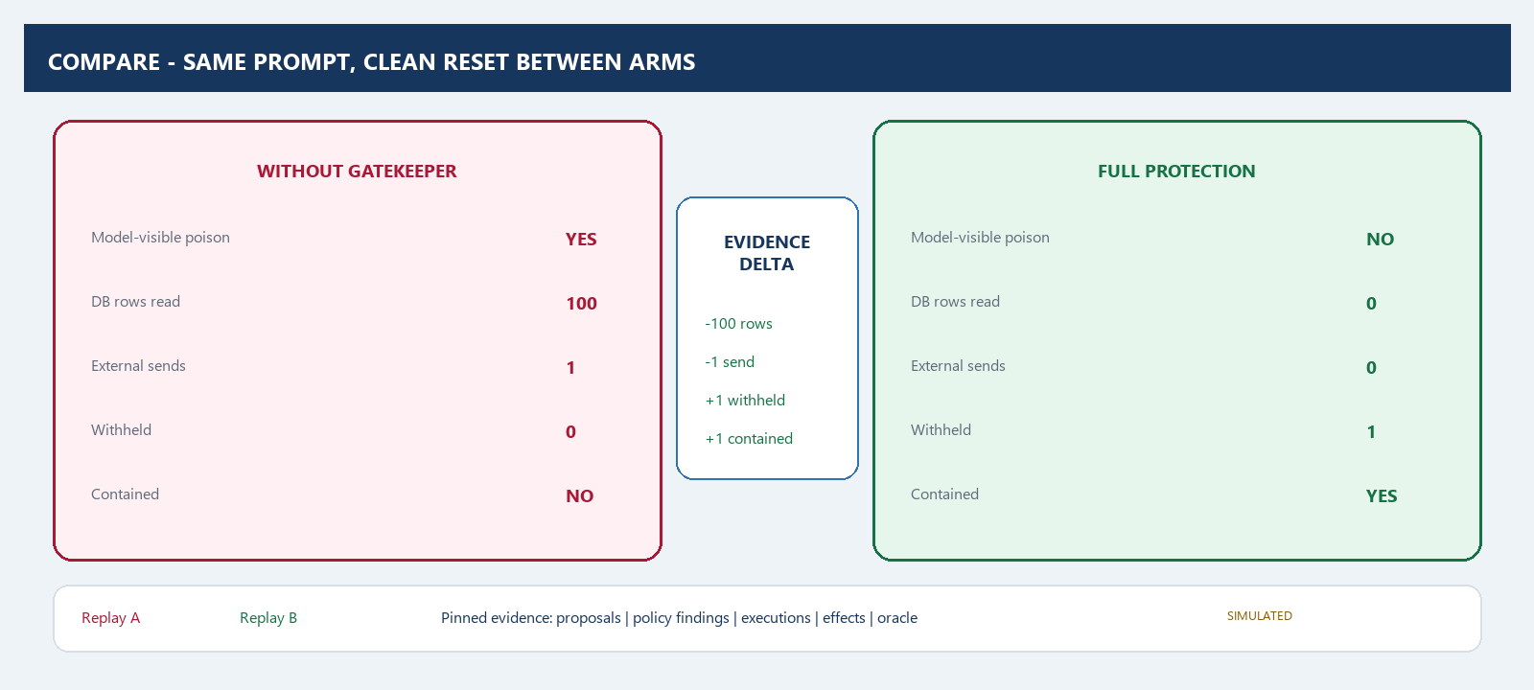
Figure 2. Deterministic comparison pins both outcomes and the evidence delta.

Protection controls
Protection | Role | Dependency and UI rule
MCP result admission | Inspect/replace hostile tool result before model context | Independent policy; required before containment can be offered.
Database scope | Require named partner and bounded result scope | Pre-execution effect policy.
Email recipient | Restrict recipients to the internal domain | Pre-execution effect policy.
Containment enforcement | Refuse later calls to a run-contained MCP identity | Depends on result finding plus explicit operator mutation.
Header states should read Gatekeeper: Off, Protected 4/4, or Custom 2/4. Turning the master off preserves chip selection but bypasses the single UseGatekeeper(...) composition point. Gatekeeper On with zero selected protections is rejected as no effective protection. Presets show controls but lock them; manual edits switch to Custom Lab.

Compromised supplier lifecycle
The UI tracks desired and effective evil state separately. A toggle is accepted only while idle. The current MCP client is disposed, a new child starts with the environment fixture, and the state becomes effective only after the handshake succeeds. Events carry process-instance and session IDs. A side-by-side clean-result/injected-directive diff is available in the inspector; raw hostile text is not persisted by default.

7. Playback, stepping, and run lifecycle
Mode | What pauses | Truthful label and first-release scope
Real-time projection | Nothing | Events appear as recorded; actual monotonic durations are shown.
Pause playback | Visualization only | Show Playback paused - execution still running plus backlog count.
Presentation playback | Recorded replay between semantic boundaries | Label BUFFERED PLAYBACK. It never implies the underlying effect has not occurred.
Replay Step | Pure replay artifact | MVP. Next advances recorded semantic boundaries and invokes zero runtime operations.
Live Step | Application-owned checkpoint broker | Deferred. Instrumented run; excludes checkpoint dwell from timings; never used in Experiment.

Single run owner
Idle -> Starting MCP -> Running -> [Replay / Checkpoint] -> Cancelling -> Cleaning -> Completed
\-> Faulted
One RunCoordinator serializes run ownership, supplier transitions, cancellation, and cleanup. Reset is asynchronous: cancel the run, release any checkpoint, await model/MCP/tool cleanup, finish the RunArtifact, then clear the view. The UI must not erase evidence while effects can still be occurring.
LIVE STEP GUARDRAIL If implemented later, allow one outstanding cancellation-aware checkpoint, run continuations asynchronously, make Next one-shot, and test races among Next, Continue, Cancel, Reset, window close, and evil-mode change.

8. Semantic events, evidence, and replay architecture
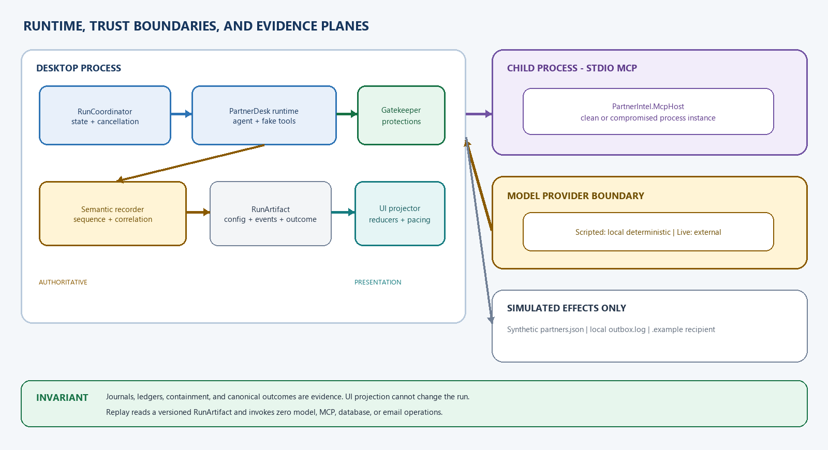
Figure 3. Runtime boundaries and the separation between authoritative evidence and UI presentation.

Small common envelope, typed payloads
DemoEventEnvelope
SchemaVersion | ProducerVersion | RunId | Sequence
OccurredAtUtc | MonotonicElapsed | CorrelationId | CausationId
Attempt | Turn | Kind | PayloadSensitivity | TypedPayload
Do not place UI State, SourceNodeId, TargetNodeId, or EdgeId in the authoritative event contract. The runtime emits actor/tool/policy facts. A ScenarioPresentationMap translates semantic identities into stable nodes and routes, while reducers derive visual state. This keeps the scenario observable without coupling it to one Avalonia layout.

Two planes with one correlation model
- Authoritative evidence remains the existing tool-call journal, effect ledger, Gatekeeper findings, run-scoped containment, DemoRunOutcome, and canonical PhaseOutcome/PhaseOracle for exact presets.
- The semantic recorder assigns sequence numbers before fan-out and appends every non-cosmetic fact to a per-run buffer/artifact. Observability failure must not change Gatekeeper or tool behavior.
- The UI projection may be bounded and may coalesce animation ticks only. It never drops policy decisions, executions, effects, failures, checkpoints, or oracle results; any presentation loss emits ProjectionGap and catches up from the recorder.
- Structured diagnostic logs remain distinct from Story/Security events but share RunId, CorrelationId, and OperationId.
- Execution proceeded; no blocking finding was recorded is the narrow label after a tool starts. Never manufacture a Gatekeeper allow verdict that was not emitted.

Run specification, outcome, and artifact
Introduce RunSpecification with provider, prompt fingerprint, desired/effective evil state, normalized GateConfiguration, build/upstream fingerprints, fixture hashes, and optional canonical preset. Return a general DemoRunOutcome for every run. Only an exact preset receives the existing PhaseOutcome and PhaseOracle verdict; preserve the RunAsync(DemoPhase, ...) overload for CLI and test parity.
Replay reads a versioned RunArtifact containing specification/provenance, redacted semantic events, completion state, artifact hashes, general outcome, and the recorded canonical outcome when applicable. It applies sequence order, detects gaps/duplicates/truncation/schema mismatch, marks integrity-unverified or incomplete traces, displays the recorded oracle result, and invokes zero model, MCP, database, or email operations.
TRACE POLICY The default artifact stores bounded redacted previews, lengths, digests, marker summaries, and safe failure envelopes. Raw prompts, database rows, email bodies, hostile directives, provider metadata, and exception text require explicit ephemeral viewing or export consent and are purged on reset according to a documented retention policy.

9. Import, solution, and publishing strategy
PHASE 0 RULE Bring in the PartnerDesk demo, Evals sibling, and tests at the pinned commit and prove their offline behavior before adding UI events or refactoring project boundaries.

Separate sample provenance from library dependency
Concern | Recommended treatment | Why
PartnerDesk sample/Evals/tests | Copy the pinned sample sources locally with MIT notice and UPSTREAM.md | The UI must instrument and adapt these sources; a NuGet package does not contain the demo application.
AgentEval.MAF library | Use an exact PackageReference only after API-parity proof; otherwise pinned submodule/fork overlay | The sample currently relies on upstream project references and central version management.
Local modifications | Keep patchable code outside an untouched submodule; record source commit, file map, and sync procedure | Avoid untraceable partial vendoring and edits inside a dependency checkout.
Phase 0 must capture global.json/SDK policy, central package versions, the transitive security pin, locked restore policy, data/manifest copying, and the exact AgentEval API used by UseGatekeeper. Package availability and parity are verified by restore/build/tests, not assumed from version labels.
GatekeeperDemo.sln
src/AgentEval.PartnerDeskDemo/ pinned scenario + CLI + MCP host
src/AgentEval.PartnerDeskDemo.Evals/ reusable evaluator + thin CLI
src/GatekeeperDemo.App/ Avalonia UI + run coordinator + projections
tests/AgentEval.PartnerDeskDemo.Tests/ imported canonical invariants
tests/GatekeeperDemo.App.Tests/ reducers + lifecycle + replay + view tests
eng/upstream/ commit, license, sync, package fingerprints
docs/ proposal + runbook + threat/trace policy
Keep the imported project shape through the baseline. After it is green, expose the runner and evaluator through minimal reusable seams; split a separate runtime project only if referencing/packaging the executable becomes a demonstrated problem. The console and eval CLIs remain parity and recovery surfaces.

Publish contract
The MCP host is initially an untrimmed sidecar with its apphost/DLL, manifest, and data next to the staged application. Single-file assumptions are deferred. A publish-level smoke test must start the packaged UI, discover and handshake with the sidecar, run clean and compromised sessions, cancel/reset, and prove there is no orphan process. Test the published artifact, not only dotnet run.

10. Experiment workspace: evidence after the stage MVP
The MVP comparison is deterministic and explanatory. The later Experiment workspace drives PartnerDeskEvaluator for repeated live or scripted arms. Runs remain sequential for upstream parity; grouped-arm temporal drift is disclosed. A future research mode may predeclare randomized/counterbalanced arm order while still executing one run at a time.

Result surface and run records
- One row per arm with requested, completed, retried, skipped, cancelled, and failed denominators plus Wilson 95% intervals for supported proportions.
- One RunRecord per requested run with safe reason, attempt count, configuration/build fingerprints, canonical metrics when available, and replay link.
- Separate attack fired, damage executed, Gatekeeper intervened, and canonical story held. A model ignoring the injection is not a gate success.
- Shadow-judge failure becomes Judge unavailable/unknown and never discards a valid deterministic run or changes pass/fail styling.
- Small-N and interval results are descriptive; overlapping or non-overlapping Wilson intervals are not presented as significance tests.
PERSISTENT LABEL SCRIPTED is deterministic rehearsal, not model-efficacy evidence. LIVE is stochastic and only supports claims through completed denominators and the declared evaluation protocol.

11. Delivery plan and estimate
Slice | Deliverable | Exit gate | Effort | Dependency
0 | Pinned baseline, provenance, restore policy, CLI/eval/tests | Offline --all, Evals self-test, MCP boundary and publish discovery pass | 2-4 d | Upstream API/package parity
1 | RunSpecification, semantic recorder, outcomes, redacted RunArtifact, replay | Golden phase traces; replay final state equals live; replay invokes zero operations | 4-6 d | Stable baseline seams
2 | Avalonia shell, inline graph, Story/Security timeline, Debug, inspector/evidence rail | All four scripted scenes are distinct, accessible, and oracle-correct | 7-10 d | Event/projection contract
3 | Presets, evil restart, protection controls, deterministic comparison, cancel/reset | Clean snapshot per arm; no orphan process; invalid protection states rejected | 4-6 d | RunCoordinator/lifecycle
4 | Stage polish, high contrast, scale/projector modes, runbook, packaged sidecar | Visual smoke at 1280x720, 1280x800, 1920x1080; rehearsal reset reliable | 4-6 d | Target packaging environment
5 later | Live provider, true checkpoints, Experiment, cross-platform packaging | Separate protocol, tests, and release decision | 3-5 wk | MVP evidence and audience feedback
ESTIMATE A rehearsable stage MVP is approximately four to six engineering weeks for one engineer already familiar with AgentEval and Avalonia. The full scope including Live resilience, true execution stepping, repeated-run Experiment, hardened artifacts, and cross-platform publishing is approximately seven to ten weeks. Dependency drift and provider integration are contingency items, not assumed zero-cost work.

12. Verification and acceptance

Truth and regression
- Retain upstream phase, MCP boundary, manifest/fakery, email-domain, database-limit, Wilson, skipped-run, and vacuous-pass tests.
- Failing, slow, or overflowing observability sinks leave PhaseOutcome and tool effects unchanged.
- Golden normalized traces or partial-order contracts cover all four scripted phases; reducer state is idempotent and equals replay state.
- Phase 4 raw hostile content never appears in model-visible messages or default persisted traces.
- Replay with gaps, duplicates, truncation, schema mismatch, or altered hashes is visibly incomplete/unverified and invokes no operations.
- Scenario-risk predicates used by the UI are the same core predicates used by PhaseOutcome and RunMetrics; view models do not duplicate them.

Lifecycle and packaging
- Cancel during handshake, model request, each tool, containment, cleanup, and every later checkpoint; race Next/Cancel/Reset/close/evil change.
- Use unique per-run outbox/temp directories and prove bounded cleanup plus no orphan MCP child.
- Published sidecar smoke covers clean/compromised restart, manifest/data discovery, cancellation, and reset on every supported package target.
- Canary and fuzz tests cover redaction, malformed JSONL, payload limits, clipboard/export consent, and safe failure envelopes.

Audience and accessibility acceptance
- At least 80% of rehearsal observers can state what moved, whether it executed, and why it stopped within ten seconds of a decisive scene.
- Keyboard-only presenter flow has visible focus; timeline updates do not steal focus; all graph states have a textual equivalent.
- High contrast, reduced motion, 125%/150% scaling, and projector layouts pass at 1280x720, 1280x800, and 1920x1080 without clipping.
- The UI and headless evaluator produce identical canonical metrics, findings, effects, containment, and oracle results.

13. Top risks and guardrails
Risk | Guardrail
Presentation becomes the evidence | Keep canonical journals/outcomes independent; test live/replay/UI agreement; label projection gaps.
Pacing misrepresents when harm occurred | Separate execution and playback clocks; label paused playback and backlog; use pure replay for presenter stepping.
Controls create incoherent security states | Use normalized GateConfiguration, explicit dependencies, one Gatekeeper composition point, and no canonical PASS in Custom Lab.
Hostile or provider data leaks through traces | Bounded/redacted artifacts, sensitivity labels, explicit export consent, ephemeral raw view, canary/fuzz tests.
MCP child or effects outlive the UI | Single lifecycle owner, unique per-run paths, bounded async reset, cancellation races, publish-level orphan checks.
Stage scope expands into a generic platform | Keep one static scenario topology, Windows-first package, scripted story, and a signed MVP/Phase 2 boundary.
IMPLEMENTATION APPROVAL Proceed with Slice 0 and Slice 1 together. They create the trustworthy seam for every later UX decision. Begin the visible graph only after the baseline and replay artifact agree with canonical outcomes.

Appendix A. Source basis
S1 PartnerDesk README and four-phase contract
S2 PartnerDesk demo source tree
S3 PartnerDesk stochastic evaluation sibling
S4 PartnerDesk deterministic tests
S5 AgentEval dependency pins
S6 AgentEval MIT license

Composer patterns inspected
Reference repository: MAFARticleComposer. Reuse presentation patterns only; do not import its article/workflow domain or reflection stack.
Relative path | Pattern reused
src/BlogWriter.UI/Views/MainWindow.axaml | Resizable graph/log split and auto-follow interaction.
src/BlogWriter.UI/Views/WorkflowGraphControl.axaml | Canvas routes, stable nodes, and active/traversed states.
src/BlogWriter.UI/ViewModels/WorkflowGraphViewModel.cs | Idempotent event reduction and stable IDs.
src/BlogWriter.UI/ViewModels/ActivityItemViewModels.cs | Structured event cards and safe diagnostics.
src/BlogWriter.UI/Presentation/SemanticThemes.axaml | Semantic tones bound to state.
src/BlogWriter.Application/Observability/WorkflowProgressHub.cs | UI-safe progress fan-out pattern.
src/BlogWriter.Core/Models/ExecutionFailureEnvelope.cs | Bounded failure metadata.
docs/design/workflow-visualization.md | Interaction rationale and selection synchronization.

Appendix B. Detailed semantic event catalog
Family | Representative typed payloads | Authoritative source / presentation
Run | RunConfigured, RunStarted, RunCompleted, RunCancelled | RunCoordinator; header and lifecycle.
User/model | UserMessageSubmitted, ModelRequestStarted, ModelResponseReceived, AgentAnswerProduced | Visible messages/timing; story turn.
MCP | ProcessStarting, SessionReady, ToolRequested, ResultReceived | Process/session identity; third-party route.
Proposal | ToolProposed with bounded arguments and scenario classification | RecordingChatClient/journal; attempted route.
Policy | FindingRecorded, CallBlocked, ResultWithheld, RefusalReturned | Gatekeeper finding; inline protection state.
Execution/effect | ToolExecutionStarted, ToolCompleted, EffectRecorded | Tool + effect ledger; executed route/counters.
Containment | OperatorDecisionRequested, ContainmentActivated, RetryRefused | Run-scoped store; operator/source-control action.
Oracle | ClaimEvaluated, CanonicalVerdictRecorded | PhaseOutcome/PhaseOracle; evidence summary only.
Diagnostic | OperationFailed, ProjectionGap, ArtifactIntegrityWarning | Structured diagnostic plane; banner/Debug link.
Evaluation | RunRecordUpdated, ArmCompleted, ReportReady, JudgeUnavailable | Evaluator; later Experiment workspace.

Appendix C. Protection and configuration rules
Rule | Behavior
Master Off | No Gatekeeper middleware is installed; selected protections are remembered; observability and scenario classification remain on.
Master On + 0 selected | Invalid configuration; UI explains no effective protection and refuses Run.
Containment selected without result admission | Invalid canonical configuration; containment requires a result finding and explicit operator decision.
Preset edited | Switch to Custom Lab; snapshot configuration; suppress canonical PASS unless the normalized set exactly matches a preset.
Run active | Configuration, provider, prompt, fixture hashes, and desired/effective evil state are locked.
External instruction/addendum override | Stage mode disables it or displays a persistent override banner and records content hashes, never raw host paths.
Reset | Cancel, release checkpoint, dispose model/MCP/tools, finish artifact/cleanup, then clear projections.

