CSIT 127

**Lab 10: Objective: Revision lab and Router configuration using Command line interface**

**Submission Due: By end of the lab. This is a graded activity**

**Time Duration: 60 Minutes**

**Marks: 1**

**Note:**

* **Make sure you have shown your activity to the instructor for grading**
* **Your submission should be with “Studnentnumber_lab10_submission”**

1. IP Host Address is 192.168.6.125 with a Subnet Mask: 255.255.255.248? Find the following:



IP host address: 192.168.6.125

Binary: 11000000 . 10101000 . 00000110 . 01111101

Subnet Mask: 255.255.255.248

Binary: 11111111 . 11111111 . 11111111 . 11111000

Subnet Adress/Network Address: AND operation of ip host address and subnet mask:

11000000 . 10101000 . 00000110 . 01111000

In decimal: 192.168.6.120

First Valid Host: 192.168.6.121

Broadcast Address: OR operation of ip address and inverted subnet mask:

11000000.10101000.00000110.01111111

In decimal: 192.168.6.127

Last Valid host: 192.168.6.126

And design a network with two PC and router using Packet Tracer.

**Configure the Router using CLI**

Click on the Router → Go to CLI (Command Line Interface).

Enter **configuration mode**:

Router> enable

Router# configure terminal

**Assign IP Address to Router’s Interface**:

Router(config)# interface FastEthernet0/0

Router(config-if)# ip address *IP_Address Subnet_Mask*

Router(config-if)# no shutdown

Router(config-if)# exit

Router(config)# exit

Router#

Add screenshots of network design and setup and, successful pinging.

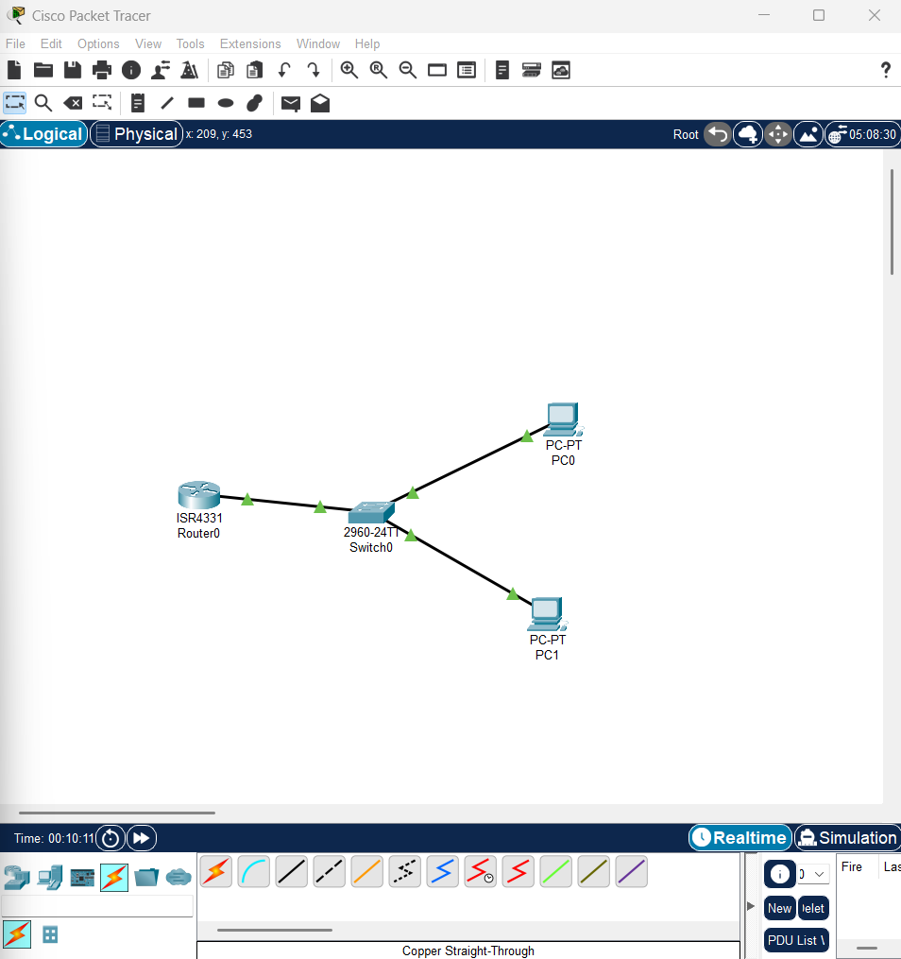

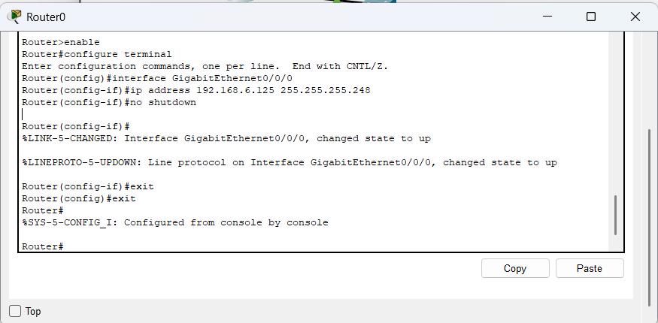

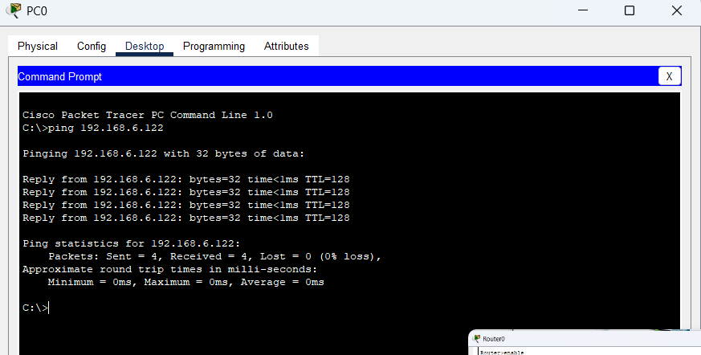

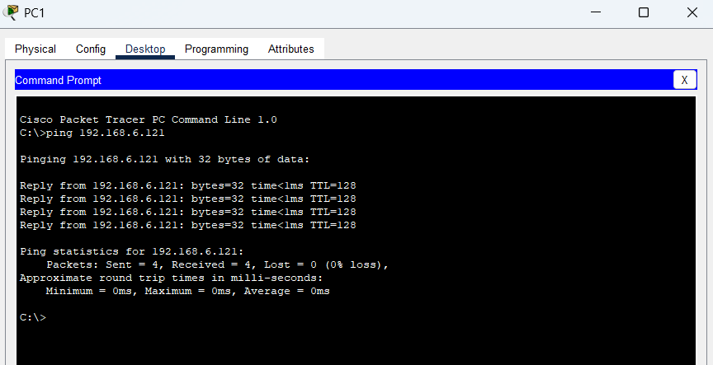

1. Given IP address 154.16.168.198/28, does the IP->162.16.168.30 belong to the same network?

No it doesn’t belong to the same network as the first octet itself is different that means they have different IP ranges.

1. Subnet mask is 255.255.192.0. How many hosts and networks can you create? Solve with the two-power method.

Subnet mask in binary = 11111111.11111111.11000000.00000000

Network bits=18

Hosts bits =14

No of hosts = 2^no of host bits

2^14 = 16,384

Useable no of hosts= 16,384 -2 = 16,382

Default subnet mask = /16 (class b)

New subnet mask = /18

No of network that can be created = 2^no of borrowed subnet bits

= 2^(18-16) = 2^2 = 4

1. Given a simple Plaintext = THIS IS A HOLY MONTH, Encryption Key (𝑀𝑖+4) mod 26, find the Cipher text.

|  |  |  |  |  |  |  |  |  |  |  |  |  |  |  |  |  |
| --- | --- | --- | --- | --- | --- | --- | --- | --- | --- | --- | --- | --- | --- | --- | --- | --- |
| Plain | T | H | I | S | I | S | A | H | O | L | Y | M | O | N | T | H |
| Alphabet position | 19 | 7 | 8 | 18 | 8 | 18 | 0 | 7 | 14 | 11 | 24 | 12 | 14 | 13 | 19 | 7 |

Applying the formula;

T = (19+4)mod 26 = 23 = X

H = (7+4)mod 26 = 11 = L

I = (8+4)mod 26 = 12 = M

S = (18+4)mod 26 = 22 = W

I = (8+4)mod 26 = 12 = M

S = (18+4)mod 26 = 22 = W

A = (0+4)mod 26 = 4 = E

H = (7+4)mod 26 = 11 = L

O = (14+4)mod 26 = 18= S

L = (11+4)mod 26 = 15 = P

Y= (24+4)mod 26 = 28 = C

M= (12+4)mod 26 = 16 Q

O = (14+4)mod 26 = 18 = S

N = (13+4)mod 26 = 17 = R

T= (19+4)mod 26 = 23 = X

H= (7+4)mod 26 = 11 =L

FINAL CIPHERTEXT = XLMWMWELSPCQSRXL

1. Use transpositional based encryption Key: GREAT

Plain Text: THANK YOU

Alphabetical order of "GREAT": A,E,G,T,R

|  |  |  |  |  |
| --- | --- | --- | --- | --- |
| G(3) | R(5) | E(2) | A(1) | T(4) |
| T | H | A | N | K |
| Y | O | U | X | X |

Rearranging columns

|  |  |  |  |  |
| --- | --- | --- | --- | --- |
| A(1) | E(2) | G(3) | T(4) | R(5) |
| N | A | T | K | H |
| X | U | Y | X | O |

Column-wise for ciphertext

NXAUTYKXHO