**Tutorial 8 Week 9**



1. Node.js Installation
2. Install upper-case package  using NPM
3. Install Formidable module using NPM
4. Modify slide 25 to display your name and Id

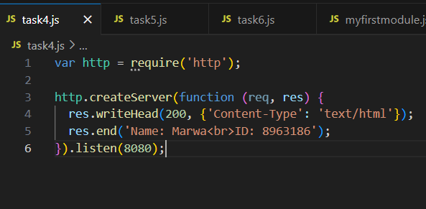

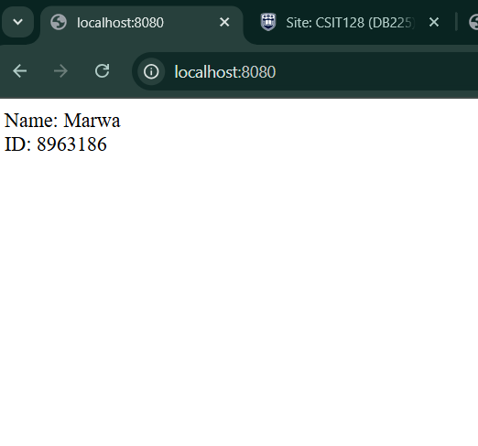

1. Consider slide 35   It should display /winter2024 and summer2024

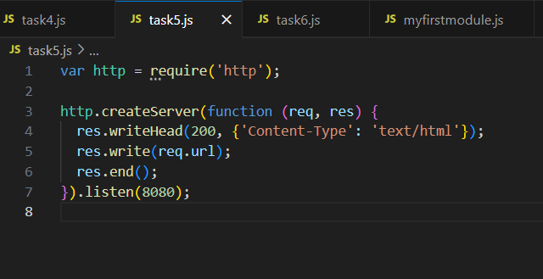

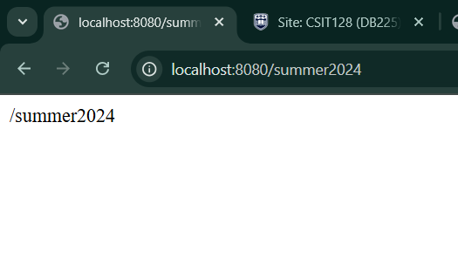

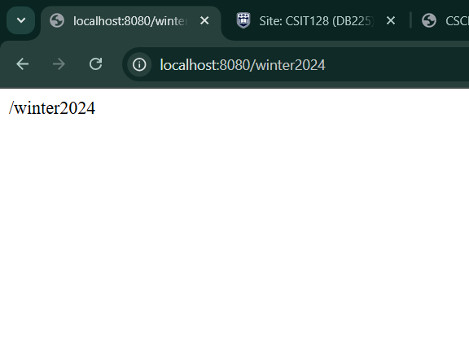

1. Consider slides 54.Display year,month and  day

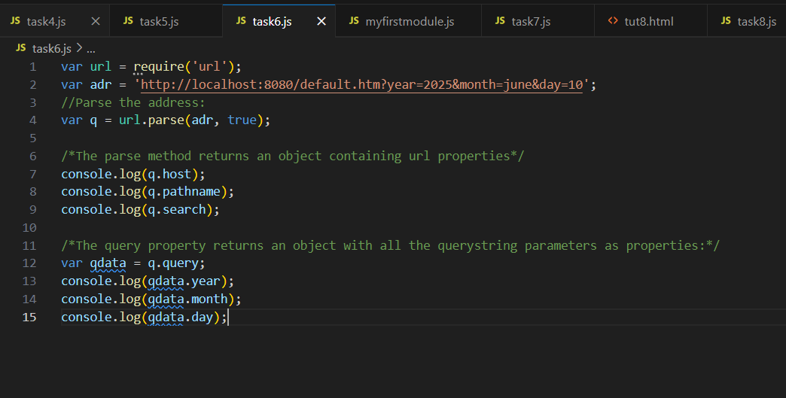

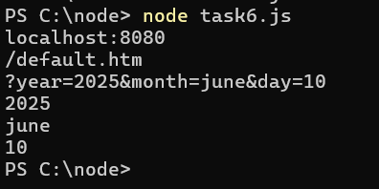

1. Try slide38,39   Create Your Own Module that displays a greeting when call.

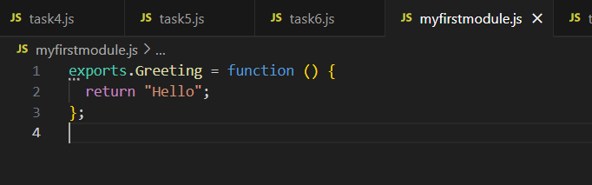

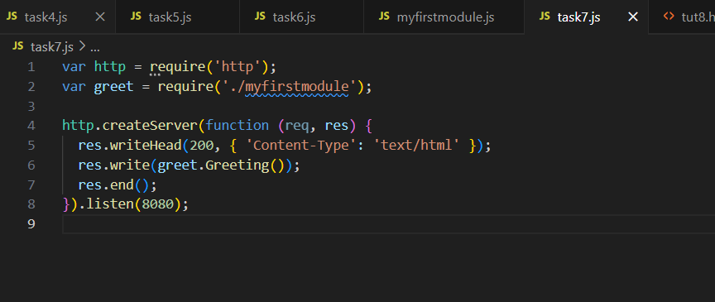

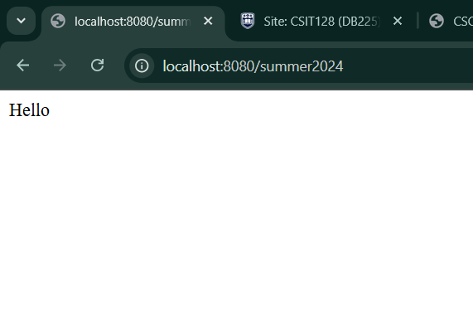

1. Try instructions in slide 44-46, the student can read an html file, and in the html file also write your name ,and student ID.

