
Assignment Cover Sheet
Subject Code: | INFO411
Subject Name: | Data Mining and Knowledge Discovery
Submission Type: | Report
Assignment Title:
Student Name: | Marwa Khot  Joslin Jolly  Zobia Shaikh
Student Number: | 8963186  8964178  8881820
Student Email:
Lecturer Name: | Dr Farhad
Due Date: | 15/03/2026
Date Submitted: | 15/03/2026

PLAGIARISM:  The penalty for deliberate plagiarism is FAILURE in the subject. Plagiarism is cheating by using the written ideas or submitted work of someone else. UOWD has a strong policy against plagiarism.  The University of Wollongong in Dubai also endorses a policy of non-discriminatory language practice and presentation.  PLEASE NOTE: STUDENTS MUST RETAIN A COPY OF ANY WORK SUBMITTED | DECLARATION:  I/We certify that this is entirely my/our own work, except where I/we have given fully-documented references to the work of others, and that the material contained in this document has not previously been submitted for assessment in any formal course of study. I/we understand the definition and consequences of plagiarism.  Signature of Student:

Optional Marks:
Comments:

Lecturer Assignment Receipt (To be filled in by student and retained by Lecturer upon return of assignment)
Subject: | Assignment Title:
Student Name: | Student Number:
Due Date: | Date Submitted:
Signature of Student:

Student Assignment Receipt (To be filled in and retained by Student upon submission of assignment)
Subject: | Assignment Title:
Student Name: | Student Number:
Due Date: | Date Submitted:
Signature of Lecturer

Table of Contents
GITHUB Link 4
Thesis 4
1. Executive Summary 4
2. Pre-processing Steps 5
2.1 Handling Missing Values and Customer Integrity Handling Data 5
2.2 Removing Financial Anomalies Handling Data 5
2.3 Redundancy and Feature Engineering 6
2.4 Conclusion of Pre-Processing 6
4. Classification Evaluations 7
4.1 Handling Data 7
4.2 Features 7
Low quantity may indicate declining interest 8
4.3 Parameter Tuning 8
4.3.1 Decision Tree 8
4.3.2 Neural Network 9
4.4 Evaluation and Analysis 10
4.4.1 Decision Tree Analysis 10
4.4.2 Neural Network Analysis 11
4.4.3 Neural Network vs. Decision Tree 12
4.5 Improving Baseline 13
4.5.1 Initial Decision Tree model 13
4.5.2 Improvement 1 14
4.5.3 Improvement 2 14
4.6 Classification Conclusion 15
4.6.1 The recommended model 15
4.6.2 Challenges 15
4.6.3 Feature engineering 15
4.6.4 Business Recommendation 15
3. Clustering Analysis 16
3.1 Data Preparation for Clustering 16
3.1.1 RFM Feature Engineering 16
3.1.2 Log Transformation 16
3.1.3 Feature Scaling (Z-Score Standardization) 17
3.2 Dimensionality Reduction (PCA) 17
3.2.1 Scree Plot Analysis 17
3.3 Cluster Optimization — Selecting k 18
3.3.1 The Elbow Method 18
3.3.2 Model Selection — k = 2 vs. k = 3 18
3.4 Clustering Results 19
3.4.1 Cluster Visualization — k = 2 19
3.4.2 Cluster Visualization — k = 3 20
3.4.3 Cluster Statistics Summary 20
3.5 Cluster Interpretation 21
3.5.1 Cluster 1 — At-Risk / Dormant Customers (n = 1,871 | 43.1%) 21
3.5.2 Cluster 2 — Potential / Regular Customers (n = 1,704 | 39.3%) 21
3.5.3 Cluster 3 — Champions / High-Value Customers (n = 763 | 17.6%) 21
3.6 Business Recommendations 22
3.7 Clustering Conclusion 22
5. Time Series Analysis 23
5.1 Data Preparation and Initial Analysis 23
5.2 Data Transformation and Smoothing 24
5.3 Seasonality and Decomposition 25
5.4 Stationarity and Model Identification 27
5.5 ARIMA Modeling and 30-Day Forecast 28
5.6 Model Comparison and Optimization 29
5.7 Recommendations In Business Scenario: 30
6. Conclusion: 31

GITHUB Link
https://github.com/Marwakhot/INFO_411

Thesis
This analysis focuses on three main objectives. The first objective is to segment customers into different behavioral groups using K-Means clustering based on RFM (Recency, Frequency, Monetary) profiles. This helps the business understand its customers better and design more targeted marketing strategies.
The second objective is to predict customer churn using classification models, specifically a Decision Tree and a Neural Network. By identifying customers who are likely to stop purchasing, the business can take preventive actions and try to retain them before they leave.
The third objective is to forecast short-term revenue using ARIMA time series modelling. Accurate forecasts can help businesses plan operations more effectively, including inventory management and resource allocation.
To support these three objectives, a careful data pre-processing pipeline was implemented. This step ensured that the dataset was cleaned and prepared properly so that the analysis would be consistent and reliable throughout the study.

Executive Summary
This report presents a detailed data mining analysis of the UCI Online Retail dataset, which includes more than 392,000 transaction records collected between December 2010 and December 2011. The analysis focuses on three main techniques: clustering, classification, and time series forecasting. The goal is to transform raw transactional data into meaningful insights that can support better business decisions.
Before performing the analysis, several preprocessing steps were carried out. Missing CustomerID values (which made up around 25% of the dataset), cancelled transactions, invalid records, and duplicate entries were removed to improve data quality. After cleaning the data, RFM (Recency, Frequency, Monetary) feature engineering was applied. This converted transaction-level information into customer-level behavioural profiles, which were then used in all three analytical tasks.
Using K-Means clustering with $k=3$, the 4,338 customers were grouped into three segments: At-Risk (43.1%), Potential (39.3%), and Champions (17.6%). Although the Champions group contained the smallest number of customers, they generated the highest value, with an average revenue of £7,954 per customer — more than three times the overall average. Principal Component Analysis (PCA) showed that 93.86% of the variance could be represented in two dimensions, supporting the reliability of the clustering results.
For churn prediction, a Neural Network model performed better than a Decision Tree, particularly in terms of sensitivity (84% compared to 65.2%). This means the neural network was able to correctly identify 94 more customers who were at risk of leaving. Feature engineering played a key role in improving the model’s performance. In particular, engagement-related features such as Product Diversity and Average Basket Value significantly improved the model’s ability to detect churn, increasing sensitivity from a baseline of 27.4%.
Finally, the time series analysis showed a steady growth trend in revenue, along with a clear weekly pattern. Sales were highest on Thursdays, while there was no recorded activity on Saturdays. The Auto-ARIMA model (5,1,3)(2,0,0)[7] produced the most accurate forecasts, achieving a Mean Absolute Percentage Error (MAPE) of 3.45%. This level of accuracy allows the model to generate reliable 30-day sales forecasts, which can help businesses plan inventory, logistics, and operational activities more effectively.

2. Pre-processing Steps
The raw "Online Retail" dataset contained several noise factors that could negatively impact the accuracy of our clustering and time series models. To ensure data integrity, we implemented a multi-stage cleaning pipeline in R.

2.1 Handling Missing Values and Customer Integrity Handling Data
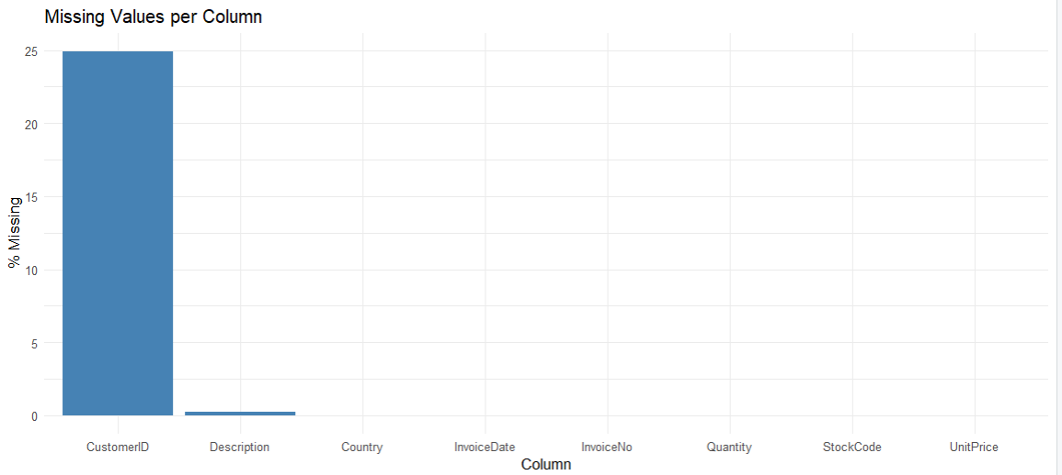
The plot shows that CustomerID is the only column with a significant missing rate at approximately 25%. Since the entire analysis is customer-level, these records cannot be attributed to any individual and imputation is not possible. They were therefore removed. All remaining columns show no meaningful missing values, confirming the dataset is otherwise well-structured

2.2 Removing Financial Anomalies Handling Data
To prepare the data for Time Series and Monetary analysis, we removed transactions that do not represent successful revenue:
- Cancellations: Invoices starting with "C" were filtered out. These represent returns or cancelled orders which would skew our daily sales forecasting.
- Invalid Quantities/Prices: Records with a Quantity or UnitPrice of zero or less were removed. These often represent administrative adjustments, damaged stock, or bad data entry rather than actual customer purchases.

2.3 Redundancy and Feature Engineering
- Duplicate Removal: We used the distinct() function to ensure that no transaction was counted twice, preventing the artificial inflation of sales figures.
- Total Revenue Calculation: A new feature, TotalPrice, was engineered by multiplying Quantity and UnitPrice. This serves as the foundation for our "Monetary" value in clustering and our target variable in time series.
- Temporal Feature Extraction: Using the lubridate package, the InvoiceDate was decomposed into Year, Month, and DayOfWeek. This allows our models to identify seasonal patterns (e.g., higher sales on specific days of the week).
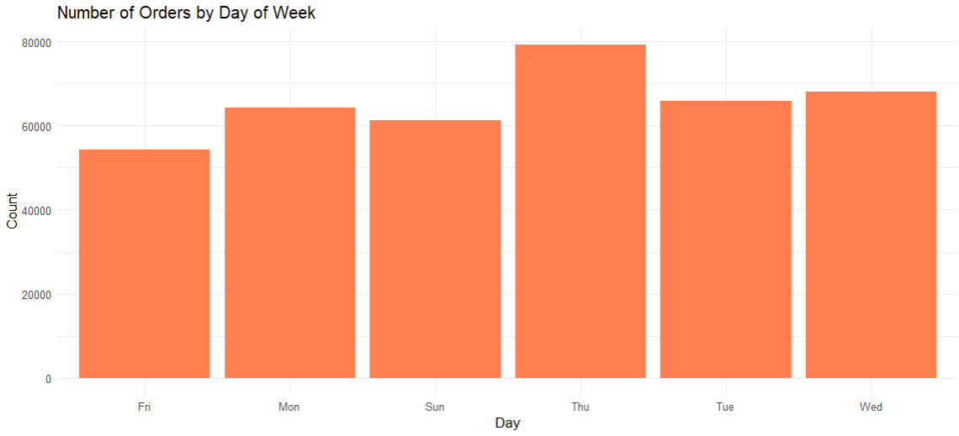
This confirms that the DayOfWeek feature captures a genuine and meaningful pattern. Thursday is the peak sales day at ~80,000 orders and Saturday records zero activity.
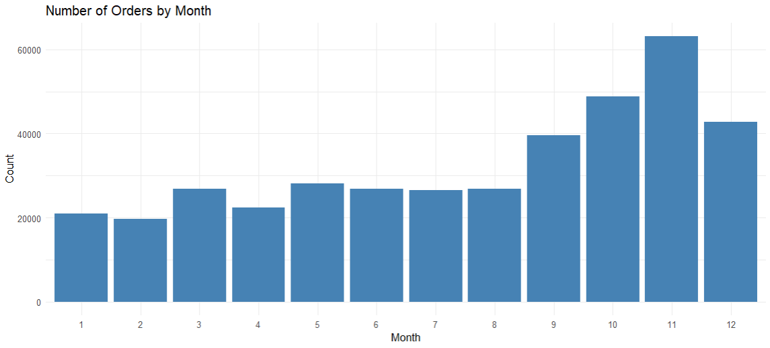
This confirms that the Month captures a real seasonal trend. Order volume nearly triples from the summer baseline to a November peak of 60,000+ orders.

2.4 Conclusion of Pre-Processing
The cleaning pipeline successfully removed all records that would compromise the integrity of the analysis. The removal of missing CustomerIDs accounted for the vast majority of data loss (135,080 rows). All other steps combined removed fewer than 10,000 rows, confirming these were minor anomalies rather than systemic issue

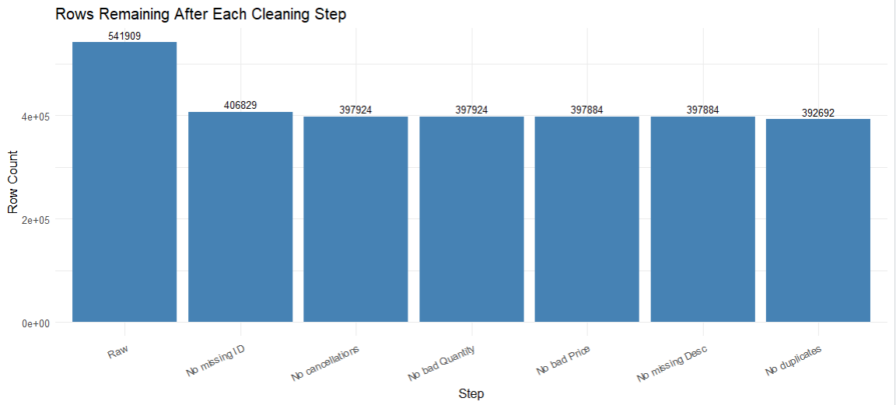

3. Clustering Analysis

3.1 Data Preparation for Clustering
The dataset used for this analysis was derived from the cleaned Online Retail dataset, which contains 392,692 transaction records spanning December 2010 to December 2011. Rather than clustering at the transaction level, the analysis was aggregated to the customer level using RFM (Recency, Frequency, Monetary) feature engineering. This approach is standard in customer analytics as it converts raw transaction logs into a compact, meaningful behavioral profile for each unique customer.

3.1.1 RFM Feature Engineering
RFM metrics were computed by grouping the dataset by CustomerID. A reference date was defined as one day after the latest recorded transaction (2011-12-10 12:50:00) to ensure Recency values are positive and interpretable. The three features constructed were:
- Recency: The number of days elapsed since the customer's most recent purchase. A lower recency indicates a more recently active customer. Computed using difftime(ref_date, max(InvoiceDate), units = 'days')
- Frequency: The total count of distinct invoice numbers associated with each customer. This captures how often a customer transacts, independent of order size. Computed using n_distinct(InvoiceNo)
- Monetary: The total revenue generated by each customer across all transactions. Computed as the sum of TotalPrice (UnitPrice × Quantity) per customer.

The resulting RFM dataset contained 4,338 unique customers. A summary of the raw RFM values is presented below:

Metric | Min | Median | Mean | Max
Recency (days) | 1.00 | 51.09 | 93.05 | 374.12
Frequency (orders) | 1 | 2 | 4.27 | 209
Monetary (£) | 3.75 | 668.57 | 2,048.69 | 280,206

3.1.2 Log Transformation
Before applying any clustering algorithm, it was essential to examine the distribution of the three RFM features. As shown in Figure 1 below, all three variables exhibited significant right-skewed distributions, with long tails driven by a small number of high-frequency, high-spending customers. Frequency showed the majority of customers making only 1–2 purchases, while Monetary had extreme outliers reaching over £280,000.

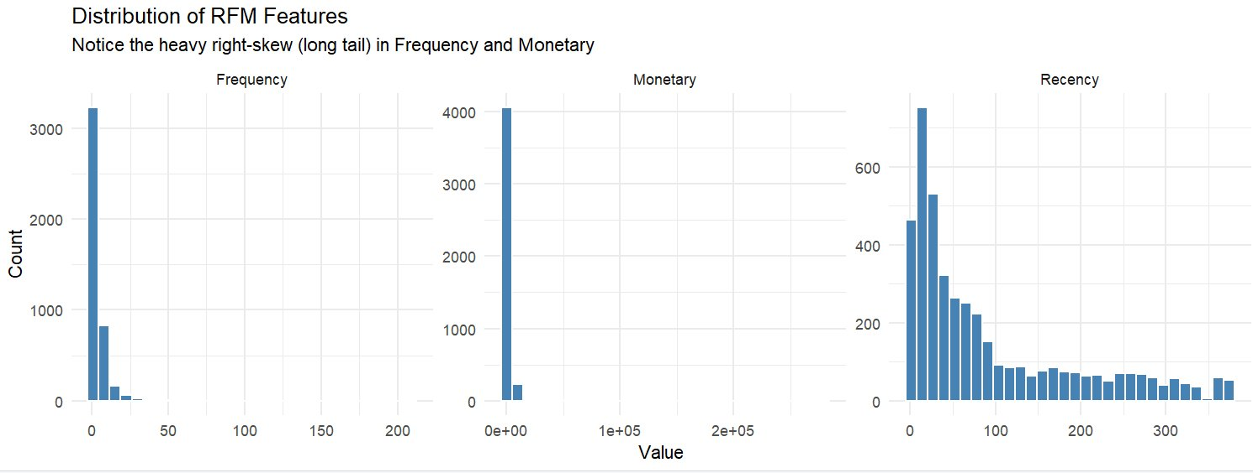
K-Means clustering relies on Euclidean distance calculations, which are highly sensitive to the scale and distribution of input variables. Skewed distributions cause the algorithm to be disproportionately influenced by extreme outliers, distorting cluster centroids away from the true behavioral majority. To address this, a log1p transformation (i.e., log(1 + x)) was applied to all three features. This transformation was chosen over a standard log because it safely handles values of zero, which are present in the dataset. The effect is to compress the long tail, bringing the distributions closer to normality while preserving the relative ordering of customers.

3.1.3 Feature Scaling (Z-Score Standardization)
Even after log transformation, the three RFM features operated on very different numeric scales. Raw Monetary values (even after log) were orders of magnitude larger than Frequency values. Without scaling, K-Means would effectively treat Monetary as the dominant clustering criterion and largely ignore Recency and Frequency. To ensure all three features contributed equally to the distance calculations, Z-score standardization was applied using R's scale() function. This transformed each feature to have a mean of 0 and a standard deviation of 1, placing all variables on a common footing.

3.2 Dimensionality Reduction (PCA)
Although K-Means was applied in the full 3-dimensional RFM space, Principal Component Analysis (PCA) was performed as a complementary step for two purposes: first, to verify the separability of clusters in a 2D projection, and second, to validate the information density of the features before clustering. PCA was applied to the scaled RFM matrix using R's prcomp() function.

3.2.1 Scree Plot Analysis
The scree plot in Figure 2 displays the proportion of total variance captured by each principal component. The results confirm that the RFM feature space is highly compressible:
- PC1 captures 75.1% of the total variance — the dominant axis of customer differentiation, primarily driven by the combined strength of Frequency and Monetary values.
- PC2 captures an additional 18.7% — largely representing the Recency dimension, orthogonal to purchase volume.
- PC3 accounts for only 6.1% — a residual component with minimal explanatory value.

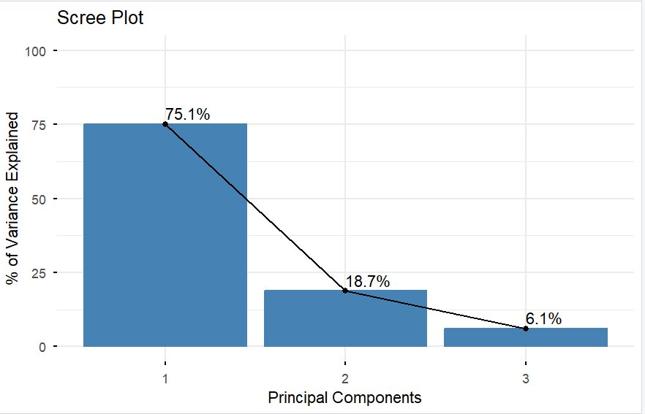
The cumulative variance explained by PC1 + PC2 is 93.86%. This is well above the commonly accepted threshold of 80–85% for meaningful 2D visualization, confirming that the PCA-reduced plot provides a highly faithful and near-complete representation of the original 3D RFM space. The elbow occurs sharply between PC1 and PC2, with a steep drop-off, reinforcing that PC1 is by far the most informative dimension and that the dataset has a strong underlying behavioral gradient separating low-value from high-value customers.

3.3 Cluster Optimization — Selecting k
Determining the appropriate number of clusters is a critical modeling decision in K-Means, as the algorithm requires k to be specified in advance. An incorrect choice leads either to over-simplification (e.g., merging meaningfully different groups) or over-fragmentation (creating artificial distinctions with no business relevance).

3.3.1 The Elbow Method
The Elbow Method was applied by computing the Total Within-Cluster Sum of Squares (WCSS) across a range of k values. WCSS measures intra-cluster compactness — lower values indicate tighter, more homogeneous clusters. The "elbow" point — where the rate of WCSS reduction diminishes sharply — indicates the most efficient number of clusters before additional splits yield diminishing returns.
The analysis indicated that the primary elbow occurs around k = 2, representing the fundamental division between active and inactive customers. However, a secondary inflection point is visible at k = 3, suggesting that a three-cluster solution captures meaningful additional structure within the active customer population.

3.3.2 Model Selection — k = 2 vs. k = 3
Both k = 2 and k = 3 were implemented and compared. K-Means was run with nstart = 25 (25 random initializations) to mitigate the sensitivity of the algorithm to the random starting positions of centroids, ensuring convergence to a globally optimal solution. A fixed random seed (set.seed(42)) was used for reproducibility.

Criterion | k = 2 | k = 3
Mathematical Basis | Clear elbow; strong WCSS reduction | Visible secondary inflection
Business Utility | Active vs. Inactive — too broad | At-Risk / Potential / Champions
Actionability | Only 2 marketing strategies | 3 distinct, targetable segments
Selected? | No — insufficient granularity | ✓ Yes — richer insight

While k = 2 is mathematically cleaner, k = 3 was selected as the final model. The k = 3 solution identifies a distinct middle tier of customers — those who are active but not yet high-value — which is the most actionable group for targeted marketing campaigns. A purely binary segmentation would collapse this critical group into either category, losing the opportunity to differentiate retention strategies.

3.4 Clustering Results

3.4.1 Cluster Visualization — k = 2
Figure 3 presents the k = 2 cluster visualization projected onto the first two principal components (which together capture 93.86% of variance). The two clusters show a meaningful separation along Dim1 (PC1, 75.1%), which primarily represents purchase value and frequency. Cluster 2 (teal triangles) extends far to the right along Dim1, confirming these are higher-value customers. However, there is significant overlap between the convex hulls of the two segments, particularly in the mid-range area, suggesting that a two-cluster model fails to cleanly separate customers of intermediate behavioral profiles.

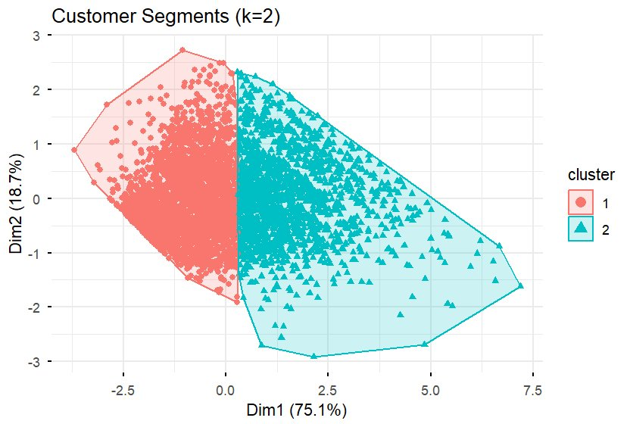

3.4.2 Cluster Visualization — k = 3
Figure 4 presents the k = 3 final model. The three clusters demonstrate clear progressive separation along Dim1, with each cluster occupying a distinct zone of the behavioral space. Cluster 3 (blue squares) is clearly displaced to the far right — representing the Champions. Cluster 1 (red circles) occupies the left region — dormant, low-engagement customers. Cluster 2 (green triangles) fills the middle ground — the Potential customers. The minimal overlap between Clusters 2 and 3 confirms that the algorithm has successfully distinguished a genuinely different behavioral segment, validating the k = 3 decision.

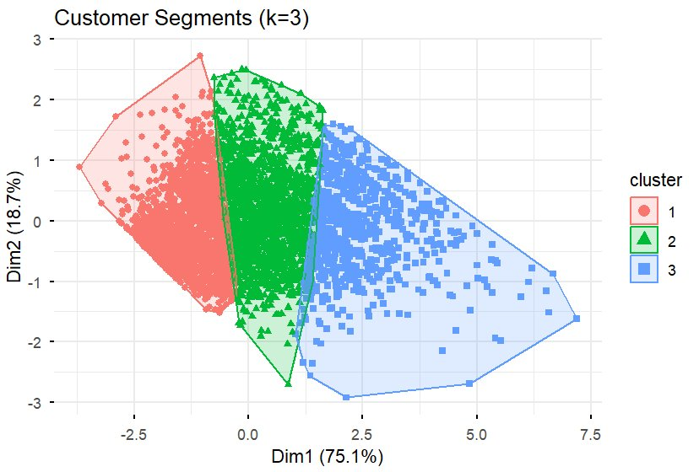

3.4.3 Cluster Statistics Summary

Metric | Cluster 1 (At-Risk) | Cluster 2 (Potential) | Cluster 3 (Champions) | Overall
Customer Count | 1,871 | 1,704 | 763 | 4,338
% of Total | 43.1% | 39.3% | 17.6% | 100%
Avg Recency (days) | 168.0 | 44.1 | 17.8 | 93.1
Avg Frequency | 1.36 | 3.37 | 13.40 | 4.27
Avg Monetary (£) | £362 | £1,256 | £7,954 | £2,049

3.5 Cluster Interpretation

3.5.1 Cluster 1 — At-Risk / Dormant Customers (n = 1,871 | 43.1%)
This cluster is the largest in terms of the number of customers, accounting for about 43% of the total customer base. The main characteristics of this group include a very high average Recency of 168 days, a very low Frequency of only 1.36 orders per customer, and a relatively small Monetary value of £362. These figures suggest that customers in this segment made very few purchases, most likely just one or two, and have not returned for more than five months.
Considering that the dataset covers a 12-month period, an inactivity period of 168 days is a strong indication that many of these customers may have already churned. The combination of low purchase frequency and long inactivity also suggests that these individuals were likely occasional or one-time buyers, such as customers making seasonal purchases or buying gifts, rather than regular shoppers who developed an ongoing relationship with the brand.

3.5.2 Cluster 2 — Potential / Regular Customers (n = 1,704 | 39.3%)
The second cluster includes customers who show a moderate level of activity. On average, their Recency is around 44 days, meaning they have made a purchase within the last six weeks. They also have a Frequency of about 3.37 orders and an average Monetary value of £1,256. These figures suggest that they are still actively engaged with the platform and return to make purchases from time to time.
Although their spending level is meaningful, it is still much lower than that of the Champions segment. Because of this, this group represents an important growth opportunity for the business. Since these customers are already familiar with the brand and have developed a purchasing habit, encouraging them to spend more or buy more frequently may require less effort than trying to bring back customers who have become inactive. With the right incentives, such as loyalty rewards or targeted promotions, some of these customers could potentially move into the high-value segment.

3.5.3 Cluster 3 — Champions / High-Value Customers (n = 763 | 17.6%)
Although it is the smallest segment, Cluster 3 is the most important group from a business perspective. Customers in this cluster have an average Recency of only 17.8 days, meaning they purchased very recently. They also show a high Frequency of 13.4 orders and an average Monetary value of £7,954, which is more than six times higher than the Potential group. These values indicate that they are the brand’s most loyal and highest-spending customers. Their recent activity also shows that they are still actively engaged with the business at the time of the analysis.
The difference between Cluster 2 and Cluster 3 is particularly noticeable. Cluster 2 customers have an average Frequency of 3.37 purchases and an average spending value of £1,256, while Cluster 3 customers purchase much more frequently and spend significantly more. This clear gap shows that the Champions segment is not just slightly better than the others, but behaviourally very different. Because of this, it makes sense for businesses to treat this group as a special segment and focus on strong retention strategies, such as personalised rewards or exclusive benefits, to maintain their loyalty.

3.6 Business Recommendations
The three-segment model translates directly into a differentiated customer relationship strategy. Rather than applying a uniform marketing approach across all customers, the following targeted interventions are recommended:
Segment | Key Behavioral Signal | Business Risk | Recommended Strategy
At-Risk (C1) | 168-day silence, 1.36 orders | High — likely churned permanently | Win-back email with time-limited discount; low budget allocation
Potential (C2) | Active, 44-day recency, moderate spend | Medium — risk of stalling at current level | Loyalty program, spend-threshold rewards, cross-sell campaigns
Champions (C3) | 17.8-day recency, 13+ orders, £7,954 | Low — currently retained, but high cost if lost | VIP tiers, early product access, personalised service, retention incentives

3.7 Clustering Conclusion
The K-Means clustering process converted 392,692 individual transaction records into a three-segment customer behaviour model. Several methodological steps were applied during the analysis to ensure meaningful results. First, RFM aggregation was used to summarise transaction-level data into customer-level behaviour. A log1p transformation was then applied to reduce skewness in the data, followed by Z-score standardisation so that each feature contributed equally to the clustering process. The choice of $k=3$clusters was made to create segments that are clear enough for practical business interpretation.
Principal Component Analysis (PCA) further supported the quality of the model. Although the dataset contained three RFM features, PCA showed that 93.86% of the total variance could be represented using only two principal components. This indicates that the features capture the majority of the information and also explains why the cluster visualisations appear clearly separated.
The final clustering model produced three distinct customer groups: At-Risk (43.1%), Potential (39.3%), and Champions (17.6%). Each segment displayed noticeably different RFM characteristics, reflecting different stages in the customer lifecycle.
One of the most important business insights from this analysis is the concentration of value among a relatively small group of customers. The Champions segment, which represents only 17.6% of the customer base, generates significantly higher revenue, with an average of £7,954 compared to the overall average of £2,049. This suggests that businesses should prioritise retaining these high-value customers. Marketing efforts should first focus on maintaining the loyalty of Champions, followed by strategies aimed at converting Potential customers into higher-value buyers, while more limited and cost-effective efforts can be directed toward re-engaging At-Risk customers.

4. Classification Evaluations

4.1 Handling Data
The Online Retail dataset does not contain an explicit churn label, and so we defined the IsChurned label using RFM-based logic. A customer was defined as churned if either of the following conditions were met:
IsChurned = Yes if:
DaysSinceLastPurchase > 90 days
OR
PurchaseFrequency <= 3 AND TotalSpent <= £100
Churn Distribution Table:
Class | Customer Count | Percentage
Not Churned (No) | 2831 | 65.3%
Churned (Yes) | 1507 | 34.7%
Total | 4338 | 100%

The resulting class distribution showed a 35/65 split which is suitable for classification without the need of using any resampling techniques.

4.2 Features
Since the RFM features were used to define IsChurned, they were excluded as model inputs to ensure the model learns genuine behavioural patterns rather than simply reversing the churn formula. Instead, features were engineered from the raw transaction data to serve as model inputs.
Feature | Description | Why it’s relevant
ProductDiversity | Number of unique products bought | High diversity indicates brand loyalty
AvgBasketValue | Average spend per order | Low spend per order suggests disengagement
DaysSinceFirstPurchase | Days since first purchase | Longer tenure suggests loyalty
AvgQuantity | Average items per transaction | Low quantity may indicate declining interest
AvgUnitPrice | Average price per item | Captures price sensitivity of the customer

4.3 Parameter Tuning

4.3.1 Decision Tree
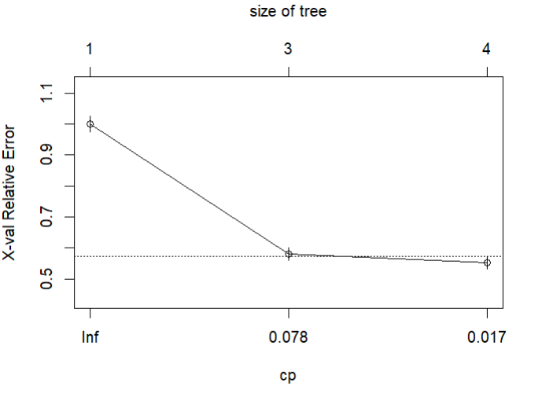
The rpart package was used to build the Decision Tree with method=’çlass’ for classification. The complexity parameter (cp) controls tree size. The optimal cp was selected by identifying the value with the lowest xerror from the cp table. Pruning was applied to remove branches that overfit the training data.

CP graph
The cp plot shows that error dropped significantly from tree size 1 to 3, after which improvement is stable. This indicates that a tree with 3 splits provides the optimal balance between complexity and accuracy. Adding further splits would yield in minimum improvement while increasing the risk of overfitting. The pruned tree was therefore set at cp = 0.078.

4.3.2 Neural Network
The Neural Network was built using TensorFlow/Keras with the following architecture.
Layer | Neurons | Activation | Purpose | Dropout
Input / Hidden 1 | 64 | ReLU | Learns basic patterns | 0.3
Hidden 2 | 32 | ReLU | Combines patterns | 0.3
Hidden 3 | 16 | ReLU | Refines patterns | 0.2
Output | 1 | Sigmoid | Output churn probability | -

- ReLU activation was used for hidden layers as it is the most effective for binary classification problems.
- Sigmoid output converts the final value to a probability between 0 and 1.
- 50 epochs was chosen as a starting point. The training history plots confirmed the model converged without overfitting.
- Class weights of {0:1, 1:2} were applied to address the class imbalance in the dataset where non-churned customers (65%) significantly outnumbered churned customers (35%). A weight of 2 was assigned to the churned class giving it more importance than the not churned class reflecting the business reality that missing an actual churner is more costly than incorrectly flagging a loyal customer.
- Dropout rate of 0.3 was applied for the first two layers and reduced to 0.2 on the third layer since it consists of only 16 neurons and keeping a high dropout rate would result in loss of information. This forced the model to learn generalized patterns rather than memorizing the training data, improving its ability to make accurate predictions on unseen customers.
- The model was trained for 50 epochs due to the size of the dataset (4338 customers) . A batch size of 32 was used; the model updated its internal weights after every 32 customers. This lead to more frequent updates and better learning.
- The Adam optimizer was used to update the model’s weights during training since it automatically adjusts the learning rate during training.
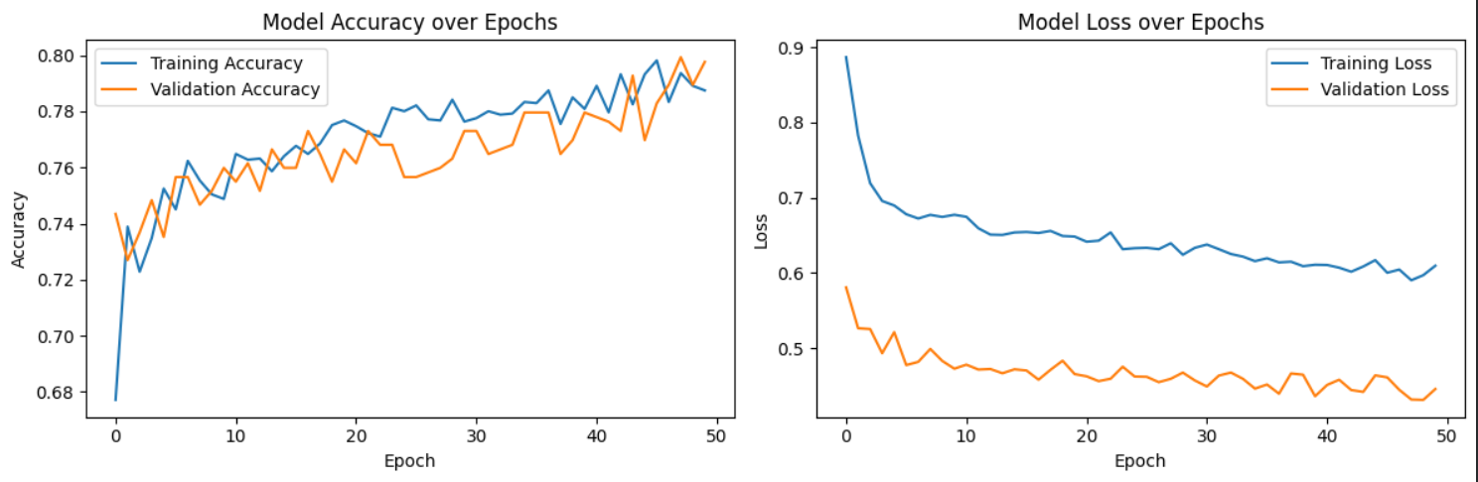
- Binary cross-entropy was used as the loss function since this is a binary classification problem (churned vs not churned).

The accuracy plot shows that both training and validation accuracy started at approximately 68-74% and and steadily improved throughout the 50 epochs, reaching approximately 79-80% by the end of training. Both curves track closely throughout, confirming that the model is not overfitting and is learning patterns that generalise well to unseen data. The loss plot shows training loss decreasing steadily from 0.9 to around 0.6, while validation loss stabilised at a lower range of around 0.45-0.48. The gap between training and validation loss is attributed to the class weights applied during training, which double the penalty for missing churned customers, artificially inflating the training loss. Validation loss is not affected by class weights, resulting in a lower and more stable curve.

4.4 Evaluation and Analysis

4.4.1 Decision Tree Analysis
The Decision Tree was evaluated on the 30% test set consisting of 1301 customers.
Metrics
Metric | Value
Accuracy | 79.7%
Sensitivity | 65.2%
Specificity | 87.2%
Precision | 72.4%

Confusion Matrix
 | Predicted Not Churned | Predicted Churned
Actually Not Churned | 749 | 154
Actually Churned | 110 | 288

The Decision Tree correctly identified 749 out of 859 non-churned customers and 288 out of 442 churned customers. However it missed 154 actual churners and incorrectly flagged 110 loyal customers as churned. It achieved an accuracy of 79.7% and sensitivity of 65.2% which shows the model was able to catch 2 in 3 churners. Specificity of 87.2% shows the model was strong at correctly identifying loyal customers. The model was correct 72.4% of the time when it predicted a customer as churned.
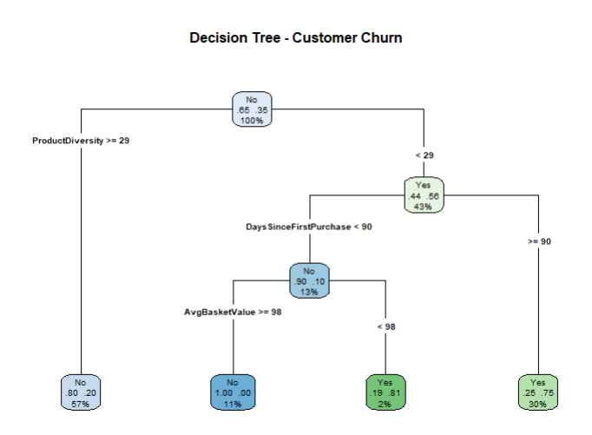
Pruning the Decision Tree showed very minimal improvement. It gave very identical results compared to the original tree. This could probably be due to the pruning algorithm selecting the same cp value the original tree was built with, resulting in no structural change to the tree. This is consistent with the cp plot which showed that the cross validation error had already stabilised at 3-4 splits, confirming the original Decision Tree was already at its optimal complexity and was not overfitting the training data.

4.4.2 Neural Network Analysis
The Neural Network was evaluated on the same 30% test set for a fair comparison.
Confusion Matrix
 | Predicted Not Churned | Predicted Churned
Actually Not Churned | 665 | 180
Actually Churned | 75 | 382

Metrics
Metric | Value
Accuracy | 80.4%
Sensitivity | 84%
Specificity | 79%
Precision | 68%
F1-Score | 75%

The Neural Network correctly identified 665 out of 845 non-churned customers and 382 out of 457 churned customers. It missed only 75 actual churners, significantly fewer than the Decision Tree’s 154, but incorrectly flagged 180 loyal customers as churned compared to 110 for the Decision Tree.
The Neural Network achieved an overall accuracy of 80.4%. The most notable difference is in sensitivity. The Neural Network achieved 84% compared to 65.2% for the Decision Tree. This means the Neural Network caught 94 additional at-risk customers. The trade-off is a lower specificity of 79% compared to 87.2% with the Decision Tree, meaning the Neural Network incorrectly flagged 70 more loyal customers as churned. Precision dropped slightly to 68% whereas F1-Score of 75% reflects a strong balance between precision and recall for the churned class.

4.4.3 Neural Network vs. Decision Tree
Metric | Decision Tree | Neural Network | Which performed better?
Accuracy | 79.7% | 80.4% | NN
Sensitivity | 65.2% | 84% | NN
Specificity | 87.2% | 79% | DT
Precision | 72.4% | 68% | DT
Missed Churners | 154 | 75 | NN
False Alarms | 110 | 180 | DT

Both models achieved similar overall accuracy of approximately 80%, confirming that the feature set was effective for churn prediction. The key difference between the two models lies in their sensitivity and specificity tradeoff. The Decision Tree was more careful about flagging customers as churned, resulting in higher precision and specificity but missing more actual churners. The Neural Network on the other hand is more aggressive, it flags more customers as churned, catching significantly more actual churners at the cost of more false alarms.
Which model is better for churn prediction?
In the context of customer churn prediction, sensitivity is the most critical metric. A missed churner represents a customer the business could have targeted with a retention offer but didn’t, resulting in a lost customer and lost revenue. A false alarm on the other hand means a loyal customer receives an unnecessary promotion, a far less costly outcome.
Based on this reasoning, the Neural Network would be the most suitable model for this business problem. It missed only 75 churners compared to 154 for the Decision Tree, meaning 79 additional at-risk customers were correctly identified and could be targeted with retention strategies.

4.5 Improving Baseline

4.5.1 Initial Decision Tree model
The baseline model was established using a Decision Tree trained on three features: AvgQuantity, AvgUnitPrice and DaysSinceFirstPurchase. These were selected as the most straightforward behavioural signals available from the raw transaction data.
Metrics
Metric | Value
Accuracy | 69.6%
Sensitivity | 27.4%
Specificity | 91.3%
Precision | 61.7%

Confusion Matrix
 | Predicted Not Churned | Predicted Churned
Actually Not Churned | 784 | 75
Actually Churned | 321 | 121

The initial Decision Tree correctly identified 784 non-churned customers but only 121 churned customers, missing 321 actual churners. It achieved an accuracy of 69.6% with sensitivity of only 27.4% meaning the model missed approximately 73% of actual churned customers. This indicated the three features were not providing strong enough signal to reliably distinguish churned from non-churned customers. AvgQuantity and AvgUnitPrice capture transaction-level behaviour but do not directly reflect customer engagement or loyalty. DaysSinceFirstPurchase captures customer loyalty but was insufficient by itself to predict whether a customer will churn.

4.5.2 Improvement 1
To address this, two additional engagement-focused features were introduced – ProductDiversity and AvgBasketValue. These two features provided the model with a more complete picture of customer engagement, which is fundamentally what churn prediction relies on.
Metric | Baseline model | Improved model | Change
Accuracy | 69.6% | 79.7% | +10.1%
Sensitivity | 27.4% | 65.2% | +37.8%
Specificity | 91.3% | 87.2% | -4.1%
Precision | 61.7% | 72.4% | +10.7%

Adding these two features resulted in significant improvements across all key metrics. Accuracy improved by 10% and most notably, sensitivity significantly increased from 27.4% to 65.2% which shows the model could now catch 2 in 3 churners. Specificity slightly dropped by 4.1% indicating the model became slightly more aggressive in flagging customers as churned which is considered acceptable given the substantial gain in sensitivity. This demonstrates that engagement-based features are significantly more informative for churn prediction than volume and price features alone.

4.5.3 Improvement 2
While the improved Decision Tree showed strong progress, the Neural Network was introduced as a more powerful alternative capable of learning complex non-linear relationships between features. The same 5 features were used for a fair comparison. Additionally class weights of {0:1, 1:2} were applied to address the class imbalance. The dataset had approximately twice as many non-churned customers (65%) as churned customers (35%), meaning the model naturally favoured predicting ‘Not Churned’. Thus, class weights were used to penalise the model twice as heavily for missing a churned customer during training.
Model Comparison Table
Model | Features | Accuracy | Sensitivity | Specificity | Precision
Baseline DT | 3 | 69.6% | 27.4% | 91.3% | 61.7%
Improved DT | 5 | 79.7% | 65.2% | 87.2% | 72.4%
NN | 5 + class weights | 80.4% | 84% | 79% | 68%

The initial weak performance of the baseline model highlighted that feature selection is the most critical factor in churn prediction. The wrong features will produce poor results regardless of model complexity. Adding engagement-focused features (productDiversity and AvgBasketValue) produced the most significant improvement, more than doubling sensitivity further to 84% confirming that for this dataset and business problem, a Neural Network with carefully selected features and class balancing is the optimal approach for customer churn prediction.

4.6 Classification Conclusion

4.6.1 The recommended model
The Neural Network outperformed the Decision Tree as the superior model for customer churn prediction on this dataset. While both models achieved similar overall accuracy, the Neural Network demonstrated significantly higher sensitivity, correctly identifying 94 more churned customers. Given that the primary business objective is to identify at-risk customers before they leave, sensitivity is the most important metric and the Neural Network is the recommended model.

4.6.2 Challenges
A key challenge encountered during this analysis was the absence of an explicit churn label in the dataset. Churn was therefore defined using a RFM formula. In a real business setting, explicit churn records such as account cancellations or subscription terminations would have helped in producing more reliable and meaningful results.

4.6.3 Feature engineering
Feature selection proved to be the most impactful factor in model performance throughout this analysis. Features that directly capture customer engagement were considered to be far more informative for churn prediction than basic transaction volume and price metrics.

4.6.4 Business Recommendation
Based on this analysis, the business should focus retention efforts on customers flagged as churned by the Neural Network. Specifically, customers with low ProductDiversity, low AvgBasketValue and short CustomerLifespan represent the highest churn risk and should be targeted with personalised promotions and loyalty incentives.

Time Series Analysis
This section focuses on time series analysis of the monthly revenue data. The goal is to identify trends and patterns in revenue over time and to build forecasting models that can predict future revenue.

5.1 Data Preparation and Initial Analysis
This section focuses on time series analysis of the monthly revenue data. The goal is to identify trends and patterns in revenue over time and to build forecasting models that can predict future revenue.
Since the dataset contains individual transaction records, the first step was to transform it into a sequential format at uniform intervals:
- Date Standardisation: The InvoiceDate field was converted into a standard Date object to facilitate chronological ordering.
- Daily Aggregation: Individual transactions were aggregated by day. The TotalPrice was summed for each date to create a single "Daily Sales" metric, reducing the noise associated with thousands of individual entries.
- Time Series Conversion: The aggregated data was converted into a formal Time Series (ts) object in R. A frequency of 365 was initially set to capture the annual timeline, spanning from December 2010 to December 2011.
- Trend Line: A basic graph was created with a red Trend Line to show whether the business is growing or shrinking
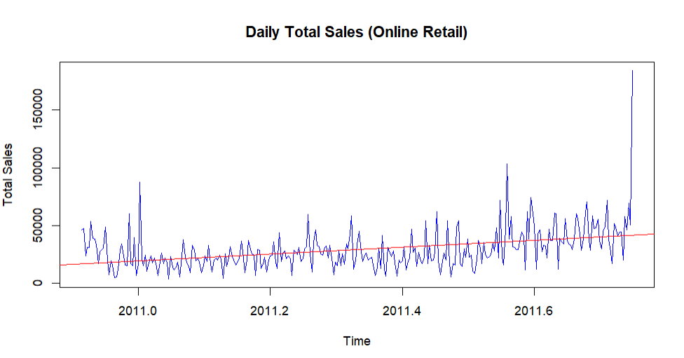
Observations from the Graph:
- The red line clearly moves upward, proving that total sales increased throughout the year.
- The "gap" between the highest and lowest sales days gets wider over time. This is common in retail due to holiday seasons.
- The blue lines (actual daily sales) show massive "spikes," especially toward the end of the year. This suggests that sales become more unpredictable as the business grows.

5.2 Data Transformation and Smoothing
To make the data easier for the model to understand, two main techniques were used:
- Log Transformation: The original data had "changing variance" (the spikes got bigger as sales grew). The Log transformation was necessary to stabilize the "variance." This ensures the model treats all parts of the year equally. Doing this "shrinks" large values more than small ones, which helps make the wild spikes in the data more consistent.
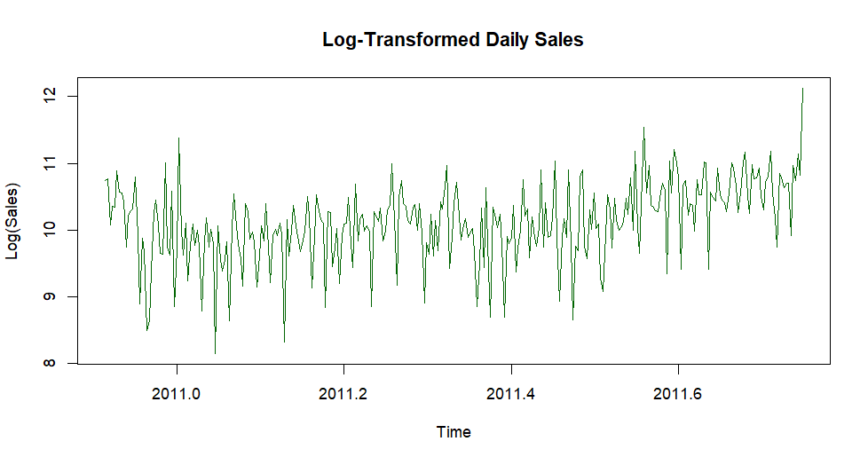As we can see the "height" of the sales fluctuations looks much more consistent from the start of the year to the end. The graph now looks like a steady band of activity.

- Simple Moving Average (SMA): The SMA function from the TTR package was used to create "smoothed" versions of the sales data.
- 7-Day SMA: Calculated by averaging the last 7 days of sales to show a weekly trend.
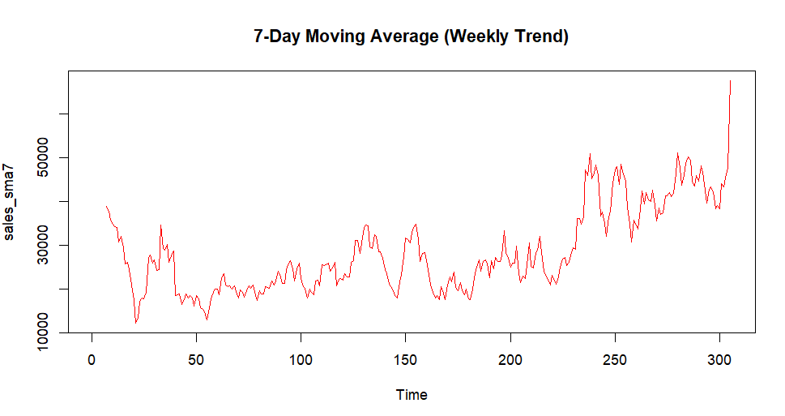
This graph removed the daily "jitter" but still showed the frequent ups and downs of the business.
- 30-Day SMA: Calculated by averaging the last 30 days to show a monthly trend.
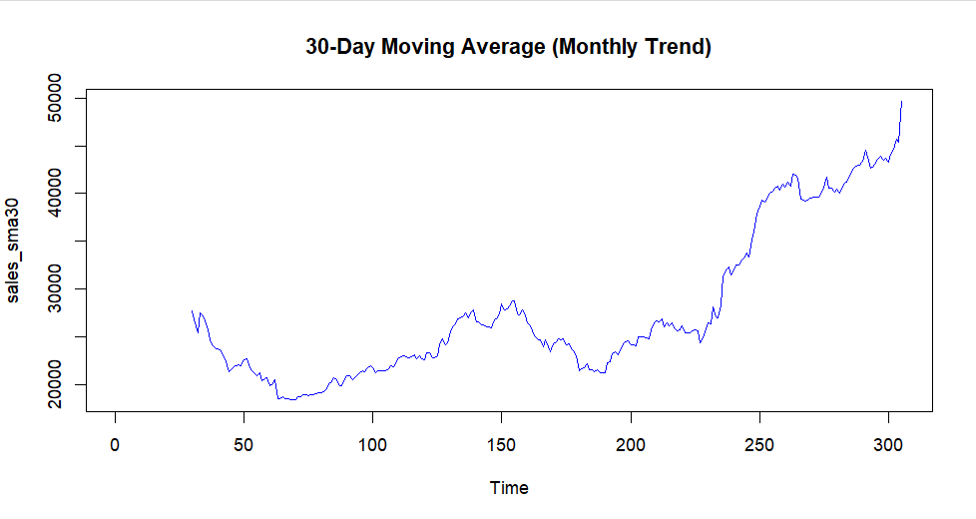
This graph is much smoother. It hides the daily and weekly noise to reveal a very clear, long-term upward climb in sales toward the end of the year.

5.3 Seasonality and Decomposition
The To identify repeating patterns within the sales cycle, the data was analyzed based on the day of the week:
- Day Identification: Each date was labeled with its corresponding day (Monday through Sunday) to group the sales data.
- Weekly Frequency Setting: The time series was updated with a frequency of 7. This informs the system that the business operates on a weekly cycle so to ensure the forecast understands that a "low" Sunday is normal and not a sign of business failure.
- Sales Distribution (Boxplot): A boxplot was generated to compare the typical
sales volume for each day of the week.
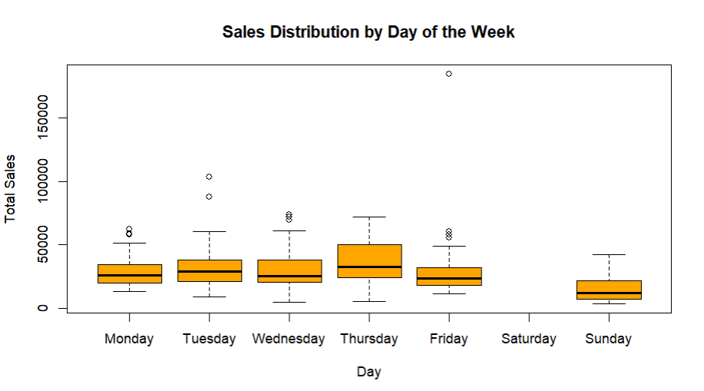
This reveals that there are zero sales recorded on Saturdays. And Thursday appears to be the strongest sales day on average, while Sunday is the lowest active day.

- Decomposition: The decompose() function was used to break the log-transformed data into four layers:
a. Observed: The actual recorded data.
b. Trend: The long-term direction of the business (growth or decline).
c. Seasonal: The repeating weekly "wave."
d. Random: Unpredictable "noise" or one-time events.
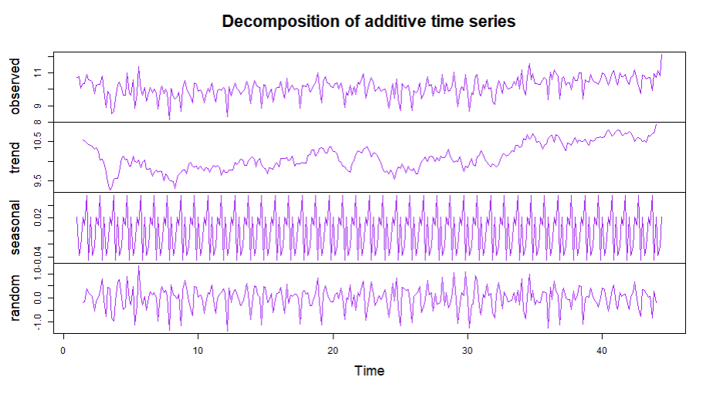
The "Seasonal" row shows a perfectly repeating pattern. This confirms that the 7-day cycle is extremely strong and predictable.
The "Trend" row shows that despite the daily fluctuations, the business has experienced a steady upward climb since the middle of the year.
- Seasonal Adjustment: The seasonal patterns were subtracted from the data to view the "pure" sales trend without the distraction of weekly ups and downs.
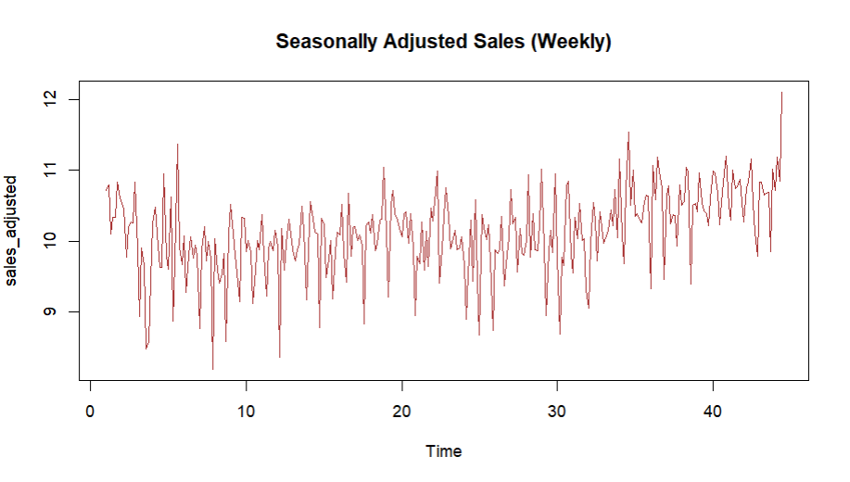
The line is gradually moving higher toward the right side of the plot. This confirms that the business is expanding over time.

5.4 Stationarity and Model Identification
The To identify repeating patterns within the sales cycle, the data was analyzed based on the day of the week:
As Before building the forecast model, the data must be "stationary," meaning its statistical properties (like average and variance) do not change over time
- Stationarity Test (ADF): The Augmented Dickey-Fuller (ADF) test was used to check for trends. A p-value of 0.01 was achieved, which is significantly lower than the 0.05 threshold, indicating the data is already stationary.
- Differencing: Even though the ADF test said the data was technically stationary, we applied differencing (d=1) because the earlier graphs showed a clear upward trend. Differencing removes that "drift" so the model doesn't over-predict growth and stays focused on the daily patterns.
- Correlation Analysis (ACF and PACF): Two specific plots were generated to help choose the correct settings for the ARIMA model:
  - ACF (Autocorrelation Function): Measures the relationship between current sales and past sales.
  - PACF (Partial Autocorrelation Function): Measures the direct relationship between sales at specific time lags.
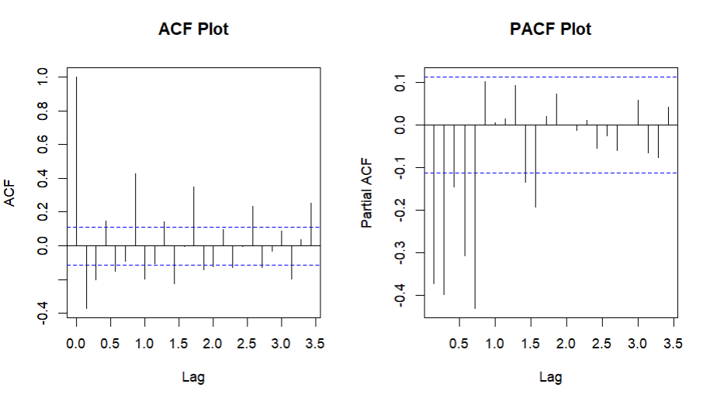
In ACF plot most of the bars stay inside the blue dashed lines, which indicates that the data is largely stable (stationary). However, a few specific spikes poke out in a repeating way.
The PACF plot shows very large negative spikes at the beginning, which immediately cut off and stay under the blue significance line for the rest of the lags. indicator of a strong Autoregressive (p) process. Thus Decision on p=5
Decision on q=0: Since There is one strong spike at lag 1 in ACF bars after that the spikes are inside the blue lines, not cutting off sharply and small and scattered instead.

5.5 ARIMA Modeling and 30-Day Forecast
With the data stabilized and the weekly patterns identified, the final step was to build the predictive model:
- Model Selection: An ARIMA (5, 1, 0) model was fitted.
- Forecasting: The model was asked to "project" sales for the next 30 days into the future.
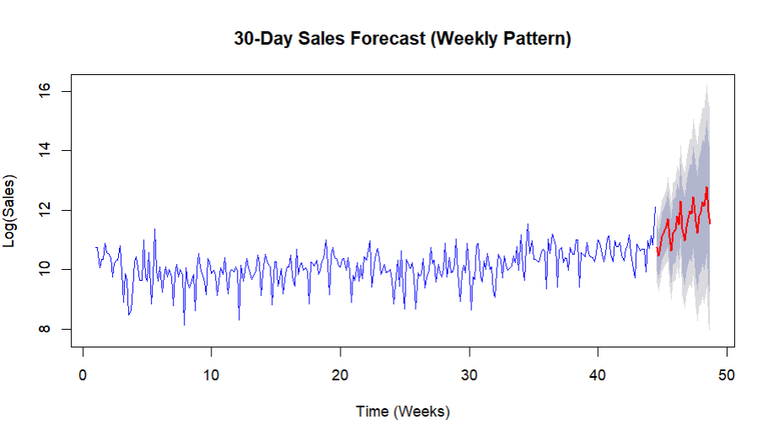
- Accuracy Evaluation: The model's performance was checked using the accuracy() function to ensure the predictions are reliable enough for business use.
  - MAPE (Mean Absolute Percentage Error): 4.57%means the model is, on average, 95.43%accurate
  - RMSE (Root Mean Squared Error): 0.593 which is relatively low, it confirms that the model didn't have any "massive fails" where it missed a sales day by a huge margin.
  - MAE (Mean Absolute Error): 0.457, Combined with the low ACF1 (0.05), it proves that the model has successfully captured almost all usable information from the historical data, leaving only random noise.

5.6 Model Comparison and Optimization
To ensure the highest possible accuracy, three different forecasting algorithms were tested and compared using their training metrics:
- Manual ARIMA (5,1,0)
- Auto-ARIMA (5,1,3)(2,0,0)[7]
- ETS (Exponential Smoothing): A different type of model that focuses on "weighted averages" of past data rather than correlations.
We compared them using MAPE and Auto-ARIMA was the lowest 3.45%
It is because the Auto-ARIMA is more complex (it uses 5 "Auto-Regressive" terms and 3 "Moving Average" terms). This complexity allows it to capture those small, specific spikes we saw in the ACF plot that the manual model missed

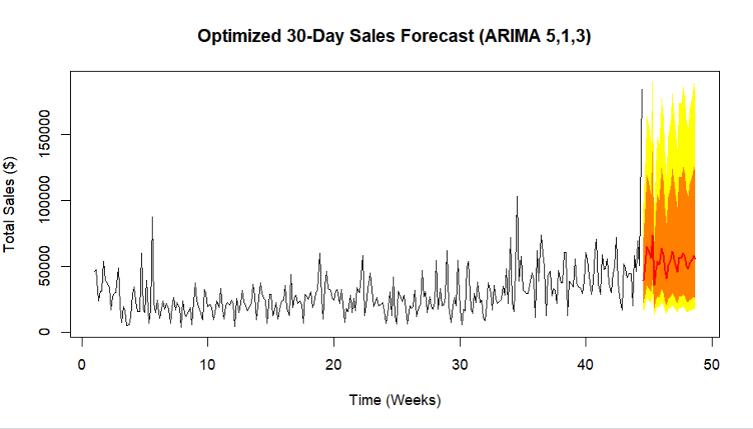
Transformation back to Dollars: In the final step, the code used exp(). This is a vital decision because it converts the "Log" numbers (which are hard to read) back into Actual Dollar Sales.
The red line shows the most likely path of sales. Because the model is now optimized, the "waves" in the forecast are much more refined, reflecting the specific daily habits of the customers.

5.7 Recommendations In Business Scenario:
- Bulk-Up Logistics for Friday: Because Thursday is the big sales day, warehouse will be busiest on Friday morning. Schedule extra packing staff then to ensure same-day or next-day shipping promises are kept.
- Targeted Sunday Discounts: Since Sunday shows a significant dip, launch Sunday Flash Sales or exclusive app-only coupons to fill that gap and keep revenue stream more consistent.
- Safety Stock Levels: Use the "Lower Bound" of the forecast (the bottom of the gray shaded area) to set your minimum stock levels. This ensures you never run out of products even during a bad week.
- Time Your "Product Drops": If they are launching a brand-new product or restocking a popular item, release it on Thursday morning. It will capture the maximum number of people who are already in the habit of visiting the site that day.
- Prepare for the "Returns Wave": Items bought on Thursday usually arrive to the customer by Monday or Tuesday. This means the customer service team should expect a spike in return requests or exchange emails by Wednesday.

Conclusion:
The findings from this report show a clear pattern in the business data. A relatively small group of loyal customers is responsible for a large share of the company’s revenue, while a significant portion of customers appear to be gradually becoming inactive. At the same time, the sales data shows a stable weekly pattern that the business has not fully taken advantage of yet.
One of the key insights from the clustering analysis is the risk created by revenue concentration. The Champions segment makes up only 17.6% of the total customer base, yet these customers generate an average of £7,954 each. In comparison, around 43% of customers fall into the At-Risk category and have not made a purchase for more than five months. This suggests that the company’s revenue relies heavily on a relatively small number of loyal customers. If even 10–15% of these Champions were to stop purchasing, the effect on revenue could be significant and difficult to recover from quickly. Because of this, businesses should focus strongly on retaining these high-value customers. Strategies such as loyalty rewards, personalised communication, and exclusive offers could help maintain their engagement and reduce the risk of losing them.
The Potential segment, which represents 39.3% of customers, offers an important opportunity for growth. These customers are still active and already have some level of trust in the brand. Encouraging them to increase their spending through loyalty programmes, special incentives, or reward thresholds could gradually move them into the Champion category. In many cases, investing in customers who are already engaged can produce better results than trying to bring back customers who have been inactive for a long period.
The churn prediction results also highlight a practical advantage for the business. The Neural Network model achieved a sensitivity of 84%, meaning it was able to identify most customers who were likely to leave. This allows the company to take action before customers actually stop purchasing. For example, businesses could send targeted promotions, personalised recommendations, or reminder emails to customers who show early signs of disengagement. Retaining an existing customer through these types of actions is usually far less expensive than acquiring a new customer.
The time series forecasting results reveal another useful insight. Sales follow a consistent weekly pattern, with Thursdays showing the highest revenue and Sundays typically recording the lowest sales. In addition, demand increases noticeably toward the end of the year. Businesses could use this information to improve their planning and operations. For instance, they could schedule more warehouse staff on high-demand days, run promotional campaigns on slower days to boost sales, and prepare additional inventory in advance for the seasonal increase in demand.
Overall, the results reinforce several well-known retail strategies. Businesses benefit from protecting their most valuable customers, encouraging moderately active customers to become more engaged, responding early to signs of customer churn, and organising operations around predictable sales patterns. While these ideas are often discussed in theory, the data analysis in this report provides clear evidence that supports them.

