iSocial Usability Findings
Matthew Schmidt
University of Missouri
schmidtma@missouri.edu

This document is licensed under the GNU Free Documentation License, version 1.2. This licensing gives you, the reader, the rights to freely copy, redistribute and modify the document for whatever purpose you wish.

The FDL puts forth the following restrictions on use of this document:

- All previous authors of the work must be attributed.
- All changes to the work must be logged.
- All derivative works must be licensed under the same license.
- The full text of the license, unmodified invariant sections as defined by the author if any, and any other added warranty disclaimers (such as a general disclaimer alerting readers that the document may not be accurate for example) and copyright notices from previous versions must be maintained.
- Technical measures such as DRM may not be used to control or obstruct distribution or editing of the document.

Introduction

On August 15 and 16, 2008 a usability study was conducted on the iSocial system. Two individuals with diagnoses of Autism Spectrum Disorder (ASD) acted as participants in the study. Both youth were male, between 11-14 years old. Participant 1 is categorized as having low computer skills. This was determined by speaking with the parent, who indicated that Participant 1 spends little to no time using computers. Participant 1 did indicate that he plays video games on a Playstation 2 console, but did not indicate how frequently he does so. The way that Participant 1 used the computer while working within the iSocial system supports the categorization of him having low computer skills. For instance, his use of navigation controls was clumsy, he exhibited difficulty using the mouse with precision and he was unfamiliar with technologies that seasoned users take for granted (e.g., text chat, common media player control icons, etc.). Conversely, Participant 2 is categorized as having high computer skills. This was determined by speaking with the parent, who indicated that Participant 2 spends considerable time every day using computers and playing video games (both on the computer and on various gaming consoles). Participant 2 also indicated that he spends “a lot” of time using computers. The way that Participant 2 used the computer while working within the iSocial system supports the categorization of him having high computer skills. He used the navigation controls with precision and dexterity, he had no difficulty using the mouse with precision and he was familiar with all of the common pieces of technology throughout the environment (text chat, media player, etc.).

The studies were conducted in the Information Experience usability laboratory at the University of Missouri. The study consisted of a facilitator and participant working through a usability protocol (see Appendix) within the iSocial environment. An expert in behavioral disorders and ASD acted as a “helper” for the participants. The screens of the participants and the facilitator were recorded using screen-recording software that allowed for keyboard and mouse tracking. Participants were also videotaped. Each session lasted approximately one hour. This hour consisted of ten minutes of explanation and getting the participants situated, approximately 45 minutes of working through the usability protocol in the iSocial environment and 5 minutes for wrap-up.

Participants worked through a six-part usability protocol. Part one focused on the participant using the built-in VOIP audio chat to take directions from the facilitator and using the navigation controls. Part two focused on the participant using a web browser inside of iSocial to play a puzzle game with the facilitator. Part three focused on the participant choosing a video from a selection, starting the video, watching it and stopping it. Part four consisted of the participant following the facilitator around in the environment, reading various posters and using heads-up controls to page through PDF documents. Part five focused on the participant using text chat to send text messages to the facilitator. Finally, part six was used to follow-up on the participants’ experiences in iSocial, focusing on whether participants were able to do everything they wanted to do in the environment, whether they found the environment easy to use and whether they would want to come back.

The facilitator executed the study from the control room of the laboratory, and the study participants and their helper worked through the usability protocol in a separate room of the lab. The participants’ parents were invited to sit with their child or observe from the control room. Both parents opted to observe from the control room.

The participants used a nearly new, well-outfitted Mac Pro computer to run the iSocial client software. The facilitator used a mid-grade Dell computer. Communication was achieved using microphone-equipped headsets and the software’s built-in VOIP software. Navigation and interaction were achieved using a keyboard and mouse.

Screen recordings and video were analyzed using ELAN Linguistic Annotator, a software package that allows for annotation and coding of multiple videos simultaneously. With this software it was possible to simultaneously analyze the video of the participants’ screens, the facilitator’s screen and the videotapes of the participants using the system. In essence, this allows for an “All Views Qualitative Analysis” (AVQA) (Goggins & Schmidt, 2007) of the activities that took place while working with the iSocial system. Data were analyzed with an emphasis on usability issues. Analysis was observational and informal. Areas where participants exhibited difficulty with the system were noted, areas where participants exhibited no difficulty were also noted, and general notes on system usage were made. As such, the analysis ultimately took the form of detailed field notes.

Findings

General Findings
Both Participant 1 and Participant 2 were able to complete all of the tasks from the usability protocol in the iSocial environment, although not without help. Participant 1 needed more help than Participant 2. When asked to categorize his experience in iSocial as easy, hard or somewhere in-between, Participant 1 replied, “Somewhere in-between.” Participant 2 ranked his experience as an 8 on a scale of 1 to 10 (with 10 meaning it was really easy and 1 meaning it was really hard). He agreed that using iSocial was “pretty easy.” He indicated that he would like to come back to iSocial because, “This place is awesome.” When Participant 1 was asked if he would like to come back to iSocial, he indicated some trepidation (“maybe”) but agreed that he would like to come back if there were more puzzles, more people and certain window controls were fixed. He stated, "Because it's kind [of] funner than I thought it would be. Because I thought when I got here that it would be all hard. But finally, it's easy." Participant 2 appeared to be very enamored of the iSocial environment, stating on multiple occasions that it was “awesome” and seems to have enjoyed his experience greatly, even asking if he could be involved in any classes that use iSocial.

Initial Experiences and Navigation
Acclimating to the environment took longer for Participant 1 than Participant 2, likely because of Participant 2’s advanced computer skills. Participant 1 had a few minor difficulties navigating within the environment, as he bumped into a few walls, but this did not appear to bother him. Navigation was unproblematic for both participants. Participant 1 needed prompting to use the arrow keys to navigate. Participant 2 did not need prompting. Participant 2 stated that using the arrow keys “just came natural” and that the controls were “very simple.” He also intuitively knew how to work with the mouse in the environment and required no prompting to use the mouse. Participant 1 had more difficulty navigating the environment than Participant 2 and had difficulty working with the mouse (likely due to his low level of computer skills). Participants both had no problems orienting to the facilitators’ avatar or to the various items, windows, etc. that the facilitator would either point to or activate and move. Participants were able to follow the facilitator’s directions to complete tasks, although Participant 2 began to show some off-task behavior towards the end of the session.

iSocial Curriculum Design
There were no usability issues with the design of the environment or with the design of the curriculum. Participant 2 intuitively understood that learners progress through iSocial in “levels,” similar to in a video game. When asked where he thought he would go after completing Lesson 1 he replied, “Upstairs to the next level.” Participants had no problems using portals to teleport their avatars to different floors, and they seemed to enjoy doing this. Participants were able to easily interpret the maps in iSocial. Participant 2 incorrectly interpreted the map when it was first presented and erroneously identified that he was in the teleport room when he was in fact in the “Introduce the Skill” room. However, when he was presented with the map in the “Verbal Practice” room, he was ultimately able to figure it out with no prompting. Participant 1 interpreted the map correctly the first time he saw it.

Both participants liked the puzzle game in the environment and found the controls to be easy. Both participants described the puzzle as “fun.” Both agreed that they would like playing puzzle games with others. Participants particularly liked watching videos in iSocial. A selection of four movie trailers was provided, and participants could choose from Wall-e, Kung Fu Panda, Indiana Jones and the Kingdom of the Crystal Skull or Star Wars: The Clone Wars. Participant 1 watched Wall-e and Participant 2 watched Indiana Jones and the Kingdom of the Crystal Skull. Both participants wanted to watch another video after the first had completed. Finally, participants reported that the PDF posters in iSocial were easy to read and were able to verify this by reading them to the facilitator with no problems.

Project Wonderland Usability Issues
The issue with which both participants struggled the most had to do with using <shift> + <left click> on the top of a window border to activate windows in the environment. This was highly problematic for Participant 1 and somewhat problematic for Participant 2. Participant 1 was unable to activate any windows in the environment without the assistance of his helper. Participant 2 got used to using <shift> + <left click> after a few tries, but still required multiple clicks in order to activate windows sometimes. Participants indicate that they would prefer to left click on a window to activate it. In addition, participants exhibited some difficulty with being unable to move their avatar when a window is selected. They would try to move their avatars and nothing would happen. It was not intuitive for them that they had to de-select the window in order to move. Even after showing them that they had to de-select a window in order to move their avatars again, they continued to have trouble with moving the avatar when a window was selected.

Working with video and PDF windows posed little difficulty for either participant. Participant 2 was able to manipulate the video controls with no prompting and said, “It just came natural.” Participant 1 was slower to learn how to control video and PDFs, but was ultimately able to learn. Participant 2 needed almost no instruction. Participant 2 described the controls for the video as “pretty simple.” Some of the PDF control buttons’ icons were not intuitive for the participants. Specifically, the controls were described as “complicated,” “unusual,” “don’t make sense,” and “confusing.” Nonetheless, both participants agreed that controlling videos and PDFs is easy.

The shared whiteboard exhibited inconsistent functionality while working with Participant 2. Participant 2 had completed a drawing on the whiteboard and began to move the whiteboard around in the environment. However, there was a major latency issue: the drawing was still rendering on the facilitator’s view, and the movements of the whiteboard were not replicated in the facilitator’s view.

The custom cell that was created by the iSocial team for selecting movies exhibited erratic behavior. This cell is intended to allow a user to click on a “poster” of a movie and then watch the movie in a designated movie window. This was built so that there would be no need to have multiple movie windows cluttering up valuable space and slowing down load times. Participant 1 was not able to click on a movie’s poster and have that movie play. Instead, a different movie played. Participant 2 had no problems with this custom functionality. The iSocial team has determined that this has to do with client-side caching and is working on fixing the bug.

Both users had trouble sending text chat messages. Participant 1 did not know what text chat or instant messaging was, and had only a vague notion of e-mail. As such, he was not able to locate the chat area on the screen until the facilitator sent him a text message. Participant 2 had no problems locating the chat area. Participant 1 also was not able to identify text entry field. Both participants had trouble sending a message once they had input it in the entry field of the chat area. Both needed prompting to press the “enter” key to send the text. The trouble sending the message was exacerbated in that a Macintosh keyboard was being used, which uses “return” as opposed to “enter.” Nonetheless, both participants were ultimately able to send text messages and both participants agree that sending and receiving text messages is easy.

Conclusions

Lack of Orientation or Usability Issues?
Many of the difficulties that the participants had with the system seem to be due to their lack of familiarity with it. Participants were given no orientation on how to use the system before they participated in the usability study. With a simple orientation and as users gain familiarity with the system, many of the difficulties outlined above will likely fade as the learning curve begins to plateau.

It is reasonable to believe activities such as navigation, text chat, operating shared application controls (PDF, video) and positioning will be most impacted by orientation and experience.

Shared Application Controls
Participants experienced some confusion in respect to the heads-up shared application controls for the PDF viewer and video player. In respect to these controls, there are some areas that could benefit from visual re-design. With the video controls, it might make sense to move non-essential buttons to a context menu or to a drop-down menu (Figure 1).

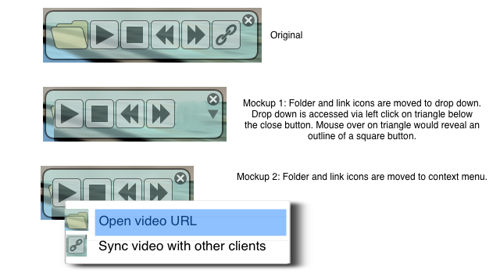
Figure 1: Non-essential buttons moved from video control heads-up
UI to a context menu or to a drop-down menu

With the PDF controls, it would appear that there are too many options for typical in-world usage scenarios. One way to improve on this would be to create two different PDF cell types. One cell type would allow for interactive PDF control. The other cell type would create a self-playing PDF that loops through user content. The interactive cell type would provide control buttons when its window is accessed. The non-interactive, self-playing cell type would not provide control buttons when its window is accessed. This makes sense because only infrequently are both self-playing and interactive controls are needed on the same PDF.

Another way to improve the PDF controls would be to move the non-essential buttons to a context menu or a drop-down menu (Figure 2). Finally, redesigning some of the graphics used for control icons may improve usability, as users did not find all of them to be intuitive (e.g,. the open icon, the sync icon, the zoom to original size icon, the go to last page icon, and the go to first page icon).

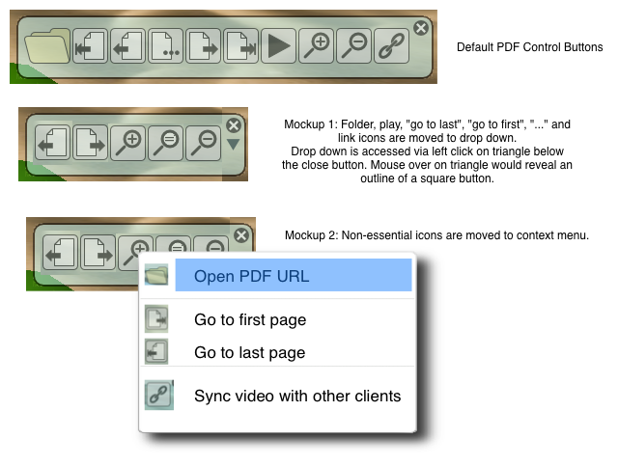
Figure 2: Non-essential buttons moved from heads-up PDF control
UI to a context menu or to a drop-down menu

Project Wonderland’s Default Windowing System
An area of acute concern from a usability perspective is associated with Project Wonderland’s in-world windowing system. The following annotated screen shots provide a graphical presentation of how the in-world windowing system could be improved.
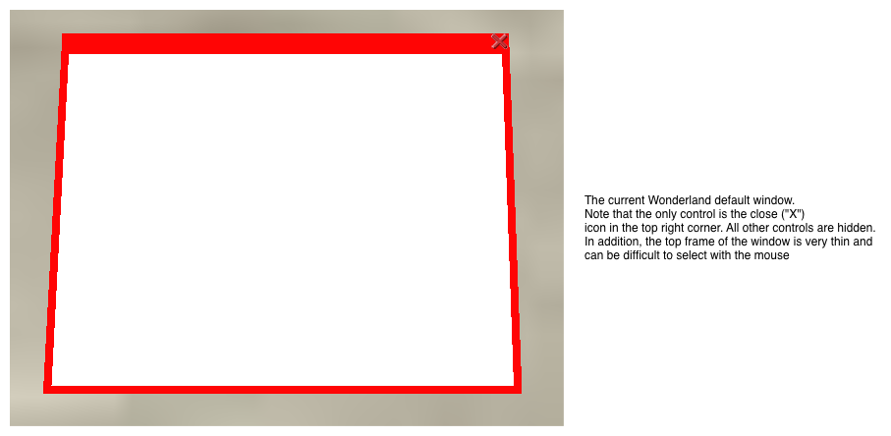

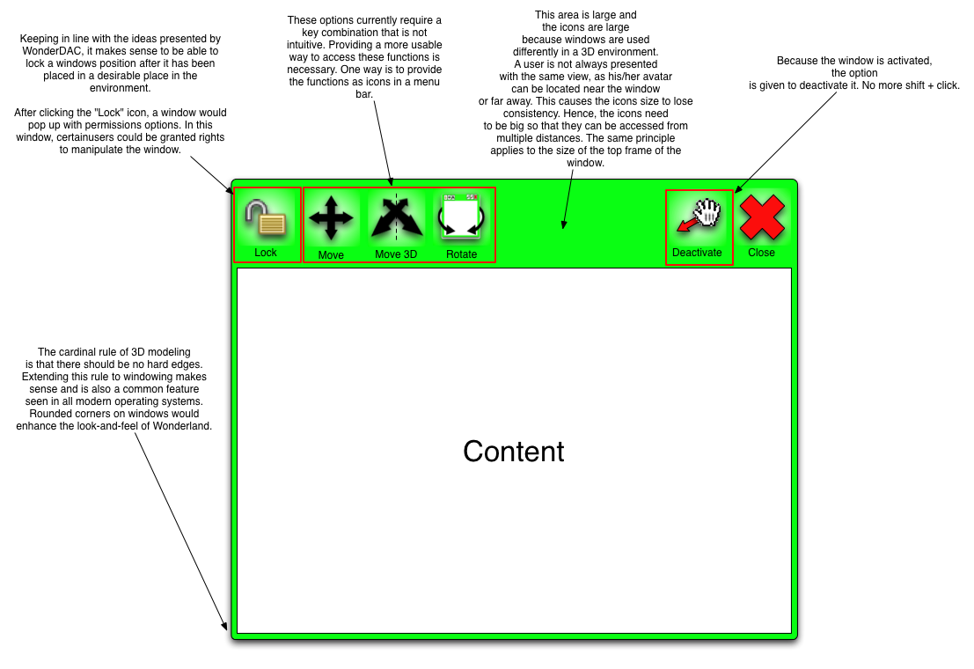
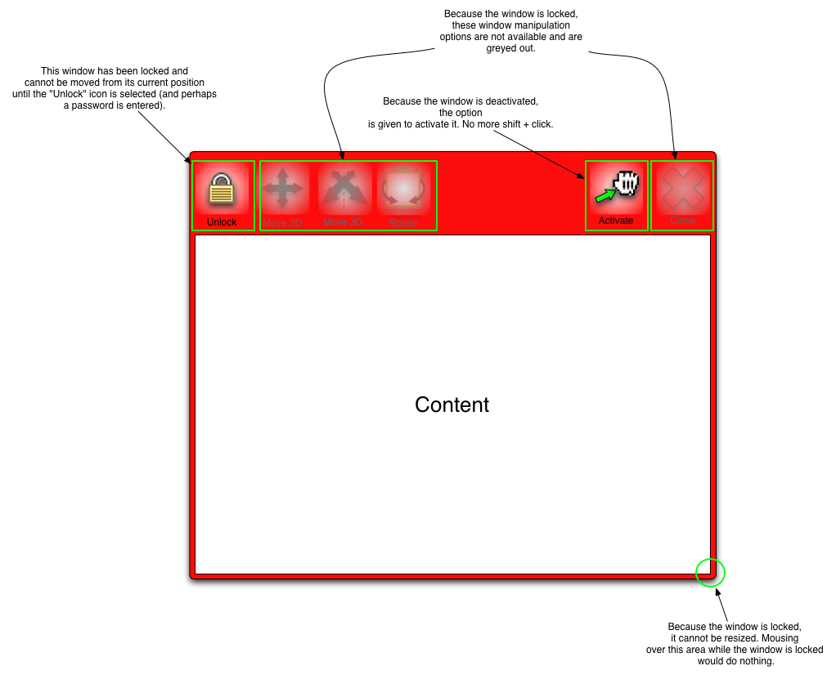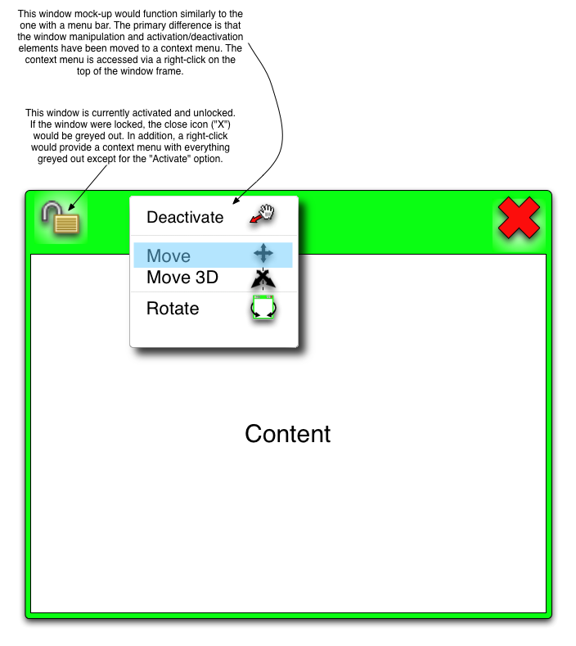

In addition to the above ideas for improvement, Nicole Yankelovich, Principle Investigator of Collaborative Environments at Sun Microsystems suggests the following:

“First, it's essential to include a space for the name of the user who has control of an app. Also, it's worth thinking about multi-user applications like the PDF viewer and the whiteboard. For these apps, multiple people can have control at the same time, but it's still useful to know who is currently using the application. Perhaps in this case a ‘current users’ list that pulls down would be the way to go.

“Another control that would be handy to have is a way to hide the window border and controls completely. I'm thinking of times when people want to put up content in applications and have them act more like posters than apps. This will probably have to be done with a key sequence and/or menu command on the Shared Apps menu since once hidden, there is no longer a visible control to show the borders and controls.”

Additional Suggestions for Enhanced Usability
Users experienced some difficulty with sending text chat messages. One way this difficulty could be alleviated would be to add a “send” button to the chat area in the client window (Figure 3).

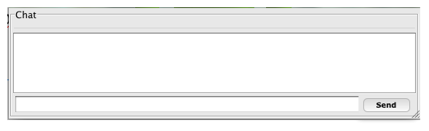
Figure 3: “Send” button added to the chat area

Further, sometimes participants had difficulty moving their avatars because a window was activated somewhere in the environment and the user was not aware of this. It would make sense when users are trying to navigate and a window is selected to provide them with some sort of notification. An example is provided in Figure 4.

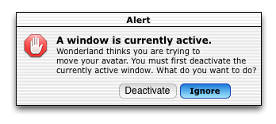
Figure 4: Alerting users that they cannot move their
avatars without deactivating an active window.

Finally, the shared whiteboard would benefit from some improvement to its latency issues. While the application is very simple and intuitive to use, the fact that it suffers from latency issues across clients has the potential to cause major usage problems. Because the shared whiteboard is used primarily for displaying user-generated content in real-time, it is essential that all clients be presented with a consistent view of both the content within the window and the positioning of the window itself.

Appendix

Usability Interview Protocol – iSocial Prototype v0.1

Setup:

Pre-Test
- Ensure that iSocial servers (voice, environment) are running
- Log in to test machines for facilitator and participant
- Load iSocial Clients for both facilitator and participant
- Ensure that appropriate avatar is selected for participant
- Ensure that appropriate avatar is selected for facilitator
- Perform voice tests for both facilitator and participant
- Start Videocamera
- Set up and start screen recorders on both machines

Introduction:

Speak the following to the participant:

“Hi, my name is [ ], and I am going to be joining you in iSocial today. First, can you hear me OK?

<Adjust sound based on participants’ feedback>

“We won’t be doing any hard work – we’ll be trying to have some fun. I am going ask you to do a few simple things in iSocial. The reason why is that we are going to use what we do today to make iSocial more fun for others. So we are really interested in how iSocial works for you.

“While we do a few things in iSocial, I’d like you to do what you would normally do when you play 3D video games. If you want to explore, just go ahead and explore. And if you want to stop, that’s OK. Just stop.

“What you think about iSocial is important, so please let me know what you think.

“We are going to do five different things today. First, we will try out moving your avatar around in iSocial and talking with each other. Next, we will play a game together. After that, we will watch a video. Then, we will look the different things inside iSocial. Finally, we’ll play with the text chat.

“Do you have any questions?”

Part 1: Navigation and audio chat

Prompting:

Let’s go ahead and try to move our avatars around in iSocial. Just follow my instructions and answer my questions. If you want to stop at any time, just let me know.

- Are you comfortable and do you feel ready to start?

- Try to follow me into the lighthouse

  - If successful:

    - How did you know how to follow me?

  - If unsuccessful:

    - What do you think you should do to follow me?

    - Negotiate process with participant and explain/help them to navigate. Use participant’s helper if needed.

- Did you have any problems following me?

- Go into foyer from hallway an ask following:

- Do you like the controls that you use to move your avatar?

  - Why or why not?

  - How would you improve the controls?

~ Part 2 on Next Page ~
Part 2: Playing the puzzle turn-taking game

Prompting:

I’d like to play a puzzle game with you. Follow me over to the area where the game is. Be sure to take turns while we play. If you want to stop at any time, just let me know.

- Are you comfortable and do you feel ready to start?

- Will you please try to move a puzzle piece?

  - If successful:

    - How did you know how to move the puzzle piece?

  - If unsuccessful:

    - What do you think you should do to move a puzzle piece?

    - Negotiate process with participant and explain/help them to play the game. Use participant’s helper if needed.

<Continue playing puzzle until it is solved>

- Did you think the puzzle game was fun?

  - Why or why not?

- Do you like the controls that you use to take turns and play the game?

  - Why or why not?

  - How could we improve the controls for the game?

- What did you like best about the game?

- What did you like least about the game?

- If you could change one thing about the game, what would it be?

~ Part 3 on Next Page ~
Part 3: Watching a video

Prompting:

I’d like to watch a video with you. Follow me over to the area where the video is. I’m going to ask you some more questions when the video is over. If you want to stop at any time, just let me know.

- Are you comfortable and do you feel ready to start?

- Will you please try to start the movie?

  - If successful:

    - How did you know how to start the movie?

  - If unsuccessful:

    - What do you think you should do to start the movie?

    - Negotiate process with participant and explain/help them to start the movie. Use participant’s helper if needed.

- Did you like watching a video in iSocial?

  - Why or why not?

- Do you like the controls that you use to play the movie?

  - Why or why not?

  - How would you improve the controls for the movie?

- If you could watch any movie in iSocial, which movie would you choose?

  - Why?

~ Part 4 on Next Page ~

Part 4: Reading and interacting with PDFs

Prompting:

I’d like to walk around iSocial with you and look at some of the things in the lighthouse. Just follow me around and I’ll ask you some questions about those things. If you want to stop at any time, just let me know.

- Are you comfortable and do you feel ready to start?

<Navigate to “Taking Turns” poster in Lesson One level of lighthouse and activate the poster so that the border becomes green>

- There are three windows on this wall, but I only want you to look at one. Which one do you think I want you to look at?

  - Why do you think I want you to look at that poster?

- This poster actually has more than one page. Will you please try to turn the page on the poster?

  - If successful:

    - How did you know how to turn the page?

  - If unsuccessful:

    - What do you think you should do to turn the page?

    - Negotiate process with participant and explain/help them to turn the page. Use participant’s helper if needed.

<Continue working through the Taking Turns poster until the end>

- Did you think it was easy to read the poster?

  - Why or why not?

- Do you like the controls that you use to turn the pages on the poster?

  - Why or why not?

  - How would you improve the controls for the poster?
~ Part 5 on Next Page ~
Part 5: Using text chat

Prompting:

I’d like to try out the text chat with you. I’ll ask you a few questions while we try it out. If you want to stop at any time, just let me know.

- Are you comfortable and do you feel ready to start?

- Do you know what chatting and instant messaging is?

- Do you see a chat area on your screen?

  - If yes:

    - How did you know that was the text chat area?

  - If no:

    - Can you guess where it might be?

    - Negotiate process with participant and point them to the text chat area. Use participant’s helper if needed.

- Try to send me an instant message.

  - If successful:

    - How did you know what to do?

  - If unsuccessful:

    - What do you think you should do to send me an instant message?

    - Negotiate process with participant and show them how to send instant message. Use participant’s helper if needed. Follow up as to why participant had difficulty

- Did you think it was easy to send an instant message??

  - Why or why not?

~ Post-study steps on next page ~
Part 6: Follow-up

Prompting:

Say: “We moved our avatars around and talked. We played a game. We watched a video. And we looked at all the different things in iSocial. We even got to try out the text chat.

“Is there anything else you’d like to do in iSocial today?”

<Let participant continue exploring if time and interest>

Log out of the system and have participant do the same.

Say: “I just have a few more questions I’d like to ask you.”

- Are you comfortable and do you feel ready to start?

- Did you have any trouble getting started in iSocial and learning how to move around or do the tasks?

- Was there anything that you wanted to do that you were not able to do?

- How would you rate iSocial on a scale of 0 to 10 with zero indicating it was very hard to use iSocial and 10 indicating it was very easy to use.

- iSocial let you talk and interact with (fill in the name of the person) did you have any trouble talking or working with (name)?

- Was there anything that you wanted to do with (name) that you were not able to do?

- How would you rate iSocial on a scale of 0 to 10 with zero indicating it was very hard to interact with (name) and 10 indicating it was very easy to interact with (name).

- Would you like to come back again and try iSocial to do more tasks? (why or why not)

~ Last steps on next page ~

Finishing up:

Speak the following to the participant:

We are all finished now. Do you have any questions?

<Answer any questions>

Thank you very much for helping us to improve iSocial!

