

**MASENO UNIVERSITY**

**SCHOOL OF MATHEMATICS, ACTURIAL SCIENCE AND STATISTICS**

**DEPARTMENT OF PURE AND APPLIED MATHEMATICS**

**CCS 323: GROUP PROJECT II**

**PROJECT TITLE: SCHOOL MANAGEMENT SYSTEM**

**PROJECT REPORT SUBMITTED TO THE SCHOOL OF**

**COMPUTING AND INFORMATICS IN PARTIAL FULFILMENT**

**OF THE REQUIREMENTS FOR AWARD OF THE DEGREE OF BACHELOR OF SCIENCE MATHEMATICS AND COMPUTER SCIENCE**

**STUDENT NAME ADM. NO**

JOSPHINE NZILA MT/00231/015

**SUPERVISOR**

**MR. ADONGO**

# **DECLARATION**

I hereby declare that this project report is my original work and it has not been plagiarized from any other source except for citations and quotations which have been dully acknowledged. My Signature indicates approval of this project report.

**REG NO. NAME SIGNATURE DATE**

MT/00231/015 JOSPHINE NZILA ____________ __/___/____

This project report is presented for examination with my approval as the project supervisor.

**Name Signature Date**

____________________ ______________ __/___/___

# **ABRIDGEMENT**

Education system outlines the backbone of every nation. Technology can play a very crucial role in streamlining the whole system of education. Exploring the technological approach to education becomes essential for today's fast growing educational environment.

Today's schools need to manage more information than ever before. Without a solid internal infrastructure for teachers, administrators and departments to share data, critical school and student information can be lost, or worse, communicated incorrectly, leading to problems that can affect the school's image.

The proposed system has automated various activities of schools through online student registration for easy admission and Integration of academic calendar, school notices and other activities to ensure better interaction within the school management. The application has provided a web based portal to users.

Numerous school management systems have been developed to automate creation of timetables, examinations process, grading system, fee payment, student attendance, library usage, news and event management. Existing literature concerning school management systems has been discussed in order to bring the concept into perspective and to understand previous studies on the same.

In conclusion, the purpose of the based school management system is to ensure transparency in school operations, availability of real-time up to date information, better management of school academic process and administration, instant access to required information and activities of the school.

Future increments could be added to include Unstructured Supplementary Service Data (USSD) technology. USSD is an interactive, menu-based technology that allows users with any mobile handset to access various services without the need for internet connection. On such a platform, parents would dial a USSD code such as *123# on any mobile handset and they will be able to access their students fee balance, exam results, fee structure, upcoming events, and so on.

# **ACKNOWLEDGEMENT**

My sincere gratitude goes to the almighty God for His gratefulness since the start of this project, for giving me good health, wisdom and knowledge to handle issues. I also pass my sincere gratitude to my supervisor Mr. Adongo for his expert guidance he offered throughout the project. Special thanks go to my colleagues for their assistance through their active role of criticism and ideas that made this entire project a success not forgetting my parents for their financial assistance in doing the relevant research and printing the project. To the school of computing, thanks for providing the needed resources for this project. I thank all for their support and contributions towards the success of my project.

Contents

**DECLARATION** 2

**ABRIDGEMENT** 3

**ACKNOWLEDGEMENT** 4

**CHAPTER ONE: INTRODUCTION** 7

1.1 Background information 7

1.2 Statement of the problem 8

1.3 Purpose of the study 8

1.4 Objectives of the study 8

1.5 Significance of the study 8

**CHAPTER TWO: LITERATURE REVIEW** 9

2.1 Background information 9

2.2 Justification 10

2.3 Benefits of the System 10

**CHAPTER THREE: METHODOLOGY** 11

3.1 Introduction 11

3.2 Methodology 11

3.3.1 Advantages of Prototyping 12

3.3.2 The Process of Prototyping 12

3.4 Reasons for using Rapid Prototype Model 12

3.5 Phases in prototyping Model 13

3.6 Shortcomings of the Rapid Prototyping Model 14

3.7 System Analysis 14

3.7.1 Introduction 14

3.7.2 Feasibility study 14

3.7.3 Requirement Analysis 15

3.7.4 Requirement Definition 15

3.7.5 Requirement Specification 15

**4.1 Introduction** 17

4.1.1 Logical Design 17

4.1.2 Physical design 17

4.2 Input design 18

4.3 Data capturing 18

4.4 Input Validation 18

4.5 Output Design 19

4.6 Data Base Design 19

4.7 Architectural Design 19

4.8 Conceptual Database Design 19

4.9 Modular Design 20

4.10 Physical Database Design 25

4.11 Logical Database Design 27

4.12 Entity 27

4.13 Entity Relationship Model 27

4.14 Entity Relationship Diagram 27

4.15 Use case Diagram 27

CHAPTER FIVE: SYSTEM IMPLEMENTATION 30

5.1 Overview 30

CHAPTER SIX: SYSTEM TESTING 36

6.1 Introduction 36

6.2 Testing Objectives 36

6.3 Testing Strategies 36

6.3.1 Black Box Testing 36

6.3.2 White Box Testing 37

6.3.3 Stress Testing 37

6.3.4 Unit Testing 37

6.3.5 Integration Testing 37

CHAPTER SEVEN: CONCLUSION AND RECOMMENDATION 38

7.1 Summary 38

7.2 conclusion 38

7.3 Recommendation 38

REFERENCES 40

# **CHAPTER ONE: INTRODUCTION**

## 1.1 Background information

Kenya has placed considerable emphasis on the importance of ICT in its Education Sector Support Programme as evidenced in the recent promulgation of the National ICT Strategy for Education and Training. The Ministry of Education has taken steps to support the implementation of the strategy either by direct action or through the various institutions and agencies with which it works. In addition, there are many other organizations not involved directly with the Ministry of Education that continue to be active in implementing and supporting projects involving ICT in education.

Today educational institutions are not limited to imparting education alone, but it is adapting latest trends in IT for improving the quality of education and handling various activities of school including SMS communication to parents, teachers and management, fee balance tracking, keeping parents up to date with their students’ progress in school, online student registration for easy admission and Integration of academic calendar and school notices.

The IT sector has been offering a number of solutions to schools like smart classroom, digital learning solutions and school management system to make learning easier and manage school administration effectively. With the existing School Management Systems, many features have been added over the years with little regard to the end user experience which has made them too complicated to be used in real life scenarios. This particular School Management System has further bridged the gap between parents, students and teachers and has standardized platform for meaningful collaboration to happen.

## 

## 1.2 Statement of the problem

The manual system used consumes a lot of time and effort. The manual system is complex, inaccurate and records are often mishandled. It also encourages data redundancy. This poses challenges to the integrity and security of data. This often leads to misleading reports due to poor data entry.

## 1.3 Purpose of the study

The main aim of this study was to develop a school management system that will automate various activities of a school through online student registration for easy admission and integration of academic calendar, school notices and other activities to ensure better interaction within the school management. The application has provided a web based portal to users.

## 1.4 Objectives of the study

This system aims:

* To generate timely reports on demand.
* To ensure better interaction between parents, teachers and school management.
* To provide a simple user friendly interface which to ensure a smooth user experience.

## 1.5 Significance of the study

The system ensures transparency in school operations, better management of school academic process and administration, instant access to required information and activities of the school, facilitate online registration, easy follow up and admission and ensure better interaction during school management.

# 

# **CHAPTER TWO: LITERATURE REVIEW**

## 2.1 Background information

Educational institutions world over have revolutionized the way they manage their data in which processing computer based information systems have been adopted as a tool to support managers in their management duties (Webber, 2003). Information technology has been used in both developing county’s’ major economic sectors such as transport. Webber (2003) points out that despite the success registered in the use of information technology in other sectors of economy, educational institutions have lagged in the integration of computers for schools management purpose.

Studies conducted in development countries in USA, the United Kingdom, France and Canada indicate that Information and Community Technology (ICT) has the potential of improving the efficiency and effectiveness of school manager’s administrative duties (Graca, 2005; Someketh, 2001). In their study on need for computer technology holds the power for effective transformation of schools management and consequently for the improvement of schools. By 1970’s countries such as United State Of America, Netherlands Australia Hong Kong and Mexico had computerized their school’s management tasks mainly maintenance of payroll, financial reporting and accountings (cunninghan,1986;Bozeman et al,1991).

With regard to the status of ICT in Kenyan secondary schools one of the earliest ICT projects in the education sector was implemented by the Aga Khan Foundation (AKF), which was responsible for introduction of computers in Kenya’s secondary schools through the Computers in Education Project in Kenya (CEPAK) in 1983. The first phase began with the Aga Khan Academy receiving five computers and the necessary software from AKF (Makau & IDRC, 1990). The second phase introduced computers to four public secondary schools in Nairobi.

In recognition of ICT in management of the catalytic role that information plays in national development, Kenya developed its initial information communication (ICT) National Policy in 2003 (MOEST, 2006) the policy framework document that emphasized the need for national ICT policy and the need to embrace ICT in education management.

## 

## 2.2 Justification

There is growing need to evaluate benefits of ICTs and to create opportunities for capacity building that will ensure their beneficial use and absorption within schools (Bessom 1996). He further stresses the need for African government to utilize science and technology in education sector. Marker, Wallace and MacNamara (2002) note that, recent innovations have led to cutting edge information and communication tools specifically relevant to need of school managers. Mudhai (2004) underscores the importance of ICT and reflects on the latest developments initiated by African governments to leap into the information age and gives example of achievements in Nigeria, Egypt, Mozambique and Rwanda that have established high level multi-sector task for ICT in school management.

## 2.3 Benefits of the System

* Transparency in school operations.
* Better management of school academic process and administration.
* Instant access to required information and activities of the school.
* Online Registration, easy follow up and Admission.
* Integration of Academic Calendar, School Notices and other activities.

# 

# 

# **CHAPTER THREE: METHODOLOGY**

## 3.1 Introduction

Methodology is defined as a standard or process followed in an organization to conduct all the steps necessary to analyze, design, implement, and maintain an information system. The framework in which software is designed, developed, and maintained is known as the Software Development Life Cycle (SDLC). It shows the steps, phases, milestones, and evolution of the software development process.

There are many types of models used in software design and development. Among them are the waterfall model, rapid prototyping model, evolutionary/incremental model, spiral models, agile development model, component based models, and so on.

## 3.2 Methodology

Prototyping model has been used to develop this application. It is a technique for quickly building software with limited functional capabilities, low reliability and insufficient performance compared to the actual software. It always turns out to be a very crude version of the actual software. It is always difficult to get a perfect product at first attempt hence the need to throw away the first version. The figure below illustrates the rapid prototyping process.

Analyze

Prototype

Design

Implement

Test

Maintain

.

***Figure 1: Prototype Model Process.***

**3.3 Rapid Prototyping Model**

### 3.3.1 Advantages of Prototyping

* Reduces development time.
* Reduces development costs.
* Results in higher user satisfaction.
* The Prototype hints the user about the final product look.
* Easy to find design flaws in the early stages of developmental.
* There is better communication between the user and designer.
* A high-quality product is delivered.

### 3.3.2 The Process of Prototyping

**Identifying initial requirements**: I determined basic requirements including the input and output information desired. Details, such us security, was typically ignored.

**Developing initial prototype**: The initial prototype was developed that included only user interfaces.

**Review**: The customers, end-users, examined the prototype and provided feedback on additions or changes.

**Revise and enhancing the prototype**: Using the feedback, both the specifications and the prototype were improved.

This method involved a series of iterations and refinement until the prototype product has a fully working system, and the user is satisfied.

## 3.4 Reasons for using Rapid Prototype Model

* Users are actively involved in the development
* Since in this methodology a working model of the system is provided, the users get a better understanding of the system being developed.
* Errors can be detected much earlier.
* Quicker user feedback is available leading to better solutions.
* Missing functionality can be identified easily

## 

## 3.5 Phases in prototyping Model

Prototyping

Initial Requirements

Customer Evaluation

Design

Review and update

Development

Testing

Maintenance

***Figure 2: Phases in Rapid Prototyping Model***

**Phase 1: Identifying initial requirements**:

I obtained major requirements which defined the need for the new system including the main input and output requirements.

**Phase 2: Developing initial prototype:**

I developed a basic initial prototype which only had UI screens.

**Phase 3: Reviewing the prototype:**

End users and relevant stakeholders examined the prototype and provided feedback for improvements/enhancements.

**Phase 4: Revising and enhancing the prototype:**

Scope was changed based on feedback from end users and the prototype was enhanced and refined to accommodate user’s feedback.

## 3.6 Shortcomings of the Rapid Prototyping Model

* It fails in exact replication of the real product or system.
* Some important developmental steps might get omitted to get a quick and cheap working model. This turns out to be one of the greatest disadvantages of rapid prototyping.
* Many problems may be overlooked resulting in endless corrections and revisions.
* Unsuitable for large sized applications.
* The developer may produce an inadequate system that is unable to meet the overall demands of the organization.
* Over involvement of user might hamper optimization of the program.

## 3.7 System Analysis

### 3.7.1 Introduction

System analysis is a process of gathering and interpreting facts, diagnosing problems and the information about the School Management Systems to recommend improvements on the system. It is a problem-solving activity that requires intensive communication between the system users and system developers. System analysis or study is an important phase of any system development process. The system is studied to the minutest detail and analyzed. The system analyst plays the role of the interrogator and dwells deep into the working of the present system. System analysis is concerned with becoming aware of the problem, identifying the relevant and decisional variables, analyzing and synthesizing the various factors and determining an optimal or at least a satisfactory solution or program of action. A detailed study of the process must be made by various techniques like interviews, questionnaires etc. The data collected by these sources must be scrutinized to arrive to a conclusion. The conclusion is an understanding of how the system functions.

### 3.7.2 Feasibility study

After study and analyzing all the existing or required functionalities of the system, the next task is to do the feasibility for the project. All the projects are feasible-given unlimited resources and infinite time.

Feasibility study includes consideration of all the possible ways to provide a solution to the given problem. The system should satisfy all the user requirements and should be flexible enough so that future changes can be easily done based on the future upcoming requirements.

#### 3.7.2.1 Economical feasibility

This is a very important aspect to be considered while developing a project. The cost of converting the manual system into a computerized is one of the important factors. I decided the technology based on minimum possible cost factor.

#### 3.7.2.2 Technical feasibility

This included the study function, performance and constraints that may affect the ability to achieve an acceptable system. For the feasibility study, we studied complete functionality to be provided in the system and checked if everything was possible using different type of frontend and backend platforms.

#### 3.7.2.3 Operational feasibility

No doubt the proposed system is fully GUI based that is user friendly and all inputs to be taken all self-explanatory even to a layman. As far as my study is concerned the clients will be comfortable and happy as the system will cut down their loads and doing.

### 3.7.3 Requirement Analysis

It is a communication between customer and the software development team. To get better understanding of the requirement, I made prototype and visited some schools for requirements gathering which resulted more benefits and functionalities which was impossible without requirement specification.

### 3.7.4 Requirement Definition

In this stage I defined different users of the system and their role in operating the software i.e. administrator will manage the whole system. While users manage information of his own.

### 3.7.5 Requirement Specification

Out of various alternatives structured language is used to write down the functional requirement. Structure language which is a restricted form of natural language use template to specify requirements. The software requirements specification is produced at the culmination of the analysis task. The function and performance allocated to software as part of system engineering are refined by establishing a complete information description, a detailed functional and behavioral description, an indication of performance requirements and design constraints, appropriate validation criteria and other data pertinent to requirements.

The proposed system had the following requirements:

* To store information about new students and teachers.
* To give notices to the users
* To maintain quality records for the users.
* To keep all the school information.
* To update and delete the necessary records.
* Security system to prevent data loss.

# CHAPTER FOUR: SYSTEM DESIGN

## 4.1 Introduction

This chapter will provide a full description of the system and its users. Then it depicts the functional and non-functional requirements that have been collected using several methods from brainstorming, interviews and so on. After determining the most important requirements, requirement analysis is adopted using several tools such as use-case diagram, context diagram and System Flowchart.

There are three main elements in planning of system development.

* System administrator or the user- primarily information can be recorded by the system user.
* The administrator will enter data regarding the students, teachers, subjects, events, exams etc through their own login username and password.
* All the data that will be used by users will be saved and processed on a system. The administrator will be able to make changes in the system, rectify the errors, edit, add or delete user.

The design is the process of analyzing, organizing and developing database model that accurately reflects the organization functioning in the real world and implementing that model by creating a database. In this phase, a logical system is built which fulfills the given requirements. It deals with transforming the client’s requirements into a logically working system.

It can be divided into 2 phases:

1. Logical design

2. Physical design

### 4.1.1 Logical Design

The logical design describes the detail specification for the proposed system. We can say that it describes its own feature. Input, output, file and database in manner that meets the project needs. In logical design work with users is done to develop general design, choose best design, develop system flow charts, identify hardware, software and personal needs and revise estimates.

### 4.1.2 Physical design

The purpose of physical design is to translate the logical description of data into the technical specification for storing and retrieving data. The goal is to create design for storing data that will provide adequate performance and ensure database integrity, security and recovery.

Physical database design does not include implementing files and databases.

## 4.2 Input design

The input design specifies the number in which the user enters the data to the system for processing at later stage. Input design can ensure the reliability of the system and provide an accurate result. The input determines whether the user interacts with the system efficiently or not. Input design consists of those steps necessary to put transactions data into usable form processing.

While designing the input for the School Management system for schools in Kenya we considered the following guidelines:

1. Reducing the amount of input
2. Avoiding errors in data
3. Keeping extra steps
4. Keeping the process simple.
5. Avoiding delay

## 4.3 Data capturing

In input design only, those items are captured which must actually be the subject of input while designing the input, following points were kept in mind.

1. School information
2. Student information
3. Admin information
4. Teacher information
5. Parent information

## 4.4 Input Validation

Input validation is general term given to method, aim for detecting errors in the input. The main thing, which is considered in the input, is that what the chances of error are? Following are input validations used for centralized system for School Management System for schools.

1. Empty entry Control

2. Data Type Validation

3. Not Null

## 4.5 Output Design

A system is considered to be successful or unsuccessful on the basis of output design. The term “output” means that after compilation of physical design what errors come out of the computer system for the user. The output in project is considered as the backbone of the project. All managerial design is actually made through these reports. Basically, the reports are very important aspect of the output. The user creates various reports in response to queries.

## 4.6 Data Base Design

Database Design is a creative process of transforming:

1. Problems into Solution
2. The description of solution
3. Intelligent database design is perhaps the most critical element of an optimal solution with respect to performance. In fact, poor design is usually the culprit for poorly performing solutions.
4. Designer of the database should satisfy the user.

## 4.7 Architectural Design

The primary objective of architectural design is to develop a modular program structure and represent the control relationship between them.

## 4.8 Conceptual Database Design

Conceptual Database Design tells the user exactly:

1. What the system will do

2. Describe the functions of the systems

3. The system will work in the following areas

4. Unique authorized access to all registered users

5. Data Validation checks

6. The system is defined by its boundaries, entities, attributes, and relationship

## 

## 

## 4.9 Modular Design

Modular design occurs after data; architecture and interface designs have been established. In and world, the modular specification required to be define algorithmic details would be stated in a natural language such as English because it is easily understandable. And then that straight forward plain English are converted to diagrams. There is no question that graphics tools such as flow charts or box diagrams provide excellent pictorial patterns that readily depict modular details. However graphical tools are misused, the wrong picture may lead to wrong software. In this section we demonstrated some of our basic modules by using Flow Charts. Such as form entry, deletion, insertion, updating and reports. The following are some of the flow charts depicting the modules.

## 

## 

FORM

## 

## 

NO

ENTER DATA

YES

VALID?

END

STORED IN DATABASE

***Figure 3: General data entry***

LOGIN

NO

ENTER USERNAME & PASSWORD

IS CORRECT?

YES

LOGGED IN

RUNS LOGIN MODULE

## 

***Figure 4: Login module***

LOAD DATA

NO

DELETE CONIFIRMATION MESSEGE

STORE

RUNS DELETE MODULE

IS FOUND?

YES

***Figure 5: Delete module***

LOAD DATA

NO

IS FOUND?

YES

END

UPDATE CONFIRMATION MESSAGE

STORE

RUNS UPDATE MODULE

***Figure 6: Update module***

## 

## 4.10 Physical Database Design

The purpose of the internal or physical database design is to translate the logical description of data into the technical specification for storing and retrieving data. As we know that the physical database design requires several critical decisions that will affect the integrity and performance of the application system. One of the decisions is the storage format (data type). The following are the tables, their attributes and the primary and foreign keys in the tables.

***Table 1:User’s table***

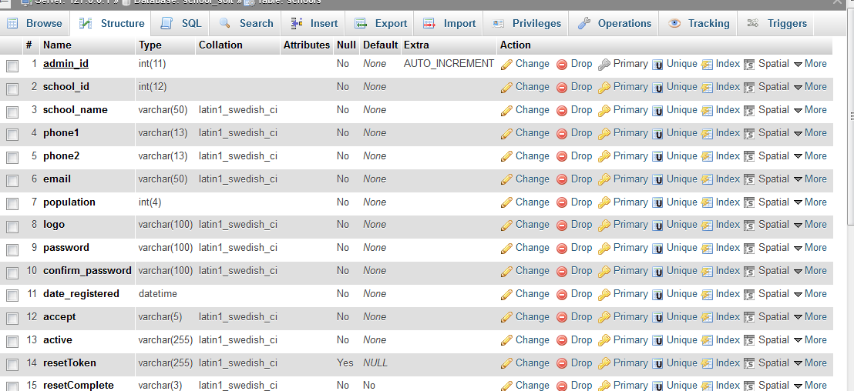

***Table 2: Student’s table***

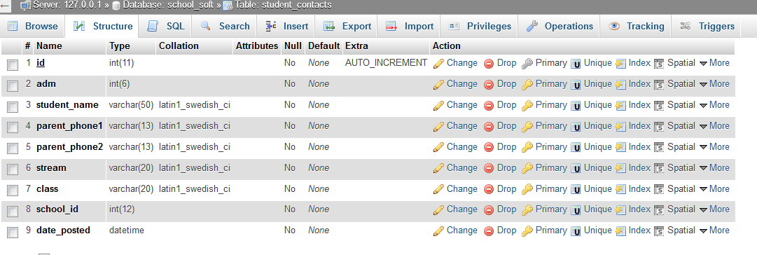

***Table 3: Staff’s table***

## staff.PNG

***Table 4: Fee structure’s table***

## feestructure.PNG

***Table 5: Exam’s table***

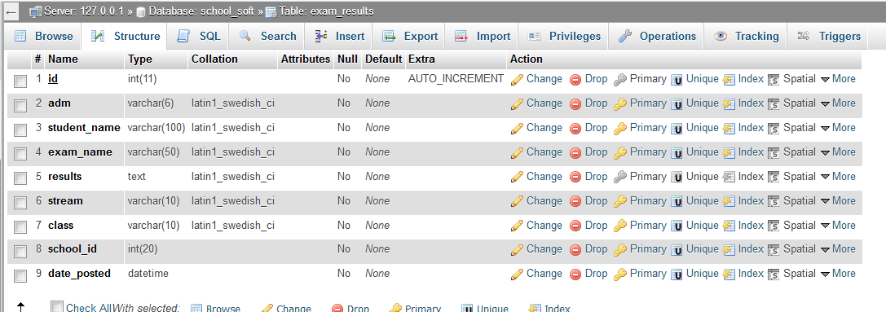

## 4.11 Logical Database Design

Logical design describes the detail specification for the proposed system. We can say that it describes its own features. Input output tables and database in a manner that meets the project needs. In logical design work with users is done to develop general system design, choose best design, develop system flowcharts, identify hardware, software and personal needs and revise estimates etc.

## 4.12 Entity

Anything that produces or consumes information is called entity. The representation of any composite information that must be understood by software is called data object, by composite information we mean something that has a number of different properties or attributes.

## 4.13 Entity Relationship Model

The entity relationship model is a tool for analyzing the semantic feature of an application that is independent of events. Entity-relationship modeling helps reduce data redundancy. This approach includes a graphical notation, which depicts entity classes as rectangles, relationships as diamonds and attributes as ovals. For example, situations a partial entity relationship diagram may be used to present a summary of the entities and relationships but not include the details of the attributes.

## 4.14 Entity Relationship Diagram

The entity relationship diagram provides a convenient method for visualizing the inter- relationship among entities in a given application. This tool has proven useful in making the transition from an information application description to a formal database schema. The entity relationship model is used for describing the conceptual scheme of an enterprise without attention to the efficiency of the physical database design. The entity relationship diagrams are later turned into a conceptual schema in one of the other models in which the database is actually implemented.

## 4.15 Use case Diagram

A use case describes the sequence of actions a system performs yielding visible results. It shows the interaction of things outside the system with the system itself. Use case diagrams present an outside view of the manner the elements in a system behave and how they can be used in the context. There is one main user of the proposed system; the Administrator. The user can perform several different functions during the use of the system. The figure below summarizes the functions performed by the user (actor).

USER

## 

***Figure 7: Use Case Diagram***

Add Events

Add New Student, Teacher

Manage Users

Administrator

***Figure 8: Context Diagram***

## 

# 

# CHAPTER FIVE: SYSTEM IMPLEMENTATION

## 5.1 Overview

It is particularly important first to design how the system will look and respired to user before designing the software structure. The most critical and creative aspect of development is to design the user interface. User interface design determines how the system will look from outside. The interface design creates effective communication medium between human and a computer, following a set of design principle. The design identifier interface objects action and then creates screen layout that formats the basic for a user interface prototype. User interface begins with the identification of user, tasks and environment requirements. User interface for the software should be designed in such a way that is friendly to the user, easy to use and easy to understand. It should provide high quality interface between the user and the system. The results produced by the software should be consistence. In designing the user interface, it has been kept in mind that non-technical personnel will operate the system therefore, the user interface designed is user friendly as possible to facilitate easy and quick. The modules that have been used and designing the screen are:

1. Registration
2. Login
3. Overview
4. Admissions
5. Exams
6. Fees Payment
7. Subject
8. Exam
9. Upcoming Events
10. Settings

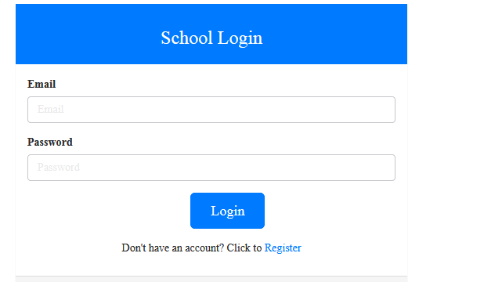

***Figure 9: School Management System home page***

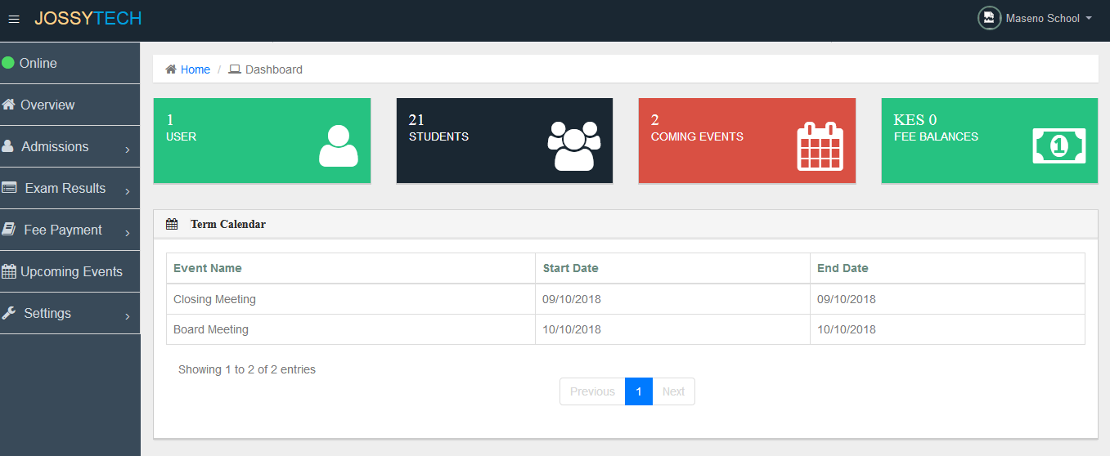

***Figure 10: Dashboard***

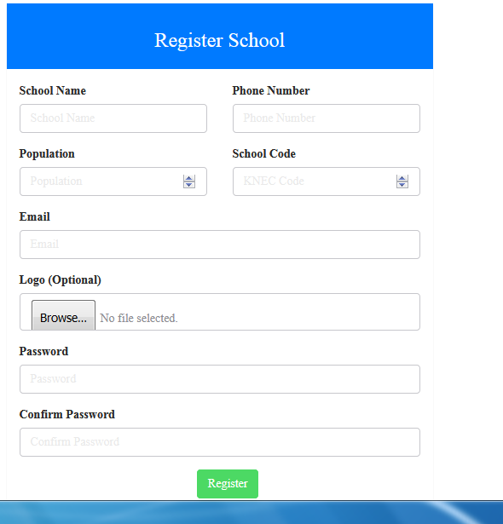

***Figure 11: Register User***



***Figure 12: Login User***

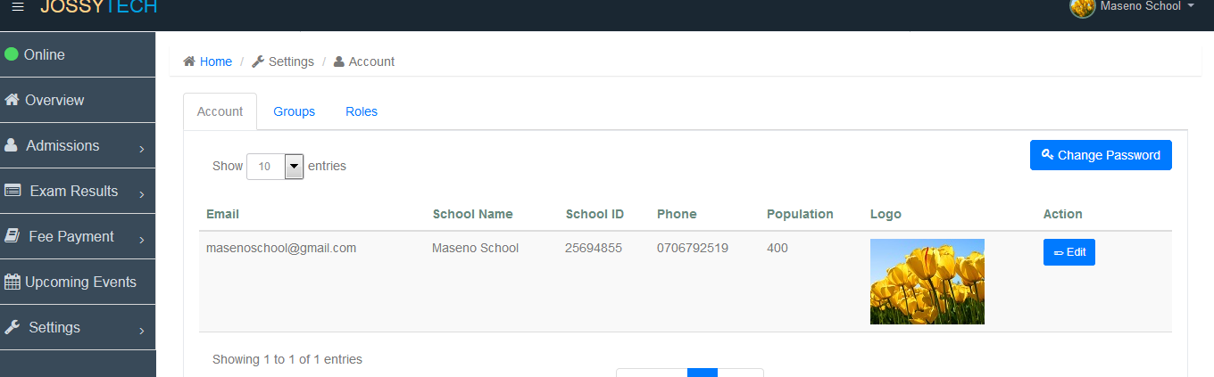

***Figure 13: Manage User***

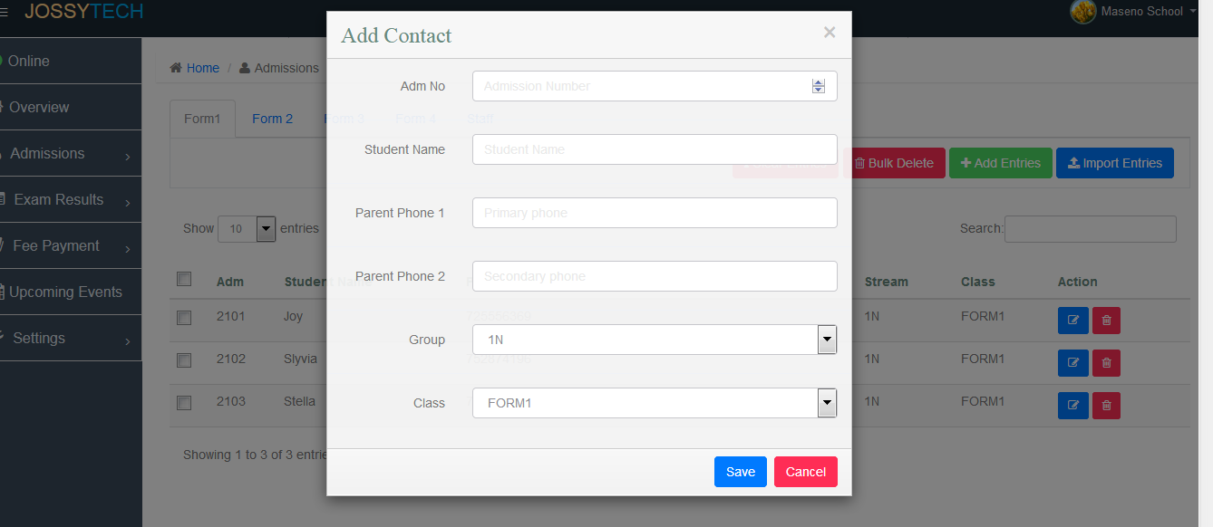

***Figure 14: Student Admission***

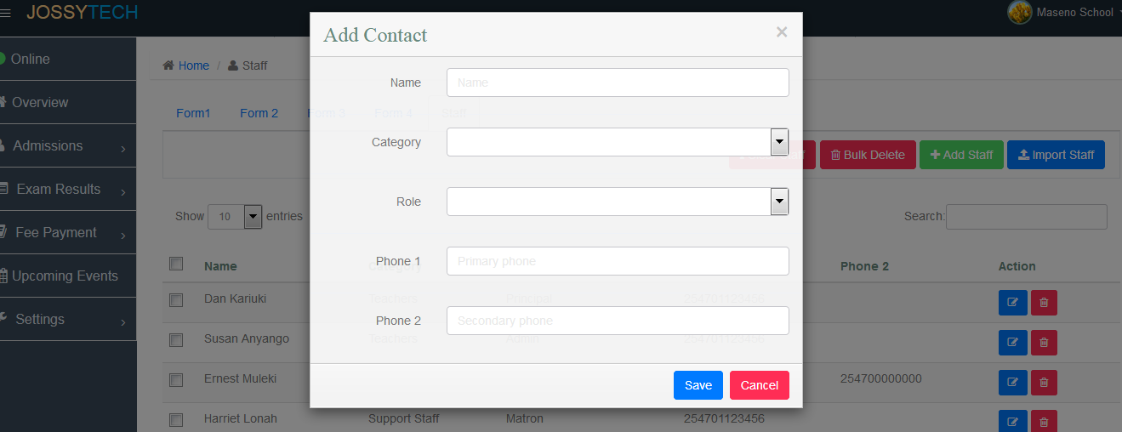

***Figure 15: Add staff***

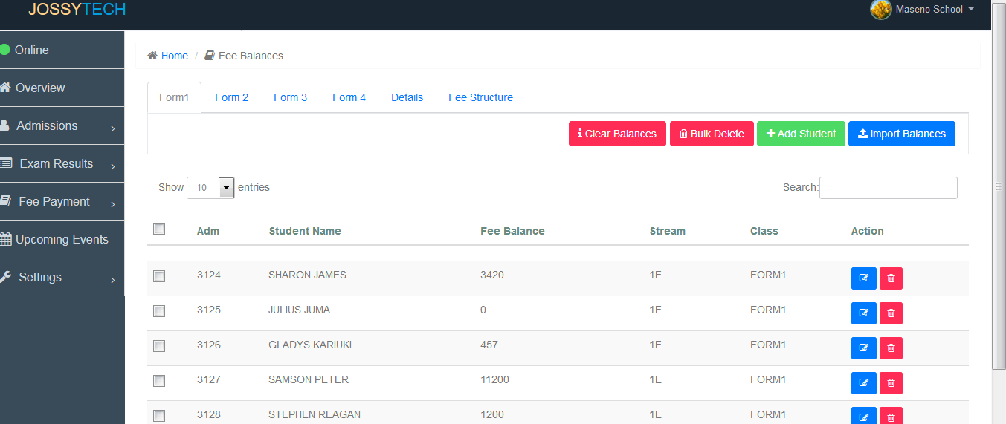

***Figure 16: Exam Results***

## feesform1.PNG

***Figure 15: Fee balances***

# 

# CHAPTER SIX: SYSTEM TESTING

## 6.1 Introduction

System testing is essential step for the development of a reliable and error free system. In a software development project, errors can be introduced at any stage during the development. Each phase has its own techniques for the detection and correction of errors in that phase. However, some requirements errors and design errors are likely to remain undetected.

Ultimately these errors will be reflected in a code. Since code is the only product that can be executed and whose actual behavior can be observed, testing is the phase where the errors remaining from the early phases also must be detected. Testing is the process of detecting and correcting as many errors as possible in the developed software before delivery to the customer. Test case is specification of the test and the output from the system plus a statement of what is being tested. Test data are the inputs which have devised to test the system.

## 6.2 Testing Objectives

1. To find errors in the developed software.
2. To check that working of the software is according to the specifications. The behavior and performance requirement are fulfilled.
3. To check the reliability and quality of the software.

## 6.3 Testing Strategies

The following are the basics strategies that were used for testing of the software:

* Black box testing
* White box testing
* Stress testing
* Acceptance testing
* Assertion testing

### 6.3.1 Black Box Testing

Can only be determined by studying its inputs and the related outputs. It is called functional testing because here the tester is only concerned with functionality and not with the implementation of the software.

In black box testing only the functionality of the software was tested without a record to the code. If the functionality which was expected from a component is provided then the black box testing is completed.

### 6.3.2 White Box Testing

White box testing is also called glass box testing and structural testing. The objective of white box testing is not to exercise all the different input or output condition but to exercise the different programming and data structure used in the program.

In white box testing internal code return in every component was tested and it was checked that the code written is efficient in utilizing various resources of the system like memory etc.

### 6.3.3 Stress Testing

Stress test is designed to confront program with abnormal situation. Stress testing executes system in a manner that demands rescore in abnormal quality, frequency or volumes. For example:

1. Input data rates may increase to determine how input function will respond
2. Tests that’s requires maximum memory or other resources are executed.

In stress testing the software was tested against the boundary conditions. Various inputs fields were tested against abnormal values and it was tested that the software does not behave abnormally at any time.

### 6.3.4 Unit Testing

Unit testing focuses verification effort on software component or module which is the smallest unit of software design. The unit testing is white box oriented and it can be conducted in parallel for multiple components.

In unit testing we checked that all individual components were working properly. Before integration of all components unit testing is essential because it gives a confidence that all the components individually are working fine and ready to be integrated with the other ones.

### 6.3.5 Integration Testing

After unit testing, combined testing of all modules was carried out where individual units were combined and tested as a group. The purpose was to determine that all the modules are correctly integrating with each other.

# 

# CHAPTER SEVEN: CONCLUSION AND RECOMMENDATION

## 7.1 Summary

This project titled as “School Management System” is a web-based application that provides facility to automate various activities of a school through online student registration for easy admission and integration of academic calendar, school notices, to ensure better interaction within the school management. All modules in the system are tested with valid data and invalid data to ensure that everything works successfully and thus the system fulfils all the objectives identified and it is able to replace the existing systems.

The project has been successfully completed with the maximum satisfaction of the end users. The constraints are met successfully. This system is designed as like it was decided in the design phase and it gives a good idea on developing a full-fledged application satisfying the user requirements. The system is flexible and versatile and has a user-friendly screen that enables the user to replace the existing systems.

## 7.2 conclusion

In conclusion, the based school management system will ensure transparency in school operations, availability of real-time up to date information, better management of school academic process and administration, instant access to required information and activities of the school.

## 7.3 Recommendation

I recommend this system to the secondary schools of Kenya to adopt this new automated system…

In this project I was not able to integrate the SMS and the multi user modules.

Therefore this system can further be enhanced by:

* Integrating the SMS and the multi user modules.
* Including Unstructured Supplementary Service Data (USSD) technology. On such a platform, parents would dial a USSD code such as *123# on any mobile handset and they will be able to access their students fee balance, exam results, fee structure, upcoming events, and so on.

# REFERENCES

Charles F. Webber, (2003) "New technologies and educative leadership", Journal of Educational Administration, Vol. 41 Issue: 2, pp.119-123, <https://doi.org/10.1108/09578230310477013>

Cunningham, G.L (1986). *Blowing the whistle on global education*. Denver, CO: United States Department of Education

Da Graca. P. Peano. S. & Saito M. (2005). *Educational Management Information Systems.* Paris: IIEP-UNESCO

MAKAU, B.M. & IDRC (1990). *Computers in Kenya's secondary schools: case study of an innovation in education*. Ontario: IDRC.

Marker P, McNamara K, Wallace L. (2002). *The significance of information and communication technologies for reducing poverty*. London, UK: DFID

MINISTRY OF EDUCATION, SCIENCE & TECHNOLOGY (2005). ICT in Education Options Paper. Nairobi: MOEST.

Okoth, Fred Mudhai (2010). *Researching the impact of ICTs as change catalysts in Africa*, Ecquid Novi: African Journalism Studies, 25:2, 313-335, DOI: [10.1080/02560054.2004.9653300](https://doi.org/10.1080/02560054.2004.9653300)