Tutorial link:

<https://www.youtube.com/watch?v=k-zMkzmduqI>

# Camera Movement

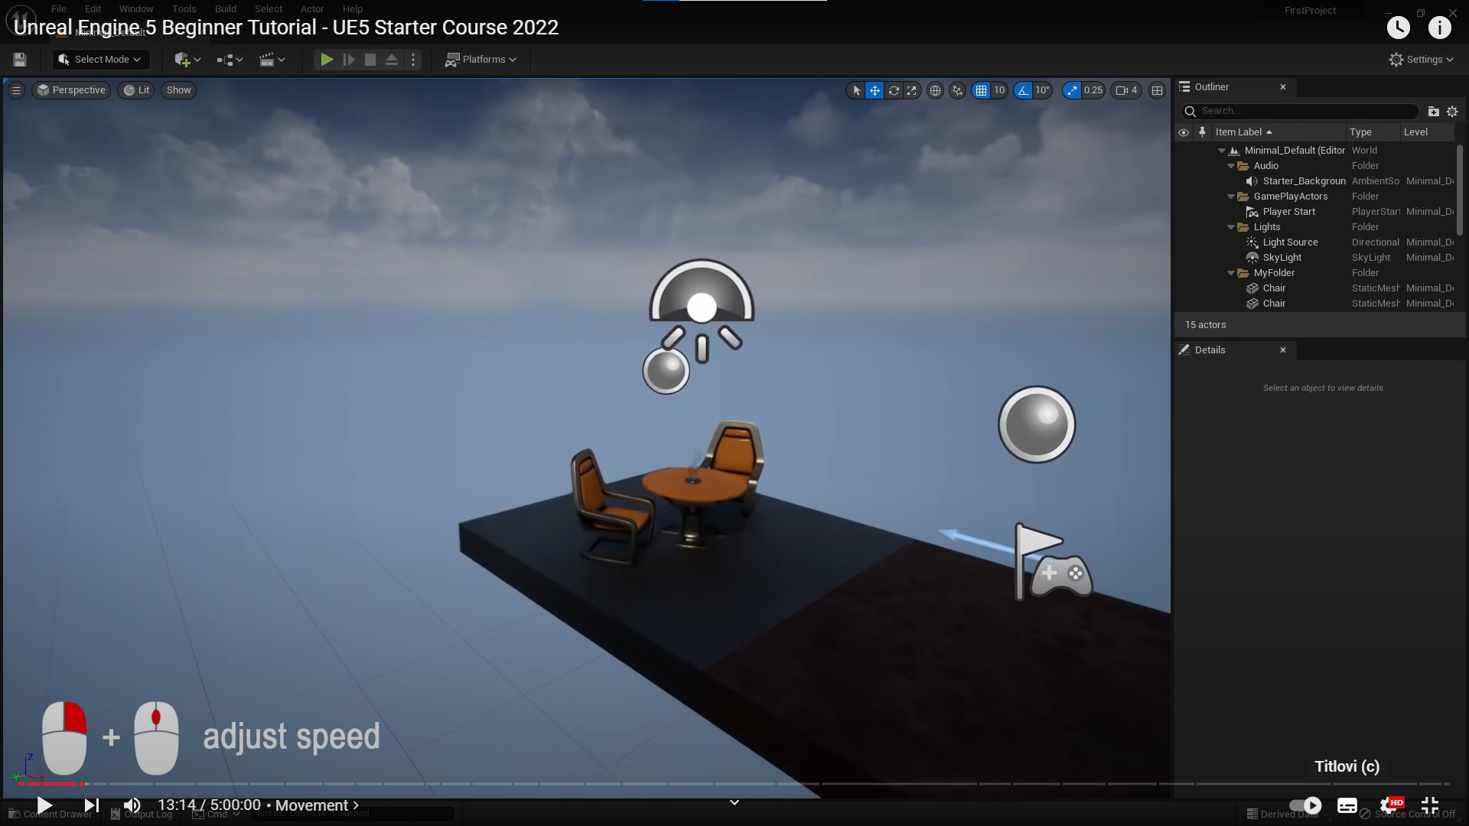

Rotate around object:

Connect object to bottom object(floor)

# Image rendering

UE has its image rendering properties located in Hierarchy -> Volumes -> GlobalPostProcessingVolume

This is only regarding to processing via camera, not for lighting settings(if understood correctly)

Here we can adjust settings:

